**Area calculation using Method Overloading**

**Code:**

package Experiment2;

import java.util.*;

class Area

{

// Area of the Square

int area(int side)

{

return 4*side;

}

// Area of the rectangle

int area(int length,int breadth)

{

return length*breadth;

}

// Area of the Circle

float area(float radius)

{

return 3.14f*radius*radius;

}

}

public class AreaCalculation {

public static void main(String[] args) {

// Scanner class

Scanner sc= new Scanner(System.in);

// Method Overloading

Area a = new Area();

int l,b,side;

float r;

// For area of the square

System.out.println("Area of the Square");

System.out.println("==================");

System.out.print("Enter the value of Side : ");

side=sc.nextInt();

System.out.println("Area of the Square : "+a.area(side)+" Sq.units\n");

// For area of the square

System.out.println("Area of the Rectangle");

System.out.println("==================");

System.out.print("Enter the value of Length : ");

l=sc.nextInt();

System.out.print("Enter the value of Breadth : ");

b=sc.nextInt();

System.out.println("Area of the Rectangle : "+a.area(l,b)+" Sq.units\n");

// For area of the square

System.out.println("Area of the Circle");

System.out.println("==================");

System.out.print("Enter the value of Radius : ");

r=sc.nextInt();

System.out.println("Area of the Rectangle : "+a.area(r)+" Sq.units\n");

}}

Output :

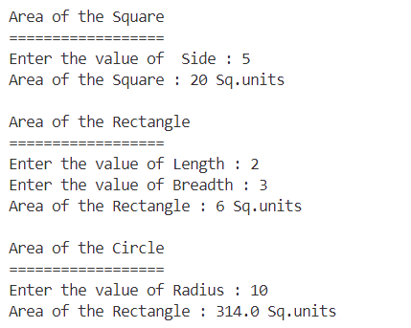

**Sum of an Array elements**

**Code :**

package Experiment3;

import java.util.*;

public class ArraySum {

private static int sumOfArray(int[] arr)

{

int sum=0;

for(int i=0;i<arr.length;i++)

sum+=arr[i];

return sum;

}

public static void main(String[] args) {

Scanner sc = new Scanner(System.in);

System.out.println("Sum of Array");

System.out.println("============");

System.out.print("Enter the size of an array : ");

int size=sc.nextInt();

sc.nextLine(); // consume nextline

int[] arr = new int[size]; //declaring an array

for(int i=0;i<size;i++) // defining an array

{

System.out.print("Enter the value for arr["+(i+1)+"] : ");

arr[i] = sc.nextInt();

}

System.out.println("The sum of an array = "+sumOfArray(arr));

sc.close();

}

}

Output :

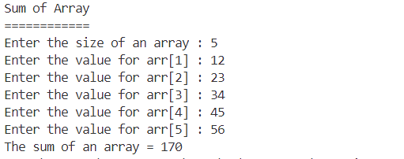

**Insurance Premium Calculation System**

**Code :**

package Experiment1;

import java.util.*;

public class InsuranceCalculator {

static int basePremium = 500;

static double rawPremium,finalPremium,taxAmt;

static float ageFactor,medicalHistoryFactor,vehicleTypeFactor,coveragePlanFactor;

static float taxRate = 0.18f;

public static double calculatePremium(int age, boolean medicalHistory, String vehicleType, String coveragePlan)

{

// finding the age factor

if(age<25)

ageFactor=1.2f;

else if(age>=25 && age<40)

ageFactor = 1.5f;

else if(age>=40 && age<60)

ageFactor = 2.0f;

else

ageFactor = 2.5f;

// finding the medical history factor

if(medicalHistory)

medicalHistoryFactor = 1.5f;

else

medicalHistoryFactor = 1.0f;

// Vehicle Type Factor

switch(vehicleType.toLowerCase())

{

case "sedan":

vehicleTypeFactor=1.2f;

break;

case "suv":

vehicleTypeFactor=1.5f;

break;

case "sports car":

vehicleTypeFactor=2.0f;

break;

default:

vehicleTypeFactor=1.0f;

break;

}

// coverage plan factor

switch(coveragePlan.toLowerCase())

{

case "basic":

coveragePlanFactor=1.0f;

break;

case "standard":

coveragePlanFactor=1.3f;

break;

case "premium":

coveragePlanFactor=1.7f;

break;

default:

break;

}

// Raw premium calculation

rawPremium = basePremium * ageFactor * medicalHistoryFactor * vehicleTypeFactor * coveragePlanFactor;

// tax amount calculation

taxAmt = rawPremium * taxRate;

// final premium calculation

finalPremium = rawPremium +taxAmt;

return finalPremium;

}

public static void main(String[] args) {

// TODO Auto-generated method stub

System.out.println("```Health Insurance Premium Calculator```");

System.out.println("-----------------------------------------");

Scanner sc = new Scanner(System.in);

String name,vehicleType,coveragePlan;

int age;

boolean medicalHistory;

System.out.print("Tell me your name : ");

name = sc.nextLine();

System.out.print("Tell me your age : ");

age = sc.nextInt();

sc.nextLine();

System.out.print("Choose your Vehicle Type (Sedan/SUV/Sports car/Others) : ");

vehicleType = sc.nextLine();

System.out.print("Choose your Coverage Plan (Basic/Standard/Premium) : ");

coveragePlan = sc.nextLine();

System.out.print("Did you have/had any Medical History (Yes/No) ? : ");

String medHis = sc.next();

if(medHis.toLowerCase().equals("yes"))

medicalHistory = true;

else

medicalHistory = false;

System.out.println("==================================================");

System.out.println("Hi "+name+" , Your Health insurance premium amount is Rs. "+String.format("%.2f",calculatePremium(age,medicalHistory,vehicleType,coveragePlan)));

}

}

**Output :**

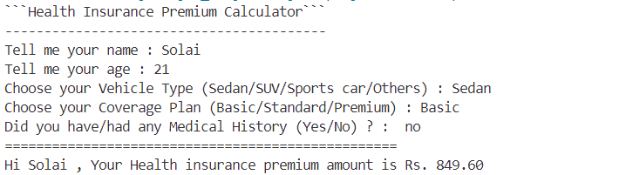

**Health Diagnosis System**

**Code :**

import java.util.*;

class HealthDiagnosis {

private static final Map<String, Integer> symptomRisk = new HashMap<>();

// Initialize some risk scores for symptoms

static {

symptomRisk.put("fever", 20);

symptomRisk.put("cough", 15);

symptomRisk.put("headache", 10);

symptomRisk.put("fatigue", 25);

symptomRisk.put("chest pain", 30);

symptomRisk.put("shortness of breath", 35);

symptomRisk.put("nausea", 15);

symptomRisk.put("dizziness", 20);

}

public double analyzeSymptoms(String[] symptoms, int age, boolean hasChronicDisease, boolean hasFamilyHistory) {

int riskScore = 0;

for (String symptom : symptoms) {

riskScore += symptomRisk.getOrDefault(symptom.toLowerCase(), 5); // Default low risk

}

// Adjust based on age

if (age > 60) {

riskScore += 20;

} else if (age < 18) {

riskScore += 10;

}

// Increase risk if patient has chronic disease

if (hasChronicDisease) {

riskScore += 25;

}

// Increase risk if there is a family history of disease

if (hasFamilyHistory) {

riskScore += 15;

}

// Normalize risk score to a probability percentage

return Math.min(100, riskScore);

}

}

public class HealthDiagnosisSystem {

public static void main(String[] args) {

Scanner scanner = new Scanner(System.in);

HealthDiagnosis diagnosis = new HealthDiagnosis();

System.out.println("Enter your age:");

int age = scanner.nextInt();

scanner.nextLine(); // Consume newline

System.out.println("Do you have a chronic disease? (yes/no):");

boolean hasChronicDisease = scanner.nextLine().equalsIgnoreCase("yes");

System.out.println("Do you have a family history of disease? (yes/no):");

boolean hasFamilyHistory = scanner.nextLine().equalsIgnoreCase("yes");

System.out.println("Enter your symptoms separated by commas:");

String[] symptoms = scanner.nextLine().split(",");

double probability = diagnosis.analyzeSymptoms(symptoms, age, hasChronicDisease, hasFamilyHistory);

System.out.println("Computed Health Risk: " + probability + "% chance of disease.");

scanner.close();

}

}

**Output :**

