Huq2Chess: Manual Test Plan

To Begin, start by running Main from ChessGUI, this should build the GUI for the board, as well as

Two panels for a each player, as displayed below.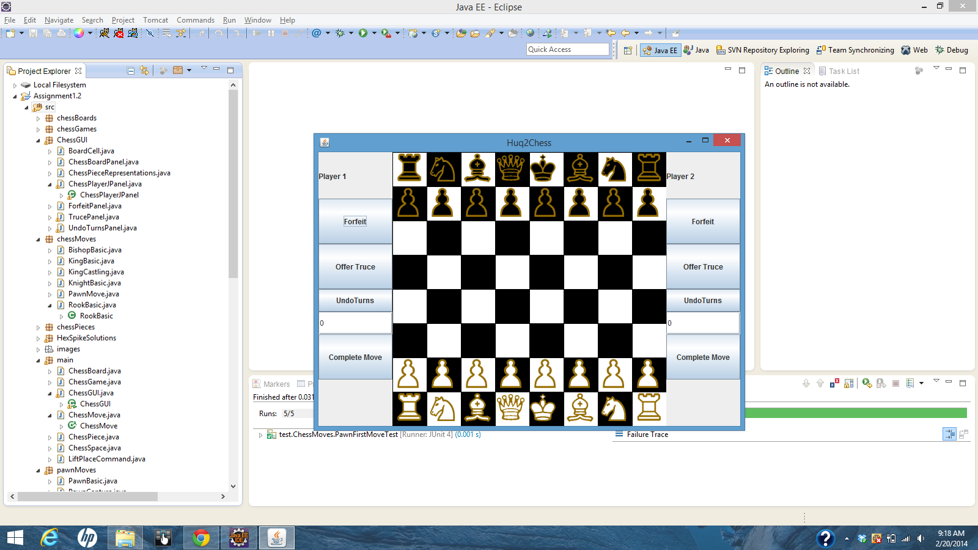

As not everything has been implemented, it is expected that many of the displayed features will do little.

Follow the next sequences for what has been implemented:

ChessBoardGUI

To begin, click on the rightmost white pawn, its move spaces should be highlighted as shown below

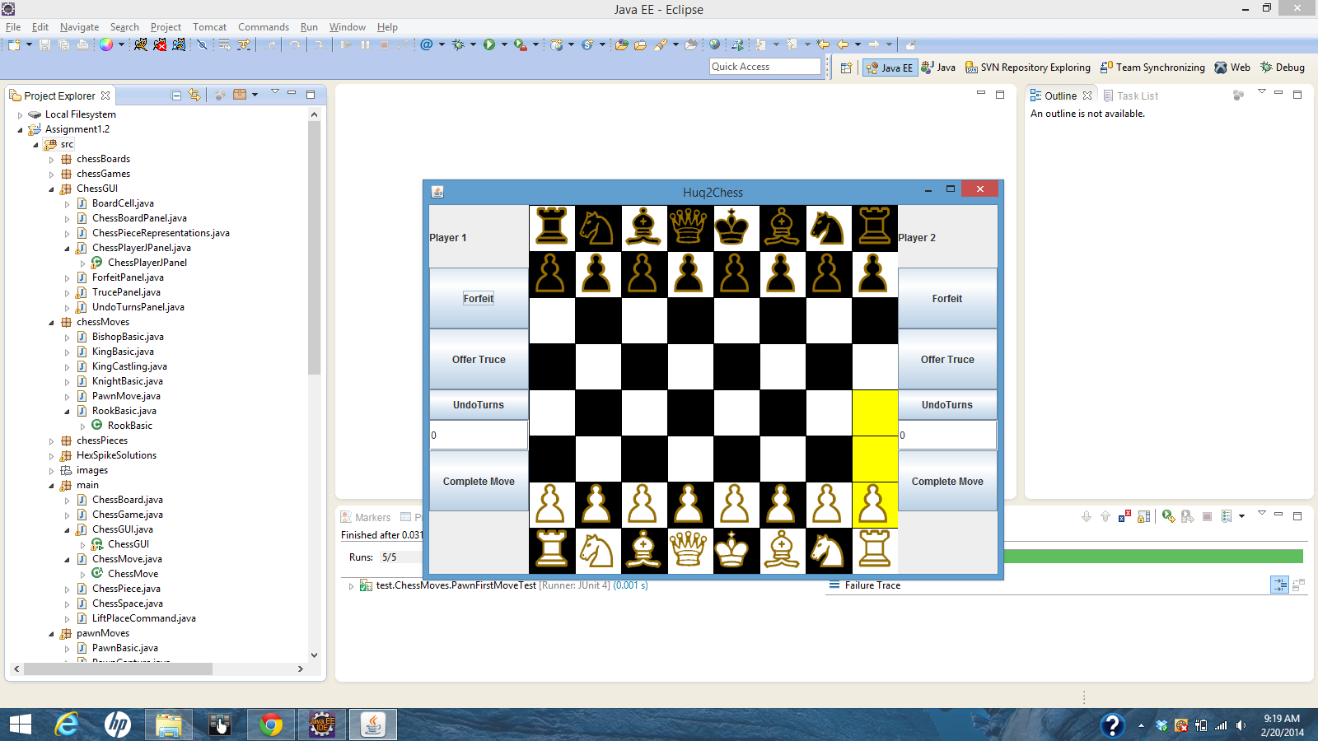

Try clicking on the pawn itself, or any space that is not highlighted, this should clear the highlighted spaces and nothing else; no move was performed and it is still white’s move. Click on the Pawn again to highlight its move spaces.

Finally, click on the topmost highlighted space. The Pawn should move, as displayed below

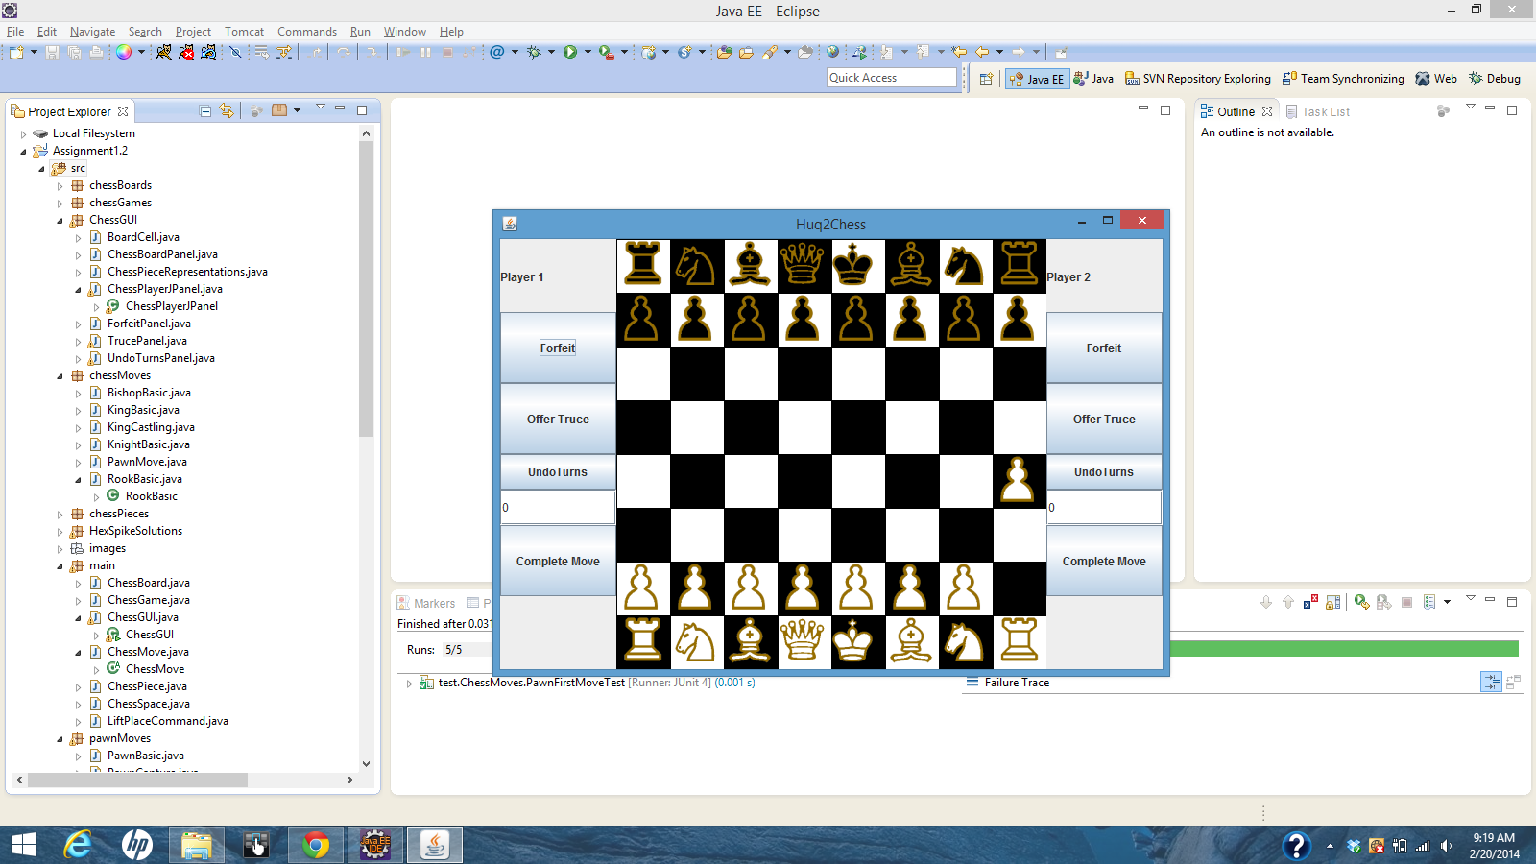

If we get this far, basic movement has been assured. And it is now Black’s turn. Try clicking on a white any white piece. What is seen should still match the screen above. Turn logic is now assured

next, first move the 2nd rightmost black pawn to the shown location, and then the 3rd rightmost white piece after. Click on the black pawn. What is seen should match the image below.

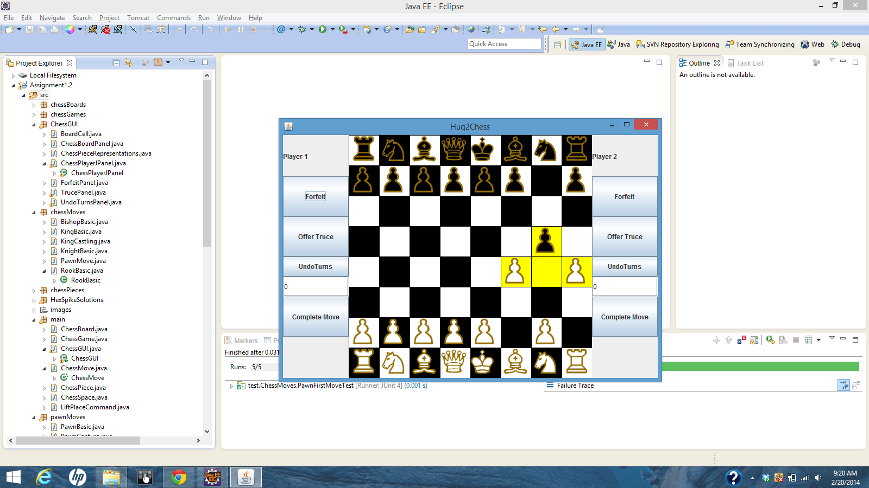

Click on the rightmost white pawn to “capture” it. The black pawn should take its place. Finally, click on the rightmost white rook. If what is seen matches what is below, then capturing logic is assured.

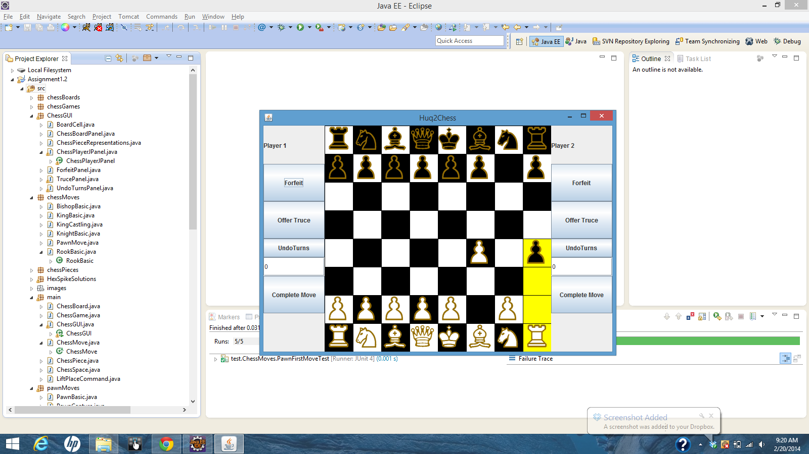

Get the pieces to match those shown below by

1. Capturing the pawn at (8,4) with rook at (8,0) 2. Moving pawn at (5,7) to (5, 5)

3. moving rook at (8,0) to (8, 6), and finally 4. moving queen at (4,8) to (8,4)

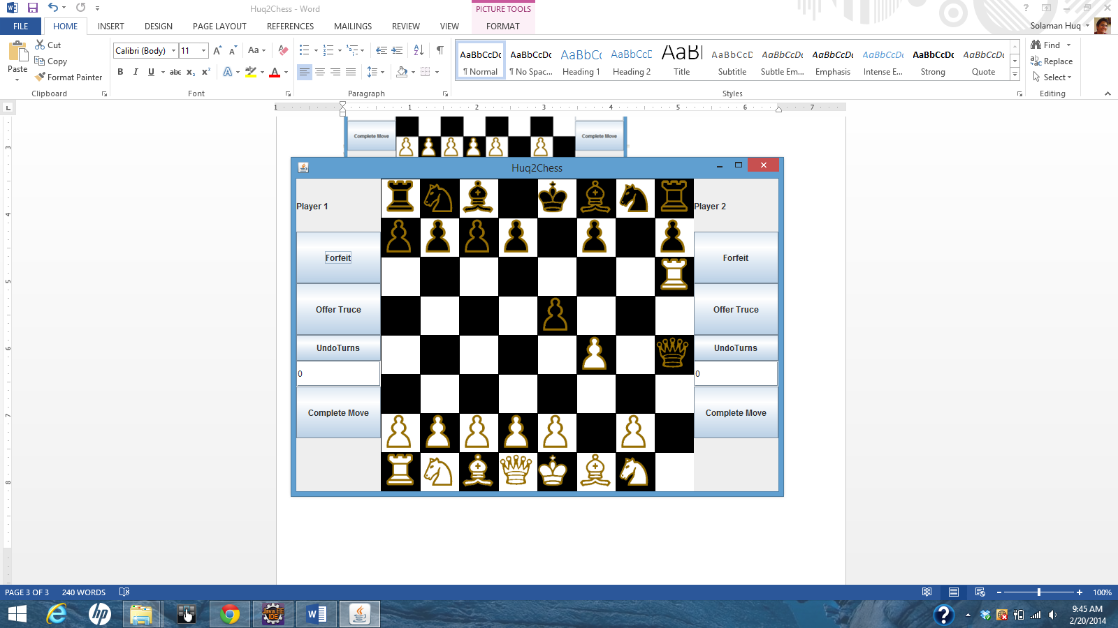

Try moving the leftmost white pawn, or the leftmost white knight. After each attempt, what is seen should match the previous Image. This assures Check logic.

UNDO:

Set a two arbitrary moves. You may do as is below

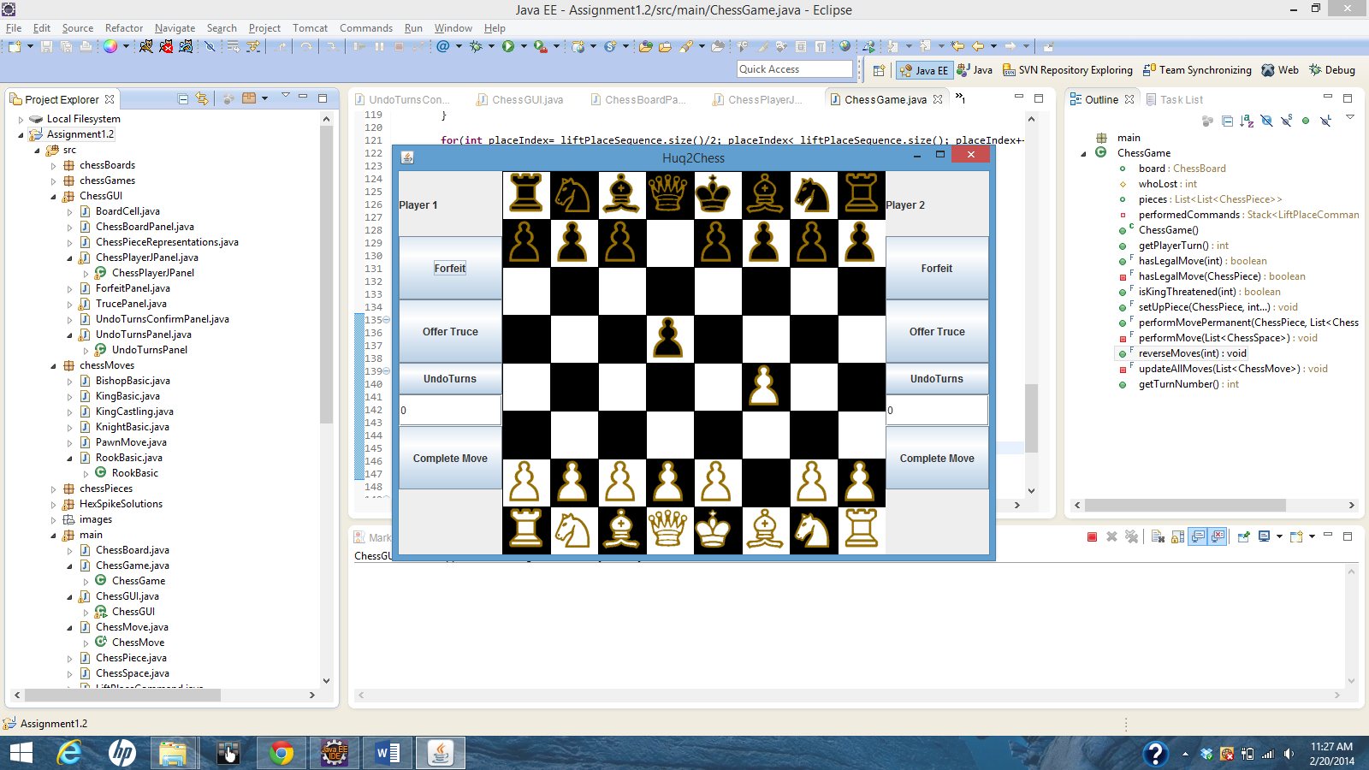

Select either the player 1 or player 2 side, below the “undoTurns” button type in “1” and press the button. A window very similar to the one below should appear.

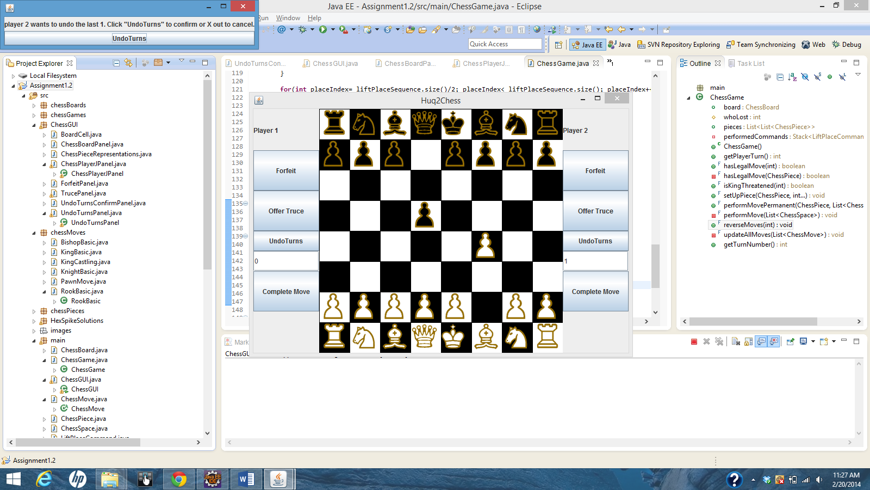

Press “undoTurns” in the window. The two moves you made previously should be undone sequentially.

Next, set up an arbitrary two moves again, but this time type “2” under a “undoTurns” button and press the button.

Exit out the window that appears. Nothing should occur. Press “undoTurns” for the button with the text “2” and press enter.

Press enter on the window that appears. Both moves should be undone simultaneously. This asserts the Undo Turn Logic.