**CURRICULAM VITAE**

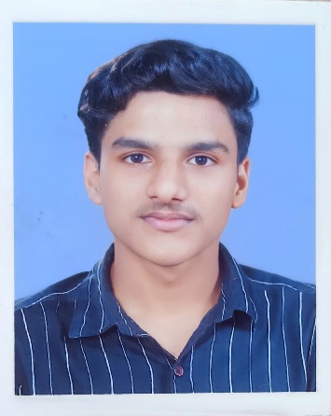**GOKUL SUBASH**

Thazhutheveetil House,

Kothamangalam P.O

Ramalloor – 686691

Kerala, INDIA

Mob. +91 7736229627/ 9446459627

Email: gokuls2k3@gmail.com

**PERSONAL PROFILE**

Name : GOKUL SUBASH

Father’s Name : SUBASH TT

Date of Birth : 14.05.2003

Age : 18

Gender : Male

Marital Status : Single

Permanent Address : Thazhutheveetil House,

Kothamangalam P.O

Ramalloor

Ernakulam District,

Kerala, INDIA

PIN – 686691

Religion : Hindu

Nationality : Indian

Language known : English, Malayalam & Hindi

**CAREER OBJECTIVE**

To work in a challenging ambience where I can contribute to my full potential and develop my career

**EDUCATIONAL QUALIFICATIONS**

|  |  |  |  |  |
| --- | --- | --- | --- | --- |
| COURSE | NAME OF INSTITUTION | BOARD / UNIVERSITY | YEAR OF PASSING | MARKS |
| PLUS TWO | St Stephens HSS , Keerampara | Kerala Board | 2021 | 95.25% |
| S.S.L.C | Bes – Ania public school Chelad | Central Board | 2019 | 89.4% |

**PASSPORT DETAILS**

Passport Number : V2851635

Place of issue : Cochin

Date of Issue : 11.10.2021

Date of Expiry : 10.10.2031

**REFERENCE**

Name : Sijo Jacob

Designation : Class Teacher, XII B

St Stephens H.S.S,

Keerampara, Kothamangalam – 686681

Mobile No. : +91 9447664842

Email : [sijojacub@gmail.com](mailto:sijojacub@gmail.com)

**Extra Curricular activities**

Dancing, Writing, Swimming

**DECLARATION**

I hereby declare that all the above information is true and correct to the best of my knowledge and belief.

Place : Ramalloor

Date : 24.04.2022

GOKUL SUBASH