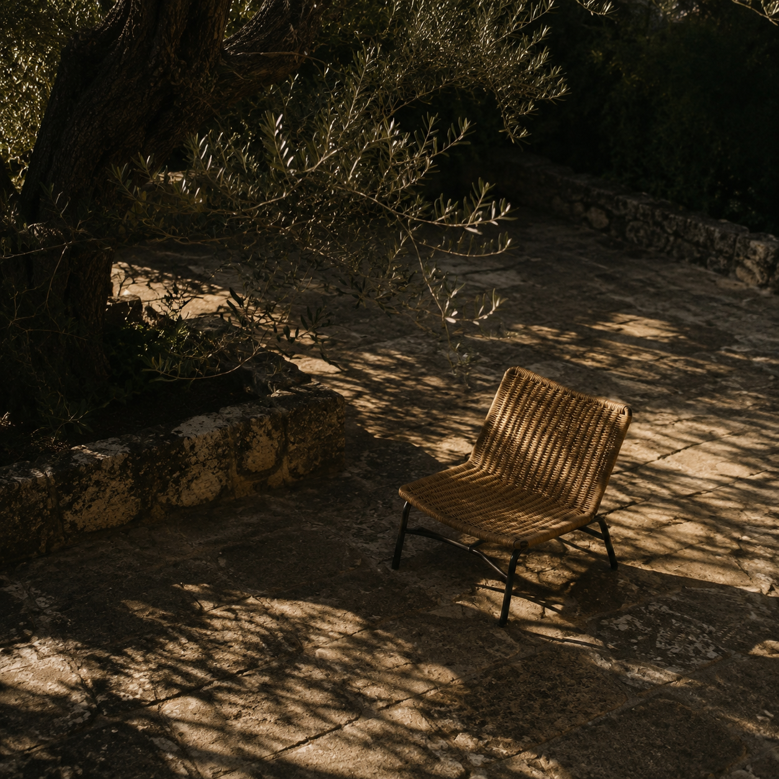

Website design report
Heekmah Group: design, CMS and production handoff |  | Prepared for Heekmah Group  August 2026

Contents

Executive summary 2
At a glance 2
Introduction 2
Key findings 3
Context and conditions 3
Patterns in the evidence 3
Implications 3
Recommendations 4
Conclusion 4
Appendix 5
Notes 5
Publishing checklist 5

Executive summary
The rebuilt Heekmah Group website is now a Nuxt public experience backed by WordPress as the content-management system. It removes the fragile Elementor and paid-theme dependency while retaining the existing media library, brand logo and recognizable deep green.
The design gives visitors a clear path from understanding the group and its companies to exploring services, reading updates and making an enquiry. Structured sections keep every page editable without allowing routine content changes to break typography, spacing, responsiveness or motion.

At a glance
- Content. Editors manage structured page sections in Heekmah Content and publish articles through normal WordPress Posts.
- Experience. The interface is mobile-first, accessible and responsive, with image-specific slider captions and System, Light and Dark themes.
- Delivery. The production site is live on cPanel; the final mobile audit scored 98 Performance and 100 for Accessibility, Best Practices and SEO.

Introduction
The public domain serves generated Nuxt HTML, images and client-side interactions. WordPress remains the private editorial source for page copy, media, posts and editable SEO text.
Existing content changes normally appear after the short cache window. New or removed posts, slug changes, sitemap changes and crawler-ready SEO updates require a release so the generated route set remains complete.

Key findings
The interface audit focused on information hierarchy, mobile legibility, image handling, theme behavior, touch targets and restrained motion. It also checked that the CMS contract supports daily editing without reintroducing layout fragility.

Context and conditions
The former WordPress presentation layer coupled content to a paid theme and Elementor. The new split keeps WordPress for familiar editorial work while Nuxt owns the public markup, navigation, responsive layout and technical SEO.

Patterns in the evidence
Pages now explain what Heekmah does before asking for action. Company and product evidence appears ahead of conversion panels; slider text describes the visible scene; page heroes use controlled image crops; separators exist only between items, never after the last item.

Key takeaway. A stable component system, not a page builder, now protects the visual quality. Editors change the substance; Nuxt preserves hierarchy, spacing, responsive behavior and accessible interactions.

Implications
The operating model is clear, but it depends on keeping content, routes and enquiries within their intended responsibilities.
Theme | Observation | Implication
Content | Structured sections and Posts have separate editorial roles. | Pages stay consistent; new post routes still need a release.
Interface | Shared components control imagery, motion, themes and controls. | Mobile and accessibility behavior remains predictable.
Operations | Nuxt renders SEO; WordPress supplies content and receives enquiries. | Avoid duplicate SEO plugins and review stored enquiries.

Recommendations
Keep the design system stable by treating WordPress as the source of truth for content and Nuxt as the renderer. The following routine protects both editorial freedom and production quality.
- Edit through the intended screen. Use Heekmah Content for structured pages, Site settings and policies; use normal WordPress Posts for the blog. Preserve locked IDs and enquiry values.
- Publish images with context. Choose media-library assets, add accurate alternative text, keep slider titles short and scene-specific, and preview the crop on a phone before saving.
- Release when the route set changes. Allow the short cache window for ordinary edits. Run the cPanel release workflow for new, removed or renamed posts, sitemap changes, or immediately crawler-visible SEO.

Conclusion
The site now separates content ownership from presentation responsibility. Heekmah's team can improve the substance of every page without rebuilding the layout or returning to Elementor.
The strongest long-term result will come from concise editorial choices, accurate imagery, periodic enquiry cleanup and disciplined release checks when URLs or public metadata change.

Appendix

Notes
Edit pages under WordPress > Heekmah Content. Edit news and articles under Posts. The homepage slider is under Home page > Hero > Slides; four reviewed slides are the recommended set.
WordPress owns editable titles, descriptions, page sections, posts and media. Nuxt owns public canonicals, Open Graph tags, structured data, robots rules, the sitemap, responsive behavior and theme modes.

Publishing checklist
- Preview edited pages on phone and desktop in System, Light and Dark mode.
- Check headings, actions, image crops, alternative text and last-item separators.
- After mail changes, submit a test enquiry and verify the stored record and email status.
- Run pnpm release:cpanel when posts or slugs are added, removed or changed, or when search-facing HTML must update immediately.

Release status. Production is live from commit 53780e1. Automated tests, type-checking, strict CMS validation, generation and SEO audit passed; the final mobile PageSpeed audit recorded 98/100/100/100.

