Nodejs官网<https://nodejs.org/en/>

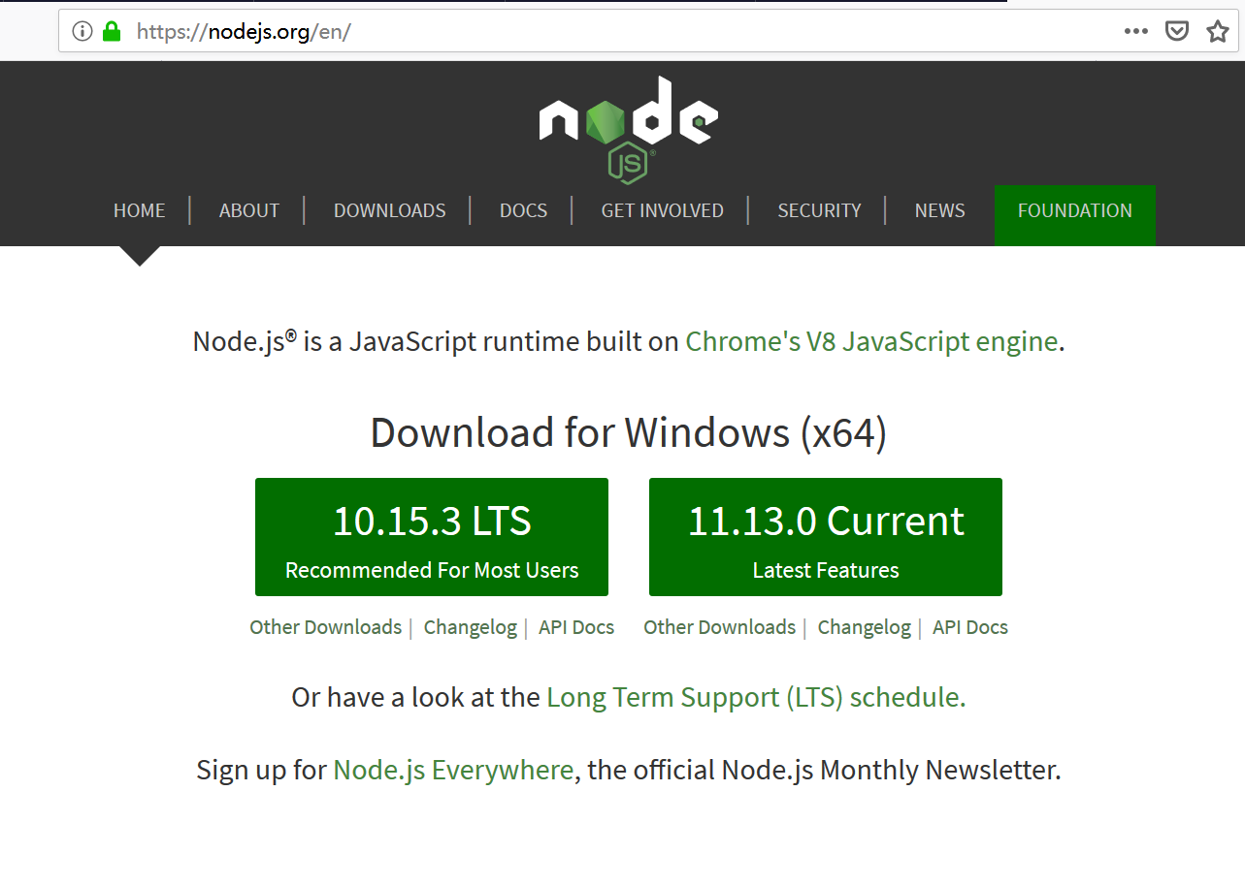

node –v

npm –v

node package manager

open source -> dependencies -> download automatically

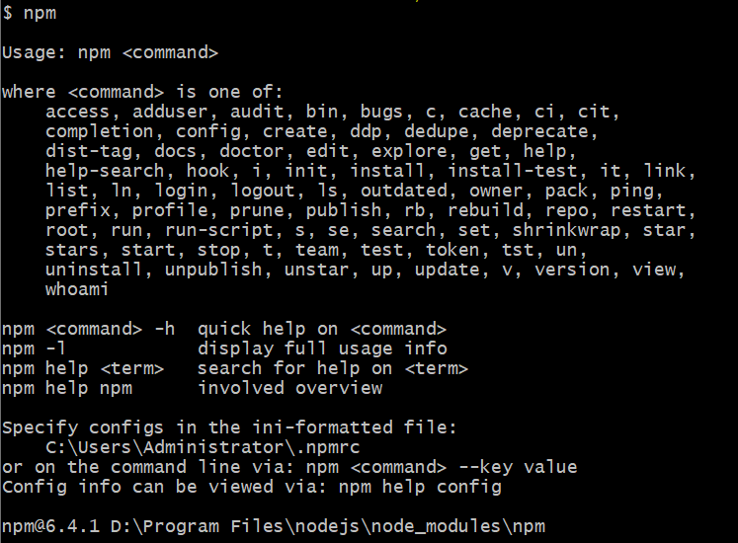

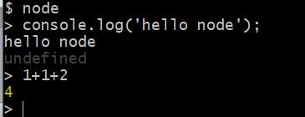

IDE: Visual Studio Code

<https://code.visualstudio.com/>

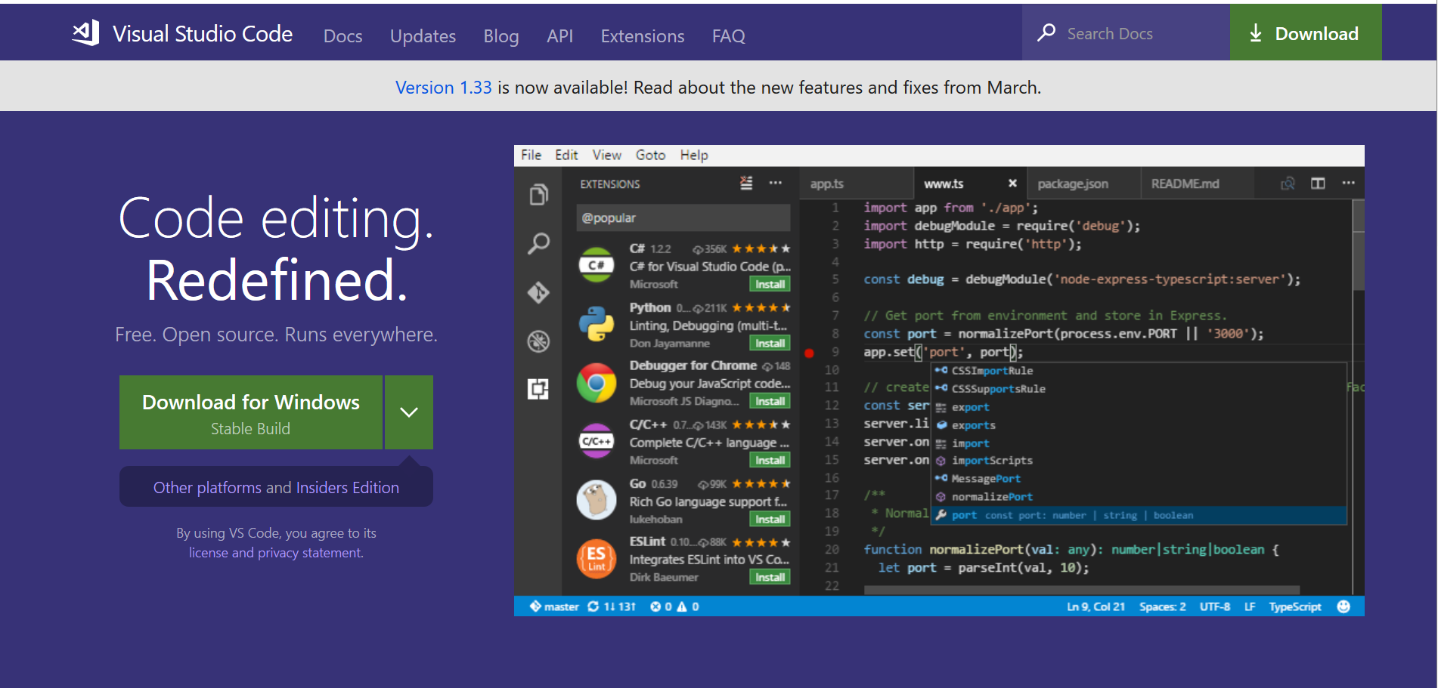

Install:

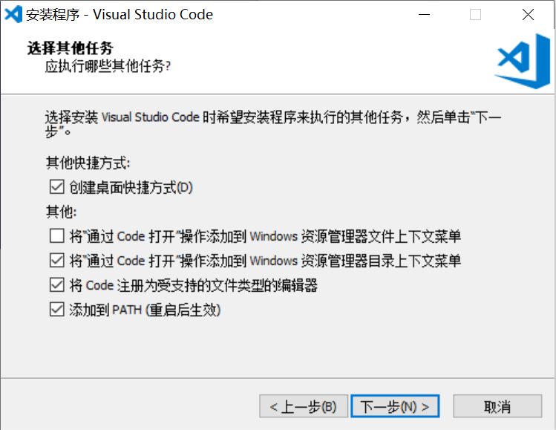

npm install -g create-react-app

<https://github.com/facebook/create-react-app>

Github:

<https://github.com/>

Git command line:

<https://git-scm.com/>

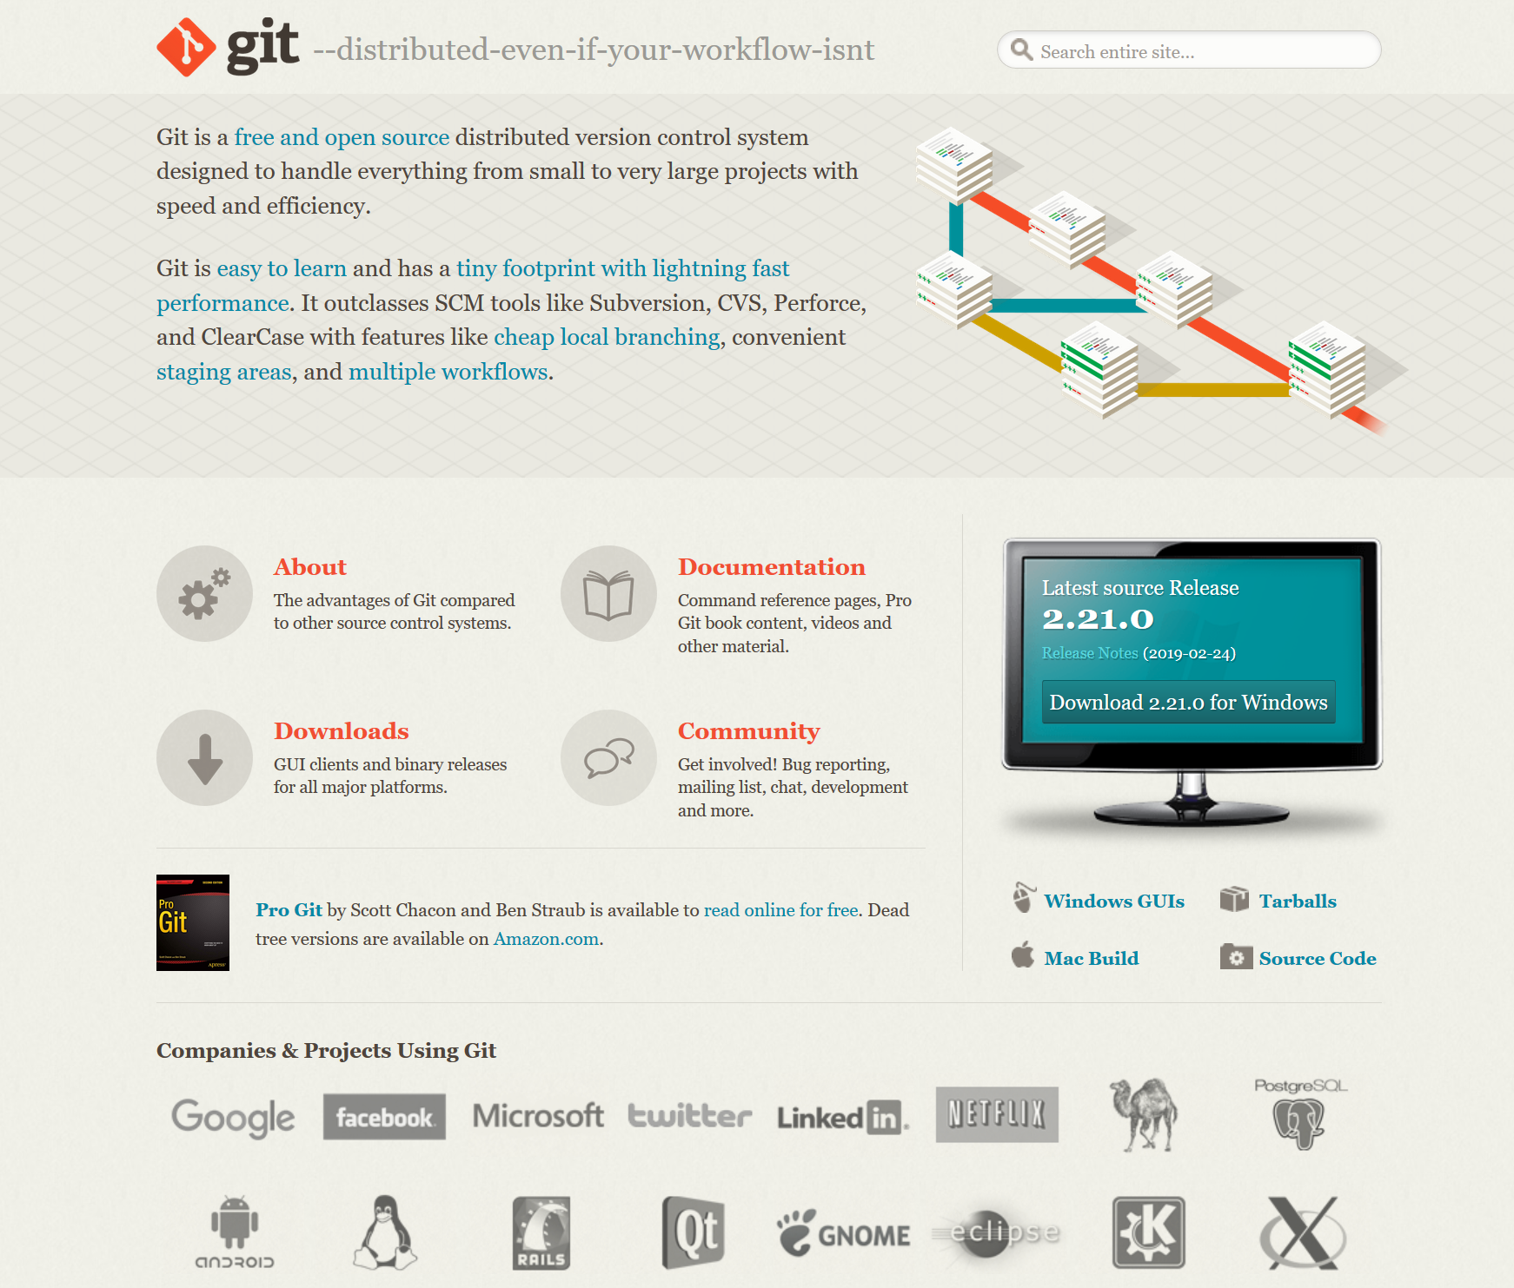

Git desktop client:

<https://desktop.github.com/>

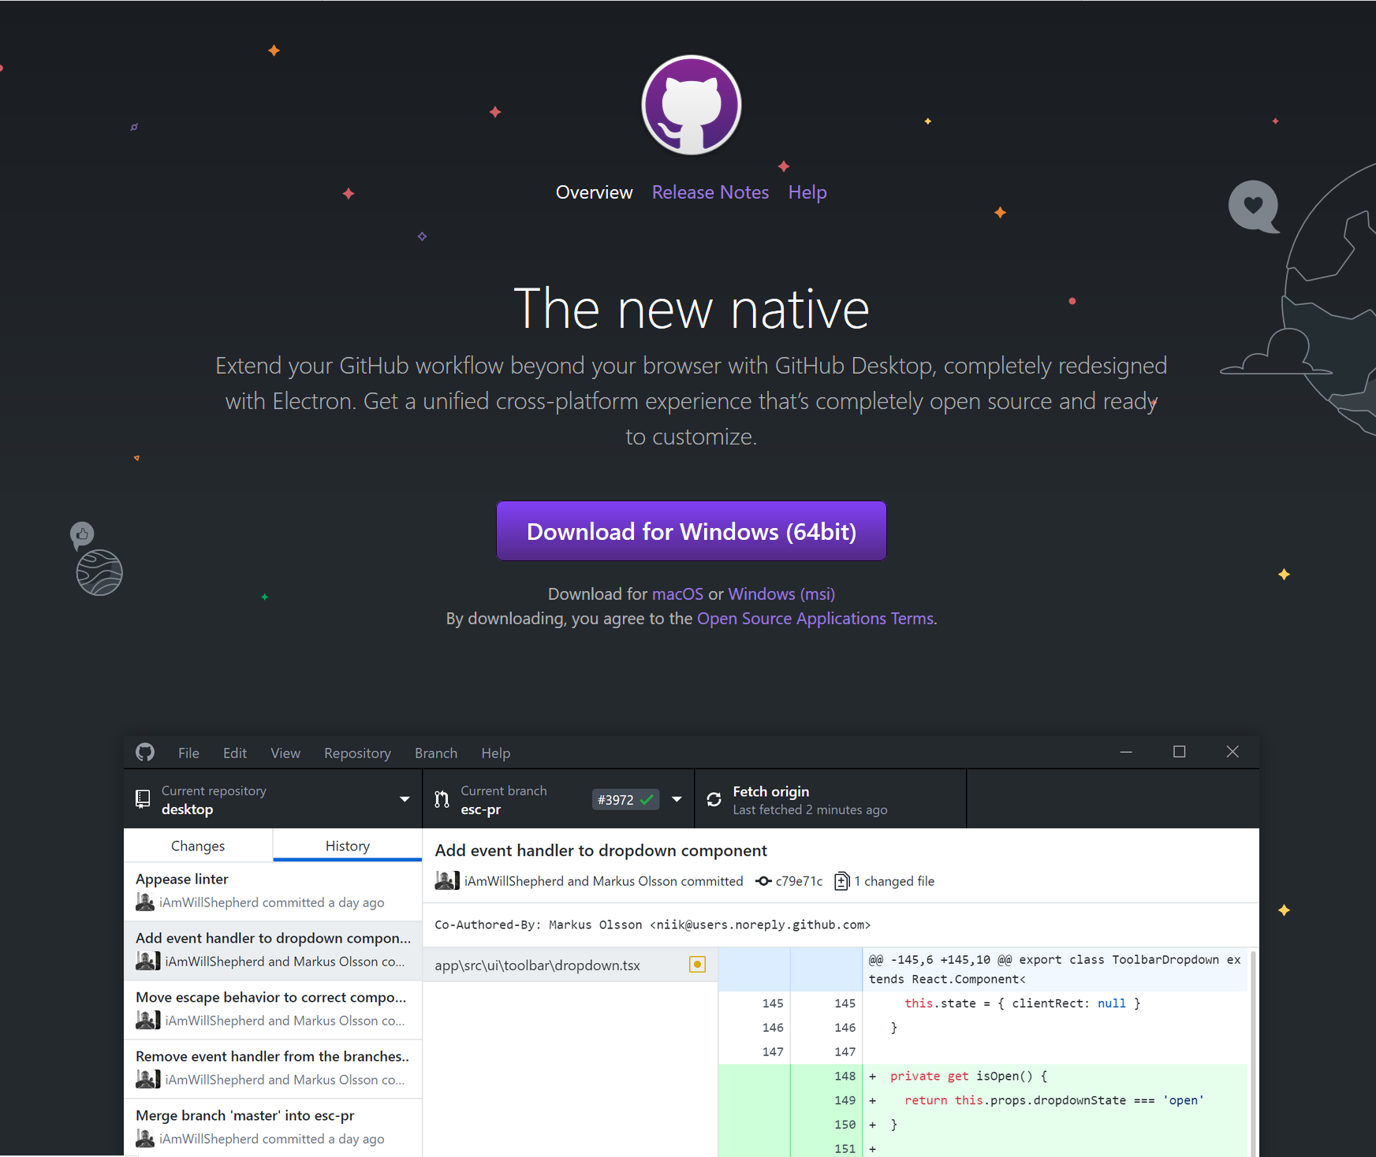

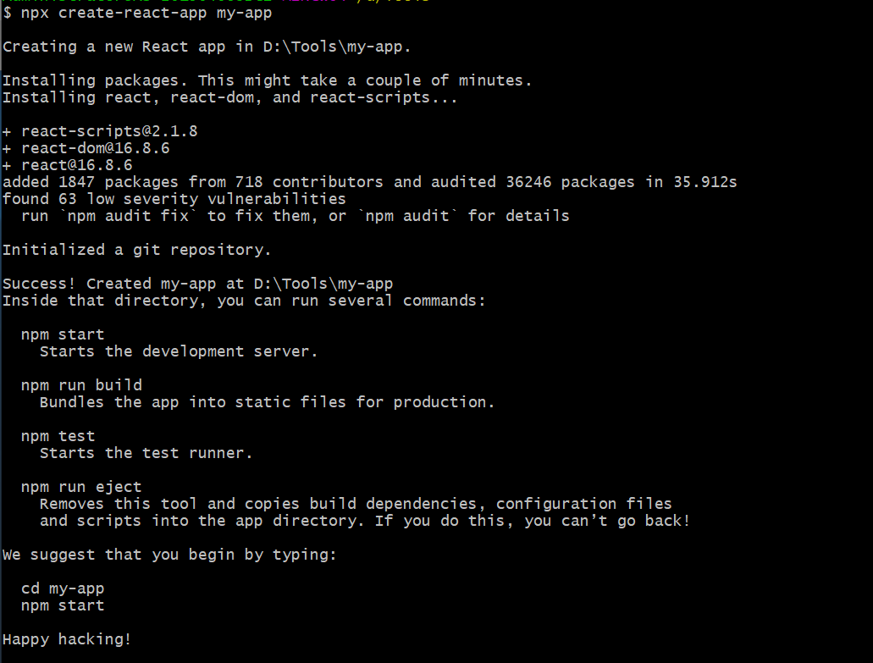

Npm add antd

npm add react-highlight-words

1. this.props.dispatch({
2. type: 'updateState',
3. payload: {
4. childTree: ref
5. }
6. onRef = (ref) => {
7. this.drawer = ref
8. }
9. openPanel = (e) => {
10. this.drawer.showDrawer()
11. }
12. <RecipeDrawer onRef={r => this.drawer = r} />

npm install --save react-loadable

npm install --save react-router-dom