REPUBLIC OF THE PHILIPPINES
POLYTECHNIC UNIVERSITY OF THE PHILIPPINES
OFFICE OF THE VICE PRESIDENT FOR CAMPUSES
PARANAQUE CITY CAMPUS
PUP Paranaque Campus, Col. E de Leon St. Wawa,
Brgy. Sto. Nino, Paranaque City
Direct line: (02) 8553 8623 | Website: www.pup.edu.ph |
Email: paranaque@pup.edu.ph
A LEADING COMPREHENSIVE
POLYTECHNIC UNIVERSITY IN ASIA
M O D U L E 1
Laboratory Activities
Installing Testing Tools & Creating Sample Test Documentation
Introduction to Software Testing
[Your Full Name]
BSIT 3-1
IT Elective 3
System Under Test: Bayport Veterinary Clinic Management System (VCMS)

REPUBLIC OF THE PHILIPPINES
POLYTECHNIC UNIVERSITY OF THE PHILIPPINES
OFFICE OF THE VICE PRESIDENT FOR CAMPUSES
PARANAQUE CITY CAMPUS
PUP Paranaque Campus, Col. E de Leon St. Wawa,
Brgy. Sto. Nino, Paranaque City
Direct line: (02) 8553 8623 | Website: www.pup.edu.ph |
Email: paranaque@pup.edu.ph
A LEADING COMPREHENSIVE
POLYTECHNIC UNIVERSITY IN ASIA
Part 1 — Installing Testing Tools
Install one tool from each category below. For each tool, capture a screenshot showing a successful installation or version check. These screenshots make up the submission for this part.
1. Functional / Manual Testing — Postman
A GET request was sent to https://jsonplaceholder.typicode.com/posts/1 and a 200 OK response was received.
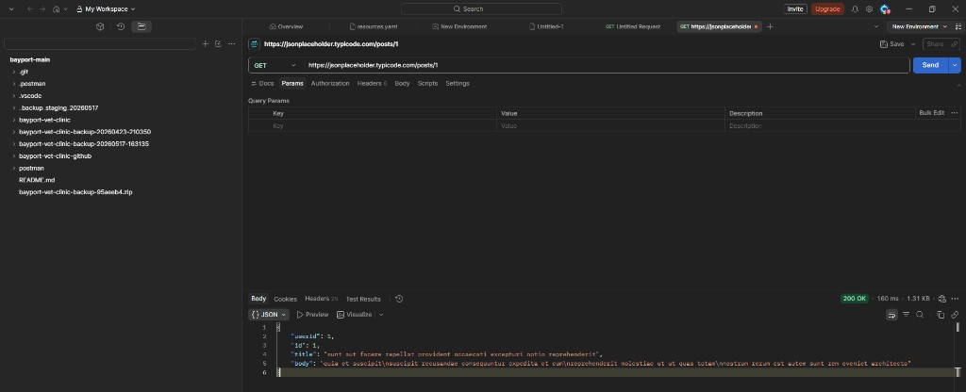
Figure 1. Postman GET request with 200 OK response
2. Test Management — Zephyr
Zephyr was installed in Jira and a test case named "Bayport Module 1 Functional Cycle" was created.
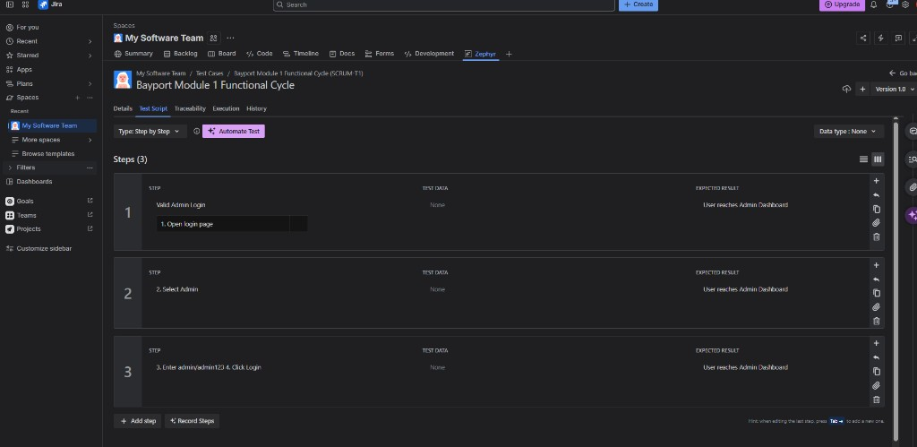
Figure 2. Zephyr test case with test script steps
3. Unit Testing — PyTest
PyTest was installed and test_example.py was executed successfully with 1 passed result.
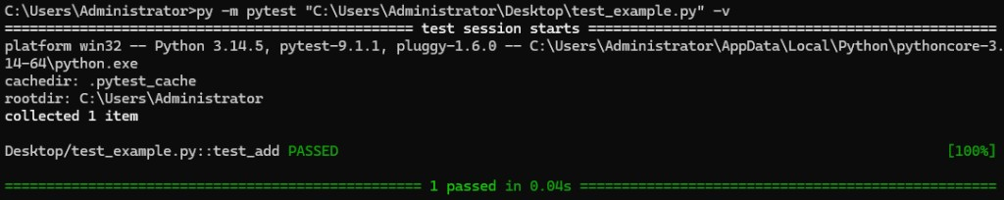
Figure 3. PyTest execution showing 1 passed
4. Defect Tracking — Jira
A Jira project was created and a sample issue "Front Office user can attempt direct access to Consultations & Rx" (SCRUM-6) was logged in the backlog.
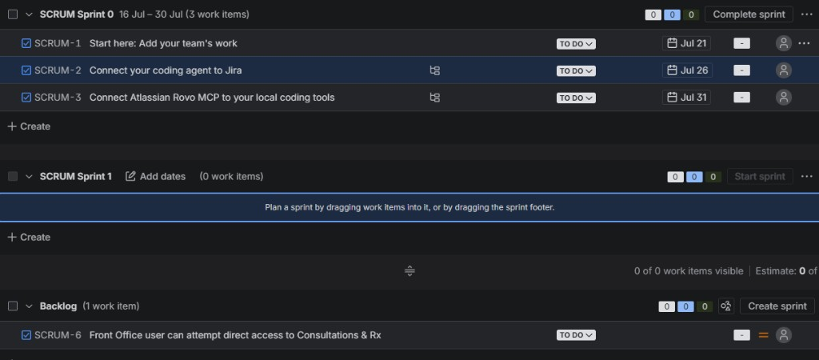
Figure 4. Jira backlog showing created sample issue
Deliverable: A short screenshot log — one screenshot per tool (four total) — showing each tool successfully installed and verified.

REPUBLIC OF THE PHILIPPINES
POLYTECHNIC UNIVERSITY OF THE PHILIPPINES
OFFICE OF THE VICE PRESIDENT FOR CAMPUSES
PARANAQUE CITY CAMPUS
PUP Paranaque Campus, Col. E de Leon St. Wawa,
Brgy. Sto. Nino, Paranaque City
Direct line: (02) 8553 8623 | Website: www.pup.edu.ph |
Email: paranaque@pup.edu.ph
A LEADING COMPREHENSIVE
POLYTECHNIC UNIVERSITY IN ASIA
Part 2 — Creating Sample Test Documentation
Using the STLC phases from lecture, three documents were produced for the Bayport Veterinary Clinic Management System (VCMS). Together these artifacts form the lab submission for this part.
1. Test Plan (per IEEE 829)
Project / System: Bayport Veterinary Clinic Management System (VCMS)
1.1 Scope
What will be tested
- User Authentication (valid login, invalid password, empty fields)
- Pet Profiles — create and view a pet record
- Appointments — schedule and cancel
- Role-Based Access Control — Front Office vs Consultations & Rx
What will not be tested
- Load, stress, and performance testing
- Mobile application testing
- Penetration testing / security certification
- Production cloud hosting infrastructure
1.2 Objectives
Verify that Bayport VCMS login and selected clinic workflows behave correctly under normal, boundary, and invalid inputs before further deployment.
1.3 Test Approach / Strategy
A primarily manual functional testing approach was used. Manual testing fits this lab because Bayport is a multi-page clinic UI with role-based navigation. PyTest was used to verify the unit testing toolchain; Postman was used for API smoke checks.
1.4 Resources Needed
- Student / QA Tester — writes and executes test cases
- Windows 11, Chrome/Edge, Java 17+, Maven, Spring Boot backend
- Postman, Zephyr, PyTest, Jira
- Seeded accounts: admin/admin123, vet/vet123, frontdesk/frontdesk123
1.5 Schedule
Milestone | Target
Test planning & environment ready | Day 1
Test case preparation | Day 1–2
Test execution | Day 2–3
Defect logging & retest | Day 3
Test summary report & submission | Day 4
1.6 Entry and Exit Criteria
Entry: backend/UI reachable, seeded accounts available, test cases reviewed. Exit: all planned test cases executed, results recorded, summary report complete.

REPUBLIC OF THE PHILIPPINES
POLYTECHNIC UNIVERSITY OF THE PHILIPPINES
OFFICE OF THE VICE PRESIDENT FOR CAMPUSES
PARANAQUE CITY CAMPUS
PUP Paranaque Campus, Col. E de Leon St. Wawa,
Brgy. Sto. Nino, Paranaque City
Direct line: (02) 8553 8623 | Website: www.pup.edu.ph |
Email: paranaque@pup.edu.ph
A LEADING COMPREHENSIVE
POLYTECHNIC UNIVERSITY IN ASIA
2. Test Case Document
Six test cases covering normal, boundary, and invalid inputs. Actual Result and Status were recorded during execution against Bayport VCMS.
Test Case ID | Description | Preconditions | Steps | Expected Result | Actual Result | Status
TC_001 | Valid Admin login with correct credentials (normal) | Admin account exists (admin / admin123) | 1. Open login page  2. Select Admin role  3. Enter valid credentials  4. Click Login | User is redirected to the Dashboard with Admin sidebar | Dashboard displayed; Admin modules visible | Pass
TC_002 | Login with incorrect password (invalid) | User account exists | 1. Open login page  2. Select role  3. Enter valid username, wrong password  4. Click Login | Error message indicating invalid credentials | Correct error / rejection shown | Pass
TC_003 | Login with empty fields (boundary / invalid) | None | 1. Open login page  2. Leave fields blank  3. Click Login | Validation message prompts for required fields | Required-field validation displayed | Pass
TC_004 | Create a new Pet Profile (normal) | Front Office or Admin logged in | 1. Open Pet profiles  2. Click Add Pet  3. Fill required fields  4. Save | Pet record is saved and appears in the list/grid | Pet profile created successfully | Pass
TC_005 | Schedule appointment then cancel (normal) | Pet exists; staff logged in | 1. Open Appointments  2. Create appointment  3. Save  4. Cancel appointment | Appointment is created, then status becomes Cancelled | Create and cancel both succeeded | Pass
TC_006 | Front Office blocked from Consultations & Rx (RBAC) | Front Office logged in (frontdesk / frontdesk123) | 1. Login as Front Office  2. Check sidebar for Consultations & Rx | Module not available / access denied | Front Office cannot access Consultations & Rx | Pass
Supporting execution evidence:
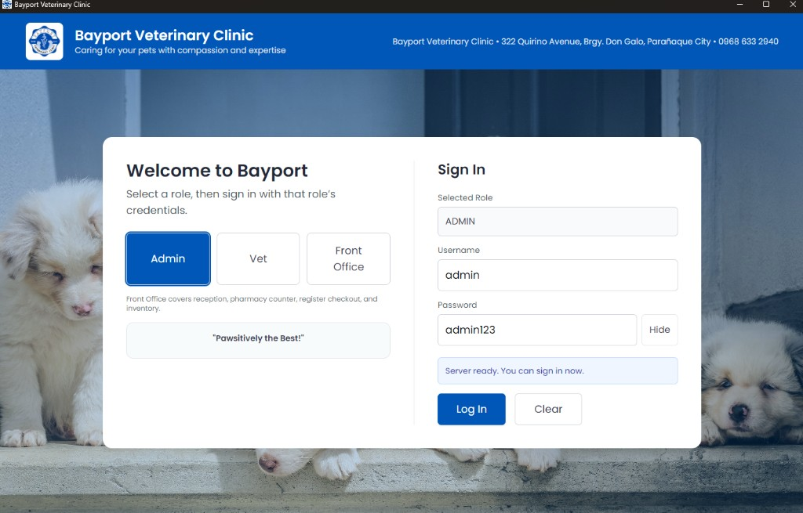
Figure 5. Bayport Admin login screen
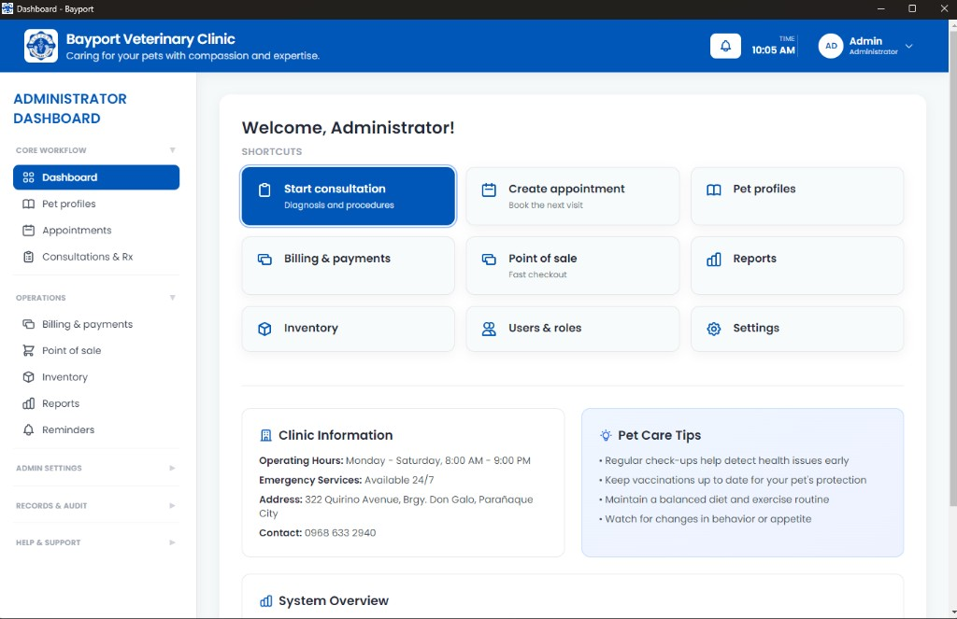
Figure 6. Administrator Dashboard after login
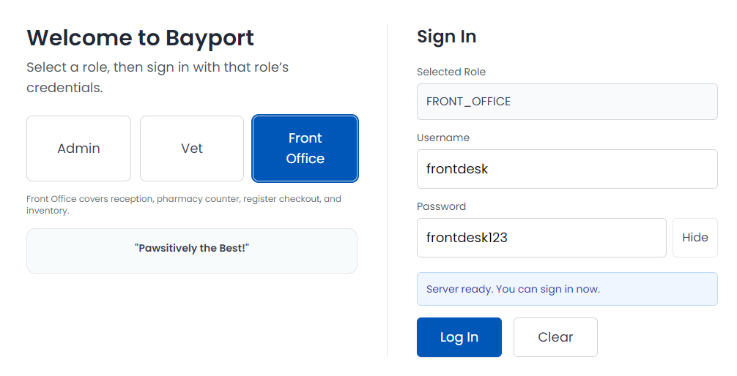
Figure 7. Bayport Front Office login screen
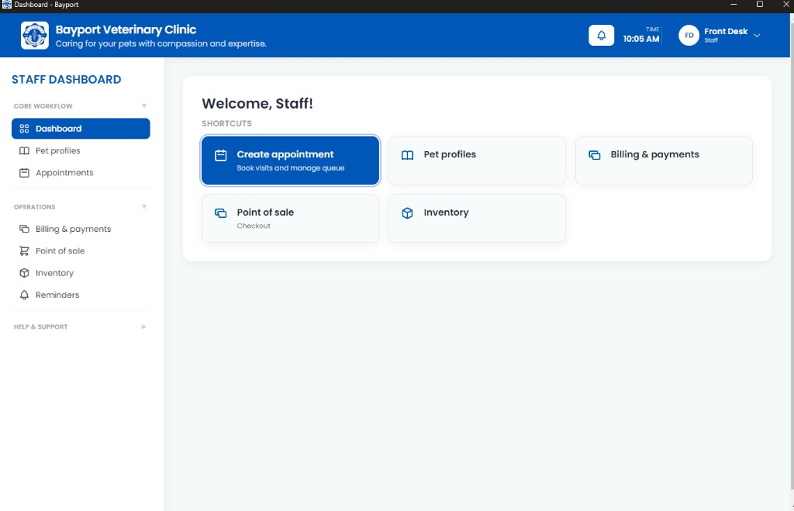
Figure 8. Staff Dashboard (Front Office role)

REPUBLIC OF THE PHILIPPINES
POLYTECHNIC UNIVERSITY OF THE PHILIPPINES
OFFICE OF THE VICE PRESIDENT FOR CAMPUSES
PARANAQUE CITY CAMPUS
PUP Paranaque Campus, Col. E de Leon St. Wawa,
Brgy. Sto. Nino, Paranaque City
Direct line: (02) 8553 8623 | Website: www.pup.edu.ph |
Email: paranaque@pup.edu.ph
A LEADING COMPREHENSIVE
POLYTECHNIC UNIVERSITY IN ASIA
3. Test Summary Report
Project Name: Bayport Veterinary Clinic Management System (VCMS)
Test Environment: Localhost Development Environment
Testing Type: Manual Functional Testing
Testing Date: July 16, 2026
3.1 Execution Summary
Metric | Result
Total test cases executed | 6
Passed | 6
Failed | 0
Blocked | 0
Pass rate | 100%
3.2 Defects Found
A sample defect was logged in Jira for documentation purposes (SCRUM-6). No blocking functional defects were confirmed during the executed Bayport test cases in this cycle.
Defect ID | Description | Severity | Status
SCRUM-6 | Front Office user can attempt direct access to Consultations & Rx | Medium | Logged (sample)
3.3 Coverage Achieved
Features / paths tested
- Authentication — valid, invalid password, empty fields
- Pet Profiles — create
- Appointments — create and cancel
- RBAC — Front Office vs Consultations & Rx
Features / paths not tested
- Consultations & Rx clinical workflow
- Inventory, POS, Billing, Reports, Reminders
- Load / stress / performance
- Production deployment
3.4 Retrospective
The testing process was completed successfully. Core login and role-based navigation behaved as expected for Admin and Front Office users. The Part 1 tools (Postman, Zephyr, PyTest, Jira) were installed and verified with screenshots.
Next cycle should expand coverage to Consultations & Rx, POS, and billing, and include performance testing before production deployment.
Deliverable: One document containing all three artifacts in order — Test Plan, then Test Cases, then Summary Report — based on executing test cases against the system under test.

