“real_stallman” Metadata Security Report

**Nombre de la sesión**: real_stallman

**Dominio base**: stallman.org

**URL de entrada**: https://stallman.org/civillibertiesminute/

**Nivel de peligro**: ??%

**Primera entrada BD**: 2021-04-26 15:33:42

**Última entrada BD**: 2021-04-26 15:39:53

Contenido

2 Domain Frequency 2

3 File type Frequency 3

4 Metadata Key Frequency 4

5 Metadata Values Frequency 5

# Domain Frequency

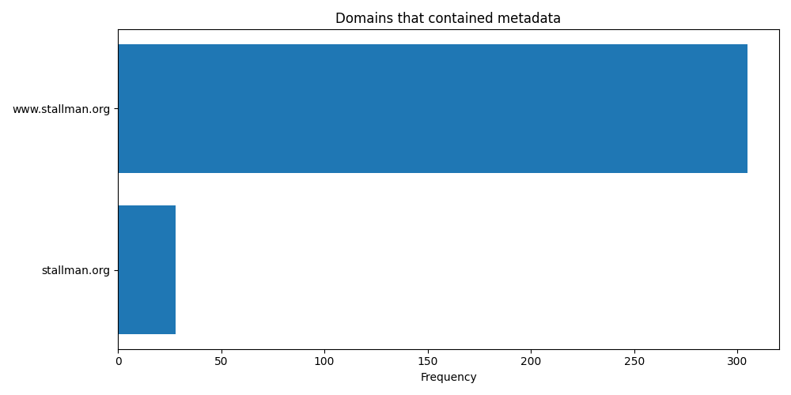

|  |  |
| --- | --- |
| Nombre de dominio | Frecuencia |
| www.stallman.org | 305 |
| stallman.org | 28 |

# File type Frequency

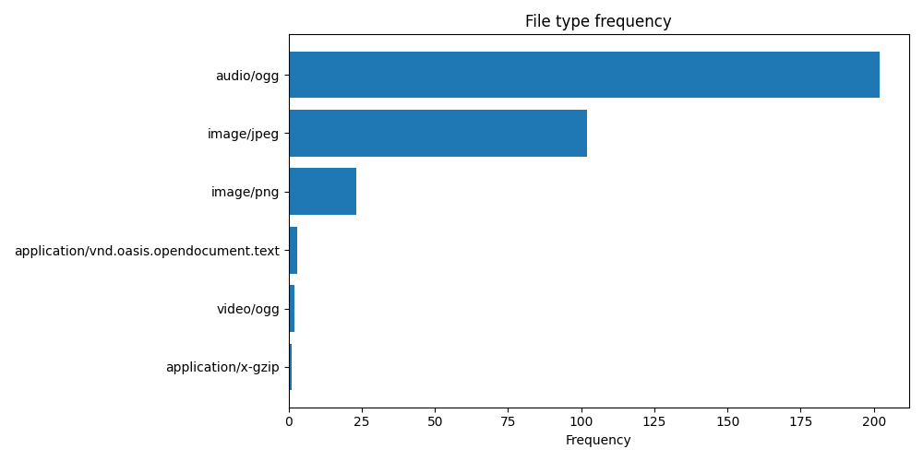

|  |  |
| --- | --- |
| Tipo de archivo | Frecuencia |
| audio/ogg | 202 |
| image/jpeg | 102 |
| image/png | 23 |
| application/vnd.oasis.opendocument.text | 3 |
| video/ogg | 2 |
| application/x-gzip | 1 |

# Metadata Key Frequency

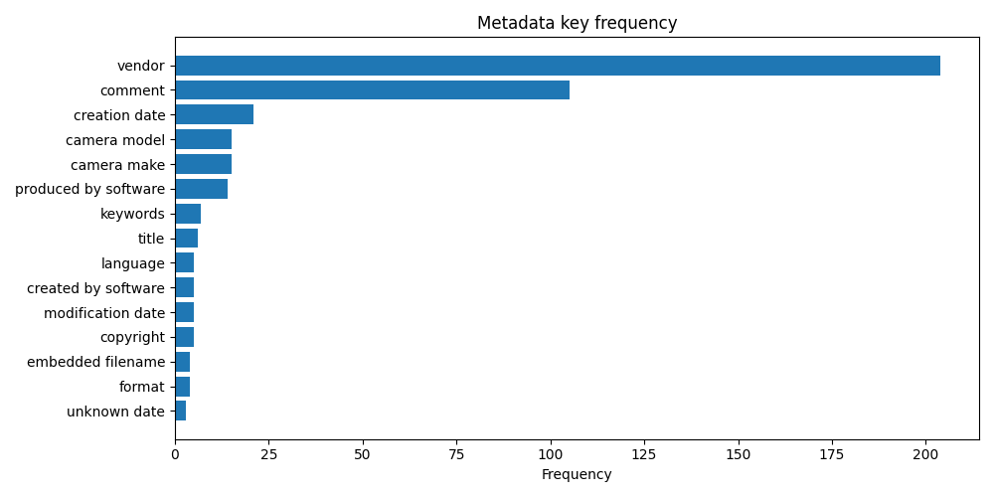

|  |  |
| --- | --- |
| Clave de metadatos | Frecuencia |
| vendor | 204 |
| comment | 105 |
| creation date | 21 |
| camera make | 15 |
| camera model | 15 |
| produced by software | 14 |
| keywords | 7 |
| title | 6 |
| copyright | 5 |
| modification date | 5 |

# Metadata Values Frequency

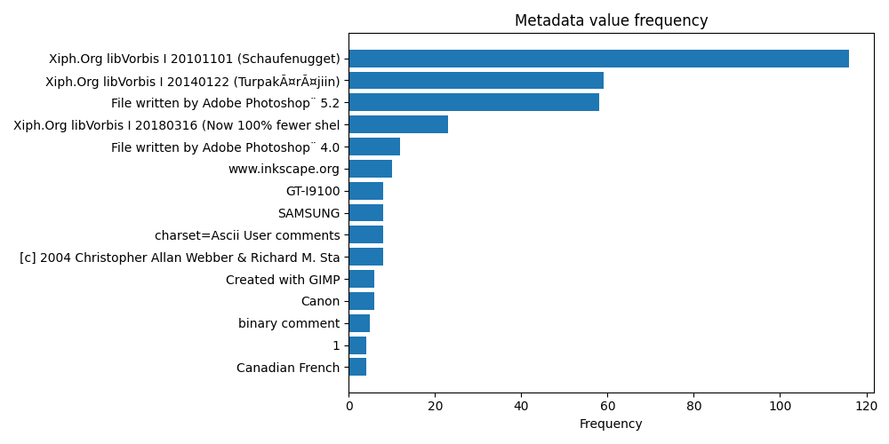

|  |  |
| --- | --- |
| Valor de metadatos | Frecuencia |
| Xiph.Org libVorbis I 20101101 (Schaufenugget) | 116 |
| Xiph.Org libVorbis I 20140122 (TurpakÃ¤rÃ¤jiin) | 59 |
| File written by Adobe Photoshop¨ 5.2 | 58 |
| Xiph.Org libVorbis I 20180316 (Now 100% fewer shells) | 23 |
| File written by Adobe Photoshop¨ 4.0 | 12 |
| www.inkscape.org | 10 |
| [c] 2004 Christopher Allan Webber Richard M. Stallman | 8 |
| charset=Ascii User comments | 8 |
| SAMSUNG | 8 |
| GT-I9100 | 8 |