Zombie Fight PC

Small Time Beach Bandits

## The Game

**Controls**

WASD/ Left stick - movement

JILK/ Right stick - directional shooting

ER/ Triggers - cycling through weapons

**The Goal is to Survive, Upgrade, Survive**

Every time you die, you will be able to go to the shop where you can get upgrades, then you can go out and try to get a higher score. You get five lives at most at the rate of 1 per 15 minutes and you can have friends give you life once per day. You can also compare highest score with other players.

**Currency**

Two options - level score to gain money, or monsters can drop money (based on difficulty)

**Score**

Killing enemies will give you points depending on the type of enemy

**Achievements**

Completing theses gives you in game bonuses, unlock weapons for purchase, unlock harder enemies, character skins

**The World**

Players will travel across an infinitely wide 2D world, with platforms and walls to navigate around. Players will be able to drop through platforms at their own choosing.

**Player and Shop**

Player has a basic health stat, can be upgraded in the shop

Unlock new weapons that enemies will start dropping ammo for

Each weapon type can be upgraded in the shop (damage / max ammo)

Possibly might include some sort of crafting mechanic (enemies drop can drop special items, those plus money allows for upgrade)

**Weapon Types**

Each weapon does some range of damage. They will only affect what’s on screen.

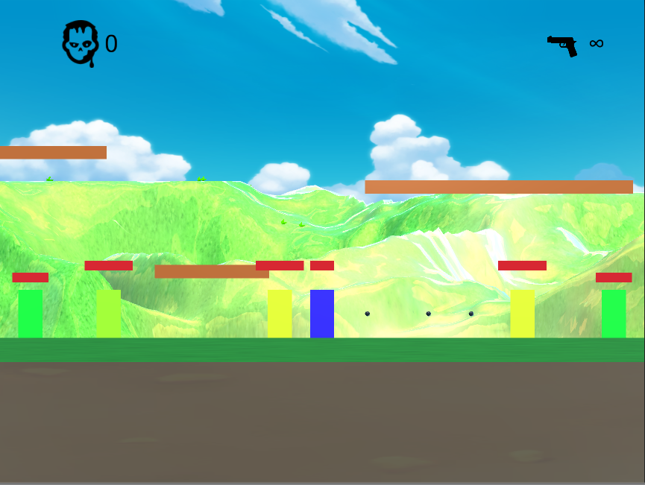

Revolver

* low damage per bullet
* infinite ammo
* shoots one bullet per button press and release
* stops if it hits enemies or walls

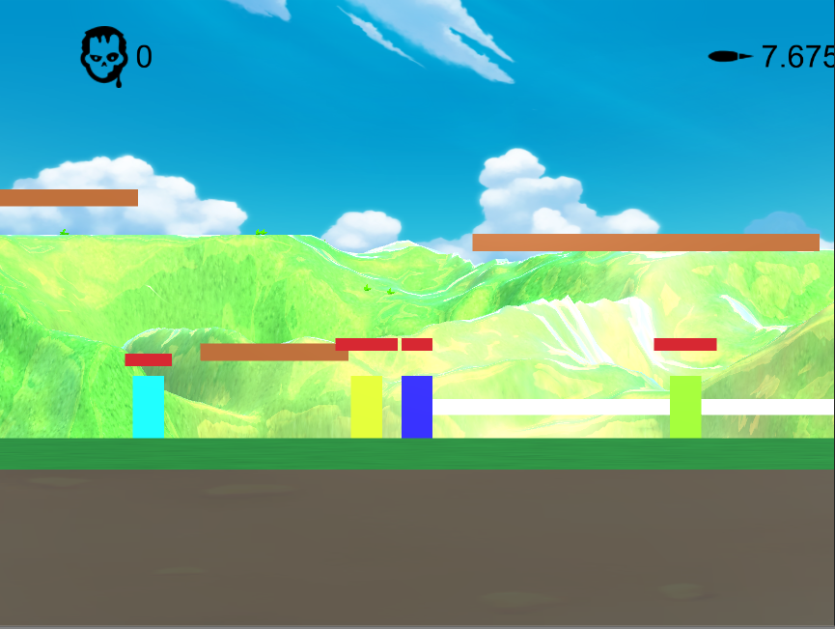

Laser

* medium damage per 0.1 second contact (some other time format) First hit counts (doesn't travel through enemies)
* 10 seconds of constant shooting
* shoots in a straight line as long as pressing
* the further the target is from the player, the weaker the damage becomes

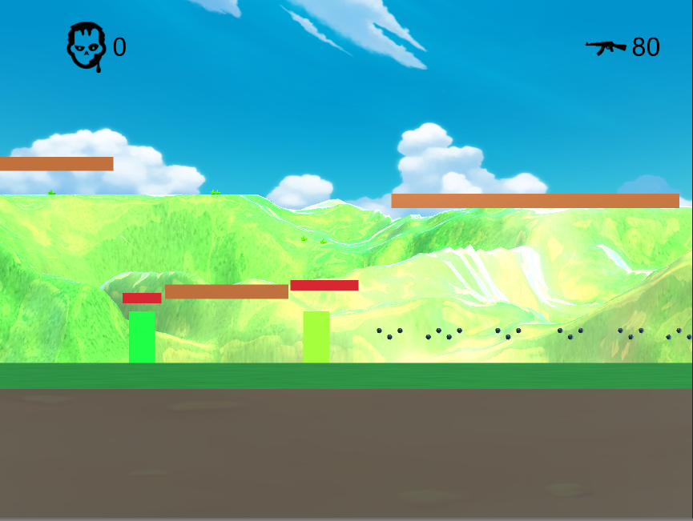

Machine Gun

* low damage per bullet
* 200 ammo
* shoots about 4 bullets per shot, timed shots on button press
* stops if it hits enemies or walls

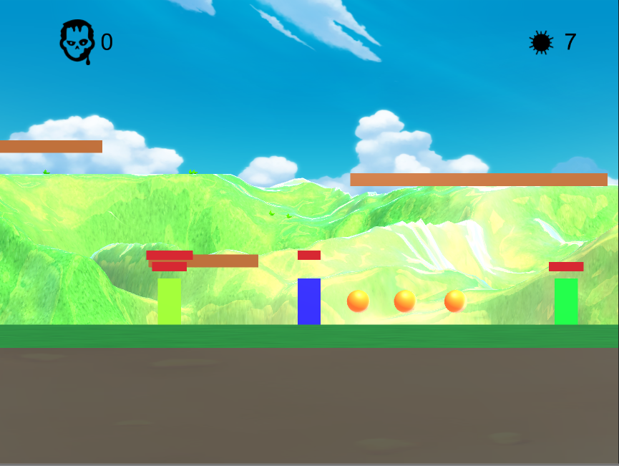

Fireball

* medium damage per 0.1 second contact
* 10
* shoots 1 per button press and release
* have cool down
* stops once it hits walls

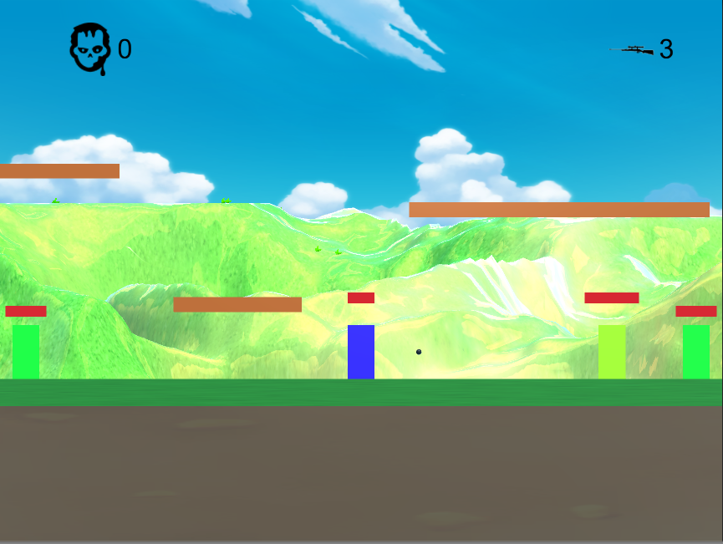

*New* Sniper

* High damage
* 3 shots in straight line originating from player
* shoots 1 per click
* have cool down
* Targets a single enemy on the screen

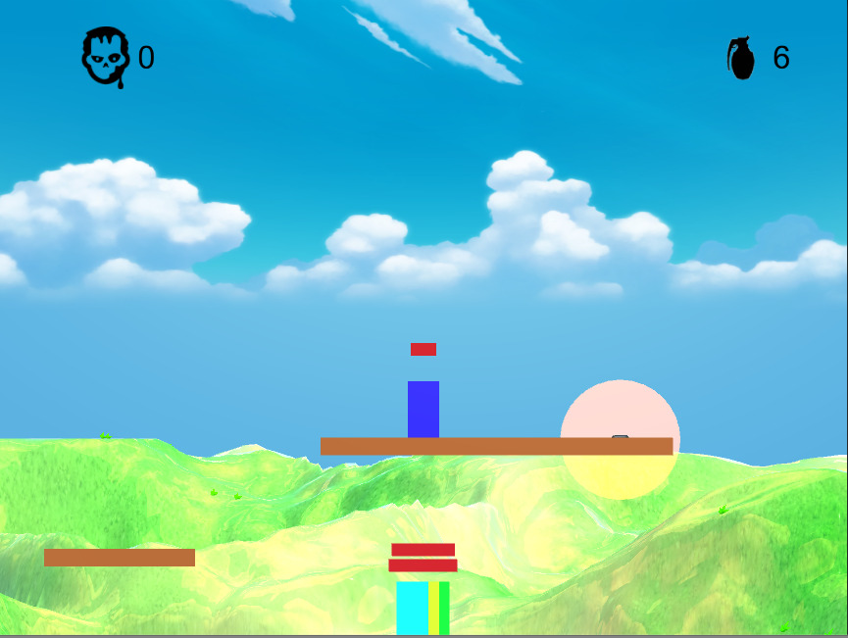

*New* Grenade

* High Damage
* 5 uses
* Throws one per click
* No cool down
* Radial damage from contact point

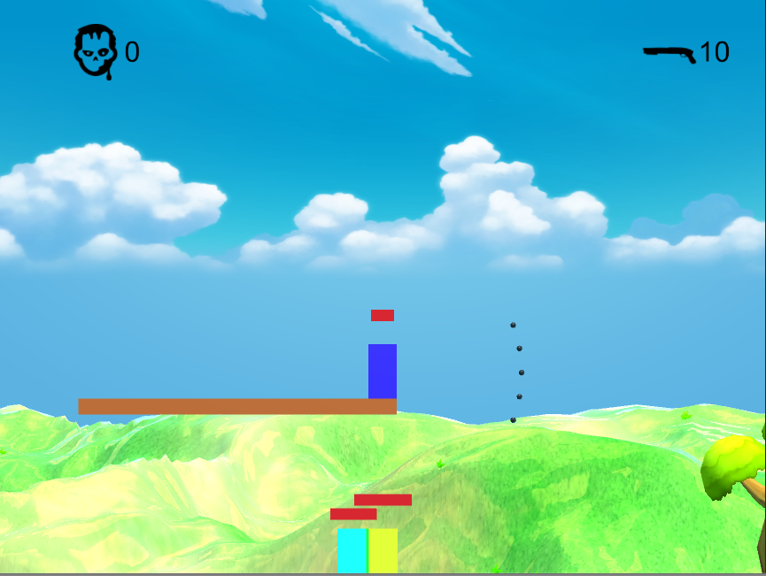

*New* Shotgun

* High Damage (close range, quickly decreases based on distance)
* 5 uses
* Throws 5 per click
* Shoots out like a cone (randomly?)

**Enemies**

Three ranges of stats, low, medium, and high. Can vary based on player level

EX. Low: 5-10, Med: 8-13, High 11-16

Stat Types

* [1] Low Health High Speed
* [2] Med Health Med Speed
* [3] High Health Low Speed
* [4] Highest Health No Speed

Monster Points Earned is the sum of those two stats (in some form)

Types

Simple Enemies

* three stat types (1, 2, 3)
* just walks normally, cannot jump

*New* Obstacle enemies

* one stat type (4)
* big one that gives a lot of points for high health range of 4+ and low low speed of zero
* can have different ones with different sizes for different range of health

Jumping Enemies

* three stat type (1, 2, 3)
* can jump over platforms and walls

*New* Boss enemy (spawns after certain score)

* three stat type (1, 2, 3)
* Drops many items and a weapon
* Could act like any other enemy
* Stupidly large

**Pick Ups**

Health

Ammo

Currency

## Continuing Focus Plan

**Level design**

**Cleaner UI**

**Achievements**

**Shop**

**Achievements**

|  |  |
| --- | --- |
| Task | Gold Earned |
| Kill 50 | **5** |
| Kill 100 | **10** |
| Kill 500 | **50** |
| Kill 1000 | **100** |
| Kill 5000 | **500** |
| Kill 500 in one game | **200** |
| Kill 1000 in one game | **500** |
| Unlock all weapons | **100** |
| Max 1 weapon | **100** |
| Max all weapon | **200** |
| Upgrade health once | **100** |
| Max health | **200** |

**Upgrades**

|  |  |  |  |  |  |  |  |
| --- | --- | --- | --- | --- | --- | --- | --- |
|  | **Thing** | **Base** | **Upgrade 1 (100)** | **Upgrade 2 (200)** | **Upgrade 3 (300)** | **Upgrade 4 (400)** | **Upgrade 5 (500)** |
| **0** | **Health** | **100** | **150** | **200** | **250** | **300** | **350** |
| **1** | **Revolver** | **0.3** | **0.37** | **0.44** | **0.5** | **0.55** | **0.6** |
| **2** | **M-Gun** | **0.3** | **0.37** | **0.44** | **0.5** | **0.55** | **0.6** |
| **3** | **Fireball** | **0.1** | **0.13** | **0.15** | **0.165** | **0.19** | **0.2** |
| **4** | **Laser** | **0.1** | **0.13** | **0.15** | **0.165** | **0.19** | **0.2** |
| **5** | **Snipe (350)** | **1.5** | **1.9** | **2.2** | **2.5** | **2.7** | **3.0** |
| **6** | **Grenade (550)** | **1.0** | **1.3** | **1.5** | **1.65** | **1.9** | **2.0** |
| **7** | **Shot Gun (750)** | **0.7** | **0.9** | **1.1** | **1.2** | **1.3** | **1.4** |