GUI- Program

**Name: Anuj Solanki**

**Registered No: 20218411**

**Ques: Create a Single window and display following widgets on it:**

1. **Label**
2. **Textbox**
3. **Menu Bar**
4. **Button**
5. **List Box**

**Program:**

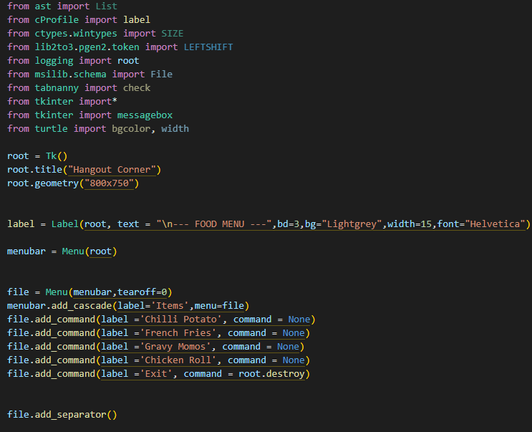

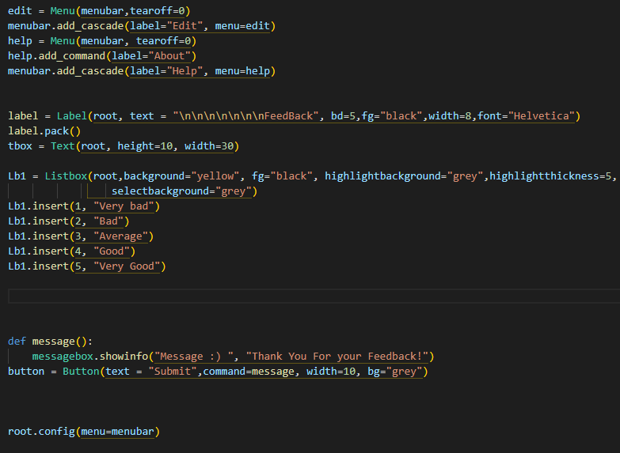

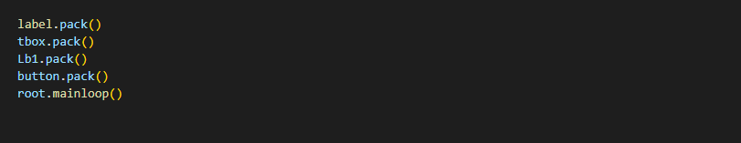

**OUTPUT:**

