## NATIONAL INSTITUTE OF TECHNOLOGY, TIRUCHIRAPPALLI-15



### Department of Computer Applications

**“Online Feedback System”**

PROJECT WORK

*Submitted By*

Sunil Solanki - 205119103

*Under the guidance of*

### Dr. U. Vignesh

*Submitted in fulfillment of the project in PL/SQL*

# CONTENTS

|  |  |  |
| --- | --- | --- |
| **S. No.** | **Description** | **Page No.** |
| 1 | Problem Description and Analysis | 3 |
| 2 | Schema and Tables Descriptions | 4 |
| 3 | Creation of Tables using SQL | 6 |
| 4 | Object Model, Flow Charts | 11 |
| 5 | Description of project files | 14 |
| 6 | Software used | 24 |
| 7 | Future Enhancements and Conclusion | 24 |

**PROBLEM DESCRIPTION AND ANALYSIS**

In recent times we have encountered many problems related to education system.

There is a communication gap between students and teachers. So here this project comes to mitigate the problem. This project will allow students to give feedbacks to

their teaching faculty to improve the current scenarios. The interface has a login system with different levels of functionality. The different levels of users are:-

**Student :** Students can register their username and password, and later log in using the same. After login, they can give feedback to the faculties teaching them in current semesters.

**Faculty:** Faculty can register their username and password, and later log in using the same. After login, they can view the feedbacks given by students to him. He can also check the average of all feedback ratings.

**Administrator :** An administrator can view the total no. of students, faculties registered, total no. feedbacks given, he can manage the record of students, faculties, feedback and can also delete the same. He can update the details of any particular user and many things more.

Project can become a very important factor in taking decisions for improving the education system.

# SCHEMA AND TABLE DESCRIPTION

Table **User**

|  |  |
| --- | --- |
| ID  Name  Email  Pass  Mobile  Programme  Semester  Gender  Hobbies  Image  Dob  Regid | int(11) Primary key Auto increment  char(40) Not Null  varchar(40) Not Null Unique  varchar(40) Not Null  bigint(11) Not Null  varchar(20) Not Null  varchar(10) Not Null  varchar(40) Not Null  varchar(40) Not Null  varchar(50) Not Null  date Not Null  varchar(20) Not Null |

Table **Faculty**

|  |  |
| --- | --- |
| Id  User_alias  Name  Designation  Programme  Semester  Email  Password  Mobile  Date  status | int(11) Primary key Auto increment  varchar(30) Not Null  varchar(30) Not Null  varchar(100) Not Null  varchar(50) Not Null  varchar(10) Not Null  varchar(255) Not Null Unique  varchar(75) Not Null  bigint(11) Not Null  date Not Null  int(11) Not Null |

Table **Admin**

|  |  |
| --- | --- |
| adminID  user  pass | Int(11) Primary Key Auto Increment  Not Null  Not Null |

Table **Feedback**

|  |  |
| --- | --- |
| Id  Student_id  Faculty_id  Questions  date | Primary key Auto Increment  Varchar(50) Not Null  Varchar(50) Not Null  Enum(‘5’,’4’,’3’,’2’,’1’) Not Null  Date Not Null |

|  |  |
| --- | --- |
| Id  Name  Email  Mobile  Message  Date | Int(11) Primary Key Auto Increment  Varchar(50) Not Null  Varchar(100) Not Null  Bigint(20) Not Null  Text Not Null  Datetime Not Null |

Table **Contact**

Table **Files**

|  |  |
| --- | --- |
| Notice_id  Attachment  Subject  Description  Date | Int(11) Primary Key Auto Increment  Varchar(255) Not Null  Varchar(100) Not Null  Text Not Null  Datetime Not Null |

#### CREATING TABLES

1. Table **USER:**

CREATE TABLE `user` (

`id` int(11) NOT NULL,

`name` char(40) NOT NULL,

`email` varchar(40) NOT NULL,

`pass` varchar(40) NOT NULL,

`mobile` bigint(11) NOT NULL,

`programme` varchar(20) NOT NULL,

`semester` varchar(10) NOT NULL,

`gender` varchar(40) NOT NULL,

`hobbies` varchar(40) NOT NULL,

`image` varchar(50) NOT NULL,

`dob` date NOT NULL,

`regid` varchar(20) NOT NULL

) ENGINE=InnoDB DEFAULT CHARSET=latin1;

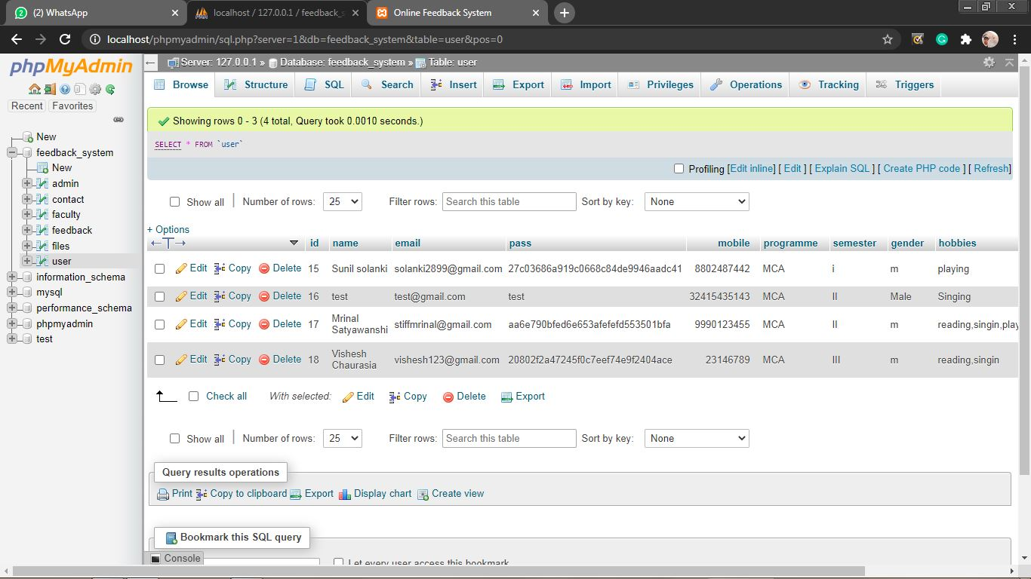

1. Table **Faculty**

CREATE TABLE `faculty` (`id’ int(11) NOT NULL,

`user_alias` varchar(30) NOT NULL,

`Name` varchar(30) NOT NULL,

`designation` varchar(100) NOT NULL,

`programme` varchar(50) NOT NULL,

`semester` varchar(10) NOT NULL,

`email` varchar(255) NOT NULL,

`password` varchar(75) NOT NULL,

`mobile` bigint(20) NOT NULL,

`date` datetime NOT NULL,

`status` int(11) NOT NULL

) ENGINE=InnoDB DEFAULT CHARSET=latin1;

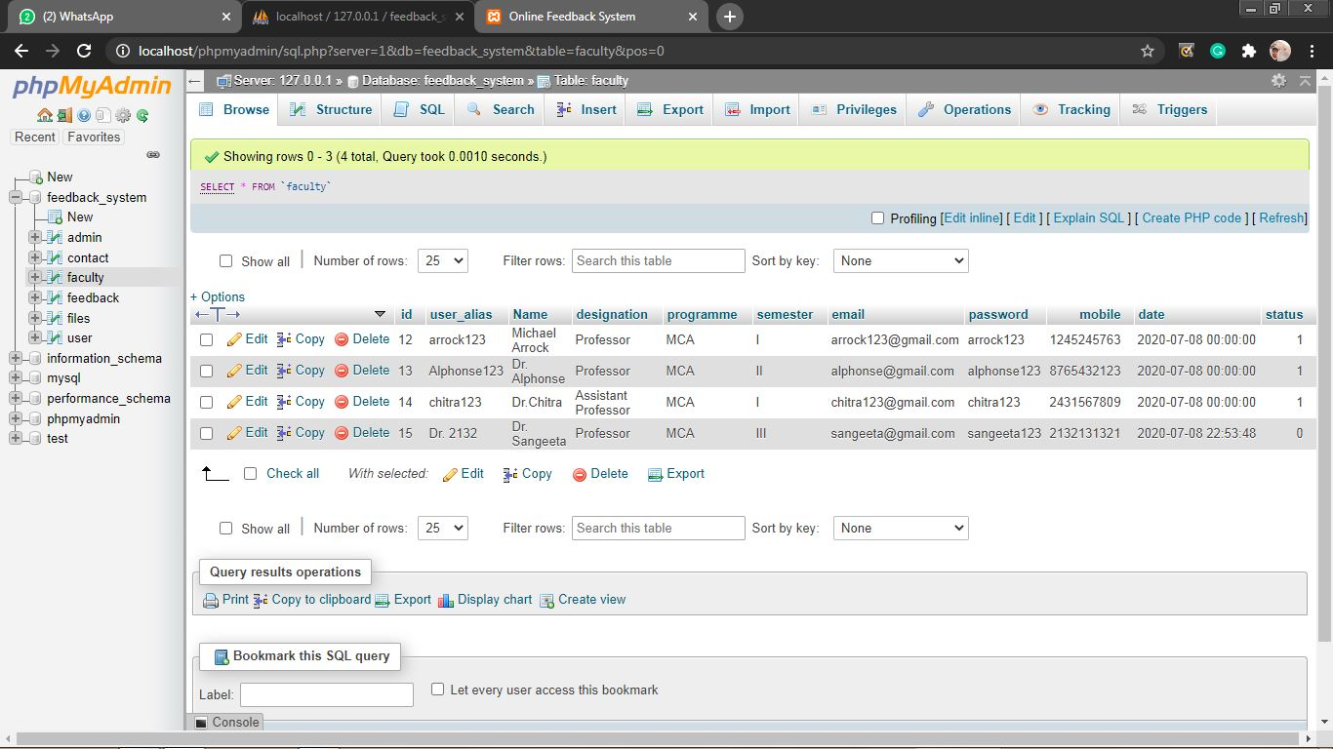

1. Table **Admin:**

CREATE TABLE `admin` (

`admin_id` int(11) NOT NULL,

`user` varchar(50) NOT NULL,

`pass` varchar(50) NOT NULL

) ENGINE=InnoDB DEFAULT CHARSET=latin1;

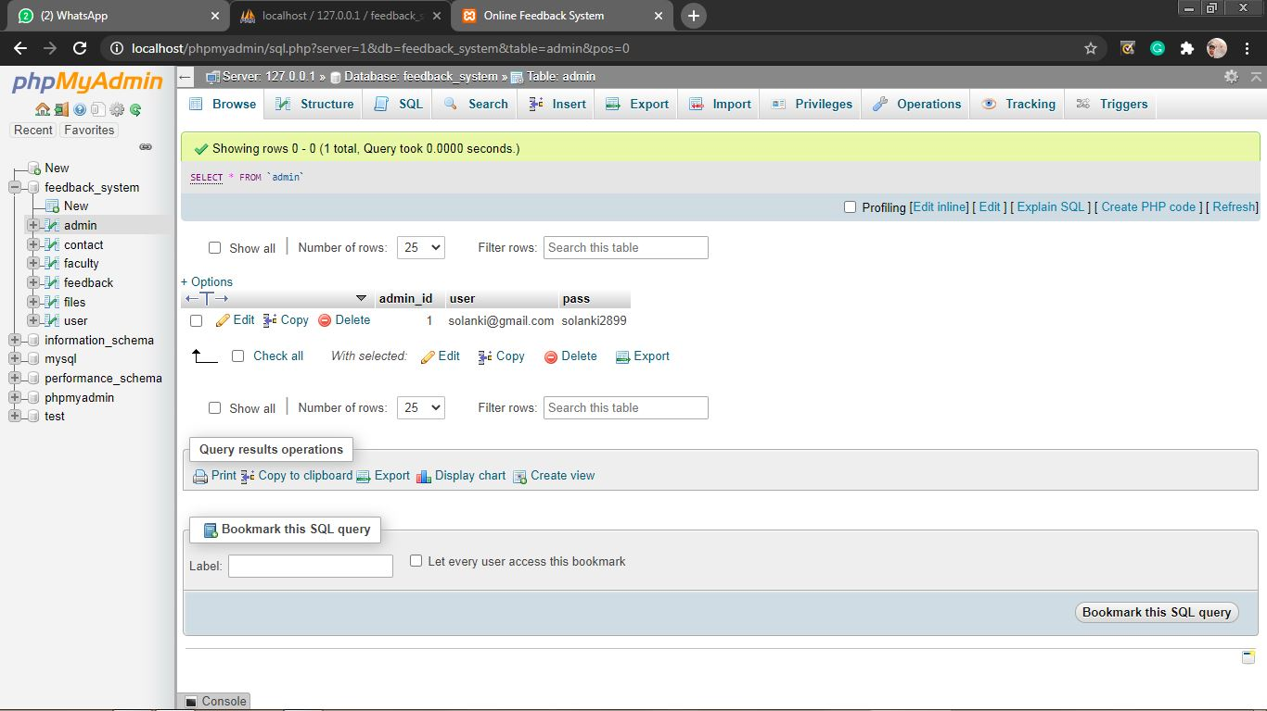

1. Table **Contact**

CREATE TABLE `contact` (

`id` int(11) NOT NULL,

`name` varchar(50) NOT NULL,

`email` varchar(100) NOT NULL,

`mobile` bigint(20) NOT NULL,

`message` text NOT NULL,

`Date` datetime NOT NULL

) ENGINE=InnoDB DEFAULT CHARSET=latin1;

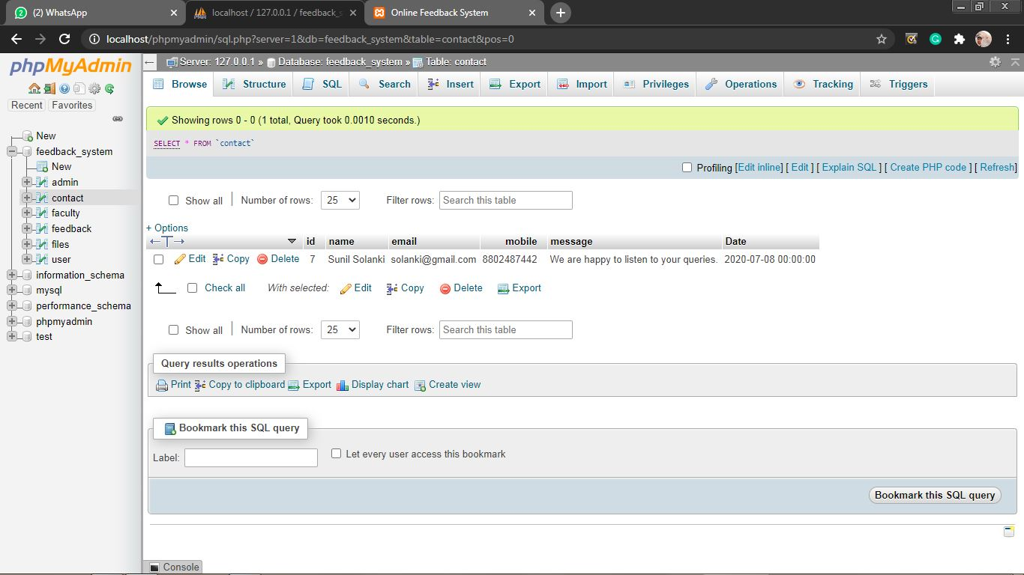

1. Table **Feedback**

CREATE TABLE `feedback` (

`id` int(11) NOT NULL,

`student_id` varchar(50) NOT NULL,

`faculty_id` varchar(50) NOT NULL,

`Teacher provided the course outline having weekly content plan w` enum('5','4','3','2','1') NOT NULL,

`Course objectives,learning outcomes and grading criteria are cle` enum('5','4','3','2','1') NOT NULL,

`Course integrates throretical course concepts with the real worl` enum('5','4','3','2','1') NOT NULL,

`Teacher is punctual,arrives on time and leaves on time` enum('5','4','3','2','1') NOT NULL,

`Teacher is good at stimulating the interest in the course conten` enum('5','4','3','2','1') NOT NULL,

`Teacher is good at explaining the subject matter` enum('5','4','3','2','1') NOT NULL,

`Teacher's presentation was clear,loud ad easy to understand` enum('5','4','3','2','1') NOT NULL,

`Teacher is good at using innovative teaching methods/ways` enum('5','4','3','2','1') NOT NULL,

`Teacher is available and helpful during counseling hours` enum('5','4','3','2','1') NOT NULL,

`Teacher has competed the whole course as per course outline` enum('5','4','3','2','1') NOT NULL,

`Teacher was always fair and impartial:` enum('5','4','3','2','1') NOT NULL,

`Assessments conducted are clearly connected to maximize learinin` enum('5','4','3','2','1') NOT NULL,

`What I liked about the course` text NOT NULL,

`Why I disliked about the course` text NOT NULL,

`date` date NOT NULL

) ENGINE=InnoDB DEFAULT CHARSET=latin1;

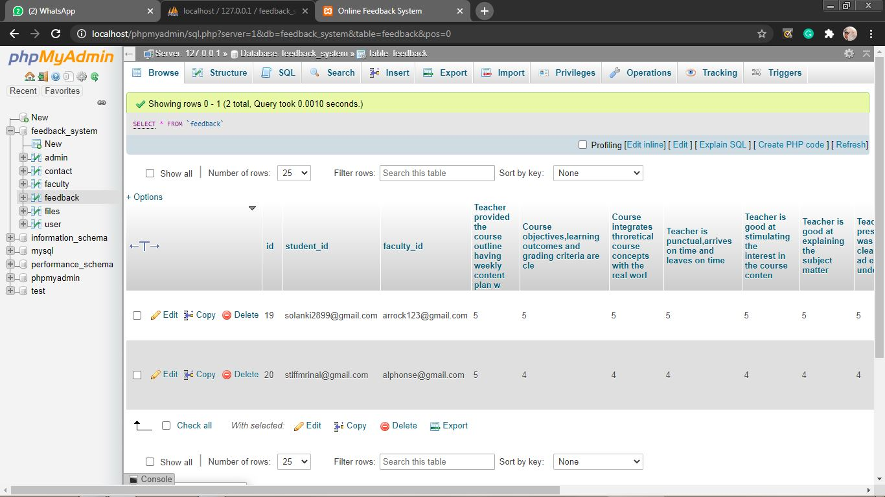

1. Table **Files**

CREATE TABLE `files` (

`notice_id` int(11) NOT NULL,

`attachment` varchar(255) NOT NULL,

`subject` varchar(100) NOT NULL,

`Description` text NOT NULL,

`Date` datetime NOT NULL

) ENGINE=InnoDB DEFAULT CHARSET=latin1;

#### OBJECT MODEL

#### Object Model.png

**Flowcharts**

**(Level 1)**

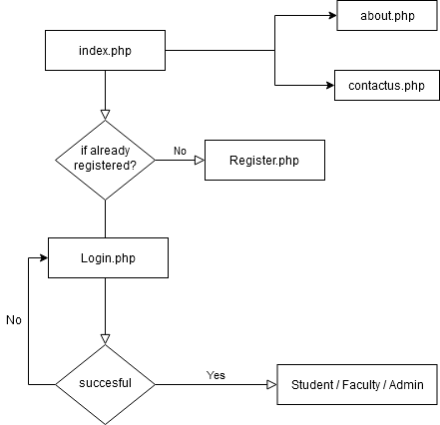

**User module**

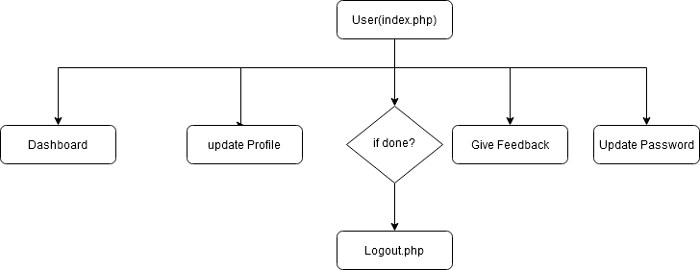

**Faculty**

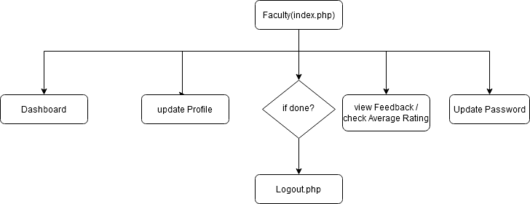

**Admin**

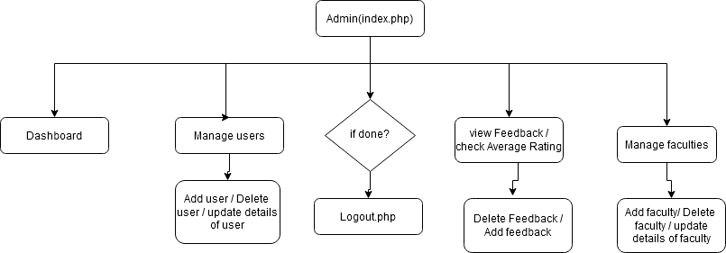

#### File Wise Description

#### Online Feedback (Main Folder )

**Database.php**

It starts the session.

It creates the connection between mysql database and the website.

**Index.php**

This is the first page of the website.

It gives you the introduction of the project.

It has a navigation bar (Home, aboutus, contactus, Registration, Login ).

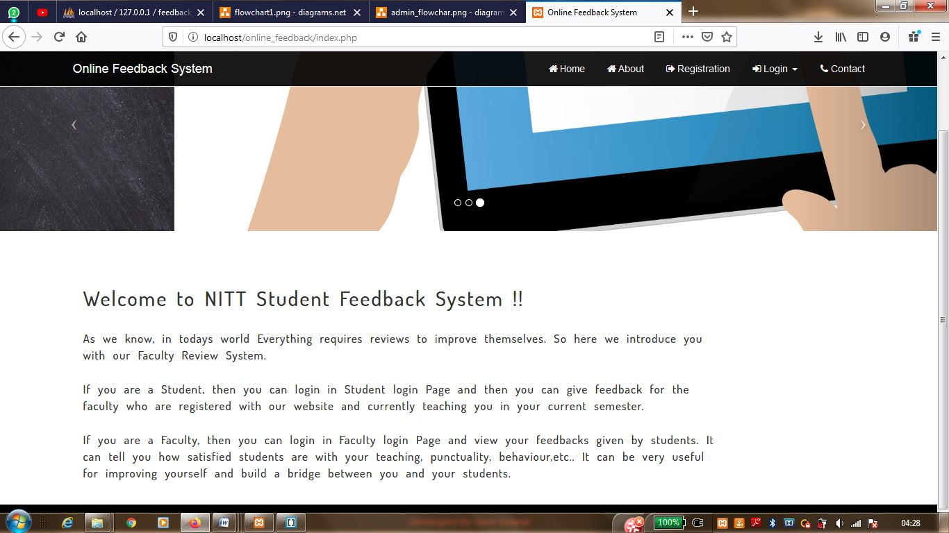

**Login.php**

If(not registered) redirect to Register.php

Else If(user=student) redirect to Student/Login.php

Else If(user=faculty) redirect to Faculty/Login.php

Else If(user=admin) redirect to Admin/Login.php

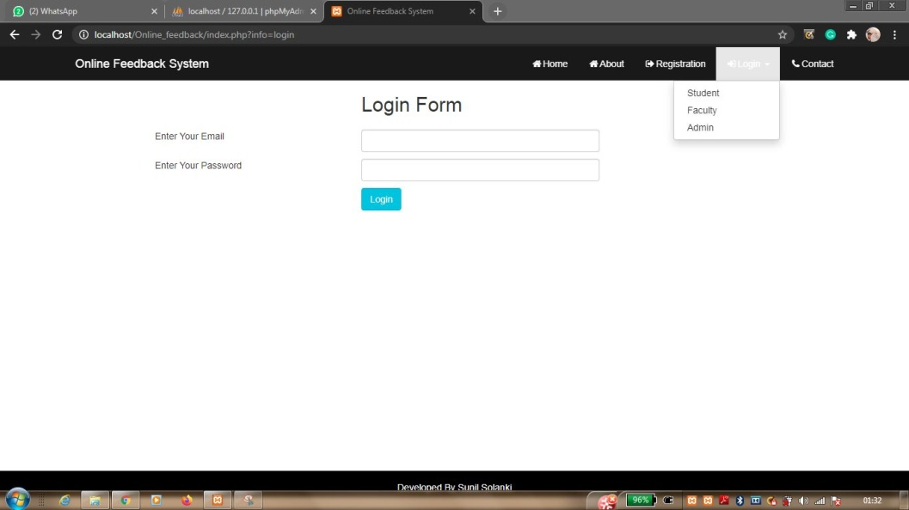

**Register.php**

It takes all the details and inserts them to database.

After Registration, it will redirect you to Login.php

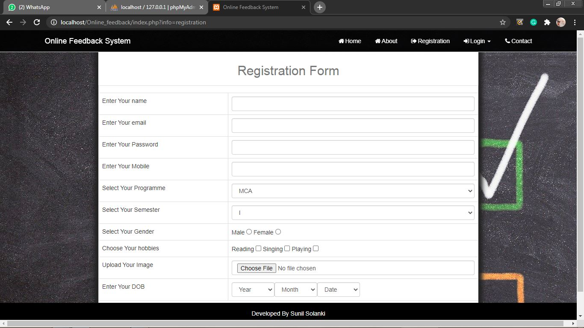

**About.php**

It will show you the about us and project screen.

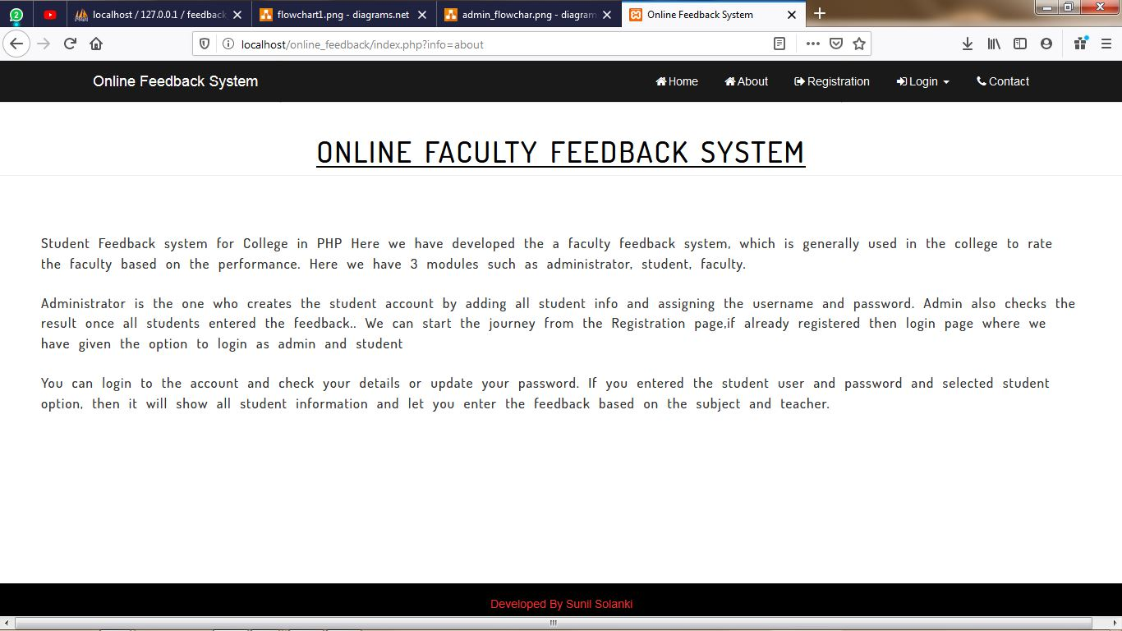

**Contact.php**

It will give you form to contact the admin.

Once the message is sent, he will contact you whenever he is free.

It also has personal details of the admin.

So you can approach him either way.

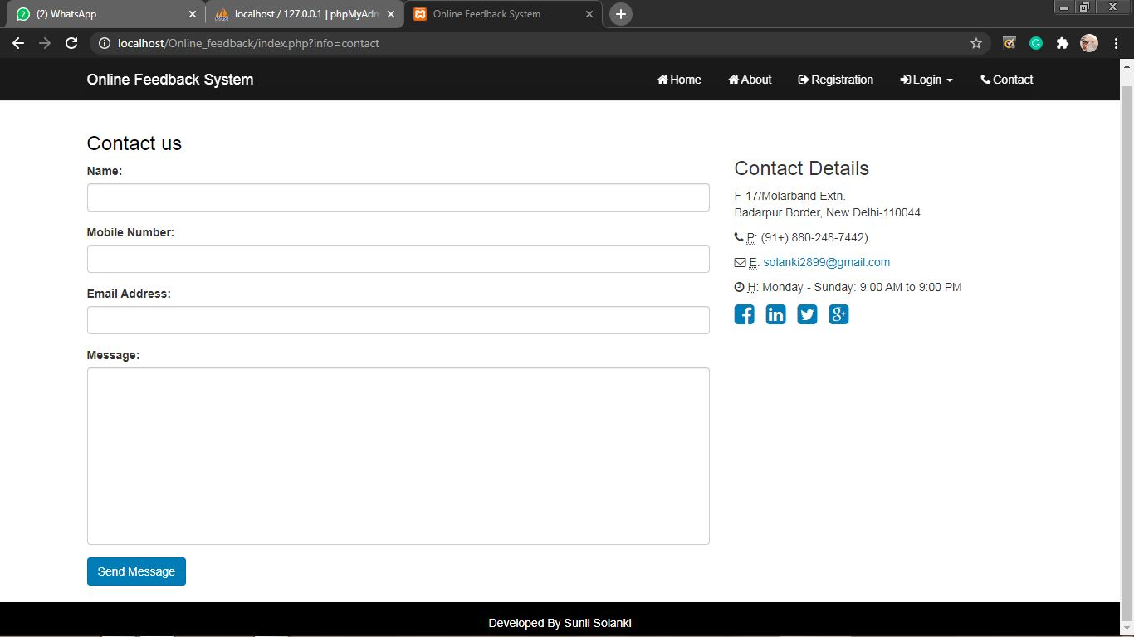

**User module:**

**Index.php**

It will show you your details.

It gives you navigation options to give feedback, update password, update profile, Logout.

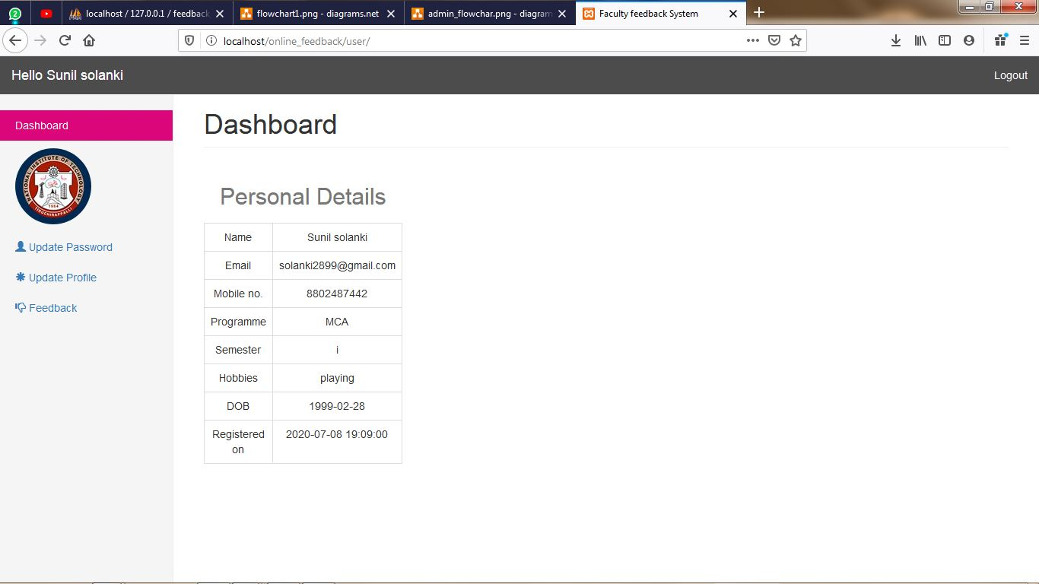

**Give_Feedback.php**

It will display all faculties teaching in current semester. Choose from it.

It will give you a form with predefined questions. You have to give the rating according to your satisfaction.

It will insert the feedback into feedback table.

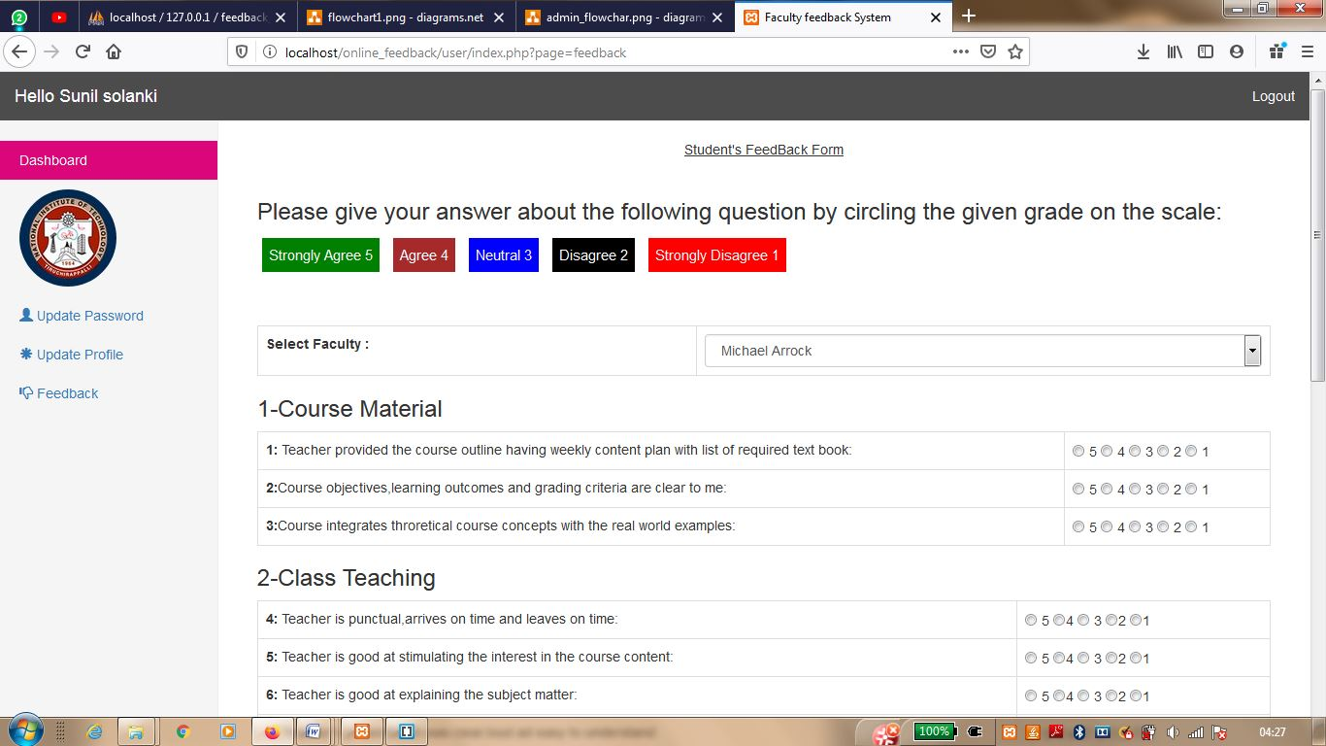

**Update_profile.php**

Here you can make changes in your profile.

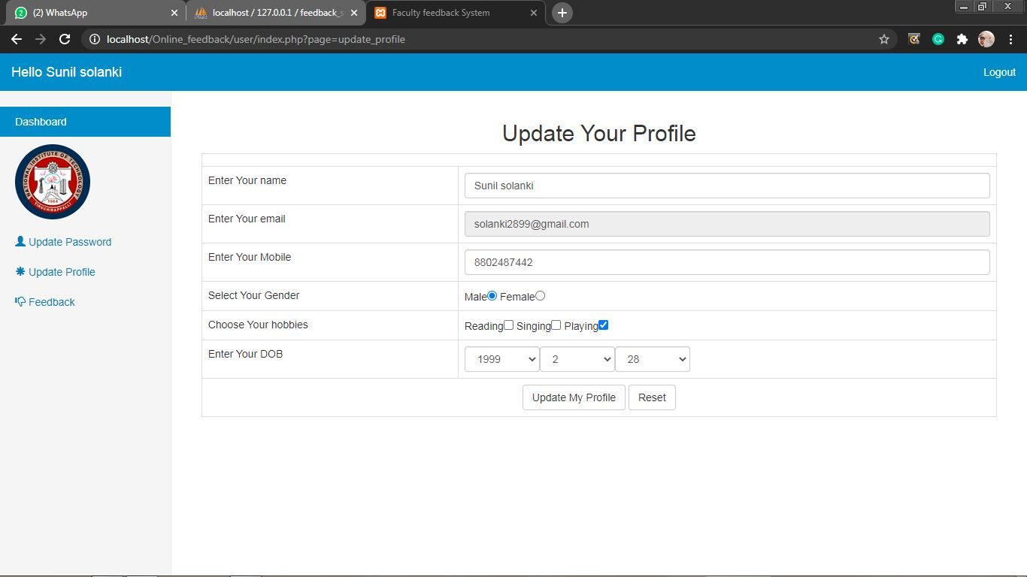

**Update_Password.php**

Here you can update your password

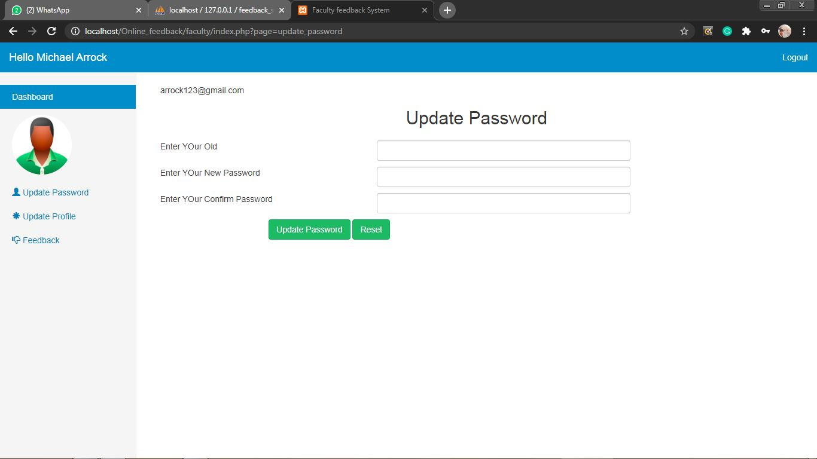

**Logout.php**

It will log you out and finish your session.

**Faculty module:**

**Index.php**

It will show you your details.

It gives you navigation options to view feedback, update password, update profile, Logout.

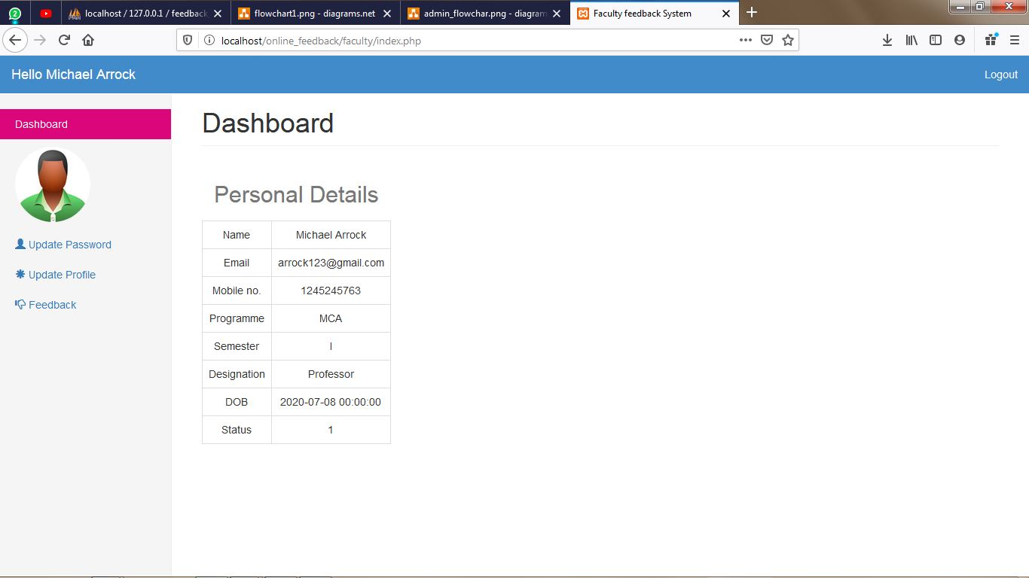

**View_Feedback.php**

Here you can see the feedbacks given by students.

It will also show the average rating of your feedbacks.

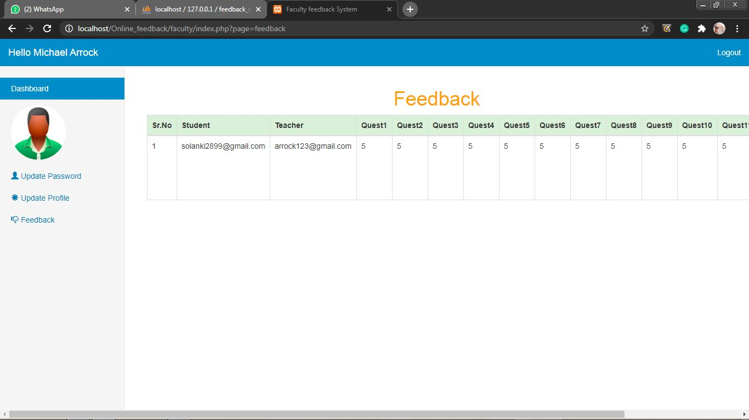

**Update_profile.php**

Here you can make changes in your profile.

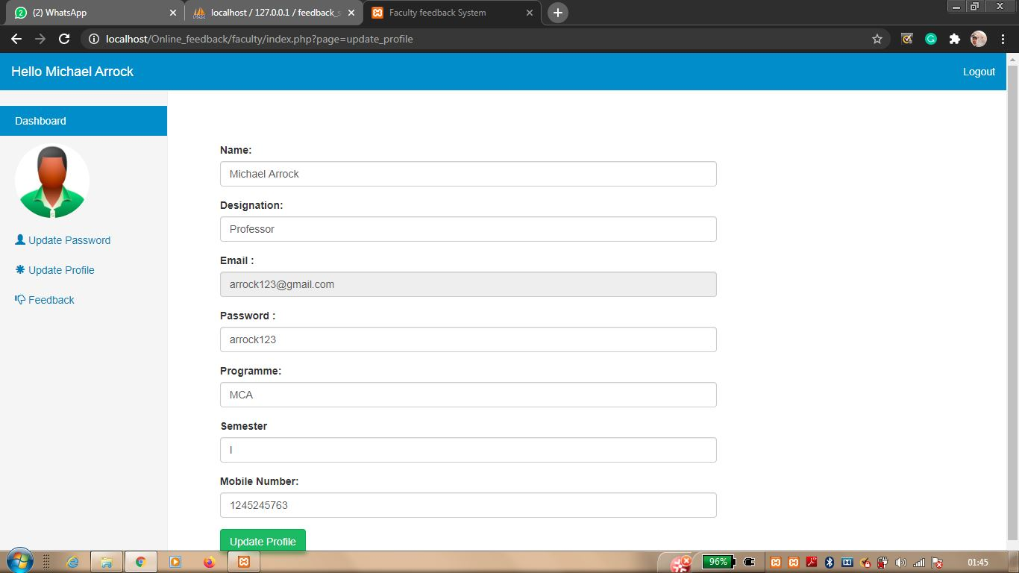

**Update_Password.php**

Here you can update your password



**Logout.php**

It will log you out and finish your session.

**Admin module:**

**Index.php**

It will show you total no. of students, faculties registered and feedbacks given.

It gives you navigation options to add feedback, delete feedback, update feedback, manage faculties profile, manage student’s profile password, contact us details, Logout.

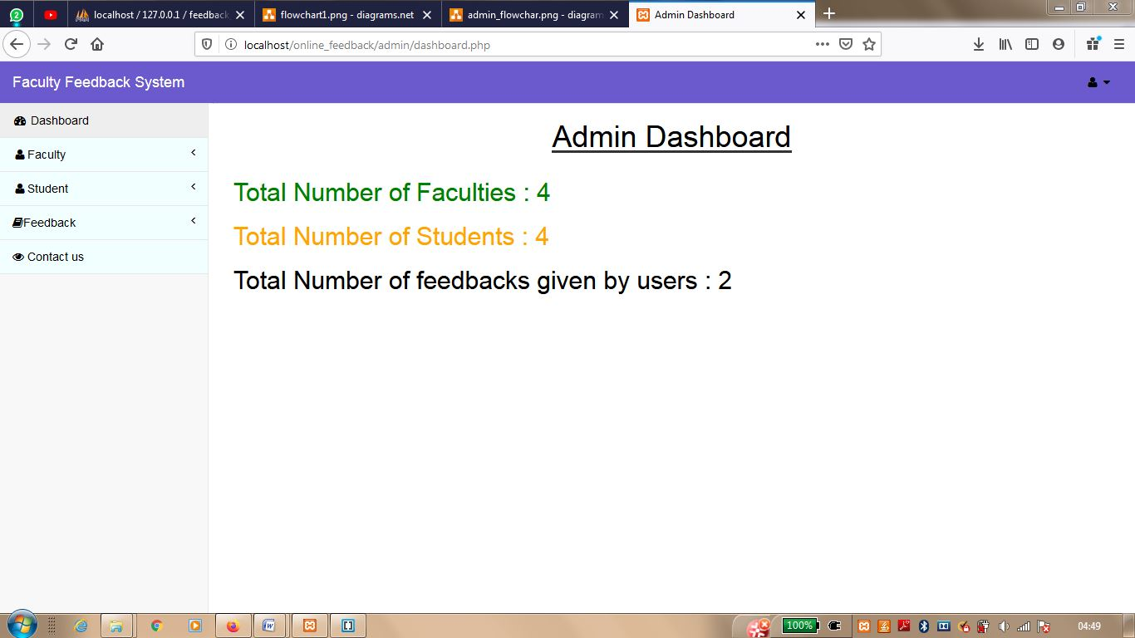

**Manage_Feedback.php**

It will add, delete, update the feedback of the chosen faculty.

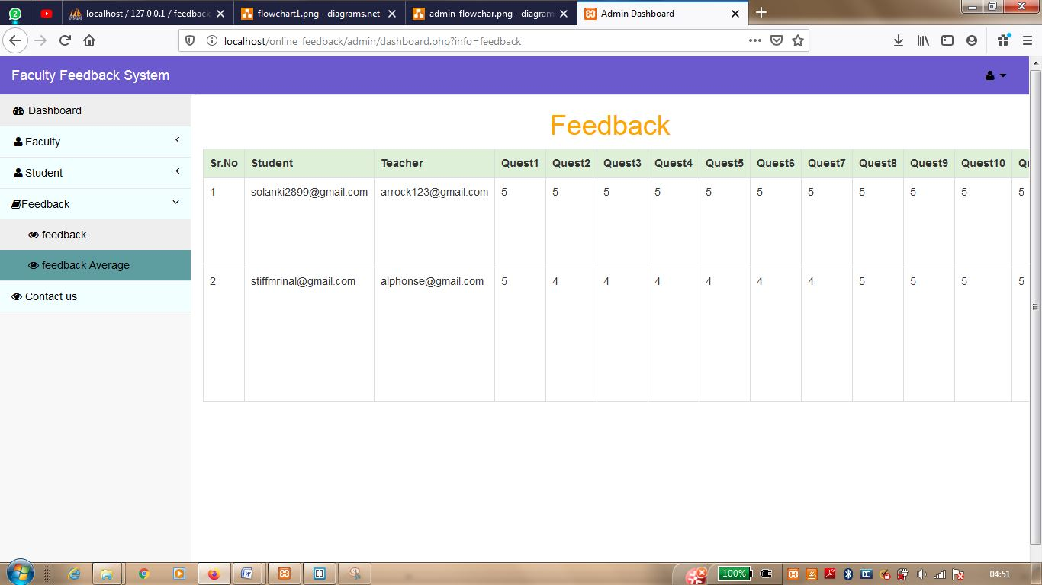

**Check_feedback_average.php**

It will show the average of all the feedback ratings.

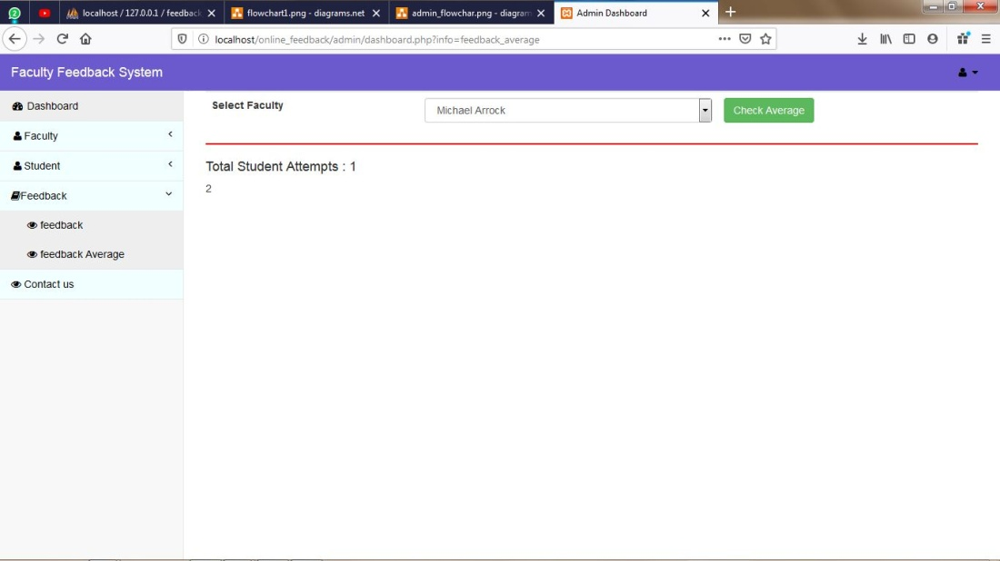

**Manage_students.php**

Here you can add students, delete student profiles, and even update their details.

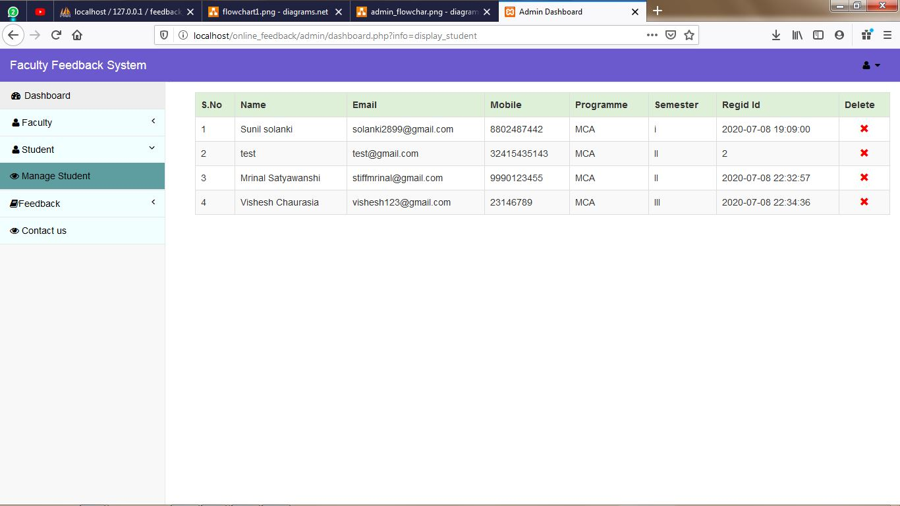

**Manage_Faculty.php**

Here you can add faculties, delete their profiles, and even update their details.

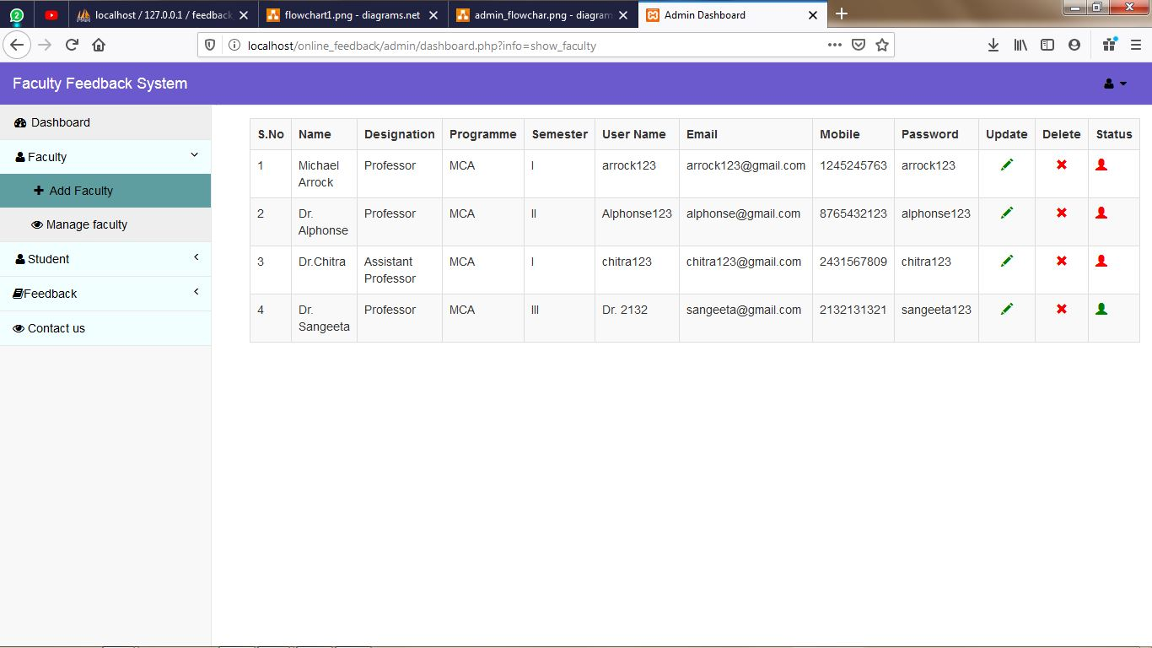

**Contactus.php**

It will show you the details of people who tried to contact admin through contact us form.

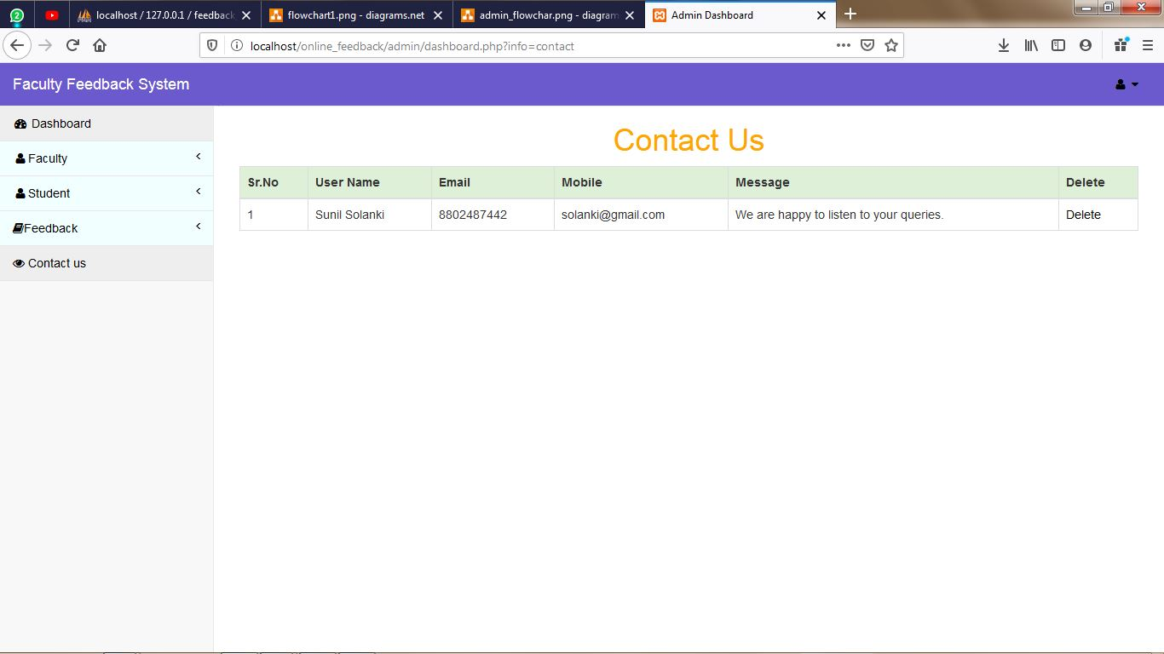

**Logout.php**

It will log you out and finish your session.

**Softwares used:**

* Xampp (Localhost Server)
* Brackets (IDE)
* Firefox (Browser)

#### FUTURE ENHANCEMENTS and CONCLUSION

**Enhancement:**

This project is very small effort to improvise the education system.

There are a lot of features that can be added to it which are as follow:

* We can extend this system to other departments of research and development.
* It can be implemented to any club, committee to track the progress.

#### Conclusion:

This project can become important factor in improving quality of decisions in education system improvisation.

As it is not an easy task to start with a project, least to mention a database oriented one. On this regard I owe my whole hearted thanks to our faculty

**Dr. U. Vignesh** for lending a helping hand during the course of my project.