Lab#2 Design Form of Student Registration and Employee registration with 11 fields.

Employee Registration form:

TAGS USED | ATTRIBUTES USED | DESCRIPTION
<!DOCTYPE html> | - | Declares HTML5 document.
<html> | lang | Root element; sets language.
<head> | - | Contains metadata.
<meta> | charset, name, content | Defines character set viewport. | and
<title> | - | Sets browser tab title.
<body> | - | Contains webpage content.
<h1> | - | Displays main heading.
<form> | action, novalidate | Creates a form.
<fieldset> | - | Groups related fields.
<legend> | - | Gives fieldset title.
<label> | - | Labels input fields.
<input> | type, required, value,  readonly | Accepts user input.
<select> | - | Creates a drop-down list.

Student registration form:

TAGS USED |  |  | ATTRIBUTES USED |  |  | DESCRIPTION
<!DOCTYPE html> - HTML5 declaration |  |  | <!DOCTYPE html> - HTML5 declaration |  |  | <!DOCTYPE html> - HTML5 declaration
<html> lang Root element |  |  | <html> lang Root element |  |  | <html> lang Root element
<head> - Metadata section |  |  | <head> - Metadata section |  |  | <head> - Metadata section
charset, name,  <meta>  content | Page metadata |  | charset, name,  <meta>  content | Page metadata |  | charset, name,  <meta>  content | Page metadata
<title> - Page title |  |  | <title> - Page title |  |  | <title> - Page title
<body> - Page content |  |  | <body> - Page content |  |  | <body> - Page content
<h1> - Main heading |  |  | <h1> - Main heading |  |  | <h1> - Main heading
action, method, target,  <form>  novalidate |  | Creates form | action, method, target,  <form>  novalidate |  | Creates form | action, method, target,  <form>  novalidate |  | Creates form
<fieldset> - Groups fields |  |  | <fieldset> - Groups fields |  |  | <fieldset> - Groups fields
<legend> - Fieldset title |  |  | <legend> - Fieldset title |  |  | <legend> - Fieldset title
<label> - Field label |  |  | <label> - Field label |  |  | <label> - Field label
type, name, pattern, placeholder, value, User  <input> checked, disabled, input multiple |  |  | type, name, pattern, placeholder, value, User  <input> checked, disabled, input multiple |  |  | type, name, pattern, placeholder, value, User  <input> checked, disabled, input multiple

Final Outcome:

Employee Registration form
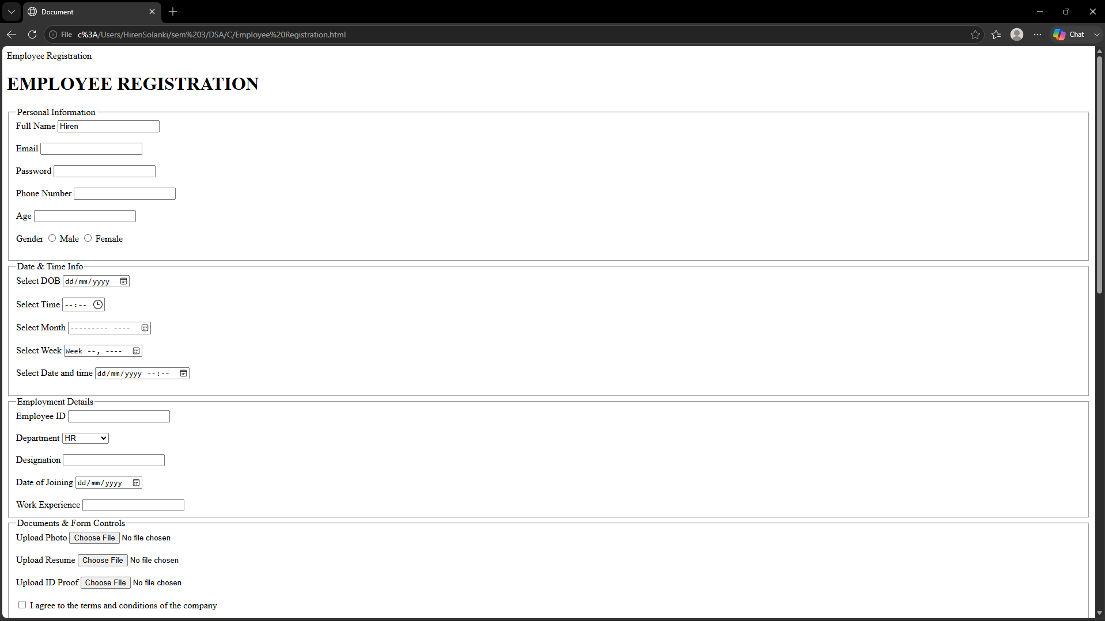

Student Registration form
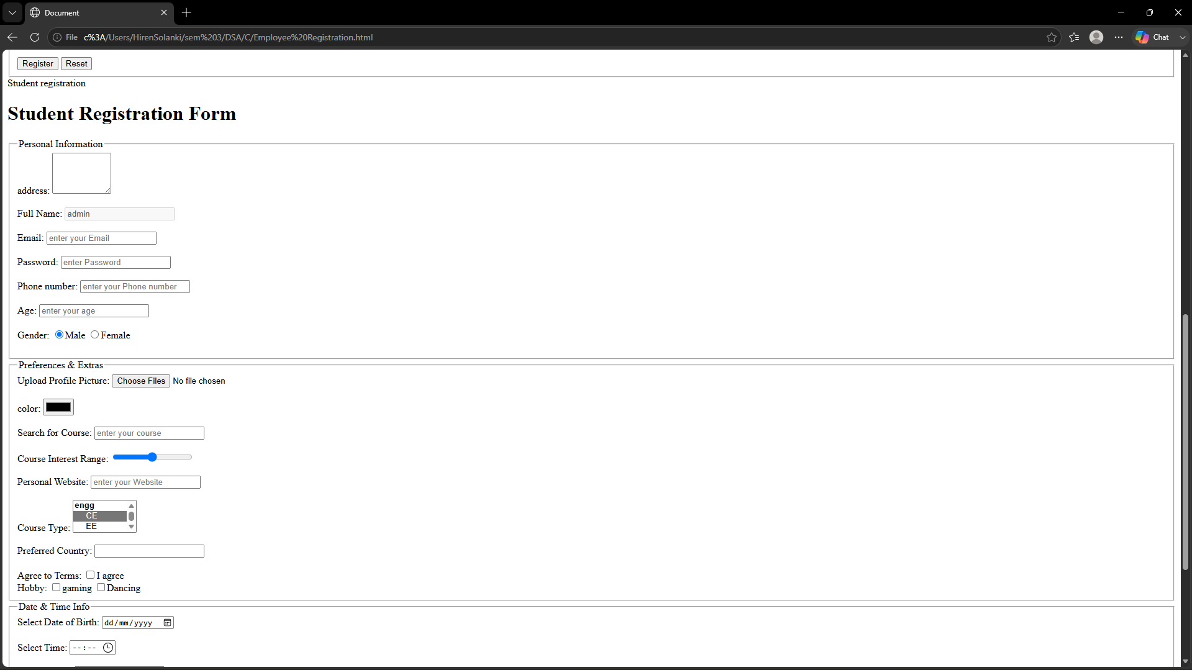

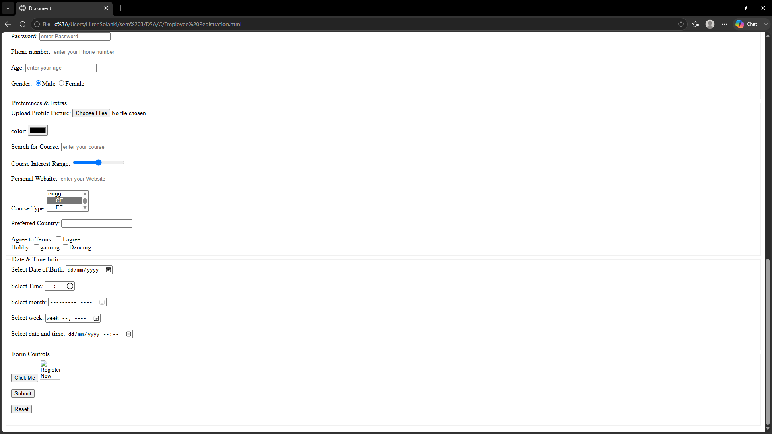

Code Snippet:

Employee Registration

<!doctype html>
<html lang="en">
<head>
<meta charset="UTF-8" />
<meta name="viewport" content="width=device-width, initial-scale=1.0" />
<title>Document</title>
</head>
<body>
<h1>EMPLOYEE REGISTRATION</h1>
<form action="welcome.html" novalidate></form>
<fieldset>
<legend>Personal Information</legend>
<label>Full Name</label>
<input type="text" required value="Hiren" readonly />
<br />
<br />

<label>Email</label>
<input type="email" required />
<br />
<br />

<label>Password</label>
<input type="password" required />
<br />
<br />

<label>Phone Number</label>
<input type="tel" required />
<br />
<br />
<label>Age</label>
<input type="number" required />
<br />
<br />

<label>Gender</label>
<input type="Radio" /> <label>Male</label> <input type="Radio" />
<label>Female</label>
<br />
<br />
</fieldset>

<fieldset>
<legend>Date & Time Info</legend>

<label>Select DOB</label>
<input type="date" />
<br />
<br />

<label>Select Time</label>
<input type="time" />
<br />
<br />

<label>Select Month</label>
<input type="month" />
<br />
<br />

<label>Select Week</label>
<input type="week" />
<br />
<br />

<label>Select Date and time</label>
<input type="datetime-local" />
<br />
<br />
</fieldset>

<fieldset>
<legend>Employment Details</legend>
<label>Employee ID</label>
<input type="text" />
<br />
<br />

<label>Department</label>
<select>
<option>HR</option>
<option>Finance</option>
<option>Marketing</option>
<option>IT</option>
</select>
<br />
<br />

<label>Designation</label>
<input type="text" />
<br />
<br />

<label>Date of Joining</label>
<input type="date" />
<br />
<br />

<label>Work Experience</label>
<input type="number" />
</fieldset>

<fieldset>
<legend>Documents & Form Controls</legend>

<label>Upload Photo</label>
<input type="file" />
<br />
<br />
<label>Upload Resume</label>
<input type="file" />
<br />
<br />
<label>Upload ID Proof</label>
<input type="file" />
<br />
<br />

<input type="checkbox" /> I agree to the terms and conditions of the company
<br />
<br />

<input type="submit" value="Register" />
<input type="reset" value="Reset" />
</fieldset>
</body>
</html>

Student registration

<!doctype html>
<html lang="en">
<head>
<meta charset="UTF-8" />
<meta name="viewport" content="width=device-width, initial-scale=1.0" />
<title>Student Reg Form</title>
</head>
<body>
<h1>Student Registration Form</h1>
<form action="welcome.html" method="get" novalidate target="_blank">
<fieldset>
<legend>Personal Information</legend>

address:
<textarea rows="4" cols="10"> </textarea>
<br/>
<br/>
<label>Full Name:</label>
<input type="text" name="reg_name" pattern="[A-Za-z ]{3,50}" placeholder="enter your Email" value="admin" disabled>
<br />
<br />
<label>Email:</label>
<input type="email" name="reg_email" pattern="[a-zA-Z]+\.{1}[09]{6}@marwadiuniversity\.ac\.in" placeholder="enter your Email" multiple/>
<br />
<br />

<label>Password:</label>
<input type="password" name="reg_pass" pattern="(?=.*[A-Z])(?=.*[a-z])(?=.*\d).{8,}" placeholder="enter Password"/>
<br />
<br />

<label>Phone number:</label>
<input type="tel" name="reg_phone" pattern="[0-9]{10}" placeholder="enter your
Phone number"/>
<br />
<br />

<label>Age:</label>
<input type="number" nmae="reg_age" pattern="[0-9]{2}" placeholder="enter your age"/>
<br />
<br />

<label>Gender:</label>
<input type="radio" name="reg_gender" checked value="Male" /><label>Male</label> <input type="radio" name="reg_gender" value="Female"/><label >Female</label
>
<br />
<br />
</fieldset>

<fieldset>
<legend>Preferences & Extras</legend>
<label>Upload Profile Picture:</label>
<input type="file" multiple/>
<br />
<br />
<label>color:</label>
<input type="color" name="reg_color"/>
<br />
<br />

<label>Search for Course:</label>
<input type="search" name="reg_search" placeholder="enter your course"/>
<br />
<br />

<label>Course Interest Range:</label>
<input type="range" name="reg_course" />
<br />
<br />

<label>Personal Website:</label>
<input type="url" pattern="https?://.+" name="reg_url" placeholder="enter your Website"/>
<br />
<br />

<label>Course Type:</label>
<select size="3" name="reg_course">
<optgroup label="engg">
<option selected value="CE">CE</option>
<option value="EE">EE</option>
<option value="ME">ME</option>
<option value="CIV">CIV</option>
</optgroup>
<optgroup label="Management">
<option>BBA</option>
<option>MBA</option>
</optgroup>
</select>
<br />
<br />
<label>Preferred Country:</label>
<input list="countries" />
<datalist id="countries">
<option value="USA">USA </option>
<option value="UK">UK</option>
<option selected value="India">India</option>
<option value="Japan">Japan</option>
</datalist>

<br />
<br />
<label>Agree to Terms:</label>
<input type="checkbox" /><label>I agree</label>
<br/>
<label>Hobby:</label>
<input type="checkbox" name="reg_hobbies[]" value="gaming"/><label>gaming</label> <input type="checkbox" name="reg_hobbies[]"
value="Dancing"/><label>Dancing</label>
</fieldset>

<fieldset>
<legend>Date & Time Info</legend>

<label>Select Date of Birth: </label>
<input type="date" reg="date"/>
<br />
<br />

<label>Select Time: </label>
<input type="time" name="Time"/>
<br />
<br />

<label>Select month: </label>
<input type="month" name="Month"/>
<br />
<br />
<label>Select week: </label>
<input type="week" name="Week"/>
<br />
<br />
<label>Select date and time: </label>
<input type="datetime-local" name="local"/>
<br />
<br />
</fieldset>

<fieldset>
<legend>Form Controls</legend>

<button onclick="sub()">Click Me</button>
<input type="image" src="mu logo.png" alt="Register Now" height="50" width="50" /> <br /><br />

<input type="submit" />
<br /><br />

<input type="reset" />
<br /><br />
</fieldset>
</form> <script> function sub()
{

}
</script>
</body>
</html>

