# **WPF**

It is a technology introduced by Microsoft in .NET Framework 3.5.

## **Architecture:**

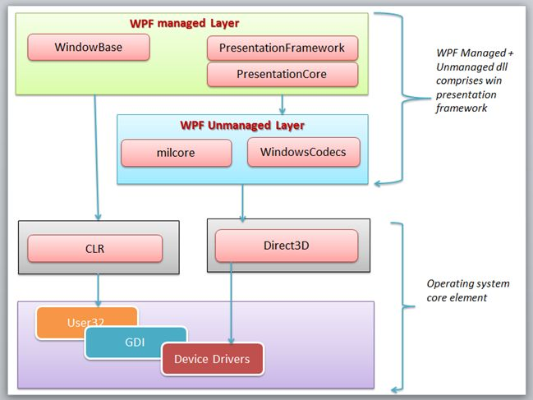

### **Managed Module:**

**PresentationFramework**.**dll**: This section contains high-level features like application windows, panels, styles controls, layouts, content and so on that helps us to build our application.

**PresentationCore**.**dll**: This is a low-level API exposed by WPF providing features for 2D, 3D, geometry and so on.

**WindowsBase**.**dll**: It holds the more basic elements that are capable to be reused outside the WPF environment like Dispatcher objects and Dependency objects.

### **Un Managed Layer**

This section is unmanaged code because it acts as a bridge between WPF managed and the DirectX / User32 unmanaged API.

**milCore**.**dll**: It is called the Media Integration Layer (MIL) and resides in milCore.dll. The purpose of the milCore is to interface directly with DirectX and provide basic support for 2D and 3D surface.

**WindowsCodecs**.**dll**: WindowsCodecs support in WPF applications like image processing, image displaying and scaling and so on.

**Core operating System Layer (Kernel)**  
  
This layer has OS core components like User32, GDI, Device Drivers, Graphic cards and so on. These components are used by the application to access low-level APIs.

**DirectX**: DirectX is the low-level API through which WPF renders all graphics. DirectX talks with drivers and renders the content.

**User32**: User32 actually manages memory and process separation. It is the primary core API that every application uses. User32 decides which element will be placed where on the screen.

**GDI**: GDI stands for Graphic Device Interface. GDI provides an expanded set of graphics primitives and a number of improvements in rendering quality.

**CLR**: WPF leverages the full .NET Framework and executes on the Common Language Runtime (CLR).

**Device** **Drivers**: Device Drivers are used by the applications to access low-level APIs.

## WPF Class Hierarchy

**Dispatcher Object**

WPF uses single threaded model it means entire UI is owned by single thread. So you can’t access UI Elements from another thread. To overcome with this situations WPF introduced dispatcher. Almost all UI Elements are derived from DispatcherObject class. This class contains two methods CheckAccess and VerifyAccess. CheckAccess method returns true if calling thread has access to this object and VerifyAccess throws an exception if calling thread does not have access to that object. So using this simple functionality all WPF objects are being able to determine that they only used by UI Thread.

**Dependency Object**

Dependency Object is the base class that supports Dependency Property and Attached Property. The Dependency Properties are used in Data Binding. You can create your own Dependency Property by deriving Dependency Object to you own class. Dependency Object has two Major methods GetValue and SetValue. GetValue method used to get value from Dependency Property and SetValue method used to set value to Dependency Property. I will explain more about data binding in my future posts.

**Visual**

Each and every element that has visual representation and appears in WPF Window is derived from Visual class. Visual class provides some basic Drawing functionality to encapsulate drawing instructions also some drawing related information like clipping, opacity etc. It also has some basic methods to add and remove visuals. Visual class also provides link between managed libraries and milcore.dll that renders display.

**UI Element**

UI Element added support for Layout, Focus, Input, Event, command bindings etc. These are core and essential features of WPF. At UI element level basic layout is introduced – Measure and Arrange passes. Measure allows determining that how much size it would take and Arrange allows a parent to determine final size of each child. UI Element also introduce notation of command binding.

**Framework Element**

Framework element extends layout features of UI Element and adds support for features like data binding, animation and styles. It also supports key properties like HorizontalAlignment, VerticalAlignment, and Margin etc.

**Control**

Control is base class for almost all controls available in WPF such as Button, StatusBar, Combobox, Label etc. At this level many control level properties introduced like background, foreground and Font related properties like FontSize, FontStyle, FontWeight etc.

## **Why do we use WPF?**

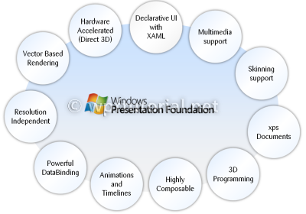

1. Vector based rendering and resolution Independence.

WPF uses vector graphics instead of bitmaps. Due to this we get the feature of resolution independence.

Question 1: My question here is how WPF manages the resolution independent property?

The basic unit of measurement in the WPF graphics system is the device independent pixel, which is 1/96th of an inch, regardless of actual screen resolution, and provides the foundation for resolution-independent and device-independent rendering. Each device-independent pixel automatically scales to match the dots-per-inch (dpi) setting of the system it renders on.

In WPF we Implement resolution Independency by understanding the layout control. There is mainly 2 keywords in it.

1. Auto : Takes only control space.

2. * : Takes all the available space.

1. Hardware acceleration

WPF uses DirectX to obtain GPU accelerated rendering. This GPU is the chip that powers your video card. So, By using hardware on your video card that is specifically designed for rendering graphics instead of software functions run by the CPU, the performance of your application's graphics and user interface is increased, or accelerated.

1. Declarative UI with XAML

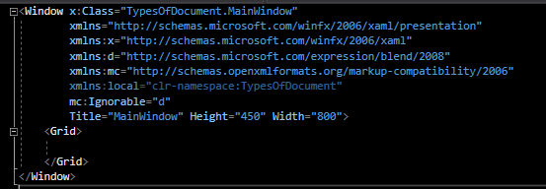

We will learn more about XAML in later part of this ebook.

1. Multimedia support
2. Types of Document supported in WPF

There are 2 types of documents supported in WPF:

1. Fixed Document – Static ready to print document.
2. Flow Document – Dynamic and formatting can be done.

