**Practical - 1**

**Aim: To implement Caesar cipher encryption-decryption.**

a ="HelloWorld"  
key = "a"  
# a = input("Enter Plain Text :")  
# key = input("Input Key:(Only First Letter will be Considered.) ")  
encryptedtext = ''  
def ciphertext(a, key, encryptedtext=None):  
 try:  
 key = int(key[0])  
 except Exception as e:  
 key = ord(key[0]) - (ord('A') if key.isupper() else ord('a'))  
 finally:  
 for i in range(len(a)):  
 encryptedtext += chr((ord(a[i]) + key) % (26 + (ord('A') if a[i].isupper() else ord('a'))))  
 return encryptedtext  
  
  
print(ciphertext(a, key,''))

**OUTPUT:**

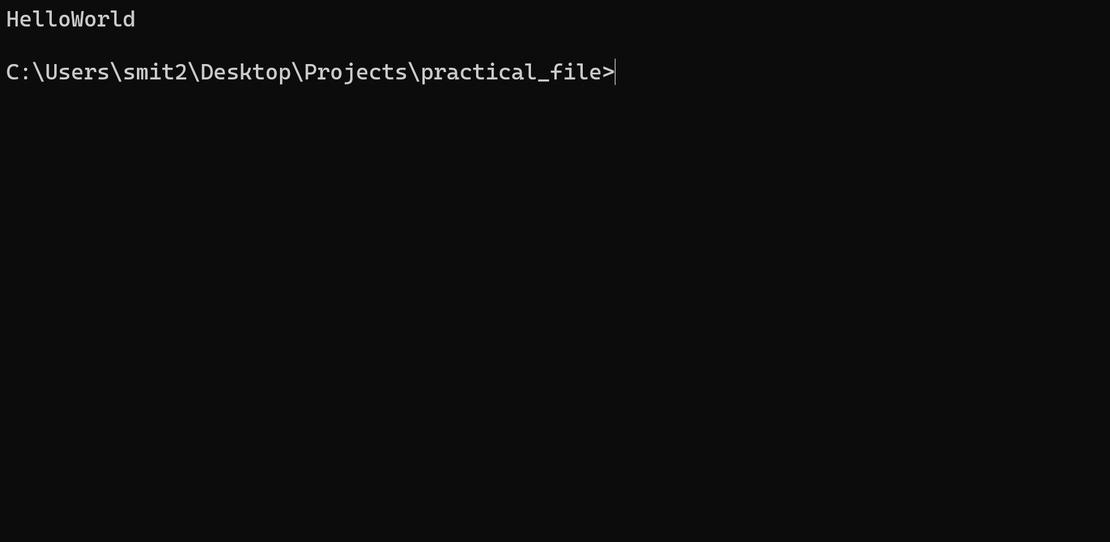

**Practical - 2**

**Aim: To implement Monoalphabetic cipher encryption-decryption.**

a ="HelloWorld"  
key = "a"  
# a = input("Enter Plain Text :")  
# key = input("Input Key:(Only First Letter will be Considered.) ")  
encryptedtext = ''  
def ciphertext(a, key, encryptedtext=None):  
 try:  
 key = int(key[0])  
 except Exception as e:  
 key = ord(key[0]) - (ord('A') if key.isupper() else ord('a'))  
 finally:  
 for i in range(len(a)):  
 encryptedtext += chr((ord(a[i]) + key) % (26 + (ord('A') if a[i].isupper() else ord('a'))))  
 return encryptedtext  
  
  
print(ciphertext(a, key,''))

**OUTPUT:**

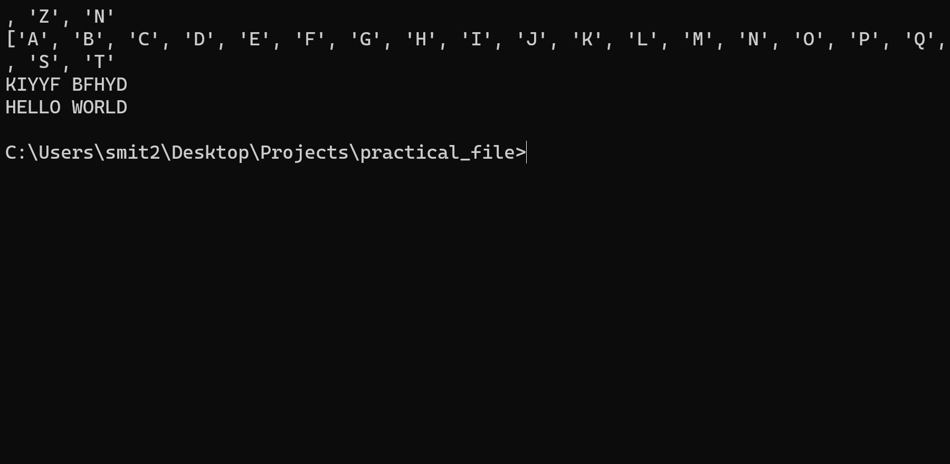

**Practical - 3**

**Aim: To implement Playfair cipher encryption-decryption.**

a ="HelloWorld"  
key = "a"  
# a = input("Enter Plain Text :")  
# key = input("Input Key:(Only First Letter will be Considered.) ")  
encryptedtext = ''  
def ciphertext(a, key, encryptedtext=None):  
 try:  
 key = int(key[0])  
 except Exception as e:  
 key = ord(key[0]) - (ord('A') if key.isupper() else ord('a'))  
 finally:  
 for i in range(len(a)):  
 encryptedtext += chr((ord(a[i]) + key) % (26 + (ord('A') if a[i].isupper() else ord('a'))))  
 return encryptedtext  
  
  
print(ciphertext(a, key,''))

**OUTPUT:**

