PROJECT REPORT
ELECTRIC VEHICLE CHARGING DEMAND FORECASTING
Forecasting EV charging demand using time, weather and traffic indicators
Project Details | Information
Student Name | Sumiksha Solanki
Project Area | Data Analytics / Time-Series Forecasting
Tools | Python, Excel, Tableau
Dataset | Synthetic demonstration dataset
Period | 180 days of hourly observations
Stations | Station A, B, C, D

1. Abstract
This project develops an analytics workflow to study and forecast electric vehicle charging demand using time, weather and traffic indicators. The workflow covers data preparation, exploratory analysis, a seasonal-naive time-series baseline, forecast evaluation, Tableau-ready outputs and charging optimization recommendations. The dataset is synthetic and is used only to demonstrate the methodology.

2. Objectives

Objectives
- Merge EV usage with weather and traffic indicators.
- Clean and transform hourly time-series data.
- Identify daily, hourly and weekday demand patterns.
- Build and evaluate a baseline forecasting model.
- Prepare Tableau-ready heatmap and forecast data.
- Develop charging optimization recommendations.

3. Tools and Technologies
Tool | Purpose
Python | Analysis and forecasting workflow
Pandas | Data cleaning and aggregation
NumPy | Numerical calculations
Matplotlib | Visualizations
Excel | PivotTables and reporting
Tableau | Interactive dashboard

4. Dataset Description
The dataset contains 4,320 hourly records across four example charging stations.
Field | Description
timestamp | Date and hour
station | Charging station identifier
temperature_c | Temperature in °C
rain_mm | Rainfall in mm
traffic_index | Traffic intensity indicator
charging_sessions | Hourly charging sessions

5. Methodology
- Convert timestamp to datetime and derive hour, date, weekday and month.
- Remove duplicate records and prepare analysis fields.
- Aggregate charging demand by hour, weekday and date.
- Use a 7-day seasonal-naive baseline as the transparent forecasting benchmark.
- Evaluate using MAE, RMSE and MAPE.
- Export data for Tableau and operational recommendations.

6. Exploratory Data Analysis
Average demand is 33.73 sessions per hour. The highest average hour is 19:00 and the lowest is 14:00. Thursday has the highest average weekday demand in the demonstration data.
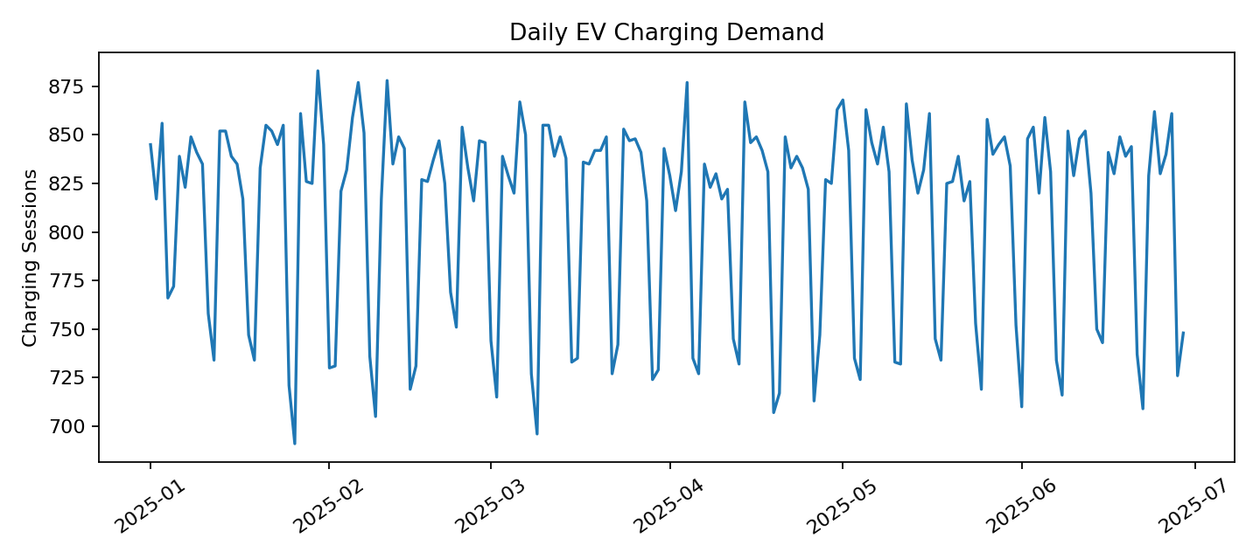
Figure 1. Daily EV charging demand trend.
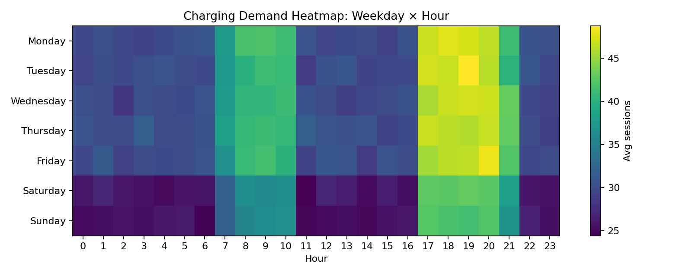
Figure 2. Weekday × hour charging-demand heatmap.

7. Forecasting Model and Results
Metric | Result
Model | 7-day seasonal-naive baseline
MAE | 17.51 sessions
RMSE | 21.45 sessions
MAPE | 2.17%
The evaluation results are calculated on the synthetic demonstration data. They should not be interpreted as real-world production accuracy.
The baseline is intentionally simple and provides a benchmark before testing ARIMA/SARIMA, Prophet or machine-learning models with weather and traffic features.

8. Tableau Dashboard Design
- KPI cards: total sessions, average demand and peak-hour demand.
- Demand line chart over time.
- Weekday × hour heatmap.
- Filters for station, month and weekday.
- Actual versus forecast comparison.
- Weather and traffic comparison views.
Suggested dashboard title: EV Charging Demand Forecast & Optimization Dashboard

9. Excel Analysis
- Raw Data worksheet.
- PivotTable for demand by weekday and hour.
- Forecast worksheet with actual versus predicted values.
- Conditional-formatting heatmap.
- Summary worksheet for KPIs and observations.

10. Charging Optimization Strategy
- Prioritize charger availability and queue monitoring near 19:00.
- Use lower-demand periods near {low}:00 for maintenance where operationally feasible.
- Monitor Thursday more closely because it has the highest average demand in this demonstration dataset.
- Use weather and traffic forecasts as additional model inputs in an advanced model.
- Compare forecasted demand with station capacity before making operational decisions.

11. Limitations
- Dataset is synthetic and does not represent actual EV station measurements.
- Baseline model does not fully model weather or traffic effects.
- Holidays, events, pricing, battery state-of-charge and station capacity are not included.
- Production deployment requires larger historical data and out-of-sample validation.

12. Future Scope
- Compare ARIMA/SARIMA, Prophet and machine-learning models.
- Add holiday, event and station-capacity features.
- Use real weather forecasts and traffic data where appropriate.
- Automate Tableau refreshes.
- Create alerts for predicted demand spikes and capacity constraints.

13. Conclusion
The project demonstrates an end-to-end EV charging demand analytics workflow from data preparation to forecasting and dashboard preparation. Recurring time patterns can support charging operations, while more advanced forecasting models can be evaluated as additional real-world data becomes available.

14. Deliverables
Deliverable | Status
EV + weather + traffic dataset | Completed
Forecasting model | Completed – seasonal-naive baseline
Forecast evaluation | Completed – MAE/RMSE/MAPE
Charging heatmap | Completed
Tableau-ready data | Completed
Optimization strategy | Completed
ARIMA/Prophet comparison | Future enhancement

15. References
- Python documentation.
- Pandas documentation.
- Matplotlib documentation.
- Tableau documentation.
- General time-series forecasting references for ARIMA/Prophet extensions.

