PROJECT REPORT 2

Cold-Chain Integrity and Last-Mile Reefer Monitoring System
An IoT prototype using Raspberry Pi 4

Circuit Diagram, Raspberry Pi Features and Program Flow Chart

Course: ECE-504 Internet of Things
Semester: Monsoon Semester 2026
Group No. 4: Sky is the Limit

Submitted by:
Vedant Solanki
(other group members names here)

1. Introduction
In India a big amount of fruits, vegetables and medicines gets spoiled while moving in refrigerated trucks (reefer trucks), because nobody comes to know when the cooling has stopped. The owner finds out only when the truck reaches the destination and by then the cargo is already damaged. As per the NABCONS study for Ministry of Food Processing Industries, post harvest loss in our country is around Rs. 92,000 crore every year, and a good part of it is because of breaks in the cold chain.
In our project we are making a small IoT unit which sits inside the reefer box and keeps checking the cargo all the time. It is build around a Raspberry Pi 4 Model B. Two DS18B20 probes measure temperature at two places inside the box and a MC-38 reed switch tells if the door is open. When something goes wrong the unit turns on a buzzer and red LED, tries to restart the cooling through a relay (a 5V fan acts as the compressor in our prototype), shows the reason on a 0.96 inch OLED for the driver, and sends a SMS with GPS location using the SIM7600 4G/GPS HAT. Every reading is saved with a SHA-256 hash linked to the previous one, so if anybody changes old data later it gets caught.
Our first report already covered the problem statement, objectives, architecture and cost. This report covers the circuit diagram with component selection, the features of Raspberry Pi with comparision to other platforms, and the flow chart of our program.

2. Materials Required
S.No | Component | Qty | Use in our project
1 | Raspberry Pi 4 Model B (4 GB) | 1 | Main controller, runs Python program and database
2 | DS18B20 waterproof temperature probe | 2 | Probe A near cooling outlet, Probe B at far corner
3 | 4.7 kΩ and 220 Ω resistors | 1 each | 1-Wire pull-up and LED current limit
4 | MC-38 magnetic reed switch | 1 | Door open / closed detection
5 | 5V active buzzer module + 5 mm red LED | 1 each | Sound and light alarm for driver
6 | 5V 1-channel relay module + 5V DC fan | 1 each | Auto restart of cooling (fan acts as compressor)
7 | SIM7600 4G/GPS HAT | 1 | SMS alert, 4G upload, GPS location and GPS time
8 | 0.96 inch I2C OLED display (SSD1306) | 1 | Shows temperature, status and alert to driver
9 | 32 GB high endurance microSD card | 1 | OS and local log database
10 | 5V 3A USB-C supply + UPS HAT / power bank | 1 each | Main power and backup on power cut
11 | Jumper wires, GPIO terminal breakout | 25, 1 | Connections that dont come out with vibration

We also need a SIM card with SMS pack (arranged seperately as it was not issued), a laptop for SSH, and Python libraries gpiozero, luma.oled, pyserial, sqlite3 and hashlib.

3. Circuit Diagram and Explanation
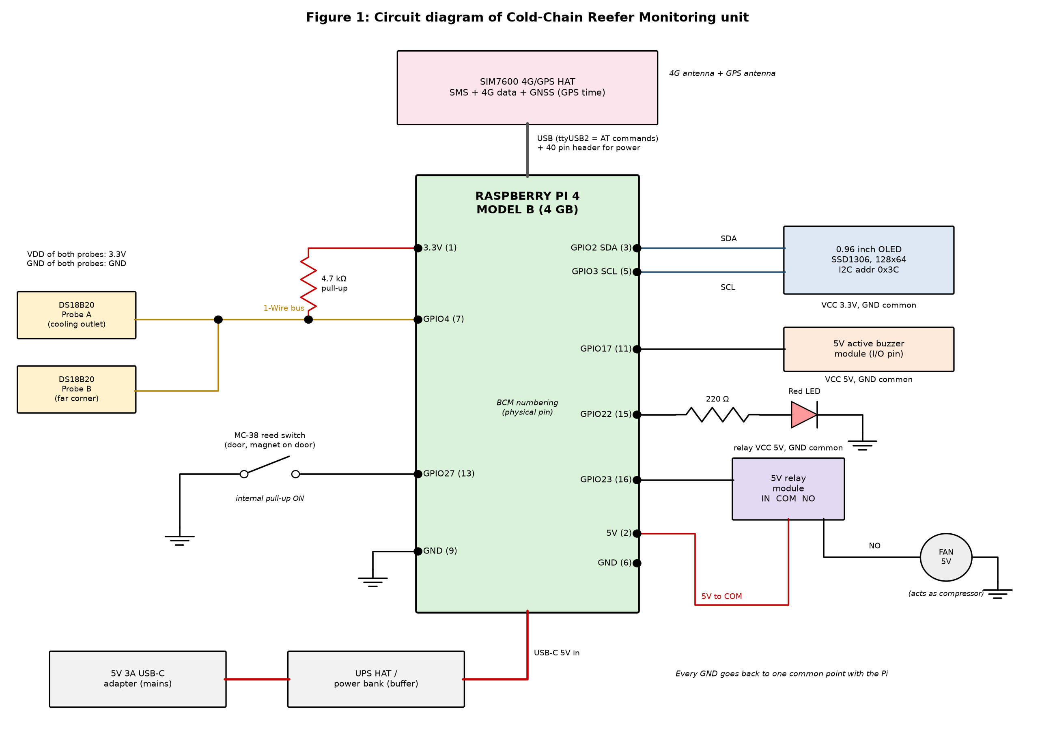
Figure 1: Circuit diagram (BCM GPIO numbering, physical pin in bracket)
Power: The 5V 3A adapter goes to the UPS HAT / power bank first and then to the Pi, so the battery acts as a buffer. On power cut the Pi keeps running long enough to write a POWER_LOSS record and shut down safely, so the SD card does not get corrupted. It also supports the peak current (about 3.5 A) when 4G transmit, relay, fan and buzzer all come ON together.
Temperature: Both DS18B20 probes share one data wire on GPIO4 with a single 4.7 kΩ pull-up to 3.3V. 1-Wire is open drain so the resistor pulls the line HIGH. Each probe has its own 64 bit ROM address, so Pi reads both on the same pin. We enabled it with dtoverlay=w1-gpio,gpiopin=4 and saved both ROM IDs in the config file so Probe A and B dont swap after reboot.
Door: The reed switch is between GPIO27 and GND with internal pull-up ON. Door closed means magnet is near, contact closes and pin reads LOW. Door open gives HIGH. We added 100 ms software debounce.
Display: OLED is on I2C (SDA to GPIO2, SCL to GPIO3) at address 0x3C, checked with i2cdetect -y 1. We gave it 3.3V and not 5V because its on board pull-ups would otherwise put 5V on the Pi pins which are only 3.3V tolerant.
Outputs: The active buzzer on GPIO17 needs only a HIGH signal, no PWM. The LED on GPIO22 goes through 220 Ω, so current is about (3.3 - 2.0) / 220 = 5.9 mA which is safe for the pin. GPIO23 drives the relay module IN pin; on the contact side 5V goes to COM and NO goes to the fan. The SIM7600 HAT is mounted on the 40 pin header and data goes over USB, where ttyUSB2 is used for AT commands (AT+CMGS for SMS, AT+CGPSINFO for GPS).

3.1 Inputs and outputs
Signal | Device / Pi pin | Interface | Technical details
IN: Temperature A, B | DS18B20 x 2 / GPIO4 | Digital 1-Wire | -55 to +125 °C, ±0.5 °C, 12 bit (0.0625 °C), 750 ms conversion
IN: Door status | MC-38 / GPIO27 | Digital input | LOW = closed, HIGH = open
IN: Location, speed, time | SIM7600 GNSS / USB | Serial, AT commands | Lat, lon, km/h, UTC at 1 Hz
OUT: Sound alarm | Active buzzer / GPIO17 | Digital output | About 2.3 kHz, 85 dB
OUT: Warning light | Red LED / GPIO22 | Digital output | 5.9 mA, solid or blinking
OUT: Cooling restart | Relay + fan / GPIO23 | Digital output | Contact 10 A, fan 150 mA
OUT: Driver display | OLED / GPIO2, GPIO3 | I2C, 0x3C | 128 x 64 mono, 5 rotating screens
OUT: SMS and cloud | SIM7600 4G / USB | AT+CMGS, MQTT | SMS with Maps link, JSON record + hash

3.2 Sensors, actuators and display with selection criteria
Our main points for selection were: it should work in cold and wet condition, it should be digital because Pi dont have ADC, and less wiring.
Part | Selected | Options checked | Why we selected it
Temperature | DS18B20 probe | LM35, DHT22, thermistor | Digital so no ADC needed, waterproof steel probe, works till -55 °C, many sensors on one pin. LM35 and thermistor are analog, DHT22 is not waterproof and slow
Door | MC-38 reed switch | IR, ultrasonic sensor | Needs no power, no false reading from fog inside reefer, reads like a push button
GPS / time | SIM7600 GNSS | NEO-6M module | Already inside the 4G HAT, also gives trusted UTC time for logs
Communication | SIM7600 4G | SIM800L 2G, WiFi | 2G is shutting down, WiFi is not there on highway
Sound | Active buzzer | Passive buzzer | Only ON/OFF needed, passive one needs PWM
Load switch | Relay module | MOSFET | Full isolation from Pi, can switch real compressor line later, driver circuit on board
Display | 0.96 inch OLED | 16x2 LCD | Only 4 wires, self lit so readable in dark box, no contrast pot, works well in cold

4. Raspberry Pi 4 Features and Comparison
Raspberry Pi 4 Model B is a single board computer which runs full Linux. It has a Broadcom BCM2711 quad core Cortex-A72 (64 bit) at 1.5 GHz, 4 GB LPDDR4 RAM in our board, microSD storage, 40 pin header with 28 GPIO (3.3V logic), 2 USB 3.0 and 2 USB 2.0 ports, Gigabit Ethernet, dual band WiFi, Bluetooth 5.0 and 5V 3A USB-C power. It has no ADC. The features we actually use are:
- GPIO: GPIO27 as input with internal pull-up, GPIO17, 22, 23 as outputs using gpiozero.
- 1-Wire and I2C: Built in drivers, so temperature is read from a file and OLED is driven with luma.oled.
- USB: SIM7600 HAT for SMS, 4G data and GPS through pyserial.
- Linux and multitasking: Sensor reading, OLED, SMS and upload run together. Program runs as a systemd service with watchdog so it restarts by itself after a crash.
- CPU, RAM and storage: SHA-256 hashing and SQLite database are easy for it, 30 days of data is only about 5 MB.

4.1 Comparison of platforms
Feature | Arduino UNO / Mega | Raspberry Pi 4 B | BeagleBone Black | Intel Galileo Gen 2 | Intel Edison
Type | Microcontroller | Single board computer | Single board computer | x86 board, Arduino shield compatible | Compute module (needs breakout)
Processor | ATmega328P / 2560, 8 bit, 16 MHz | 4 core Cortex-A72, 64 bit, 1.5 GHz | 1 core Cortex-A8, 1 GHz | Intel Quark X1000, 400 MHz | 2 core Atom 500 MHz + Quark MCU
RAM / storage | 2 KB / 32 KB (UNO), 8 KB / 256 KB (Mega) | 1 to 8 GB, microSD | 512 MB, 4 GB eMMC | 256 MB, 8 MB + microSD | 1 GB, 4 GB eMMC
OS | None | Linux | Linux (Debian) | Yocto Linux | Yocto Linux
GPIO / ADC | 14 / 6 (UNO), 54 / 16 (Mega) | 28 / none | 65 / 7 (1.8V max) | 20 / 6 | 40 / via breakout
Logic level | 5V | 3.3V | 3.3V | 3.3V or 5V | 1.8V
Networking | None, needs shield | Ethernet, WiFi, BT | Ethernet | Ethernet | WiFi, BT
Real time I/O | Yes | No | Yes (2 PRU) | Limited | Yes (MCU)
Power | 0.25 to 0.4 W | 3 to 6 W | About 2 W | About 3 W | About 1 W
Approx. price | Rs. 450 to 3,500 | Rs. 6,500 | Rs. 6,000 to 7,000 | USD 65 at launch | USD 50 at launch
Status | Available | Available | Available | Discontinued 2017 | Discontinued 2017

Platform | Strengths | Weaknesses
Arduino UNO / Mega | Cheap, easy, real time, has ADC, very low power, starts instantly | Very little memory, no networking or OS, cannot do database or hashing
Raspberry Pi 4 | Powerful, full Linux and Python, WiFi/BT/Ethernet built in, biggest community | No ADC, not real time, more power, SD card can corrupt on power cut
BeagleBone Black | Many GPIO, 12 bit ADC, PRU for real time, eMMC on board | Slower CPU, 512 MB RAM, no WiFi, costlier, smaller community
Intel Galileo Gen 2 | Works with Arduino shields, x86 with Linux, Ethernet | Slow CPU and slow GPIO, high power, discontinued
Intel Edison | Very small, WiFi and BT, 1 GB RAM, low power | Needs breakout board, 1.8V logic needs level shifters, discontinued

We selected Raspberry Pi because our unit has to keep a database, hash every reading, talk to a 4G module, update the OLED and upload to cloud at the same time. Arduino does not have enough memory for this, BeagleBone is slower and costlier, and both Intel boards are discontinued. Since all our sensors are digital, the missing ADC did not matter. For a real product with many trucks an ESP32 version will be cheaper, but for a prototype the Pi made our coding and debugging much faster.

5. Program Flow Chart
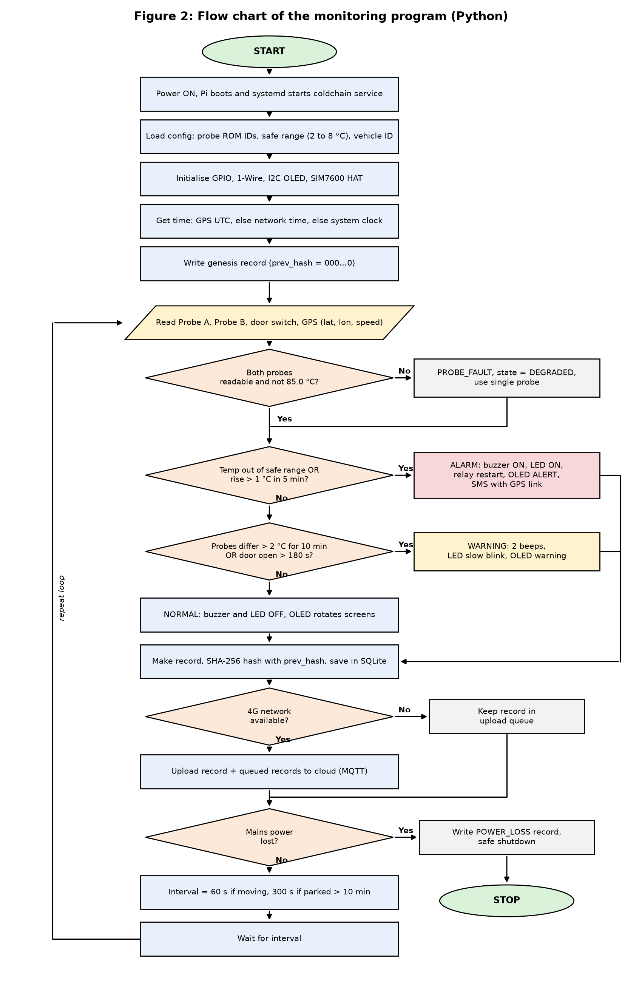
Figure 2: Flow chart of the monitoring program
On power ON, systemd starts our Python program. It loads the config (probe ROM IDs, safe range like 2 to 8 °C for vaccines, vehicle ID), initialises GPIO, 1-Wire, OLED and the SIM7600, takes time from GPS (else network, else system clock) and writes the first genesis record. Then the loop starts and reads both probes, the door and GPS.
If a probe is not responding or gives 85.0 °C (the power on default of DS18B20, not a real value) it logs PROBE_FAULT and continues with one probe. If temperature is out of range or has risen more than 1 °C in 5 minutes, it goes to ALARM: buzzer, LED, relay restart, OLED alert and SMS (max one per fault in 15 minutes so the manager does not recieve hundreds of messages). If the probes differ by more than 2 °C for 10 minutes or door is open more than 180 s, it is a WARNING. Otherwise state is NORMAL.
Every cycle a record is made, hashed with the previous hash and saved in SQLite. If 4G is available it is uploaded with any queued records, otherwise it waits in the queue. If mains power is lost the program writes POWER_LOSS and shuts down safely. Else it waits 60 s (moving) or 300 s (parked) and repeats.

6. Conclusion
In this report we gave the materials, circuit diagram, inputs and outputs and the reason for selecting each part, mostly digital parts that work well in cold. After comparing five platforms we found Raspberry Pi 4 fits our prototype best because we need Linux, database, hashing and 4G together. The flow chart shows that local action is taken first and data is saved and uploaded after. Next we will finish the code as per this flow chart and run the test cases from our first report.

References
[1] Raspberry Pi Ltd., Raspberry Pi 4 Model B Product Brief.
[2] Analog Devices, DS18B20 1-Wire Digital Thermometer datasheet; Solomon Systech, SSD1306 datasheet.
[3] SIMCom, SIM7600 Series AT Command Manual.
[4] Arduino UNO R3 / Mega 2560 specs (docs.arduino.cc); BeagleBone Black System Reference Manual; Intel Galileo Gen 2 and Intel Edison datasheets.
[5] Group 4, Project Report: Cold-Chain Integrity and Last-Mile Reefer Monitoring System, ECE-504, 2026.

