IoT Experiment Set 3
Circuit Diagrams — Experiments 21 to 31
Arduino UNO · 7-Segment Display · Serial Monitor/Plotter · HC-SR04 · 16x2 LCD · Ethernet Shield / ThingSpeak
Vedant Solanki

How to Read the Diagrams
- Red wire / +5V tag: Arduino 5V supply (breadboard + rail).
- Black wire / GND tag: Arduino GND (breadboard − rail).
- Coloured wires: signal lines. Each digital or analog pin has its own colour.
- Grey thick line: USB cable to the PC (power, upload and Serial Monitor). Green-teal thick line: Ethernet cable.
- A black dot marks a real electrical junction. Wires that cross without a dot are not connected.
- × marks a pin that is left unconnected.
- All LEDs and display segments use a 220 Ω series resistor. The LED's long leg (+, anode) faces the Arduino pin.

Summary of Pins Used
Exp | Input pin(s) | Output pin(s) | Extra hardware
21 | — | D2–D8 (segments a–g) | 7-segment display + 7 × 220 Ω
22 | A0 (pot) | Serial | Potentiometer
23 | D2 (button) | Serial | Push button + pull-up resistor
24 | A0 (pot) | D9 PWM LED + Serial | Potentiometer + LED
25 | A0 (pot) | D9 PWM LED + Serial | Same as 24 (no map())
26 | USB serial in | USB serial out | None
27 | USB serial in | D3, D4, D5 (LEDs) | 3 LEDs + 3 × 220 Ω
28 | D8 (Echo) | D7 (Trig) + Serial | HC-SR04
29 | D8 (Echo) | D7 (Trig); D10–D13 reserved | HC-SR04 + Ethernet Shield
30 | — | D12 RS, D11 E, D5–D2 DB4–DB7 | 16x2 LCD + 10 kΩ pot + 220 Ω
31 | Ethernet (client) | Serial | 2 × (UNO + Ethernet Shield)

Experiment 21 — 7-Segment Display Counting 0 to 9
A single common-cathode 7-segment display counts from 0 to 9, changing every 2 seconds. Each segment a–g is driven by its own digital pin (D2–D8) through its own 220 Ω resistor, and the common pin goes to GND.
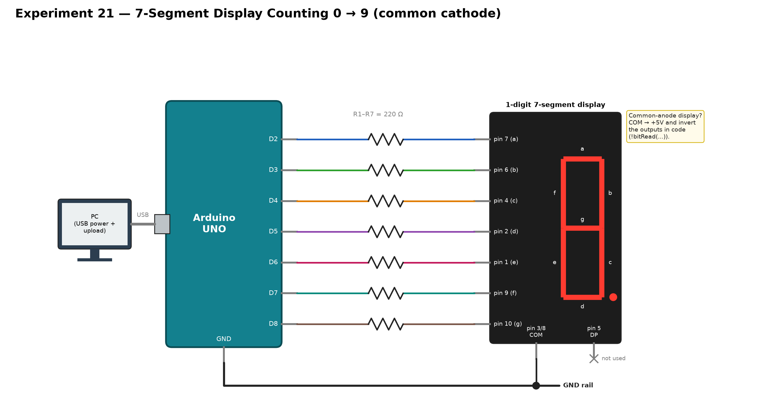
Figure 1: Circuit diagram of Experiment 21

Connections
# | Connection
1 | Power the Arduino UNO from the PC using the USB cable
2 | Arduino Digital Pin 2 — one end of Resistor 1
3 | Resistor 1 other end — display pin 7 (segment a)
4 | Arduino Digital Pin 3 — one end of Resistor 2
5 | Resistor 2 other end — display pin 6 (segment b)
6 | Arduino Digital Pin 4 — one end of Resistor 3
7 | Resistor 3 other end — display pin 4 (segment c)
8 | Arduino Digital Pin 5 — one end of Resistor 4
9 | Resistor 4 other end — display pin 2 (segment d)
10 | Arduino Digital Pin 6 — one end of Resistor 5
11 | Resistor 5 other end — display pin 1 (segment e)
12 | Arduino Digital Pin 7 — one end of Resistor 6
13 | Resistor 6 other end — display pin 9 (segment f)
14 | Arduino Digital Pin 8 — one end of Resistor 7
15 | Resistor 7 other end — display pin 10 (segment g)
16 | Display pin 3 or 8 (common) — Arduino GND
Note: If the display is common-anode, connect the COM pin to +5V and invert the outputs in the sketch with !bitRead(...).

Experiment 22 — Potentiometer Value on Serial Monitor / Plotter
The potentiometer acts as a voltage divider between 5V and GND. Its wiper feeds A0, and the 0–1023 reading is sent over USB to the Serial Monitor and the Serial Plotter.
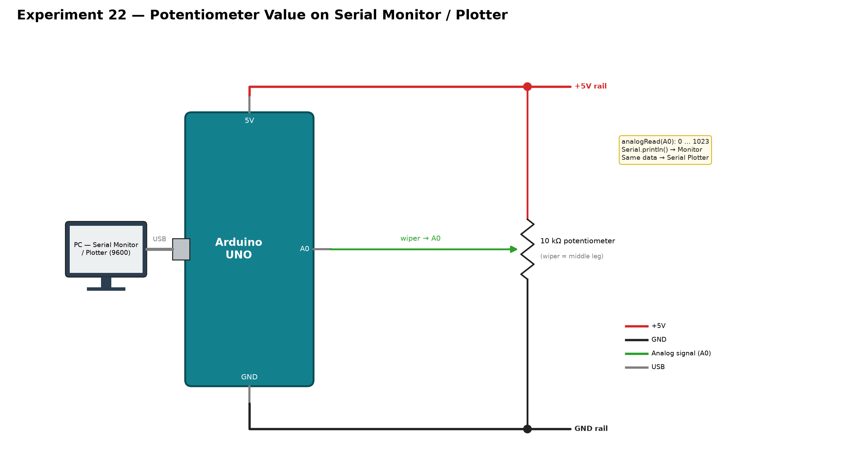
Figure 2: Circuit diagram of Experiment 22

Connections
# | Connection
1 | Power the Arduino UNO from the PC using the USB cable
2 | Potentiometer outer leg A — Arduino 5V
3 | Potentiometer outer leg B — Arduino GND
4 | Potentiometer wiper (middle leg) — Arduino A0
Note: The Serial Monitor and the Serial Plotter cannot be open at the same time. Set the baud rate to 9600.

Experiment 23 — Push Button State on Serial Monitor / Plotter
A pull-up resistor keeps D2 HIGH (1) while the button is released. Pressing the button pulls the junction to GND (0).
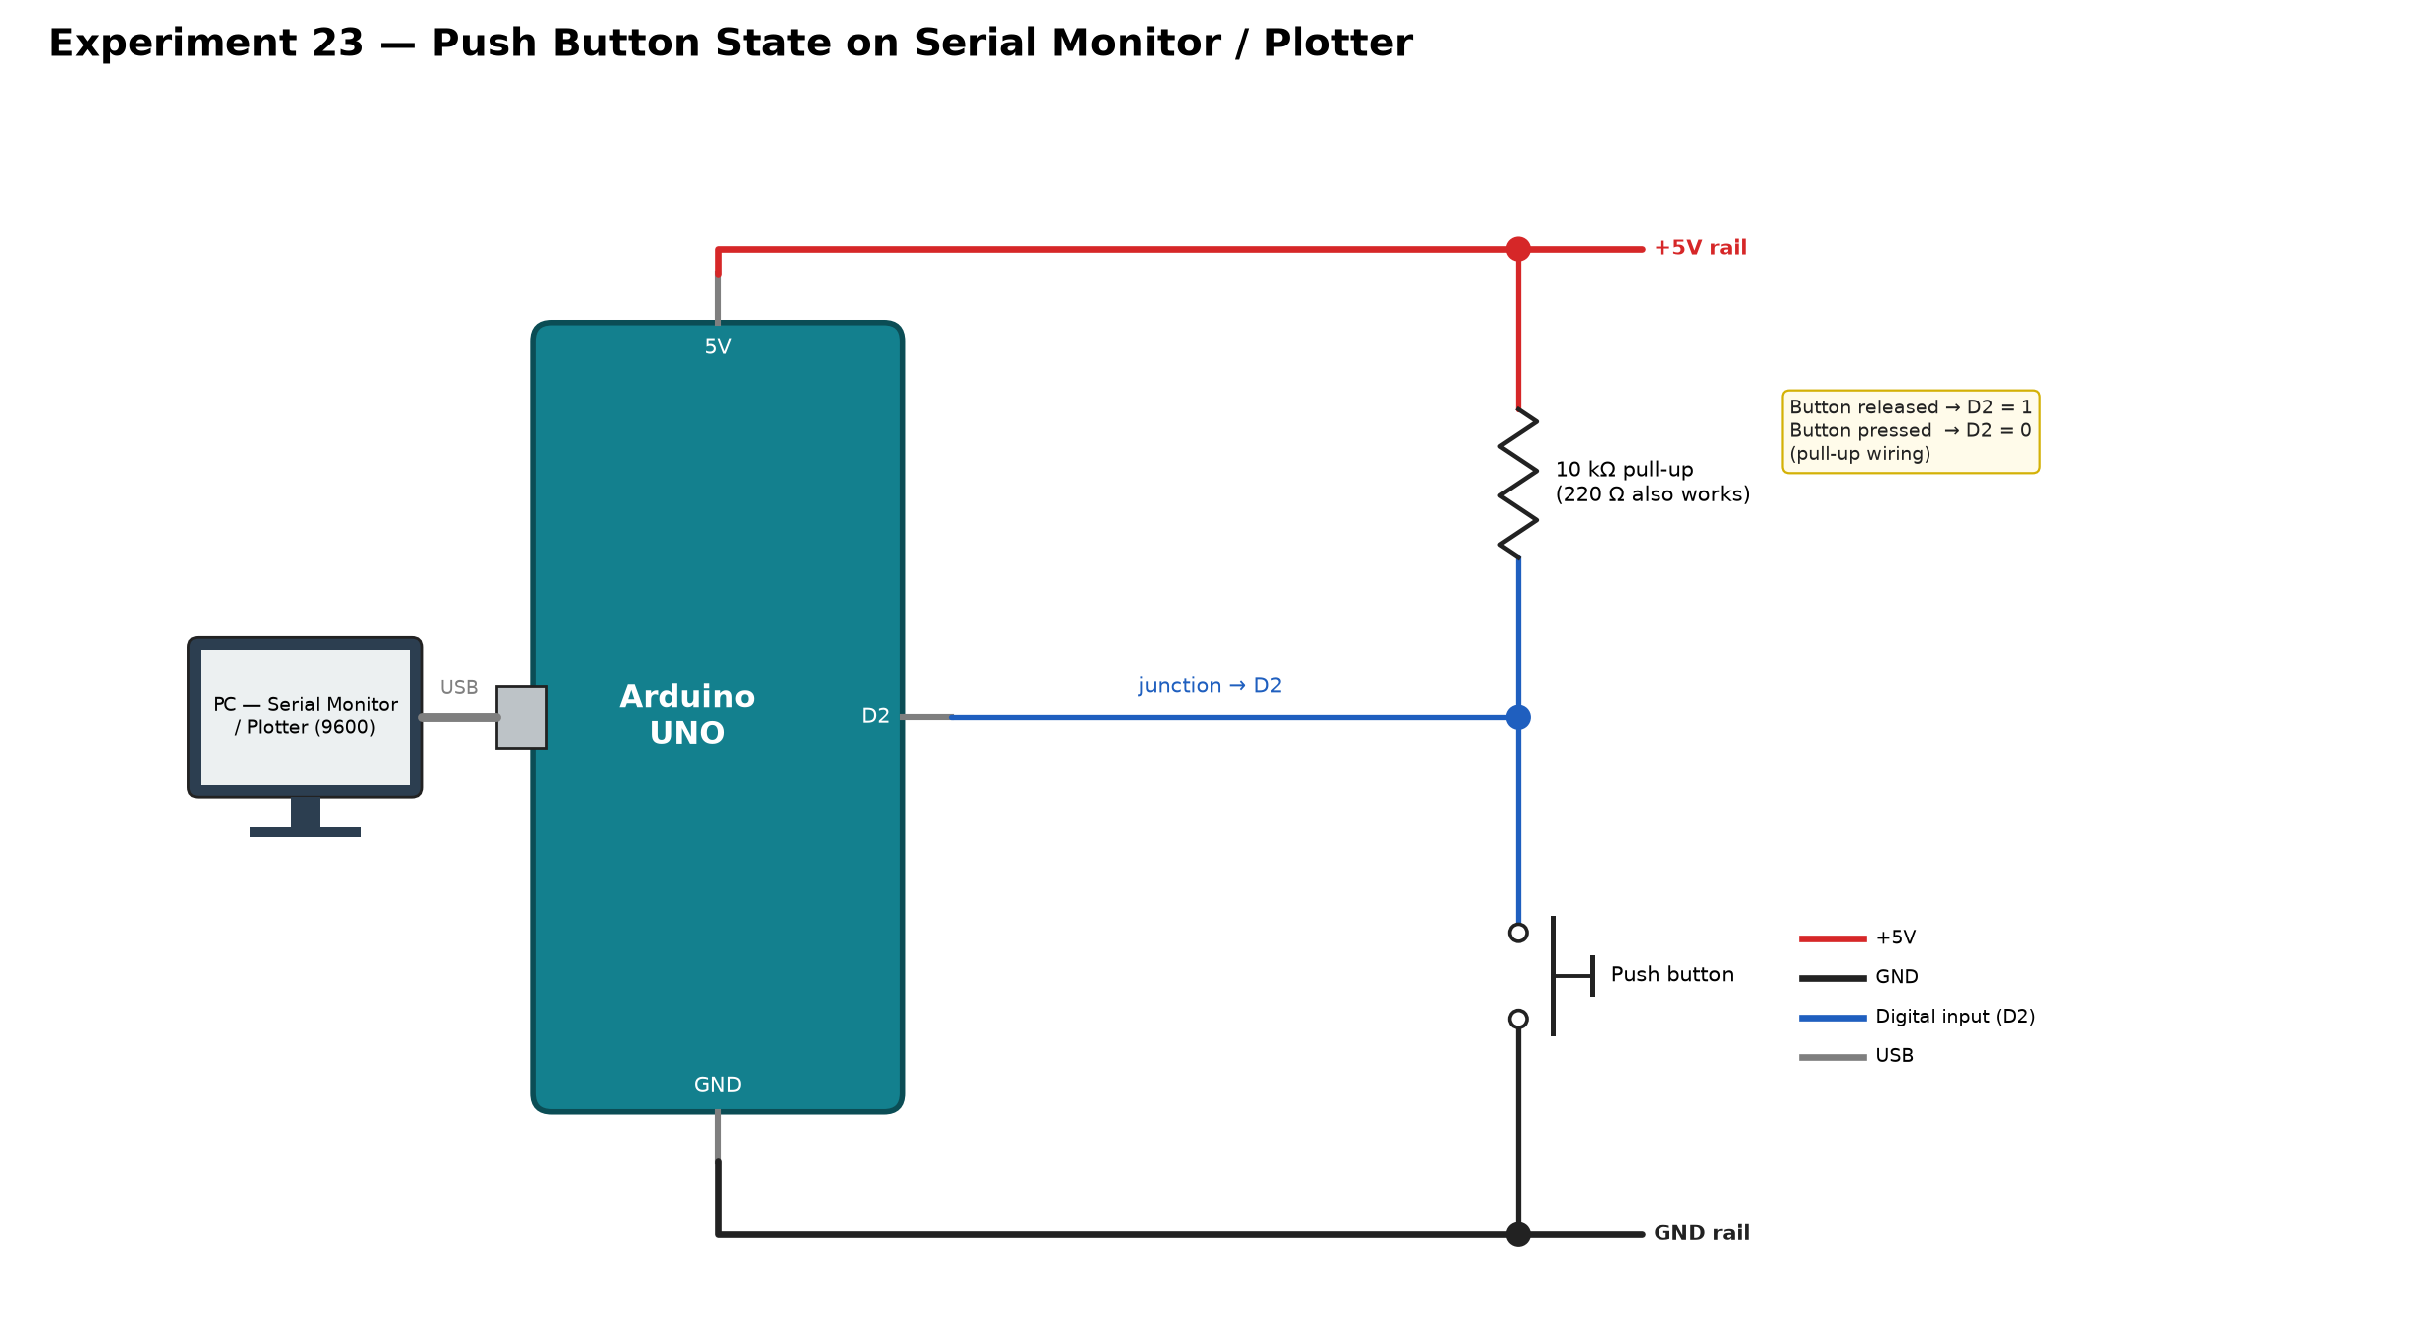
Figure 3: Circuit diagram of Experiment 23

Connections
# | Connection
1 | Power the Arduino UNO from the PC using the USB cable
2 | Resistor (10 kΩ recommended, 220 Ω also works) — one end to Arduino 5V
3 | Resistor other end — switch Side A (its two same-side legs, internally joined) (this row is the junction)
4 | Switch Side B (its two same-side legs, internally joined) — Arduino GND
5 | Junction of resistor and switch (step 3) — Arduino Digital Pin 2
Note: The junction of the resistor and the button is the only point wired to D2.

Experiment 24 — Potentiometer → Serial Monitor + LED Brightness (map)
The potentiometer on A0 sets the PWM duty cycle of the LED on D9 (outputValue = map(sensorValue, 0, 1023, 0, 255)). Both values are printed to the Serial Monitor.
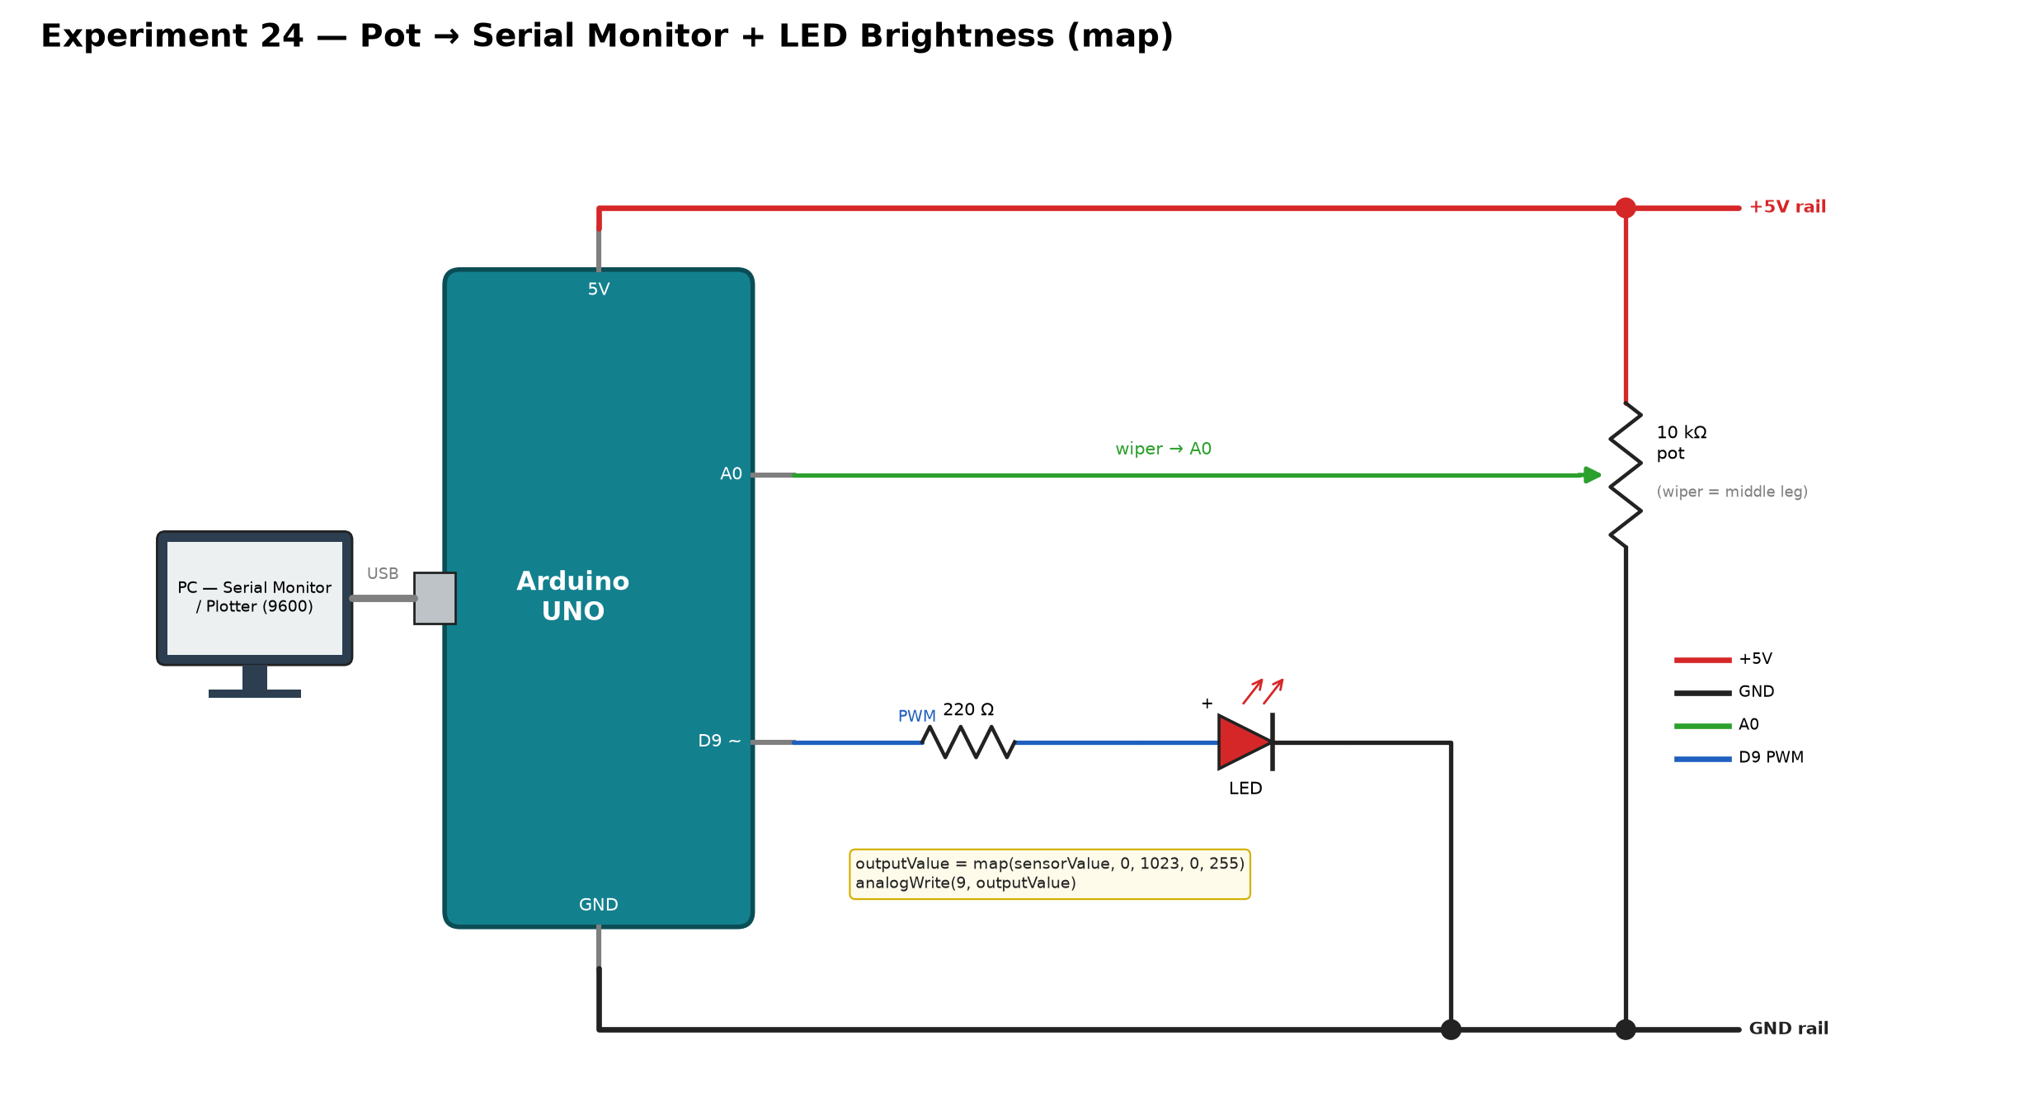
Figure 4: Circuit diagram of Experiment 24

Connections
# | Connection
1 | Power the Arduino UNO from the PC using the USB cable
2 | LED anode (long leg) — one end of the resistor
3 | Resistor other end — Arduino Digital Pin 9 (9~, PWM)
4 | LED cathode (short leg) — Arduino GND
5 | Potentiometer outer leg A — Arduino 5V
6 | Potentiometer outer leg B — Arduino GND
7 | Potentiometer wiper (middle leg) — Arduino A0
Note: D9 is a PWM pin (~). The LED needs its 220 Ω series resistor.

Experiment 25 — Same Circuit as 24, Without map()
The hardware is identical to Experiment 24. The sketch scales the reading with outputValue = sensorValue / 4 instead of map().
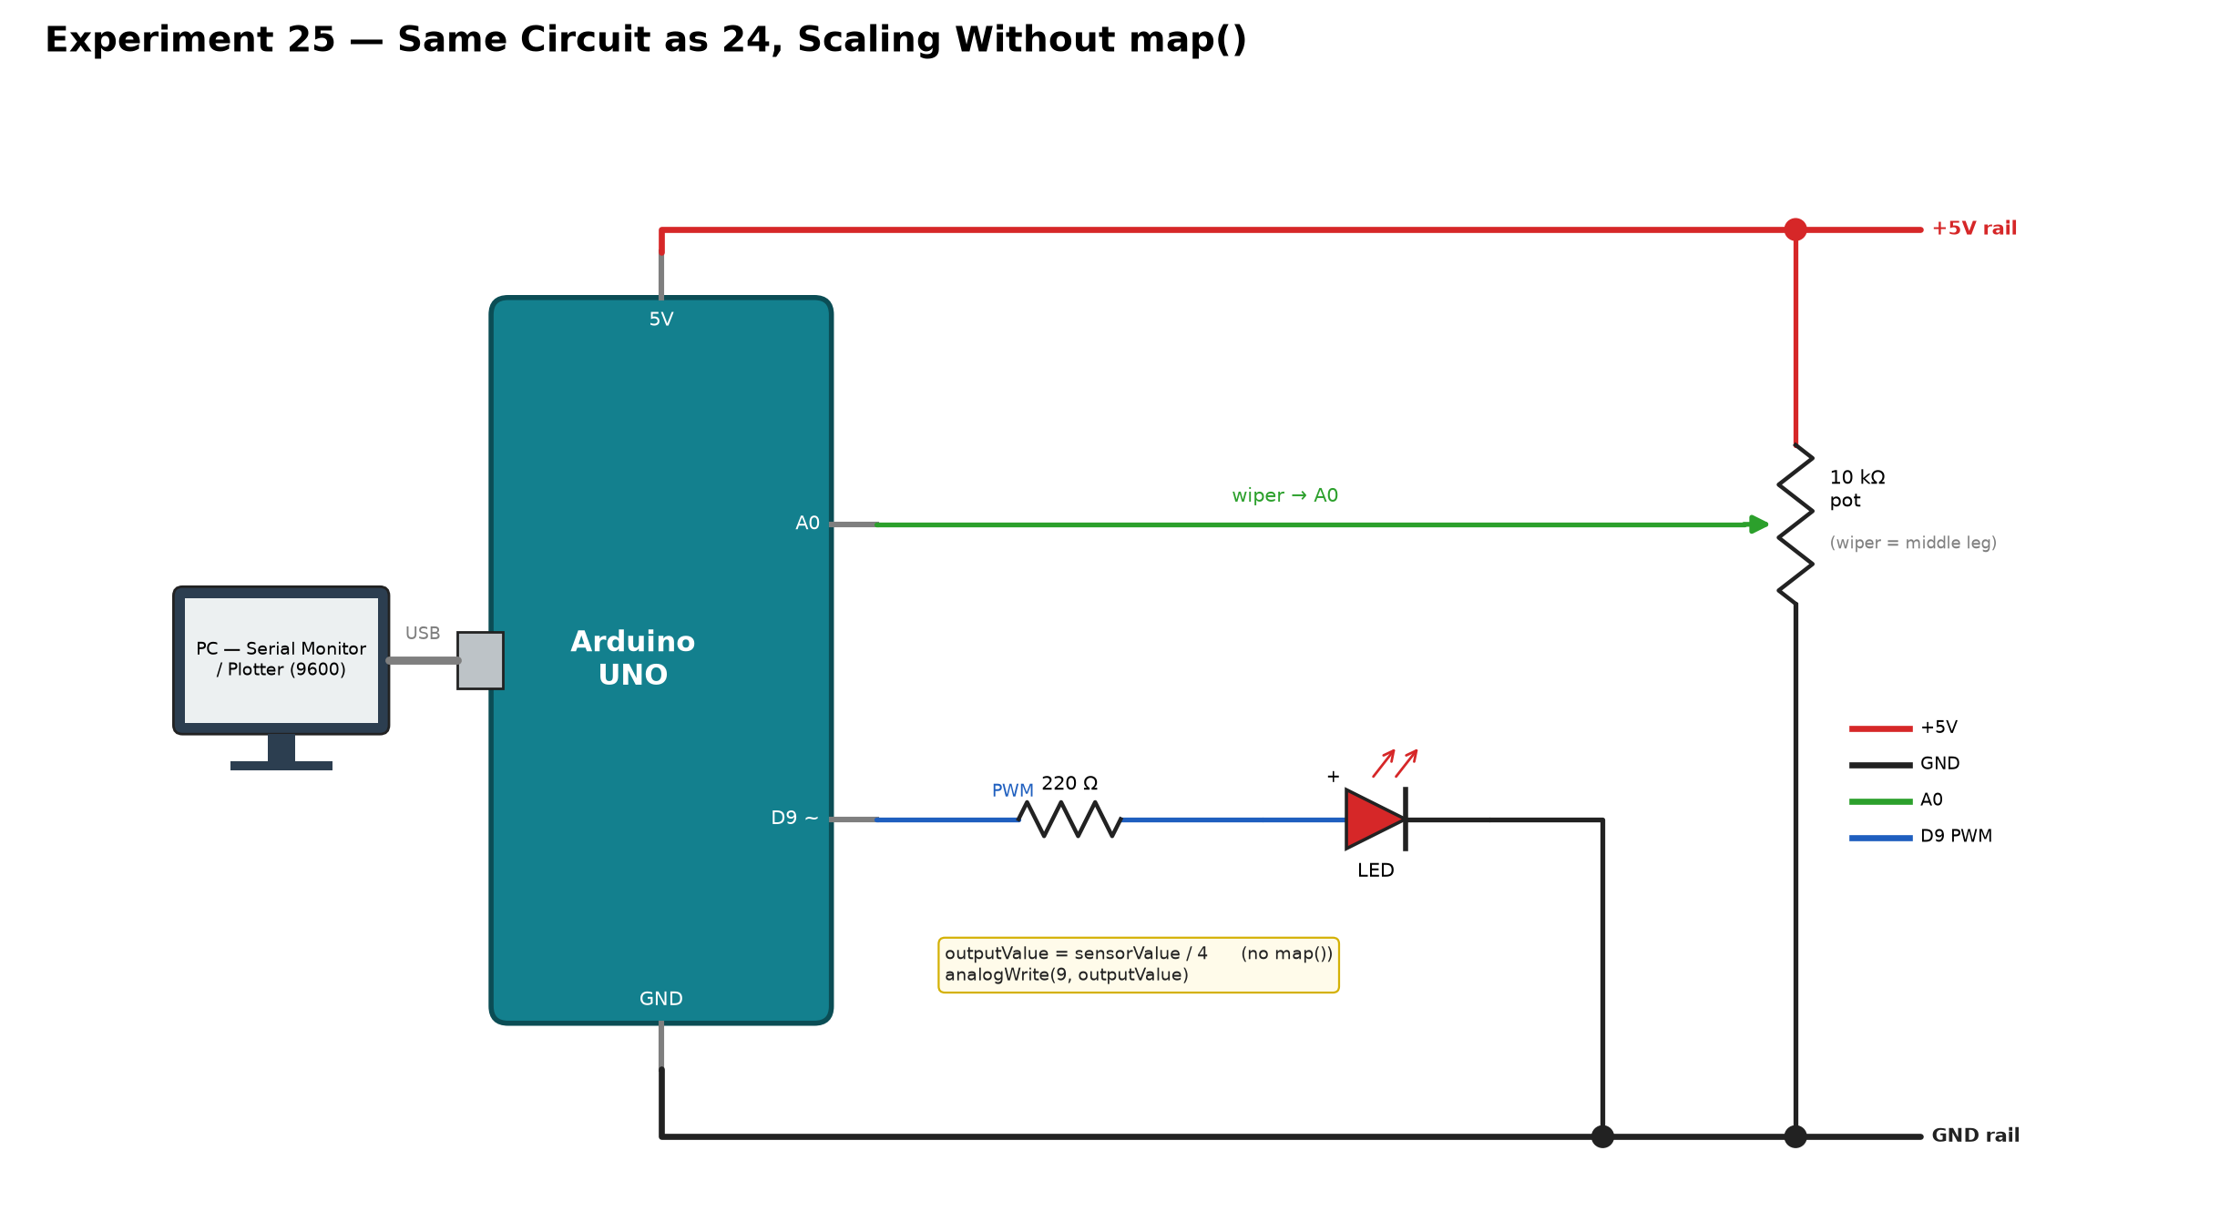
Figure 5: Circuit diagram of Experiment 25

Connections
# | Connection
1 | Power the Arduino UNO from the PC using the USB cable
2 | LED anode (long leg) — one end of the resistor
3 | Resistor other end — Arduino Digital Pin 9 (PWM)
4 | LED cathode (short leg) — Arduino GND
5 | Potentiometer outer leg A — Arduino 5V
6 | Potentiometer outer leg B — Arduino GND
7 | Potentiometer wiper (middle leg) — Arduino A0
Note: No wiring changes from Experiment 24.

Experiment 26 — Serial Read (Typing to the Arduino)
No external components. A character typed in the Serial Monitor is sent over USB, and the Arduino replies with its ASCII code.
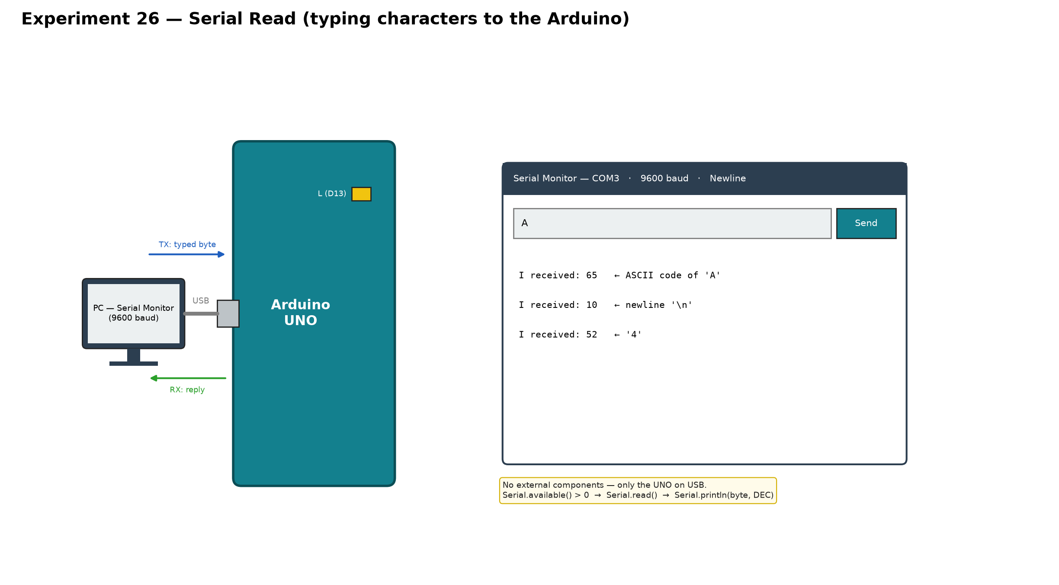
Figure 6: Circuit diagram of Experiment 26

Connections
# | Connection
1 | Power the Arduino UNO from the PC using the USB cable
Note: With the line ending set to Newline, an extra 'I received: 10' appears for the '\n' character.

Experiment 27 — Typed Number 3, 4 or 5 Lights That LED for 2 s
Three LEDs with 220 Ω resistors sit on D3, D4 and D5. The number typed in the Serial Monitor selects which pin goes HIGH for 2 seconds.
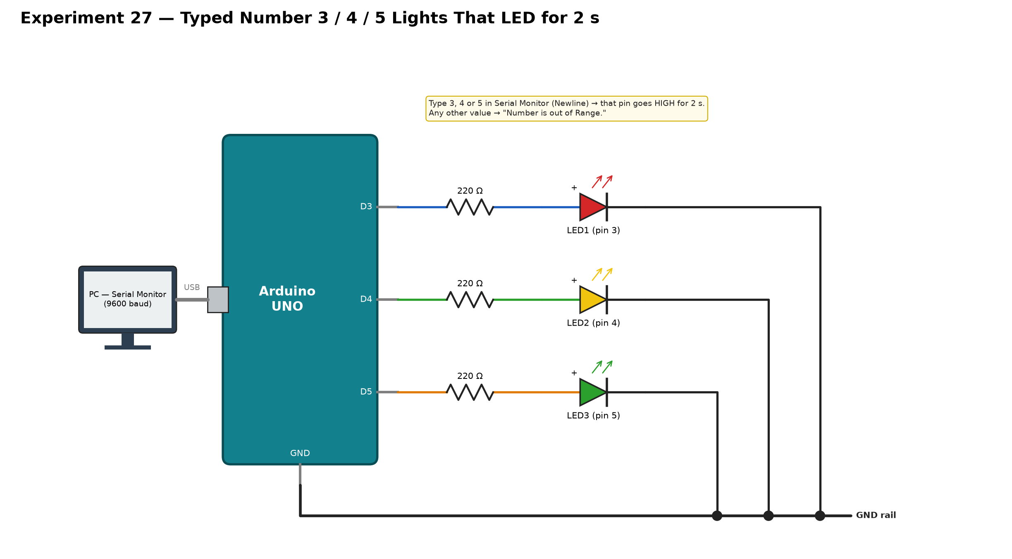
Figure 7: Circuit diagram of Experiment 27

Connections
# | Connection
1 | Power the Arduino UNO from the PC using the USB cable
2 | LED 1 anode (long leg) — Resistor 1 one end
3 | Resistor 1 other end — Arduino Digital Pin 3
4 | LED 1 cathode (short leg) — Arduino GND
5 | LED 2 anode (long leg) — Resistor 2 one end
6 | Resistor 2 other end — Arduino Digital Pin 4
7 | LED 2 cathode (short leg) — Arduino GND
8 | LED 3 anode (long leg) — Resistor 3 one end
9 | Resistor 3 other end — Arduino Digital Pin 5
10 | LED 3 cathode (short leg) — Arduino GND
Note: Any other input prints "Number is out of Range."

Experiment 28 — Distance Measurement with HC-SR04
Trig (D7) receives a 10 µs pulse. Echo (D8) stays HIGH for the round-trip time of the 40 kHz burst, so distance = duration × 0.034 / 2 cm.
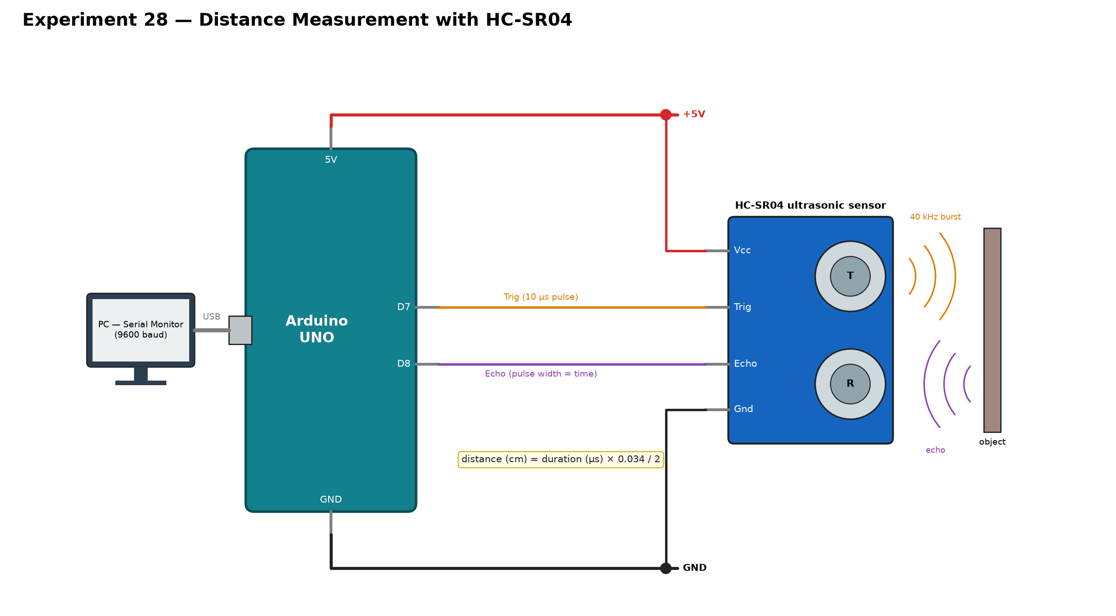
Figure 8: Circuit diagram of Experiment 28

Connections
# | Connection
1 | Power the Arduino UNO from the PC using the USB cable
2 | HC-SR04 Vcc — Arduino 5V
3 | HC-SR04 Gnd — Arduino GND
4 | HC-SR04 Trig — Arduino Digital Pin 7
5 | HC-SR04 Echo — Arduino Digital Pin 8
Note: Pins 7 and 8 are used so that the same wiring still works in Experiment 29, where the Ethernet Shield reserves D10–D13.

Experiment 29 — Ultrasonic Distance Sent to ThingSpeak
This is Experiment 28's sensor wiring with the W5100 Ethernet Shield stacked on the UNO. The measured distance is uploaded to ThingSpeak Field 1 through the router.
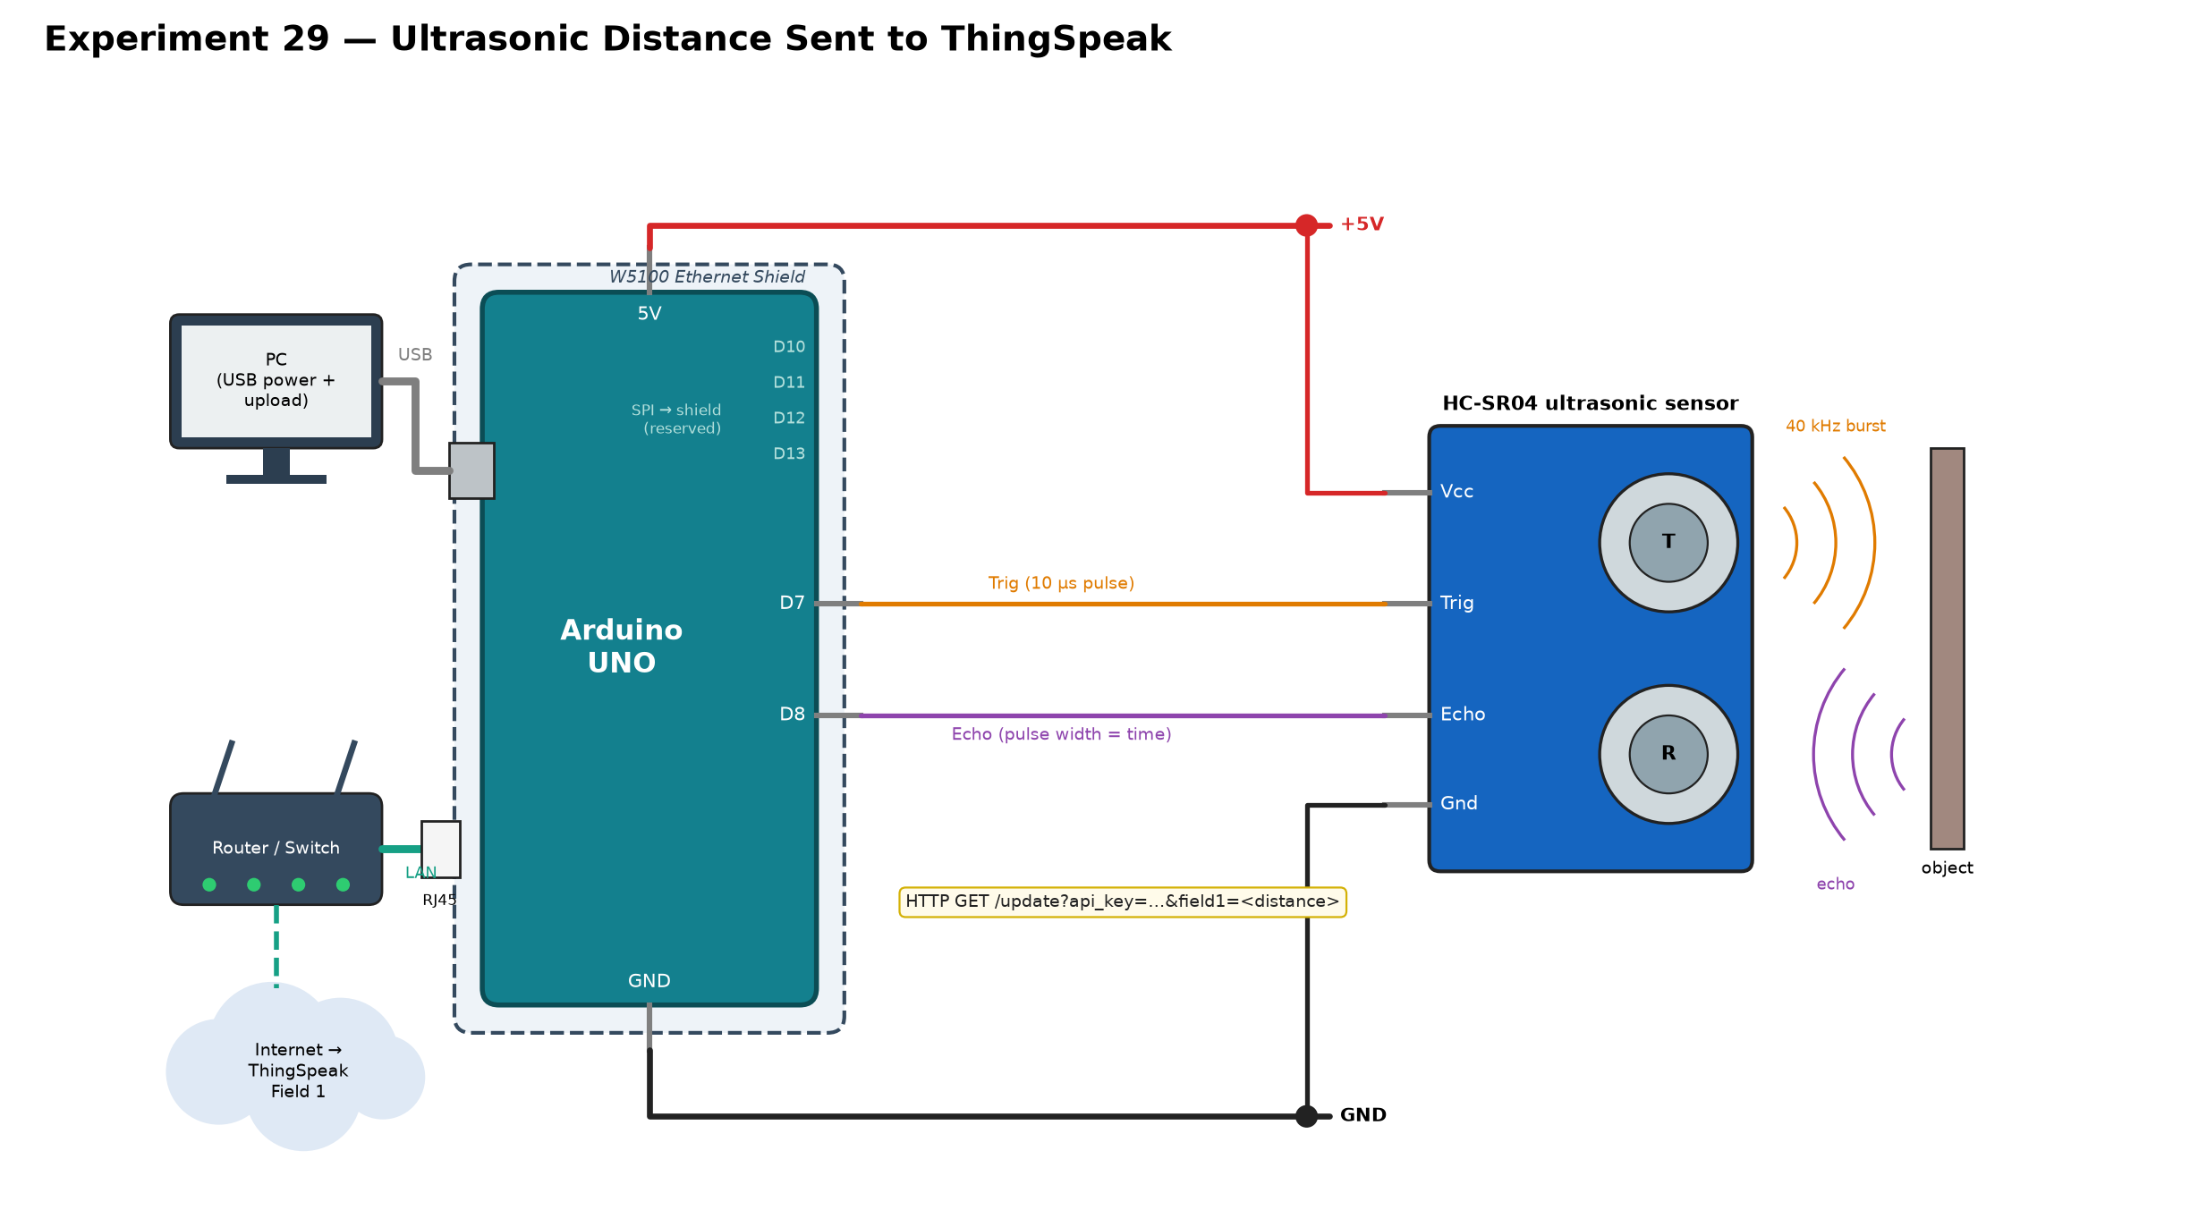
Figure 9: Circuit diagram of Experiment 29

Connections
# | Connection
1 | Seat the Ethernet Shield onto the Arduino UNO headers (all pins aligned, pressed flush)
2 | Ethernet Shield RJ45 port — network cable — router with internet access
3 | HC-SR04 Vcc — Arduino 5V
4 | HC-SR04 Gnd — Arduino GND
5 | HC-SR04 Trig — Arduino Digital Pin 7
6 | HC-SR04 Echo — Arduino Digital Pin 8
7 | Power the Arduino UNO (through the shield) from the PC using the USB cable
Note: D10–D13 are taken by the shield (SPI), so do not wire anything else to them.

Experiment 30 — 16x2 LCD (JHD162A) in 4-bit Mode
The LCD runs in 4-bit mode: RS→D12, E→D11, DB4–DB7→D5–D2. A 10 kΩ potentiometer sets the contrast on V0, the backlight is fed through 220 Ω, and R/W is tied to GND (write-only).
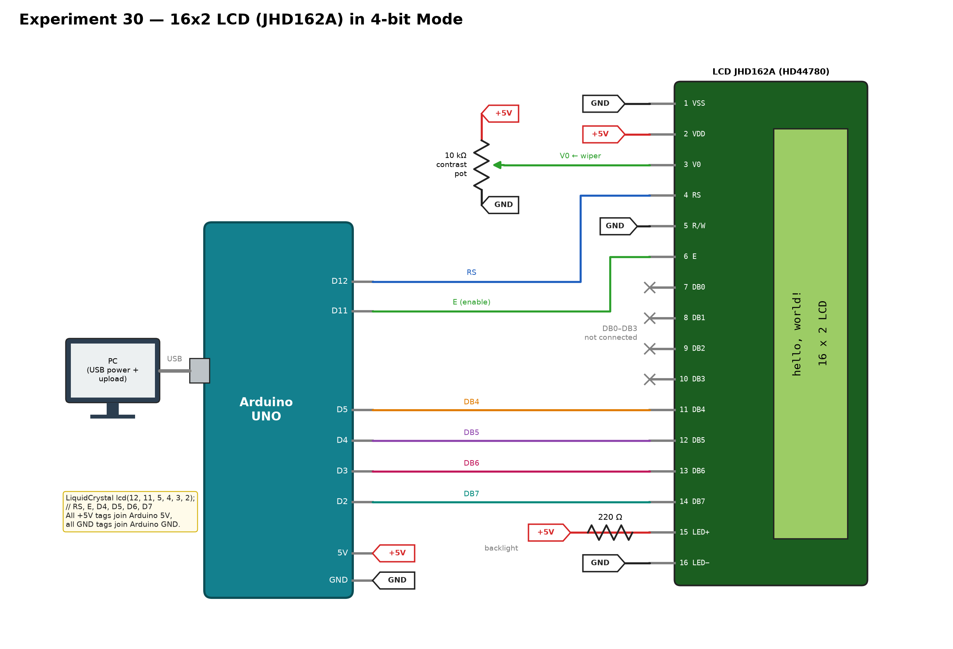
Figure 10: Circuit diagram of Experiment 30

Connections
# | Connection
1 | Power the Arduino UNO from the PC using the USB cable
2 | Arduino 5V — breadboard + rail; Arduino GND — breadboard − rail
3 | LCD pin 1 (VSS) — − rail (GND)
4 | LCD pin 2 (VDD) — + rail (5V)
5 | Potentiometer outer leg A — + rail (5V)
6 | Potentiometer outer leg B — − rail (GND)
7 | Potentiometer wiper (middle leg) — LCD pin 3 (V0) (contrast)
8 | LCD pin 4 (RS) — Arduino Digital Pin 12
9 | LCD pin 5 (R/W) — − rail (GND) (write-only)
10 | LCD pin 6 (E) — Arduino Digital Pin 11
11 | LCD pins 7–10 (DB0–DB3) — not connected
12 | LCD pin 11 (DB4) — Arduino Digital Pin 5
13 | LCD pin 12 (DB5) — Arduino Digital Pin 4
14 | LCD pin 13 (DB6) — Arduino Digital Pin 3
15 | LCD pin 14 (DB7) — Arduino Digital Pin 2
16 | LCD pin 15 (LED+) — one end of the 220 Ω resistor
17 | 220 Ω resistor other end — + rail (5V)
18 | LCD pin 16 (LED−) — − rail (GND)
Note: In the diagram, every +5V tag connects to Arduino 5V and every GND tag to Arduino GND (use the breadboard rails). If you see only blocks or a blank screen, adjust the contrast pot first.

Experiment 31 — Arduino B Reads Arduino A's Web Page
Board A (server, 192.168.1.177) runs the Experiment 18/19 web-server sketch. Board B (client, 192.168.1.178) connects to it on port 80, sends an HTTP GET and prints the returned page on its Serial Monitor.
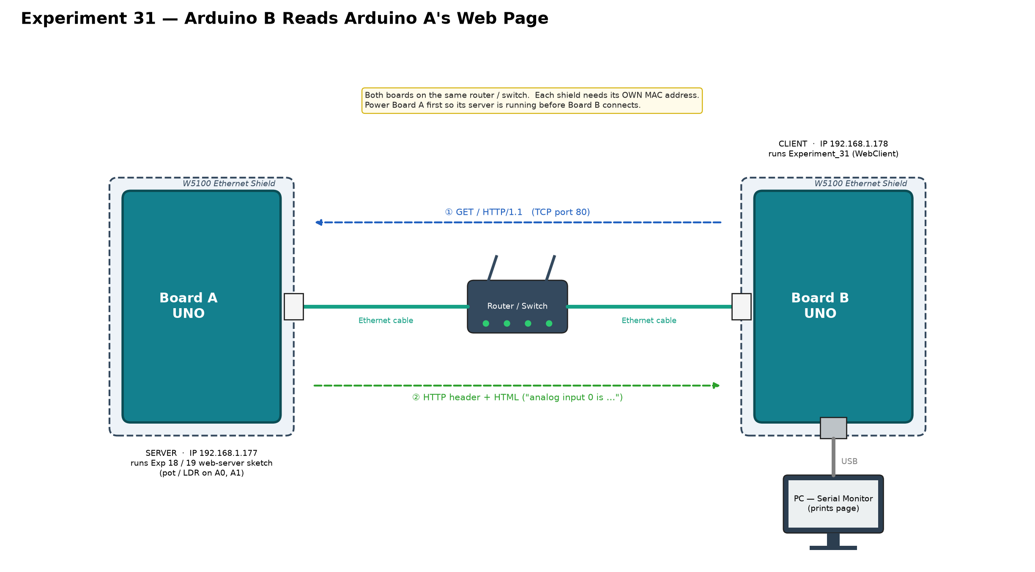
Figure 11: Circuit diagram of Experiment 31

Connections
# | Connection (Board B)
1 | Seat the Ethernet Shield onto Board B's UNO headers
2 | Board B shield RJ45 port — network cable — the same router/switch Board A is connected to
3 | Power Board B from the PC using the USB cable (Serial Monitor shows the received page)
Note: Both boards must be on the same router or switch and must have different MAC addresses.

