PROJECT REPORT 3

Cold-Chain Integrity and Last-Mile Reefer Monitoring System
An IoT prototype using Raspberry Pi 4

Raspberry Pi Features, Program Flow Chart, Sensors, Actuators and Displays

Course: ECE-504 Internet of Things
Semester: Monsoon Semester 2026
Group No. 4: Sky is the Limit

Submitted by:
Vedant Solanki
(other group members names here)

1. Introduction
Our project is a small IoT unit for refrigerated (reefer) trucks built on a Raspberry Pi 4. Two DS18B20 probes measure cargo temperature, a MC-38 reed switch checks the door, and the SIM7600 HAT gives GPS location and sends SMS. On a fault the unit turns on a buzzer and red LED, restarts the cooling through a relay (a 5V fan acts as compressor), shows the reason on a 0.96 inch OLED and logs every reading with a SHA-256 hash chain.
Report 2 gave the materials, circuit diagram and a first part of the Pi features and flow chart. This report completes Chapters 5 to 8: Raspberry Pi features and comparison, program flow chart, sensors, and actuators and displays. The circuit diagram and component list are the same as in Report 2.

2. Raspberry Pi 4 Features and Comparison (Chapter 5)
Raspberry Pi 4 Model B has a Broadcom BCM2711 quad core Cortex-A72 (64 bit) at 1.5 GHz, 4 GB RAM, microSD storage, 40 pin header with 28 GPIO (3.3V logic), 4 USB ports, Gigabit Ethernet, WiFi and Bluetooth 5.0, and runs on 5V 3A USB-C (about 3 to 6 W). It has no ADC. The features we use are:
Pi feature | Use in our project | Pins / library
GPIO input, internal pull-up | Door reed switch | GPIO27, gpiozero Button
GPIO output | Buzzer, red LED, relay | GPIO17, 22, 23, gpiozero
1-Wire (kernel driver) | Two DS18B20 probes on one pin | GPIO4, dtoverlay=w1-gpio
I2C bus 1 | OLED display at 0x3C | GPIO2 SDA, GPIO3 SCL, luma.oled
USB + Linux | SIM7600 for SMS, 4G and GPS; SQLite log, SHA-256, systemd auto start | pyserial, sqlite3, hashlib

GPIO pins are 3.3V only (not 5V tolerant) and give max 16 mA, so the buzzer and relay are driven through the transistor on their modules and the OLED is powered from 3.3V.
Feature | Arduino UNO | Raspberry Pi 4 | BeagleBone Black | Intel Galileo 2 | Intel Edison
Processor | 8 bit, 16 MHz | 4 core 1.5 GHz | 1 core 1 GHz | Quark 400 MHz | 2 core Atom 500 MHz
RAM | 2 KB | 1 to 8 GB | 512 MB | 256 MB | 1 GB
OS | None | Linux | Linux | Yocto Linux | Yocto Linux
GPIO / ADC | 14 / 6 | 28 / none | 65 / 7 | 20 / 6 | 40 / via breakout
Networking | Needs shield | Ethernet, WiFi, BT | Ethernet | Ethernet | WiFi, BT
Power | 0.3 W | 3 to 6 W | 2 W | 3 W | 1 W
Strength | Cheap, real time, ADC | Fast, Python, networking, big community | Many GPIO, PRU real time | Arduino shield support | Very small, low power
Weakness | No memory for DB or hashing | No ADC, SD card risk on power cut | Slow, no WiFi, costly | Slow, discontinued | 1.8V logic, discontinued

We selected Raspberry Pi 4 because our unit must run a database, hash every record, talk to a 4G modem and drive the OLED at the same time. Arduino has too little memory, BeagleBone is slower and costlier, and both Intel boards are discontinued. All our sensors are digital, so the missing ADC does not matter.

3. Program Flow Chart (Chapter 6)
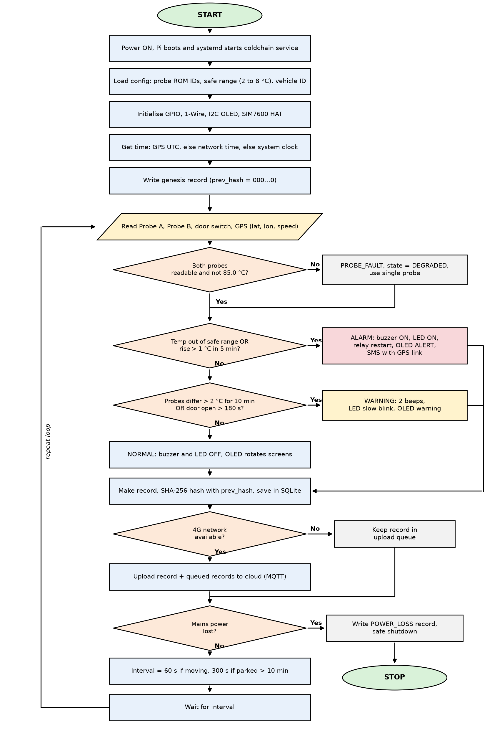
Figure 1: Flow chart of the monitoring program
On power ON, systemd starts the Python program. It loads the config (probe IDs, safe range 2 to 8 °C, vehicle ID), initialises GPIO, 1-Wire, OLED and SIM7600, takes time from GPS and writes the first (genesis) record. In the loop it reads both probes, the door and GPS.
A missing probe or a 85.0 °C reading (DS18B20 power on value) gives PROBE_FAULT and the program continues on one probe. Temperature out of range or a rise of more than 1 °C in 5 min gives ALARM: buzzer and LED ON, relay switched OFF for 5 s and ON again to restart cooling (max 3 times), OLED alert and SMS with GPS link (max one per fault in 15 min). Probes differing by more than 2 °C for 10 min or door open more than 180 s gives WARNING (2 beeps, LED blink). Every cycle a hashed record is saved in SQLite and uploaded when 4G is available, else queued. On mains failure a POWER_LOSS record is written and the Pi shuts down safely. The loop repeats every 60 s while moving and 300 s when parked.

4. Sensors (Chapter 7)
Detail | DS18B20 temperature probe (x2) | MC-38 reed switch | SIM7600 GNSS (GPS)
Operating principle | Silicon bandgap sensor with built in ADC, gives 12 bit digital value (0.0625 °C per bit) | Two iron reeds in a glass tube touch when a magnet comes near, so contact closes | Measures signal travel time from 4 or more satellites and finds position by trilateration; also gives UTC time and speed
Range / accuracy | -55 to +125 °C, ±0.5 °C (-10 to 85 °C), 750 ms conversion | Closes within about 15 to 25 mm | < 2.5 m, 1 Hz update, cold start about 35 s
Power rating | 3.0 to 5.5 V, 1 mA while converting (about 3 mW) | Passive, 66 µA through pull-up | 5V via HAT, GNSS about 30 to 50 mA
Dimensions | Steel probe 6 mm x 50 mm, 1 m cable | Each part about 27 x 14 x 8 mm | HAT 65 x 56 mm
Pins | Red VDD, Black GND, Yellow DATA | 2 wires, no polarity | 40 pin header (5V, GND) + micro USB
Interface with Pi | 1-Wire on GPIO4, 4.7 kΩ pull-up to 3.3V, each probe has 64 bit ROM ID | Digital input GPIO27, internal pull-up, closed = LOW | USB serial /dev/ttyUSB2, AT+CGPSINFO

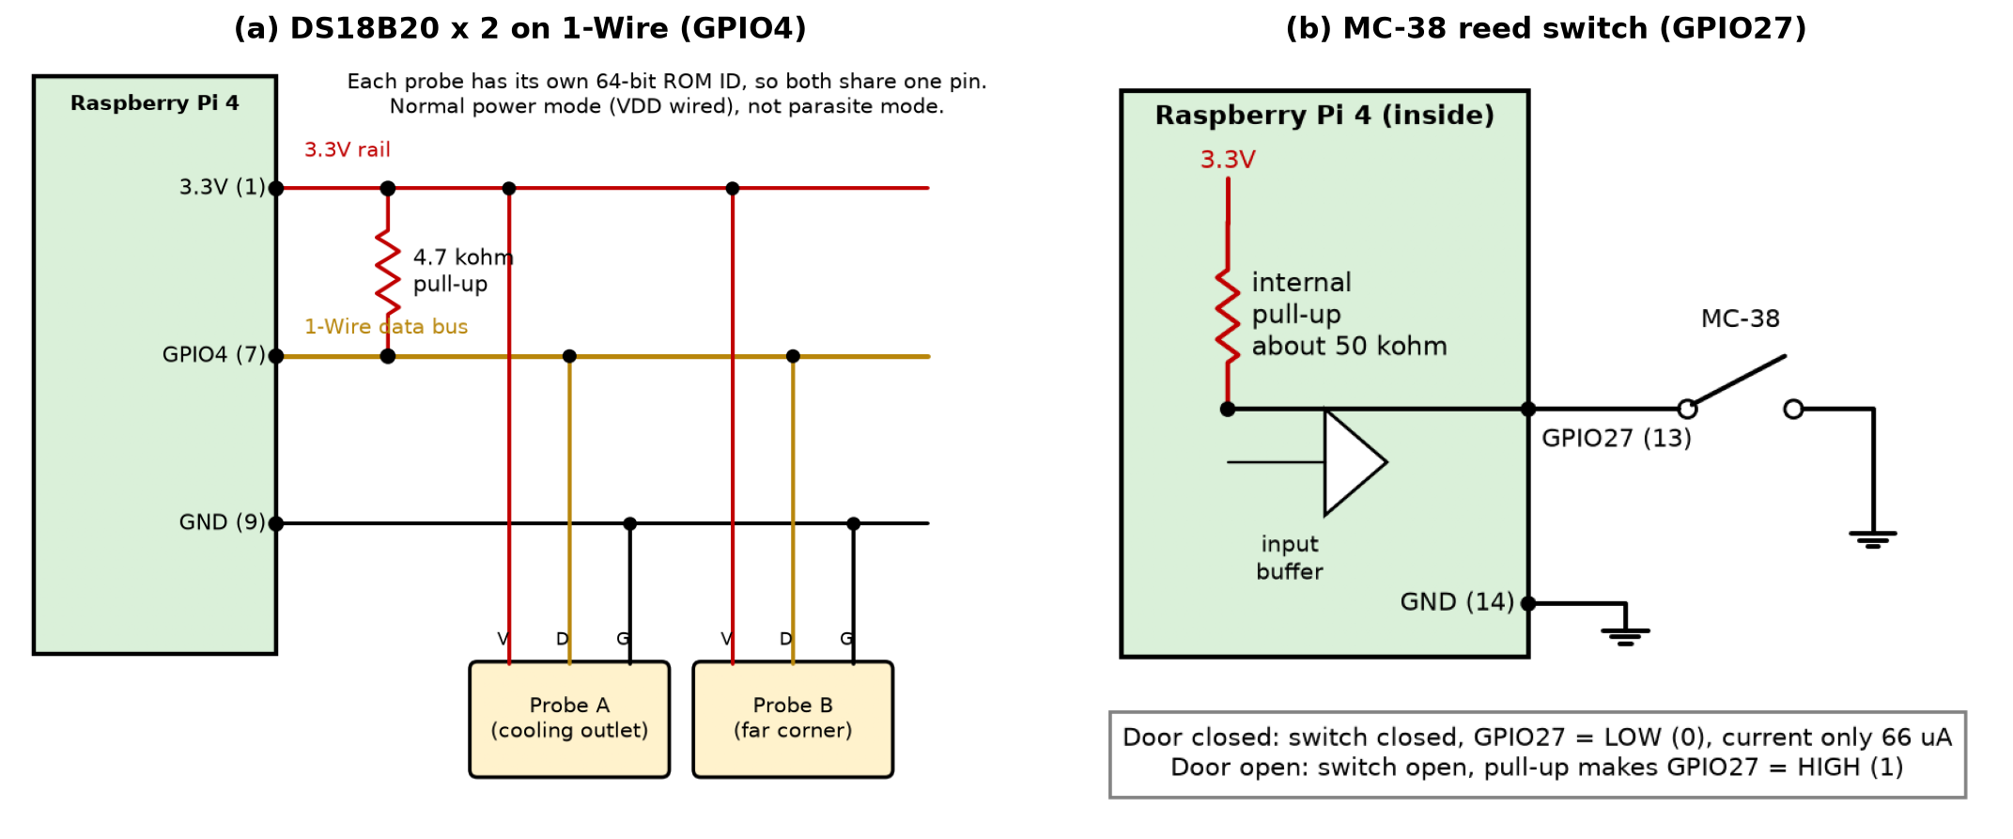
Figure 2: Interfacing diagrams of (a) DS18B20 probes and (b) MC-38 door switch
Listing 1: Python code to read all sensors
import serial, time
from gpiozero import Button

PROBES = {"A": "28-xxxxxxxxxxxx", "B": "28-yyyyyyyyyyyy"} # from ls /sys/bus/w1/devices
door = Button(27, pull_up=True, bounce_time=0.1) # closed switch = LOW
gps = serial.Serial("/dev/ttyUSB2", 115200, timeout=1)

def read_probe(rom):
try:
lines = open(f"/sys/bus/w1/devices/{rom}/w1_slave").read().splitlines()
except OSError:
return None # probe missing
if not lines[0].endswith("YES"):
return None # CRC error
t = int(lines[1].split("t=")[1]) / 1000
return None if t == 85.0 else t # 85.0 = power on value

def read_gps():
gps.write(b"AT+CGPSINFO\r\n"); time.sleep(0.5)
reply = gps.read(gps.in_waiting).decode(errors="ignore")
f = reply.split("+CGPSINFO:")[1].strip().split(",") if "+CGPSINFO:" in reply else [""]
if f[0] == "":
return None # no fix yet
deg = lambda v: int(float(v) / 100) + (float(v) % 100) / 60
return deg(f[0]), deg(f[2]), float(f[7] or 0) * 1.852 # lat, lon, km/h

gps.write(b"AT+CGPS=1\r\n") # switch GNSS ON
while True:
print(read_probe(PROBES["A"]), read_probe(PROBES["B"]),
"CLOSED" if door.is_pressed else "OPEN", read_gps())
time.sleep(5)

5. Actuators and Displays (Chapter 8)
Detail | Active buzzer | Red LED | Relay module + 5V fan | 0.96 inch OLED
Operating principle | Built in oscillator switches a coil about 2.3 kHz, diaphragm vibrates | p-n junction, electrons and holes recombine and give red light | Coil current makes an electromagnet that pulls the armature, COM moves from NC to NO | Organic layers give light when current flows; SSD1306 scans 128 x 64 matrix
Power rating | 5V, about 30 mA, 85 dB | Vf 2.0 V, 5.9 mA (max 20 mA) | Coil 5V 72 mA; contact 10 A 250 VAC; fan 5V 0.15 A | 3.3V, 10 to 25 mA
Dimensions | Buzzer 12 x 9.5 mm, module about 33 x 13 mm | 5 mm dia, 8.6 mm high | Module 50 x 26 x 18.5 mm, fan 40 x 40 x 10 mm | Module 27 x 27 mm, 128 x 64 pixels
Pins | VCC, I/O, GND | Anode (long leg), cathode | VCC, GND, IN | COM, NO, NC | GND, VCC, SCL, SDA
Interface with Pi | Digital output GPIO17 via module transistor | GPIO22 through 220 Ω to GND | Digital output GPIO23; 5V to COM, NO to fan | I2C bus 1, address 0x3C, 400 kHz

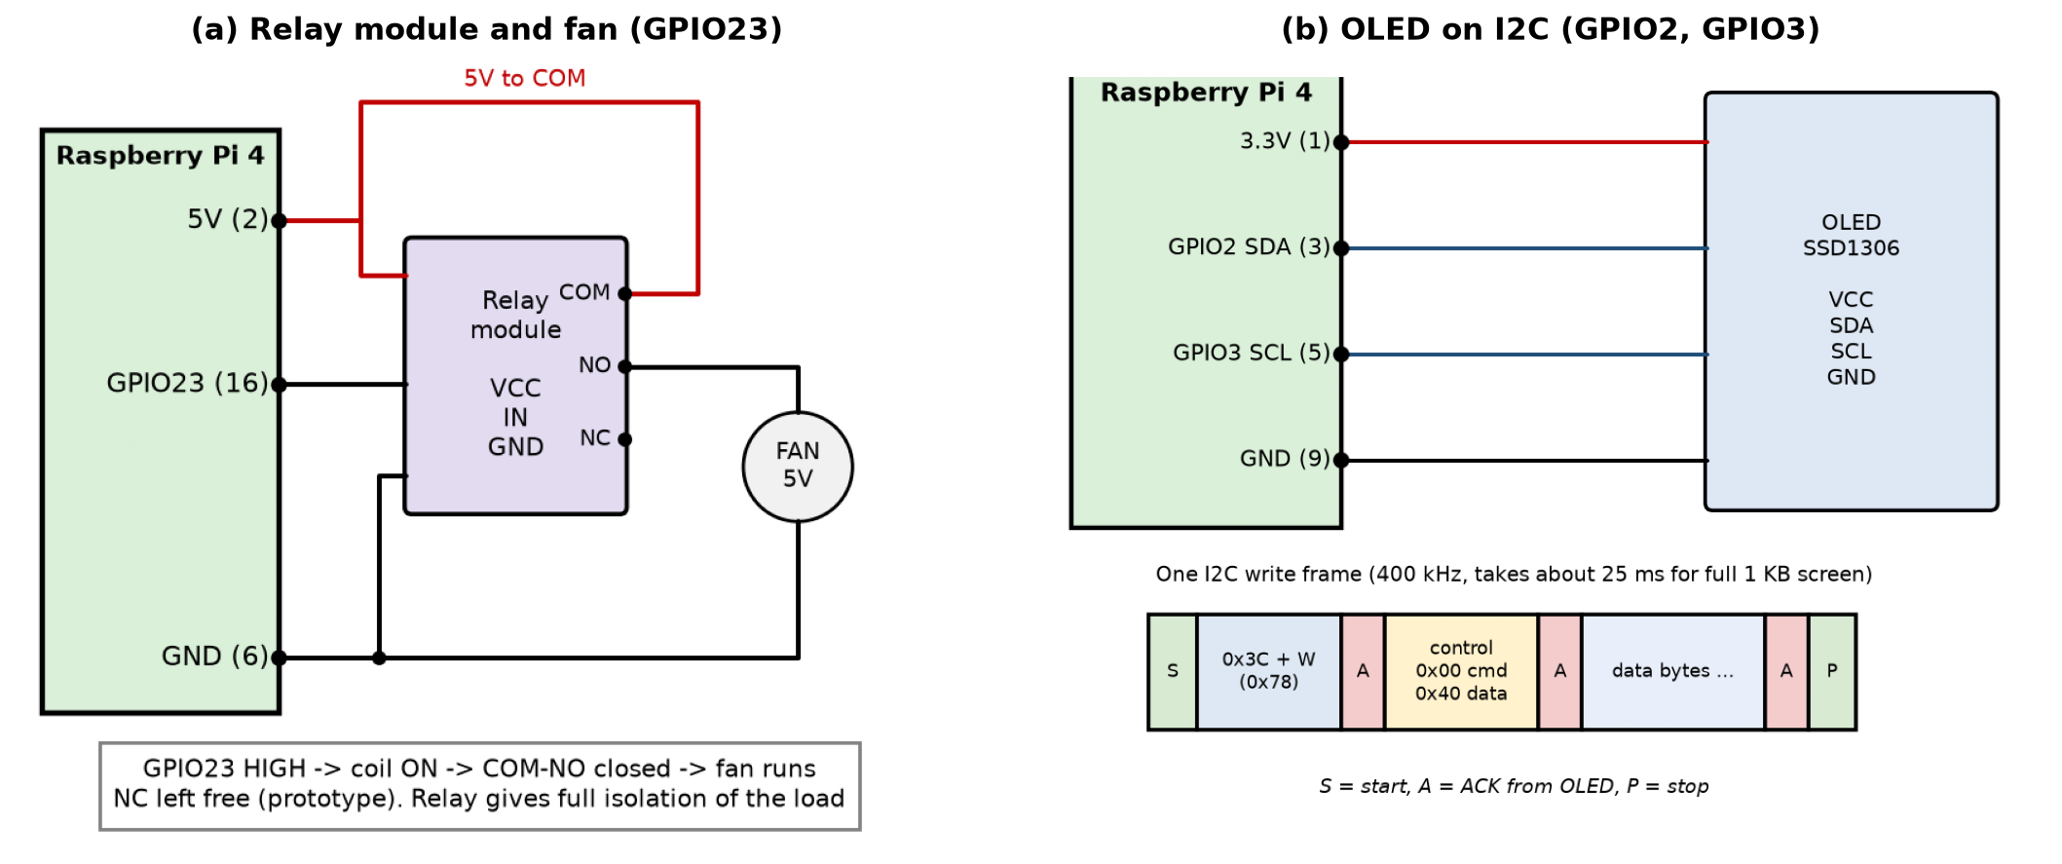
Figure 3: Interfacing diagrams of (a) relay module with fan and (b) OLED display
The buzzer and LED connections are simple: GPIO17 goes to the buzzer module I/O pin, and GPIO22 drives the LED through 220 Ω, giving (3.3 - 2.0) / 220 = 5.9 mA. The relay coil needs 72 mA, more than a GPIO pin can give, so the transistor on the module drives the coil and its flyback diode protects against the back EMF.
Listing 2: Python code for buzzer, LED, relay and OLED
from gpiozero import Buzzer, LED, OutputDevice
from luma.core.interface.serial import i2c
from luma.oled.device import ssd1306
from luma.core.render import canvas
from time import sleep

buzzer, led = Buzzer(17), LED(22)
relay = OutputDevice(23, initial_value=True) # ON = cooling running
oled = ssd1306(i2c(port=1, address=0x3C))

def show(line1, line2):
with canvas(oled) as d:
d.text((0, 0), line1, fill="white")
d.text((0, 20), line2, fill="white")

show("COLD-CHAIN [NORMAL]", "A 4.2C B 5.1C"); sleep(4)
show("!! TEMP HIGH !!", "A 8.6C limit 8.0C") # ALARM
buzzer.on(); led.on()
relay.off(); sleep(5); relay.on() # restart cooling
sleep(3); buzzer.off(); led.off()
show("COLD-CHAIN [NORMAL]", "A 5.0C B 5.3C")

Photos and videos: photos of the working hardware and Google Drive video links: ____________________ (to be added)

6. Conclusion
We completed Chapters 5 to 8. Raspberry Pi 4 was selected after comparing five platforms, mainly because we need Linux, a database, hashing and 4G together. The flow chart takes local action first and logs and uploads after. For all sensors, actuators and the display we gave the working principle, power rating, dimensions, pins, interface with the Pi and Python code. Next we will add hardware photos, videos and datasheet pages (Appendix A).

References
[1] Raspberry Pi Ltd., "Raspberry Pi 4 Model B datasheet," 2019.
[2] Analog Devices, "DS18B20 Programmable Resolution 1-Wire Digital Thermometer," datasheet, 2019.
[3] SIMCom, "SIM7500_SIM7600 Series AT Command Manual," V3.00, 2021.
[4] Solomon Systech, "SSD1306 OLED Driver with Controller," datasheet, Rev. 1.1, 2008.
[5] Songle Relay, "SRD-05VDC-SL-C relay datasheet"; gpiozero and luma.oled documentation (readthedocs.io).
[6] Arduino UNO, BeagleBone Black, Intel Galileo Gen 2 and Intel Edison official specifications.
[7] Group 4, Project Report 1 and 2, Cold-Chain Reefer Monitoring System, ECE-504, 2026.

