DETAILED PROJECT REPORT (DPR)
Cold-Chain Integrity & Last-Mile Reefer Monitoring System
An IoT-based Working Prototype for Industry 5.0 — Raspberry Pi Edition
Submitted in partial fulfilment of the requirements of the course project
Prepared: August 2026

Abstract
Refrigerated (“reefer”) transport is the weak link in India's food and pharmaceutical supply chains: perishable cargo loses its protective cold environment silently, and the damage is discovered only at delivery, when the loss is already unrecoverable. This report presents the design and prototype of an IoT-based Cold-Chain Integrity and Last-Mile Reefer Monitoring System, built around a Raspberry Pi 4 Model B. The system continuously senses cargo temperature and door status, applies two lightweight rule-based checks — a threshold check and a rate-of-change check — to catch both sudden and slow-developing failures, and responds immediately through local actuation (buzzer, warning light, and an automatic compressor-restart relay) as well as remote alerting (SMS) and cloud logging. A UPS HAT with a battery-backed real-time clock protects the system against data corruption from sudden power loss, and a combined 4G/GPS HAT handles both alerting and location tracking. Every reading is time-stamped and sequentially linked so it cannot be silently altered afterward, allowing the system to generate a trustworthy digital cold-chain certificate at the end of each trip. The complete bill of materials, circuit diagram, and test plan defined in this report are sufficient to reproduce the prototype.

Contents
1. Introduction
2. Problem Statement
3. Existing Systems and Their Limitations
4. Proposed Solution and Objectives
5. Application Areas — Where It Is Needed
6. System Architecture
7. Working Principle — Software Logic
8. Scope of the Prototype
9. Exact Bill of Materials
10. Circuit / Wiring Diagram
11. Pin Connection Reference Table
12. Project Procedure — Build Sequence
13. Testing Methodology
14. Results and Output Display
15. Cost Analysis
16. Advantages
17. Limitations of the Prototype
18. Future Scope
19. Conclusion
20. References

1. Introduction

1.1 What This Project Is
This project is an embedded IoT system that continuously monitors the internal condition of a refrigerated transport vehicle or cold storage unit, and takes both local and remote action the moment that condition drifts outside safe limits. It combines a Raspberry Pi single-board computer, temperature and door sensors, a combined 4G/GPS HAT for alerting and location, a UPS HAT for power-loss protection, and cloud software into a single working unit that can be fitted inside a truck.

1.2 Why This Project Is Important
Post-harvest and cold-chain losses in India are estimated at roughly ₹92,000 crore annually, driven largely by breaks in the cold chain that go undetected until goods reach their destination. Less than 10% of Indian horticultural produce is ever covered by organised cold-chain infrastructure, and even where refrigerated transport exists, there is typically no continuous, tamper-proof way to verify it worked. The consequences are not only economic: vaccines and medicines carry zero tolerance for temperature failure, and undetected excursions during transport have been documented as a real cause of spoiled immunisation stock reaching sub-district health centres in India.
This project also sits squarely in the Industry 5.0 paradigm rather than plain automation: the goal is not to remove the driver or fleet manager from the loop, but to give them timely, trustworthy information so they can act — augmenting human decision-making with continuous machine oversight, while keeping a human in control of the response.

2. Problem Statement
Despite the existence of refrigerated transport infrastructure in India, there is no widely adopted, tamper-proof mechanism to continuously verify that temperature-sensitive cargo remains within safe limits throughout transit. This creates four specific, unresolved problems:
- No continuous monitoring — manual spot-checks miss failures that occur between checks, and a compressor can fail for hours before anyone notices.
- No tamper-evidence — conventional digital temperature logs can be edited or fabricated after the fact, so they carry little weight in a dispute.
- No early warning — most existing systems only alert once cargo has already left the safe range, by which point damage may already be done.
- No standardised proof of compliance — shippers, carriers, and receivers have no shared, objective record to resolve spoilage disputes or satisfy regulatory audits.

3. Existing Systems and Their Limitations
A range of IoT-based cold-chain monitoring approaches have been documented in the literature and in commercial products. Wireless-sensor-network and RFID-based systems have been proposed for tracking temperature and humidity across warehouses and containers [1][2][4][6], and GSM/SMS-based alerting for refrigerated containers has also been demonstrated [6]. Commercial Indian fleet-tracking platforms typically log temperature at intervals of two to fifteen minutes with basic threshold alerts.
However, three gaps recur across most existing systems: (a) tamper-evidence is usually treated as a secondary feature rather than a core design requirement, so records can technically be altered by the platform operator; (b) very few systems pair detection with an automatic local recovery action — most only notify a human and wait; and (c) rate-of-change detection (catching a slow failure before it crosses a hard threshold) is rarely implemented, even though this is the failure mode most likely to cause a total loss. This project's design directly targets those three gaps.

4. Proposed Solution and Objectives
The proposed solution is a single in-vehicle unit with the following objectives:
- Continuously measure cargo temperature and door status at a fixed interval (60 seconds).
- Detect both threshold breaches and dangerous rate-of-change trends using simple, explainable rules — not a black-box model — so the logic can be verified by an auditor.
- Respond locally within seconds through a buzzer, a warning light, and a relay that attempts to auto-restart the cooling unit.
- Respond remotely by sending an SMS alert with the vehicle's live GPS location.
- Store every reading — not only faults — and protect that data against corruption even if power is cut suddenly.
- Sequentially link each reading so tampering is detectable, and generate a simple, verifiable cold-chain certificate at the end of each trip.

5. Application Areas — Where It Is Needed
Pharmaceutical and vaccine logistics — zero-tolerance cold chain for immunisation stock and temperature-sensitive medicines, from district vaccine stores to primary health centres.
Dairy and perishable food transport — milk and dairy cooperatives, where spoilage is fast and quality-linked payment already exists.
Horticulture export — fruit and vegetable exporters seeking to meet destination-market cold-chain compliance requirements.
Blood banks and hospital supply chains — inter-facility transport of blood units and temperature-sensitive diagnostic reagents.
Government cold-chain schemes — State health missions (vaccine cold chain) and MoFPI-supported cold-chain infrastructure projects under PMKSY [7].
Disaster relief and defence logistics — cold-chain integrity for emergency medical supplies and ration transport in areas with unreliable infrastructure.

6. System Architecture
The system is organised into five layers: a Sensing Layer that reads the physical world, a Processing Layer that runs the decision logic on the Raspberry Pi, two parallel output paths (Actuation and Communication), a Cloud Layer that verifies and stores data, and an Output Layer that presents results to people. The diagram below shows how data moves through these layers.
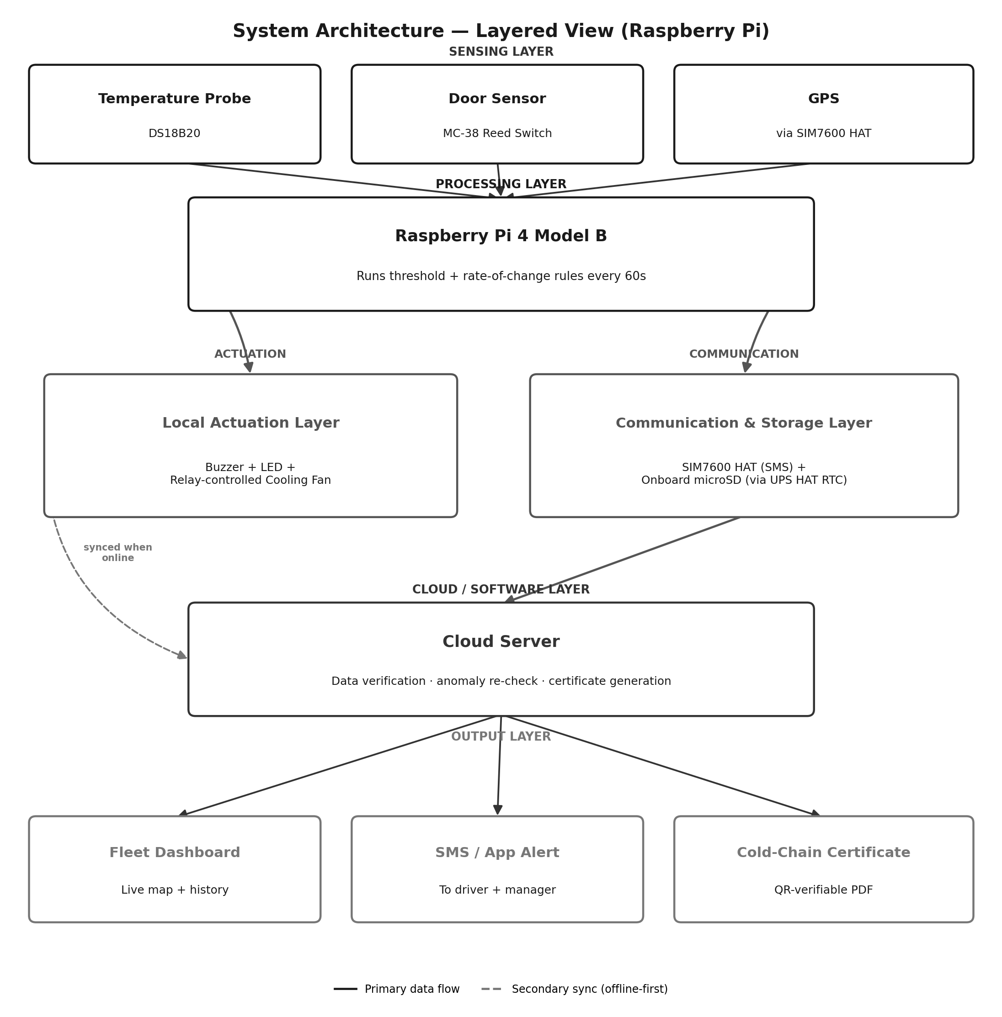
A key design choice is that the Actuation Layer acts immediately and locally, without waiting for the Cloud Layer — the buzzer, light, and relay all respond within the same control loop that reads the sensors, so the system remains fully functional even with zero network connectivity. The Communication Layer and Cloud Layer add remote visibility and long-term record-keeping on top of that already-functional local safety loop.

7. Working Principle — Software Logic
The Raspberry Pi runs a simple, deterministic decision loop every 60 seconds, implemented as a Python service, deliberately avoiding a machine-learning model — a rule that can be stated in one sentence is also a rule that can be defended as evidence in a dispute or audit.
- Threshold check — is the current temperature outside the safe range defined for this cargo (for example, 2–8°C for vaccines)?
- Rate-of-change check — is the temperature rising faster than a safe cooling unit ever would (for example, more than 1°C in 5 minutes), even if still technically within range? This is what catches a slowly failing compressor before the threshold is crossed.
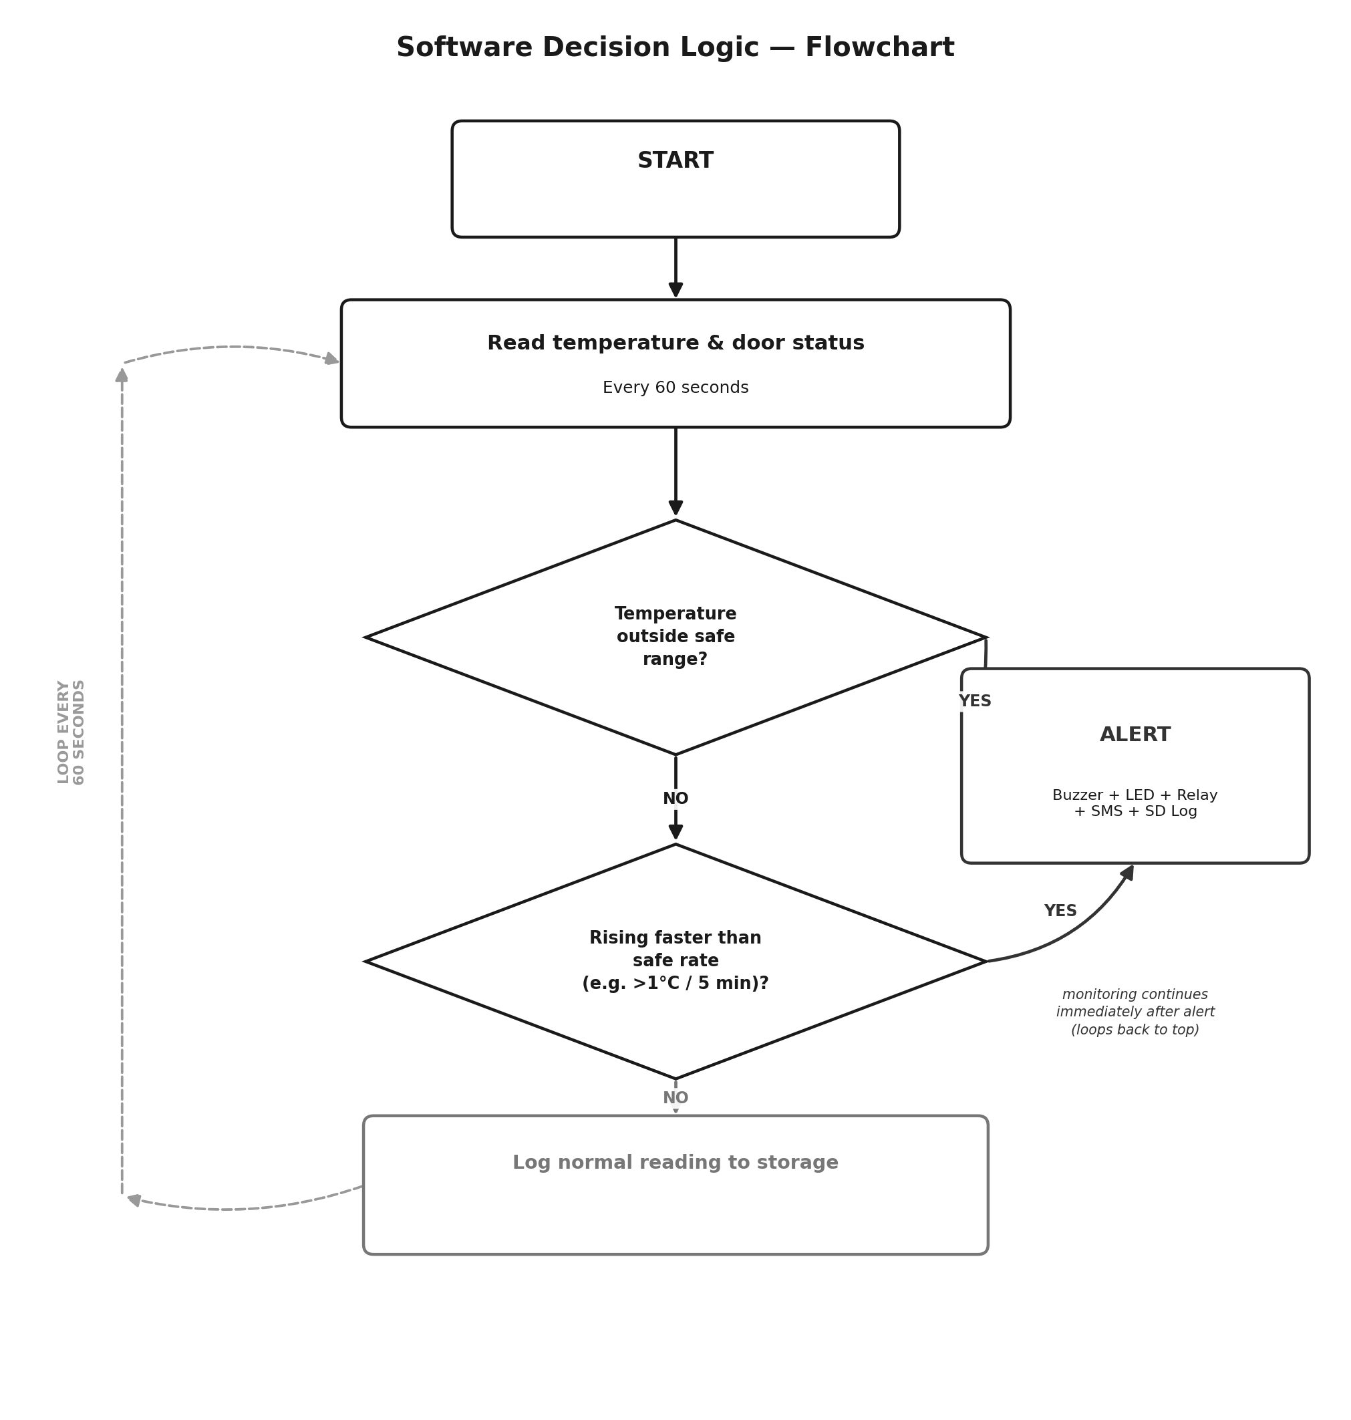
If either check fails, the system fires all outputs together — buzzer, LED, relay, SMS, and a storage log entry — and then immediately resumes monitoring on the next 60-second cycle. This means a fault is never “acknowledged and forgotten”; if the condition persists, the alert continues to fire every cycle until it clears.

8. Scope of the Prototype
This report specifies the exact components, wiring, and build sequence for one working prototype unit, suitable for a college demonstration and DPR submission. It reads temperature and door status, triggers a local alarm and a relay-controlled fan on a fault, and sends alerts and location data over a combined 4G/GPS HAT. Every part specified below is a real, purchasable component with an exact quantity and a defined location of use in the circuit.
Hardware revision note: this version of the report uses a Raspberry Pi 4 Model B in place of the ESP32 microcontroller used in an earlier revision. The Raspberry Pi was chosen here for easier Python-based development and simpler HAT-based connectivity, at the cost of higher power draw and a significantly higher component cost — both discussed in Sections 15 and 17.

9. Exact Bill of Materials
Every component required to build the complete working prototype, with exact quantity and the segment of the system it belongs to.

9.1 Sensors — Input Segment
Component (exact part) | Qty | Segment / Location | Purpose
DS18B20 Waterproof Digital Temperature Sensor (1m cable) | 1 | Inside the cargo box, taped to the wall | Reads cargo temperature
4.7kΩ resistor, 1/4W | 1 | Between DS18B20 data pin and 3.3V | Required pull-up for 1-Wire protocol
MC-38 Magnetic Reed Switch (2-wire) | 1 | One half on the door, one half on the frame | Detects door open / closed

9.2 Actuators — Output Segment
Component (exact part) | Qty | Segment / Location | Purpose
Active Buzzer Module (3-pin, 5V) | 1 | Mounted on/near enclosure, cab-facing | Local audible alarm
5mm Red LED | 1 | Mounted on enclosure front panel | Visual warning light
220Ω resistor, 1/4W | 1 | In series with the LED | Limits current to protect the LED
5V 1-Channel Relay Module (opto-isolated) | 1 | Between Raspberry Pi and the fan's power line | Switches the cooling fan on/off
5V DC Cooling Fan (40mm) | 1 | Inside the cargo box | Simulates the real compressor / cooling unit

9.3 Brain, Time & Storage — Processing Segment
Component (exact part) | Qty | Segment / Location | Purpose
Raspberry Pi 4 Model B (4GB RAM) | 1 | Center of the enclosure — main board | Main controller, runs all logic in Python
UPS HAT with battery-backed RTC (e.g. PiJuice HAT or equivalent) | 1 | Stacked directly on the Pi's GPIO header | Keeps accurate time and shuts down cleanly on power loss, protecting the SD card
High-Endurance MicroSD Card, 32GB | 1 | Inserted into the Pi's onboard slot | Boots the Pi and stores up to 30 days of logged data

9.4 Connectivity — Communication Segment
Component (exact part) | Qty | Segment / Location | Purpose
SIM7600 4G/GPS HAT for Raspberry Pi | 1 | Stacked on the Pi's GPIO header, antenna toward roof | Sends SMS alerts and tracks location — one board replaces two separate modules
Prepaid SIM card (data + SMS pack active) | 1 | Inserted into the HAT | Required for SMS alerts and mobile data

9.5 Power Segment
Component (exact part) | Qty | Segment / Location | Purpose
12V Battery or 12V DC Adapter | 1 | Main power input | Simulates the truck's 12V electrical line
LM2596 Buck Converter Module (5V, 3A rated, adjustable) | 1 | Between battery and the Pi's power input | Steps 12V down to a single 5V rail able to supply the Pi and both HATs
Inline Fuse, 5A + fuse holder | 1 | Between battery positive and the circuit | Protects everything from a short circuit

9.6 Assembly & Housing
Component (exact part) | Qty | Segment / Location | Purpose
GPIO terminal block breakout board | 1 | Sits between the Pi's header and external wiring | Secure, vibration-proof screw connections for sensors and actuators
Jumper wires (M-M, M-F, F-F, assorted) | ≈20 | Throughout the circuit | Short internal connections
IP65 waterproof enclosure box (250×180×100mm) | 1 | Houses the entire assembled stack | Protects the electronics from dust and moisture — sized to fit the Pi + HAT stack
Cable glands, PG7 size | 4 | Enclosure wall, wire entry points | Weatherproof entry for external wires and antennas

10. Circuit / Wiring Diagram
The diagram below shows every connection in the prototype: which exact Raspberry Pi GPIO pin each module connects to, and how the single power rail is distributed. Line style indicates the category of wire — sensor/actuator signal, HAT interface, or power.
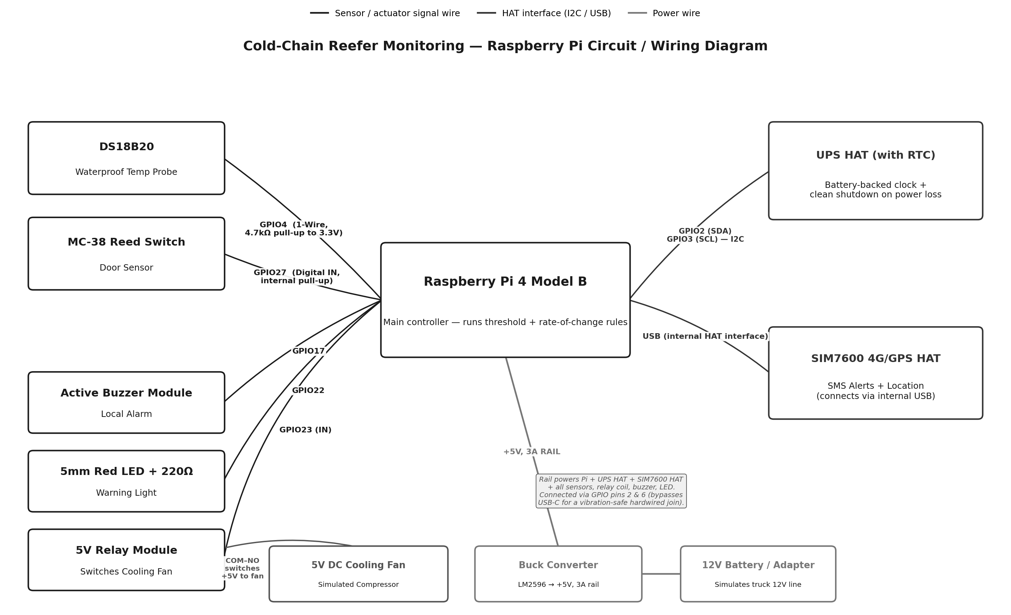
Note on power: switching to the Raspberry Pi removes the two-rail workaround the ESP32 build needed for its GSM module. Both HATs here draw current through the Pi's own regulated 5V supply, so a single, higher-current buck converter (5V at 3A) is sufficient for the entire circuit — simpler than the previous design, though the converter itself must be rated for more current than before.

11. Pin Connection Reference Table
Use this table alongside the diagram when wiring the board — it lists every single connection in the circuit. Pin numbers use Raspberry Pi's BCM GPIO numbering.

11.1 Signal and HAT connections
From (Pi pin) | To (component, pin) | Wire type / notes
GPIO4 | DS18B20 — Data pin | 1-Wire. This is the Pi's default 1-Wire pin. Add 4.7kΩ resistor between this line and 3.3V.
GPIO27 | MC-38 Reed switch — either wire | Digital input. Other wire of switch goes to GND. Enable internal pull-up in software.
GPIO2 (SDA) / GPIO3 (SCL) | UPS HAT — I2C interface | I2C. Provides both the battery-backed RTC and power-loss detection.
GPIO17 | Buzzer module — Signal (S) | Digital output.
GPIO22 | LED — Anode (through 220Ω resistor) | Digital output. LED cathode to GND.
GPIO23 | Relay module — IN | Digital output. Relay coil side powered from 5V rail.
USB (internal) | SIM7600 4G/GPS HAT | The HAT's onboard USB interface handles SMS and GPS together; appears to software as a serial device.

11.2 Power connections
From | To | Notes
12V battery / adapter (+) | Fuse (5A) → Buck Converter IN | Single power source for the whole circuit.
Buck Converter OUT (set to 5V, 3A) | Raspberry Pi 5V/GND (via GPIO pins 2 & 6), UPS HAT, SIM7600 HAT, all sensors, buzzer, LED, relay coil | Single shared rail — powering the Pi through its GPIO pins rather than USB-C gives a vibration-safe hardwired connection.
All GND pins | Common ground point | Every module's GND must connect to the same ground point as the Pi.

12. Project Procedure — Build Sequence
Build and test the circuit in this order. Testing each segment before adding the next means a fault is always found in the part you just added, not buried somewhere in a fully wired board.

Stage 1 — Power segment
- Wire the 12V source through the fuse to the buck converter.
- Set the buck converter's output to exactly 5.0V using a multimeter, adjusting its onboard potentiometer, with no load connected.
- Confirm the rail holds 5V steady once the Pi is connected and drawing current, since voltage can sag under load if the converter is undersized.

Stage 2 — Brain segment
- Flash Raspberry Pi OS onto the high-endurance microSD card using the official Raspberry Pi Imager tool.
- Boot the Pi from the 5V rail and confirm it starts up correctly, either with a monitor attached or over SSH.

Stage 3 — Sensors, one at a time
- Wire the DS18B20 with its pull-up resistor to GPIO4. Enable the 1-Wire interface in the Pi's configuration and confirm a real temperature reading appears.
- Wire the reed switch to GPIO27. Confirm the reading changes correctly when a magnet is brought near and taken away.

Stage 4 — UPS HAT (time and power safety)
- Attach the UPS HAT to the Pi's GPIO header. Install its Python library and confirm the Pi can read the correct time from its RTC.
- Disconnect the network, set the time once, then power-cycle the Pi and confirm the time is still correct — proving the RTC works independently of internet time sync.
- Simulate a sudden power cut while the Pi is writing a file, and confirm the UPS HAT gives it enough time to shut down cleanly without corrupting the SD card.

Stage 5 — Actuators
- Wire the buzzer to GPIO17 and confirm it sounds on command.
- Wire the LED with its resistor to GPIO22 and confirm it lights on command.
- Wire the relay to GPIO23, and the fan through the relay's COM/NO terminals to the 5V rail. Confirm the fan switches on and off on command.

Stage 6 — Connectivity
- Attach the SIM7600 HAT to the Pi's GPIO header. Insert the active SIM card. Install the HAT's driver and AT-command tools, and confirm it registers on the 4G network and can send a test SMS.
- Confirm the same HAT returns a valid GPS fix when tested outdoors or near a window.

Stage 7 — Full integration and logic
- Write and run the Python service that reads all sensors every 60 seconds, checks the two rules (threshold and rate-of-change), and triggers the buzzer, LED, and relay together when a fault is detected.
- Set this service to start automatically on boot (e.g. as a systemd service), so the system resumes monitoring on its own after any restart.
- Confirm an SMS is sent and the event is logged at the same time a fault is triggered.
- Run a full simulated trip: warm the temperature probe by hand to cross the threshold, open the door sensor, and confirm every output responds correctly and together.

Stage 8 — Housing and finishing
- Mount the Pi with both HATs stacked, the GPIO terminal breakout, and all wiring inside the IP65 enclosure, matching the wiring table in Section 11.
- Route the temperature probe, reed switch wires, and antennas out through the cable glands, and seal the box.
- Re-run the Stage 7 full test once the circuit is inside its final housing, to confirm nothing shifted or came loose during assembly.

13. Testing Methodology
Testing proceeds in three levels — unit, integration, and full system — followed by a formal test case table for the report record.

13.1 Unit testing (per component)
Component | Test procedure | Expected result
DS18B20 | Compare sensor reading to a household thermometer at room temperature, then in a fridge. | Reading matches reference within ±0.5°C.
MC-38 Reed switch | Bring magnet near, then move it away, while reading the GPIO state. | State flips cleanly between HIGH and LOW with no bouncing.
UPS HAT (RTC) | Set time, remove power for 5 minutes, reconnect. | Time is still correct after power is restored.
UPS HAT (shutdown) | Cut power while the Pi is writing a file. | Pi shuts down cleanly; file is not corrupted on next boot.
Buzzer / LED / Relay | Trigger each output individually from a test script. | Each responds immediately and independently.
SIM7600 HAT (SMS) | Send an AT command to check network registration; send a test SMS. | HAT registers on the 4G network; SMS is received on a phone within 30 seconds.
SIM7600 HAT (GPS) | Power the HAT outdoors and read its GPS output for 2–3 minutes. | HAT returns a valid latitude/longitude fix.

13.2 Integration testing
Once each component passes individually, they are tested together in pairs and small groups before the full service is loaded:
- Sensors + Pi: confirm both readings update correctly and simultaneously when read from the Python script.
- Actuators + relay + fan: confirm the relay switches the fan without any voltage drop affecting the Pi.
- Both HATs running together: confirm the UPS HAT and SIM7600 HAT do not interfere with each other on the shared GPIO header.

13.3 Full system / field testing
The complete assembled prototype is tested as a full simulated trip:
- Normal condition run — confirm the system logs readings quietly with no false alerts for at least 30 minutes.
- Threshold-breach simulation — warm the DS18B20 probe by hand (or with a hot water pouch nearby) until it crosses the safe range, and confirm every output fires.
- Rate-of-change simulation — warm the probe gradually but do not let it cross the hard threshold, and confirm the rate alert still fires.
- Door-event simulation — open and close the reed switch and confirm it logs correctly without triggering a false temperature alert.
- Power-cut test — cut main power mid-trip and confirm the UPS HAT allows a clean shutdown, then confirm the Pi resumes monitoring correctly once power is restored.

13.4 Formal test case table
Test ID | Description | Input | Expected output
TC-01 | Normal operating condition | Temp within range, door closed | No alert; reading logged normally
TC-02 | Threshold breach | Temp pushed above safe range | Buzzer + LED + relay + SMS + log, all together
TC-03 | Rate-of-change breach | Temp rising fast but still in range | Same alert response as TC-02
TC-04 | Door opened unexpectedly | Reed switch opened mid-“trip” | Door event logged; SMS if outside expected stop window
TC-05 | Network unavailable | SIM7600 HAT has no signal during an alert | Alert stored locally; sent automatically once signal returns
TC-06 | Sudden power interruption | Main 12V supply cut without warning | UPS HAT enables clean shutdown; RTC retains correct time; system resumes monitoring cleanly on power return

14. Results and Output Display
The system's output is designed to be understood in seconds, not analysed — a fleet manager or auditor should be able to see the state of every vehicle at a glance.

14.1 Fleet dashboard
The dashboard is the primary screen for a fleet operations team: a vehicle list on the left with a status marker (dark for an active alert, light gray for normal), a live temperature graph for the selected vehicle with the safe threshold drawn as a reference line, a simple live-location panel, and a running alert/event log at the bottom.
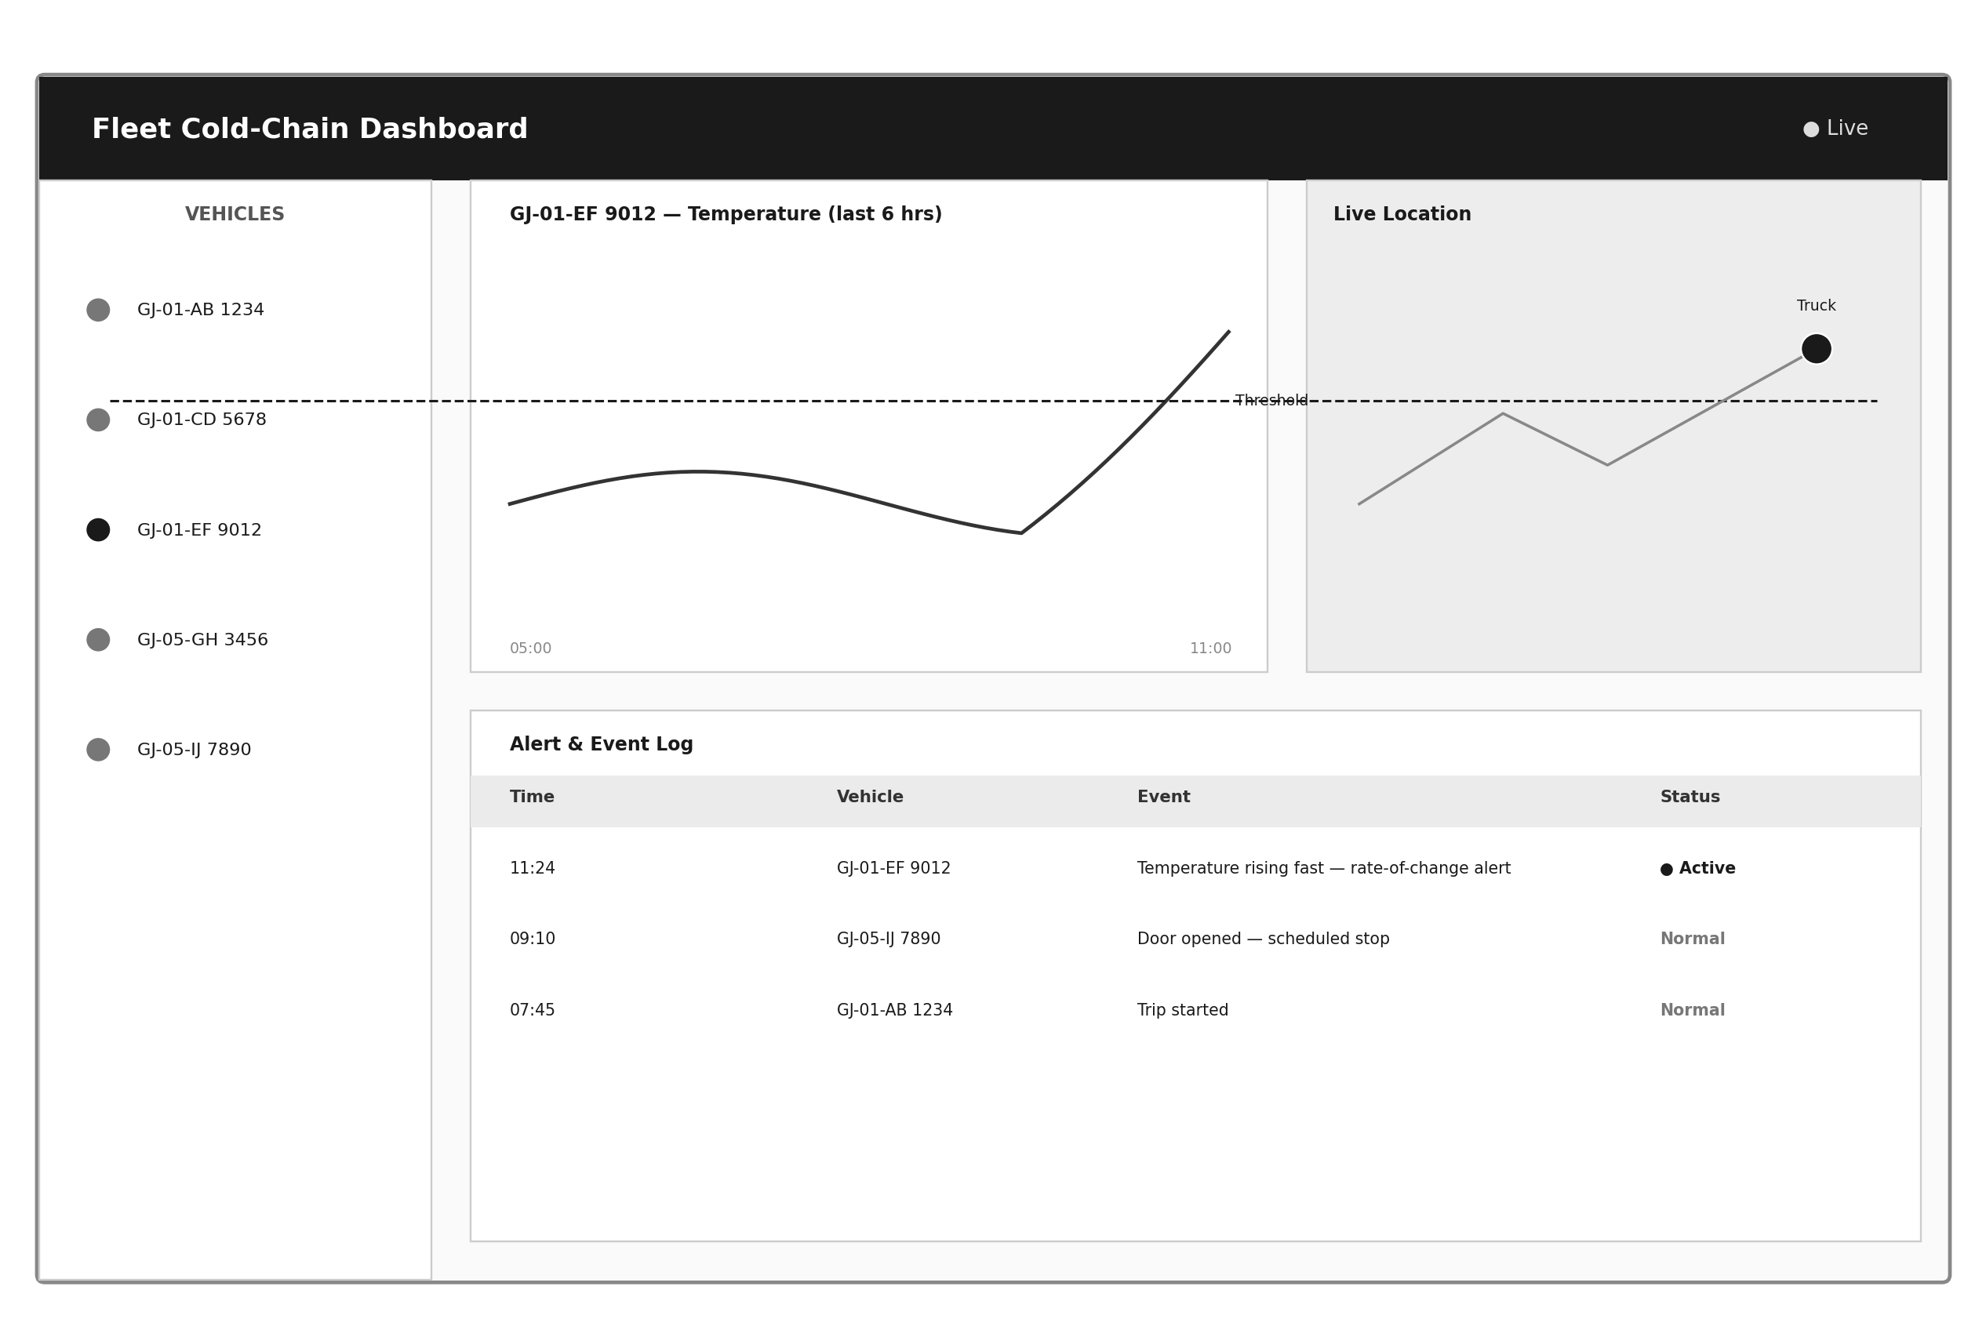

14.2 Sample SMS alert format
“ALERT: Vehicle GJ-01-EF 9012 — Temperature rising fast (currently 7.4°C, safe limit 8.0°C). Location: [GPS link]. Cooling relay auto-restart attempted at 11:24.”

14.3 Cold-chain certificate — fields generated at end of trip
Field | Description
Trip ID / Vehicle ID | Unique identifier for this specific delivery run
Start / end time and location | Taken from GPS and the UPS HAT's RTC timestamps
Temperature range for the trip | Minimum and maximum recorded values
Number and duration of door-open events | From the reed switch log
Any threshold or rate-of-change excursions | With exact start and end time of each
Data integrity check result | Confirms the sequential reading chain was unbroken — i.e. not tampered with

14.4 Suggestions for the live demonstration
- Keep the enclosure open (or use a transparent box) during the demo so the professor can see the buzzer, LED, and relay respond in real time.
- Use a cup of warm water placed near the DS18B20 probe to trigger the threshold alert on demand, rather than waiting for a real fault.
- Have the dashboard open on a laptop next to the physical unit, so the audience sees the physical alert and the software alert appear together.
- Demonstrate the power-cut protection live — pull the power plug mid-demo and show the Pi coming back up cleanly, with the correct time still intact.

15. Cost Analysis
Category | Cost
Minor hardware (wiring, protection, mounting) | ₹460
Sensors (core) | ₹1,000
Actuators (core) | ₹270
Brain, time and storage (Pi + UPS HAT + SD card) | ₹14,200
Connectivity (SIM7600 4G/GPS HAT) | ₹5,500
Power | ₹480
Enclosure | ₹650
Total hardware cost per unit (Raspberry Pi build) | ≈ ₹22,560

For comparison, the equivalent ESP32-based build (an earlier revision of this design) costs approximately ₹6,050 in hardware — roughly 3.7× less. The extra cost here buys easier Python-based development, a combined 4G/GPS HAT instead of two separate modules, and a UPS HAT that directly solves the power-loss data corruption risk inherent to any SD-card-based Linux computer. Recurring costs (not included above): SIM data and SMS balance (≈₹150–300/month), and cloud hosting if deployed beyond the prototype stage (≈₹1,500/month, shared across a fleet).

16. Advantages
- Works without any internet connection for its core safety function — the buzzer, LED, and relay respond locally, independent of network signal.
- Catches slow failures early through rate-of-change detection, not just outright threshold breaches.
- Attempts automatic recovery (compressor restart) instead of only notifying a human and waiting.
- Produces tamper-evident records suitable as real evidence in a spoilage dispute or compliance audit.
- The UPS HAT directly solves the biggest practical weakness of any SD-card-based computer — data corruption from a sudden power cut.
- Python-based development is faster to write, easier to debug, and easier for a larger student team to divide work on than low-level microcontroller firmware.
- A single combined 4G/GPS HAT replaces what would otherwise be two separate modules and their wiring.

17. Limitations of the Prototype
- Single point of failure — the prototype uses one Raspberry Pi and one set of sensors; a production version would need redundancy for critical routes.
- Significantly higher cost and power draw than a microcontroller-based equivalent — roughly 3.7× the hardware cost and considerably more continuous current draw, which matters for a vehicle that may sit parked with the engine off for extended periods.
- The tamper-evident “chain” implemented here is a software-level sequential hash, not a full blockchain — sufficient for dispute resolution, but not equivalent to a distributed ledger.
- The prototype does not yet include the fuel-level sensor or solenoid door lock discussed as future features, both of which add real value in a production fleet.
- No data-in-transit encryption is implemented in the prototype's cellular link; a production version should add TLS or an equivalent secure channel.

18. Future Scope
- Add a fuel-level sensor on the reefer's independent diesel tank to detect fuel theft before it causes a cooling failure.
- Add a solenoid door lock for tamper/theft protection on high-value cargo.
- Move from a sequential-hash log to a proper cryptographically signed chain for stronger legal defensibility.
- Add a lightweight predictive-maintenance model (not for anomaly detection, but for forecasting compressor wear from cycling patterns) once several seasons of real trip data are available — the Raspberry Pi's extra processing headroom makes this easier to add later than it would be on a microcontroller.
- Scale from a single prototype unit to a multi-vehicle fleet dashboard with role-based access for drivers, fleet managers, and auditors.
- Integrate directly with the PMFBY/WINDS and PMKSY compliance data formats so the generated certificate can be submitted for scheme reporting without manual reformatting.

19. Conclusion
This project demonstrates that a reliable, tamper-evident cold-chain monitoring system can be built from widely available components, using a Raspberry Pi to trade higher hardware cost and power draw for simpler development and easier-to-debug Python software. By combining simple, explainable detection rules with both local actuation and remote alerting, the prototype closes the three gaps most common in existing systems: it acts immediately without depending on connectivity, it attempts automatic recovery rather than only notifying a human, and it produces a tamper-evident record trustworthy enough to serve as real evidence. The complete bill of materials, circuit diagram, and test plan in this report are sufficient to reproduce the prototype and extend it toward a field-ready product for cold-chain logistics operators, pharmaceutical distributors, and government cold-chain programmes.

20. References
- “An IoT Smart System for Cold Supply Chain Storage and Transportation Management,” Engineering, Technology & Applied Science Research. Available: https://www.etasr.com/index.php/ETASR/article/view/6857
- C. K. M. Lee, Y. Lv, K. K. H. Ng, W. Ho, and K. L. Choy, “Design and application of Internet of things-based warehouse management system for smart logistics,” International Journal of Production Research, vol. 56, no. 8, pp. 2753–2768, 2018. DOI: 10.1080/00207543.2017.1394592
- M. Humayun, N. Jhanjhi, B. Hamid, and G. Ahmed, “Emerging Smart Logistics and Transportation Using IoT and Blockchain,” IEEE Internet of Things Magazine, vol. 3, no. 2, pp. 58–62, 2020. DOI: 10.1109/IOTM.0001.190009
- “IoT based cold chain logistics monitoring,” IEEE Conference Publication. Available: https://ieeexplore.ieee.org/document/8392059/
- “IoT-Driven Cold Chain Management for Real-Time Monitoring and Alerts for Perishable Goods,” IEEE Conference Publication, 2024. Available: https://ieeexplore.ieee.org/document/10940754/
- “Internet of Things enabled real time cold chain monitoring in a container port,” Journal of Shipping and Trade, Springer Nature. Available: https://link.springer.com/article/10.1186/s41072-022-00110-z
- Ministry of Food Processing Industries, Government of India, “Revised Guidelines for the Integrated Cold Chain and Value Addition Infrastructure Scheme (PMKSY),” May 22, 2025. Available: https://mofpi.gov.in/en/announcements/revised-operational-guidelines-dated-22052025-respect-component-scheme-integrated-cold
- Raspberry Pi Foundation, “Raspberry Pi 4 Model B Product Brief,” (manufacturer datasheet).
- Maxim Integrated / Analog Devices, “DS18B20 Programmable Resolution 1-Wire Digital Thermometer,” (manufacturer datasheet).
- SIMCom Wireless Solutions, “SIM7600 Series Hardware Design Manual,” (manufacturer datasheet).

