Dhaka, January 22, 2026
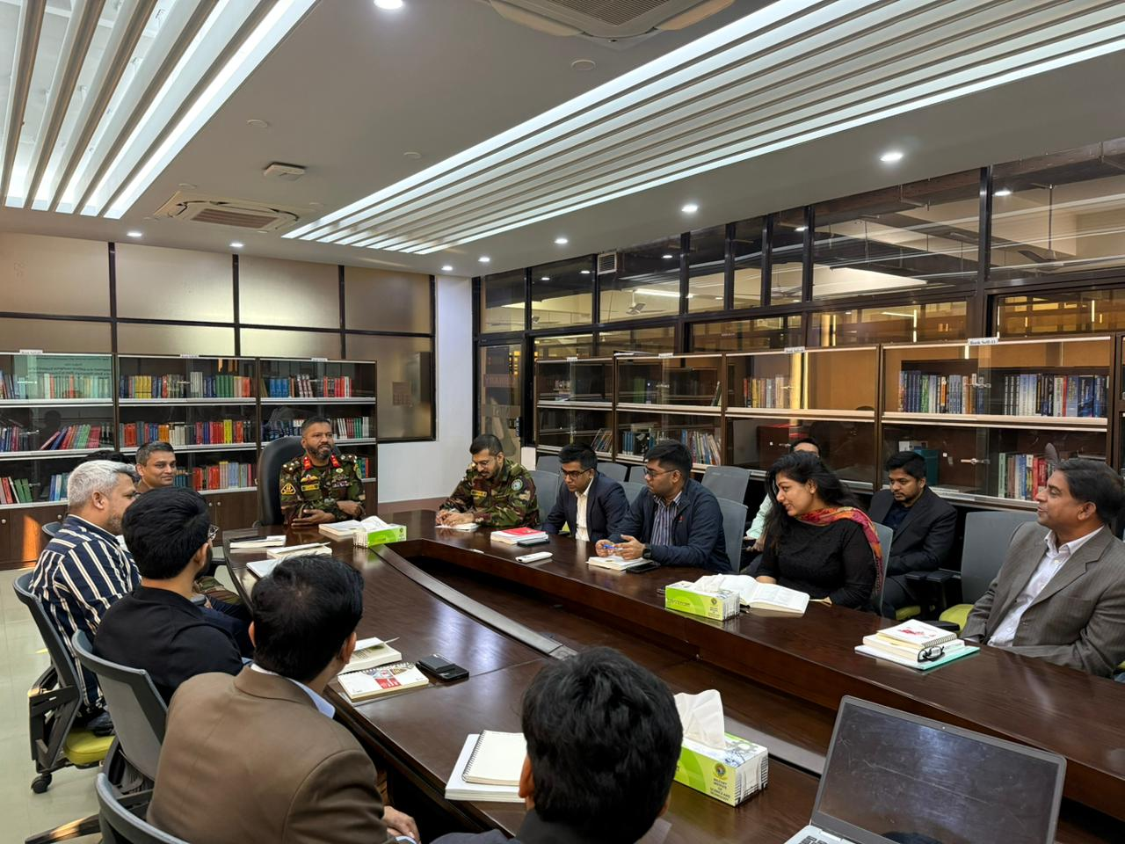
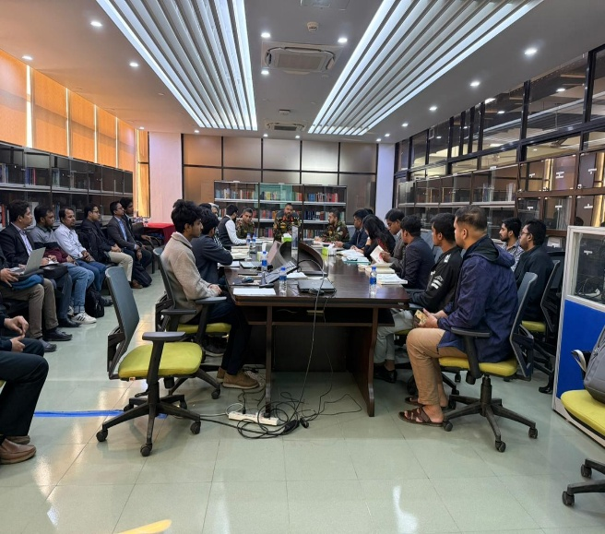
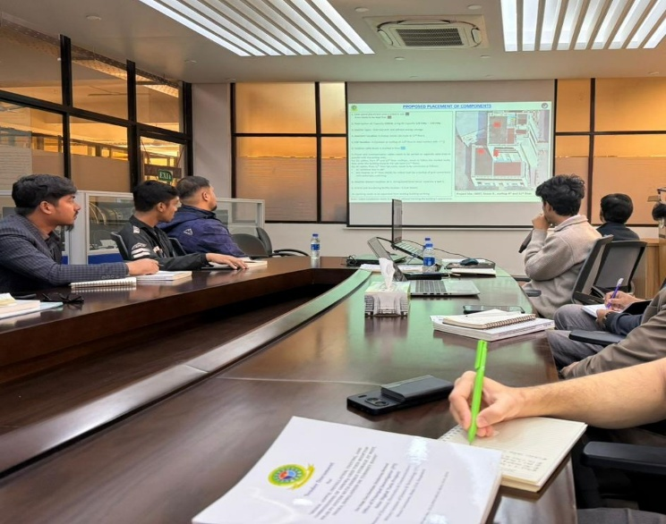

The Department of Electrical, Electronic and Communication Engineering at the Military Institute of Science and Technology hosted a pre bid meeting on January 22, 2026, bringing together 14 renowned companies to discuss the upcoming project titled “100 kWac Grid Tied Rooftop Solar PV System with Energy Storage at MIST On a Trunkey Basis”
The meeting was attended by departmental leadership managing the project, with Brigadier General K M Mustafizur Rahman, psc, Head of the Department, EECE, MIST, serving as the chief attendee.
The session was held at the EECE departmental library room on Tower 3, 2nd Floor, MIST in Mirpur Cantonment, Dhaka. During the meeting, prospective vendors and participating firms raised technical and procedural queries on project scope, expected deliverables, compliance requirements, and implementation considerations. The organizing committee and departmental representatives addressed these questions to ensure clarity and alignment among all stakeholders ahead of bid submission.
A brief discussion also focused on the broader impact of solar power plants in Bangladesh and the role of energy storage. The participants noted that storage can improve the usability of solar generation by reducing short term variability and supporting better energy management when demand patterns shift. The meeting also highlighted that well planned solar and storage integration can strengthen operational reliability and serve as a practical reference for future rooftop deployments in Bangladesh.
The pre bid engagement aimed to strengthen transparency in the procurement process, reduce ambiguity in vendor interpretation, and support a more competitive and technically responsive bidding environment for the renewable energy installation at MIST.

