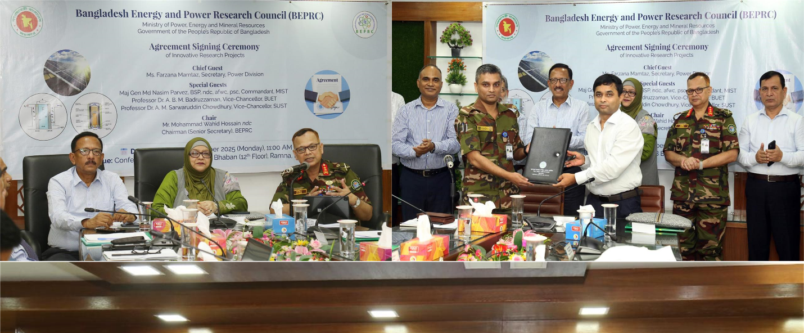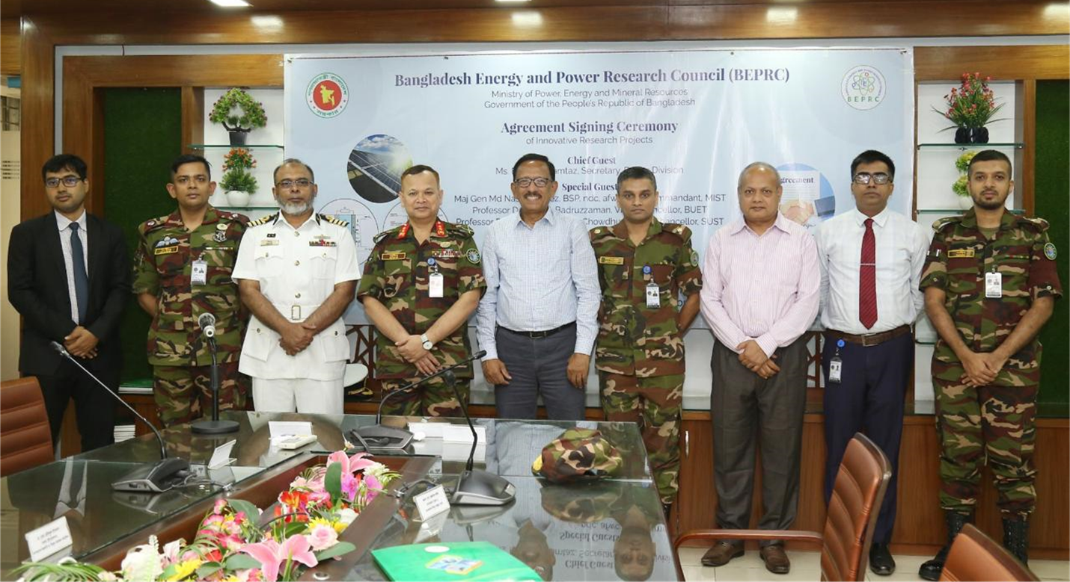

On 29 September 2025, Bangladesh Energy and Power Research Council (BEPRC) hosted the contract signing ceremony for the transformative and visionary project titled “DEVELOPMENT OF AN ARTIFICIAL INTELLIGENCE ENABLED DIGITAL TWIN OF A SOLAR PHOTOVOLTAIC PLANT TO ENHANCE RENEWABLE PENETRATION IN POWER GRID OF BANGLADESH.” An agreement was signed between the BEPRC and MIST through Major Shah Mohazzem Hossain, PhD, Signals, Instructor Class B, Department of EECE, MIST, who will serve as the Principal Investigator (PI) of this three-year research project with a total budget allocation of BDT 1.63 crore; the project team of EECE Dept includes Major Mohammad Naim Uddin, Signals, and Assistant Professor Md. Ahsan Kabir as Co-PIs, while Assistant Professor Hasan Monir will act as the Lead Research Engineer, collectively bringing together strong academic and technical expertise to ensure the project’s successful implementation and impactful outcomes. The signing ceremony was graced by the Senior Secretary (Chairman BEPRC), Secretary (Power Div), Commandant (MIST), Chairman (BPDB), Chairman (SREDA), Member (BEPRC & BERC), distinguished professors and researchers from BUET & SUST. As a highlight of the event, Major Shah Mohazzem Hossain, PhD delivered an insightful presentation on an AI-enabled Digital Twin (DT) of a solar PV system. The proposed system will be able to monitor real time output and perform energy generation forecasting of a solar plant using advanced machine learning techniques. This innovation is designed to address key challenges in solar energy integration into the national grid, including weather-dependent output, lack of real-time monitoring, and high computational demands of renewable system modeling. Overall, this research aims to strengthen existing grid resiliency, improve renewable integration, and accelerate Bangladesh’s clean energy transition.

