Development of an Artificial Intelligence-Enabled Digital Twin of a Solar Photovoltaic Plant to Enhance Renewable Penetration in the Power Grid of Bangladesh

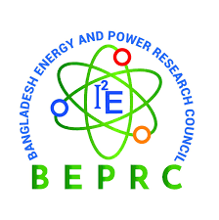

High penetration of solar PV into the power grid introduces significant operational challenges due to its inherent intermittency and uncertainty. Rapid fluctuations in irradiance can cause voltage instability, frequency deviations, and increased ramping stress on conventional generators. In weak or poorly monitored grids, these effects may propagate and escalate into cascading failures, potentially leading to large-scale outages or grid-level catastrophes.

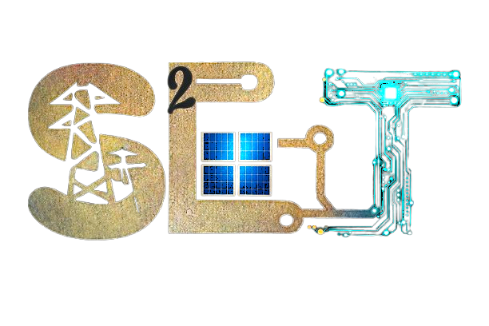
Therefore, accurate forecasting, real-time monitoring, and coordinated control are essential to ensure secure and reliable grid integration of solar energy. To contribute to this objective, EECE Department of MIST, Bangladesh, is implementing a Research facility named Smart Grid and Sustainable Energy Transition Lab

and part of that facility will be a 100 kW (AC) grid-tied rooftop solar photovoltaic power system. Beyond electricity generation, the ultimate goal of this project is to develop an Artificial Intelligence–enabled Digital Twin of the solar PV plant. The digital twin will enable real-time monitoring, data acquisition, analytics, and performance assessment, serving both operational and research purposes. The proposed system will operate as a grid-tied solar PV plant, where the generated electrical energy will be synchronized with and supplied to the national grid. The project will support clean energy integration within an academic campus while providing a practical platform for advanced research in smart grids, digital twins, and data-driven energy management.
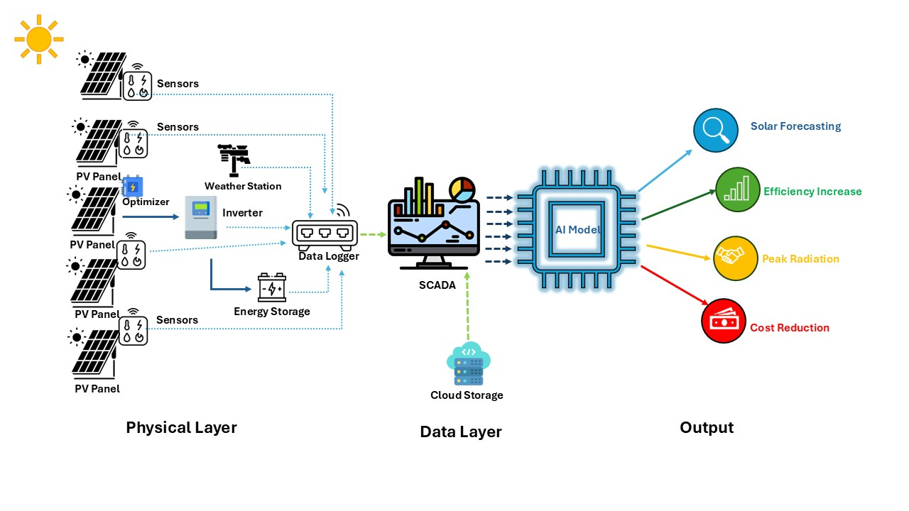

Awarding of the Project

Research Grant: BDT 1.63 Crore (≈ USD 133,000)
Funding Agency: Bangladesh Energy and Power Research Council (BEPRC)
Project Duration: October 2025 – October 2028

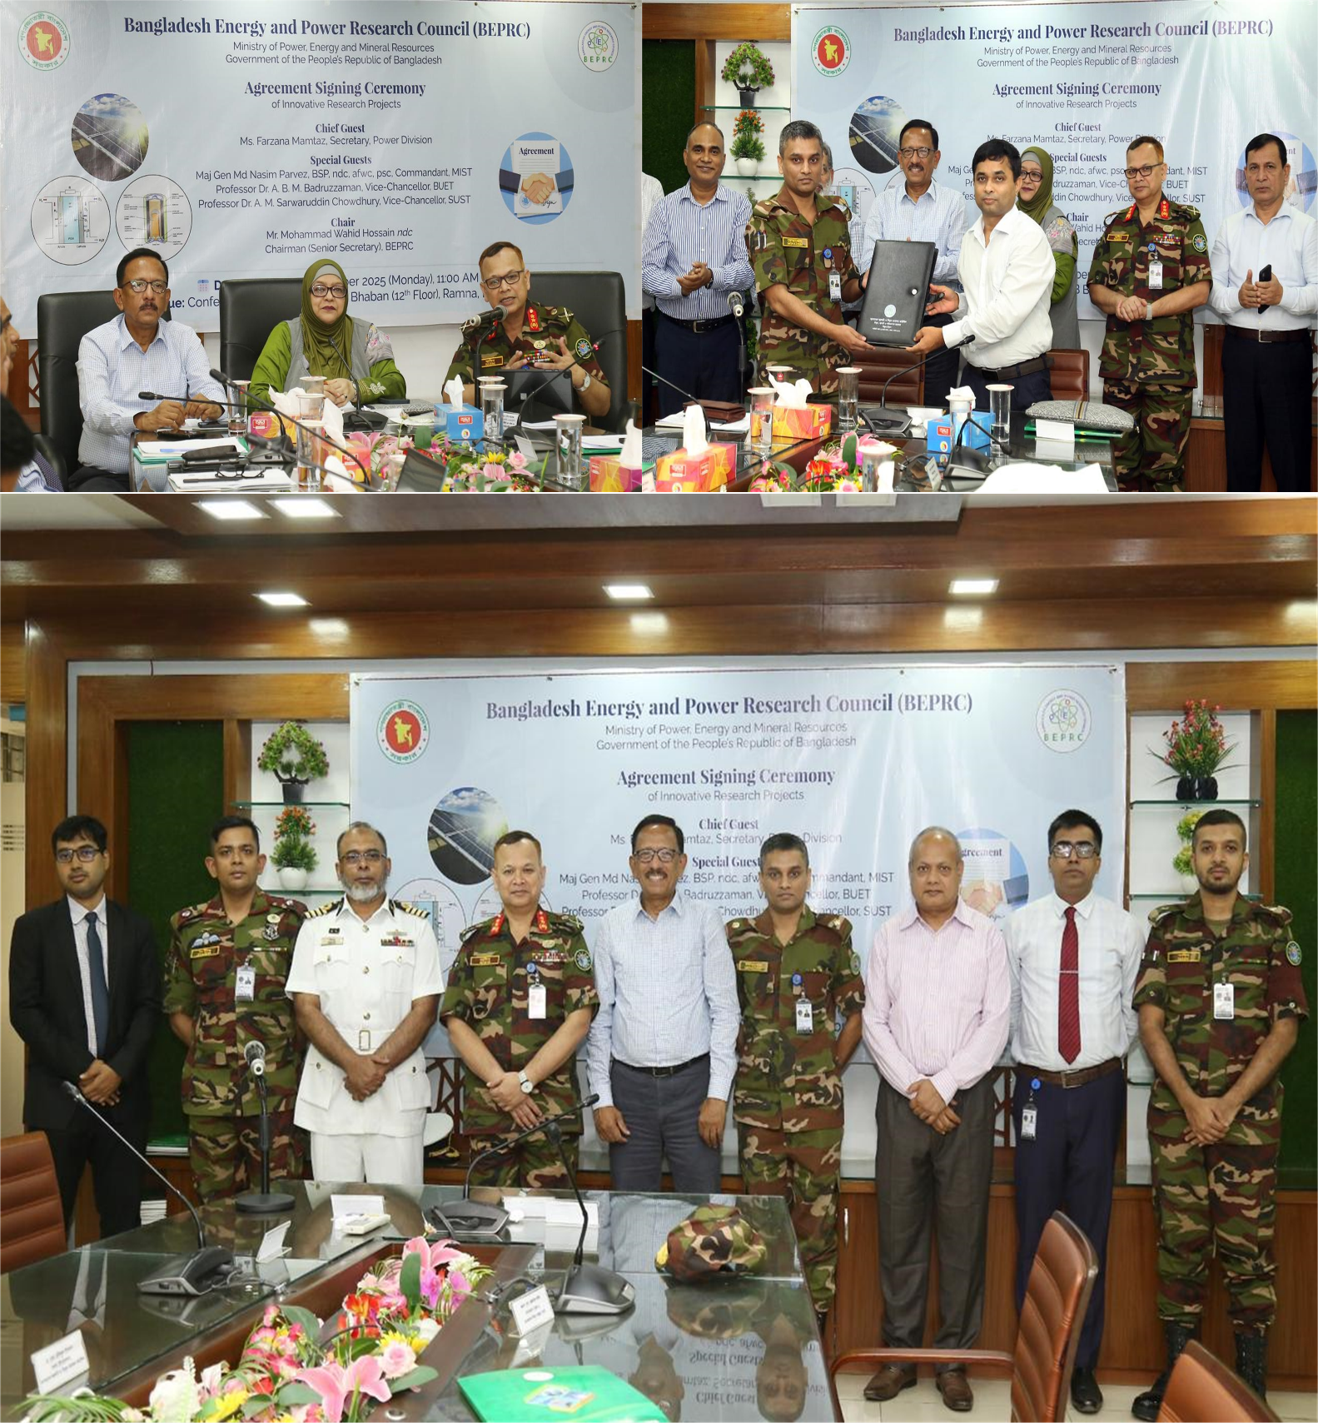

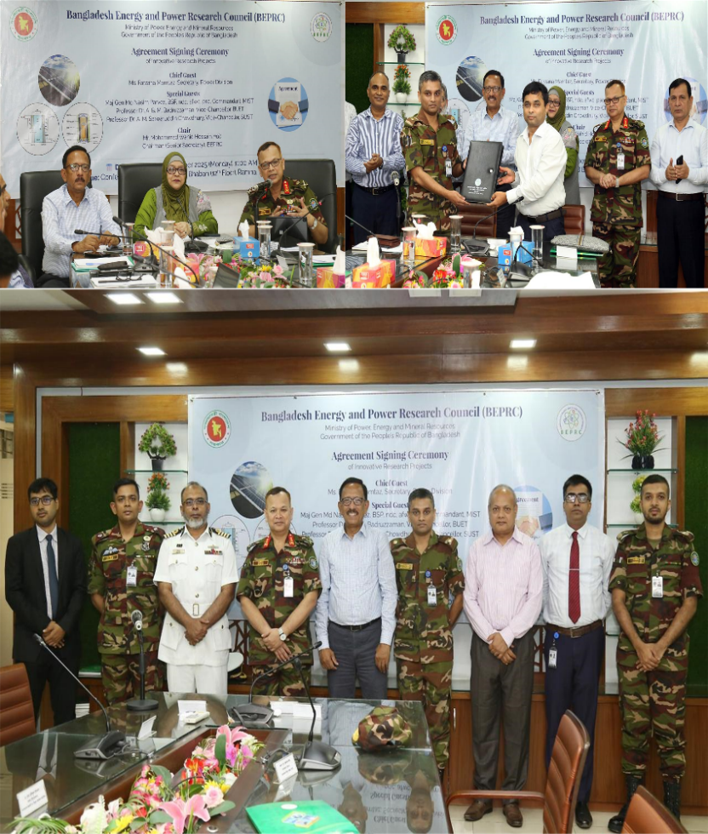

Core Team Behind the Project

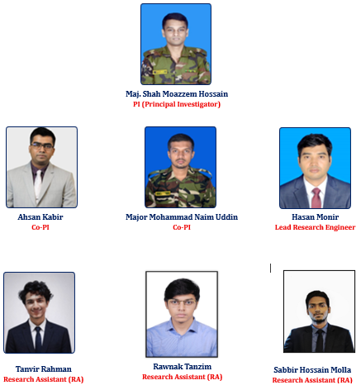
Objective of the Project

The overall research work is structured around the following key objectives:
- To develop a scalable digital twin (DT) model for a 100 kWp grid-connected rooftop PV system as a testbed, designed to replicate the behavior of a large-scale solar farm.
- To integrate AI-based algorithms into the DT model for real-time monitoring and forecasting of PV output across various future time intervals.
- To evaluate the accuracy of the developed DT by comparing its outputs with actual measurements from the pilot-scale 100 kWp testbed system.
- To demonstrate and validate the scalability of the DT architecture by applying it to smaller PV systems, such as 20 kWp and 50 kWp installations.
- To assess the scalability and accuracy of the AI-driven DT model by comparing its performance with real-world data from a large-scale 7.6 MWp solar farm in Sirajganj, Bangladesh.
- To develop a comprehensive, multi-featured real-world solar PV dataset specific to Bangladesh for use in further research and applications.

Overview

This research presents an AI-driven digital twin–based framework to address critical challenges in large-scale solar energy integration into the national grid, including weather-induced power variability, limited real-time system observability, and the high computational burden associated with conventional renewable energy modeling. By enabling accurate real-time monitoring, forecasting, and scalable system representation, the proposed approach enhances grid resiliency and operational reliability. Overall, the study aims to facilitate efficient renewable energy integration and contribute to accelerating Bangladesh’s transition toward a sustainable and clean energy future.

Methodology

This research aims to develop a scalable digital twin (DT) model of a grid-connected PV system integrated with battery storage that accurately replicates the dynamic behavior of real-world PV installations. To support this objective, a small-scale rooftop solar PV testbed will be established on the MIST campus to serve as the experimental platform. The testbed will be equipped with essential system components, including a weather monitoring station, high-resolution digital instrumentation, and power and environmental data acquisition systems to enable high-resolution data collection. Operational and environmental datasets obtained from the testbed will be analyzed using advanced AI-based algorithms to develop a robust, scalable DT model that enables real-time estimation and forecasting of electrical power output. Finally, the scalability and real-world applicability of the developed DT framework will be evaluated through deployment and validation using data from large-scale operational PV plants in Bangladesh.
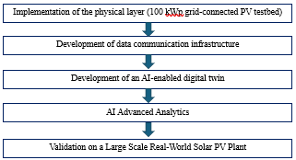

Outcomes

- Enhanced grid resiliency and operational performance through real-time monitoring, predictive analytics, and intelligent optimization of solar power generation.
- A validated AI-driven digital twin framework for PV systems, suitable for deployment in energy management centers across Bangladesh.
- Improved load management, situational awareness, and grid stability for grid operators.
- An intelligent and simplified PV plant modeling tool to support researchers and practitioners in renewable energy studies.
- A comprehensive real-world solar PV dataset tailored to Bangladesh, enabling further academic and industrial research.
- Dissemination of research findings through:
- Technical reports
- Policy briefs
- Workshops and training programs
- Peer-reviewed academic publications

  - Promotion of AI-based digital twin adoption in Bangladesh’s renewable energy sector.

