29.5.2026
Analysis Of Survey Data

1. Demographic Summary
The survey captured responses from a sample size of 46 individuals, displaying a relatively young and highly student-centric profile:
- Age: The cohort is split almost equally. 52.2% (24 respondents) are Above 20, and 47.8% (22 respondents) are Between 15 and 20.
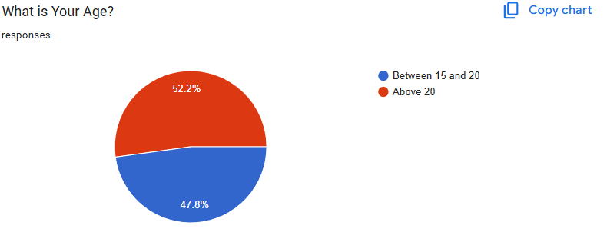
- Gender: The sample consists of 58.7% Male (27 respondents) and 41.3% Female (19 respondents).
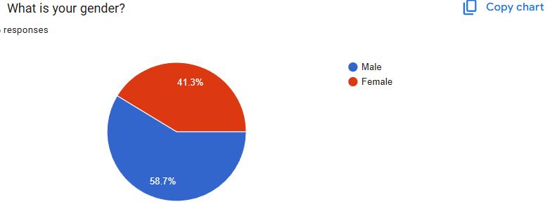
- Employment Status: The demographic heavily skews toward Students (73.9% / 34 respondents), followed by Employed individuals (21.7% / 10 respondents), and Self-employed individuals (4.3% / 2 respondents).
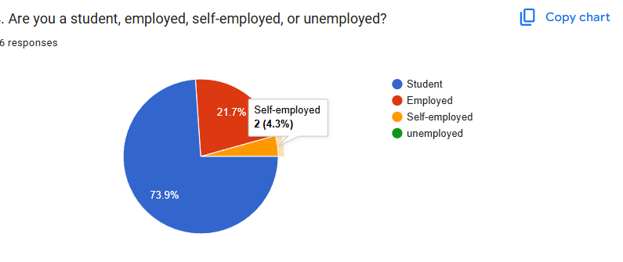

2. IoT Usage & Landscape
IoT integration is deeply embedded within this demographic, with a noticeable trend toward dense home networks:
- Adoption Rate: An overwhelming 95.7% (44 respondents) actively use smart or IoT devices at home or work.
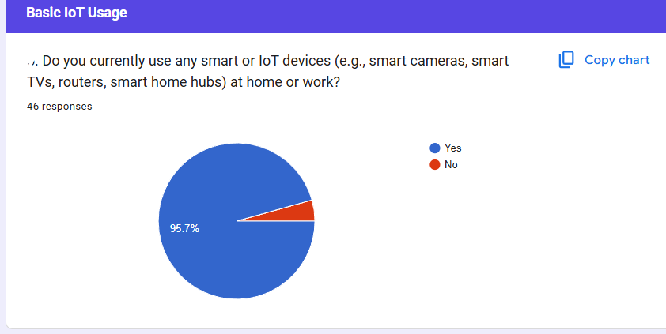
- Network Density: Network environments are remarkably dense. 58.7% have More than 5 devices connected to their primary network, while 41.3% host fewer than 5 devices.
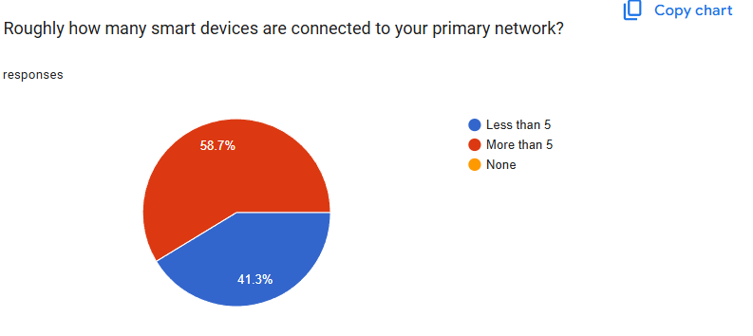
- Most Popular Devices: Routers lead the ecosystem, followed closely by Wearable devices and Smart speakers/security cameras:
  - Routers (24 selections)
  - Wearable Devices (21 selections)
  - Smart Security Cameras (14 selections)
  - Smart Speakers (14 selections)
  - Smart Plugs & Lights (13 selections)
  - Doorbells (11 selections)
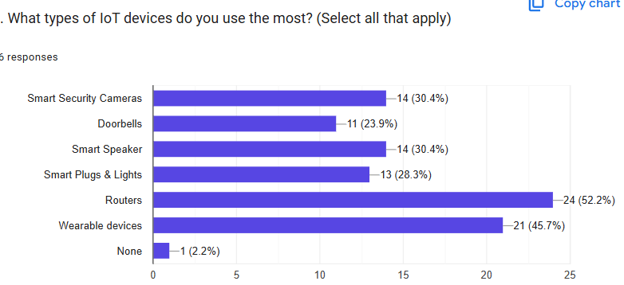

3. Security Hygiene & Authentication Habits

Password Behaviors
- Policy Awareness: 93.5% (43 respondents) state they understand what a strong password policy means.
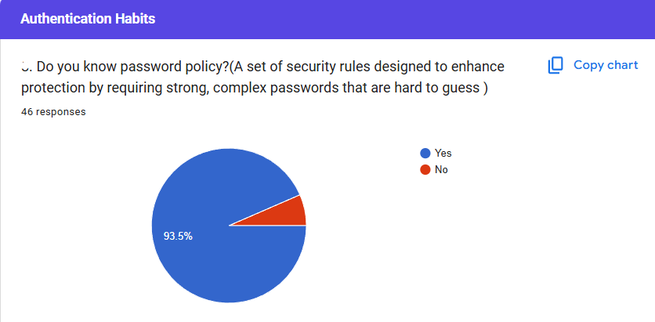

- Default Passwords: Initial hygiene is strong: 63.0% always change default passwords immediately upon purchase, 28.3% Sometimes change them, while the remaining 8.7% Rarely or Never do.
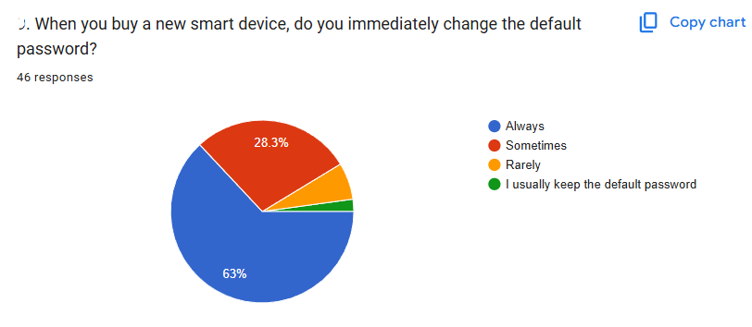
- Password Reuse: Despite changing default credentials, password reuse is rampant. 43.5% reuse identical credentials most of the time across multiple accounts/devices, and 32.6% do so sometimes. Only 23.9% utilize unique credentials everywhere.
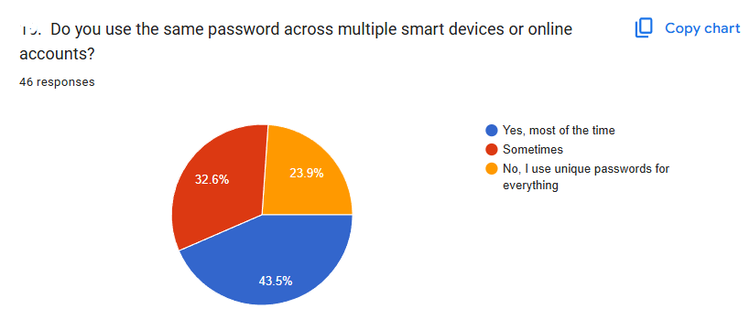

MFA/2FA Adoption
- Awareness of Multi-Factor Authentication is high: 80.4% (37 respondents) claim they are familiar with and actively use MFA/2FA.
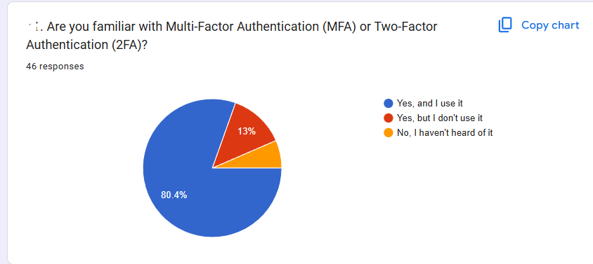
- When looking at admin environments, 73.9% (34 respondents) declare that All or Most of their IoT devices have MFA enabled for administrative control.
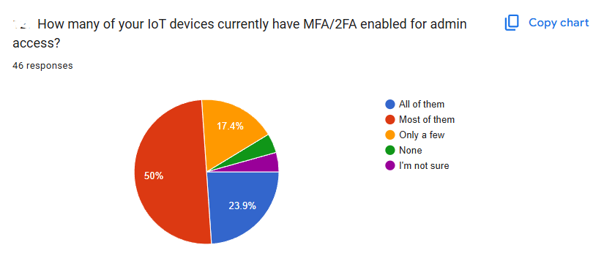

Key Behavioral Correlations
- Employment vs. Default Password Changes: Employed individuals demonstrate stricter initial setups. 70.0% of employed individuals Always change default passwords immediately, compared to 61.8% of students. Students are more prone to complacency, with 32.4% only updating default credentials Sometimes.
- Device Density vs. MFA Administration: Users managing complex environments (5+ devices) practice better endpoint control: 61.5% have MFA enabled on Most admin accounts. Conversely, users with fewer than 5 devices show broader polarization. 27.8% have managed to protect All devices, but a large 27.8% have enabled MFA on Only a few endpoints.

4. Awareness & Threat Perception
- User Concern: Anxiety regarding data intrusions (e.g., threat actors accessing live camera feeds) is highly elevated. 58.7% are Very concerned, and 37.0% are Somewhat concerned.
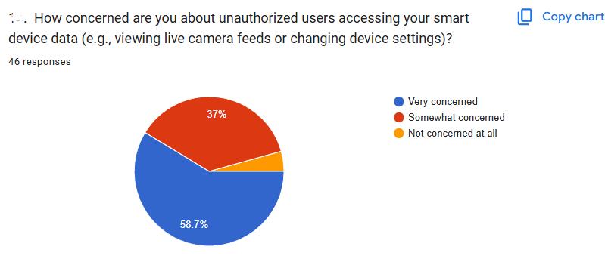
- Botnet Awareness: 73.9% are aware that flawed IoT systems can be hijacked into destructive botnets.
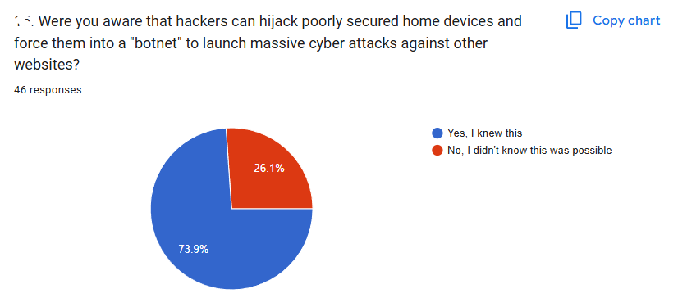
- Suspicious Encounters: Alarmingly, a definitive 58.7% ( have already experienced suspicious activity on their IoT devices (such as sudden settings configurations changing autonomously, unfamiliar active logins, or unexpected extreme lag).
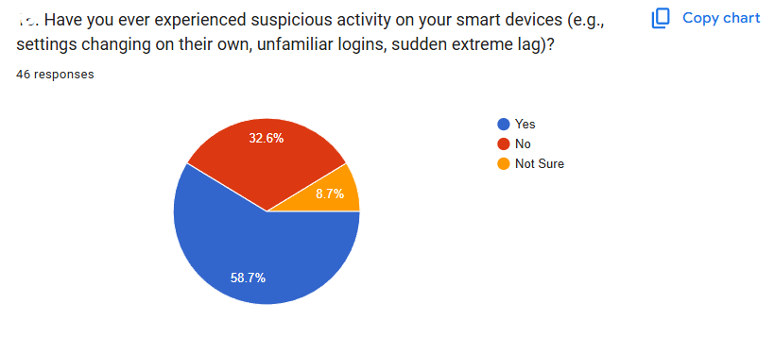

5. Qualitative Insights (Thematic Analysis)

Why Users Keep Default or Old Passwords (Col 13)
Across the 43 cleaned, valid responses, two overriding friction points emerged:
- Cognitive Fatigue / Memory Overhead: The predominant reason is the convenience of relying on a familiar string. Users report a fear of forgetting unique passwords when dealing with multiple systems.
- Confounding Setup Configurations: Users noted that the native setup process within vendor applications is frequently overly complex, encouraging them to skip credential updates to avoid system errors.

Worst-Case Scenarios Feared by Users (Col 17)
The primary concerns go far beyond digital data theft into physical and psychological safety:
- Surveillance & Blackmail: The most common fear is an attacker hijacking smart security cameras to record private, domestic moments, weaponizing the footage for blackmail or extortion.
- Gateway Pivoting: Users fear that compromising a minor IoT device (like a smart bulb or router) will serve as a launchpad to bypass local network security, allowing access to personal computers to steal banking data or corporate documents.

Frictions in Securing Devices (Col 20)
- Unclear Vendor Update Frameworks: Users heavily criticize opaque firmware management. Updates are often hidden, lack auto-install functions, and feature technical menus that fail to explain the real-world consequences of altering specific toggles.
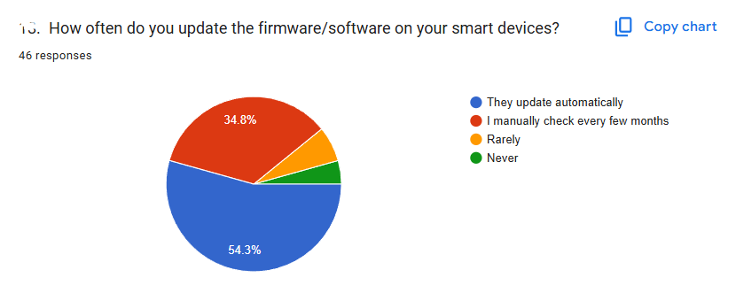

- Network Segmentation Complexities: Setting up a separate guest Wi-Fi network to isolate IoT devices from primary computers is highlighted as highly confusing and time-consuming for non-technical users.
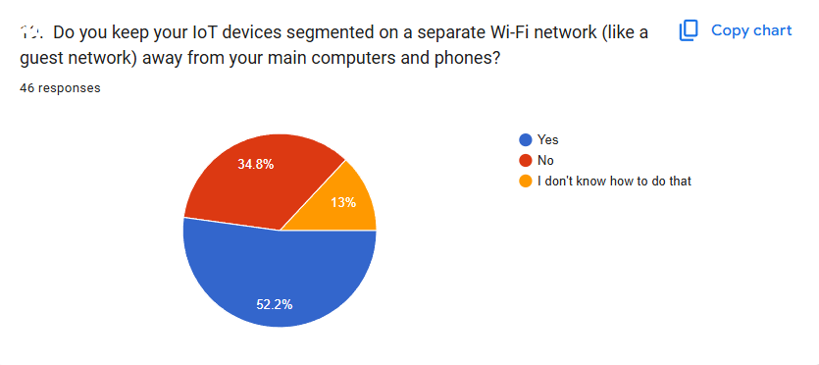

6. Localized Challenges (Myanmar Context)

Macro Challenges (Col 21 & 22)
- Top Structural Impediments: The primary obstacle identified is a shortage of technical skills/knowledge required to configure backend security settings (29 selections). This is worsened by budget limits restricting users to cheap, unbranded, or outdated equipment flooding local markets (25 selections).
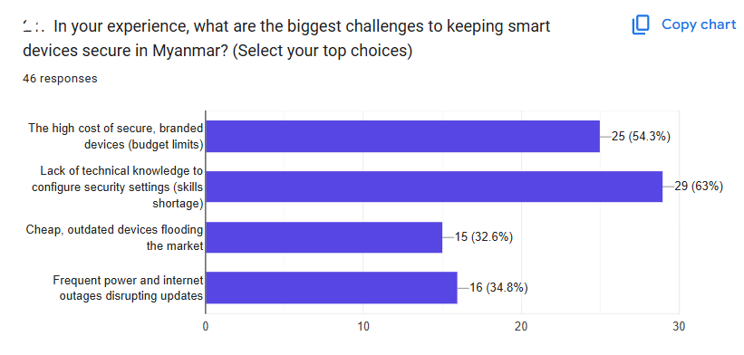
- Infrastructure Failure: Infrastructure stability is an immediate security threat. 63.0% (29 respondents) state that power outages and internet drops are a major issue preventing them from maintaining secure devices.
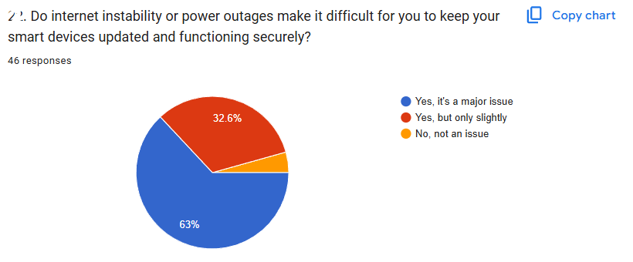

Real-World Incidents from Myanmar (Col 23)
The following are a few case studies that show how local infrastructure directly compromises cybersecurity:

The Bricked Firmware Vulnerability: One of the respondents explained trying to perform a normal update of the home router's firmware, but the power went out during the process. When power was restored, the corrupted partial install caused a complete factory reset, putting the device in an insecure, unpatched, and very vulnerable state, as a result of lost connections.

The Security Camera Failure: The second failure that got reported was a bad security camera software patch that was delivered during a rolling black-out. It would permanently brick the device and with high import cost and tech inflation in Myanmar, there is no way of replacement with security.

The Data Cost Penalty: Several respondents noted that when fixed broadband cuts, they have to use cellular data to get security updates. But the cost of local mobile data, however, is too high for the download of large firmware files, so that users purposely withhold essential security updates.

Autonomous Setting Resets: One user reported that their home router was constantly power cycling and resetting to the factory settings with no warning, even though the security configuration has been set.

7. Executive Conclusion & Recommendations
What the dataset shows is a worrying paradox: Users have high conceptual security awareness (that is, they know what passwords should look like, what a botnet is, etc.) but they are pushed into insecure states because of infrastructure failures and system friction. A security strategy in Myanmar has to be built on the premise that the internet is not always available and the grid won't always hold up.

Actionable Recommendations:
- Implement Offline-First & Resilient Local Upgrades: To counteract mid-update power cuts bricking routers or cameras, local tech distributors should emphasize and provide guides on how to perform local offline firmware flashing via USB or local LAN cables. Dual-firmware-bank devices (which store an older version of the operating software if a software update is aborted) should be specifically considered for purchasing.
- Standardize Frictionless Local Passkeys over Traditional Rules: Remove cognitively burdensome passwords from the picture and instead encourage vendor-app native Passkeys or biometric authorisation (unlocking with fingerprint/face on a smartphone link to vendor apps) for access to IoT administrative settings. This eliminates having to memorize separate strings and fully mitigates credential stuffing attacks.
- Community-Driven "Security Hardening" Blueprints: Local tech communities should create step-by-step, visual, and simplified localization playbooks, given the fact that a skill shortage is the biggest challenge. These should specifically be on how to set up a separate Guest Network for smart devices on regular home local ISP routers, and the steps to audit the settings of devices after sudden grid failures to make sure routers haven't reverted to factory settings.

