The format of the data file for the real world instances is explained as follows. The set of all PVAs is continuously placed in a table and the solar inverter has been installed at a known location. Each line gives the location information of a PVA, including the ID of the PVA, the x-coordinate of the PVA in millimeters and the y-coordinate of the PVA in millimeters. The last line provides the location information of the inverter.

Concerning the format of the data file for the CMST instances, interested readers can refer to the website: http://people.brunel.ac.uk/~mastjjb/jeb/orlib/capmstinfo.html.

The format for the result files is explained as follows. The first line records the cost of the solution, and each of the remaining line represents a subtree. For each line which represents a subtree, the first number N is the number of nodes in the subtree, the next N number are the node IDs in the subtree, and the last N numbers are the positions of the fathers. For exmple, array "8 16 10 4 17 11 5 23 22 -1 1 2 1 4 5 4 1" represents a subtree with 8 nodes like this:
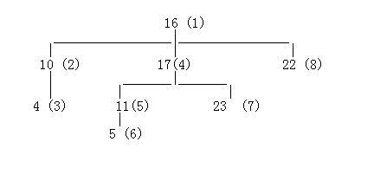
For the real world instances, to calculate the cable cost, we use the first instance (Region 1) as an example.

- ∑distance = ∑distance_{PVAs_to_combinerboxes} +2.77× ∑distance_{combinerboxes_to_inverter}
- 2.77 means that the cable cost per unit for connecting the combiner boxes to the inverter is 2.77 times of that for connecting PVAs to the combiner boxes.
- The price of the cable cost for connecting PVAs to the combiner boxes is about 0.0039365 USD/millimeter.
- ∑cost = 0.0039365 × ∑distance (i.e., 21103.63=0.0039365×5361013)

