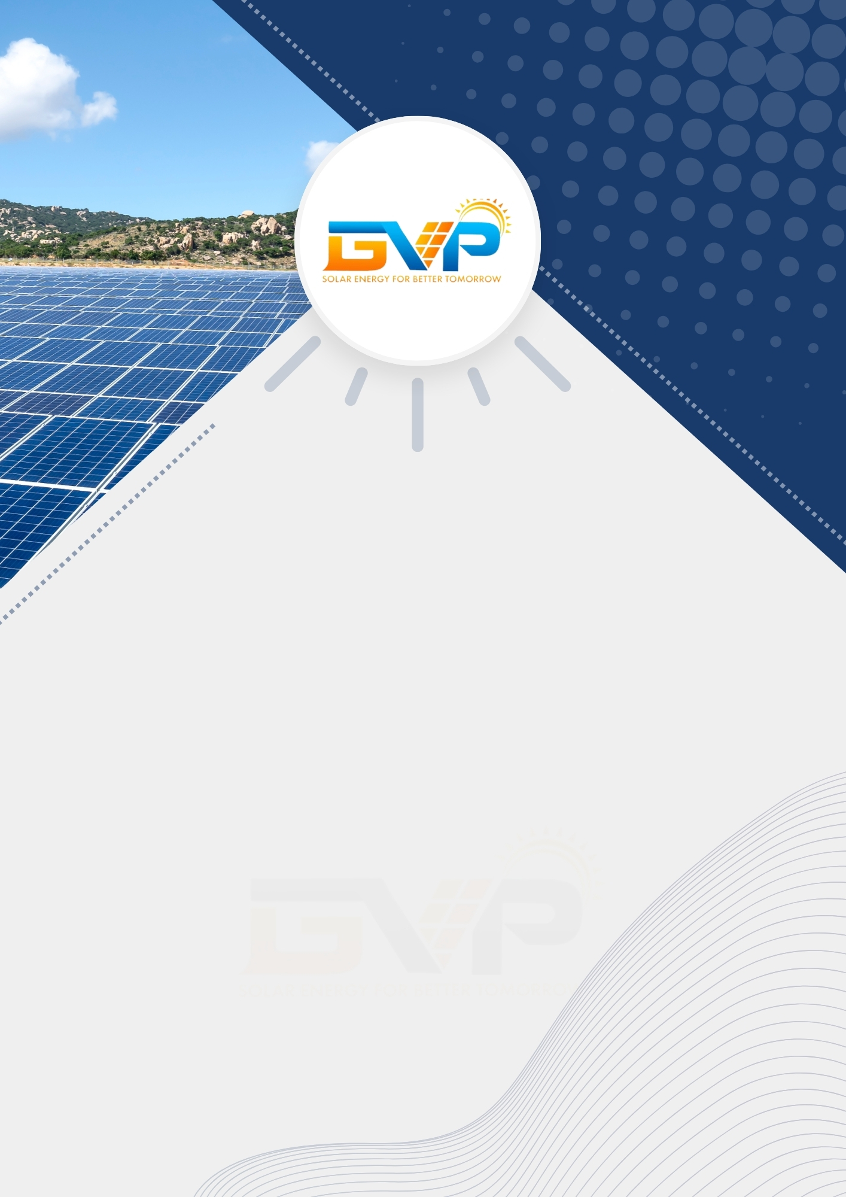

«Project Size (kW)» Solar
Proposal

Date: «Date»
Ref. No.: «Reference No.»

For,
«Customer Name»
«Customer Address»
«Customer Phone»
«Customer Mail»

By,
«Company Name»
«Company Address»
«Company Phone»

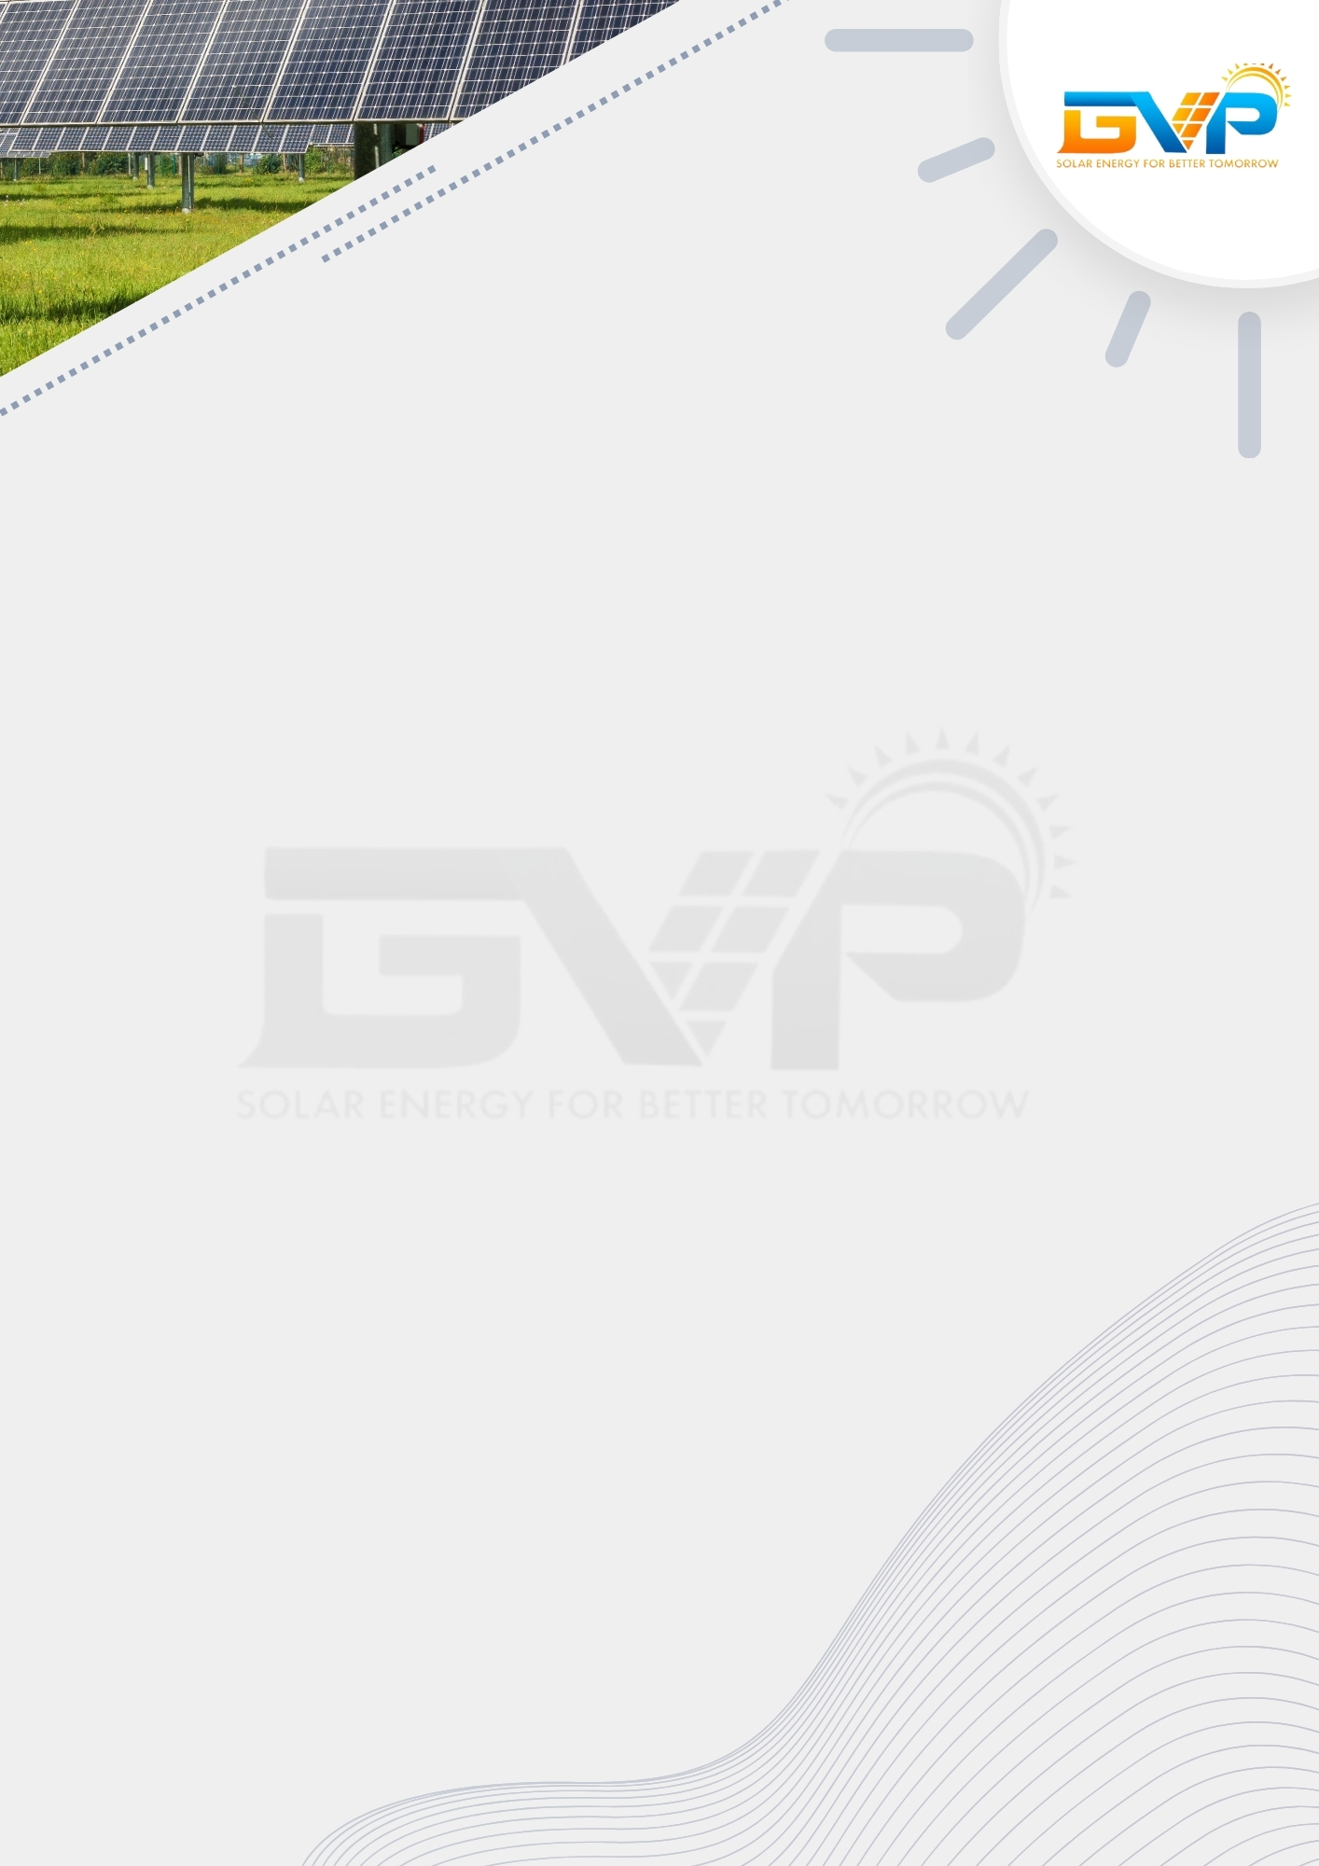

Welcome

To,
«Customer Name»,
«Customer Address»

Sub: Proposal for Supply & Installation of «Project Size (kW)» Grid Connected Solar PV Power Plant.
Thank you for your interest in our service. We're pleased to offer supply and installation of Grid Connected Solar PV Power Plants. Also known as 'GridTie Systems', these units convert DC power into AC power via an inverter. They allow users to utilize solar energy and feed excess power to the grid, cutting costs. Power can be drawn from the grid when sunlight is unavailable, eliminating the need for battery banks.
Thanks & Regard,
«Company POC»,
«Company Name».

Product Feature

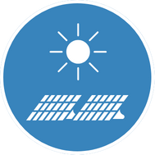
Project Size
«Project Size (kW)»
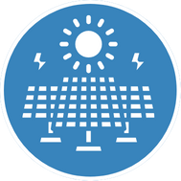
Structure Type
«Structure Type»
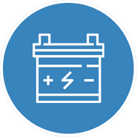
Inverter Type
«Type»

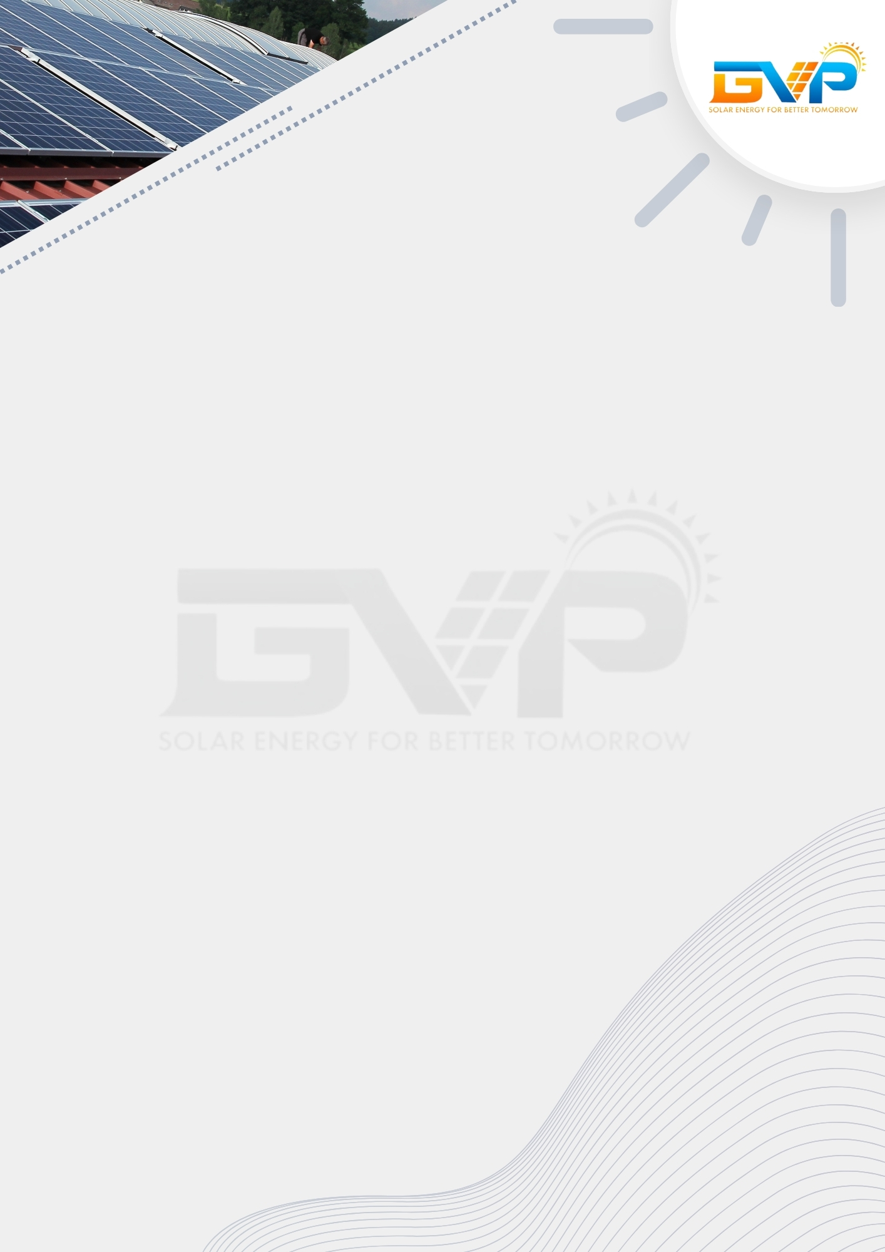

Savings & Payback Period


Payback Period
«Pay Back Period» Years
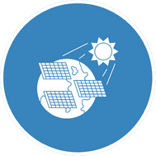
Average Yearly Generation
«Annual Generation» Units

Average Annual Savings
Rs. «Annual Saving»


Project Cost
Rs. «Project Cost»


Trees Saved
«Tree Saved»

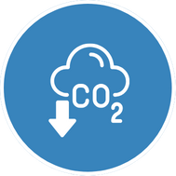
Co2 Reduction
«Co2 Reduction» Tonnes

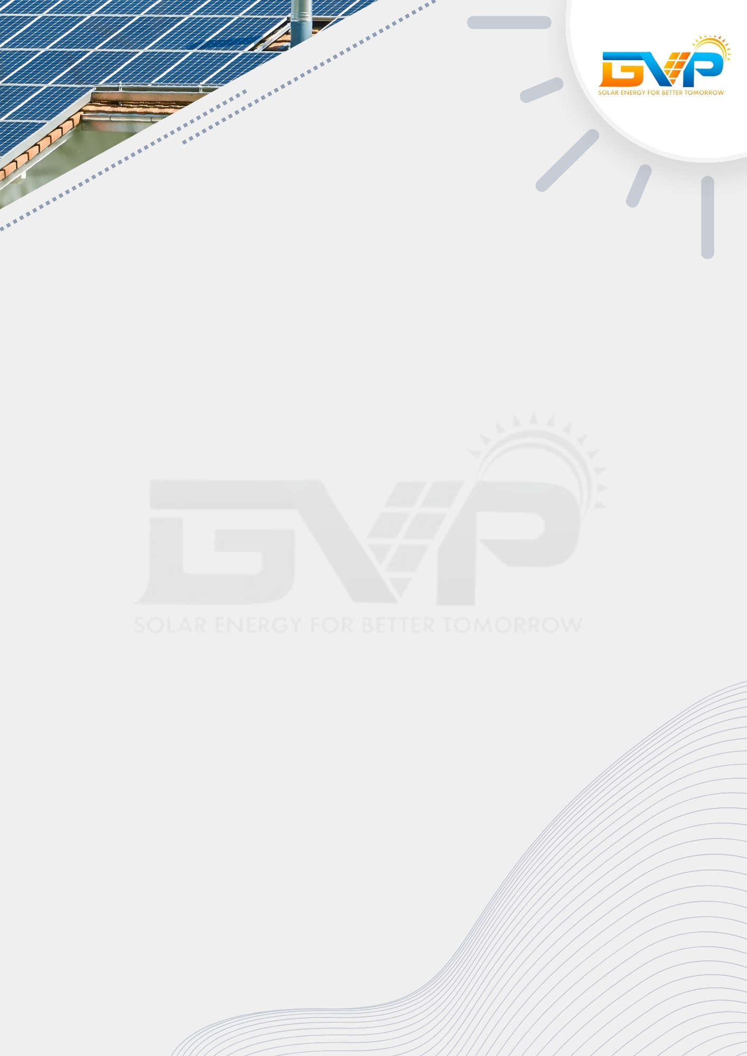

Your Solar Savings

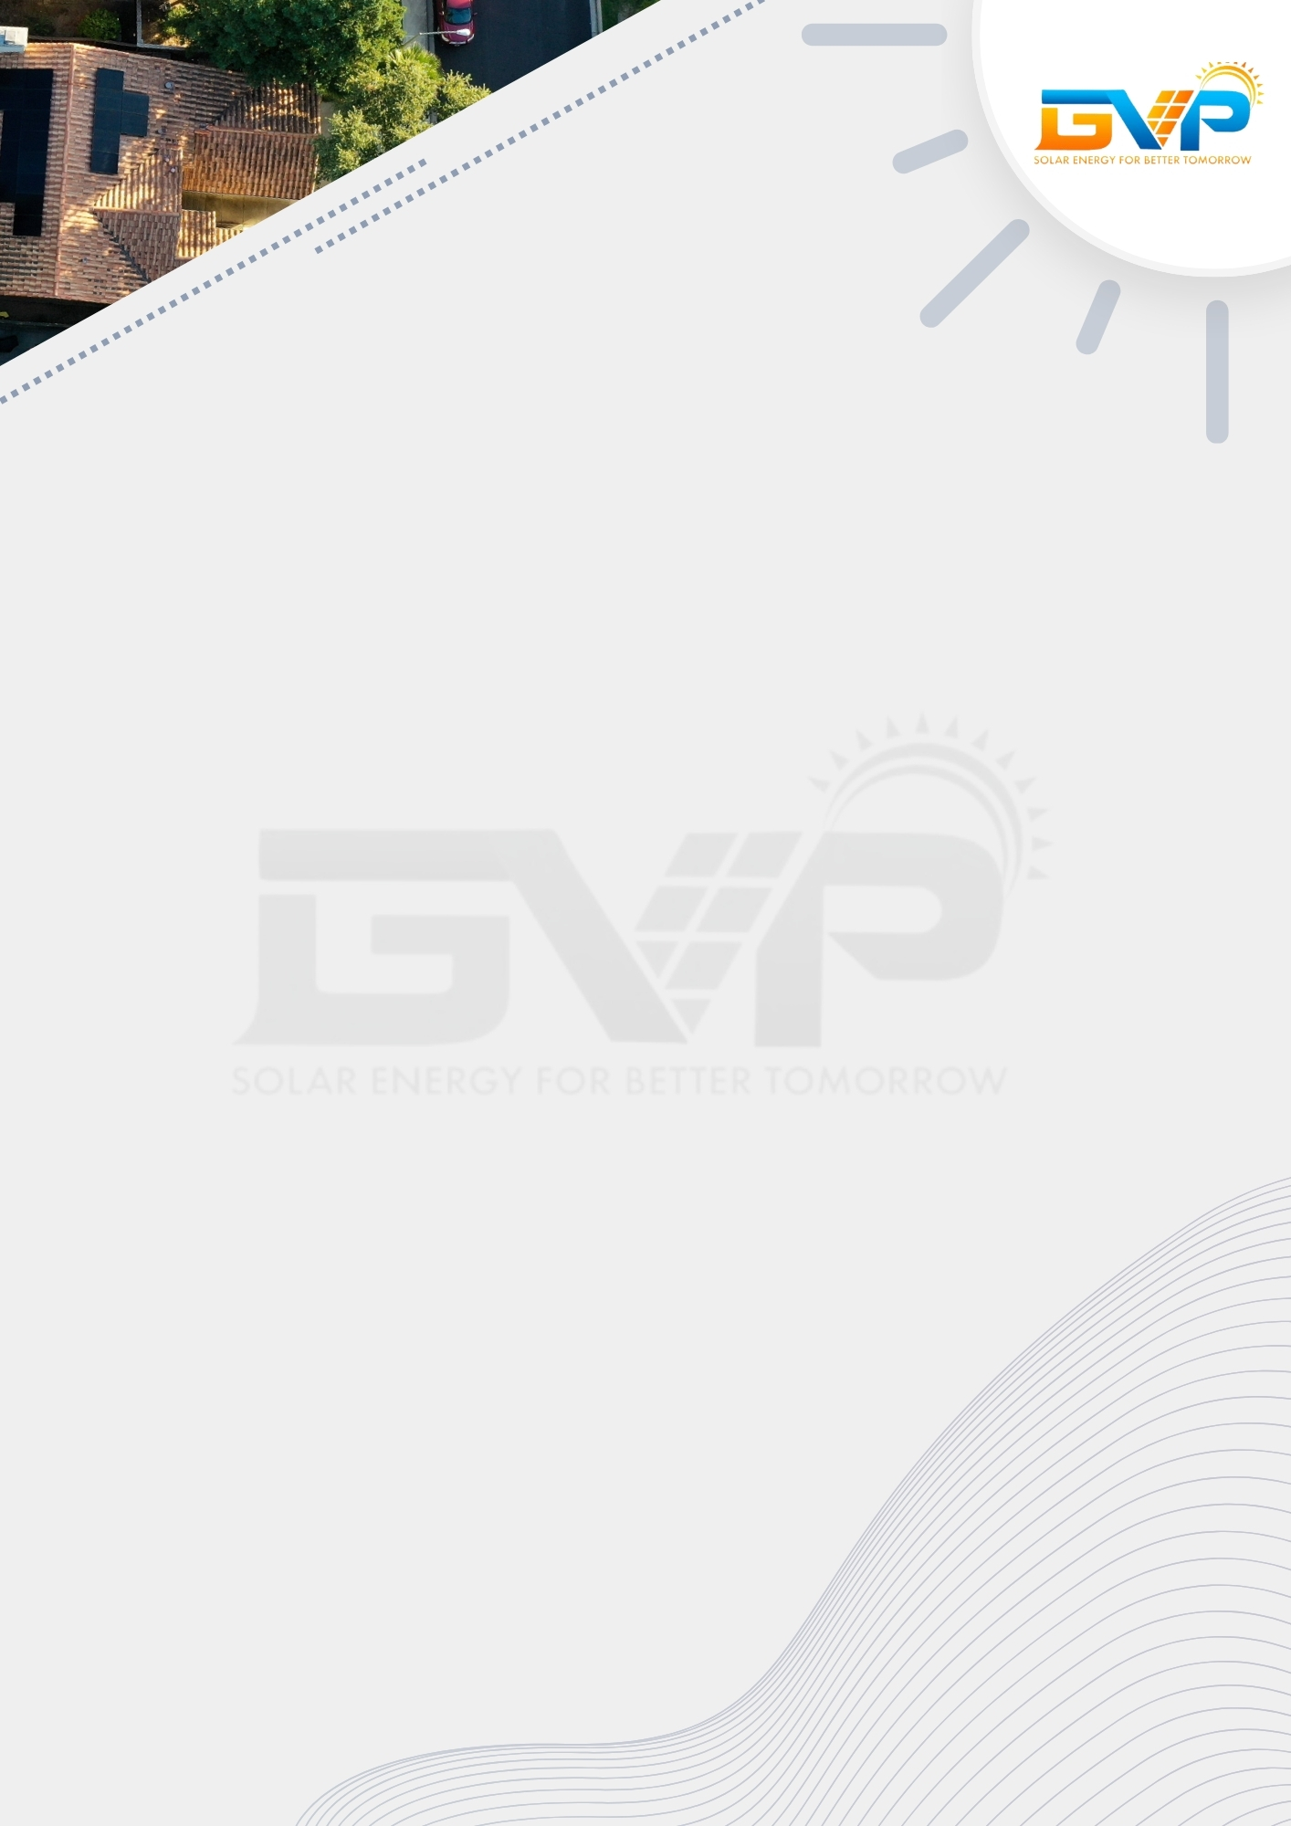

Know Your 30 Years Savings

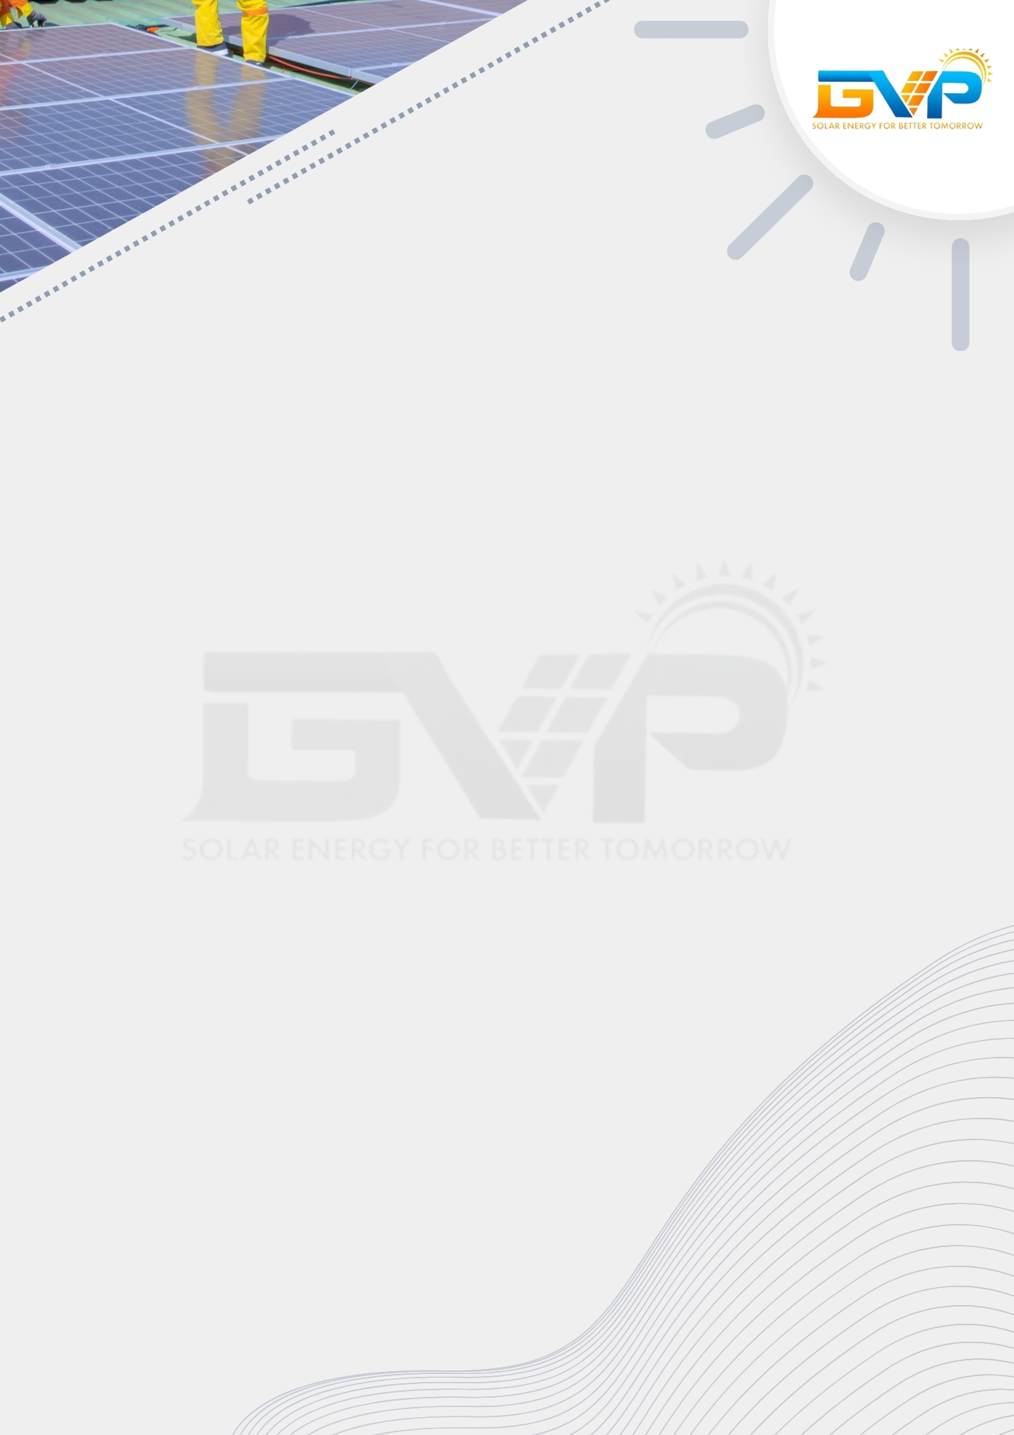

Commercial Offer

Price Quote & Payment schedule for «Project Size (kW)» Crid Tie Rooftop Solar System:

Payment Terms:
Account Details:

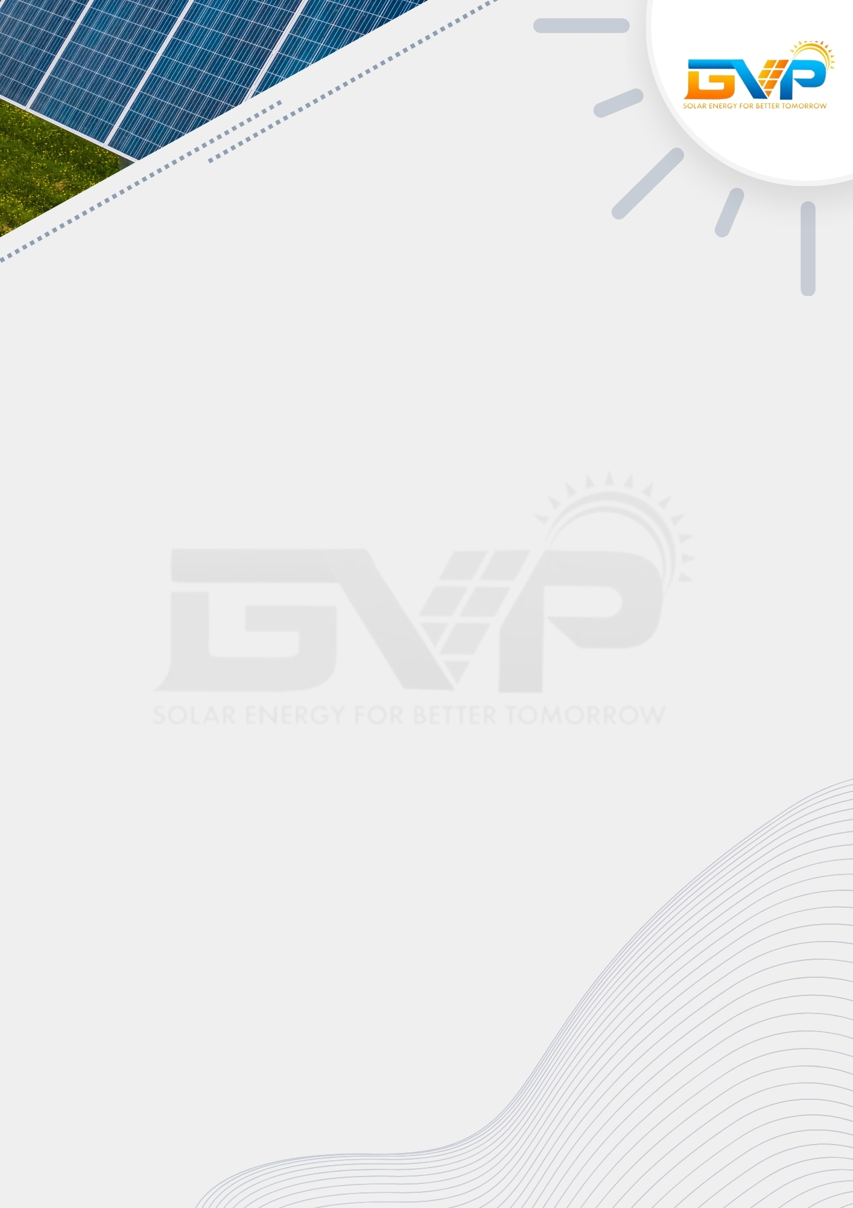

Bill of Material

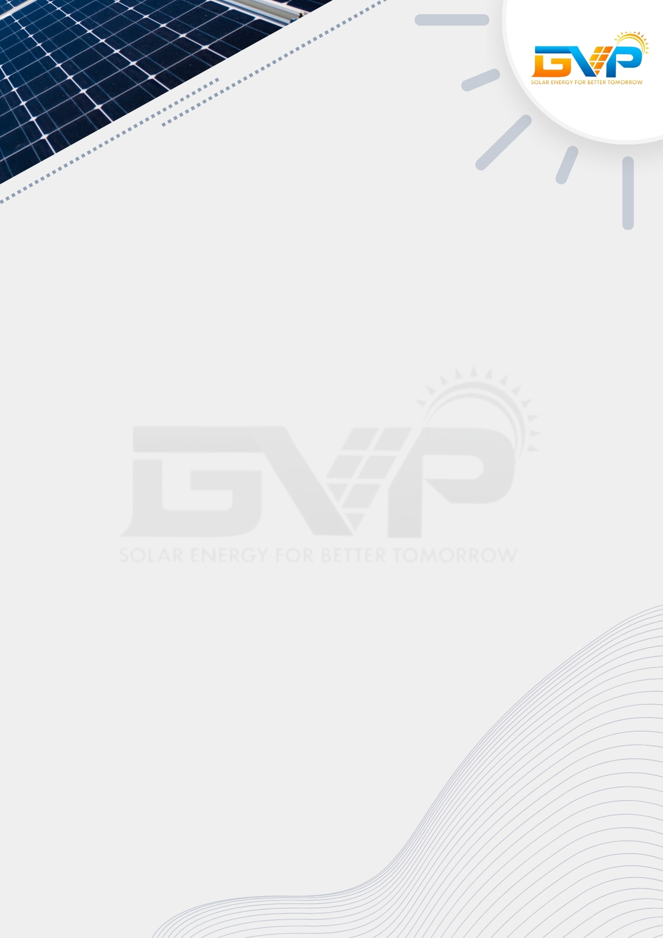

Project Timeline


01 To 07 Days
07 To 14 Days
14 To 21 Days
21 To 30 Days
Finalization of Design and Drawings
Solar Plant Installation
Commissioning and Testing
Engineering, Procurement, and Supply of Material

Scope of Work

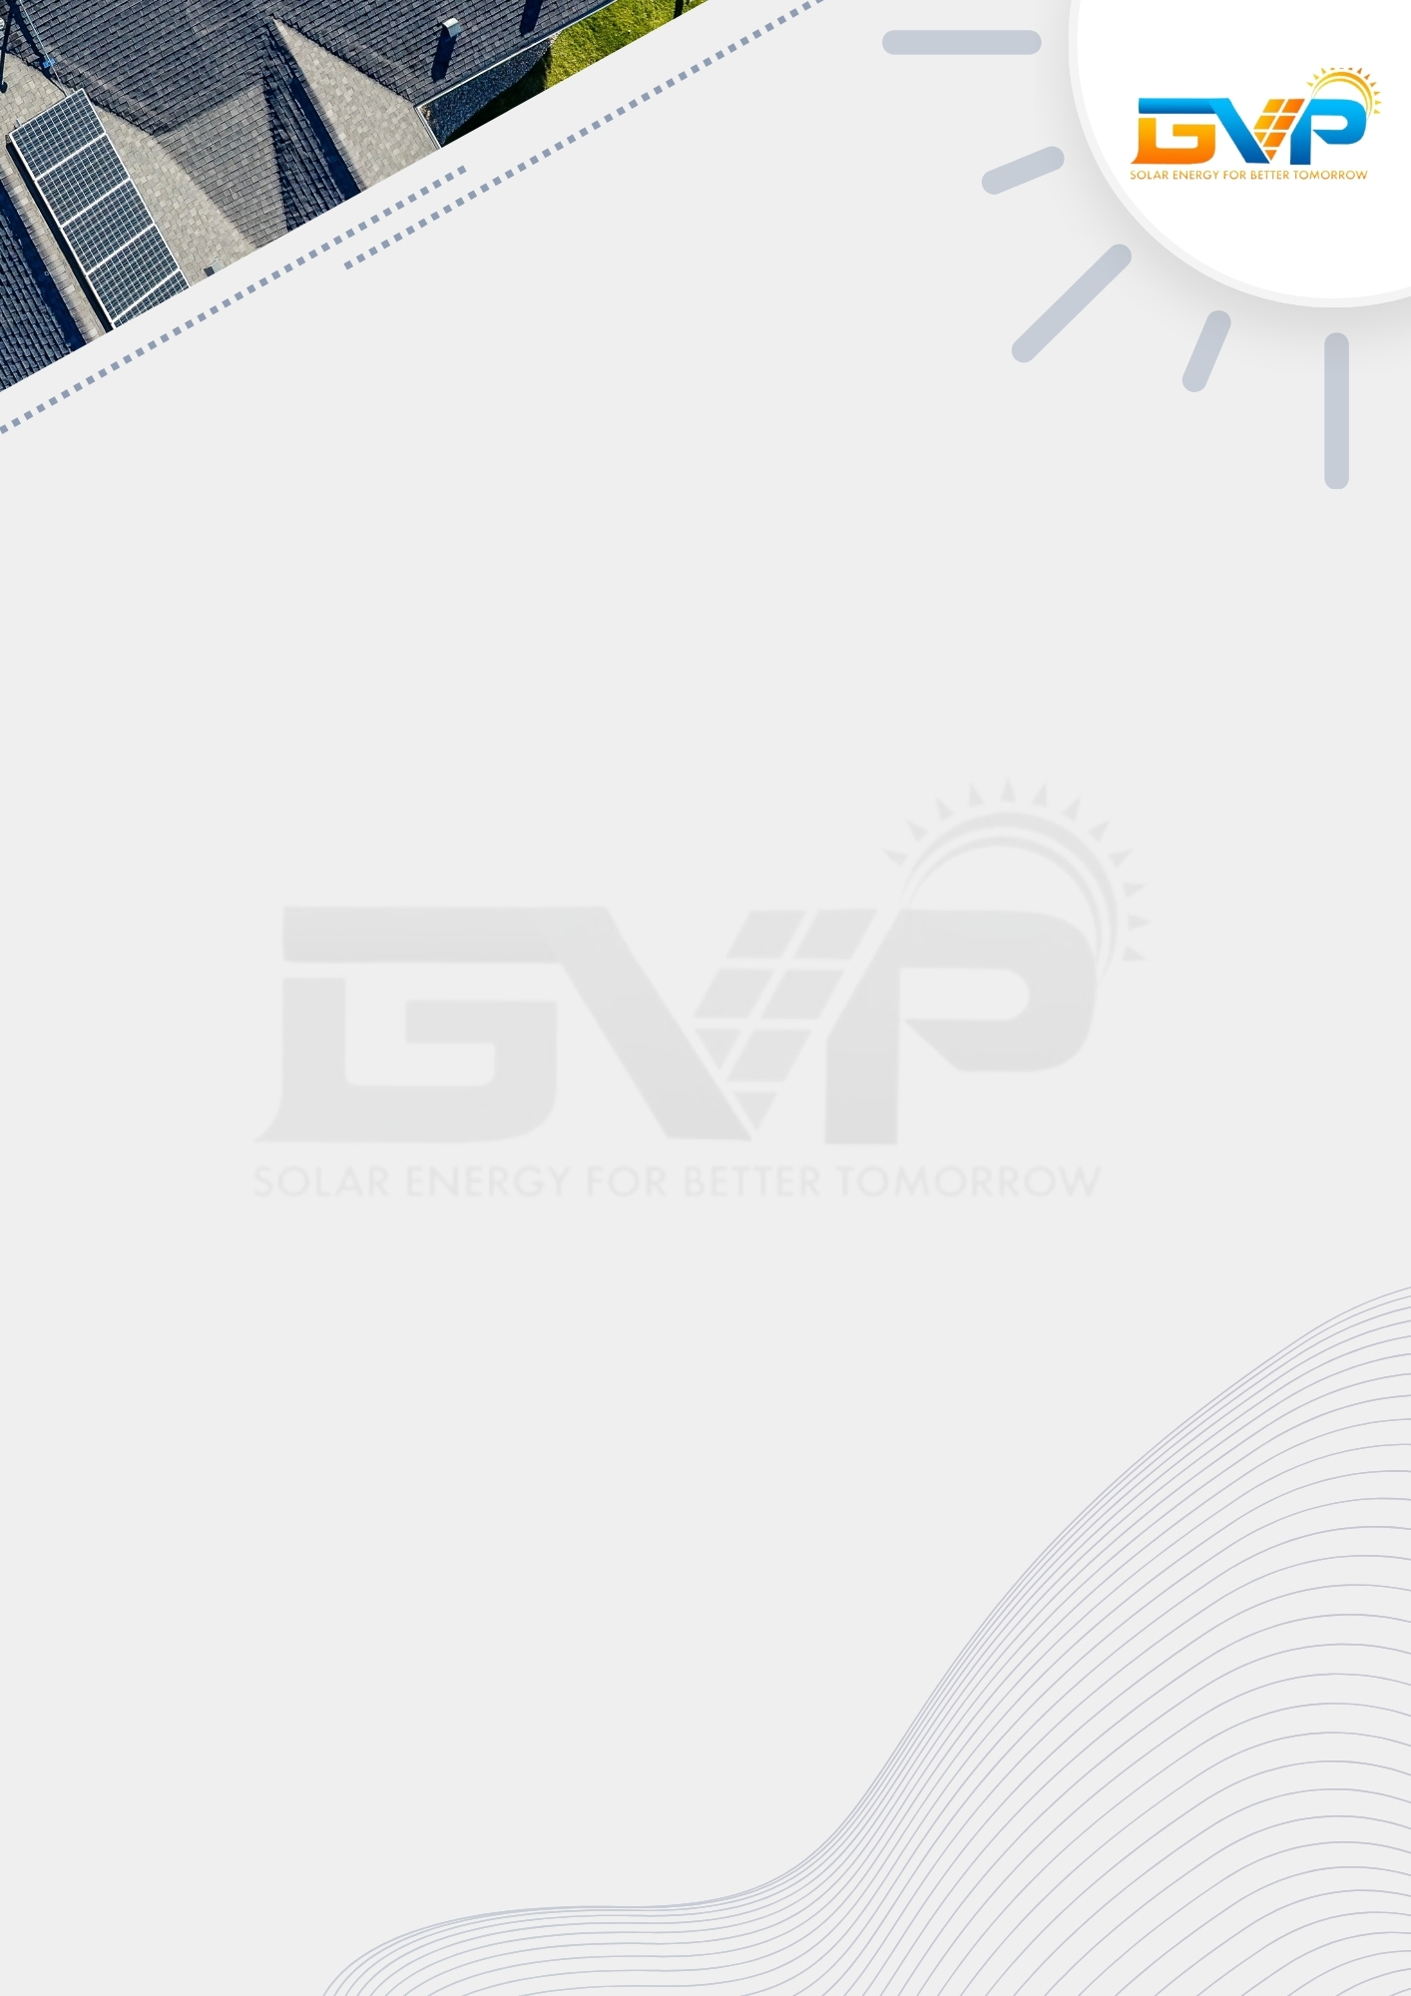

Terms & Conditions

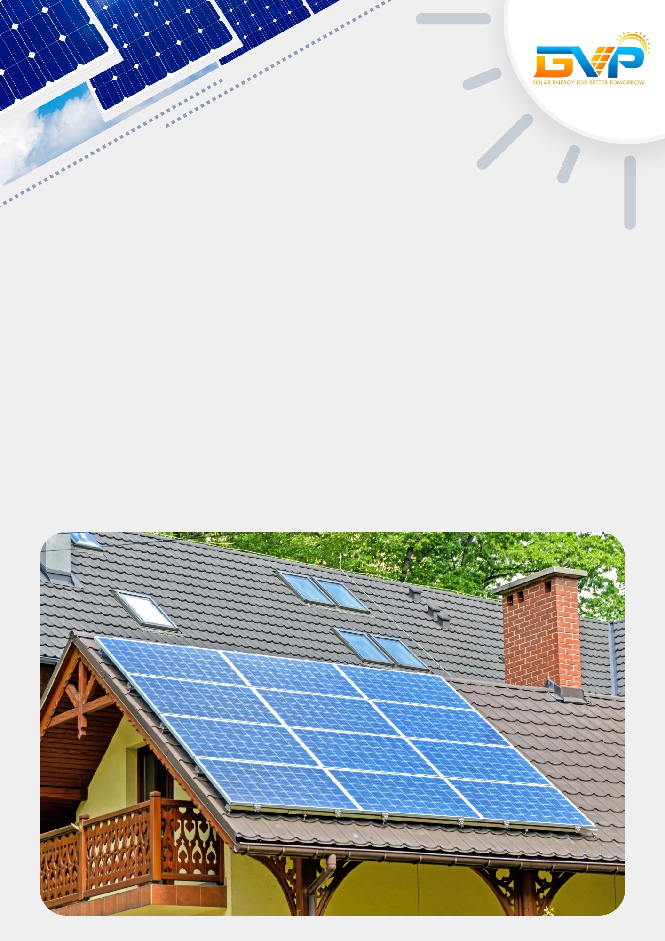

Thank You!
Contact Us:

Address: «Company Address»
Contact Number: «Company Phone»
Mail ID: «Company Mail»

