ClarkFin
Personal Financial Literacy Web Application
Feature Requirements Document | v2.0 | May 2026
Application | ClarkFin
Document Type | Feature Requirements Document (FRD)
Target Users | Community College Students
Purpose | Educate students on saving and financial goal achievement
Platform | Web App (Frontend + Backend) — confirm stack with developer
Status | Draft — for developer review
Version | 2.0
Date | May 2026

1. Executive Summary
ClarkFin is a web-based personal financial literacy application designed for community college students. Research shows only 25% of college students believe they have sufficient financial understanding — yet money management is among the most consequential skills they will develop. ClarkFin bridges knowledge and action by guiding students through a structured financial setup, tracking income and expenses, and dynamically projecting exactly how long it will take to reach each personal financial goal based on the savings rate the student selects.

Unlike general-purpose budgeting apps (YNAB, Monarch Money, Copilot Money), ClarkFin is purpose-built for the community college context: variable and part-time income, student loan debt, limited investing experience, and first-time financial independence. It combines best practices from leading personal finance platforms with educational guidance appropriate for young adults beginning their financial journey.

The application is organized around five core modules:
- Dashboard — Student onboarding, baseline profile, goal setup, and allocation targets
- Income Statement — Rolling monthly and weekly income and expense tracker
- Balance Sheet — Net worth snapshot (assets minus liabilities)
- Budget Planner — Week-to-week discretionary spending tool tied to allocation targets
- Goal Timeline Engine — Calculates projected years and months to reach every goal based on savings rate

2. Application Overview & Design Philosophy

2.1 Core Problem Statement
Community college students frequently manage money independently for the first time. They carry student loan debt, earn irregular income, and lack long-term planning habits. ClarkFin makes the connection between today's spending decisions and tomorrow's financial outcomes visible, concrete, and motivating by showing students a direct line from their chosen savings rate to their goal achievement dates.

2.2 Design Principles
- Goal-first design: every feature connects back to the student's stated goals
- Plain language: financial concepts explained in context, no jargon in UI labels
- Progressive disclosure: simple entry at onboarding, deeper analytics revealed as the student engages
- Motivational feedback loops: progress bars, completion percentages, and timeline projections reward engagement
- Mobile-responsive: optimized for mobile browsers — community college students are predominantly mobile-first
- Manual-entry first: no bank API integrations required in v1.0 — student enters data manually, reducing friction and privacy concerns

2.3 Application Architecture (Logical Layers)
Note: Confirm specific framework, database, and hosting with developer. The table below describes logical layers, not implementation prescriptions.

Layer | Description
Frontend | Responsive web UI, works on desktop and mobile browser. Confirm framework with developer (React, Vue, etc.).
Backend / API | Server-side logic for all goal calculations, timeline projections, budget rules, and data persistence.
Database | Stores student profile, income/expense entries, goals, allocation settings, and historical snapshots.
Calculation Engine | Core module computing goal timelines, debt payoff projections, net worth trajectory, and weekly discretionary targets. See Section 6.
Authentication | Student account login. Confirm approach (email/password, SSO) with developer.

3. Module 1 — Dashboard (Student Setup & Command Center)
The Dashboard is the first screen a new student sees and the primary returning-user home screen. It collects the foundational data that drives every other module. On first login it functions as a guided setup wizard; on subsequent logins it displays a live financial summary.

3.0 Guided Training Sub-Module (New in v2.0)
Before entering any data, students are offered a Guided Tour that walks them through what ClarkFin does and why each piece of information matters. This sub-module is entirely optional but strongly recommended for students with no prior personal finance experience.

Training Entry Point — The Button:
🎓 Take the Guided Tour First
Learn what each field means and why it matters — before you fill anything in. Takes about 8 minutes.
[ Start Guided Tour ] [ Skip — Fill it in directly ]

Note: The training button appears at the very top of the onboarding wizard, before Step 1. It is prominently styled but never blocks progress — students can always skip and enter data directly.

3.0a What Training Mode Does
When a student selects the Guided Tour, the setup wizard transforms into an interactive narrated walkthrough. Training Mode and data entry happen in the same flow — the student learns a concept, then immediately enters their real data into that same field. There is no separate training app and real app; they are one unified experience.

Approach | Contextual learning embedded inside the setup wizard. Each training tooltip appears directly above the field it explains, then collapses when the student is ready, and the field becomes active for data entry.
Tone | Friendly, non-judgmental, plain language. No assumed prior financial knowledge. All examples use realistic college-student scenarios.
Skippability | Each individual tooltip has a 'Got it, skip this one' option. Training Mode can be exited at any point and the student continues directly to data entry.
Re-accessibility | All training content remains in the Help & Glossary tab after setup completes. Students can revisit any concept at any time.

3.0b Training Content by Setup Step
Setup Step | Concept Taught | What the Student Learns
Step 1: Profile | Net Pay vs. Gross Pay | Gross pay is what you earn before taxes. Net pay is what hits your account — the number ClarkFin uses for all budgeting and savings calculations.
Step 1: Profile | Why retirement age matters | The gap between your age and retirement age is your wealth-building runway. A 21-year-old has 44 years — time is the most powerful financial tool available.
Step 2: Debts | The minimum payment trap | On a $1,200 credit card balance at 20% interest, minimum payments take 6+ years and cost hundreds in extra interest. ClarkFin shows you this cost before you decide on a payment amount.
Step 3: Goals | Why emergency fund comes first | 3-6 months of essential expenses as a savings buffer prevents any unexpected cost (car repair, medical) from going straight onto a credit card and erasing months of progress.
Step 3: Goals | Short vs. long-term goals | Short-term goals (1-3 years) are specific near-future targets. Long-term goals (3+ years) are bigger milestones. The Timeline Engine calculates how long each takes based on monthly savings.
Step 4: Income | What a savings rate is | The percentage of net pay set aside for goals each month. Even 5% is a meaningful start. The higher the rate, the faster every goal arrives — ClarkFin shows this live as you set the number.
Step 4: Income | How allocations work | Every dollar of net pay goes somewhere: Essential (needs), Debt (payments), Discretionary (wants), Savings (goals). The four percentages must total 100% — this is your complete personal spending plan.
Step 4: Income | The weekly discretionary budget | Your discretionary percentage translates into a weekly limit for wants (dining, shopping, entertainment). Staying within it each week is the most direct way to keep savings on track.

3.0c Training Mode UX Specifications
- Training tooltip design: light blue card with a lightbulb icon, appearing above the relevant input field with an animated slide-in.
- Each tooltip: concept name (bold header), plain-language explanation (2-3 sentences), real-world college-student example.
- After reading, student clicks 'Got it' — tooltip collapses, input field activates with a gentle highlight animation.
- Progress tracked: 'Training step 3 of 8' shown alongside 'Setup step 1 of 4'.
- If the student exits Training Mode mid-way, their position is saved and they are offered to resume on next login.
- Completion: after the final tooltip, a brief congratulations screen transitions to the setup review before data is submitted.

Recommended: Developer implementation note: Training Mode tooltips are a JSON-driven content layer overlaid on the existing setup wizard. The same setup wizard components are reused — Training Mode injects tooltip content before each field becomes editable. No duplicate UI code required.

3.1 Onboarding Step 1: Personal Profile
Field | Input Type | Notes
Full Name * | Text | Used to personalize all screens and reports
Current Age * | Number (integer) | Drives all timeline calculations
Target Retirement Age * | Number (integer) | Used in retirement goal projection engine
Target Retirement Net Worth * | Currency ($) | Core goal input for long-term projection

3.2 Onboarding Step 2: Debts
Students enter long-term debts. These feed the Debt Repayment Timeline and Balance Sheet.

Debt Category | Balance ($) | Repayment Goal | Logic
Student Loans | User entry | Date picker | Pre-populated label; user-nameable
Home / Mortgage | User entry | Date picker | Optional if not applicable
Credit Cards | User entry | "ASAP" option | Goal: pay in full weekly. App must flag minimum-only payments. See Section 8.4.
Car Loan | User entry | Date picker
Other (nameable) | User entry | Date picker | Student can add and label custom rows

3.3 Onboarding Step 3: Financial Goals
Students define short-term and long-term goals beyond retirement. These become trackable milestones in the Goal Timeline Engine.

Short-Term Goals (~1–3 years) | Examples: emergency fund, laptop, semester abroad. Student enters description + target dollar amount.
Long-Term Life Event Goals (3+ years) | Examples: car down payment, wedding, home purchase. Student enters description + target amount + optional target year.
Other (custom) | Free-form goal: name + target amount. For anything not covered above.

Recommended: Allow students to add, edit, and re-prioritize goals at any time. Each goal should display a live progress bar once the Income Statement is populated. Auto-suggest an Emergency Fund goal if none is present (see Section 8.5).

3.4 Onboarding Step 4: Income & Expense Baseline
After setting goals, the student enters monthly net pay and last month's expenses (mirrors the Income Statement structure). This establishes the baseline for all initial projections. A helper tooltip should explain each category and encourage students to reference their bank statement.

3.5 Dashboard Ongoing View — Returning Users
After setup, the Dashboard displays a live financial summary. All panels update automatically as the student enters new data.

Present Allocations Panel (auto-calculated from Income Statement):
Essential | Debt Payments | Discretionary
% of net pay (output) | % of net pay (output) | % of net pay (output)

Target Allocation Panel (student inputs — must total 100%):
Essential % | Debt % | Discretionary % | Savings %
User input (e.g. 60%) | Auto-calc from Income Statement; editable | User input (e.g. 20%) | User input — drives all goal timelines
CRITICAL: All four percentages must sum to exactly 100%. Validate in real time with inline error.

Goal Progress Summary Panel:
- Debt Repayment Timeline — each debt with balance, target date, % complete, on-track indicator
- Short-Term Goals — target amount, saved to date, % complete, projected completion date
- Long-Term Goals — same as above with years-to-target projection
- Retirement Countdown — years remaining, % of net worth target reached, On Track / Behind badge

4. Module 2 — Income Statement
The Income Statement is the primary data-entry module. It records all income and expenses across a rolling monthly and weekly timeline. It is the source of truth that feeds the Dashboard, Budget Planner, Balance Sheet, and Goal Timeline Engine.

4.1 Time Structure
Columns represent: Starting Point (Month 0 baseline), then Month 1 Weeks 1–4, Month 2 Weeks 1–4, and so on rolling forward. Week columns are auto-dated. Months are labeled by calendar month.

4.2 Income Section
Line Item | Type | Notes
Gross Pay | User entry | Pre-tax income
Taxes | User entry | Can be estimated as % of gross (optional enhancement)
Net Pay | Auto-calculated | Gross minus Taxes — the primary budget baseline for all allocations
Bonus | User entry | One-time income entries
Interest / Investment Income | User entry | Savings interest, dividends, etc.
Other Income (nameable) | User entry | Student can rename this row (e.g., "Side Gig", "Scholarship")
Total Income | Auto-calculated | Sum of all income lines

4.3 Expenses Section
Expenses are grouped into three categories matching the Dashboard allocation targets: Essential, Debt Payments, and Discretionary.

4.3a Essential Expenses
- Utilities
- Health / Medical
- Groceries
- Rent / Housing (if not a loan payment)
- Transportation (fixed: insurance, registration)
- Other Essential (nameable)

4.3b Debt Payments
- Rent / Mortgage payment
- Student Loan payment
- Car loan payment
- Credit card payment (with minimum-payment flag — see Section 8.4)
- Home repairs (if financed)
- Other Debt (nameable)

4.3c Discretionary Expenses
- Gifts
- Personal care
- Pets
- Restaurants / Dining out
- Shopping
- Transportation (variable: rideshare, gas, parking)
- Travel / Entertainment
- Subscriptions (see Section 8.3)
- Other Discretionary (nameable)

4.4 Net Income Row
Auto-calculated: Total Income minus Total Expenses. This is the amount available for savings each period. A negative net income triggers a prominent warning on the Dashboard and affects all goal timeline projections.

Recommended: Color-code the Net Income row green (positive) or red (negative). Display it as a headline summary card at the top of the Income Statement. This pattern is used by Copilot Money and Monarch Money with strong user engagement results.

4.5 Customization Rules
- All rows marked nameable allow students to rename the label
- Students can add rows within each category
- Rows cannot be deleted (only zeroed out) to preserve historical data continuity
- Each week column should be auto-date-stamped

5. Module 3 — Balance Sheet (Net Worth Report)
The Balance Sheet provides a point-in-time snapshot of the student's net worth: what they own versus what they owe. It is primarily a report (output-oriented) that refreshes as the student updates their data across other modules.

5.1 Assets (What You Own)
Category | Examples | Entry Method
Liquid Assets | Checking, savings account, cash on hand | Manual entry; savings balance auto-accumulates from Income Statement savings allocation
Investments | Stocks, ETFs, mutual funds, crypto (optional) | Manual entry, updated periodically by student
Personal Property | Car (estimated value), home if applicable | Manual entry; no auto-depreciation in v1.0
Retirement Accounts | 401(k), IRA, Roth IRA, employer plan | Manual entry; student tracks contributions over time
Other Assets (nameable) | Any asset the student wants to track | Free-form label + current dollar value
TOTAL ASSETS |  | Auto-summed. Displayed as large headline figure.

5.2 Liabilities (What You Owe)
Category | Examples | Notes
Current Liabilities | Credit card balances, short-term personal loans | Auto-populated from Dashboard debt entries
Long-Term Liabilities | Mortgage, student loans, car loans | Auto-populated from Dashboard; updated as payments are logged
TOTAL LIABILITIES |  | Auto-summed. Displayed as large headline figure.

5.3 Net Worth Calculation & Display
NET WORTH = Total Assets − Total Liabilities
Displayed as a large, color-coded headline number. Compared against the student's retirement net worth target.

The Net Worth figure should visually compare against the retirement target from Dashboard onboarding — showing both the current value, the gap remaining, and a progress bar showing % of retirement goal achieved.

Recommended: Add a Net Worth History chart (line graph) plotting the student's net worth over time. This is a high-impact motivational feature used by Monarch Money and Copilot Money and is especially effective for students to see their trajectory improving month over month.

6. Module 4 — Goal Timeline Engine (Core Calculation Feature)
The Goal Timeline Engine is the computational heart of ClarkFin. It takes all data entered by the student — age, income, expenses, debts, savings rate, and goals — and projects how long it will take to achieve each goal. Every time the student adjusts their savings rate or allocation targets, all projections update automatically in real time. This is the primary behavioral change mechanism of the application: students see directly and immediately how their savings rate choices affect their goal dates.

6.1 Inputs to the Calculation Engine
Input Variable | Source Module | Used For
Current Age | Dashboard Onboarding | All timeline calculations
Target Retirement Age | Dashboard Onboarding | Retirement projection, years remaining
Net Monthly Income | Income Statement | Monthly savings capacity baseline
Savings % (allocation target) | Dashboard Target Allocation | Monthly savings dollar amount
Debt Balances | Dashboard / Balance Sheet | Debt payoff timeline
Debt Payment Amounts | Income Statement | Monthly debt reduction rate
Goal Target Amounts | Dashboard Goals | Time-to-goal calculations
Retirement Net Worth Target | Dashboard Onboarding | Retirement projection gap
Current Net Worth | Balance Sheet | Gap-to-retirement calculation

6.2 Foundation Formula: Monthly Savings Amount
This derived variable is the foundation of every projection in the system:

Monthly Savings ($) = Net Monthly Income × (Savings % ÷ 100)
Example: $2,000 net income × 10% savings rate = $200/month available for goals

6.3 Goal Timeline Calculations
For each goal type below, the engine computes the projected completion date and time in years and months. All calculations are performed server-side and recalculated whenever any input changes, with results pushed to the UI in real time.

6.3a Short-Term Goals (Emergency Fund, Laptop, Semester Abroad, etc.)
Core Formula | Years to Goal = (Goal Target Amount − Amount Saved to Date) ÷ Monthly Savings Amount ÷ 12
Display Output | "You will reach this goal in X years and Y months" with a calculated target completion date
Progress Display | % Complete = Amount Saved to Date ÷ Goal Target Amount × 100, shown as a progress bar
Sensitivity Nudge | Show how the timeline changes if savings rate increases by 5%: "Save 5% more and reach this goal X months sooner"

6.3b Debt Payoff Timelines
Standard Debts (Student Loan / Mortgage / Car) | Projected Payoff Date = today + (Current Balance ÷ Monthly Payment) months. Compare against student's stated Repayment Goal Date. Green if on track, red if behind.
Credit Card — Minimum Payment Warning | If student is paying only the minimum: calculate and prominently display the true payoff date and total interest cost at minimum payments vs. at the recommended accelerated payment. This is a required educational feature.
% Complete | Cumulative Payments Made ÷ Original Balance × 100, shown as progress bar
Repayment Goal Comparison | If Projected Payoff Date > Repayment Goal Date: red warning indicator. If on track: green indicator.

6.3c Long-Term Goals (Car, Home Down Payment, Wedding, etc.)
Core Formula | Same as short-term: Years to Goal = Remaining Target Amount ÷ Monthly Savings ÷ 12
Multi-Goal Display | Show all goals ranked by projected completion date. Allow student to manually re-prioritize order.
What-If Slider | Student slides savings rate up/down and sees all goal timelines update simultaneously in real time. This is the central interactive feature of the Engine.
Table Output | Goal Name | Target $ | Saved to Date | Monthly Savings Allocated | Years to Goal | Projected Date

6.3d Retirement Net Worth Projection
Years Remaining | Target Retirement Age − Current Age
Simple Linear Projection (v1.0) | Projected Net Worth at Retirement = Current Net Worth + (Monthly Savings × 12 × Years Remaining). Note: v1.0 uses linear projection for clarity; compound growth projection is a recommended v2.0 enhancement.
Retirement Gap | Retirement Target − Projected Net Worth at Retirement Age = Shortfall (if positive)
On-Track Indicator | Green "On Track" / Yellow "Close" / Red "Behind" badge displayed prominently on Dashboard
Required Savings Rate | Back-calculate and display: "To retire at age X with $Y, you need to save Z% of your income" — this gives the student an actionable target

6.4 Savings Rate Sensitivity — The Key Motivational Feature
The most powerful feature in ClarkFin is showing students how their chosen savings rate directly and immediately affects the time it takes to reach every goal. This must be highly visible and interactive throughout the application.

Recommended: Implement a 'What If I Save More?' interactive panel on both the Dashboard and Budget Planner. When the student adjusts their savings rate target, all goal timelines update simultaneously, showing how many months or years are eliminated from each goal. This is the core behavioral change mechanism of ClarkFin.

Illustrative example of savings rate sensitivity output (calculated dynamically using the student's actual numbers):

Savings Rate | Monthly Savings | Years to $5,000 Goal | Years to $30,000 Goal
5% | $100/month | 4.2 years | 25.0 years
10% | $200/month | 2.1 years | 12.5 years
15% | $300/month | 1.4 years | 8.3 years
20% | $400/month | 1.0 year | 6.3 years
Note: Example assumes $2,000/month net income. The live app calculates this for the student's actual numbers across all goals simultaneously.

7. Module 5 — Budget Planner (Weekly Discretionary Tool)
The Budget Planner translates the Dashboard's allocation targets into a concrete weekly discretionary spending limit. The student distributes their weekly budget across categories however they choose — the constraint is the total, not the individual lines. This empowers spending decisions while enforcing the savings target.

7.1 Weekly Discretionary Target
Weekly Discretionary Budget = (Net Monthly Income × Discretionary %) ÷ 4.33
Example: $2,000 × 20% ÷ 4.33 = $92.38/week available for discretionary spending

7.2 Weekly Line Items
Category | This Week ($) | Notes
Gifts | Editable
Personal Care | Editable
Pets | Editable
Restaurants / Dining | Editable
Shopping | Editable
Transportation (variable) | Editable
Travel / Entertainment | Editable
Other (nameable) | Editable | Student-named row
WEEKLY TOTAL (KEY TARGET) | Auto-calculated target. Student adjusts individual lines freely but total must stay at or below this number.

7.3 Budget Planner Rules
- Running total updates in real time as student adjusts line items: green (under target), yellow (within 10% of limit), red (over budget)
- Each weekly entry rolls back into the Income Statement for that week's column — no double-entry required
- If the student exceeds their weekly discretionary target, the Goal Timeline Engine recalculates and shows the impact on goal dates
- Credit card banner: if any discretionary spending is charged to a credit card, a persistent reminder prompts the student to pay the full balance this week

Recommended: Consider a roll-over option (inspired by YNAB): unspent discretionary budget from one week carries forward to the next instead of resetting. This rewards frugality and is especially motivating for students who have a low-spend week.

8. Recommended Additional Features
The following features are recommended based on research into leading personal finance applications (YNAB, Copilot Money, Monarch Money, Quicken Simplifi) and financial literacy platforms for college students. They are not in the original spreadsheet designs but would significantly increase educational impact and user engagement.

8.1 Dashboard KPI Summary Cards
Priority: HIGH | Inspired by: Copilot Money, Monarch Money

The top of the Dashboard should display large, scannable summary cards before any data tables:
- Net Worth today (large number, green if positive / red if negative)
- Net Income this month (positive = green, negative = red)
- Savings rate this month vs. target (gauge or progress bar)
- Weekly discretionary budget remaining (countdown meter)
- Next goal milestone: name of the soonest goal completion and how many months away

8.2 Financial Education Tooltips & Glossary
Priority: HIGH | Inspired by: Intuit for Education, Zogo, PersonalFinanceLab

Because ClarkFin targets students new to personal finance, every key concept needs an inline explanation via a help icon or expandable tooltip. Recommended topics:
- What is net worth and why does it matter?
- What is a savings rate and how does it affect your future?
- What is the difference between essential and discretionary spending?
- What does paying only the minimum on a credit card actually cost you? (with live calculation using the student's own data)
- What is an emergency fund and how much should I have?
- Why does starting to save early matter? (simple time-value-of-money explainer)

Recommended: Add a 'Financial Tip of the Week' card on the Dashboard that surfaces a relevant educational insight based on the student's current situation (e.g., if they have credit card debt, show a tip on debt payoff strategies).

8.3 Subscription Tracker
Priority: MEDIUM | Inspired by: Rocket Money, Simplifi, Copilot Money

Subscriptions are a significant untracked expense for college students. A dedicated tracker within the Discretionary section of the Income Statement should:
- Allow student to enter: service name, monthly cost, billing date
- Calculate and display total monthly subscription spend
- Show subscriptions as a callout on the Dashboard
- Prompt periodically: "You're spending $X/month on subscriptions. Would you like to review them?"

8.4 Credit Card Warning & Payoff Accelerator
Priority: HIGH | Critical educational feature for community college students

Credit card debt is the highest-cost financial risk for this demographic. ClarkFin must have prominent, persistent logic to address it:
- If student is paying only the minimum on any credit card: display a persistent red warning banner
- Calculate and display: "At this payment rate, you will pay off this card in X years and pay $Y in total interest"
- Contrast with accelerated payment: "If you pay $Z more per month, you pay it off in X months and save $Y in interest"
- State explicitly as a ClarkFin best-practice goal: pay the full credit card balance each week
- Credit card payment field in Budget Planner should carry a tooltip explaining the cost of carrying a balance

8.5 Emergency Fund Auto-Suggestion
Priority: HIGH | Universal best practice in personal finance

Every leading personal finance platform recommends building an emergency fund (3–6 months of essential expenses) before pursuing other goals. ClarkFin should auto-suggest this during onboarding:
- During Step 3 (Goals), if no emergency fund goal is present: show a prompt — "Financial experts recommend saving 3–6 months of essential expenses ($X–$Y based on your data) as your first priority. Add this goal?"
- Emergency fund target range = Essential Expenses (monthly) × 3 to × 6
- If added, display the emergency fund goal first in the Goal Timeline Engine

8.6 Goal Milestone Celebrations & Progress Notifications
Priority: MEDIUM | Inspired by: YNAB, Zogo

Behavioral finance research confirms that celebrating small wins increases long-term habit formation. Recommended milestone triggers:
- Goal 25% complete, 50% complete, 75% complete — celebratory messages
- Debt fully paid off — congratulations with net worth impact displayed
- First month with positive net income
- First time savings rate hits the student's own target
- Net worth crosses a round number milestone (e.g., first time positive net worth)

8.7 Debt Payoff Strategy Selector
Priority: MEDIUM | Inspired by: YNAB, NerdWallet

For students with multiple debts, offer a choice of the two most common payoff strategies with a plain-language explanation of each:
- Avalanche Method: Pay off highest-interest-rate debt first — mathematically optimal, saves the most money
- Snowball Method: Pay off smallest balance first — psychologically motivating, builds momentum
The Goal Timeline Engine calculates and displays the total interest saved and months saved under each strategy so the student can make an informed, personalized choice.

8.8 Monthly Financial Snapshot Report
Priority: MEDIUM | Inspired by: Copilot Money, Simplifi

At month-end, auto-generate a summary card showing:
- Income vs. last month
- Total spending by category vs. allocation targets
- Net worth change this month vs. last month
- Progress toward each goal this month
- Savings rate achieved vs. target
- One personalized insight (e.g., "Your dining out spending was 22% above your target this month")

9. Data Model
The following describes the logical data entities ClarkFin requires. Implementation details (SQL vs. NoSQL, exact schema, naming conventions) to be confirmed with developer.

9.1 Core Entities
Entity | Key Fields
Student | student_id, name, email, password_hash, current_age, target_retirement_age, retirement_net_worth_target, created_at, updated_at
Debt | debt_id, student_id, category (student_loan | mortgage | credit_card | car | other), label, original_balance, current_balance, monthly_payment, repayment_goal_date, is_credit_card (boolean)
Goal | goal_id, student_id, label, goal_type (short_term | long_term | emergency_fund | retirement), target_amount, target_date (optional), priority_order, created_at
Income Entry | entry_id, student_id, period_year, period_month, period_week (1–4), category (gross_pay | taxes | bonus | interest | other), label, amount
Expense Entry | entry_id, student_id, period_year, period_month, period_week, category (essential | debt | discretionary), subcategory, label, amount, is_credit_card_charge (boolean)
Asset | asset_id, student_id, category (liquid | investment | property | retirement | other), label, current_value, updated_at
Allocation Target | allocation_id, student_id, essential_pct, debt_pct, discretionary_pct, savings_pct, effective_date. Constraint: essential_pct + debt_pct + discretionary_pct + savings_pct = 100
Subscription | sub_id, student_id, service_name, monthly_cost, billing_date, is_active
Goal Progress Snapshot | snapshot_id, student_id, goal_id, snapshot_date, amount_saved_to_date, pct_complete, projected_completion_date

9.2 Key Derived Values (Computed at Runtime — Not Stored)
- Net Monthly Income = Total Income − Total Expenses (from Income Statement entries for the period)
- Monthly Savings Amount = Net Monthly Income × (savings_pct ÷ 100)
- Weekly Discretionary Budget = Net Monthly Income × (discretionary_pct ÷ 100) ÷ 4.33
- Net Worth = Sum(Asset.current_value) − Sum(Debt.current_balance)
- Time to Goal (years) = (goal.target_amount − amount_saved_to_date) ÷ Monthly Savings Amount ÷ 12
- Debt Payoff Date = today + (Debt.current_balance ÷ Debt.monthly_payment) months
- Projected Retirement Net Worth = Current Net Worth + (Monthly Savings × 12 × Years Remaining)
- Required Savings Rate for Retirement = (Retirement Target − Current Net Worth) ÷ (Net Monthly Income × 12 × Years Remaining) × 100

10. UX & UI Requirements

10.1 Navigation Structure
Primary Navigation | Dashboard | Income Statement | Balance Sheet | Budget Planner | Goals
Secondary Navigation | Profile / Settings | Help & Glossary | Monthly Report
Mobile | Bottom tab bar on mobile; left sidebar on desktop

10.2 Responsive Design
- Fully functional on mobile browsers (iOS Safari, Android Chrome) — the primary access device for this demographic
- Tables and input forms must reflow to single-column on small screens
- Minimum 44px tap targets for all interactive elements
- Data entry uses appropriate mobile keyboard types: numeric for currency, date picker for dates

10.3 Data Entry UX
- Currency fields: $ prefix, auto-format with commas, no negative numbers
- Percentage fields: validated in real time; error shown if allocation targets don't sum to 100%
- Date fields: date picker only — no manual string entry
- Editable category labels: inline edit with single click or tap
- Auto-save: all entries save as the student types — no explicit Save button required

10.4 Visual Design Guidance
- Color system: Green = positive / on-track / under budget. Red = negative / behind / over budget. Yellow = warning / approaching limit. Blue = neutral / informational.
- Progress bars for every goal and debt — visual progress is the primary motivational mechanic for this user group
- Large, readable headline numbers for net worth, savings rate, and weekly budget remaining
- Plain language labels throughout: "What You Own" not "Assets"; "What You Owe" not "Liabilities"
- Friendly, encouraging tone in all messaging — avoid language that makes students feel judged for their current financial situation

11. Implementation Notes for Claude Code (Developer Guidance)

11.1 Recommended Build Order
Phase | Module | Rationale
1 | Auth + Student Profile | Foundational — every other record requires student_id
2 | Dashboard Onboarding | Collects all inputs that drive calculations
3 | Goal Timeline Engine | Core value proposition — build and test calculation logic before display modules
4 | Income Statement | Primary data entry; enables all periodic tracking
5 | Budget Planner | Depends on Income Statement and allocation targets
6 | Balance Sheet | Report module; depends on asset/liability data model
7 | Dashboard KPIs & Summary | Aggregates all previous modules into visual summary
8 | Recommended Features | Education tooltips, credit card warnings, subscription tracker — layer in after core is stable

11.2 Calculation Engine Implementation Notes
- Perform all timeline calculations server-side — keep business logic out of the frontend
- Recalculate all projections whenever any of these change: savings %, income entries, expense entries, debt balances, or goal target amounts
- Expose calculation results via API endpoints so the frontend can fetch updated projections without full page reload
- v1.0: use simple linear projections (no compound interest). Note where compound growth would be more accurate; flag as v2.0 enhancement
- Validate that allocation percentages sum to exactly 100% before saving — return a descriptive error if not
- For the credit card minimum payment warning: use standard amortization formula to calculate true payoff date and total interest cost

11.3 Out of Scope for v1.0
- Bank account / financial institution API integrations (Plaid, Finicity, MX) — manual entry only
- Compound interest / investment return projections — linear projection only in v1.0
- Tax preparation features
- Multi-user / household shared budgets
- Native mobile app (iOS / Android) — responsive web app only
- Investment portfolio performance tracking beyond manual Balance Sheet entry

12. Open Questions for Development Team

# | Question | Owner
1 | What is the confirmed tech stack (frontend framework, backend language, database)? | Developer
2 | Should savings % be a target the student inputs, or the residual after the other three percentages? Recommendation: make it a target input, solve for discretionary as the flex variable. | Product Owner + Developer
3 | How should debt % in the allocation target be handled — auto-populated from Income Statement or fully editable? Recommendation: auto-populate, allow override. | Product Owner
4 | Should unspent weekly discretionary budget roll over to the following week? Recommendation: yes. | Product Owner
5 | What is the authentication approach: email/password, Google SSO, or school email integration? | Developer
6 | Should goal savings be treated as a single pool or allocated per-goal? E.g., can the student split their $200/month savings into $100 for emergency fund + $100 for car? | Product Owner
7 | Is an instructor or administrator view planned (e.g., a professor monitoring aggregate class progress without seeing individual student data)? | Product Owner
8 | What is the deployment environment: hosting platform, domain, expected concurrent users? | Developer

End of ClarkFin Feature Requirements Document — v2.0 | May 2026

Appendix A — UX Flow Walkthrough
The following pages reproduce the ClarkFin UX Flow Walkthrough document in full. This appendix illustrates the complete student experience from first-time onboarding through weekly updates, monthly reviews, and the end-of-class report. It also documents the Guided Training Sub-Module interaction patterns described in Section 3.0.

Note: The interactive HTML version of this walkthrough (clarkfin_ux_walkthrough.html) is delivered alongside this FRD and should be reviewed by the development team in a browser for the full interactive experience.

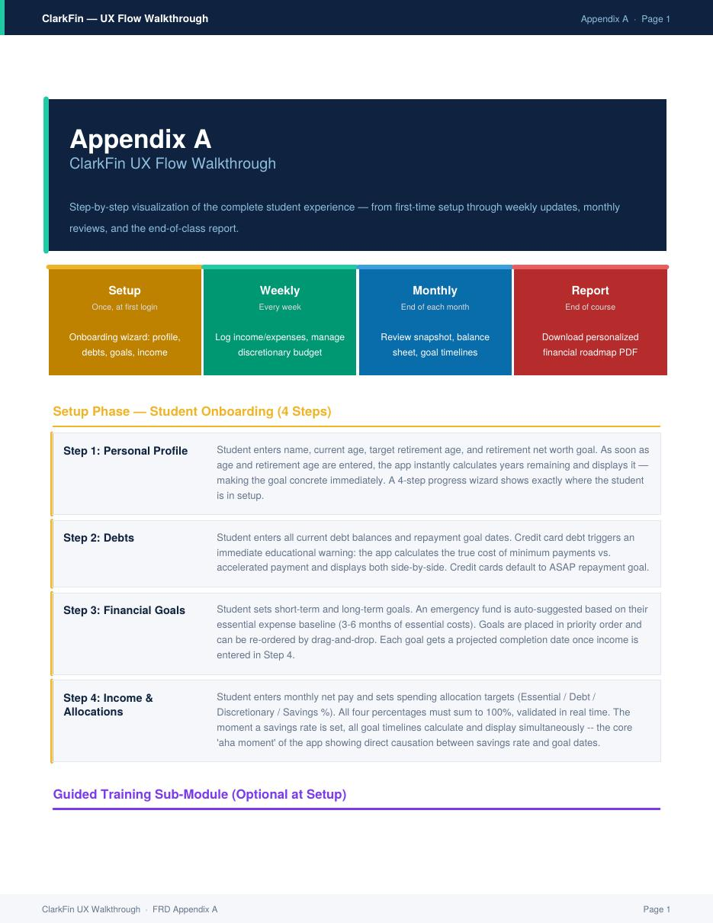

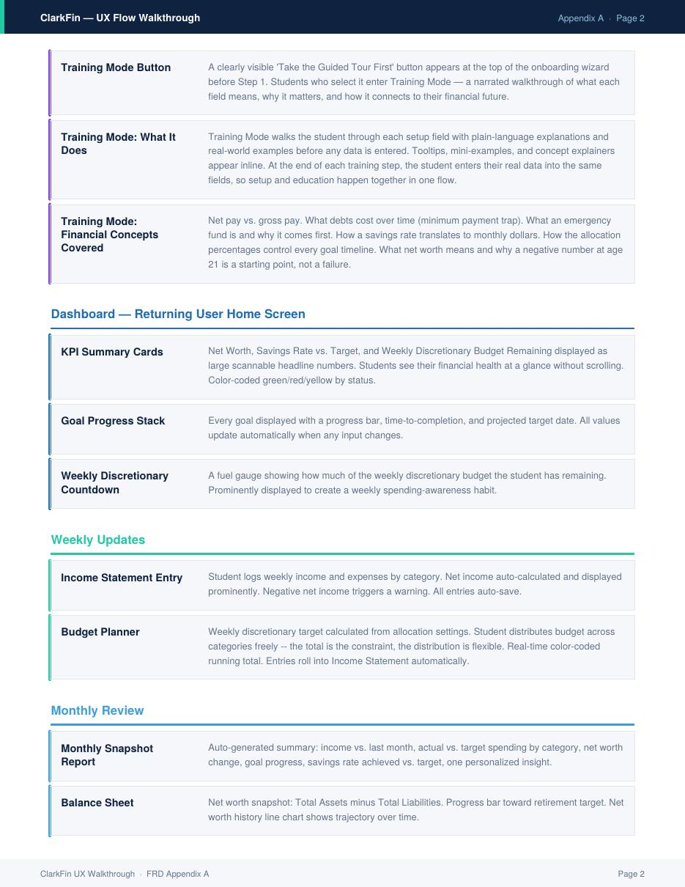



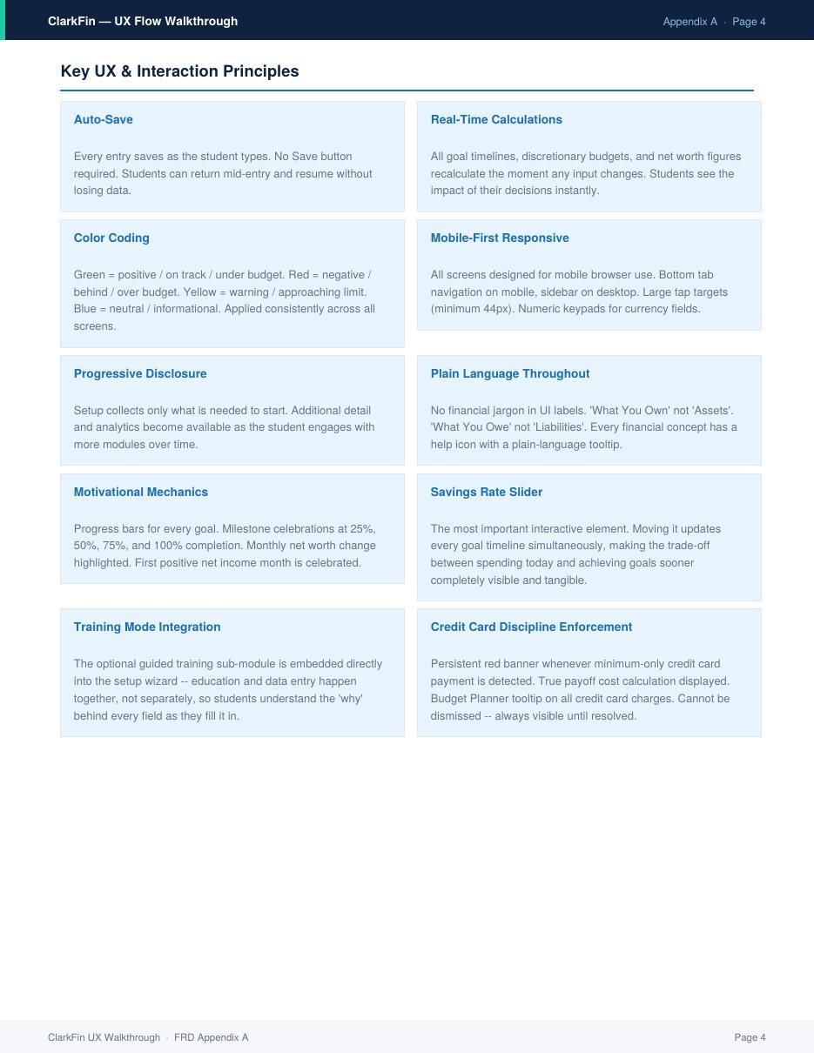

Appendix B — End-of-Class Report Template
The following pages reproduce the ClarkFin End-of-Class Report template in full. This is the downloadable PDF report students receive at course completion. It is populated from their actual ClarkFin data and contains their personal financial snapshot, goal roadmap, savings rate sensitivity analysis, debt payoff plan, key concepts learned, personalized action plan, and an ongoing financial checklist they can use after the course ends.

The report is generated server-side from the student's database records. The template below shows sample data for a student named Maria Santos. In production, all figures, goal timelines, and action steps are replaced with each student's real data.

Note: The full PDF file (ClarkFin_EndOfClass_Report.pdf) is delivered alongside this FRD for reference.

