

**MarketPlace – Publishing Document**

**SolarWinds**

04 May 2020

**TABLE OF CONTENTS**

1. EC2 Instance Creation 4

2. Create an AMI from Instance 5

3. AMI Scanning 6

4. Submitting your product for publication 7

1. EC2 Instance Creation

Launch the EC2 instance Via Console Open the Amazon EC2 console at <https://console.aws.amazon.com/ec2/>.

* Choose Launch Instance.
* In Step 1: Choose an Amazon Machine Image (AMI), find an Amazon Windows AMI at the top of the list and choose Select.
* In Step 2: Choose an Instance Type, choose Next: Configure Instance Details.
* In Step 3: Configure Instance Details, provide the following information:
* Choose Next: Add Storage change the size of **EBS to 250**
* Choose Next: Add Tags.
* Name your instance and choose Next: Configure Security Group.
* In Step 6: Configure Security Group, set Assign a security group to Select an existing security group. Choose the default security group to make sure that it can access your EFS file system.
* Choose Review and Launch.
* Choose Launch.
* Select the check box for the key pair that you created, and then choose Launch Instances.
* Connect the EC2 and upload all the artifacts in **C drive** at the following path **C:/CFN/artifacts**
* Click on Ec2 Launch setting from Start Menu.
* Shutdown the system with SysPrep (Please see the screenshot below for reference)

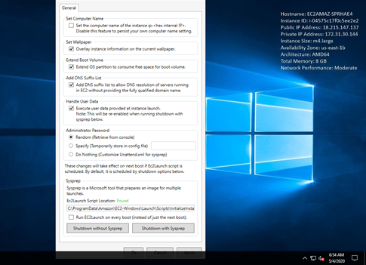

1. Create an AMI from Instance

* Right-click the instance you want to use as the basis for your AMI and choose Create Image from the context menu.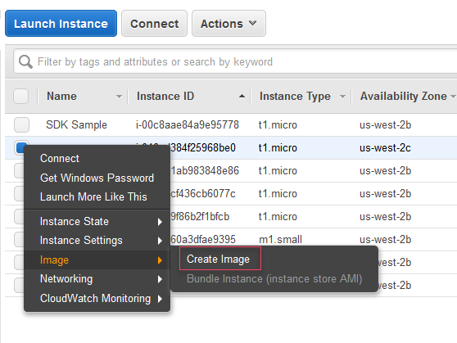
* It may take a few minutes for the AMI to be created. After it is created, it will appear in the AMIs view in AWS Explorer. To display this view, double-click the Amazon EC2 | AMIs node in AWS Explorer. To see your AMIs, from the Viewing drop-down list, choose Owned By Me. You may need to choose Refresh to see your AMI. When the AMI first appears, it may be in a pending state, but after a few moments, it transitions to an available state.

1. AMI Scanning

* Share your AMI with AWS Marketplace to get started. This action will grant several AWS Account IDs belonging to the AWS Marketplace Team's access to your source AMI. Once shared, your AMI will be scanned to ensure it meets AWS listing requirements.
* Select Amazon Machine Image at MarketPlace management Portal.

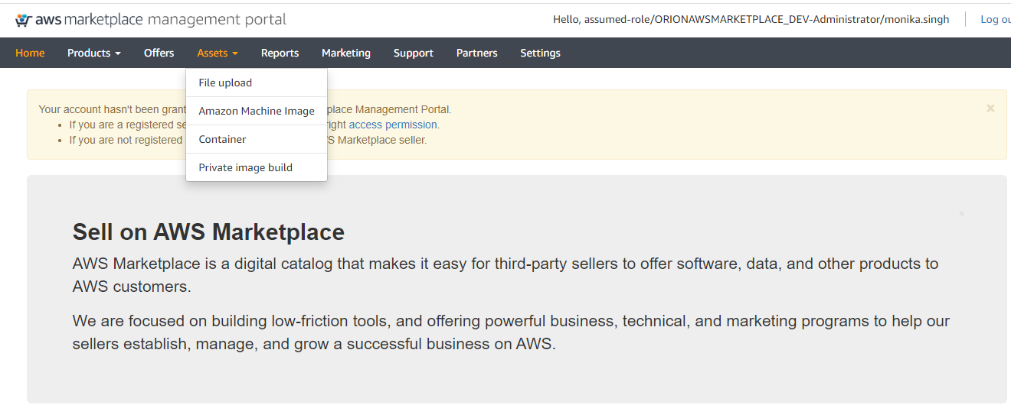

* Click on AMIs Tab under Manage AMIs and share your AMI. It will scan the AMI first before

sharing it.  
  
  
 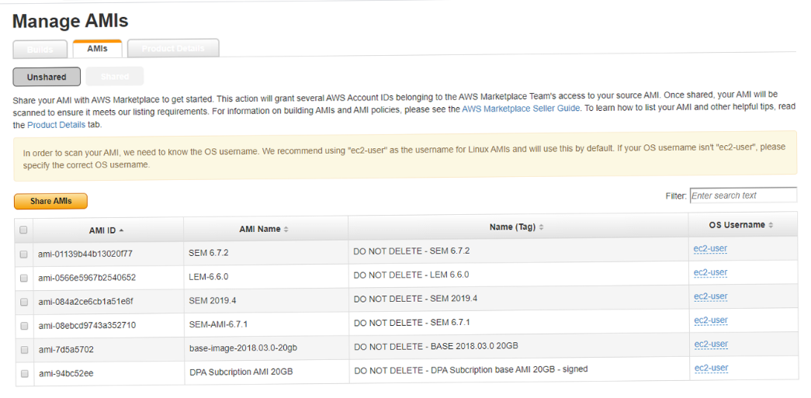

1. Submitting Product for Publication

* Log in to the AWS Marketplace Management Portal.
* From the [AMMP](https://aws.amazon.com/marketplace/management/products/?), download the Product Load Form for the product.
* Add your product definition, which includes product information (title, description, highlights), technical information (AMI_ID, regions, instance types, OS), and pricing details (pricing model, like BYOL).
* Under the Assets tab, choose File upload.
* Submit form and fill the product Description.



Once you complete the submission you can see the uploaded form in dashboard. After review AWS MP team will contact you with there feedback and listing URL.