Web Components Review
The devices used for testing were Windows desktop/laptop with JAWS and NVDA screen readers and iPhone with VoiceOver screen reader.

ButtonV2
JAWS has the same issue with the disabled button variant as it did with V1, it reads the buttons twice, once as text and once as the button element. Also new issue with JAWS, the pending variant is read as ‘unlabelled 0/1 button unavailable’.
New issue with VoiceOver, the pending variant has the same label as the disabled variant, they are both ‘button dimmed’.
No issues with NVDA.

CheckboxV2
No issues with JAWS, NVDA or VoiceOver.

CheckboxGroupV2
For the label hint and invalid variants, VoiceOver reads the description text (“additional description” and the error message) twice when focus is on a checkbox.
No issues with JAWS or NVDA.

ComboboxV2
VoiceOver focus is very inconsistent after selecting an option, sometimes it stays on the combobox (which is the expected behaviour) or jumps to the top of the page or some other random point on the page. It’s also difficult to close the combobox when an option hasn’t been selected, VoiceOver users must navigate backwards to close it (and again focus jumps back to the top of the page when this happens).
No issues with JAWS or NVDA.

IconButtonV2
No issues with JAWS, NVDA or VoiceOver.

RadioGroupV2
For the label hint and invalid variants, VoiceOver and NVDA has the same issue, the description text (“additional description” and the error message) is read twice when focus is on a radio button.
No issues with JAWS except that the radio button groups are always described as ‘vertical’ – was this intentional?

SelectV2
VoiceOver focus is inconsistent when closing the select and when choosing an option, sometimes focus stays on the select (which is the expected behaviour) or jumps to the previous focusable element or next focusable element.
NVDA also labels these as ‘menu button’, which isn’t needed and should be removed if possible.
No issues with JAWS.

TextInputV2
JAWS and NVDA skips the euro symbol in the start slot variant and the end slot icon when users are using the tab key.
No issues with VoiceOver except the end slot icon being marked as decorative (was this intentional?)

IconButtonMenuV2
VoiceOver focus is inconsistent when closing the menu but haven’t selected an item, focus jumps to the top of the page or the previous/next focusable element.
No issues with JAWS or NVDA.

MenuV2
VoiceOver focus is inconsistent when closing the menu but haven’t selected an item, focus jumps to the top of the page or the previous/next focusable element.
No issues with JAWS or NVDA.

ResponsiveTable
NVDA does not read out the tooltips “Additional information” when navigating to it with the arrow keys and selecting it. This applies to variants also. Same issue occurs with JAWS and VoiceOver.
When selecting the information icon on iPhone, they disappear until user interacts with another element.
When using NVDA or JAWS, in “with tabs” variant, unable to navigate to “Green car loan” tab using tab keys, must use arrow keys, should be able to use both.

Accordion
No issues with NVDA, JAWS or VoiceOver

AccordionGroup
No issues with NVDA, JAWS or VoiceOver

CurrencyInput
All input fields need a label for them, the first field on this page needs a label as it has with the variant. I’m assuming the first field is just to test functionality, but on a live site a label would be needed.
In variants, after selecting the information icon this error appears:
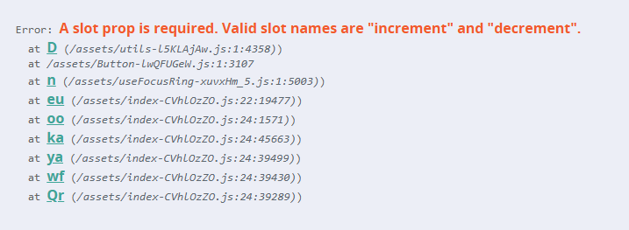
Same issue occurs with VoiceOver and JAWS

DatePicker
When the user selects an information/hint icon, focus should move to the card instead of the close icon “x”.
In Variants “with calendar” when changing the month the calendar moves between being above the textfield and below the textfield. It should stay in the same place as it does in the “With hint” variant.

NestedCheckboxGroup
There is a blank space after “Bacon” which is read by NVDA.
When the user selects an information/hint icon, focus should move to the card instead of the close icon “x”.
Focus moves to the programmatically determined location of the checkbox, not where it is visually.
In “Invalid” variant, error should be read to the user when moves to the radio buttons.
No other issues with VoiceOver or JAWS.

NumberInput
All input fields need a label for them, the first field on this page needs a label as it has with the variant. I’m assuming the first field is just to test functionality, but on a live site a label would be needed.
When selecting tooltips on this page, error occurs: 
No other issues with VoiceOver or JAWS

PasswordInput
First field needs a label.
When the user selects an information/hint icon, focus should move to the card instead of the close icon “x”. Same issue occurs on NVDA and VoiceOver.
Labels from “With tooltip” variant to the end, are skipped by the screen reader and are read as part of their respective text fields.
In Variant “Disabled”, blanks are read when navigating past the text field.

SearchInput
All input fields need a label for them, the first field on this page needs a label as it has with the variant. I’m assuming the first field is just to test functionality, but on a live site a label would be needed.
No issues with NVDA, JAWS or VoiceOver

Slider
Focus moves to an invisible number (the same number as the slider is set to) after navigating past the “+” button with NVDA and VoiceOver. This happens with all variants also.
When using JAWS, “+” button reads “Increase value button, decrease value {amount} increase value”. Should just read “Increase value button” and then say the amount when selected. This is across all sliders.
In variant “With tooltip notches” focus skips the tooltip and does not read out the “APR of 6.5%”. Occurs on NVDA, JAWS and VoiceOver.

ButtonTabs
When Tab is selected focus should stay on the tab, currently in VoiceOver, focus moves back up.
No issues with NVDA or JAWS

Tabs
“Tab group heading” is skipped by VoiceOver and is read as part of the dropdown field, focus should move to the heading first and then to the dropdown field.
User is unable to navigate through dropdown options as navigating past the first option closes the dropdown.
When using NVDA and JAWS, user unable to navigate between tabs using tab key, has to use arrow keys, should be able to use both.

