Arduino Lesson17
74HC595
- Intro
74HC595 has a 8-bit shifting register , a memorizer and 3 states output. Here we use it control 8 leds. Why? Because you have to use 8 interfaces if you use Arduino. But how many I/O we have on Arduino? Include the analog interface is 20 totally. These 8 leds would take lots of space. So we use 74HC595 to reduce the I/O interface occupation. Now we can use just 3 I/O to control 8 leds.
- Parts Required
74HC595 x 1
Red 5mm LED x 4
Green 5mm LED x 4
220ΩResistors x 8
Breadboard x 1
Jumper wires x 1 Bundle
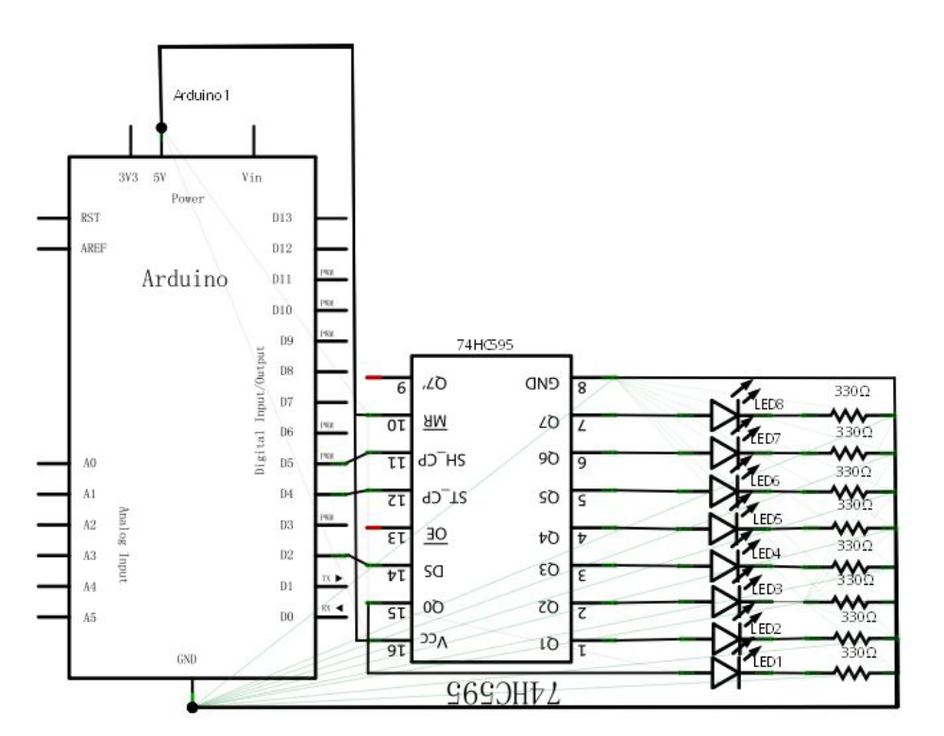
Schematic diagram
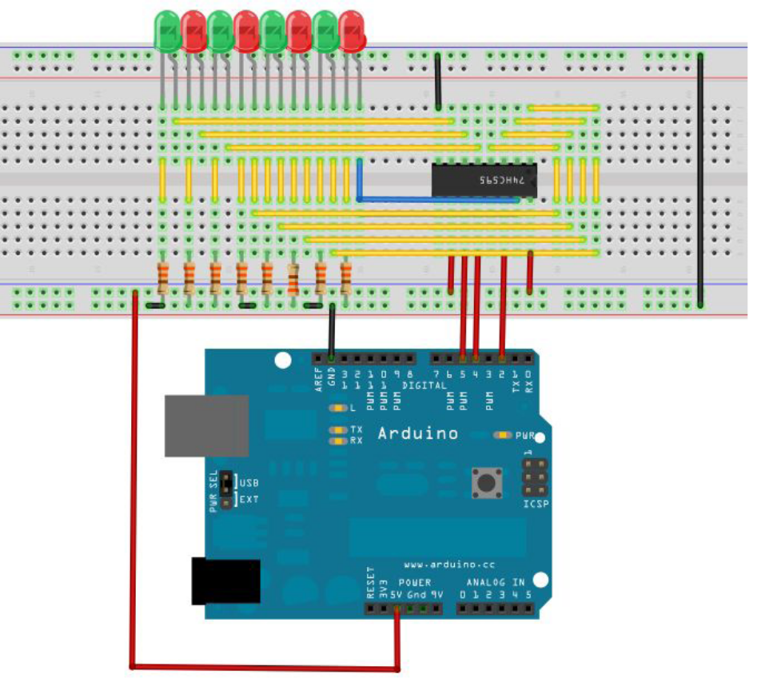
- Program for reference
int data = 2;
int clock = 4;
int latch = 5;
int ledState = 0;
const int ON = HIGH;
const int OFF = LOW;
void setup()
{
pinMode(data, OUTPUT);
pinMode(clock, OUTPUT);
pinMode(latch, OUTPUT);
}
void loop()
{
int delayTime = 100;
for(int i = 0; i < 256; i++)
{
updateLEDs(i);
delay(delayTime);
}
}
void updateLEDs(int value)
{
digitalWrite(latch, LOW);
shiftOut(data, clock, MSBFIRST, value);
digitalWrite(latch, HIGH);
}
void updateLEDsLong(int value)
{
digitalWrite(latch, LOW);
for(int i = 0; i < 8; i++)
{
int bit = value & B10000000;
value = value << 1;
if(bit == 128){digitalWrite(data, HIGH);}
else{digitalWrite(data, LOW);}
digitalWrite(clock, HIGH);
delay(1);
digitalWrite(clock, LOW);
}
digitalWrite(latch, HIGH);
}
int bits[]={B00000001, B00000010, B00000100, B00001000, B00010000, B00100000,
B01000000, B10000000};
int masks[] ={B11111110, B11111101, B11111011, B11110111, B11101111, B11011111,
B10111111, B01111111};
void changeLED(int led, int state)
{
ledState = ledState & masks[led];
if(state == ON){ledState = ledState | bits[led];}
updateLEDs(ledState);
}
Download the program and you can see 8 beautiful blinking leds.

