Title: Effects of poor hygiene in rural areas as compared to urban areas.

Name of student: Daniel Majur Majok

Institute: strategian Netherland

Course: Diploma in Water, Sanitation and Health, (WASH).

Admission number: SN/206/11/2018

Course Code: D002

Year: 2019

Month of Submission: May_2019

Introduction

The concepts of water, sanitation and hygiene (WASH) initiatives are based on good hygiene practice, access to improved water supply and improved sanitation, which are essential to reduce environmental health risks for population’s well-being at the global level

Poor hygiene in urban areas as compare to rural areas as put as a title above is the major concern in my area of research because it differentiate hygiene behaviors at two different aspect, in term of it population and environmental situation, and it can give clear indication of what to improve and how it will be done .

This research is done in Cueibet, Gok State, supported with some information during research period by the two ministries of Gok State, which are state ministry of health department of public health and state ministry of physical infrastructure directorate of water hygiene and sanitation. This research was done in Cueibet which is the capital headquarters of the State, and moreover this document is produce at Dong Village in Tiap – Tiap County Cueibet, Gok State.

Furthermore, the definition of urban areas is not limited in this definition, urban are areas that are much populated, congested and overcrowded by the number of people, houses and animals living in the area whereas rural areas has less number of people, houses and animals. Therefore in term of poor hygiene both two terms urban and rural have some positive and negative effects on hygiene behavior practices, of which hygiene health department has to maintain the positive practices and encourage good hygiene practices.

The poor hygiene in both rural and urban areas includes but not limited to the following;

One of the poor hygiene is Lack of clean **water** which increases the risk of cholera, typhoid and hepatitis - **water**-borne diseases that are prone to explosive outbreaks. Poor sanitation and hygiene can increase the spread of diseases like intestinal worms, blinding trachoma and schistosomiasis, which affect people in the developing countries.

Many health problems are associated with **poor sanitation** and waste management, principally caused by contact with human faeces. ... **Environmental impacts** of **poor sanitation** and waste management at a local level include pollution of land and watercourses, the visual **impact** of litter, and **bad** odors in areas that use open defecation.

So in Urban areas: Health costs associated with waterborne diseases such as malaria, diarrhea, and worm infections represent more than one third of the income of **poor** households, while in rural areas. Health risks are often exacerbated by **poor sanitation**. ...**Urban** solid waste disposal is another **sanitation**-related challenge.

photo of (CHCs) community hygiene clubs discussing poor hygiene and open defecation in Tiap-Tiap Village

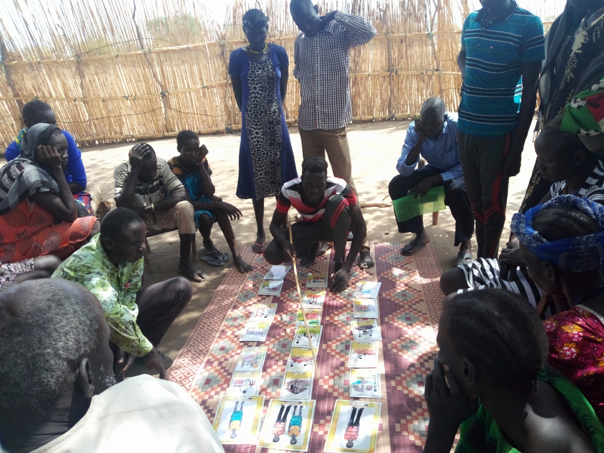

It is great to see an update of the commitments made at a similar meeting back in 2008. Clearly, a ‘focus on the poorest, most marginalized and unsaved and save water change’, must include the needs of poor people living in urban slums alongside their rural counterparts. However, there is precious little experience in ‘eliminating open defecation’ in urban slums. This will be a huge challenge that should not be under-estimated.

At the end of the project, we worked with the [CLTS Foundation](http://www.cltsfoundation.org/)reflect on how we had adapted the usual CLTS process for the challenges of an urban context. [The report](http://bit.ly/uclts_pakenya)highlights the greater scope of action required in urban contexts because of the importance of better-quality toilets, and the need for safe faecal sludge management. It explores the whole range of stakeholders who need to be involved from tenants and landlords, to pit empties, builders, banks and micro-credit, different levels of government, the local water and sewerage utility company, and many more.

Here are the 11 key differences we found between rural Hygiene, and urban context.

|  |  |  |
| --- | --- | --- |
|  | **Rural** | **Urban** |
| **1.** | Low toilet coverage and strong preference for or habit of OD | High toilet coverage but they are highly unsanitary. OD is out of necessity rather than preference or habit. |
| **2.** | Majority of households own land on which they can build their toilets | Most households are tenants and have to rely on landlords to provide sanitary toilets. However, it is tenants’ role to maintain them well. |
| **3.** | A single triggering aims to reach whole population | Two types of triggering exercises are needed: one for landlords and one for tenants |
| **4.** | The triggering methodology is principally based on eliciting feelings of shame and disgust to motivate behavior change. | The triggering methodology with landlords is based more around obligation and threat of legislation. Eliciting disgust is still a motivating factor in triggering with tenants. |
| **5.** | The key challenge is triggering behavior change to break the long held habit of open defecation. | The key challenge is ensuring adequate provision and maintenance of facilities. Open defecation is no longer a habit but an outcome of poor facilities. |
| **6** | Once a toilet is full, there is usually space to build more within the household compound. | Space is limited and density of population is high resulting in the need to dispose of faecal sludge outside the plot once toilets fill up. |
| **7** | Households can build very basic low cost toilets, starting and the lowest rung of the sanitation ladder if they choose. | There are often regulations about the standard of toilets substructure and the superstructure. Negotiation with authorities can be an important aspect of intervention. |
| **8** | Households can usually finance low cost toilet building without external finance. | Landlords often require external finance in order to be able to adequately upgrade sanitation facilities. This may require negotiating a loan facility, whether through banks or a community fund. |
| **9** | There are few stakeholders external to the community who has an influence on sanitation provision. | There are several stakeholders involved, such as tenants, landlords, planning department, public health officials, and water and sewerage companies. |
| **10** | As there are few stakeholders involved, the intervention process can be relatively fast. | Due to the regulatory environment and the number of stakeholders involved the intervention process, even before any triggering takes place, can take quite long. |
| **11** | Natural leaders and community consultants are key players in driving and scaling up hygiene practices | In this particular urban context natural leaders and community consultants were not developed as Community Health Volunteers already existed. |

In Gok State: Latrine possession, disposal of children's faeces and waste-water in 1015 households in 33 sites in Cueibet, Tiap-Tiap and Malou pec were studied in May. Assistants conducted interviews and observed the state and use of latrines, disposal of children's faeces, wastewater, and household socio-demographic characteristics. Latrine possession was 50.4% in Malou pec, 55% in Tiap-Tiap and 45% in Dong. In un piped sites, 45.5% of Cueibet, 40.5% of Jierial and 35% of Mukodit households had latrines. Over 30% of latrines in rural Malou pec contaminated with faeces, compared with 10% in Cueibet. More latrines in urban Rumbek and Juba had contaminated surroundings than in the rural areas. The mean number of people using a toilet in the urban areas (10) was significantly higher than in rural areas (7), (*F* = 45.5; *P* < 0.001). Toilets in Rumbek Town and Juba capital city of South Sudan were more likely to be fouled than in neighboring estate. Households where the head was an educated professional or business person, or the toilet had a door, lid or concrete wall or floor or waste water was disposed of in the latrine, were less likely to have fouled toilets. Most households disposed of the faeces safely with a few placing them in the garden or elsewhere. The study emphasizes the need to promote appropriate sanitation and hygiene.

Keywords: sanitation, hygiene South Sudan, Urban, Rural.

**Definition of access to drinking-water and improved sanitation according to WHO and UNICEF.**

| **Variables** | **Definition of WHO and UNICEF** | **Definition adapted according to the study** |
| --- | --- | --- |
| Access to drinking water/improved water source | Use the following facilities:     • Piped water     • Public tap/stand post     • Tube well/borehole     • Protected dug well     • Protected spring     • Rainwater | Households that use in their household only an improved water source (tap water, water reselling or standpipe and hand pump) |
| Access to improved sanitation | Using basic sanitation facilities that are likely to ensure hygienic separation of human excreta from human contact. They include     • Flush/pour flush to: piped sewer, system, septic tank, pit latrine     • Ventilated improved pit (VIP) latrine     • Pit latrine with slab     • Composting toilet | Households with a basic sanitation facility in their household (flush to sewerage or septic tank, improved latrines with ventilated pit, or San Plat or basic pits with slab tanks), and the destination of faecal sludge is not the street or the environment or the drainage channels. |

Construction of logistic regression models

To build the two logistic regression models, six potential confounding factors collected in the cross-sectional survey and describing the socio-economic characteristics of the study population were identified. These were: (i) the settlements: the location of the residence; (ii) the level of education of the respondent: not educated or highest level achieved (primary, secondary and higher school); (iii) the religion: Christianity, Islam and ‘other’; (iv) housing condition reflecting the socio-economic status (e.g. very-low class socio-economic households: traditional housing made of wood and plastic, low class socio-economic households: shared courtyard referring to grouped houses with a common courtyard and most of the household are using open defecation and middle class socio-economic households: economic or social housing); (v) household size: number of people living in a household as a continuous variable; and (vi) the presence of the household head’s wife at home during the survey. In poor areas, most of the household head’s wives stay at home for household duties.

The model was not reduced as the number of model parameters does not clearly exceed 10% of the number of cases or non-cases. The odds ratio (OR) and corresponding confidence intervals (CI) were present.

Results

Socio-demographic characteristics of the respondents

In total, 106 households were investigated in the six selected settlements of the municipality of Tiap-Tiap The main socio-demographic characteristics of the respondents based on the frequency analysis, In all the settlements, more than half of the respondents were young and predominantly female. Secondary and primary school were the highest level achieved by the majority of the respondents (30.8%) and 47% had no formal education. Also, more than half of the individuals were married and about 30% were single. Christianity was represented religions, by 100%.

Water supply

Several types of water sources were used in the different settlements. The main ones were tap water (9%), well water (22%), rainwater (12%) and water obtained by hand pump (57%).

Management of wastewater and excreta

Water used for dishes and laundry were mostly spilled (70%) into the streets in all areas investigated. Eight percent of all households assessed did not have any latrines with household members practicing open defecation. In addition, in 18% of households, content from the latrines were released onto the street contributing to the degradation of the environment and leading to health risks.

Access to clean water

The results revealed that 64 of the 106 respondents (76%) had access to clean water. According to information I gather from water for lakes staffs, because water for lakes project make drilling and rehabilitation of hand pump and offered training and mentorship on using the water at the right source which is water from the hand pump because they are not open, like water get from the pools and other uncover source like digging well and rain water.

Access to improved sanitation

In total, less than half of all investigated households (33%) had access to improved sanitation because of team of water for lakes making hygiene promotion campaign in the area. Compared with households which had access to improved sanitation those without were significantly associated with ‘living in a very low class socio-economic household’ ‘living in all the studied settlements In the multivariate logistic regression model, several factors were associated with lower access to improved sanitation. They included ‘living in a very low class socio-economic.

Discussion

In the investigated settlements, the proportion of the type of water source used, varied significantly from one settlement to another (p < 0.001). Several sources of clean drinking water were identified (i.e. water for resale, tap, hydraulic or hand pump, standpipe). However, the technology and accessibility of the sources for improved drinking water are often inadequate, resulting in pressure drops and untimely water shortages, hence people tend to use unimproved water sources including unprotected wells. The results of the study showed that more than one fifth of households in the investigated settlements lack access to clean water. Dong, Dhongyep and Malual Tiap-Tiap are settlements where households have lower access to clean water compared with those who live in other investigated settlements. Originally, these settlements are villages with wells for water supply. In Dong 11% of surveyed households still using unprotected wells because of recurrent water shortages. In Malual Amel, the situation was found to be somewhat different. Households were not connected to the drinking water system and there was only one hand pump for the supply of this settlement. People have to pay to access it and, moreover, a significant physical effort is involved in operating the pump. Almost all people surveyed therefore stated to prefer using well water.

Conclusions

Access to improved water and sanitation remains a challenge for poor urban population of Urban cities, particularly those living in poor peri-urban areas. Innovative planning approaches tailored to communities’ conditions and based on social context of each specific settlement are needed for faster progress in these areas in order to achieve access to basic drinking water and sanitation by 2030 as recommended by the United Nations Sustainable Development Goals (UN-SDG). Those approaches should involve not only local actors and administrative authorities but also religious communities e.g. for WASH communication because of their large representation, and women owing to their important role in ensuring access to clean water in these specific environments.

Acknowledgments

I would like to thank ministry of physical infrastructure of Gok Stat directorate of water hygiene and sanitation for allowing me to do my work with their collaboration, also my appreciation to State ministry of health particularly Department of Epidemiology and Public Health, for technical and scientific assistance. i would also like to thank the respondent for their collaboration and their time during the interview. Iam grateful for the support provided by CSO (GARD) Great Action for Relief and development staff implementing Water for Lakes project for giving me WASH information in the area.

Lastly my sincere thanks to my Big two (2) people who organized this scholarship for under water for lakes, Mott macdonald as a donor,

1. Jacqueline Muthura: WASH expert water for lakes project
2. Theo Hendriksen: Team Leader water for lakes project