**COLLEGE ERP**

**System Modules and specifications**

# 1. Staff portal

* Staff can access all the information related to academics and administration from their login at any place.
* Communicate, share and discuss more easily with pupils and parents.
* Quick and easy access pupil’s performance data to monitor their strengths and weaknesses.
* Perfect documentation and storage of assignments, class notes and lesson plans helps the staff in getting more organized.
* Leave application & status monitoring.
* Assignments updating, monitoring and feedbacks.
* Interaction with Guardians, Students & other staff through messages.

Screenshot

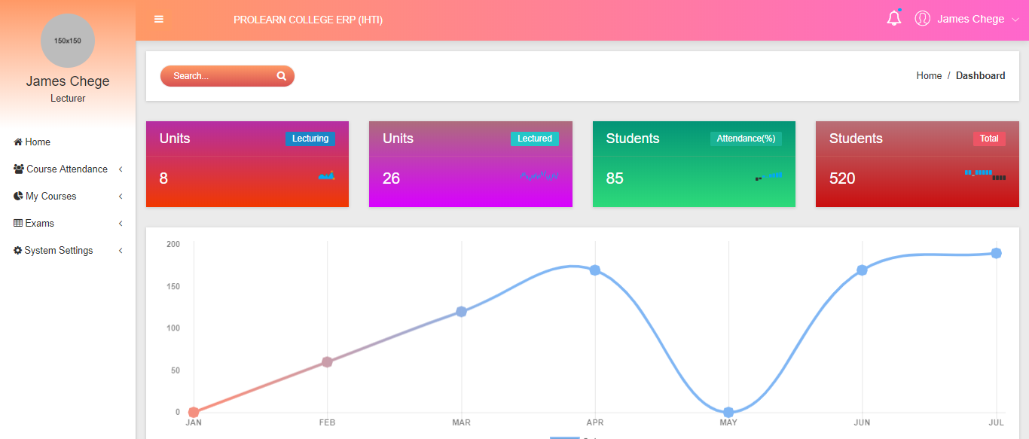

# 2. Students Portal

* The Student can directly log on to their portable and check up-to-date attendance, progress reports, fee reports, book hostel and download examination cards.
* What’s more, this service will be made available 24/7 and can be accessed from any place with a web connection.

Screenshot

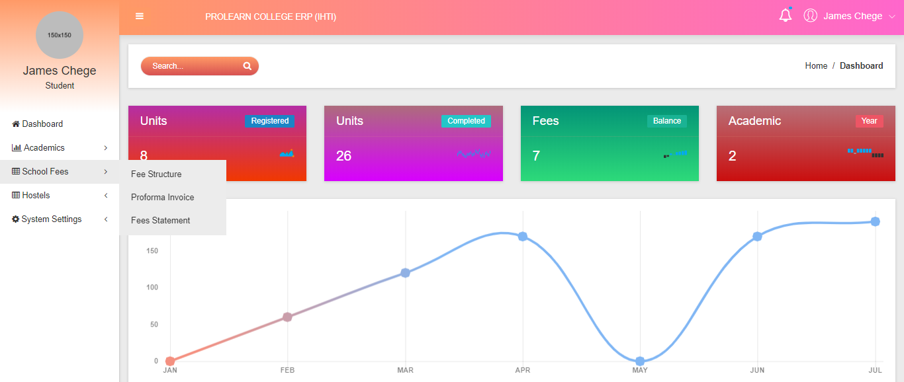

# 3. Admin’s portal

The admin portal will encompass all the stakeholders responsible for the day to day running of the institution

* Admin can monitor/manage all Student Details, Fee, Attendance, and Academic, Staff, Payroll and all other information from a single portal.
* Integrate, automate and streamline all academic and administrative functions.
* Communicate with any or all stakeholders within seconds using automated SMS, e-mail and internal messaging.
* Convey required information via virtual notice boards.
* Maintenance of staff attendance.
* Keep track of exam schedules and marks.
* Subject-wise marks analysis.
* Manage and track entire Transport system.
* Manage and facilitate the library management system

Screenshot

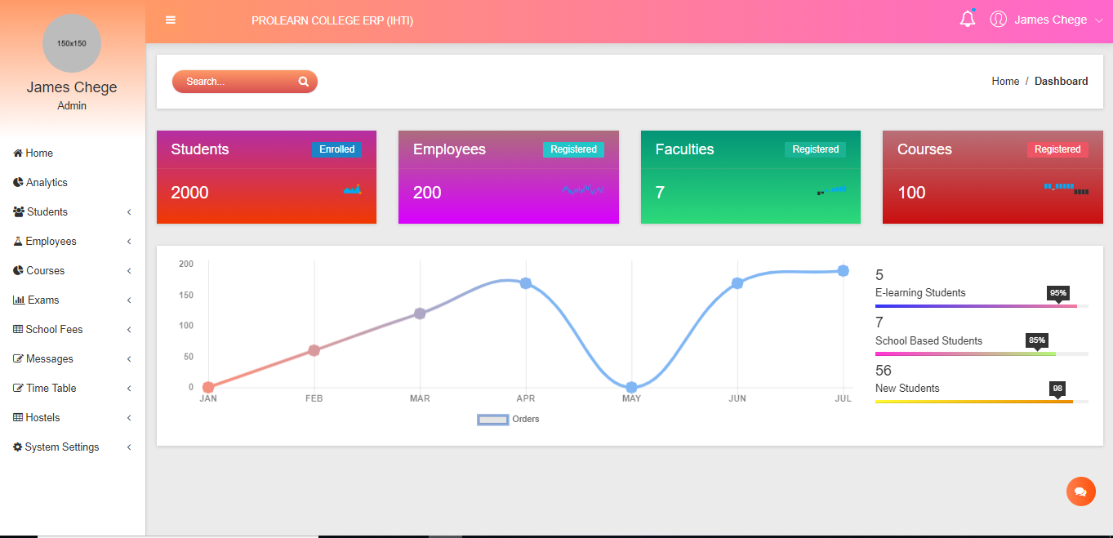

**Highlight of the ERP features**

# 1. Pre-Admission Management

Pre-admission process is the most hectic process which can be made easy with ERP for Educational Institution. Catering as a school ERP system in India, it reduces the hectic job of maintaining physical documentation as the process can be simplified by documents being scanned and attached in the software itself.

* Student Enquiry
* Students' Admission Form
* Required Documents Attachment
* Pending Documents Reports
* Allocation of faculty and course to Student

Screenshot

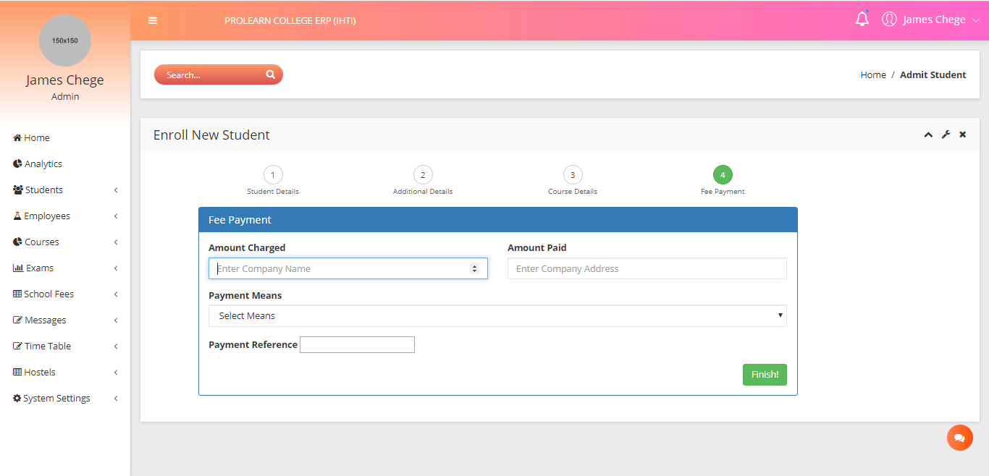

# 2. Student Management System

Education Institute module eases the tedious job of maintaining students’ profile. The School Management ERP system generates reports based on class, subject, division, caste, etc. and gives additional usage of getting students' declaration, bona fide certificate and leaving certificates printed.

* Manage student personal profile
* Creation of faculties and courses
* Auto/Manual Section / Roll no. assignment
* Allocation of units to the courses Promoting/shifting of student to different class/division
* Printing of relevant documents required by the student, i.e. exam transcrippts, exam cards, graduation documents etc.
* Student Statistics

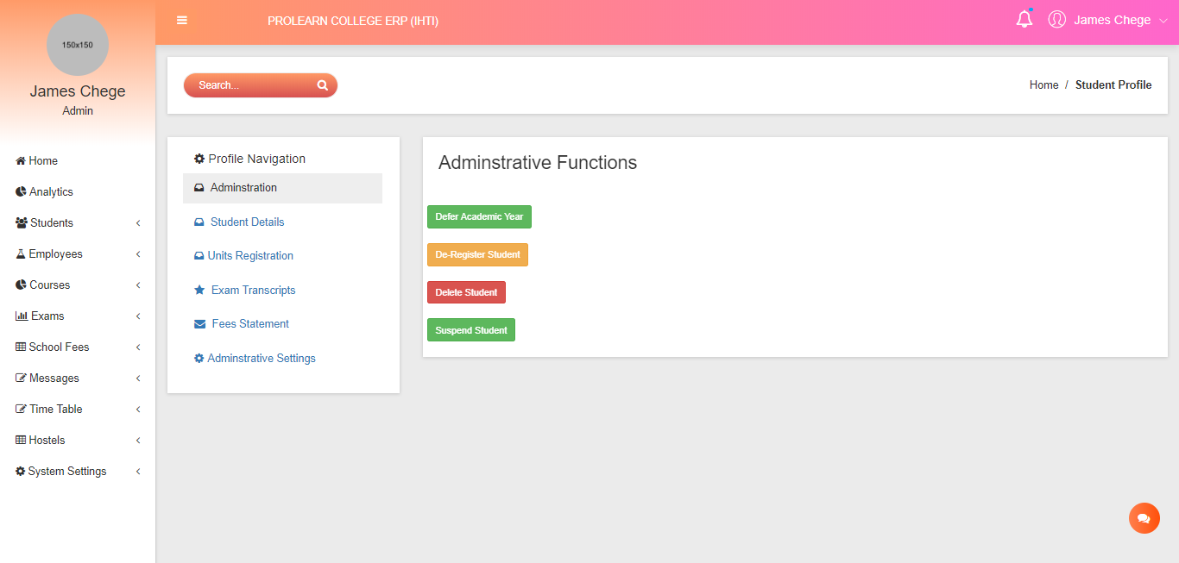

# 3. Fees Management System

Fees Management System acts as a strong tool as it can define fees per student based on their standard and category they belong to. It can print receipts and give details of the outstanding per student, class wise. The Fees Management System is efficient to generate reports based on daily and monthly collections, segregating it component and standard wise. Definition of Student Fees template is also provisioned. (Individual as well as for entire class/ standard/ category wise).

* Defining student fees template and structures
* Fee Collection and Receipt Printing
* Fees booking and register printing (detailed and summary)
* Daily Fee Collection Register
* Monthly Collection Report - Fee Component Wise, Standard Wise
* Fee Collection Reconciliation for Received cheques
* Outstanding (standard/division/student and fee component wise)

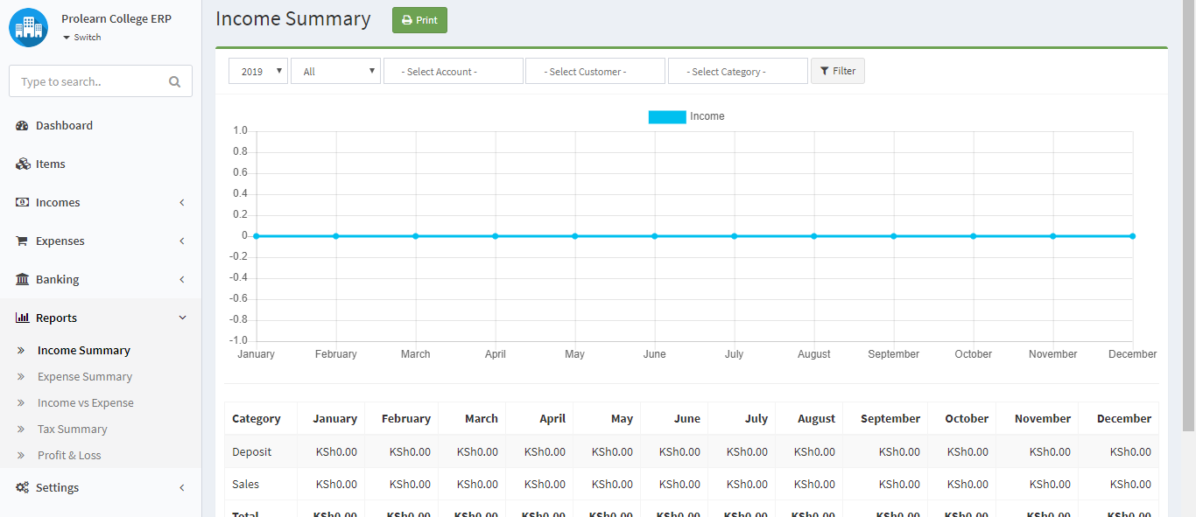

# 4. Attendance Management System

Attendance Management System plays a vital role for educational institutes like school where lecturers have to record the class attendance of their students. In that case Attendance Management Module can make the task of quite easy by its.

* Biometrics attendance integration
* Weekly posting of the attendance sheets
* Status Monitor & Processing of Data

# 5. Examination & Result Management

Exams and result management, an integral part of Educational ERP compressive as ERP for school and play schools help in managing individual and group subject marks based on

* Creation of Academic year and defining examinations
* Filtering students allowed to sit for an examination
* results list entry and Register
* Exam reporting
* Faculty wise analysis of results
* Performance analysis
* Transcript printing
* Examination cards Printing

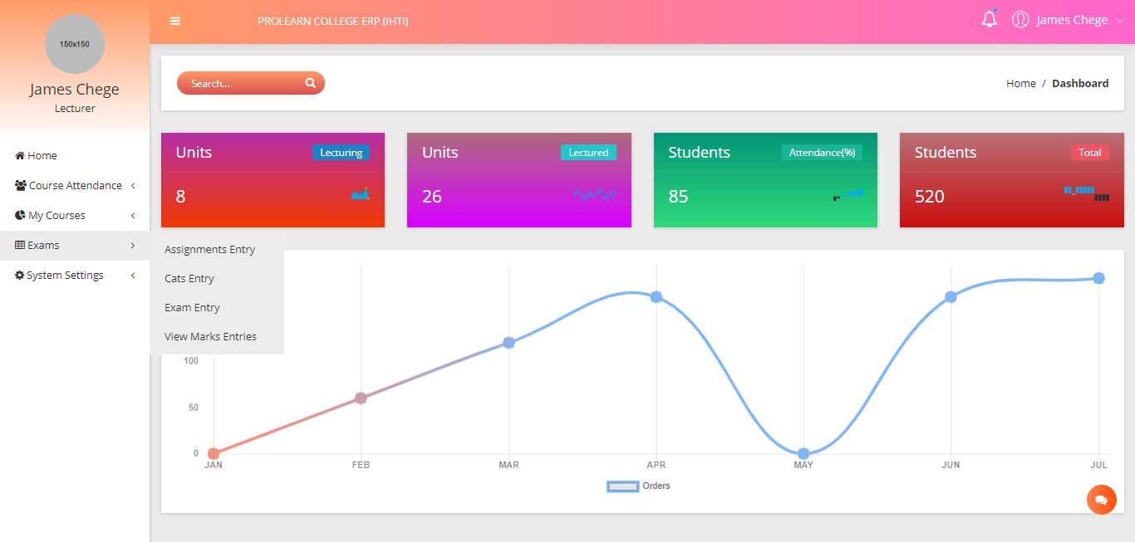

# 6.SMS Facilities

SMS module acts as a very important feature as it provides acknowledgement for the fees receipt, intimation over the fees overdue and attendance of the students, which are very useful for the parents as well as the institutions. It can also be used for campaigns using bulk messaging.

* Fees receipt acknowledgement.
* Fees outstanding intimation to parents.
* Student attendance alert to parents
* Birthday wishes
* Group SMS to teachers/parents/students/staff/trustees
* Bulk SMS for campaigns
* SMS history
* SMS balance

# 7. Account Management

The financial Accounting modules enable effective management of complete account of school. And it integrated Accounting Package allows comprehensive management of accounts without the need of cumbersome posting of vouchers. All types of vouchers can be entered from single voucher entry screen. It generates no. of reports like Bank/Cash Book, Income and Expenditure sheet are available in a single click.

* Accounts Group Type
* Accounts Payable (Creditors)
* Accounts Receivable (Debtors)
* Payroll Management
* Expenses/Purchasing Management
* Get real time updates of fee collected related status
* Fee Calculations & Postings
* Reports for Income and Expenses Statement

