2025-03-13

${Energy}

${Information}

${Decisions}

${Lifestyle}

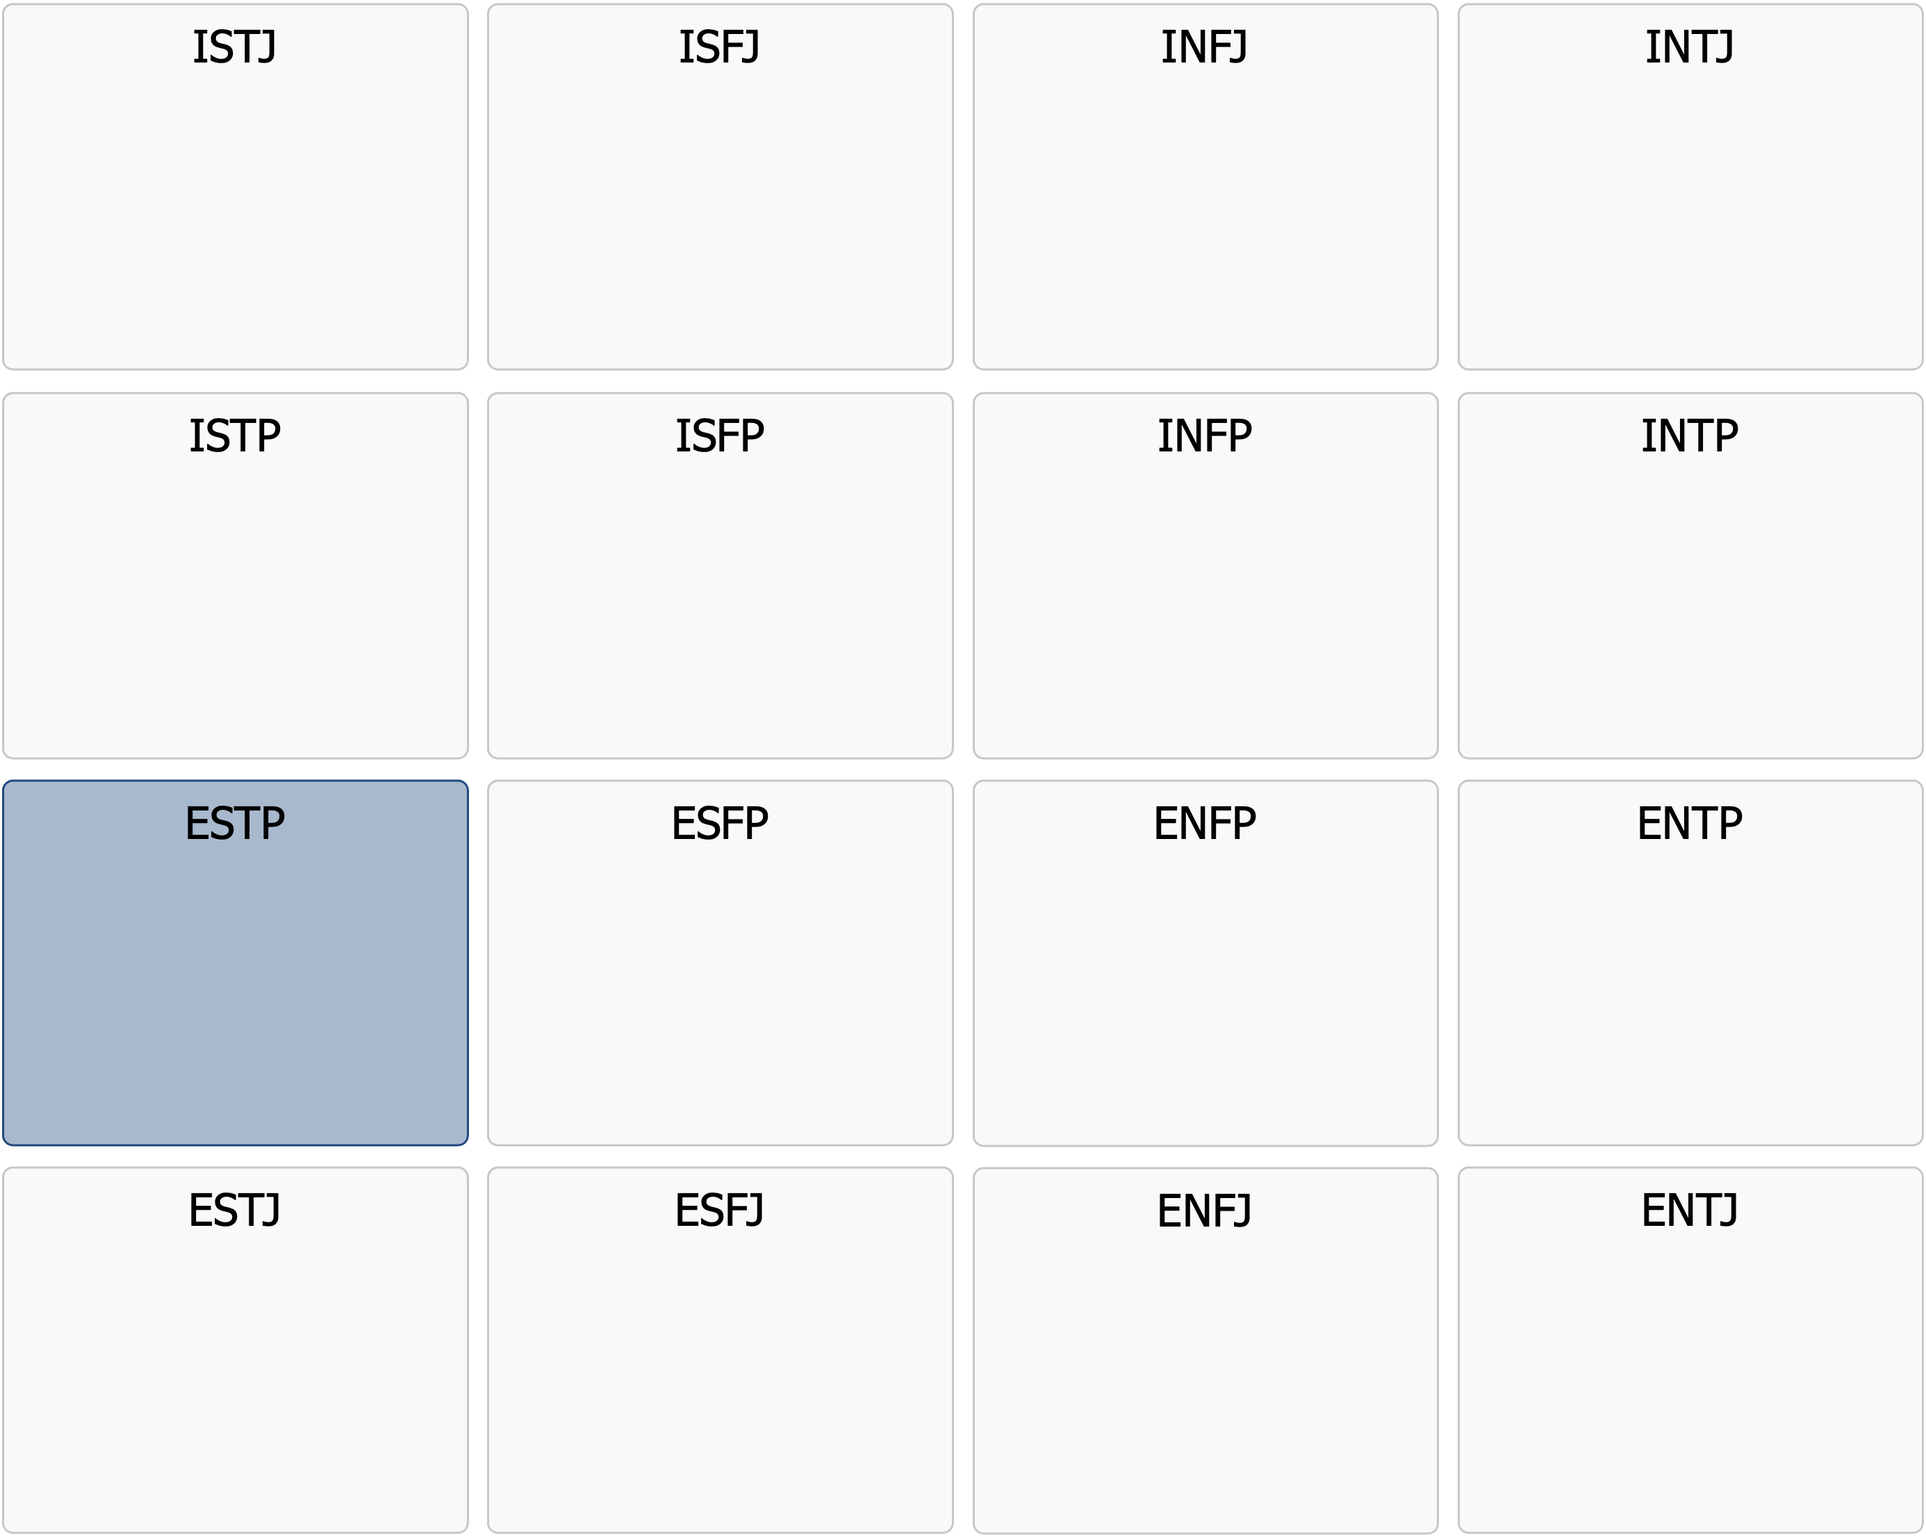

Profile Description

ESTP

|  |
| --- |
| ESTP  The Reliable Executor |

Meeting an ESTP means encountering someone who is always on the move. They are doers, often acting on impulse and solving tasks methodically in a way they are accustomed to. For them, life is about solving problems, moving forward, and doing things as correctly as possible. They have a sharp eye for what works and what is likely a waste of time.  
  
ESTPs are social, but not in a conventional way. They enjoy being around people, but more for the dynamism and exchange rather than for building deep emotional bonds. They are sharp in their comments and often say what others are merely thinking. With a dry sense of humor and the ability to quickly adapt to situations, they know exactly when to strike with a powerful remark.  
  
In practical situations, ESTPs are task-oriented and like to take charge. They observe, analyze, and usually act immediately. If necessary, they can grind through tasks, but they rarely have the patience for slow processes or unclear goals. They work best when the direction is clear and when they can see tangible results from their efforts.  
  
At work, they seek freedom and flexibility. They thrive in roles where they can be self-reliant and react quickly to changes. Sales, business, crisis management, and other jobs that require decisiveness and social agility suit them well. They struggle with strict routines and quickly become frustrated in sluggish organizations where they have to wait for approvals before getting things done.  
  
In relationships, ESTPs stay engaged as long as there is energy and momentum. They appreciate people who are independent, direct, and don’t drag things out unnecessarily. Emotional drama does not interest them, and they have no problem speaking up if someone tries to complicate things. They are loyal to those they respect but feel no need to conform just to fit in.  
  
Their questioning nature can make them seem rebellious, but for ESTPs, it’s not about being contrary for the sake of it. They want to understand why things are done a certain way and whether there is a smarter solution. They remain calm under pressure, but too many tasks at once can make them scattered. Structure is not their strongest suit, and they may struggle to prioritize if there are too many options.  
  
ESTPs act on instinct and know exactly when it’s time to make a move. They navigate life by trusting their ability to read situations and quickly find the best way forward. To them, the world is a place to conquer through action, not through theories and lengthy explanations.

Below is a list of in-depth points that further describe the core personality you have likely had throughout your life. A tip is to print out the list and mark the points that you feel still apply to you today.

# Strenghts

* Logical and analytical with the ability to quickly identify what is relevant
* High energy and drive, especially when they have clear goals to work toward
* Outspoken and independent in their thinking, often saying what they think without a filter
* Adaptable and functions well in unpredictable environments where they have the freedom to act spontaneously
* Practical and pragmatic, preferring action over theoretical discussions
* Observant and perceptive, quickly noticing changes in their surroundings
* Resourceful and capable of working hard and persistently when the situation demands it
* Stay calm under pressure as long as they do not have to handle too many things at once
* Can focus well when there are only a few tasks to do but may struggle to prioritize when workload increases
* Driven and moves quickly toward clear goals but may struggle to define their own long-term objectives

# Drivers and common motivations

* Motivated by having clear and concrete goals to work toward
* Thrives in fast-paced environments where they can be at the center of action
* Enjoys solving problems directly and efficiently without getting stuck in theories
* Performs best in roles where they have freedom and can avoid unnecessary bureaucracy
* Enjoys using their social skills to influence and collaborate with others
* Motivated by seeing quick and tangible results from their work
* Naturally inclined to test limits and challenge rules and traditions
* Thrives in environments where variety and change are part of daily life

# Communication style

* Direct and straightforward in their communication, without sugarcoating their opinions
* Has a witty sense of humor and often uses sharp remarks to lighten the mood
* Persuasive and skilled at convincing others when they hold a strong opinion
* Socially adept, quickly reading people and adjusting to the situation
* Enjoys challenging established truths and can be provocative in discussions
* Struggles with long, theoretical conversations that lack practical relevance
* Prefers dynamic and engaging discussions where quick decisions can be made

# Relationships

* Enjoys people and thrives in social settings where they can be themselves
* Spontaneous and playful in relationships, appreciating new experiences with others
* Has a strong need for independence and avoids relationships where they feel restricted
* Loyal to people they respect but struggles with those who are overly emotionally dependent
* Expresses appreciation through actions rather than words
* Prefers resolving conflicts quickly and dislikes dwelling on problems for too long
* Focuses on the present in relationships but may sometimes forget about long-term consequences

# Work and career

* Performs best when they have a clear direction and someone pushing them forward
* Prefers working hands-on and solving problems rather than long-term planning
* Thrives in fast-moving work environments where they can act immediately
* Skilled at improvising and handling unexpected situations
* Struggles with monotonous tasks and environments with too many rules
* Motivated by competition and the opportunity to prove their competence
* Prefers tasks where they can quickly see concrete results
* Often suited for careers in sales, entrepreneurship, sports, or entertainment

# Typical Role in a group

* Often takes on an informal leadership role due to their energy and enthusiasm
* Creates a dynamic and lively atmosphere where others feel comfortable
* Challenges and questions ideas, which can lead to both innovation and conflicts
* Struggles with inefficient meetings and prefers to find quick solutions
* Quick to take action and initiates when others hesitate
* Can jump between tasks if there is no clear prioritization
* Thrives in groups that balance freedom and structure
* Finds it difficult to work with people who are slow or overanalyze situations

# As a leader

* Driven and results-oriented, focused on getting things done
* Stays calm under pressure and can handle stressful situations
* Makes quick decisions based on what works in practice
* Creates a high-energy and fast-paced work environment
* Prefers an informal leadership style and working closely with the team
* Expects others to be as fast and action-oriented as they are
* Struggles to manage employees who require extensive support and structure
* Leads by inspiring and building momentum rather than through detailed plans

# Appreciated leadership style

* Needs a manager who provides freedom but also clear goals
* Performs best in workplaces where they can use their energy and problem-solving skills
* Thrives in structures where the rules are clear but allow for independent decisions
* Needs a leader who lets them test boundaries but also holds them accountable
* Motivated by seeing quick results and may lose interest in slow processes
* Needs help prioritizing when tasks pile up
* Prefers concrete and action-oriented feedback over general criticism
* Best suited for a dynamic workplace where quick decisions and changes are part of the job

# Areas for development – Which ones apply to you currently?

* Tends to be impulsive and make decisions without considering long-term consequences
* Can struggle to focus when too many tasks compete for attention
* Enjoys challenging things without always offering a better alternative
* Struggles to create long-term goals without external direction
* May become restless and find it hard to complete long-term projects
* Competitive nature can sometimes hinder effective collaboration
* Needs to work on handling criticism without becoming defensive
* Could benefit from balancing spontaneity with long-term planning

# Things to consider moving forward – How do they apply to you?

* Learn to prioritize and handle multiple tasks simultaneously
* Practice creating and following long-term plans, even when they feel less exciting
* Develop strategies to maintain focus rather than jumping between tasks
* Surround yourself with people who help structure and prioritize
* Work on listening to others and considering different perspectives
* Balance spontaneity with strategy for greater success
* Accept that some things take time and cannot be solved instantly
* Learn to delegate and trust that others can solve problems too