2025-03-16

Niklas Pettersson

${Energy}

${Information}

${Decisions}

${Lifestyle}

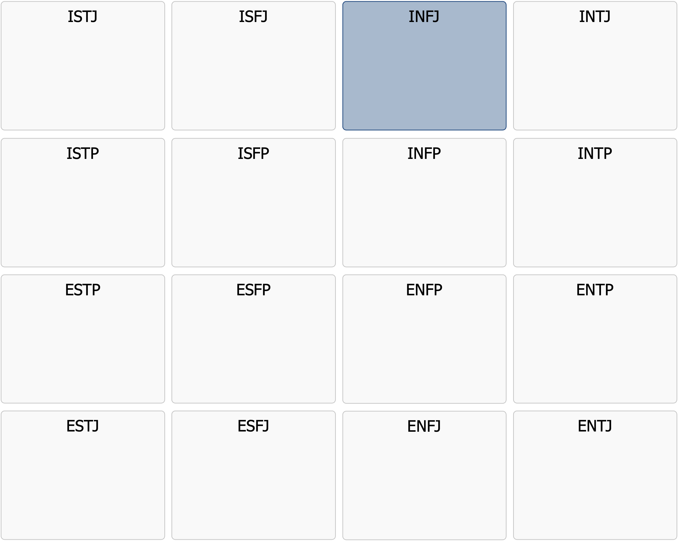

Profile Description

INFJ

|  |
| --- |
| INFJ  Sees the depth and understands the meaning – long before others do |

Meeting an INFJ means encountering a person with a deep inner world, filled with visions, insights, and a strong drive to make the world a better place. The INFJ personality is a unique combination of empathy, strategic thinking, and determination. They are idealists with a practical side – they don’t just dream of a better future, they actively seek ways to turn those dreams into reality.  
  
INFJs are often difficult to truly get to know. They have a complex and deep personality, and while they are socially skilled and warm, they only share their innermost thoughts with a select few. They are natural guides who intuitively see patterns and connections in the world. They can often sense people's emotions and motivations before they even express them and use this insight to help, inspire, and guide others.  
  
An INFJ is driven by a greater purpose – they want their life to have meaning and their actions to make a difference. They are not satisfied with superficial solutions or short-term gains; they strive for long-term change and profound personal development. This often leads them to engage in social causes, creative projects, or work where they can use their insights to make a deep impact.  
  
Despite their strong empathy and interest in others, INFJs are introverted. They often need a lot of time alone to reflect, process impressions, and recharge their energy. Too much social interaction can be exhausting, especially if they don’t feel the conversations have real meaning. They also tend to be perfectionistic and hard on themselves, especially when they feel they are not meeting their own high ideals.  
  
In the workplace, INFJs thrive in careers where they can combine their analytical abilities with their need to help others. They often excel as mentors, coaches, therapists, artists, writers, or strategic thinkers. They handle complex issues well and have a natural ability to see the bigger picture.  
  
In a world where many focus on superficial achievements and quick results, INFJs remind us of the importance of depth, meaning, and authenticity. They are guides, inspirers, and visionaries – people who see beyond the present moment and strive to create a future that is more mindful, more compassionate, and more meaningful.

Below is a list of in-depth points that further describe the core personality you have likely had throughout your life. A tip is to print out the list and mark the points that you feel still apply to you today.

# Strenghts

* Visionary and deep-thinking – sees patterns and connections that others often miss
* Empathetic and perceptive – deeply understands and senses people’s emotions
* Strategic and long-term thinker – plans with a clear purpose and goal in mind
* Intuitive and insightful – has a strong ability to read between the lines and understand underlying motives
* Loyal and dedicated – committed to their loved ones and their beliefs and values
* Inspiring and motivating – helps others find their path and purpose
* Creative and reflective – finds innovative solutions to complex problems
* Strong integrity – lives according to their values and rarely compromises on them

# Drivers and common motivations

* Helping others reach their full potential
* Working toward a greater vision and creating positive change
* Engaging in meaningful and profound work rather than superficial tasks
* Feeling that their efforts genuinely impact and create change
* Understanding and developing themselves on a spiritual and intellectual level
* Expressing their strong creativity in a way that feels genuine and inspiring
* Being part of a community where authenticity and deep understanding are valued
* Having time and space for reflection and self-development

# Communication style

* Soft yet persuasive – speaks with emotion and conviction without being aggressive
* Reflective and thoughtful – does not always say much, but when they do, it carries weight
* Deep and philosophical – prefers meaningful conversations over small talk
* Sensitive and attentive – adapts their message based on the person and situation
* Able to express complex ideas in a clear and inspiring way
* May struggle to share their deepest thoughts unless they feel safe
* Enjoys using metaphors and symbolism to explain their thoughts and emotions
* Prefers written communication where they can better structure their ideas

# Relationships

* Loyal and devoted – invests significant time and emotion in their relationships
* Seeks fewer but deeper and more meaningful connections rather than many acquaintances
* Can be reserved at first but opens up to the right people
* Has high expectations for relationships and seeks authenticity and sincerity
* Can feel disappointed if others do not live up to their idealistic view of relationships
* Often provides guidance and advice to their loved ones
* Needs alone time to recharge and process emotions
* Has a natural ability to understand and support others but may sometimes neglect their own needs

# Work and career

* Thrives in professions where they can help and inspire others
* Prefers working independently or in small, tight-knit teams
* Struggles with work environments that lack purpose or feel overly mechanical
* Wants a balance between creativity and structure
* May struggle with bureaucracy and strict hierarchies
* Excels at solving complex and strategic problems
* Has a natural talent for working with people but also needs time for reflection
* Performs best when they feel inspired and appreciated

# Typical Role in a group

* The listener, observer, and contributor of insightful analysis
* Often acts as a guide and mentor within the group
* Has a strong sense of group dynamics and can foresee problems before they arise
* May struggle with conflicts but tries to resolve them through diplomacy
* More interested in fostering meaningful work dynamics than pushing for performance
* May withdraw if they feel the group does not share their values
* Takes responsibility and works hard but wants the freedom to do things their way
* Functions best in a group where they can combine independence with collaboration

# As a leader

* Visionary and inspiring – leads with a clear direction and a higher purpose
* Calm and reflective – makes decisions with care and thoughtfulness
* Cares about their team’s well-being and development
* Has an intuitive sense of which strategies will work long-term
* May struggle to give criticism and rarely handles conflicts directly
* More focused on building a positive culture than pushing for short-term goals
* Often makes people feel seen and valued
* May struggle with inefficiency and become frustrated when things are done without a clear purpose or against their values

# Appreciated leadership style

* A leader who respects their integrity and gives them the freedom to work their way
* A work environment where empathy and visionary thinking are appreciated
* Opportunities to work on long-term and meaningful projects
* A leader who values their insights and gives them time to develop their ideas
* A workplace where they can influence and create change
* A leader who provides feedback in a thoughtful and respectful way
* Room for independent work but with clear goals
* A culture where authenticity and sincerity matter more than external status

# Areas for development – Which ones apply to you currently?

* May be overly idealistic and struggle to accept that the world does not always align with their vision
* Tends to take on others’ problems and forget about their own needs
* Struggles with setting boundaries and saying no
* May hold themselves and others to excessively high standards, leading to disappointment
* Can be sensitive to criticism because they put so much of themselves into their work
* Needs to work on handling conflicts more directly rather than avoiding them through silence or withdrawal
* May struggle to make quick decisions because they deeply analyze every aspect
* Needs to practice letting go of control and trusting that others can also contribute

# Things to consider moving forward – How do they apply to you?

* Practice setting clear boundaries and prioritizing your well-being
* Learn to handle criticism as part of personal growth rather than a personal attack
* Balance your idealism with more realism – change takes time
* Work on letting go of control and allowing others to take responsibility for their own decisions
* Surround yourself with people who understand and value your deep-thinking nature
* Use your strategic skills more to plan practical steps toward your goals
* Find a work environment where you can combine independent thinking with collaboration
* Remember that even small changes can make a big difference – you do not have to carry the entire world on your shoulders