**Thinking**

**Sensing**

**Extraversion**

**Perception**

**Judging**

**Feeling**

**Intuition**

**Introversion**

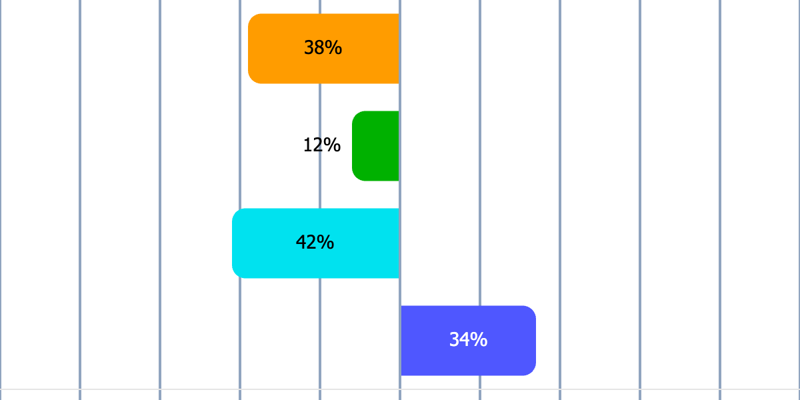

Niklas Pettersson

${Energy}

${Information}

${Decisions}

${Lifestyle}

Short profile description

Your personality type is probably  
INFJ

|  |
| --- |
| Sees the depth and understands the meaning – long before others do |

INFJ-personer är idealister med en stark känsla för syfte och vision. De drivs av en önskan att förstå världen på djupet och att hjälpa andra att uppnå sitt fulla potential. Med en unik kombination av empati och strategiskt tänkande har de en förmåga att både knyta nära relationer och se den större bilden. INFJ trivs bäst i miljöer där de kan arbeta för en högre mening eller bidra till positiv förändring. Deras introverta natur gör att de ibland föredrar tyst reflektion framför social interaktion, men deras djupa omtanke och förståelse för andra gör dem till inspirerande vägvisare. Samtidigt kan deras perfektionism och höga krav på sig själva bli en utmaning.

# Fundamental traits

* Empathetic and supportive – often sensing others' feelings and needs.
* Visionary and idealistic – strives to contribute to a better world.
* Analytical and strategic – sees connections and solutions that others may miss.
* Principled and committed – works hard to live according to their values.
* Reflective and introspective – may spend much time understanding themselves and their surroundings.

# Work style and decision-making

* Prefers to work on projects that have a deeper meaning or purpose.
* Makes decisions based on both intuition and their strong values.
* Creative problem solvers who often see solutions to complex problems.
* Can be perceived as perfectionistic and have high expectations of themselves and others.
* Thrives best in roles where they can combine their empathy with strategic thinking.

# Social relationships

* Loyal and supportive – builds deep and meaningful relationships.
* Can be perceived as reserved or hard to get to know initially.
* Shows care by listening and supporting others in a genuine way.
* Values relationships where they can share ideas and visions.
* Has a strong intuition for what others need and tries to help in subtle ways.

# Development areas

* Can be perceived as overwhelmed by their own high expectations.
* Risks becoming burned out when prioritizing others' needs over their own.
* Can struggle with conflicts and tends to avoid them.
* Tends to overanalyze situations, which can lead to indecision.
* Needs to work on balancing their ideals with realistic expectations.