2025-03-13

${Energy}

${Information}

${Decisions}

${Lifestyle}

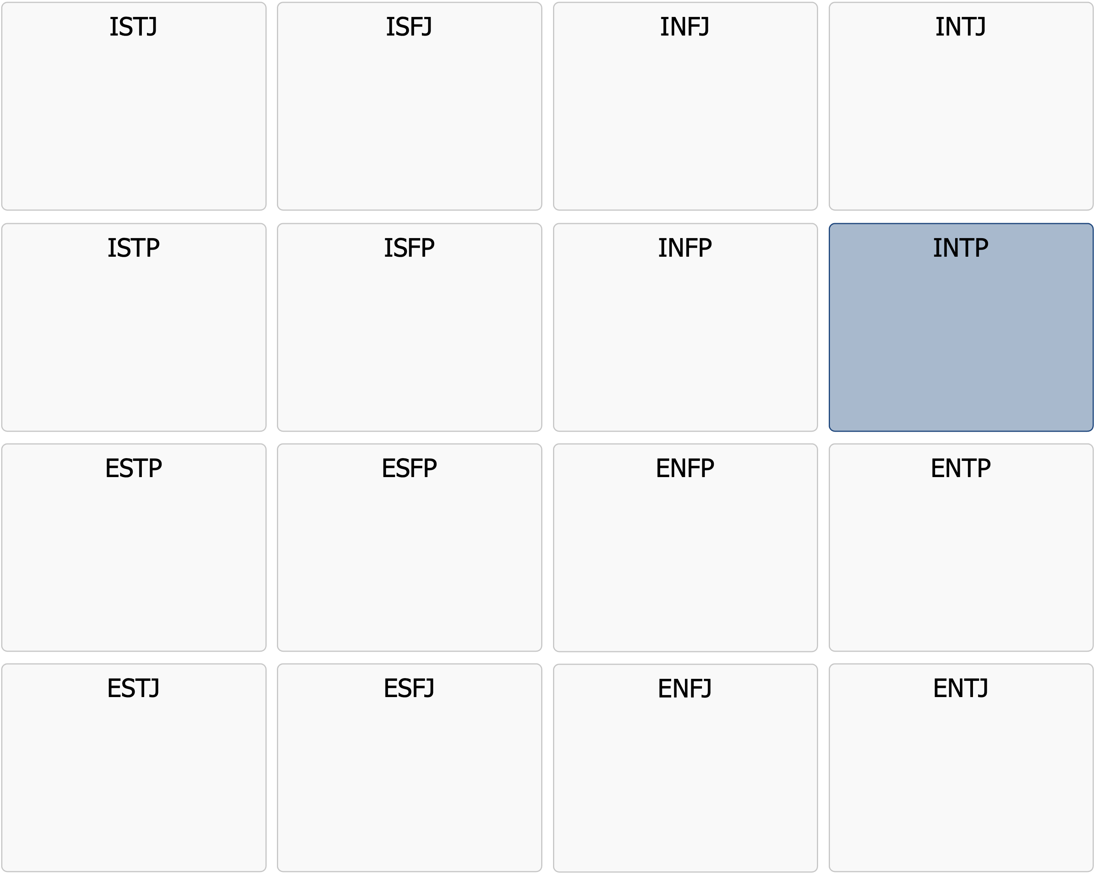

Profile Description

INTP

|  |
| --- |
| INTP  There is always a smarter solution – and I will find it |

Meeting an INTP is like encountering a person with a sharp, analytical mind and an almost inexhaustible curiosity about the world. They are natural philosophers and theorists, always engaged in exploring ideas, solving complex problems, and finding patterns in life. INTPs are deeply logical and value intellectual clarity above all else – they want to understand the world in depth, and they care more about finding the truth than following social conventions.  
  
The INTP personality is often immersed in their own thoughts. They question a lot and are constantly searching for new concepts, theories, and innovative solutions. They have an almost innate skepticism towards rules, traditions, and authorities – not because they want to rebel, but simply because they want to understand why things are the way they are. If something does not logically hold up, they will often question it, regardless of the reactions of those around them.  
  
Despite being introverted, INTPs can be passionate in discussions about topics they care about. They love deep conversations and theoretical reasoning, but they often struggle with small talk or social games. Their communication style can be direct and sometimes a bit distant, as they focus more on logic than emotions. They have an ability to break down complex ideas and see details that others miss, but they can also get stuck in their own reasoning and sometimes struggle to complete projects or translate their ideas into action.  
  
In the workplace, INTPs thrive in careers where they can work independently and solve intellectual problems. They can be brilliant researchers, programmers, analysts, engineers, or theorists – but they need an environment where they can think freely without too many structural constraints. They dislike monotonous tasks and strict hierarchies and perform best when given the freedom to explore their ideas in their own way.  
  
In relationships, INTPs can be both fascinating and difficult to understand. They are loyal and sincere but rarely express their emotions in a traditional way. Instead, they show their love through intellectual stimulation, shared interests, and a desire to discuss deep topics together. They may sometimes seem distant, but this is often because their thoughts are elsewhere – in a theory, a problem, or an idea they are trying to solve.  
  
In a world that often focuses on surface and speed, the INTP is the one who digs deeper. They seek understanding, question the obvious, and find new paths where others only see obstacles. They are the thinkers, the inventors, and the analytical geniuses who, even if they sometimes seem absent, are often light-years ahead of their time.

Below is a list of in-depth points that further describe the core personality you have likely had throughout your life. A tip is to print out the list and mark the points that you feel still apply to you today.

# Strenghts

* Logical and analytical – has a natural talent for solving complex problems
* Independent and self-reliant – thrives best when they can work alone
* Innovative and forward-thinking – sees connections and patterns that others miss
* Intellectually curious – has a strong drive to understand the world deeply
* Objective and factual – makes decisions based on logic rather than emotions
* Creative and full of ideas – enjoys exploring new concepts and theories
* Open to new perspectives – willing to reconsider their views when presented with new information
* Deep and reflective – often has insights that go far beyond the obvious

# Drivers and common motivations

* Understanding how things work at a fundamental level
* Thinking freely and creatively without limitations
* Solving problems and piecing together information into a bigger picture
* Working with intellectually stimulating topics
* Challenging established norms and finding new ways to view things
* Developing ideas without the immediate need to implement them
* Surrounding themselves with intelligent and interesting people
* Exploring philosophical, scientific, and abstract questions

# Communication style

* Intellectual and in-depth – prefers meaningful discussions over small talk
* Factual and objective – often expresses themselves in terms of logic and facts
* Enjoys discussing ideas rather than emotions and personal experiences
* Has a tendency to become long-winded and delve into complex details that others find difficult to follow
* Communicates in their own way without adjusting to others’ styles
* Often has a dry humor and a preference for sarcasm or wordplay
* Thinks in long chains of reasoning, which can make them seem to drift off in conversations

# Relationships

* Values independence and grants the same freedom to their loved ones
* May struggle to understand and handle strong emotions in others
* Prefers deep and intellectual conversations over superficial socializing
* Loyal and reliable when they commit to a relationship
* Has a tendency to live inside their own head
* Appreciates a partner who shares their intellectual curiosity
* May find it difficult to express emotions verbally but shows care through actions
* Needs a lot of alone time to recharge and think

# Work and career

* Thrives best in jobs where they can work independently and think creatively
* Prefers focusing on theory and analysis rather than practical application
* Often experts in their field with deep specialized knowledge
* Struggles in work environments with excessive bureaucracy and rules
* Performs best in roles where they can solve problems without too many restrictions
* Innovative and capable of contributing new, original ideas
* Has difficulty managing routine work and repetitive tasks
* Needs a work environment that allows them to think, experiment, and question

# Typical Role in a group

* Observant and analytical – prefers listening before contributing
* Dislikes social games and political maneuvering
* Often the one in the group who asks the questioning, critical questions that others haven’t considered
* May seem distant because they prefer thinking before speaking
* Brings innovative solutions and creative perspectives
* Sometimes struggles to collaborate with people who are overly emotional
* Enjoys discussing ideas but can become frustrated if the conversation is too shallow

# As a leader

* Strategic and analytical – prefers to have a well-thought-out plan before acting
* Allows their team members to work independently and trusts their competence
* Encourages new ways of thinking and intellectual exploration
* More focused on long-term vision than on details and daily routines
* May seem distant and not always provide emotional support to the team
* Has high standards for logic and quality in work
* Prefers to lead through ideas rather than traditional hierarchy
* Struggles to manage people who require constant guidance and validation

# Appreciated leadership style

* A manager who gives them freedom to think and work in their own way
* A work environment that encourages innovation and deep analysis
* The ability to focus on theoretical or strategic issues without being interrupted by administrative tasks
* A manager who understands their need for solitude and thinking time
* An organization that values intellectual insights and strategic thinking
* A leader who provides logical and objective feedback rather than emotionally charged criticism
* Clear goals but with flexibility in how to achieve them
* The opportunity to work with like-minded individuals who share their passion for knowledge
* Would often prefer to be their own boss rather than being led by others

# Areas for development – Which ones apply to you currently?

* Can be so absorbed in their thoughts that they forget practical details
* Sometimes struggles to handle emotional situations and understand others’ feelings
* May come across as critical and questioning in a way that seems arrogant
* Has a tendency to procrastinate because they prefer analyzing over taking action
* Can be so preoccupied with their own ideas that they miss social cues
* Needs to work on being more present and engaged in everyday interactions
* Struggles with working under strict leadership and needs to find ways to adapt

# Things to consider moving forward – How do they apply to you?

* Try to complete more projects rather than just focusing on idea development
* Work on better understanding and responding to others’ emotions
* Learn to handle practical details more effectively, even if they seem unimportant
* Practice expressing your thoughts more clearly and structured so others can follow
* Find a better balance between analysis and action – sometimes decisions must be made without complete information
* Work on being more present in social situations and actively listening
* Ensure that your creativity and intelligence are used in a way that leads to more practical results
* Embrace collaboration – sometimes others can contribute valuable perspectives that you may have missed