2025-03-10

Sören Lehmann

${Energy}

${Information}

${Decisions}

${Lifestyle}

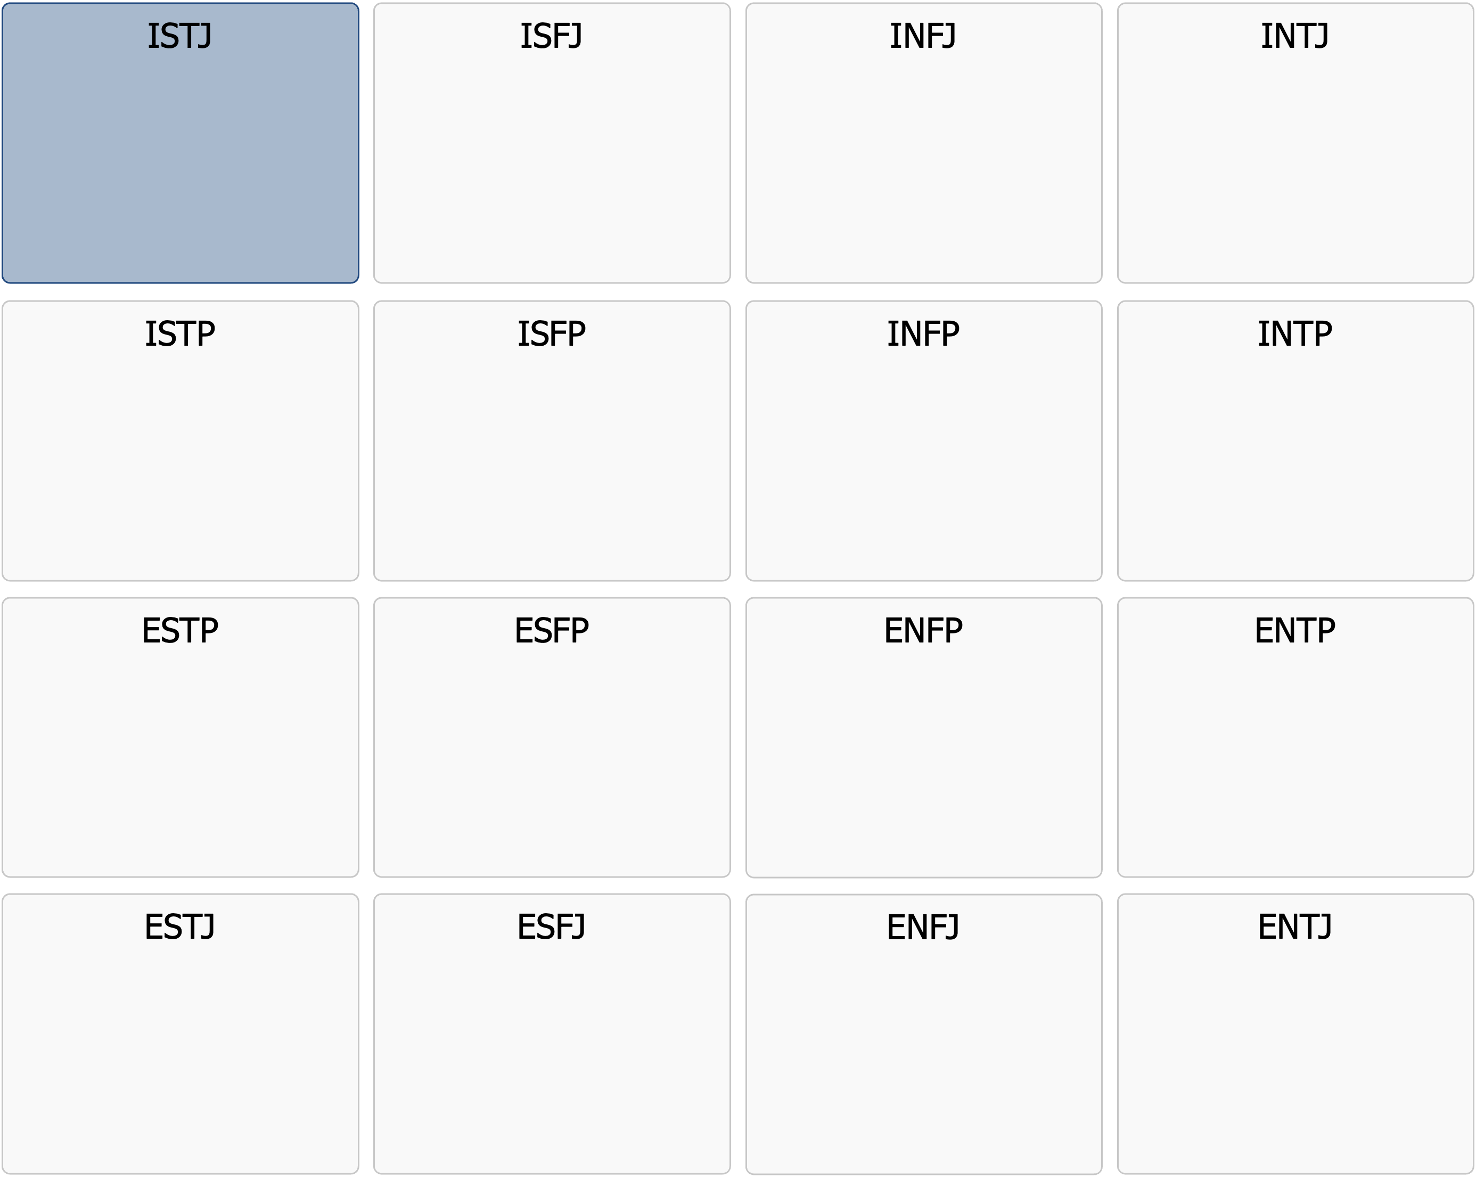

Profile Description

ISTJ

|  |
| --- |
| ISTJ  Order, responsibility, loyalty – this is how I do things right |

Meeting an ISTJ means encountering someone who takes responsibility very seriously. They are reliable, principled, and meticulous organizers who ensure that things get done – and done right.  
  
The ISTJ personality is driven by a strong sense of duty, order, and structure, with a natural talent for creating stability both at work and in personal life. They rarely speak unnecessarily or seek attention, but their work and dedication speak for themselves.  
  
ISTJs are extremely pragmatic and results-oriented. They trust facts, proven methods, and logical reasoning rather than emotions or speculation. For them, efficiency and clarity are crucial – they want to know exactly what is expected of them and deliver at the highest standard. They dislike carelessness, vague instructions, and unnecessary shortcuts, and they see no reason to question systems that already work well.  
  
At work, ISTJs are often the ones who keep everything on track. They ensure that projects and processes run smoothly. They may not be the most spontaneous, positive, or flexible individuals, but their perseverance and precision make them invaluable assets to any team. They are known for their strong work ethic and reliability, and they expect the same level of commitment from others.  
  
In relationships, ISTJs are loyal and stable, even though they are rarely expressive with their emotions. They show care through actions rather than words – taking responsibility, planning, and creating security for their loved ones. They are rarely spontaneous or adventurous partners, but they make up for it with loyalty, reliability, and a strong desire to protect and support those they care about.  
  
Despite their strengths, ISTJs may struggle with change and unexpected events. They thrive best in structured environments where they know what to expect and may feel uncomfortable in situations that require improvisation or thinking outside the box. They may also be perceived as rigid or overly critical when they see things being done inefficiently or in ways that deviate from their high standards.  
  
In a world where many chase quick fixes and constant changes, ISTJs are the stabilizing force that ensures everything functions smoothly. They are the ones who build foundations, uphold traditions, and maintain structure and order. They rarely receive the recognition they deserve, but without them, much would fall apart.

Below is a list of in-depth points that further describe the core personality you have likely had throughout your life. A tip is to print out the list and mark the points that you feel still apply to you today.

# Strenghts

* Responsible and dutiful – takes commitments very seriously
* Structured and organized – creates order out of chaos
* Meticulous and detail-oriented – ensures everything is done correctly
* Practical and realistic – focuses on what works in practice
* Independent and reliable – does not need constant supervision to perform well
* Loyal and principled – stands by their values and promises
* Logical and fact-based – rarely influenced by emotions in decision-making
* Persistent and disciplined – does not give up until the job is done
* Prefers proven methods over experiments and uncertain changes

# Drivers and common motivations

* Having clear rules and guidelines to follow
* Seeing concrete results from their work
* Maintaining stability and order, both at work and in personal life
* Efficiency – working methodically and seeing tasks completed
* Being able to work independently without unnecessary distractions
* Contributing to something greater through structure and reliability
* Having clear responsibilities and knowing what is expected of them
* Being part of a tradition or system that works well
* Receiving recognition for their accuracy, work ethic, and productivity

# Communication style

* Matter-of-fact and clear – says what needs to be said without exaggeration
* Prefers concise, concrete, and practical information over abstract discussions
* Communicates more through actions than words
* Rarely the most emotional speaker but always sincere
* Often quiet and struggles with unnecessary small talk and vague ideas
* Can come across as curt or strict in verbal communication
* Can be long-winded and detailed in written communication
* Short and to the point in email conversations
* Expects others to be as direct and honest as they are
* Prefers written communication where details and instructions can be documented

# Relationships

* Loyal and dedicated – a stable and reliable partner or friend
* Shows love and care through practical actions rather than words
* Expects mutual respect and responsibility in relationships
* Is rarely expressive with emotions but deeply cares for loved ones
* Struggles with spontaneity and unexpected changes in plans
* Values traditions and prefers building long-term relationships with a few close friends
* Gets frustrated with people who are overly emotional or irrational
* Needs time alone to recharge
* Generally has a low need for social activities after work

# Work and career

* Thrives in jobs with clear rules and structures
* Efficient and methodical – ensures tasks are completed correctly
* Follows instructions carefully and expects others to do the same
* Has a strong work ethic and sees work as an important part of life
* Rarely afraid of routine tasks – instead, they provide a sense of security
* Prefers working independently rather than in a group
* Struggles in workplaces with a lot of improvisation and change
* An excellent resource for tasks requiring precision and attention to detail

# Typical Role in a group

* Reliable and responsible – ensures things get done according to plan
* Often the one keeping the group organized and on track
* Prefers clear roles and hierarchies in group dynamics
* Contributes with calm, stability, and methodical work, even when others are stressed
* Struggles with people who are disorganized or undisciplined
* Rarely shares opinions unnecessarily but speaks up when needed
* Thrives in groups where everyone takes responsibility and does their part
* More skeptical and realistic than optimistic and naïve

# As a leader

* Leads through structure and clarity – ensures everyone knows what to do
* Focuses on maintaining stability and productivity
* Sets high standards for both themselves and their team regarding performance
* Often has a strong sense of fairness and ensures rules are followed
* More of an administrative and practical leader than a visionary inspirer
* Can be tough on people who do not meet expectations
* Struggles with inefficiency and has little tolerance for carelessness
* Leads by example, shows the way through their own work, and prefers staying in the background

# Appreciated leadership style

* A manager who is clear and structured but allows freedom with responsibility
* Clear expectations and a stable work environment
* A logical and fact-based work culture without excessive emotional influence
* A workplace where order and reliability are valued, with opportunities for independent work
* Clear routines and processes that remain consistent over time
* Feedback that is concrete and constructive, without excessive emotional weight
* A leader who values accuracy and stability over quick improvisation

# Areas for development – Which ones apply to you currently?

* Can be too rigid and unwilling to adapt to changes
* Sometimes struggles to express emotions, which can create distance in relationships
* May focus too much on rules and structure, missing opportunities for innovation
* Struggles with people who work more intuitively or spontaneously
* May seem overly critical of people who are less organized than themselves
* Sometimes needs to practice being more flexible in thinking and work methods
* Struggles to delegate as they trust their own precision more than others'

# Things to consider moving forward – How do they apply to you?

* Practice being more flexible and open to changes
* Learn to say yes more often than no
* Turn expressions like "it won’t work" into "let’s see how we can make it work"
* Show a more positive expression and demeanor instead of a critical one
* Try to listen more to others’ ideas even if they differ from your own
* Encourage others more often instead of rejecting their less thought-out proposals
* Work on expressing emotions and needs more clearly in relationships
* Be more aware that others work less structured than you – and that it can be okay
* Practice handling spontaneity and unforeseen situations more often without stress
* Give more appreciation to people for who they are, not just for their work results
* Try to let go of control sometimes and allow others to contribute in their own way