**Extraversion**

**Intuition**

**Feeling**

**Perception**

**Judging**

**Thinking**

**Sensing**

**Introversion**

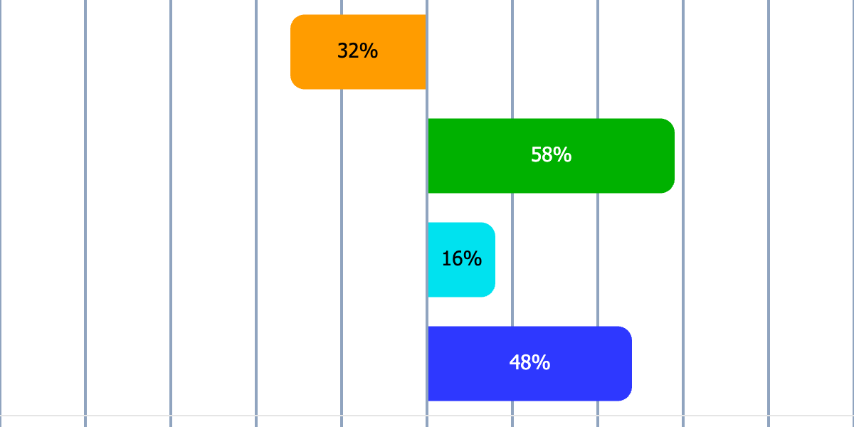

Sören Lehmann

${Energy}

${Information}

${Decisions}

${Lifestyle}

Short profile description

Your personality type is probably  
ISTJ

|  |
| --- |
| Order, responsibility, loyalty – this is how I do things right |

Med en stark känsla för ansvar och struktur är ISTJ ofta den person som ser till att allt blir gjort korrekt och i tid. De tenderar att vara metodiska, pålitliga och mycket principfasta, vilket gör dem till en stabil kraft i både arbetsliv och privatliv. ISTJ uppskattar tydliga regler och ramar, och deras förmåga att organisera och planera är ofta en stor tillgång för deras omgivning. Även om de kan uppfattas som reserverade eller försiktiga, drivs de av en önskan att skapa ordning och trygghet för sig själva och andra.

# Fundamental traits

* Organized and structured – have a natural ability to create order.
* Responsible – often takes great responsibility for their tasks and commitments.
* Practical and down-to-earth – prefer tangible results and realistic solutions.
* Meticulous and principled – sticks to their values and rules.
* Loyal and reliable – values their relationships and is often dependable.

# Work style and decision-making

* Prefer to work with clear goals and structured plans.
* Make decisions based on logic, experience, and facts.
* Focus on details and ensure that nothing falls through the cracks.
* Can be perceived as conservative in their approach, preferring tried-and-true methods.
* Less afraid to take on long-term and responsible tasks.

# Social relationships

* Reserved but loyal – prefers to build deep and reliable relationships.
* Can be perceived as withdrawn in social settings, especially in larger groups.
* Has a strong sense of right and wrong and appreciates people who share their values.
* Supportive and reliable in their relationships, but prefer to show care through actions rather than words.
* Thrive in relationships where structure and predictability are valued.

# Development areas

* Can be perceived as inflexible and unwilling to adapt to changes.
* Tend to focus so much on details that they sometimes miss the big picture.
* Can be perceived as critical or judgmental of people who do not follow rules or standards.
* Risk becoming overloaded if they take on too much responsibility.
* Needs to work on balancing their need for structure with openness to new ideas and changes.