Voyage

Interest Decision Engine – Software Design
Version: | 1.0
Status: | Draft
Release Date: | November 20, 2015

© 2015 Voyage, LLC. All rights reserved.
This document contains proprietary and confidential information of Voyage, LLC. That is protected from disclosure. If you are not an authorized recipient you are hereby notified that any dissemination, distribution, or copying of this communication is strictly prohibited. By accessing this information, you agree to keep this information confidential, and to only disclose it within your company to employees with a “need to know” who are instructed and agree not to disclose the information and not to use the information for any unauthorized purpose

Revision History

Name | Date | Reason For Changes | Version
Initial Draft | 9/1/2013 | Initial Document | 0.1
Design Draft | 9/9/2013 | Updated with class diagram and description of classes in diagram | 0.2
Revision 3 | 9/15/2013 | Updated class diagrams with service layer detail and overall class diagram | 0.3
Revision 4 | 9/21/2013 | Updated Factory class diagram to show decoupling of factory from service interfaces. Updated section 2.2 only. Both diagrams and all text altered. | 0.4
Revision 5 | 09/28/2013 | Updated overall class diagram including business layer. Built business class diagram and description section | 0.5
Revision 6 | 10/5/2013 | Updated overall class diagram including presentation layer. Built presentation layer class diagram and description section. Updated use cases with application and release creation cases as they are have been realized to be the highest priority. | 0.6
Revision 7 | 10/13/2013 | Updated overall class diagram including presentation layer diagram. Updated presentation layer detail to include MainJFrame definition describing parent window functionality and moving CreateJFrame classes into child windows. | 0.7
Draft 1.0 | 10/20/2013 | Final Release of doc in draft form. No changes since 0.7 | 1.0
1.01 | 11/02/2013 | Updated Service Layer to support collections for Application and Releases in HashTables | 1.01
1.02 | 11/9/2013 | Added DAO information about release and application svc implementation updates | 1.02
1.03 | 11/17/2013 | Added Hibernate class definitions to service layer diagram and detail | 1.03
1.04 | 11/24/2013 | Updated Factory to utilize SAXPropertyManager. Updated Service layer with SAXPropertyManager, Diagram and Factory info. Created Configuration section to detail applicationproperties xml and xsd and created diagram | 1.04
1.05 | 11/28/2013 | Added user login use case | 1.05
1.06 | 12/7/2013 | Updated InterestDecisionEngineServer.java in business layer to support multi-threading | 1.06
1.07 | 1/14/2014 | Updated section 4 Use Case Diagram. Updated Use cases 1001, 1002, and 1003 which are the top three use cases | 1.07
1.08 | 1/19/2014 | Created section 4 which describes the implementation of the web client architecture | 1.08
1.09 | 1/24/2014 | Updated section 4 diagram, and added detail for new classes | 1.08
1.10 | 2/2/2014 | Updated section 4 diagram and test to show JSP implementation and NOT Servlets. Current 674 Assignment asked to create services layer. For now it utilizes Hibernate and a Factory service method. Need to resolve Spring/Eclipse issue and then Spring will take over instead of Factory | 1.10

1. Overview 2
2. Class Diagram – Metadata Management 4
3. InterestDecisionEngine Client – Stub Implementation 6
4. InterestDecisionEngine Web Presentation Layer 7
5. Use Case Diagram 9
6. Use Case 1001a (Brief) – Create Application Metadata 10
7. Use Case 1001b (Fully Dressed)– Create Application Metadata 10
8. Use Case 1002a (Casual) – Create Release Metadata 13
9. Use Case 1002b (Fully Dressed) – Create Release Metadata 13
10. Use Case 1003 – Retrieve/Update Application Metadata 16
11. Use Case 1004 – Delete Application (Needs Dev – NOT complete!) 19
12. Use Case 1005 – Report – Application and Metadata History (Needs Dev – NOT complete!) 22
13. Use Case 1006 – User Login 24
14. Configuration 26

Overview

Summary
Voyage is an advertising technology company dedicated to providing software and services to national television programming networks. The company’s focus is providing product solutions that service a national delivery across multichannel video program distributors’ (MVPD) delivery platforms. Currently, the company focuses on one line of business, traditional cable Video On Demand Dynamic Ad Insertion. The company’s strength is in its ability to dynamically advertise across a national footprint constituting multiple MVPDs today on traditional television on-demand opportunities to future opportunities available on next generation IP platforms. Voyage was founded by Comcast, Cox, Time Warner Cable, and Brighthouse Networks and has offices in Denver, CO and New York City.

The Voyage solution will be composed of a software solution that will act as a repository for storage of a common library of embedded software applications that can be tested for specification compliance and distributed to development and distribution groups. A software vendor can retrieve a particular bundled software distribution and publish updates to that software distribution that the InterestDecisionEngine system will then test for specification compliance and then offer to hardware vendors for retrieval. There will be MVPDs and other groups that will retrieve the software for either updates or testing within their environments and they will follow the same process described here.

Project Description: InterestDecisionEngine
The consumer demand for a consistent method and user interface for accessing content is growing. As the Comcast CEO Brian Roberts recently noted in his industry keynote speech (NCTA 6/3/2013), consumers have multiple devices now and their demand for a single interface across those devices is growing. The industry is responding with a solution known as the Reference Design Kit (rdkcentral.com) which allows software vendors to build applications faster through a standards based software stack that is pre-integrated by hardware vendors onto consumer premise equipment devices (ex. Set top boxes). What this consortium does not have is a method for collectively building the software stacks, testing them, and then distributing them to hardware vendors or MVPDs that will want to test the software/hardware in their own environments.

The InterestDecisionEngine solution intends to offer the solution to this problem space and provide a software solution that allows software vendors to retrieve the design kit instances, make updates to them, and publish them to the InterestDecisionEngine system. The InterestDecisionEngine system will then in turn be able to test the design kit being published and identify it as a candidate for standardization and broad distribution. The use cases defined in this document are focused on the application management component of the InterestDecisionEngine system.

Use Case Priority
Priority | Description
1 | Create Application(s) Metadata
2 | Create Release Metadata
3 | Retrieve/Update Application Metadata
4 | Delete Application and Metadata
5 | Report – Application and Metadata History
6 | User Login

Class Diagram – Metadata Management
In the domain layer there are three main classes that are the nouns. Those three classes are the application class, hardware class, and release class and they hold unique information about an application that is received from a vendor. Because hardware and release information may be common among applications, this metadata has been normalized into separate classes. The Application class will contain unique information for a particular application. The MetadataComposite class is meant to combine the metadata from the Application, Hardware, and Release classes and will be used by the services layer when implemented.

Domain classes
The following domain classes have been identified:
- Release – Includes all information related to a particular release of the product
- Application – Includes all information related to a particular application
- Hardware – Includes all information related to a particular hardware platform
- User – Includes all information related to a particular user configured on the system
Figure 1 Domain Class Diagram
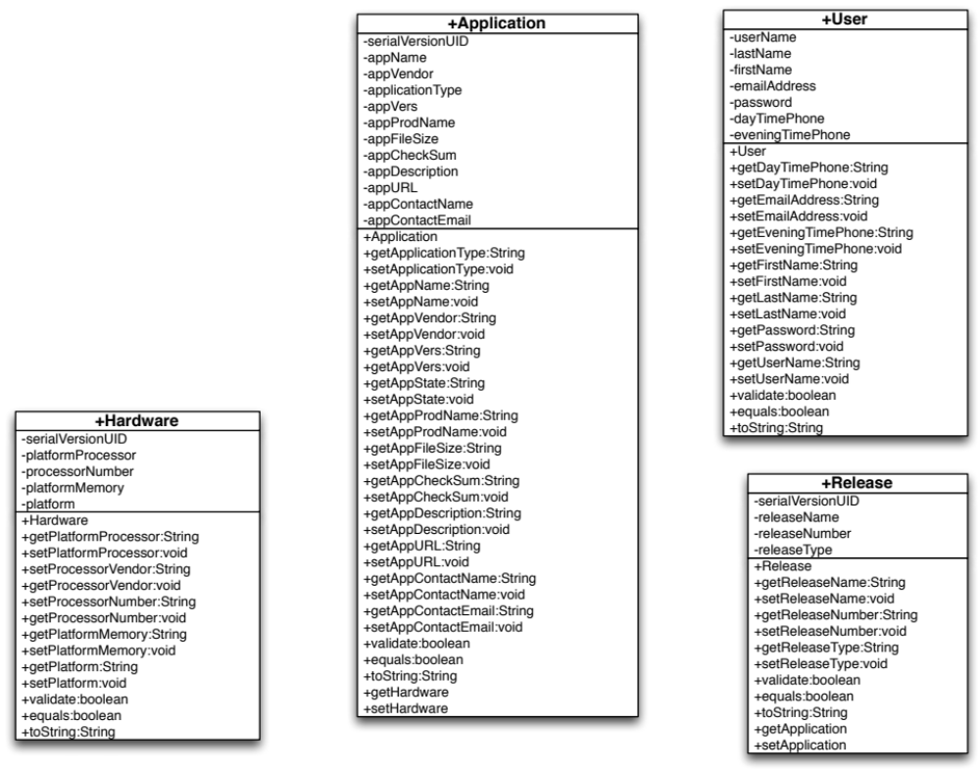

Service classes
The following service interfaces and classes have been identified:
- IApplicationSvc: Interface responsible for persisting application and hardware information. Extends IService. Has a string NAME value that the Factory uses to call it. Updated class reference with Set<Application> to support generics.
- IReleaseSvc: Interface responsible for persisting release information. Extends IService. Has a string NAME value that the Factory uses to call it.
- ILoginService: Interface responsible for acquiring login information. Extends IService. Has a string NAME value that the Factory uses to call it.
- ApplicationSvcJDBCImpl: concrete implementation of IApplicationSvc. Implemented HashSet on getApplication method to work with JDBC later. Updated setApplication methods to use jdbc calls to database to insert new application records from GUI
- ApplicationSvcHibernateImpl: Concrete implementation of IApplicationSvc. Implemented to leverage Hibernate to store Application domain objects to database through GUI. Uses HibernateFactory to get Hiberate session established.
- ReleaseSvcJDBCImpl: concrete implementation of IReleaseSvc. Updated setRelease methods to use jdbc calls to database to insert new application records from GUI
- ReleaseSvcHibernateImpl: Concrete implementation of IReleaseSvc. Implemented to leverage Hibernate to store Release domain objects to database through GUI. Uses HibernateFactory to get Hiberate session established.
- ILoginSvcHibernateImpl: Concrete implementation of ILoginService. Implemented to leverage Hibernate to retrieve User domain objects from the database. Uses Hibernate Factory to get Hibernate session established.
- IService: Marker interface that the factory uses to access all services
- Factory: Implements a singleton creation idiom. Has a getService method that’s return type is casted to IService. getService calls another method which reads in the java.util.properties file to for the Factory to use to call the correct implementation. Updated getimpl to now utilize the SAXPropertyManager for retrieval of application properties through the SAX xml parser. Configuration information is included later in the document related to the application properties.
- HibernateFactory: Creates Hibernate session for concrete implementations.
- SAXPropertyManager: Used to retrieve, parse, and store application configuration information included in the configuration section of this document. The property manager uses the SAX xml parser included within the class to manage the import of the xml data.

Figure 2 Service Class Diagram
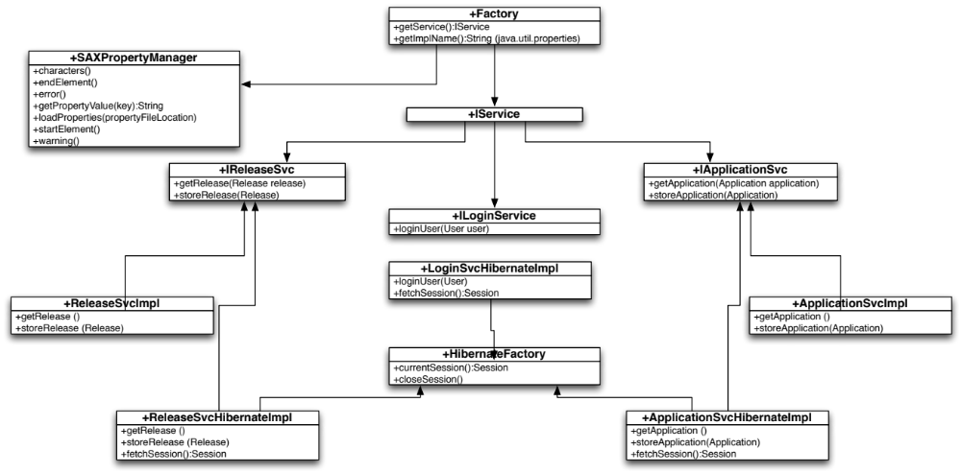

Business Classes
The following service interfaces and classes have been identified:
- ManagerSuperType: Abstract manager class that uses a Layer Supertype pattern. This has the static method to pull in the services.properties file. Also has set and get metadata methods to model the first and second use cases. The load properties method pulls in the properties file
- MetadataManager: Concrete class that extends ManagerSuperType. Singleton method is used to assure only one manager is started at a time. Two set and get selection methods are used to handle later use cases where if/then logic will be built to handle release and hardware set and get methods. Only two other methods for set and get of application data are present.
- ServiceLoadException: exception class when services cannot be loaded
- PropertyFileNotFoundException: exception class for handling errors when property file cannot be loaded
- InterestDecisionEngineServer: Used to start a server service on the InterestDecisionEngine Server. Uses the InterestDecisionEngineServerHandler for details of the implementation to properly decouple implementation details. Implemented threading to handle multiple server connections.
- InterestDecisionEngineServerHandler: Implementation details of the server implementation. Used by InterestDecisionEngineServer
Figure 3 Business Class Diagram
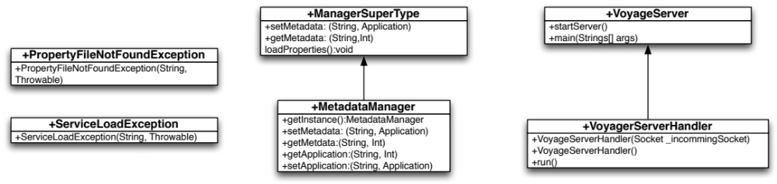

Presentation Classes
The following service interfaces and classes have been identified:
- ApplicationCreateJFrame: Concrete class that is the “GUI” that the user interacts with. initComponents is the method that builds the graphical user interface design. getSelectedData captures the application object information from the GUI. The Button methods get the private objects to support encapsulation. The class was changed to be extended by the JInternalFrame superclass to be opened by MainJFrame GUI and not independently.
- ApplicationCreateJFrameController: Concrete class that handles controller functions for the presentation layer. actionPerformed is the listener method to catch action requests from the gui. Exit, reset, and add have the detail of what to do when the actionPerformed method catches the request from the GUI.
- ReleaseCreateJFrame: Concrete class that is the “GUI” that the user interacts with for the second use case. initComponents is the method that builds the graphical user interface. getSelectedData captures the release object information from the GUI. The Button methods get the private objects to support encapsulation. The class was changed to be extended by JInternalFrame to be opened by the MainJFrame GUI and not independently.
- ReleaseCreateJFrameController: Concrete class that handles the controller functions for the presentation layer of the ReleaseCreateJFrame class. actionPerformed is the listener method to catch action requests from the gui. Exit, reset, and add have the detail of what to do when the actionPerformed method catches the request from the GUI.
- MainJFrame: Concrete class that is the main window GUI that users interact with that extends JFrame. The CreateJFrame classes above are run within this window after menu items are selected and actionlisteners catch the user request and runs the CreateJFrame classes above. initComponents builds the actual layout of the GUI including the menu bar, menu items, and actionlistener.
Figure 4 Presentation Class Diagram
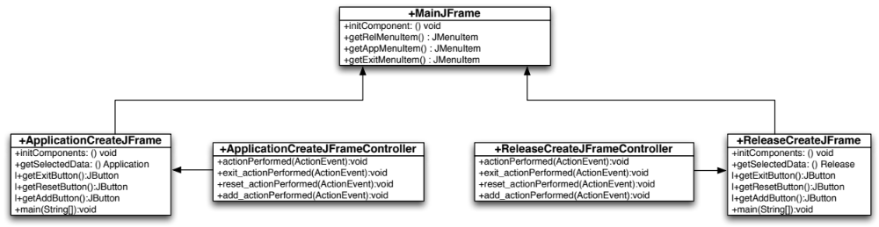

Figure 5 Complete Class Diagram
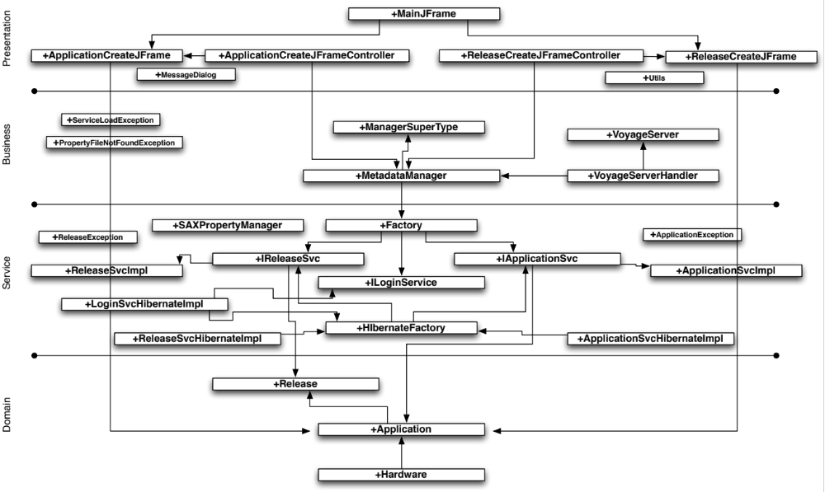

InterestDecisionEngine Client – Stub Implementation

The InterestDecisionEngine Client application was built to handle the testing of the InterestDecisionEngineServer implementation and support of decoupling of login testing to a remote client based application. The application is not meant to be a permanent part of the InterestDecisionEngine solution and is only defined here for ease of understanding the software design and implementation.

The following service interfaces and classes have been identified:
- ViewDriver: Contains a main method and is used to start the execution of the client application
- LoginUserJFrame: Concrete class that is the “GUI” that the user interacts with. initComponents is the method that builds the graphical user interface design. getSelectedData captures the application object information from the GUI. The Button methods get the private objects to support encapsulation. The class was changed to be extended by the JFrame superclass to be opened by ViewDriver class.
- LoginUserJFrameController: Concrete class that handles controller functions for the presentation layer. actionPerformed is the listener method to catch action requests from the gui. Exit, reset, and add have the detail of what to do when the actionPerformed method catches the request from the GUI.
- InterestDecisionEngineController: is a business layer (Controller) class that handles the connection to the InterestDecisionEngine Server
- InterceptingController: Is the decoupling of implementation logic from the InterestDecisionEngineController that has the definition information to make the connection to the InterestDecisionEngine Server
- User: domain object included as it is the definition of the information to send to the InterestDecisionEngine Server for User Id and Password information for the server to verify
Figure 6 InterestDecisionEngine Client All Classes Diagram
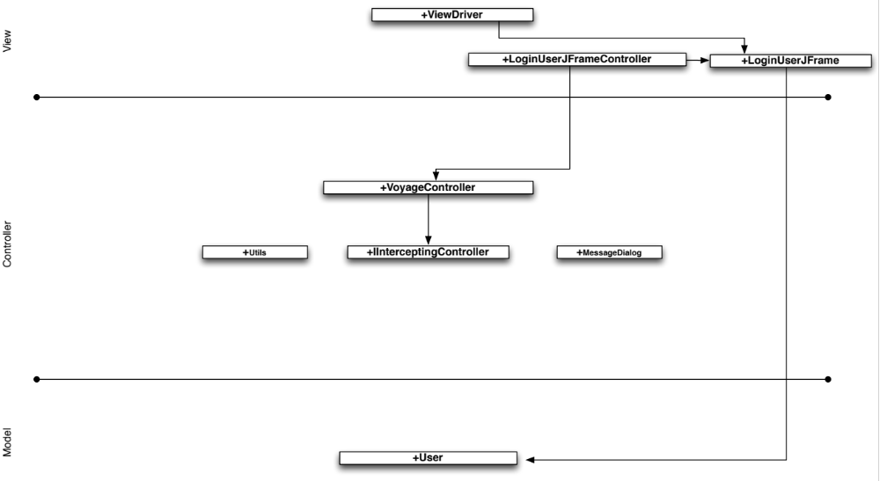

InterestDecisionEngine Web Presentation Layer

The InterestDecisionEngine Web Client implementation was built to extend the user interface to a more user accessible interface. The implementation leverages servlets currently and will be extended to JSPs eventually.

The following service interfaces and classes have been identified:
- login.html: User form to log into the system. Uses LoginController.java servlet. Use Case #1006
- LoginController.java: Servlet that is used by login.html to catch user input and then requests the business layer LoginManager.java to create a user object and verify. Calls either LoginView.jsp or LoginError.jsp based on authentication feedback from LoginManager.java
- LoginView.jsp: If login is valid, the user object is passed to the LoginView.jsp and response sent to the web client. The page has the option to create an application
- LoginError.jsp: If login is invalid, the user object is passed to the LoginError.jsp and response sent to the web client. The web page has the option to log in again.
- InterestDecisionEngineapp.html: User form to CREATE application metadata within the InterestDecisionEngine system. Use Case #1001
- AppController.java: Servlet that is used by InterestDecisionEngineapp.html to catch user input and then calls the business layer AppManager.java to create an application object and verify. Calls either AppView.jsp or AppError.jsp based on authentication feedback from AppManager.java
- AppView.jsp: If application is valid, the application object is passed to the AppView.jsp and response sent to the web client. The client has the option to create another application.
- AppError.jsp: If application is invalid, the application object is passed to the AppError.jsp servlet and response sent to the web client and the client has an option to create another application.
- web.xml: maps HTML POST message calls to servlets above and is used by Tomcat application server. Updated to point to JSPs
Figure 7 InterestDecisionEngine Web Presentation Layer
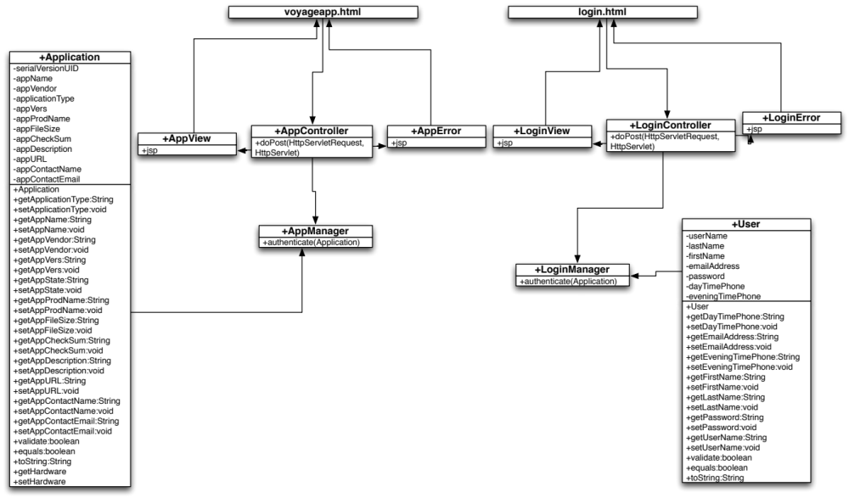

Use Case Diagram

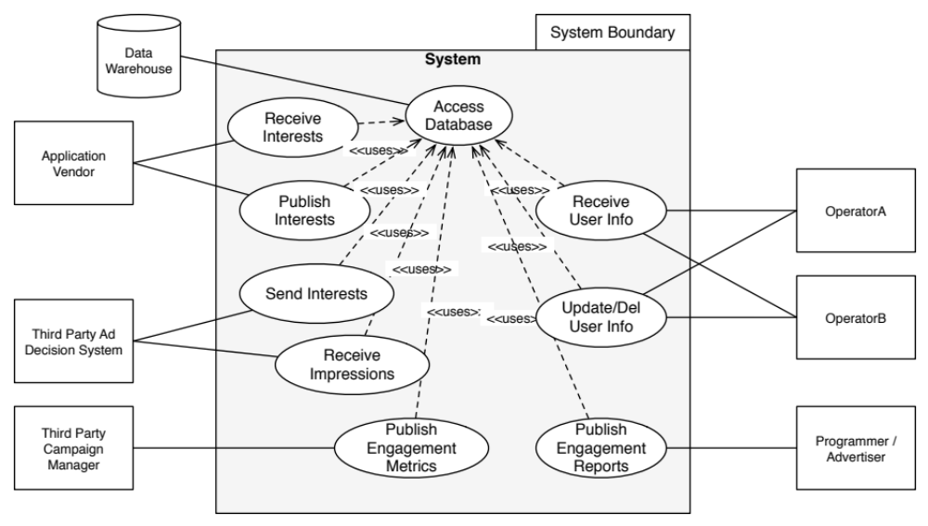

Use Case List

- IDEA receives subscriber information (Including Pinterest UID and PWD)
- IDEA stores subscriber (Including Pinterest UID and PWD) data to data base
- IDEA retrieves Pinterest UID and PWD from database
- IDEA retrieves subscriber interests from Pinterest
- IDEA stores Pinterest interests in data base
- IDEA retrieves Pinterest Interest, Ad Impression, and Ad Demo data for individual user
- IDEA analyzes interests, viewing data, and demographics and creates an Ad Interest file (Patent)
- IDEA generates Ad Interest result for user and stores in database
- IDEA retrieves all Ad Interest results for all users from database
- IDEA sends Ad Interest results to external Ad Decision System
- IDEA retrieves Ad Impression data for a user over time as well as Pinterest Interest data and Ad Interest data for a single user
- IDEA calculates engagement based on Interest and viewed Ad Impressions (Patent)
- IDEA generates Attribution report for all users in scope
- IDEA sends Attribution report to receiver(s)

Database Access – User Data Storage - UC1001

Summary
Provide the system with the ability to store operator UID as well as Pinterest UID and PWD.

Sequence Diagram
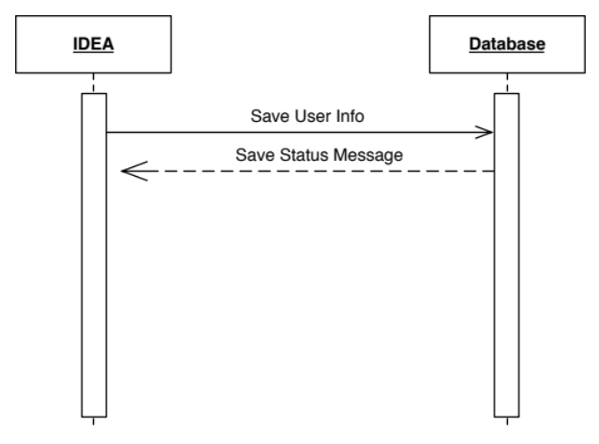

Use Case History

Created By
Jason Canney

Date Created
July 27, 2015

Last Updated By
Jason Canney

Date Last Updated
July 27, 2015

Use Case Definition

Actor
The primary actor in this use case is the Receive User Info use case that will initiate this use case to store data to the Interest Decision Engine’s database

Description
This use case provides the ability to user add application metadata to the InterestDecisionEngine system.

Preconditions
List any activities that must take place, or any conditions that must be true, before the use case can be started. Number each precondition. Examples:
- All business agreements are in place between a software vendor and InterestDecisionEngine business owners to allow for publication of applications to the system.

Postconditions
- None

Priority
The application metadata creation functionality is a core function of this component of the system and therefore it needs high priority.

Frequency of Use
This use case will be used frequently as it is a core function of the InterestDecisionEngine Application Management component.

Normal Course of Events
The following is a set of steps that the use case will use to execute
- The user executes the InterestDecisionEngine Application Management application.
- The user enters all metadata for an application in the InterestDecisionEngine interface.
- The InterestDecisionEngine system stores all application metadata in a local file. Todo: Currently based on file system storage. Later upgrade to database storage.
- The user is presented with a confirmation message that the application metadata was stored successfully.

Alternative Courses
The default course for this is the assumption that a user will be creating an application metadata definition. An alternate path is that a user enters incorrect data and an error is sent to the user.

Exceptions
If at any point during the use case the system runs into errors it will try to resolve them and make notes in a history file for future analysis

Includes
None

Special Requirements
None

Assumptions
None

Notes and Issues
None

Use Case 1002a (Casual) – Create Release Metadata

Main Success Scenario
Provide user with the ability to create all available release metadata within the system including the release identifiers that are related to the metadata. The user interface will display a set of fields for the user to enter release metadata and then submit to the InterestDecisionEngine system. The InterestDecisionEngine system will take the metadata and persist that data to the InterestDecisionEngine database. The InterestDecisionEngine system will then display a success message.
Alternate Scenarios (extensions)
Invalid Metadata – If the user enters invalid data within the user interface, upon submission to the database and database failure, the user interface will display a failure notice to the user

Use Case 1002b (Fully Dressed) – Create Release Metadata

Summary
Provide user with the ability to create all available Release metadata within the system including the application identifiers that are related to the metadata.

Sequence Diagram
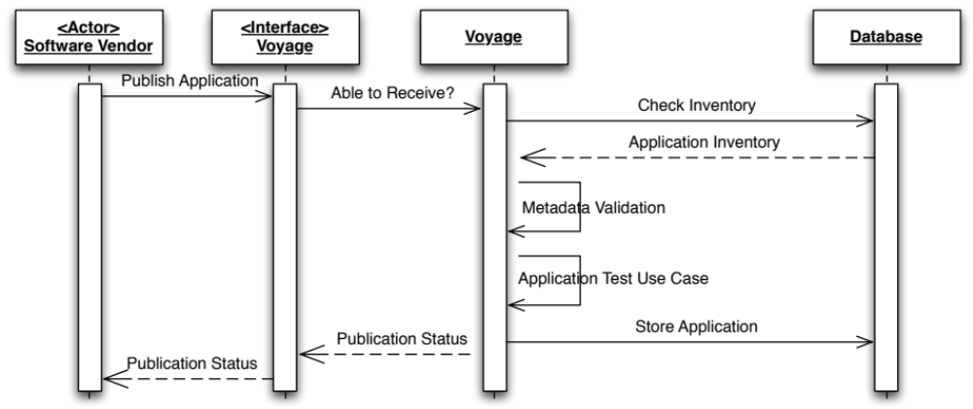

Use Case History

Created By
Jason Canney

Date Created
September 1, 2013

Last Updated By
Jason Canney

Date Last Updated
January 11, 2014

Use Case Definition

Actor
The primary actors in this use case are users of the system that will initiate the InterestDecisionEngine application and allow the user to create application metadata.

Description
This use case provides the ability to user add release metadata to the InterestDecisionEngine system.

Preconditions
List any activities that must take place, or any conditions that must be true, before the use case can be started. Number each precondition. Examples:
- All business agreements are in place between a software vendor and InterestDecisionEngine business owners to allow for publication of releases to the system.

Postconditions
- None

Priority
The release metadata creation functionality is a core function of this component of the system and therefore it needs high priority.

Frequency of Use
This use case will be used frequently as it is a core function of the InterestDecisionEngine Release Management component.

Normal Course of Events
The following is a set of steps that the use case will use to execute
- The user executes the InterestDecisionEngine Release Management application.
- The user enters all metadata for a release in the InterestDecisionEngine interface.
- The InterestDecisionEngine system stores all release metadata in a local file. Todo: Currently based on file system storage. Later upgrade to database storage.
- The user is presented with a confirmation message that the release metadata was stored successfully.

Alternative Courses
The default course for this is the assumption that a user will be creating an release metadata definition. An alternate path is that a user enters incorrect data and an error is sent to the user.

Exceptions
If at any point during the use case the system runs into errors it will try to resolve them and make notes in a history file for future analysis

Includes
None

Special Requirements
None

Assumptions
None

Notes and Issues
None

Use Case 1003 – Retrieve/Update Application Metadata

Summary
Provide user with the ability to retrieve and update existing application metadata within the InterestDecisionEngine system.

Sequence Diagram
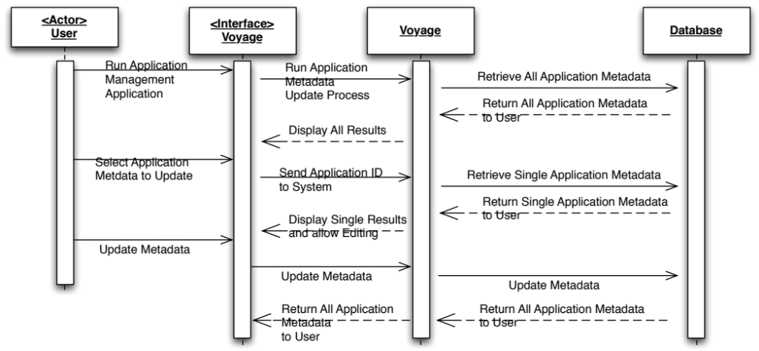

Use Case History

Created By
Jason Canney

Date Created
September 1, 2013

Last Updated By
Jason Canney

Date Last Updated
January 11, 2014

Use Case Definition

Actor
The primary actors in this use case are users of the system that will initiate the InterestDecisionEngine application and trigger the query of the application metadata repository and make updates to a single applications metadata.

Description
This use case provides the ability for a user to display the applications and metadata available in the InterestDecisionEngine system, select an application to update its metadata and then save those changes to the database.

Preconditions
List any activities that must take place, or any conditions that must be true, before the use case can be started. Number each precondition. Examples:
- All business agreements are in place between a software vendor and InterestDecisionEngine business owners to allow for publication of applications to the system.

Postconditions
- None

Priority
The use case is medium priority.

Frequency of Use
This use case will be used whenever application metadata needs to be updated

Normal Course of Events
The following is a set of steps that the use case will use to execute
- The user executes the InterestDecisionEngine Application Management application.
- The user selects the option to update metadata for an application in the InterestDecisionEngine system.
- The InterestDecisionEngine system queries the file system for all application metadata present and returns that metdata to the presentation engine for display to the user. Todo: Currently based on file system storage. Later upgrade to database storage.
- The user is presented with a display of all the application metadata within the system and can select the ID of an application to update.
- Upon selection, the panel displaying all results closes.
- The system sends that ID to the database to query just those results
- The results are displayed to the user in an editable window
- When the user updates the information and clicks Save, the updated information is sent to the database
- Once successful, the panel displays a “save successful” message

Alternative Courses
The default course for this is the assumption that a customer will be searching. An alternate path is that an employee logs into the system and has broader search criteria to enter and broader results displayed.
- If there are no applications and no application metadata to display, display no results found.
- If upon saving the metadata there was a problem, display a fail message on the existing panel.

Exceptions
If at any point during the use case the system runs into errors it will try to resolve them and make notes in a history file for future analysis

Includes
N/A

Special Requirements
None

Assumptions
None

Notes and Issues
None.

Use Case 1004 – Delete Application (Needs Dev – NOT complete!)

Summary
Provide InterestDecisionEngine with the ability to publish applications to operator enterprise software solution, have it be accepted or rejected and then provide confirmation of receipt back to the InterestDecisionEngine.

Sequence Diagram
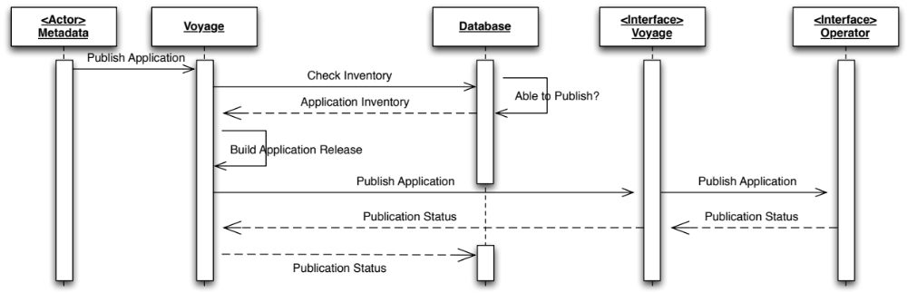

Use Case History

Created By
Jason Canney

Date Created
July 27, 2013

Last Updated By
Jason Canney

Date Last Updated
July 27, 2013

Use Case Definition

Actor
The primary actor in this use case is the metadata that is used to trigger the use case. Once an application is validated upon receipt, metadata received with the application contains a publication date and operators to publish to. This InterestDecisionEngine system knows of these dates and operators and this use case executes on those dates.

Preconditions
List any activities that must take place, or any conditions that must be true, before the use case can be started. Number each precondition. Examples:
- All business agreements are in place between a software vendor and InterestDecisionEngine business owners to allow for publication of applications to happen.
- Software vendor applications have already been built to an agreed upon format and specification by both the vendor and InterestDecisionEngine business owners
- Software interface has been built by both the software vendor that will allow for publication of applications using a InterestDecisionEngine defined interface and transport specification
- InterestDecisionEngine has implemented an interface and transport method based on a defined set of specifications that are published to a participating software vendor
- Software applications received by vendors have successfully passed testing by the application validation use case
- Metadata is stored in the InterestDecisionEngine database that contains dates and operators to publish to

Postconditions
- None

Priority
The application publication functionality is a core function of the system and therefore it needs high priority.

Frequency of Use
This use case will be used frequently as it is a core function of the InterestDecisionEngine product.

Normal Course of Events
The following is a set of steps that the use case will use to execute
- Upon completion of the Application Validation use case, the InterestDecisionEngine system has knowledge of a date and operator(s) that the application(s) should be published through metadata that is provided with the applications upon receipt from the software vendors
- The software checks the database for application availability
- If available, the database responds to the software that the application(s) is able to be published, if not, the database responds with a failure message
- The InterestDecisionEngine system builds the release to be published to the operators, including applications as well as metadata about the applications, where they originated from, and which platforms they are to be distributed to
- The InterestDecisionEngine system sends the release bundle to the InterestDecisionEngine publisher interface
- The InterestDecisionEngine publisher knows how to communicate with the operator(s) and sends the application release bundle
- The operator systems respond back with success or failure notification.
- The InterestDecisionEngine publisher sends that message to the InterestDecisionEngine subsystem
- The InterestDecisionEngine sub system stores the success/failure information in the InterestDecisionEngine database

Alternative Courses
- None.

Exceptions
If at any point during the use case the system runs into errors it will try to resolve them and make notes in a history database for future analysis

Includes
None.

Special Requirements
The entire use case steps should be complete within three minutes unless otherwise noted and agreed to in an SLA by operator(s) and the InterestDecisionEngine business team.

Assumptions
None

Notes and Issues
None.

Use Case 1005 – Report – Application and Metadata History (Needs Dev – NOT complete!)

Summary
Provide InterestDecisionEngine system with a method for anonymizing data that is received from an operator and is never passed to a software vendor.

Sequence Diagram
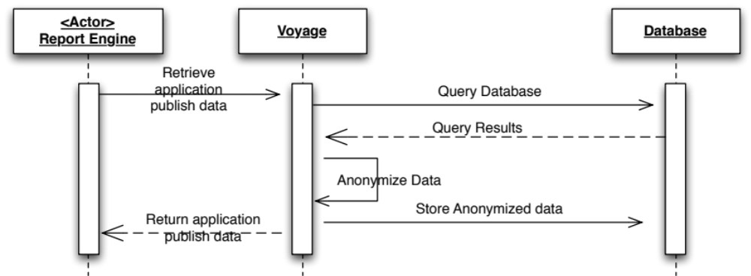

Use Case History

Created By
Jason Canney

Date Created
July 26, 2013

Last Updated By
Jason Canney

Date Last Updated
July 26, 2013

Use Case Definition

Actor
The primary actor in this use case is the Reporting Engine.

Preconditions
List any activities that must take place, or any conditions that must be true, before the use case can be started. Number each precondition. Examples:
- The use case will be run by the InterestDecisionEngine system so all pre-conditions required to be met by an use case that is executing this use case need to be met.

Postconditions
- None

Priority
The use case is medium priority as it is used by other medium priority use cases within their use case execution

Frequency of Use
This use case will be used extensively by other medium priority use cases

Normal Course of Events
The following is a set of steps that the use case will use to execute
- The Reporting Engine requests application publication data from the InterestDecisionEngine subsystem
- The InterestDecisionEngine system queries the database for application data based on the reporting engines request for a specific software vendor or all
- The database responds with results
- The InterestDecisionEngine system removes any operator specific data
- The InterestDecisionEngine system stores the new data as additional metadata for successive reports for this query
- The InterestDecisionEngine system returns the anonymized results to the reporting engine

Alternative Courses
- None

Exceptions
None

Includes
N/A

Special Requirements
None

Assumptions
None

Notes and Issues
None.

Use Case 1006 – User Login

Summary
Provide user with the ability to Log into the system via a client application. The InterestDecisionEngine Server will accept the connection from the client application, receive user id and password information, and respond back to the user with success or failure upon checking the InterestDecisionEngine user database.

Sequence Diagram
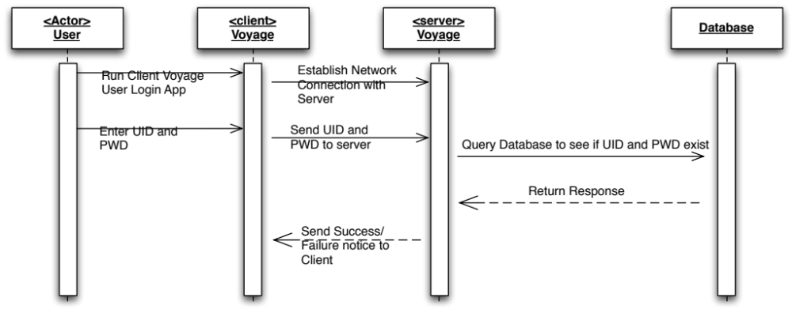

Use Case History

Created By
Jason Canney

Date Created
November 28, 2013

Last Updated By
Jason Canney

Date Last Updated
November 28, 2013

Use Case Definition

Actor
The primary actors in this use case are users of the system that will initiate the InterestDecisionEngine CLIENT application and allow the user to log into the system.

Description
This use case provides the ability to user log into the system

Preconditions
List any activities that must take place, or any conditions that must be true, before the use case can be started. Number each precondition. Examples:
- All business agreements are in place between a software vendor and InterestDecisionEngine business owners to allow for publication of applications to the system.
- User Identifier and password needs to be setup within the system database

Postconditions
- None

Priority
The ability to log into the system is a medium priority.

Frequency of Use
This use case will be used frequently once implemented, but is not required for initial setup and testing when use will be none.

Normal Course of Events
The following is a set of steps that the use case will use to execute
- The user executes the InterestDecisionEngine CLIENT application on their local machine
- The InterestDecisionEngine CLIENT application establishes a network connection with the InterestDecisionEngine SERVER
- The user enters user identification and password information
- The InterestDecisionEngine CLIENT application sends the UID and PWD information to the InterestDecisionEngine SERVER
- The InterestDecisionEngine SERVER receives the UID and PWD and checks the database to see if the information matches an already existing UID and PWD
- The InterestDecisionEngine SERVER responds back to the CLIENT application with success or failure message

Alternative Courses
If errors are encountered along the way, they are thrown and the application catches and fails gracefully with appropriate logging

Exceptions
If at any point during the use case the system runs into errors it will try to resolve them and make notes in a history file for future analysis

Includes
None

Special Requirements
None

Assumptions
None

Notes and Issues
None

Configuration

Summary
This section describes the configuration related components of the software system and any necessary supporting information about data required for configuration.

Application Properties
The sub-system requires properties to be set for the application and to support an appropriate level of maintainability the database configuration and access information as well as application service information are stored in the application properties xml file. The use of xml standardizes the information storage and also allows for extensibility and reusability. The application.properties.xml file is accompanied by an schema file titled applicationproperties.xsd. The sub-system uses a SAX property manager to pull in the properties file and use the database and services information as needed.

Schema Diagram
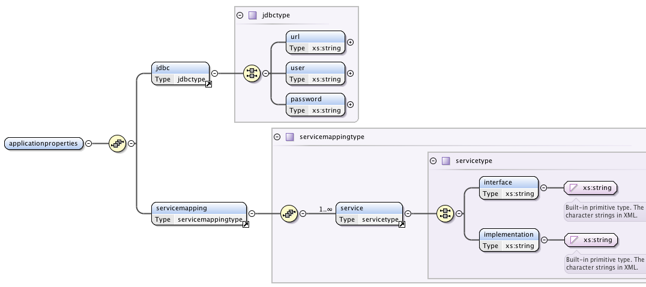

Schema Information
The application properties xsd file contains a jdbc element that contains a jdbctype element which contains url, user, and password elements for storage of that information in the applicationproperties.xml file.
The services information is stored within the interface and implementation elements within the xsd. The interface element is used to store the service name that the software uses to call and the implementation string holds the actual class name that the service relates to.

