Lab 1

Node architecture and memory

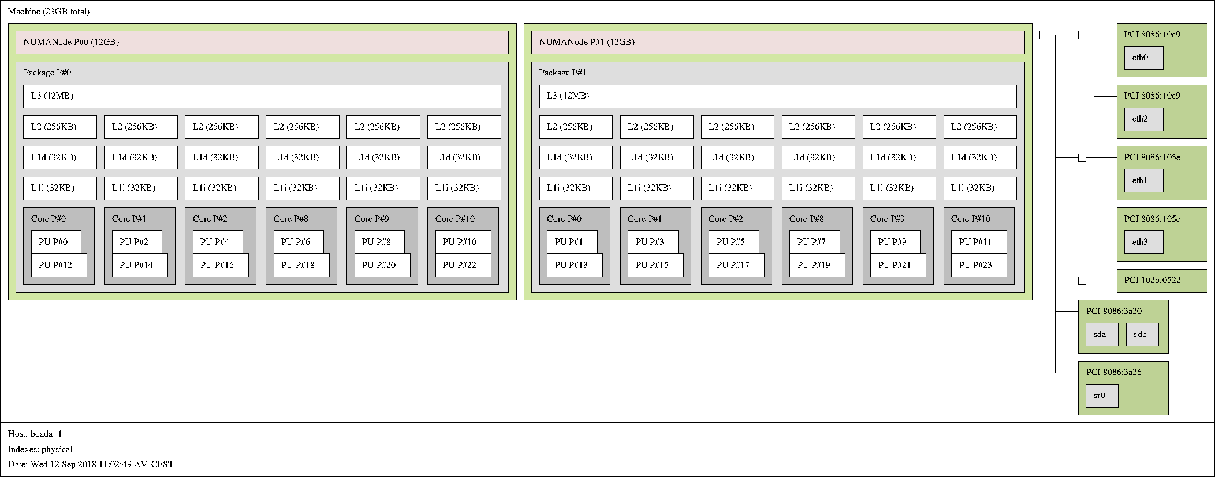

Strong vs. weak scalability
String scalability: Increase the number of processors with constant problem size.
Weak scalability: Increase the number of processors with problem size proportional to numbr of processors.
Weak:
Speed Up Time
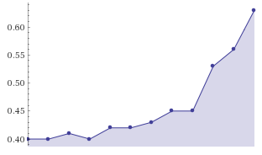
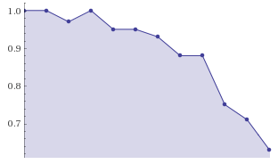
Strong:
Speed Up Time
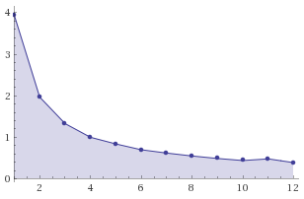
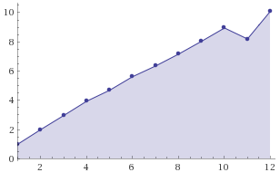

Weak method: Work increase with the number of threads, then, time, ideally, should be the same with any number of cores but with more curated result as more cores are we using.
Strong method: time decrease with the number of threads, then, time, ideally, should decrease by 1/#threats. But it is not perfect.

