1. Introduction
This lab session we have worked with an IMU sensor. This kind of sensors are composed by an accelerometer, a gyroscope and a magnetometer. It is used to measure specific forces, angular rate, orientation, etc. of the body. It can usually be found at aircraft systems.

2. Software
The projected software was a simple program that reads the data form the sensor, a software low pass filter and a accelerator to roll and pitch converter.
Our code reads the sensor via I2C using the implementation of the sparkfun. Once the data is stored, using the following formula:
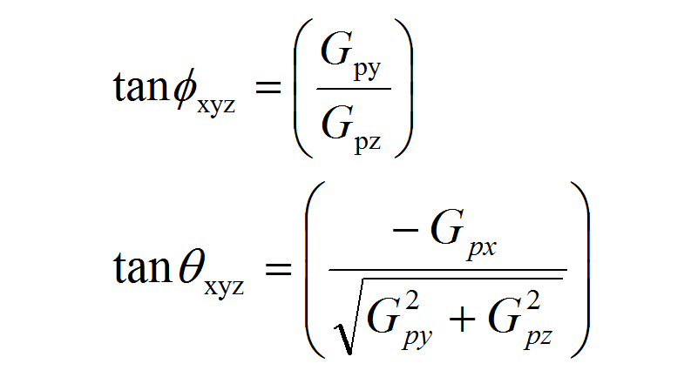

Apling this formula, our resulting coude is:
roll = atan2(y_Buff , z_Buff) * 57.3;
pitch = atan2((- x_Buff) , sqrt(y_Buff * y_Buff + z_Buff * z_Buff)) * 57.3;
After the conversion, we had applied a low pass filter by coding the following equation, being R and C our variables to optimize, t the period between samples.
(low pass filter formula)

3. Worst execution time
In order to find the worst execution time we decided to use time stamps, one before the execution of the code that was described at the previous section and other time stamp at the end of the function. The result was that the worst execution time is 1960 microseconds.

4. Conclusions
It can be implemented a real time system that registers the pitch and filtered by software, that part cab be optimized if it was implemented by hardware, with a cyclic scheduler, a scheduler that didn’t need a kernel.

