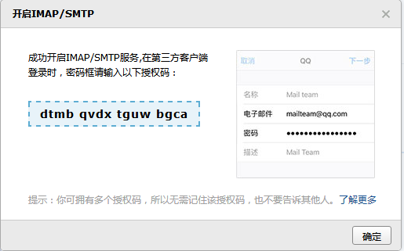

**Dtmbqvdxtguwbgca**