**Unveiling Trends in Leading AI and ML Companies' Stock Price: A Time Series Analysis**

# **Abstract**

This study explores the potential of time series analysis in predicting significant trends within the historical stock prices of leading AI and ML companies: Alphabet, Meta, and Microsoft. The primary objective is to evaluate the effectiveness of various time series models in forecasting future stock prices, thereby providing useful insights for investors and companies by informing them about the best forecasting models and optimal adjustments to predict future stock prices.

To achieve this aim, the research addresses the following objectives: employing time series models to identify significant long-term and seasonal trends within the historical stock prices of Alphabet, Meta, and Microsoft; comparing the suitability of different time series models; analysing the similarities and differences in the observed trends; and evaluating the accuracy of the models in predicting future trends.

Addressing knowledge gaps in the literature, the research contrasts traditional statistical models like ARIMA with deep learning models such as LSTMs. Traditional models often struggle with non-linear relationships inherent in financial data, while deep learning approaches have shown promise in capturing long-term dependencies. However, discrepancies in comparative studies highlight the need for a comprehensive assessment of these models' effectiveness in the specific context of AI and ML companies' stock prices.

The methodology includes several steps to ensure robustness and accuracy. Initially, data preprocessing and outlier detection are performed to ensure data quality. Exploratory Data Analysis (EDA) follows, involving the use of ACF, PACF plots, and stationarity tests like the Augmented Dickey-Fuller (ADF) and Ljung-Box tests to uncover inherent patterns and ensure data stationarity. Data is then split into training and testing subsets for model evaluation.

Both statistical and deep learning models are employed, including ARIMA-GARCH, LSTM, and GRU. Model performance is evaluated using metrics such as RMSE and MAE. The best-performing models from each category are selected for forecasting mid-term future trends, with comparisons made against actual values to determine prediction accuracy.

Ethical considerations are meticulously addressed, acknowledging the secondary nature of the data sourced from Yahoo Finance and ensuring transparency in all analyses. An Ethos application has been completed to support the ethical conduct of this research.

The findings indicate that all three companies exhibited upward long-term trends, suggesting positive investor outlooks on AI/ML futures. No significant seasonal patterns were identified, pointing to consistent long-term influencing factors on stock prices. Machine learning models, particularly GRUs, outperformed traditional statistical models in capturing underlying trends and predicting mid-term future trends. The GRU model significantly outperformed the ARIMA-GARCH model across all three stocks. Overall, these findings highlight the potential of GRU models for investors and financial analysts seeking to make informed decisions within the AI/ML industry.

However, focusing solely on historical prices might overlook other influencing factors, potentially leading to inaccurate predictions. Future research directions include exploring techniques to mitigate overfitting and improving model generalisability to support high-risk decision-making.

In conclusion, this study demonstrates the superior performance of ML models in forecasting stock prices for leading AI and ML companies, providing useful insights for investors and companies navigating the dynamic AI/ML landscape.

**Table of Contents**

**Abstract** 2

**Table of Contents** 4

**List of Figures** 6

**List of Tables** 7

**Introduction** 8

**1.1** **Background** 8

**1.2** **The Impact of AI and ML on the Stock Market** 9

**1.3** **Justifications, Research Aim and Objectives** 11

1.3.1 Research Aim 11

1.3.2 Research Objectives 12

**1.4** **Research Questions** 12

**1.5** **Research Approach** 12

**1.6** **Research Structure** 13

**1.** **Literature Review** 14

**2.1** **Introduction** 14

**2.2** **Time Series Analysis Core Concepts** 14

**2.3** **Testing for Stationarity** 18

2.3.1 Augmented Dickey-Fuller (ADF) 19

2.3.2 Ljung-Box 19

**2.4** **Statistical Time Series Forecasting Models** 19

2.4.1 Moving Average (MA) 19

2.4.2 Exponential Smoothing 21

2.4.3 Autoregressive Integrated Moving Average (ARIMA) 22

2.4.4 ARMA-GARCH (Generalized Autoregressive Conditional Heteroskedasticity) 24

**2.5** **Deep Learning Time Series Forecasting Models** 24

2.5.1 Recurrent Neural Network (RNN) 24

2.5.2 Long Short-Term Memory (LSTM) 26

2.5.3 Gated Recurrent Unit (GRU) 28

**2.6** **Comparison and Evaluation of Time-Series Models** 29

**2.7** **Knowledge Gaps and Research Questions** 31

**2.8** **Conclusion** 32

**2.** **Methodology** 34

**2.1.** **Introduction** 34

**2.2.** **Literature Search** 35

**2.3.** **Summary of Literature Review** 36

**2.4.** **Primary data** 36

**2.5.** **Secondary data** 37

**2.6.** **Research instrument design** 38

**2.7.** **Overview of secondary data used for analysis** 39

**2.8.** **Data analysis** 40

**2.9.** **Ethics** 43

**2.10.** **Summary** 44

**3.** **Data analysis and discussion** 45

**4.1** **Introduction** 45

**4.2** **Data Preprocessing and Outlier Detection** 45

4.2.1 Data preprocessing 45

4.2.2 Outlier Detection 47

**4.3** **Exploratory Data Analysis (EDA)** 49

4.3.1 EDA for Alphabet 49

4.3.2 EDA for Meta 52

4.3.3 EDA for Microsoft 55

**4.4** **Data Splitting** 58

**4.5** **Model Implementation** 58

4.5.1 Alphabet Stock Price Forecast 61

4.5.2 META Stock Price Forecast 63

4.5.3 Microsoft Stock Price Forecast 66

**4.6** **Forecasting Performance for Mid-Term Unseen Data** 69

**4.7** **Summary** 72

**4.** **Conclusion, Limitations, and Recommendations** 74

**4.1.** **Introduction** 74

**4.2.** **Research Conclusion** 74

**4.3.** **Limitations** 79

**4.4.** **Recommendations for future research** 80

**4.5.** **Conclusion** 81

**Reference List** 83

**Appendices** 97

**I.** **Outliers Data** 97

**II.** **Ljung_Box Test Results After First-Order Differencing** 99

**III.** **Mid-Term Stock Price Forecasts (Real vs. Predicted)** 108

**IV.** **Sample of Selected and Analysed Articles for Literature Review** 112

**List of Figures**

Figure 1: Stationary vs. Non-Stationary time series (source: Santra, 2023) 15

Figure 2: Differencing (source: Kai et al., 2022) 16

Figure 3: Time Series Components (source: Valse, 2020) 17

Figure 4: Autocorrelation Function (ACF) with both trend and seasonality (source: Hyndman et al., 2021) 18

Figure 5: Comparison of Moving Averages (source: Kadam, 2012) 21

Figure 6: Exponential Smoothing (source: Dash, 2020) 22

Figure 7: RNN Architecture (source: Beniwal et al., 2024) 26

Figure 8: LSTM Architecture (source: Beniwal et al., 2024) 27

Figure 9: GRU Architecture (source: Jing et al., 2021) 29

Figure 10: Historical stock prices of Alphabet, META, and Microsoft 40

Figure 11: Research Methodology 41

Figure 12: Best-fitting Distributions Plot of Alphabet, Meta, and Microsoft 47

Figure 13: Original ACF and PACF plots of Alphabet 50

Figure 14: ACF and PACF plots of Alphabet after first-order differencing 51

Figure 15: Alphabet original trends overlaid by 50-day simple moving average 52

Figure 16: Original ACF and PACF plots of META 53

Figure 17: ACF and PACF plots of META after first-order differencing 54

Figure 18: Alphabet original trends overlaid by 210-day simple moving average 55

Figure 19: Original ACF and PACF plots of Microsoft 56

Figure 20: ACF and PACF plots of Microsoft after first-order differencing 57

Figure 21: Microsoft original trends overlaid by 90-day simple moving average 58

Figure 22: Alphabet Baseline and Forecasting Models’ Charts 62

Figure 23: META Baseline and Forecasting Models’ Charts 65

Figure 24: Microsoft Baseline and Forecasting Models’ Charts 67

Figure 25: Mid-term Prediction Charts of Alphabet, META, and Microsoft 70

**List of Tables**

Table 1: Advantageous and disadvantageous of secondary data 38

Table 2: Descriptive Statistics for stock prices of Alphabet, Meta, and Microsoft 46

Table 3: Best-fitting distribution and outlier statistics for Alphabet, Meta, and Microsoft stocks 48

Table 4: Python Libraries utilised for model implementation 60

Table 5: Tuned Parameters of Forecasting Models for Alphabet Stock Price Prediction 61

Table 6: Comparative Results of Forecasting Models and Performance Metrics for Alphabet 63

Table 7: Tuned Parameters of Forecasting Models for META Stock Price Prediction 64

Table 8: Comparative Results of Forecasting Models and Performance Metrics for META 65

Table 9: Tuned Parameters of Forecasting Models for Microsoft Stock Price Prediction 67

Table 10: Comparative Results of Forecasting Models and Performance Metrics for Microsoft 68

Table 11: Summary of real and predicted values for Alphabet 70

Table 12: Summary of real and predicted values for META 71

Table 13: Summary of real and predicted values for Microsoft 72

Table 14: Comparative Table for Mid-term Forecasting of Alphabet, META, and Microsoft 72

Table 15: Outliers of Alphabet Stock Prices 97

Table 16: Outliers of META Stock Prices 98

Table 17: Outliers of Microsoft Stock Prices 99

Table 18: Ljung_Box Test Results of Alphabet 102

Table 19: Ljung_Box Test Results of META 105

Table 20: Ljung_Box Test Results of Microsoft 108

Table 21: Mid-Term Stock Price Forecasts (Real vs. Predicted) for Alphabet 109

Table 22: Mid-Term Stock Price Forecasts (Real vs. Predicted) for META 111

Table 23: Mid-Term Stock Price Forecasts (Real vs. Predicted) for Microsoft 112

Table 24: Sample of selected and analysed articles for literature review 114

**Introduction**

This chapter outlines the aim, objectives and justification of the research. It then delves to the research background to highlight significance of research questions.

* 1. **Background**

Stocks have long been considered a cornerstone asset for investors. They offer the potential for strong returns on investment over time and high liquidity. This is exemplified by the FTSE 100 on the London Stock Exchange, which delivered a total return of 645.2% (equivalent to an annualised return of 5.4%) between 1984 and 2022 (Bright, 2023). Publicly traded companies are required by law to disclose their financial status, providing a wealth of information for investors. Additionally, regulations governing the stock market help mitigate various financial risks.

However, maximising profits from stock investments demands a sound understanding of market dynamics and a well-defined strategy for buying and selling. This, in turn, hinges on accurate prediction of stock prices. Stock price prediction methods can be broadly categorized into two main approaches: fundamental analysis and technical analysis (Devadoss, 2013).

Fundamental analysis focuses on a company's intrinsic value, considering its future potential and financials. A stock trading below its intrinsic value might be a good buy, while an overvalued stock might be a sell candidate. Technical analysis focuses solely on the stock price itself, using charts and mathematical tools to identify trends and predict future price movements. This approach ignores company fundamentals and relies on historical price data (Raghunathan, 2007).

In response to these limitations, time series analysis is a statistical technique used to examine observations collected on a variable of interest over time. This technique allows researchers to uncover patterns within historical datasets, such as seasonality (Montgomery et al., 2008). In the context of this research, time series analysis will be utilised to analyse the historical stock prices of leading Artificial Intelligence (AI) and Machine Learning (ML) companies.

Employing times series analysis, help us uncover long-term patterns within historical stock price data. This involves analysis techniques to identify trend or seasonality patterns within existing data (Shanaev et al., 2020). By analysing these trend components, we can assess the overall growth trajectory of AI/ML companies.

In a general sense, time series analysis will help us to understand if stock price movement in recent years has been impacted by technological advancements. While time series analysis mainly focuses on historical data, its power can be leverage to forecast future trends as well. Techniques such as ARIMA (Hyndman et al., 2021) or machine learning models like LSTM (Asokan, 2022) utilise historical patterns in data to predict future prices.

* 1. **The Impact of AI and ML on the Stock Market**

The rapid advancements in AI and ML are driving a profound revolution across industries, fundamentally transforming their core operations (Rahman, 2023). Artificial Intelligence refers to the development of computer programs or intelligent machines that can mimic or even surpass human cognitive abilities in specific domains (Kaplan, 2016). For instance, AI-powered programs like AlphaGo have achieved superhuman performance in complex strategy games like GO by defeating the world grandmaster, Lee Sedol (Silver et al., 2016), while chess programs like Stockfish can defeat grandmasters consistently (Naroditsky, 2015). Similarly, advancements in Natural Language Processing (NLP) enables machines to understand human-like languages and respond to them with increasing accuracy (Arkhangelskaya et al., 2023).

Machine Learning, on the other hand, empowers these intelligent machines to continually improve by learning from data without the need for explicit programming. Unlike traditional algorithms with fixed set of instructions, ML models can identify patterns and relationships within large datasets, allowing them to adapt and make predictions on new data (Kaplan, 2016). This self-learning capability has fuelled significant breakthroughs in robotics, where AI-powered robots are now performing complex tasks with greater intelligence and adaptability. These tasks include autonomous navigation in transportation systems like self-driving cars, object recognition for applications like inventory management and predictive maintenance to prevent equipment failures (Soori et al., 2023).

The utilisation of AI and ML technologies is significantly impacting the global economy and financial markets. A 2022 PwC report predicts that nearly 45% of total global economic profit by 2030 will be generated through product enhancements driven by AI and ML. This economic surge, driven by three key factors, will undoubtedly impact stock prices (PWC, 2022). AI-powered automation will streamline tasks across industries, boosting productivity. Secondly, AI will augment the workforce, empowering workers with intelligent tools that unlock greater human potential. Finally, AI's ability to analyse vast data sets will personalise consumer experiences, fuelling demand and economic growth across sectors.

Companies developing and utilising these technologies are experiencing substantial growth, attracting investor interest and influencing stock prices (Bughin et al., 2018). Understanding the current trends in how leading companies utilise AI and ML, and the subsequent impact on their stock prices, can provide valuable insights for both companies and their investors. This knowledge can help them assess growth potential, identify related risks, and make more informed investment decisions.

* 1. **Justifications, Research Aim and Objectives**

The economic potential of AI and ML has been extensively explored. Research by scholars such as Chia-Hui (2021) has highlighted their disruptive power, ability to drive innovation, and contribution to economic growth. However, there is a gap in understanding how these developments translate into the concrete stock market performance of leading AI and ML companies themselves. While the broader economic impact of AI and ML advancements is well-documented (Barclays, 2024), a gap exists in understanding how these advancements are reflected in the stock market performance of leading companies driving this revolution.

* + 1. **Research Aim**

The primary objective of this research is to utilise time series analysis to evaluate the potential for predicting significant trends within historical stock prices of leading AI and ML companies. This analysis will involve uncovering long-term and seasonal patterns in the historical data, and subsequently assess the effectiveness of the chosen models for forecasting future trends.

By utilising time series analysis, this research aims to offer valuable insights withing AI and ML landscape for both investors and companies. Time series analysis can help investors make more informed decision by identifying long-term growth trajectories and assessing the impact of AI and ML’s disruptive power. For companies, this analysis can provide a better understanding of how their stock market performance aligns with their technological advancements, allowing them to optimise future stock market strategies.

* + 1. **Research Objectives**

To achieve this aim, the research will address the following specific objectives:

1. Employ time series models to identify significant long-term and seasonal trends within the historical stock prices of Alphabet, Meta, and Microsoft.
2. Compare the suitability of different time series models for uncovering underlying trends in the stock prices of leading AI and ML companies.
3. Analyse the similarities and differences observed between the long-term and seasonal trends exhibited in the chosen companies' stock prices.
4. Evaluate the accuracy of the chosen time series models in predicting future trends in the stock prices of the leading AI and ML companies.
   1. **Research Questions**

In order to achieve the research aim and objectives outlined above, this research will address the following research questions:

1. How well can the chosen time series models identify significant long-term or seasonal trends within the historical stock prices of leading Artificial Intelligence (AI) and Machine Learning (ML) companies (Alphabet, Meta, and Microsoft)?
2. In comparison to each other, how suitable are the chosen time series models for uncovering underlying trends in the stock prices of leading AI and ML companies?
3. Are there any significant similarities or differences observed between the long-term and seasonal trends exhibited in the chosen companies' stock prices?
4. How accurately can the chosen time series models predict future trends in the stock prices of the leading AI and ML companies?
   1. **Research Approach**

This research will utilise secondary data sources for analysis. Historical stock prices will be collected from Yahoo Finance.

To ensure a robust analysis, the data selection process will consider established practices in financial time series analysis. The aim is to capture both long-term trends and potential seasonal patterns, while maintaining relevance to recent developments in the dynamic AI and ML sector. A specific timeframe will be chosen to balance these considerations.

Three leading global companies in the field of AI and ML have been selected for analysis: Alphabet (Google), Meta Platforms (Facebook), and Microsoft. These companies are recognised for their dominant market positions due to their market capitalisation and their well-established applications of AI and ML technologies.

* 1. **Research Structure**

This study is structured into five chapters. Chapter 1 outlines the research aims, objectives, and justification. Chapter 2 explores relevant literature on applying time series analysis to stock market forecasting. Chapter 3 details the research methodology and data collection. Chapter 4 presents the research findings and analysis. Finally, Chapter 5 discusses the results, evaluates the study, and recommends future research directions.

1. **Literature Review** 
   1. **Introduction**

Stock price prediction is crucial for maximising investment returns. Time series analysis, analysing data sequences over time to identify patterns for forecasting, plays a vital role. Selecting the most effective model is essential, and finance boasts a rich history of developing specialised models for financial data.

This chapter delves into the core concepts of time series analysis. We will then explore some of the most commonly applied forecasting models. Finally, we will discuss a comparison and evaluation of these models in the context of real-world stock price prediction, drawing insights from various research studies and literature.

* 1. **Time Series Analysis Core Concepts**

Before diving into specific models, a brief introduction to the core time series concepts is appropriate.

* **Stationarity**

A stationary time series does not depend on the observation time and so will exhibit constant statistical properties (like mean and variance) in the long run. This contrasts with time series exhibiting seasonality or trends, where the time of observation affects the value. In this sense, cyclical behaviour can also be considered stationary because it doesn't have a fixed period within the data (Hyndman et al., 2021).



Figure : Stationary vs. Non-Stationary time series (source: Santra, 2023)

* **Differencing**

To transform a non-stationary time series into a stationary one, the difference between the current observation and its previous value (or a lagged value) is computed. This stabilises the variance of the time series. By removing the changes in the series, the mean becomes more stable, and any trends or seasonality patterns are removed (Hyndman et al., 2021).

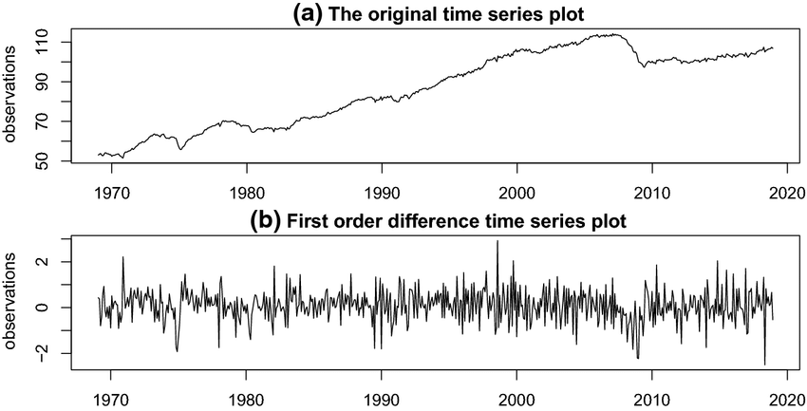

Figure : Differencing (source: Kai et al., 2022)

* **Trends**

A long-term decrease or increase in time series data, regardless of its linearity, suggests the presence of a trend. This trend might even change direction, for instance, from decreasing to increasing (Hyndman et al., 2021).

* **Seasonality**

Seasonality arises when a time series is influenced by recurring seasonal factors like day of the week or time of the year (Hyndman et al., 2021).

* **Cyclic**

A rise and fall in data without any constant frequency is termed a cycle. For instance, business cycles fluctuate due to changing economic conditions (Hyndman et al., 2021).

* **Irregular Variations**

Unpredictable fluctuations in a time series with no discernible pattern are termed irregular variations. Unlike seasonal or cyclical variations, they can occur at any time and often stem from unforeseen events (Valse, 2020), such as unexpected news announcements.

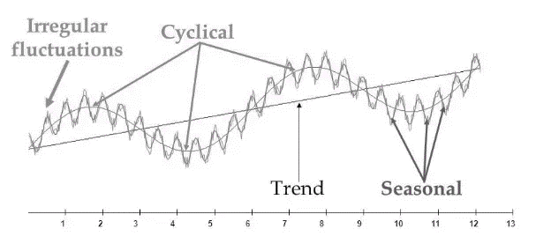

Figure : Time Series Components (source: Valse, 2020)

* **Autocorrelation Function (ACF)**

The ACF measures the correlation between a time series and its lagged observations (past values). Positive or negative values at early lags suggest trends, while spikes at specific lags indicate seasonality. Values close to zero imply little to no correlation. High ACF values at some lags, particularly for pronounced trends, can signal non-stationarity. However, interpreting the ACF for stationarity requires considering the overall pattern and employing additional tests like the Dickey-Fuller test (Hyndman et al., 2021; Brockwell, 2016).

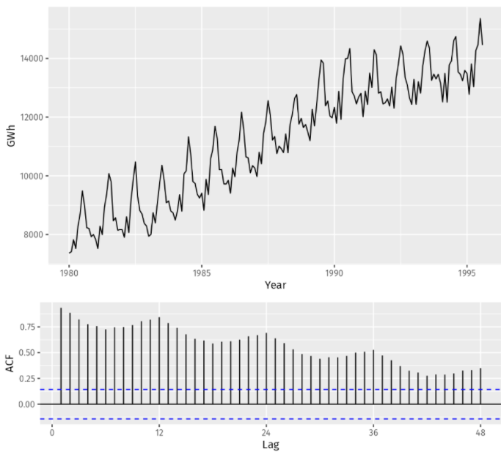

Figure : Autocorrelation Function (ACF) with both trend and seasonality (source: Hyndman et al., 2021)

* **Partial Autocorrelation Function (PACF):**

PACF is similar to the ACF with a difference that unlike ACF, it measures only the direct correlation of time series with its lagged observations excluding the influences of intermediate lags. A high PACF value suggest strong relationship between the current value and its lagged value. Similar to ACF, a value of zero or close to it indicates no direct correlation or a weak one at that lag (Dégerine et al., 2003).

* 1. **Testing for Stationarity**
     1. **Augmented Dickey-Fuller (ADF)**

This statistical test assesses whether a time series is stationary (constant mean, variance, and autocorrelation). The null hypothesis implies non-stationarity, while the alternative is stationarity.

A more negative test statistic indicates stronger evidence against non-stationarity. If the statistic falls below critical values at a chosen significance level (e.g., 5%), we fail to reject the null hypothesis, suggesting potential non-stationarity. Additionally, a p-value less than the significance level (e.g., 0.05) leads to rejection of the null hypothesis, implying stationarity (Dickey et al., 1979; Rizwan, 2011).

* + 1. **Ljung-Box**

In a well-specified model for a stationary time series, residuals should be independent and identically distributed (i.i.d.). This means they behave randomly and have no "memory" of past values. Non-random residuals (serial correlation) suggest issues with the model or data stationarity.

The Ljung-Box test's null hypothesis states no serial correlation in residuals (present residuals are unrelated to past ones). Non-stationary data (trends or seasonality) can lead to serial correlation, violating the null hypothesis. A low p-value from the Ljung-Box test on residuals indicates a potential stationarity issue (Ljung et al., 1978).

* 1. **Statistical Time Series Forecasting Models**
     1. **Moving Average (MA)**

Moving averages (MAs) are a popular technical indicator used in financial trading to identify trends and potential support and resistance levels. Considering stock data as example, this approach assumes that recent prices hold more significance for predicting future prices compared to older data. For example, a 3-period moving average calculates the average data over the last three periods (days, weeks, etc.) to predict the upcoming period's price. This implies that the price of future time periods is weighting by the patterns observed in the most recent data points. (Jain et al., 2005)

There are three main types of moving averages **(Murphy, 1999)**:

* **Simple Moving Average (SMA)**

**This basic MA takes the average of a chosen number of price points (e.g., closing prices). Recent data has equal weight as older data, making it more sensitive to recent price changes.**

* **Linearly Weighted Moving Average (LWMA)**

**This MA assigns higher weights to recent prices within the window, giving them more influence. While recent data is prioritized, some historical data is still considered.**

* **Exponentially Weighted Moving Average (EMA)**

**This MA assigns exponentially decreasing weights to past prices, with the most recent price having the most influence. This approach heavily emphasizes recent information while incorporating some historical context.**

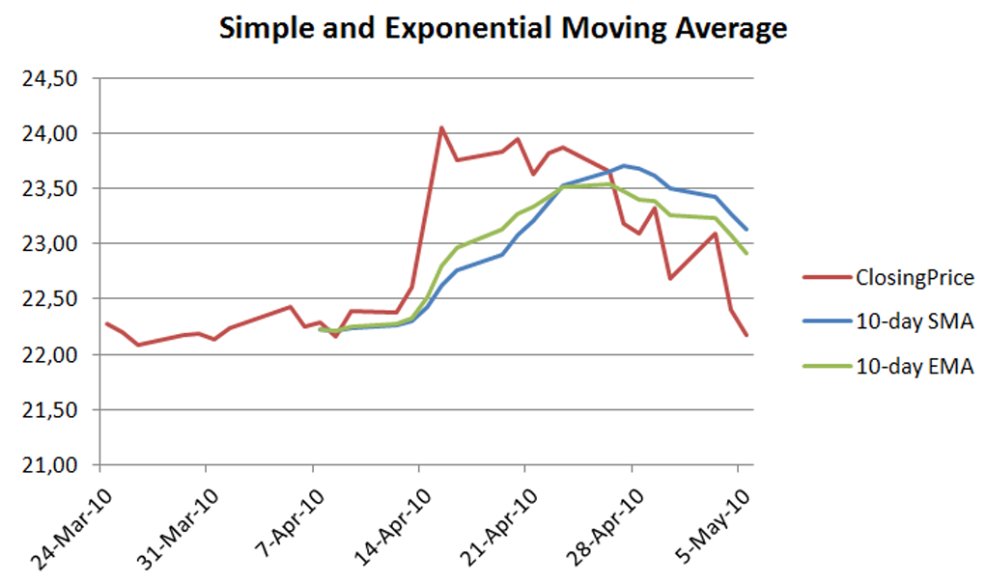

Figure : Comparison of Moving Averages (source: Kadam, 2012)

* + 1. **Exponential Smoothing**

Exponential smoothing is a forecasting technique that assigns higher weights to recent data points compared to older ones. It emphasizes the most recent observations while progressively decreasing weight for older data. This approach offers quick and reliable forecasts (Nugus, 2009), making it a valuable tool across various industries since its introduction (Holt, 1957; Brown, 1959; Winters, 1960). Exponential smoothing comes in three main types: single, double, and triple. These methods can model time series data with varying degrees of complexity, accounting for trend level, trend slope, and even seasonal components (Yibin, 2019).

Holt’s linear model excel at forecasting trends but it tends to over-predict if the trend is expected to level off. To address this limitation, researchers like Gardner & McKenzie (1985) introduced a parameter that dampens the trend, making more realistic forecast especially in situation which the trend eventually stabilise. This optimisation has proven highly successful in improving forecasting accuracy (Hyndman et al., 2021).

Holt-Winters builds on exponential smoothing by capturing seasonal patterns with weights in a multiplicative model. Simpler and requiring less data than Box-Jenkins, its strength lies in "back-forecasting" for superior accuracy, though initially computationally expensive (Rumbe et al., 2024).



Figure : Exponential Smoothing (source: Dash, 2020)

* + 1. **Autoregressive Integrated Moving Average (ARIMA)**

In the real world, observations of a variable often exhibit a dependence on past values, creating a **serial dependency** across time. For such data, exponential smoothing models become less effective in forecasting. To address this limitation, the ARMA (Auto Regressive Moving Average) model was developed by combining the strengths of Moving Average (MA) and Autoregressive (AR) approaches. Later, Box and Jenkins (Box et al., 1976) introduced the concept of stationarity, leading to the creation of more robust ARIMA models. Finally, to handle seasonal patterns in data, SARIMA (Seasonal ARIMA) models were introduced (Shumway et al., 2015).

ARIMA models (p, d, q) are characterised by 3 key components (Shumway et al., 2015):

* **Autoregression (AR)**

This component leverages past observations of a time series to predict its current value. The parameter 'p' determines the number of past data points included in the model for forecasting.

* **Integrated (I)**

This step ensures the data is stationary**.** If trends or seasonality are present, differencing is applied 'd' times to achieve stationarity.

* **Moving Average (MA)**

MA incorporates past forecast errors -the difference between actual and predicted values. The parameter 'q' determines the number of past errors considered to smooth out fluctuations and potentially improve forecast accuracy.

**ARIMA models require careful selection of p, d, and q parameters, often through statistical tests or validation. A basic example, ARIMA(0,1,0), is essentially a random walk model (d=1 for stationarity) that ignores past values (p=0) and errors (q=0) (Montgomery et al., 2008).**

SARIMA (p, d, q) * (P, D, Q)s models are an extension of ARIMA models, addressing a critical aspect missing in them: seasonality. They explicitly consider recurring patterns in the data based on time intervals. SARIMA introduces four additional parameters to capture seasonality. ‘P’ determines the number of past seasonal values; ’D’ the number of times data needs to be seasonally differenced; ‘Q’ the number of past seasonal forecast errors; and ‘s’ defines the number of observations in a single seasonal period (example: monthly = 12 and quarterly= 4) (Malki et al., 2022).

* + 1. **ARMA-GARCH (Generalized Autoregressive Conditional Heteroskedasticity)**

To capture volatility clustering of a time series which is variance fluctuation around the mean, GARCH models were introduced (Engle, 1982; Bollerslev, 1986). Since many time-series exhibits periods of high volatility followed by similar periods or vice versa, ARMA based models cannot capture these phenomena alone. However, combining ARMA models with GARCH models can recognise this volatility over time. This allows for better prediction by considering the past squared errors in calculating the variance of forecast errors (Kim, 2022).

GARCH models include two parameters of p and q. these parameters determine how past volatility influences the current conditional variance. Combination of two models, ARMA (p, d, q) – GARCH (p, q) works in two steps: First, ARMA model is applied to predict future values’ mean based on the past values, differencing and forecast errors of past observations in time-series and then using GARCH component of past squared errors (volatility) to predict the future conditional variance. The obtained value explains how much data is likely to fluctuate around the mean (Lee, 2013).

* 1. **Deep Learning Time Series Forecasting Models**
     1. **Recurrent Neural Network (RNN)**

Artificial Neural Networks (ANNs) are a powerful computational approach inspired by the structure and function of the human brain. They consist of a vast network of interconnected processing units, often referred to as artificial neurons or processing elements (PEs). Unlike biological neurons with complex inner workings, these PEs are simpler computational units. Through a training process, ANNs can adjust the connections (synapses) between these PEs and so capture knowledge and patterns from the data they are exposed to (Guresen et al., 2011)

Recurrent neural networks (RNNs) are a specific type of artificial neural network architecture designed to excel at processing temporal sequential data (Guo et al., 2012). Unlike traditional neural networks that process information in a single forward pass, RNNs are adept at handling sequences. They achieve this by employing a feedback loop mechanism that allows the output from one step to be fed back as input to the next step. This creates a form of internal memory within the network, enabling it to learn from past information and improve its understanding of future inputs in the context of the current observation within a sequence. In essence, RNNs overcome the limitation of traditional neural networks, which typically process information in a single forward pass (Ayodele et al., 2021).

RNNs operate by forecasting a sequence one element at a time. During each step, they combine the current input with the prediction from the previous step, retrieved from their internal memory. This combined information is then processed to generate a new output and update the internal memory in preparation for the next element in the sequence (Hewamalage et al., 2021).

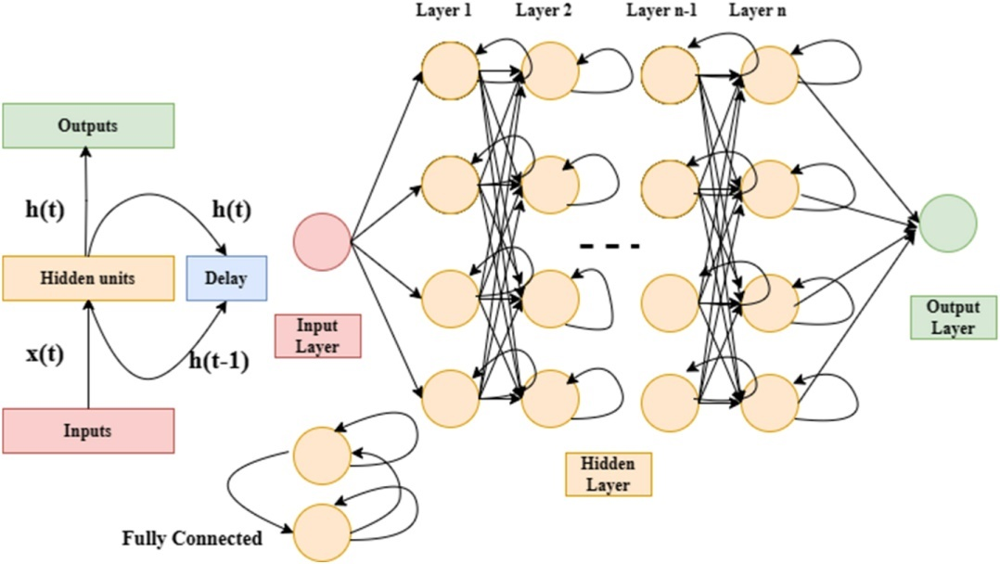

Figure : RNN Architecture (source: Beniwal et al., 2024)

However, RNNs face challenges when dealing with real-world applications involving long sequences. They can struggle to learn dependencies between elements that are far apart in the sequence, a phenomenon known as the vanishing gradient problem. Additionally, RNNs are limited by their internal memory capacity, which restricts their ability to effectively learn from very long sequences (Liu et al., 2023).

* + 1. **Long Short-Term Memory (LSTM)**

To address the vanishing gradient problem that limits traditional Recurrent Neural Networks (RNNs), Long Short-Term Memory (LSTM) models were introduced (Hochreiter & Schmidhuber, 1997). LSTMs excel at learning long-term dependencies within sequences, allowing them to effectively analyse information even for sequences exceeding 1000 steps. They achieve this by employing a specially designed architecture that incorporates gates within their cell structure. These gates help manage the flow of information and overcome the vanishing gradient problem (Zhang et al., 2023).

An LSTM memory cell is the core component of an LSTM network and contains four major elements:

* Cell State: This acts as a long-term memory unit, storing, reading, writing and forgetting information relevant to the task. It does this by using three gates.
* Input Gate: This gate controls the flow of new information into the cell state.
* Output Gate: This gate determines what information from the cell state is used as output.
* Forget Gate: This gate decides what information to forget from the cell state, allowing the network to selectively retain or discard information over time.

Each gate utilises an activation function to compute a value between 0 and 1. The input gate controls the values entering the cell, the output gate controls the values used for output, and the forget gate controls the information retained within the cell (Gao et al., 2017).

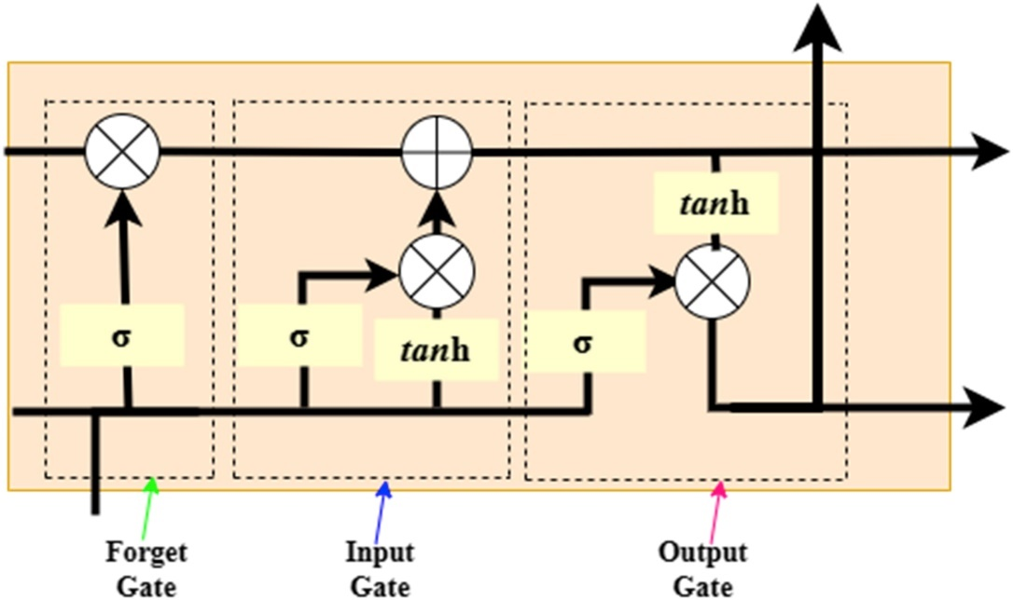

Figure : LSTM Architecture (source: Beniwal et al., 2024)

LSTMs excel at handling financial time series data due to their ability to capture long-term dependencies. However, non-stationary data and noise can challenge LSTMs, especially with sudden changes and extended prediction horizons, potentially reducing performance and forecast accuracy. To address these issues, researchers have developed LSTM-based models like LSTM-BN for financial predictions (Fang et al., 2023).

* + 1. **Gated Recurrent Unit (GRU)**

Gated Recurrent Units (GRUs), proposed by Cho et al. (2014) have emerged as a popular alternative to Long Short-Term Memory (LSTM) networks. While inspired by LSTMs, GRUs offer a more streamlined architecture, making them computationally efficient and well-suited for various applications (Pil-Soo et al., 2018).

One key difference lies in the gating mechanisms. GRUs combine the forget and input gates of LSTMs into a single update gate. This simplifies the information flow within the network. Unlike LSTMs with separate memory cells, GRUs modulate information flow directly through the hidden state, eliminating the need for dedicated memory units (ArunKumar et al., 2021).

This streamlined approach translates to faster training times and almost the same performance compared to LSTMs. The update gate acts as a controller, determining how much of the previous hidden state (information) should be retained and how much should be replaced with new information from the current input. This controlled flow of information allows GRUs to effectively learn long-term dependencies within sequences (Wang et al., 2019).

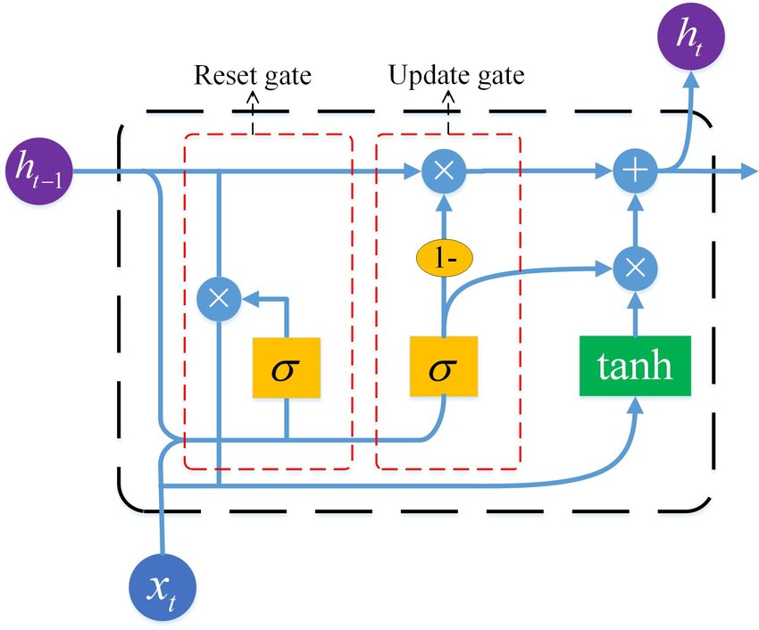

Figure : GRU Architecture (source: Jing et al., 2021)

However, a potential drawback of GRUs is their lack of a dedicated forget gate. While LSTMs can explicitly forget irrelevant information, GRUs rely solely on the update gate to manage the information flow. This could limit their ability to handle certain tasks where selective forgetting might be crucial (Srivatsavaya, 2023).

* 1. **Comparison and Evaluation of Time-Series Models**

The ARIMA model is widely used in finance for time series forecasting. Studies highlight its frequent use for predicting stock prices (Hu et al. 2020; Idrees et al. 2019). ARIMA excels in short-term predictions by leveraging past observations, requiring minimal parameters while balancing complexity and accuracy (Box et al., 1976; Ariyo et al., 2014; Wadi et al., 2018).

However, while ARIMA and similar models excel at capturing linear relationships within data, they can struggle with the complexities introduced by non-linear factors (Earnest et al., 2005) such as unexpected events or market sentiment. This is because ARIMA assumes stationarity, which might not always hold true for stock prices that often exhibit trends and seasonality. The process of differencing data to achieve stationarity can also lead to information loss, potentially overlooking valuable insights (Hyndman et al., 2021).

In contrast, combining ARIMA with models like GARCH can address volatility, a common challenge in stock price data. This is highlighted in a study using GARCH to forecast volatility and return of the four major banks (Hu et al., 2020). However, optimizing these combined models can be computationally complex (Engle, 2001).

Other statistical models have also shown promise in dynamic environments like the Dhaka Stock Exchange. Kim (2022) explores the ARMA-GARCH model with positive results. Additionally, methods like exponential smoothing have been applied to detect share price movements and predict daily prices (Shahid et al., 2020).

Recent advancements in computational power have enabled the use of novel machine learning techniques for financial forecasting, such as GRUs, LSTMs, and RNNs (Selvin et al., 2017). For example, Selvin et al. (2017) successfully applied neural network models to capture the dynamic behaviour of data for predicting the stock prices of conglomerates listed on the National Stock Exchange of India (NSE). Furthermore, Chen et al. (2015) conducted similar research to predict stock price return on the China Stock Market, also achieving good result. A significant advantage of these models, particularly RNNs, is their ability to handle non-linear relationships within data. Unlike traditional time series models like ARIMA, they do not require the data to be stationary (have constant statistical properties over time) (Hyndman et al, 2021). Deep learning techniques based on RNNs, particularly Long Short-Term Memory (LSTM) networks, have shown promise in stock price forecasting due to their ability to learn and remember long-term dependencies within financial data (Sutskever et al., 2014). Studies like Beniwal et al. (2024) further support this, demonstrating that LSTMs outperform other deep learning models in predicting the performance of various global stock indices.

Several comparative studies have been conducted to evaluate the performance of different models in stock price prediction. For instance, Siami-Namini et al. (2018) compared the performance of LSTM, a deep learning model, with ARIMA on 23 years of monthly data (1985-2018) for prominent indices like NASDAQ. Their findings suggest that LSTM outperformed ARIMA by a significant margin, with an error reduction rate of 84%-87% as measured by RMSE (Root Mean Squared Error). However, Kobiela et al. (2022) observed contrasting results when applying ARIMA and LSTM to predict NASDAQ stock exchange data. In their study, ARIMA achieved the best performance while using just one feature for modelling and forecasting multiple periods.

These contrasting outcomes highlight the importance of considering several factors when selecting a model for stock price prediction. Notably, the target population and the characteristics of the collected dataset can significantly impact model performance. Additionally, the prediction window, which refers to the timeframe for which forecasts are made, is another crucial factor. For example, Siami-Namini et al. (2018) focused on one-month predictions, whereas Chen et al. (2015) aimed for 30-day forecasts.

* 1. **Knowledge Gaps and Research Questions**

Having reviewed various time series forecasting models, it becomes evident that while traditional statistical models like ARIMA excel in specific scenarios, they struggle with non-linear relationships and complexities inherent in financial data (Hu et al., 2020). The requirement for stationarity can also lead to information loss through differencing (Hyndman et al., 2021). Deep learning approaches, particularly LSTMs, have demonstrated promising results due to their ability to capture long-term dependencies and handle non-linearity (Beniwal et al., 2024). However, comparative studies yield conflicting findings, with some highlighting LSTM's superiority over ARIMA (Siami-Namini et al., 2018) and others showcasing ARIMA's edge (Kobiela et al., 2022). These discrepancies can be attributed to variations in target data, prediction horizons (short-term vs. long-term), and feature selection.

Despite the advancements in computational power and novel machine learning techniques, there remains a lack of consensus on the most suitable models for predicting stock prices, particularly for leading AI and ML companies. This ongoing debate underscores the need for a comprehensive assessment that evaluates the suitability of various time series models for predicting trends in leading AI and ML company stock prices (Siami-Namini et al., 2018; Kobiela et al., 2022; Beniwal et al., 2024). While deep learning models hold promise due to their ability to capture complex relationships, a systematic comparison with traditional models is necessary to establish their relative effectiveness in this specific context.

Following the knowledge gaps described above, the main aim of this research is to employ a comprehensive evaluation framework to assess the effectiveness of various time series models, including traditional statistical models and deep learning models, in predicting long-term and seasonal trends in the stock prices of leading AI and ML companies.

Accordingly, the guiding research questions that arose from the literature review are the effectiveness of chosen models in identifying significant trends, their comparative suitability, the observed similarities and differences in trends among the companies, and the accuracy of these models in predicting future trends

* 1. **Conclusion**

This chapter has comprehensively explored core time series concepts and delved into various time series forecasting models. The discussion highlighted the strengths and limitations of traditional statistical models and deep learning approaches in predicting stock prices. By outlining the knowledge gaps and identifying the research questions, this review has laid the groundwork for the methodological approach to be presented in the next chapter.

1. **Methodology** 
   1. **Introduction**

This chapter outlines the methodological approach used to forecast future trends in the stock prices of leading AI/ML companies: Alphabet, Meta, and Microsoft. It details the research process, including research design, approach, strategy, and data collection methods, ensuring the study's replicability and establishing the validity and reliability of its findings.

This research adopts a quantitative approach, focusing on analysing numerical data to generate knowledge and understanding (Burrell et al., 2017). Unlike qualitative research, quantitative research is well-suited for examining historical stock price data and identifying potential trends due to its emphasis on numerical precision and statistical analysis.

A deductive approach is employed, utilising established models like ARIMA and LSTM to validate their effectiveness in stock price prediction (Saunders et al., 2019). Additionally, a case study strategy is used, focusing on historical stock prices to provide in-depth insights (Yin, 2018).

The research relies on secondary data, using existing data collected by other sources. Historical stock price data will be obtained from Yahoo Finance, a reputable source of financial information. Unlike primary data, which can be time-consuming and expensive to collect, and may suffer from limitations in sample size or generalizability, secondary research offers access to extensive datasets that might be difficult or costly to collect independently, justified by the availability and comprehensiveness of the required historical stock price data (Johnston, 2014).

The collected data will be analysed using time series forecasting models, including ARIMA and LSTM. This chapter will provide a detailed explanation of the data collection process, data preprocessing steps, and the analytical techniques used to forecast future stock price trends.

The remainder of the chapter is structured into several key sections. Following this introduction, the literature search and a summary of the literature review is presented. The chapter then discusses the theoretical aspects of primary and secondary data, followed by an explanation of the research instruments. A detailed overview of the secondary data utilised for the research is provided, after which the data analysis section is presented. Ethical considerations are subsequently addressed. Finally, the chapter concludes with a summary of the key methodological aspects of the research.

* 1. **Literature Search**

This chapter reviewed time series analysis for stock price prediction. We aimed to assess the effectiveness of various models, including traditional statistical and deep learning approaches, and identify their strengths and weaknesses. Research gaps were then pinpointed, and research questions formulated to address them.

Scholarly databases like ScienceDirect and IEEE Xplore were utilised for their collections in finance, computer science, and statistics. Google Scholar, with its extensive search capabilities, served as the primary search engine. Reviewing abstracts, introductions, and searching for keywords (time series analysis, stock price prediction, ARIMA, ARMA-GARCH, deep learning, RNN, LSTM, etc.) helped identify relevant articles (Appendix IV).

The search focused on recent, peer-reviewed journal articles and conference proceedings in English to ensure current and credible findings, incorporating the latest advancements in time series analysis and stock price prediction techniques.

* 1. **Summary of Literature Review**

The reviewed literature was categorised according to time series concepts, stationarity tests, and time series models (statistical vs. deep learning) employed for stock price prediction. We analysed their strengths and weaknesses in capturing trends and forecasting. Themes emerged regarding the effectiveness of deep learning models (LSTMs) in certain scenarios and the utility of traditional statistical models (ARIMA) in others (Appendix III). This understanding informs our conceptual framework by emphasising that feature selection, prediction windows, and model adjustments are crucial when choosing a model for stock price prediction.

* 1. **Primary data**

Primary data refers to information gathered directly by researchers through various methods like surveys, interviews, experiments, or observations. It is collected with a specific research question in mind, acting as a customized lens to explore a phenomenon. Unlike secondary data, which might be pre-existing or not perfectly aligned with the study's needs, primary data offers the distinct advantage of being tailored to the researcher's specific inquiry. This direct approach allows researchers to design and control the data-gathering process, ensuring its relevance in relation to the research objectives (Creswell, 2023).

Collecting primary data becomes necessary when existing information is scarce, outdated, or does not quite match with the research questions. By gathering primary data, researchers can directly test specific hypotheses and generate unique insights that might not be possible with secondary data alone (Fisher, 2010). This approach is particularly valuable in exploratory research, where understanding new or emerging trends necessitates fresh data that captures the current context's nuances (Bell, 2022), which is not the main aim of the present study.

* 1. **Secondary data**

The primary objective of utilising secondary data in research is to leverage existing information to address new research questions or validate findings without the need for primary data collection. This approach is particularly valuable in financial forecasting, where extensive historical datasets are often required. According to Bell et al. (2022), secondary data can provide a rich source of information that may otherwise be inaccessible due to constraints in time, cost, or logistical feasibility. By utilising secondary data, researchers can capitalise on previously gathered information to conduct comprehensive analyses, thereby enhancing the robustness and validity of their findings.

Secondary data can be classified into qualitative and quantitative types. Qualitative data is descriptive and often involves thematic analysis to uncover patterns and insights from non-numeric information such as interviews, texts, or visual media (Creswell et al., 2022). In contrast, quantitative data is numerical and is analysed using statistical methods to identify trends, correlations, or causal relationships. This research employs quantitative secondary data, specifically historical stock price data, as it aligns with the objective of forecasting future stock price trends of AI and ML companies. Quantitative data is advantageous for its precision and the ability to apply mathematical models to predict future outcomes (Fisher et al., 2010). The table below highlights the general strengths and limitations of using secondary data in research (Bell et al., 2022; Johnston, 2014).

|  |  |
| --- | --- |
| Advantages | Disadvantages |
| Provides access to extensive datasets, facilitating comprehensive analysis. | May lack specific data tailored to the research needs. |
| Saves time and reduces costs compared to primary data collection. | Limited control over data collection process and potential biases inherent in original data |
| Enhances robustness and validity by leveraging previously gathered information | Potential issues with data completeness or gaps in historical data |
| Suitable for financial forecasting, where historical data is essential | Secondary data may be outdated or not align perfectly with the research timeline |

Table : Advantageous and disadvantageous of secondary data

The type of secondary data utilised in this research includes historical stock price data. This data is sourced from Yahoo Finance. This platform provides extensive historical datasets for publicly traded companies, ensuring the reliability and accuracy required for financial forecasting. The selection of Yahoo Finance as the data source is justified by its extensive coverage and the granularity of the data it offers.

* 1. **Research instrument design**

This study's research instrument aimed to collect historical stock price data for leading AI/ML companies (Alphabet, Meta Platforms, Microsoft). This data is essential for analysing and forecasting future stock prices.

Key design considerations included:

* Relevance: Ensuring data directly supports price analysis and forecasting.
* Accuracy: Selecting Yahoo Finance for its established reputation and extensive datasets.

The instrument focused on historical adjusted closing prices as numerical values for a defined date range. These variables were chosen for their relevance to financial forecasting and their impact on time series model accuracy.

Data was recorded in a standardised CSV format, ensuring consistency for analysis. Adjusted closing prices and dates were logged numerically and consistently.

* 1. **Overview of secondary data used for analysis**

The dataset spans from 1st January 2015 to the end of May 2024, encompassing approximately nine years and five months, which translates to 2,368 working days. For the purposes of model evaluation and analysis, data from the beginning of the period until the end of February 2024 was utilised, resulting in 2,305 records. The remaining 63 working days, from 1st March 2024 to the end of May 2024, were reserved for validating the forecasting models.

The primary variables extracted from the dataset are the date and the adjusted close price. The adjusted close price is chosen due to its adjustment for corporate actions, providing a more accurate reflection of the stock's value over time.

The data collection process was straightforward: the historical stock prices were downloaded directly from Yahoo Finance on the 1st of June 2024, following the last business day of May. This ensures that the dataset is up-to-date.

The data collection period begins in 2015, a strategic choice reflecting the significant developments in AI and deep learning during that time. Around 2015, Google’s advancements in deep learning began to gain substantial attention, marking a period of rapid innovation in the field (LeCun et al., 2015). Similarly, Facebook intensified its efforts in AI research, establishing the Facebook AI Research (FAIR) lab in 2013 and achieving notable progress by 2015 (BBC, 2015). This period is therefore pivotal for analysing the stock performance of companies heavily invested in AI and ML.

To provide a comprehensive understanding of the dataset, the following figures illustrate the trends in the adjusted close prices for Alphabet, Meta Platforms, and Microsoft from January 2015 to May 2024:

|  |  |
| --- | --- |
|  |  |
|  |  |

Figure : Historical stock prices of Alphabet, META, and Microsoft

* 1. **Data analysis**

The data analysis process for this research involves several meticulous steps, each designed to ensure the robustness and accuracy of the findings. These steps are applied independently to the stock prices of Alphabet, Meta, and Microsoft.

Figure : Research Methodology

* **Data Preprocessing and Outlier Detection**

The initial stage focuses on data preprocessing and outlier detection. This stage ensures the quality and suitability of the data for subsequent analysis. Data is inspected for missing values and anomalies using descriptive statistics and visual inspection (Aggarwal, 2015). To detect outliers, statistical distribution methods were employed. This approach leverages the best-fitted distribution, according to statistical analysis to define data points deviating from the norm (Aggarwal, 2017).

* **Exploratory Data Analysis (EDA)**

During the EDA phase, we examine potential patterns and trends within the dataset. This includes preliminary tests using the Autocorrelation Function (ACF) and Partial Autocorrelation Function (PACF) plots to detect any inherent patterns (Hyndman et al., 2021; Brockwell, 2016; Dégerine et al., 2003). Stationarity tests, specifically the Augmented Dickey-Fuller (ADF) test (Dickey et al., 1979) and the Ljung-Box test (Ljung et al., 1978), are conducted to assess whether the time series data is stationary. If non-stationary, differencing is applied to achieve stationarity. After that, further analysis using ACF, PACF, and the Ljung-Box test is conducted to determine any seasonality within the dataset.

Finally, a simple moving average is overlaid on the original data to smooth out volatility and identify underlying trends. This helps in assessing trends, seasonality and other temporal dependencies in the data (Box et al., 2015). Determining the presence of seasonal patterns is vital for deciding whether to use seasonal models for forecasting.

* **Data Splitting**

To train and evaluate models, datasets are commonly divided into training and testing subsets, usually in an 80:20 proportion. This method ensures that a significant portion of the data is used for training, while a separate part is kept for testing the models' predictive performance. This division facilitates a thorough assessment of how well the models perform on new, unseen data (Goodfellow et al., 2016).

* **Model Implementation**

To evaluate the performance of advanced forecasting models, simple and exponential moving averages are utilised as benchmark models. These baselines serve as reference points, allowing for the comparison of how effective the more complex models are in predicting outcomes (Makridakis et al., 2008).

Both statistical and deep learning models are employed for forecasting. These include:

* Statistical Models: Exponential Smoothing, ARIMA, and ARIMA-GARCH.
* Deep Learning Models: Recurrent Neural Networks (RNN), Long Short-Term Memory (LSTM), and Gated Recurrent Units (GRU).

The accuracy and reliability of each model are assessed through training and evaluation using metrics such as Root Mean Squared Error (RMSE) and Mean Absolute Error (MAE). These metrics serve as benchmarks to gauge how well the models perform in forecasting tasks (Chatfield et al., 2018).

To enhance model performance, a tuning algorithm is implemented to optimize the parameters of models. This step involves iterative adjustments to find the best configurations that minimize forecasting errors (Box et al., 2015).

* **Forecasting and Validation**

The best-performing models from each category (statistical and deep learning) are selected for mid-term future forecasting. Various time windows are analysed to assess the performance of the deep learning models, ensuring a comprehensive evaluation of their predictive capabilities (Wang et al., 2018).

The final step involves comparing the forecasted values against the actual, unseen values. This comparison, based on RMSE and MAE metrics, identifies the model with the best prediction accuracy. The results are then used to draw conclusions about the most effective model for stock price forecasting (Montgomery et al., 2015).

* 1. **Ethics**

This research adheres to rigorous ethical guidelines to ensure its integrity and ethical conduct. As the study utilises secondary data, specifically historical stock prices from Yahoo Finance, there is no direct interaction with human participants. This minimises ethical risks associated with privacy and consent. However, it remains crucial to acknowledge the data source accurately and ensure its appropriate use within the research scope (Bell et al., 2022; Fisher, 2010). All analyses and interpretations are conducted with transparency and objectivity, upholding academic integrity and avoiding any data manipulation or misrepresentation.

* 1. **Summary**

This chapter outlines the methodology for forecasting stock prices of Alphabet, Meta, and Microsoft. It details a quantitative approach using established models (ARIMA, LSTM) and a case study strategy with historical data (2015-May 2024) from Yahoo Finance. The analysis involves data preprocessing, exploratory data analysis, model implementation and finally forecasting and validation. Ethical considerations are addressed through an Ethos application (details in appendices). The next chapter dives into data analysis for insights and conclusions.

1. **Data analysis and discussion**
   1. **Introduction**

This chapter details the systematic approach taken to analyse the stock price data for Alphabet, Meta, and Microsoft. The analysis begins with data preprocessing and outlier detection, followed by exploratory data analysis to reveal inherent patterns. ADF and Ljung-Box tests assess data stationarity. ACF and PACF plots identify patterns, and simple moving averages smooth volatility to expose trends. The data, covering adjusted closing prices from January 1st, 2015, to April 30th, 2024, is then split for training and testing models.

Forecasting models, including simple and exponential moving averages as baselines, and advanced models (Exponential Smoothing, ARIMA, ARIMA-GARCH, RNN, LSTM, GRU), are implemented in Python (Appendix III). Model accuracy is evaluated using RMSE and MAE metrics, with parameter tuning to improve performance.

Finally, mid-term forecasting is conducted from March to May 2024, comparing forecasted values to actual prices to identify the most effective model for each company. These results guide conclusions on the best models for this research context.

* 1. **Data Preprocessing and Outlier Detection**
     1. **Data preprocessing**

The data preprocessing stage plays an essential role in ensuring the quality of the data. This phase involved a series of checks to confirm data integrity.

* **Missing** **Values**

An inspection of the data revealed no missing values (null or empty entries) within the adjusted closing stock price data for all three companies from January 1st, 2015, to April 30th, 2024.

* **Descriptive Statistics**

Descriptive statistics were calculated for each company's stock price data using excel. These initial observations did not reveal any significant anomalies or inconsistencies within the data.

|  |  |  |  |
| --- | --- | --- | --- |
| **Statistics** | **Alphabet** | **Meta** | **Microsoft** |
| Mean | 74.87707653 | 194.199443 | 160.5447804 |
| Standard Error | 0.780019228 | 1.704249905 | 2.184334189 |
| Median | 60.275002 | 177.761383 | 130.450317 |
| Mode | 26.834499 | 137.274353 | 56.675861 |
| Standard Deviation | 37.44904725 | 81.82174611 | 104.8707921 |
| Sample Variance | 1402.43114 | 6694.798137 | 10997.88303 |
| Kurtosis | -1.057007205 | 0.125018762 | -1.075224714 |
| Skewness | 0.5628959 | 0.80461222 | 0.486417161 |
| Range | 130.279926 | 416.158486 | 384.194637 |
| Minimum | 24.56007 | 73.971519 | 34.823277 |
| Maximum | 154.839996 | 490.130005 | 419.017914 |
| Sum | 172591.6614 | 447629.7161 | 370055.7188 |
| Count | 2305 | 2305 | 2305 |

Table : Descriptive Statistics for stock prices of Alphabet, Meta, and Microsoft

* **Date Inspection**

A visual inspection of the date data confirmed no inconsistencies or unexpected entries. This ensures the temporal integrity of the time series data.

* + 1. **Outlier Detection**

Outliers were detected using the Python Fitter library, which evaluates over 16 statistical distributions (e.g., Normal, Exponential, Weibull_Min) to find the best fit. Data points outside the threshold of the best-fit distribution were identified as outliers (Appendix I). Below are diagrams and results showing the best-fitting distributions, their statistics, and outliers for each stock:

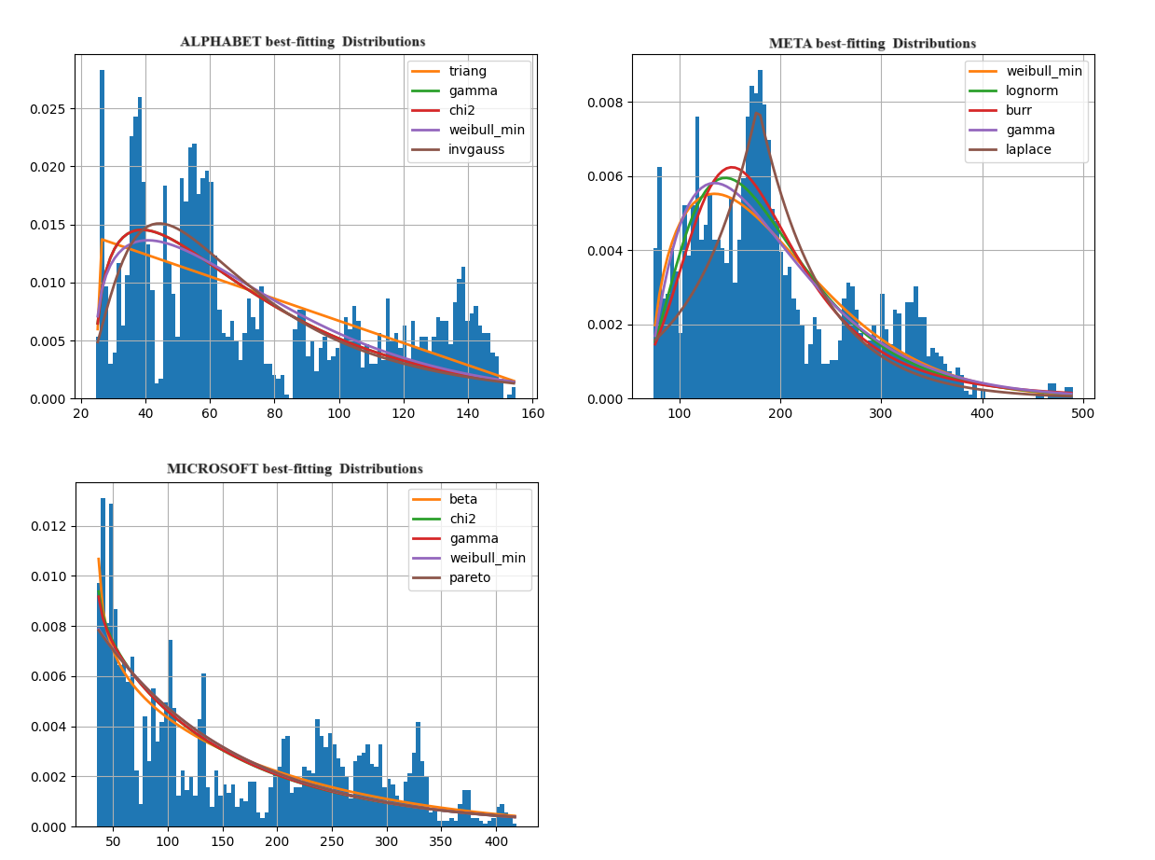

Figure : Best-fitting Distributions Plot of Alphabet, Meta, and Microsoft

|  |  |  |  |
| --- | --- | --- | --- |
| **Statistics** | **Alphabet** | **Meta** | **Microsoft** |
| Best-Fitting Distribution | Triangular | Weibull_Min | Beta |
| Distribution Parameters | 'c': 0.013965398369329092, 'loc': 24.325991499760093, 'scale': 145.6463625529612 | 'c': 1.476317889619243, 'loc': 72.3352781557903, 'scale': 34.36230849716202 | 'a': 0.8267846118714879, 'b': 4.442673066892139, 'loc': 34.82327699999999, 'scale': 782.2503021914882 |
| Threshold Percentile | 0.95 | 0.95 | 0.95 |
| No of outliers | 192 | 79 | 30 |
| Min outliers | 137.653503 | 355.073273 | 392.43512 |
| Max outliers | 154.839996 | 490.130005 | 419.017914 |

Table : Best-fitting distribution and outlier statistics for Alphabet, Meta, and Microsoft stocks

Upon inspection, Alphabet's outliers correspond to sharp growth from mid-2021 to early 2022 and from late 2023 onwards. Meta's outliers appear in Q3 2021 and late 2023 onwards. Microsoft's outliers are noticeable from early 2024.

Despite this, retaining outliers is justified due to the following factors:

* **Significant Events**

All three stocks showed significant growth with peaks in 2021-2022 and late 2023, likely influenced by major events. Retaining these outliers captures the market's behaviour accurately.

* **Market Volatility**

Stock prices are inherently volatile, and these fluctuations are essential for understanding stock behaviour.

* **Robust Modelling**

The models used are robust and can effectively handle the volatility introduced by outliers, capturing extreme values reliably.

Retaining outliers and using robust forecasting models provide a comprehensive view of stock prices, accounting for both routine fluctuations and significant market events.

* 1. **Exploratory Data Analysis (EDA)**

The exploratory data analysis (EDA) phase examined the data of all three stocks to identify patterns such as seasonality and trends. This was achieved using the Augmented Dickey-Fuller (ADF) and Ljung-Box tests, as well as ACF and PACF plots. To conduct these tests, we utilised Python libraries including ‘statsmodels.tsa.stattools’, ‘statsmodels.stats.diagnostic’, and ‘matplotlib.pyplot’. Finally, visual inspection of the original trends overlaid with a simple moving average confirmed the presence of patterns.

* + 1. **EDA for Alphabet**

The ADF test results (statistic: -0.2321, p-value: 0.9346) indicated that the series was non-stationary, as the p-value was significantly higher than the usual significance level of 0.05.

The Ljung-Box test was performed to assess the presence of autocorrelation at various lags. The results consistently showed significant p-values (p < 0.05) across multiple lags, suggesting that the data exhibited autocorrelation, further confirming non-stationarity.

To further validate these findings, ACF and PACF plots were examined. Our aim was to identify spikes at regular intervals. Based on our daily data, the lags were considered equal to 252.

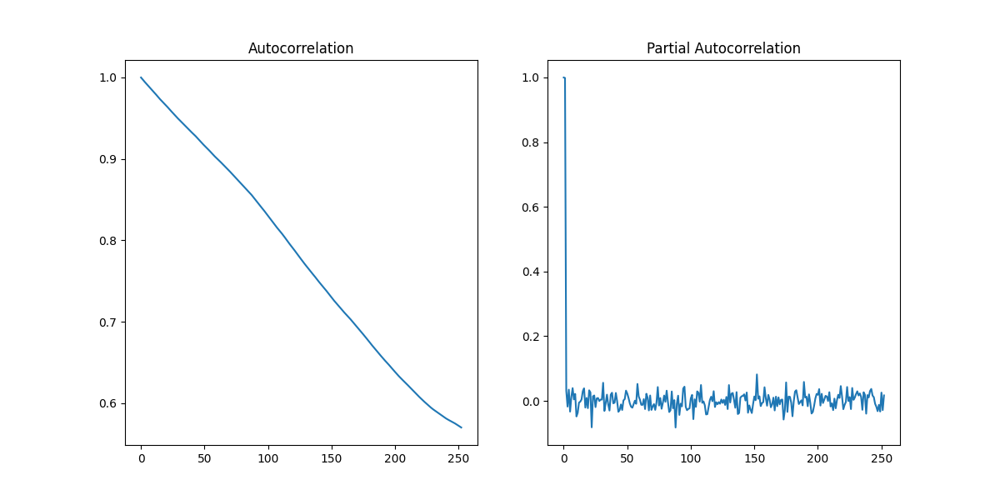

Figure : Original ACF and PACF plots of Alphabet

The ACF plot showed a slow decay, indicating non-stationarity and a strong long-range autocorrelation, but no clear seasonality. The PACF plot had a strong initial spike at lag 1, suggesting strong short-term correlation, with most subsequent lags falling within significance bounds, implying a weakened relationship after the first lag. Overall, no clear signs of seasonality were evident in the ACF and PACF plots.

Given these findings, differencing was applied to the data to unmask presence of seasonality. Subsequent analyses with ADF and Ljung-Box tests, ACF and PACF plots were conducted to identify any seasonality within the dataset.

The ADF test results indicated that after differencing, the time series was now stationary. The ADF statistic was significantly negative (-11.7524), and the p-value was extremely low (1.2003e-21), much lower than the usual significance level of 0.05. This confirmed that the null hypothesis of non-stationarity could be rejected, indicating that the differenced series was stationary.

In the Ljung-Box test statistics, lower lags showed p-values higher than the significance level (0.05), indicating no significant autocorrelation at these lags. However, as the lags increased, the p-values became extremely low (p < 0.05), indicating significant autocorrelation at these higher lags (Appendix II). This suggested that the differenced series still retained some long-term dependencies. Further analysis with ACF and PACF could fully address these dependencies.

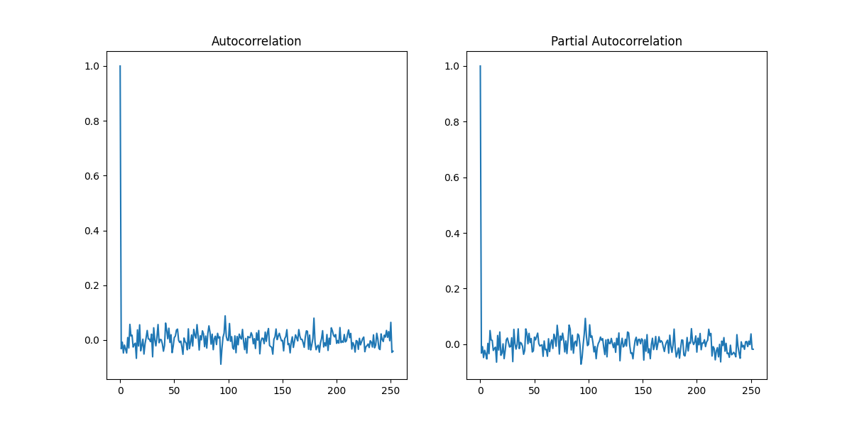

Figure : ACF and PACF plots of Alphabet after first-order differencing

The ACF showed a strong initial spike at lag 1 due to first differencing, then dropped to near zero, indicating white noise. The PACF also showed no significant partial autocorrelation beyond the first lag. The ADF and Ljung-Box tests, along with the ACF and PACF plots, suggested that the series was now stationary. There were no visible periodic spikes or regular patterns, indicating a lack of strong seasonality in the Alphabet data.

Since there was no detectable seasonality, we focused on identifying trends using the original stock price overlaid with a simple moving average of 50 days (selected based on the best metric results of RMSE and MAE).

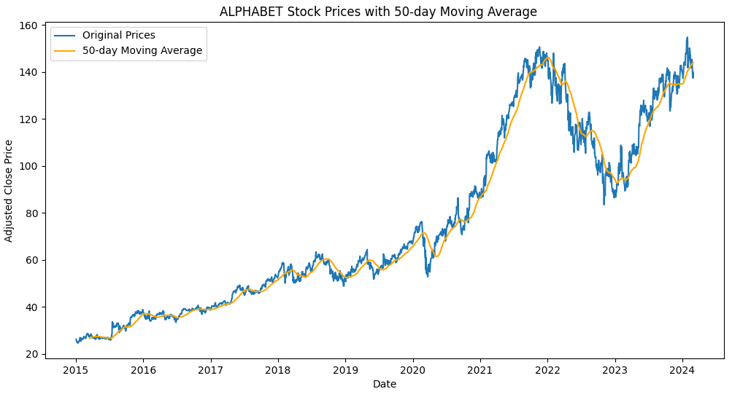

Figure : Alphabet original trends overlaid by 50-day simple moving average

Visual inspection of original and 50-day moving average trends revealed a clear upward trend in Alphabet’s stock price from 2015 to 2024. This long-term trend indicates that the stock price has generally increased over this period.

* + 1. **EDA for Meta**

The ADF test (statistic: 0.0463, p-value: 0.9622) indicated that the series was non-stationary (a high p-value suggests this). The Ljung-Box test confirmed this non-stationarity, as it revealed statistically significant autocorrelation (p-values less than 0.05) across multiple lags. To strengthen the evidence for non-stationarity, ACF and PACF plots were examined.

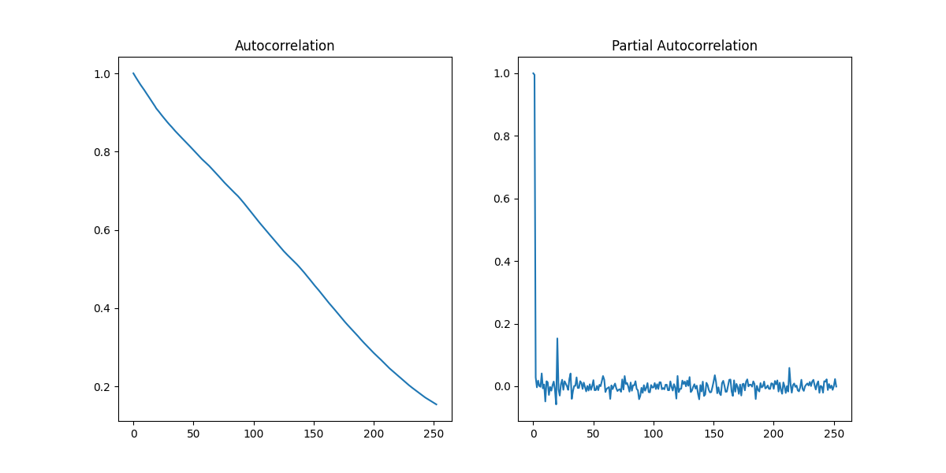

Figure : Original ACF and PACF plots of META

META's plots suggest characteristics of non-stationarity. The ACF plot exhibits strong autocorrelation across most lags, indicating no recurring patterns that might suggest strong seasonality. Similarly, the PACF plot shows a pronounced spike at lag one, with most other lags close to zero, although a few outliers exist. Overall, there's no clear evidence of seasonality.

Based on these findings, first-order differencing was performed. The ADF test results (statistic: -8.6973, p-value: 3.8947e-14) strongly suggest that the data is now stationary. While the Ljung-Box test confirms this, it revealed some remaining autocorrelation at higher lags (Appendix II). To investigate these remaining dependencies in the differenced data, ACF and PACF plots were examined.

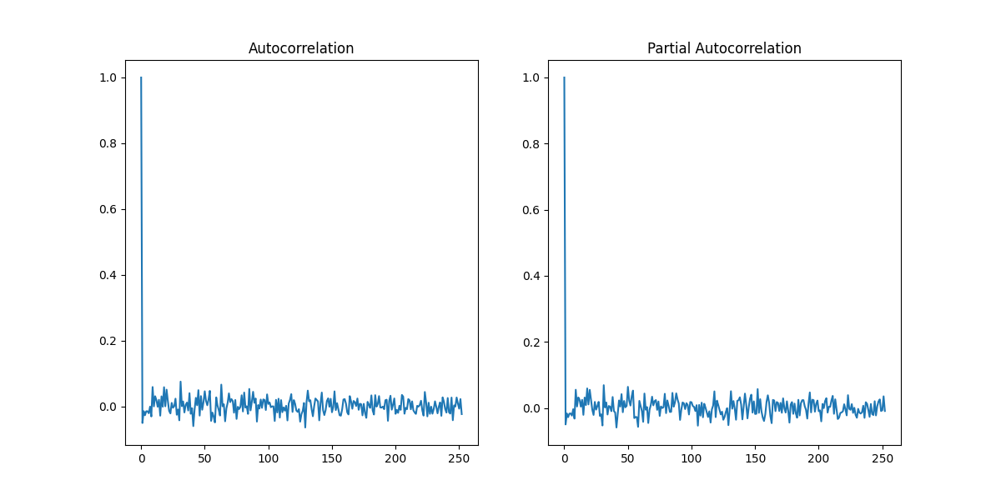

Figure : ACF and PACF plots of META after first-order differencing

The ACF and PACF plots confirmed stationarity, with the ACF showing a large initial spike due to differencing and subsequent values near zero and the PACF showing no significant autocorrelations beyond the first lag. No clear seasonal patterns were observed in the META data, and the lack of regular spikes or significant autocorrelation at specific lags further supports this. We therefore focused on trend detection using the original price data with a 210-day moving average (chosen based on RMSE and MAE metrics).

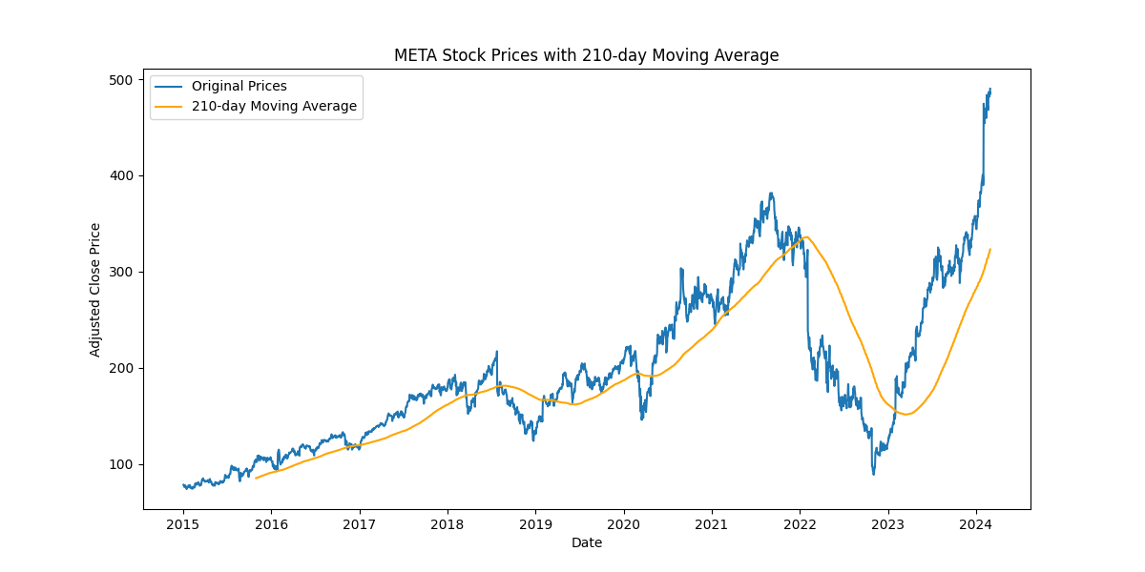

Figure : Alphabet original trends overlaid by 210-day simple moving average

Despite a sharp price drop in 2022, META's stock exhibits a clear upward trend from 2015 to 2024, confirmed by both the original price and the 210-day moving average. This long-term trend reflects a general increase over this period.

* + 1. **EDA for Microsoft**

Analysis of stationarity in the data suggests it's likely non-stationary. The ADF test statistic (1.1992) with a high p-value (0.9959) indicates this. Furthermore, the Ljung-Box test results show statistically significant autocorrelation (p-values of 0 across all lags), reinforcing the evidence for non-stationarity. Visual inspection of ACF and PACF plots can further support the evidence for non-stationarity.

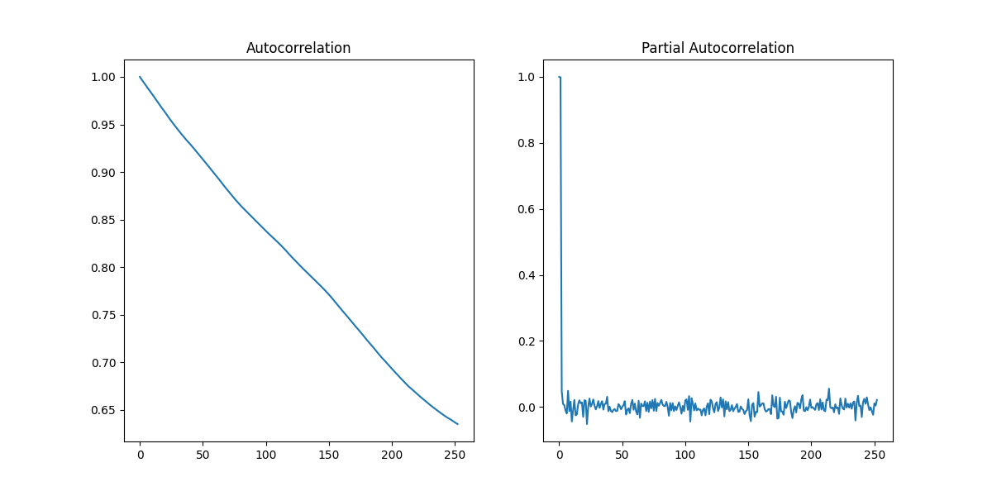

Figure : Original ACF and PACF plots of Microsoft

Examination of Microsoft's data reveals characteristics consistent with non-stationarity. The ACF plot exhibits strong autocorrelation across most lags, suggesting an absence of recurring patterns that would typically indicate seasonality. This observation is further supported by the PACF plot, which shows a pronounced spike at lag one but minimal autocorrelation at other lags, with a few exceptions.

The ADF test statistic of -10.39 and a highly significant p-value (1.9279e-18) strongly suggest the data is now stationary after first-order differencing. This is contradictory to the Ljung-Box test results which shows remaining autocorrelation (Appendix II). To further investigate potential seasonality, we examined the ACF and PACF plots.

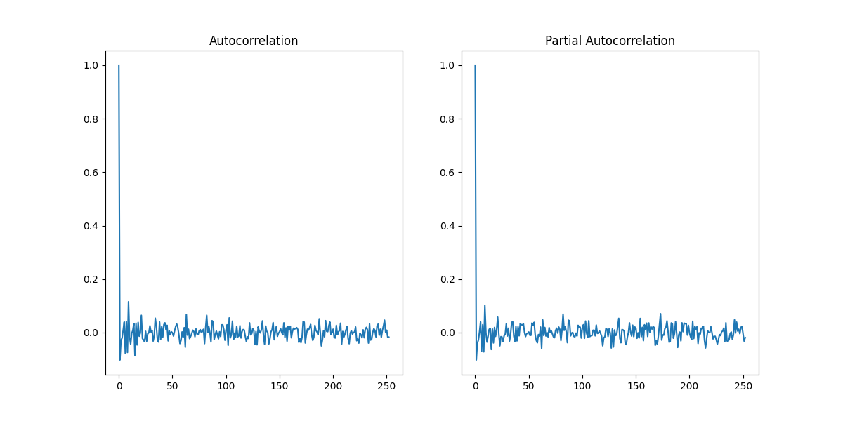

Figure : ACF and PACF plots of Microsoft after first-order differencing

The ACF and PACF plots suggest that the first-order differenced series for Microsoft is stationary, as indicated by the initial spike at lag 1 followed by autocorrelations near zero. This implies that the data no longer exhibits significant autocorrelation or clear seasonal patterns. Consequently, we focused on trend detection using the original price data with a 90-day moving average (selected based on RMSE and MAE metrics).

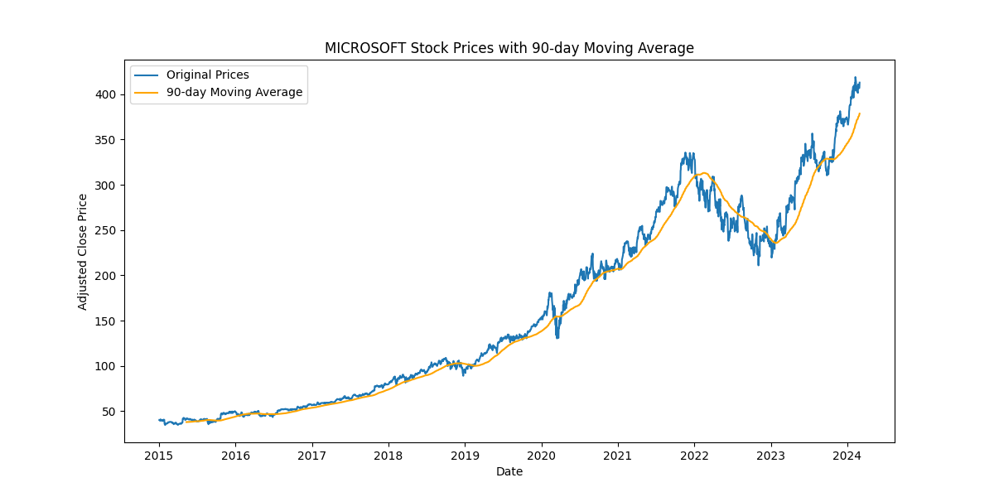

Figure : Microsoft original trends overlaid by 90-day simple moving average

Examining the period from 2015 to 2024, Microsoft's stock price reveals a clear upward trajectory, despite a price dip in 2022. This long-term trend is evident in both the original price data and the 90-day moving average, indicating a general increase over time.

* 1. **Data Splitting**

To train and evaluate the performance of our forecasting models, we adopted an 80/20 train-test split. This means that 80% of the data is utilised for training the models, and the remaining 20% is reserved for testing and evaluating their performance.

The training data comprises 1,844 daily closing prices for each stock, spanning the period from 1st January 2015 to 28th April 2022. The test data encompasses daily closing prices from 29th April 2022 to 29th February 2024.

* 1. **Model Implementation**

This stage involves fitting a series of models to the data to determine which one best captures the trends in stock prices. First, we fit two simple statistical models as baselines: Simple Moving Average (SMA) and Exponential Moving Average (EMA). These baselines are implemented using a naive approach. It means the last MA value from the training period is then used as a constant forecast for the entire test period. This naive approach assumes that the future stock prices will remain at the level of the last SMA or EMA value calculated from the training set.

Following the baseline models, we fit a range of more advanced models:

* Statistical Models:
* Exponential Smoothing
* ARIMA (Autoregressive Integrated Moving Average)
* ARIMA-GARCH (combines ARIMA with GARCH for volatility modelling)
* Machine Learning Models:
* Recurrent Neural Network (RNN)
* Long Short-Term Memory (LSTM)
* Gated Recurrent Unit (GRU)

**Model Selection Considerations**

Our decisions regarding model selection are informed by the findings of the exploratory data analysis (EDA) stage. Notably, the absence of significant seasonality allows us to set the seasonality parameter to "false" during model training. Conversely, the observed presence of volatility in the stock prices, evidenced by the results of distribution fitting and identified outliers, justifies the inclusion of models equipped to handle this phenomenon, such as ARIMA-GARCH.

**Model Tuning**

* Statistical Models

For these models, manual parameter tuning will be conducted across various scenarios to identify the configuration with the lowest Mean Absolute Error (MAE) and Root Mean Squared Error (RMSE). This process will involve trying different combinations of parameters and selecting the one that produces the best results.

* Machine Learning Models

To optimize these models, we will leverage an automated hyperparameter tuning function with 50 iterations. This function will automatically explore different combinations of hyperparameters and select the best set that minimizes the error metrics (MAE and RMSE).

**Python Libraries Used**

We will utilise the following Python libraries to implement and forecast the models:

|  |  |
| --- | --- |
| **Main Library** | **Imported Class** |
| ‘statsmodels.tsa.holtwinters’ | ‘ExponentialSmoothing’ |
| ‘statsmodels.tsa.arima.model’ | ‘ARIMA’ |
| ‘arch’ | ‘arch_model’ |
| ‘tensorflow.keras.models’ | ‘Sequential’ |
| ‘tensorflow.keras.layers’ | ‘SimpleRNN’, ‘Dense’, ‘Dropout’, ‘LSTM’, ‘GRU’ |
| ‘sklearn.preprocessing’ | ‘MinMaxScaler’ |
| ‘sklearn.model_selection’ | ‘ParameterSampler’ |
| ‘sklearn.metrics’ | ‘mean_squared_error’, ‘mean_absolute_error’ |
| ‘scipy.stats’ | ‘randint’, ‘uniform’ |

Table : Python Libraries utilised for model implementation

* + 1. **Alphabet Stock Price Forecast**

Before presenting the comparative results of the forecasting models, we first outline the hyperparameters obtained through the tuning process.

|  |  |
| --- | --- |
| **Forecasting Model** | **Tuned Parameters** |
| SMA | 50-day moving average |
| EMA | 50-day moving average |
| Exponential Smoothing | Seasonality = False |
| ARIMA | order (2, 2, 2) |
| ARIMA-GARCH | ARIMA(2,2,2)-GARCH(2,2) |
| RNN | {'batch_size': 15, 'dropout': 0.25171866634056334, 'epochs': 48, 'learning_rate': 0.0030474457706320727, 'look_back': 1, 'return_sequences': False, 'units': 88} |
| LSTM | {'batch_size': 10, 'dropout': 0.1311217605210499, 'epochs': 35, 'learning_rate': 0.009105956549136991, 'look_back': 1, 'return_sequences': False, 'units': 48} |
| GRU | {'batch_size': 24, 'dropout': 0.0010595028648908156, 'epochs': 91, 'learning_rate': 0.0065272063812476955, 'look_back': 4, 'return_sequences': False, 'units': 34} |

Table : Tuned Parameters of Forecasting Models for Alphabet Stock Price Prediction

The corresponding forecast charts are presented below:

|  |  |
| --- | --- |
|  |  |
|  |  |
|  |  |
|  |  |

Figure : Alphabet Baseline and Forecasting Models’ Charts

Based on the best-tuned hyperparameters, the following table presents a comparison of the forecasts for Alphabet stock prices:

|  |  |  |
| --- | --- | --- |
| **Models** | **RMSE** | **MAE** |
| SMA | 23.3930 | 19.3182 |
| EMA | 22.9918 | 19.0076 |
| Exponential Smoothing | 19.3459 | 14.8952 |
| ARIMA | 19.3427 | 14.8919 |
| ARIMA-GARCH | 17.7210 | 13.4031 |
| RNN | 2.6674 | 2.0425 |
| LSTM | 2.5260 | 1.9194 |
| GRU | 2.5221 | 1.9002 |

Table : Comparative Results of Forecasting Models and Performance Metrics for Alphabet

**Interpretation of the Results**

Among the statistical models, ARIMA-GARCH outperforms the SMA and EMA baseline models in forecasting Alphabet's stock price, as evidenced by its lower RMSE and MAE. The ARIMA-GARCH model also surpasses ARIMA due to its superior ability to capture volatility and temporal dynamics in the data.

However, advanced recurrent neural network models demonstrate substantially lower RMSE and MAE compared to statistical models, indicating higher accuracy in predicting the time series. This suggests that these models are better suited for capturing complex, non-linear relationships in the data.

Among these advanced models, the RNN achieved the lowest validation loss (5.9612 compared to 6.3194 for LSTM and 6.0293 for GRU). Nevertheless, the GRU model shows the most promising results in terms of RMSE and MAE, outperforming the baseline models and offering the best overall performance by effectively balancing complexity and predictive power.

* + 1. **META Stock Price Forecast**

we first outline the hyperparameters obtained through the tuning process.

|  |  |
| --- | --- |
| **Forecasting Model** | **Tuned Parameters** |
| SMA | 90-day moving average |
| EMA | 90-day moving average |
| Exponential Smoothing | Seasonality = False |
| ARIMA | order (1, 2, 2) |
| ARIMA-GARCH | ARIMA(1,2,2)-GARCH(1,1) |
| RNN | {'batch_size': 16, 'dropout': 0.05467804803565551, 'epochs': 23, 'learning_rate': 0.007659192886149137, 'look_back': 3, 'return_sequences': False, 'units': 38} |
| LSTM | {'batch_size': 19, 'dropout': 0.08034928178417022, 'epochs': 14, 'learning_rate': 0.00596315278232027, 'look_back': 1, 'return_sequences': False, 'units': 98} |
| GRU | {'batch_size': 24, 'dropout': 0.3997474663039183, 'epochs': 46, 'learning_rate': 0.010744806220539603, 'look_back': 5, 'return_sequences': False, 'units': 33} |

Table : Tuned Parameters of Forecasting Models for META Stock Price Prediction

The corresponding forecast charts are presented below:

|  |  |
| --- | --- |
|  |  |
|  |  |
|  |  |
|  |  |

Figure : META Baseline and Forecasting Models’ Charts

Based on the best-tuned hyperparameters, the following table presents a comparison of the forecasts for META stock prices:

|  |  |  |
| --- | --- | --- |
| **Models** | **RMSE** | **MAE** |
| SMA | 94.7119 | 82.5677 |
| EMA | 93.7591 | 81.3003 |
| Exponential Smoothing | 87.3022 | 71.7266 |
| ARIMA | 87.0224 | 71.6127 |
| ARIMA-GARCH | 86.2684 | 72.3196 |
| RNN | 7.3929 | 4.7165 |
| LSTM | 7.5807 | 5.0083 |
| GRU | 7.3961 | 4.9242 |

Table : Comparative Results of Forecasting Models and Performance Metrics for META

**Interpretation of the Results**

Among the statistical models, ARIMA-GARCH demonstrates the lowest RMSE and MAE compared to the baseline and other statistical models in forecasting META’s stock price. However, advanced recurrent neural network models exhibit substantially lower RMSE and MAE compared to statistical models.

Among these neural network models, the RNN presented the lowest validation loss (48.8468 compared to 48.9812 for LSTM and 51.6435 for GRU), as well as the lowest RMSE and MAE, followed closely by the GRU. This indicates that RNN is the most effective model for predicting META’s stock price, with GRU also performing well.

* + 1. **Microsoft Stock Price Forecast**

we first outline the hyperparameters obtained through the tuning process.

|  |  |
| --- | --- |
| **Forecasting Model** | **Tuned Parameters** |
| SMA | 90-day moving average |
| EMA | 90-day moving average |
| Exponential Smoothing | Seasonality = False |
| ARIMA | order (2, 2, 2) |
| ARIMA-GARCH | ARIMA(2,2,2)-GARCH(2,2) |
| RNN | {'batch_size': 23, 'dropout': 0.044295524080964044, 'epochs': 73, 'learning_rate': 0.010301134772215333, 'look_back': 5, 'return_sequences': False, 'units': 40} |
| LSTM | {'batch_size': 5, 'dropout': 0.04211393060968949, 'epochs': 69, 'learning_rate': 0.0016780074660399514, 'look_back': 9, 'return_sequences': False, 'units': 42} |
| GRU | {'batch_size': 16, 'dropout': 0.27228816701190384, 'epochs': 23, 'learning_rate': 0.001997670302453216, 'look_back': 1, 'return_sequences': False, 'units': 96} |

Table : Tuned Parameters of Forecasting Models for Microsoft Stock Price Prediction

The corresponding forecast charts are presented below:

|  |  |
| --- | --- |
|  |  |
|  |  |
|  |  |
|  |  |

Figure : Microsoft Baseline and Forecasting Models’ Charts

Based on the best-tuned hyperparameters, the following table presents a comparison of the forecasts for Microsoft stock prices:

|  |  |  |
| --- | --- | --- |
| **Models** | **RMSE** | **MAE** |
| SMA | 53.3485 | 46.7654 |
| EMA | 53.5230 | 46.5023 |
| Exponential Smoothing | 42.2610 | 35.2332 |
| ARIMA | 42.5827 | 35.5366 |
| ARIMA-GARCH | 40.8237 | 34.1141 |
| RNN | 14.1964 | 12.9562 |
| LSTM | 10.0935 | 8.8062 |
| GRU | 5.1217 | 3.9073 |

Table : Comparative Results of Forecasting Models and Performance Metrics for Microsoft

**Interpretation of the Results**

Among the statistical models, ARIMA-GARCH presented the lowest RMSE and MAE in forecasting Microsoft’s stock price. Unlike the other two stocks, this time Exponential Smoothing outperformed ARIMA. However, advanced recurrent neural network models exhibited substantially lower RMSE and MAE compared to statistical models.

Among these neural network models, the GRU exhibited the lowest validation loss (27.8640 compared to 28.0490 for RNN and 27.8863 for LSTM), as well as the lowest RMSE and MAE. This indicates that GRU is the most effective model for predicting Microsoft’s stock price.

* 1. **Forecasting Performance for Mid-Term Unseen Data**

To investigate discrepancies with findings from other studies, the final forecasts generated by the GRU model (representing deep learning models) are compared to those from the ARIMA-GARCH model (the best performer among statistical methods). This selection is based on the RMSE and MAE scores presented in the previous section. Notably, the GRU model's score for Meta was marginally lower than the RNN model, but the GRU was chosen due to the negligible difference.

The forecast horizon considered a mid-term timeframe, encompassing three calendar months – from the beginning of March to the end of May 2024 – which translates to 63 business days. For each model, the best-tuned parameters identified during the modelling phase were employed.

The visual representation of ARIMA-GARCH and GRU model forecasts for Alphabet, META, and Microsoft is as follows:

|  |  |
| --- | --- |
|  |  |
|  |  |
|  |  |

Figure : Mid-term Prediction Charts of Alphabet, META, and Microsoft

Appendix III provides the full prediction table, while the following tables summarize the key findings:

|  |  |  |  |
| --- | --- | --- | --- |
| **Statistics** | **Real Data** | **ARIMA-GARCH Forecast** | **GRU Forecast** |
| Mean | 158.8312698 | 118.5202297 | 159.4705051 |
| Standard Error | 1.677293441 | 0.110022838 | 1.029708699 |
| Median | 157.66 | 118.5305587 | 162.09752 |
| Mode | 151.94 | #N/A | #N/A |
| Standard Deviation | 13.31310396 | 0.873279204 | 8.173059424 |
| Sample Variance | 177.2387371 | 0.762616568 | 66.79890035 |
| Kurtosis | -0.890379401 | -1.19576964 | -0.595870826 |
| Skewness | -0.234767037 | -0.003255059 | -0.780712469 |
| Range | 46.98 | 2.98102 | 27.72407 |
| Minimum | 132.56 | 117.0109123 | 140.77133 |
| Maximum | 179.54 | 119.9919323 | 168.4954 |
| Sum | 10006.37 | 7466.77447 | 10046.64182 |
| Count | 63 | 63 | 63 |

Table : Summary of real and predicted values for Alphabet

|  |  |  |  |
| --- | --- | --- | --- |
| **Statistics** | **Real Data** | **ARIMA-GARCH Forecast** | **GRU Forecast** |
| Mean | 485.6965094 | 212.6107345 | 484.6987952 |
| Standard Error | 2.875910666 | 0.15982517 | 0.173658043 |
| Median | 491.350006 | 212.5984275 | 484.08276 |
| Mode | #N/A | #N/A | #N/A |
| Standard Deviation | 22.82683324 | 1.268572955 | 1.378367986 |
| Sample Variance | 521.0643159 | 1.609277343 | 1.899898306 |
| Kurtosis | -0.079848557 | -1.193884676 | 2.847212346 |
| Skewness | -0.567019961 | 0.001294391 | 1.737867769 |
| Range | 97.170014 | 4.3322994 | 6.26981 |
| Minimum | 430.170013 | 210.4653215 | 483.61697 |
| Maximum | 527.340027 | 214.7976209 | 489.88678 |
| Sum | 30598.88009 | 13394.47627 | 30536.0241 |
| Count | 63 | 63 | 63 |

Table : Summary of real and predicted values for META

|  |  |  |  |
| --- | --- | --- | --- |
| **Statistics** | **Real Data** | **ARIMA-GARCH Forecast** | **GRU Forecast** |
| Mean | 415.2309 | 281.6476058 | 411.2951716 |
| Standard Error | 1.279222 | 0.288803756 | 0.040978789 |
| Median | 415.6703 | 281.6731341 | 411.18304 |
| Mode | #N/A | #N/A | #N/A |
| Standard Deviation | 10.15351 | 2.292308751 | 0.325259052 |
| Sample Variance | 103.0938 | 5.254679412 | 0.105793451 |
| Kurtosis | -0.48916 | -1.159064321 | 6.673300909 |
| Skewness | -0.48231 | -0.025395912 | 2.271451127 |
| Range | 41.89099 | 8.1259588 | 1.59491 |
| Minimum | 388.629 | 277.3374435 | 411.01602 |
| Maximum | 430.52 | 285.4634023 | 412.61093 |
| Sum | 26159.55 | 17743.79917 | 25911.59581 |
| Count | 63 | 63 | 63 |

Table : Summary of real and predicted values for Microsoft

The following table presents a prediction comparison for all three stock prices:

|  |  |  |  |
| --- | --- | --- | --- |
| **Models** | **Alphabet**  **(RMSE, MAE)** | **META**  **(RMSE, MAE)** | **Microsoft**  **(RMSE, MAE)** |
| ARIMA-GARCH | (41.6175, 39.7798) | (274.6141, 273.5990) | (133.7888, 133.4012) |
| GRU | (5.9912, 5.2584) | (22.3640, 18.0397) | (10.7544, 9.1580) |

Table : Comparative Table for Mid-term Forecasting of Alphabet, META, and Microsoft

A visual inspection of the predicted values, alongside the RMSE and MAE results, clearly indicates that the GRU model significantly outperforms the ARIMA-GARCH model. This is evident from the lower values for both RMSE and MAE for GRU. This finding aligns well with the research of Siami-Namini et al. (2018), who highlighted the superiority of LSTM (another recurrent neural network) compared to ARIMA models. This is further supported by the detailed statistics in Summary Tables, which demonstrate the GRU model's ability to predict values closer to the actual closing prices.

* 1. **Summary**

In the EDA section, our examination of the stock price datasets for Alphabet, Meta, and Microsoft aimed to identify seasonality or trends. We utilised ADF and Ljung-Box tests, along with ACF and PACF plots. Additionally, a visual inspection of the original price data, overlaid with a simple moving average, helped to corroborate the presence of these patterns. None of the stock price series exhibited strong seasonality. However, all three companies displayed upward trends over the 2015-2024 period.

In the next step, to train and evaluate the performance of our forecasting models, we adopted an 80/20 train-test split. While the ARIMA-GARCH model provided a significant improvement over traditional statistical models, advanced recurrent neural networks, particularly GRU (with the exception of RNN for META), offered the highest accuracy for forecasting all three stock prices.

In the subsequent phase, the top performer from each category of models, i.e. ARIMA-GARCH and GRU was chosen to forecast a mid-term unseen data. A visual inspection of the predicted values, alongside the RMSE and MAE results, indicated that the GRU model significantly outperformed the ARIMA-GARCH model across all three stocks.

In the final chapter, "Conclusion, Limitations and Recommendations," we will discuss our research aims, objectives, and questions based on the findings of this chapter, and draw our final conclusions.

1. **Conclusion, Limitations, and Recommendations**
   1. **Introduction**

This concluding chapter revisits the original research aims, objectives, and questions outlined in the first chapter. It then synthesizes the key findings from the data analysis presented in Chapter 4 to draw comprehensive conclusions about our investigation into stock price forecasting models. Finally, the chapter addresses the limitations of the current study and proposes valuable recommendations for future research directions in this field.

* 1. **Research Conclusion**

**RQ1: Identifying Long-Term Trends**

This section investigates the effectiveness of time series models in identifying significant long-term trends within the historical stock prices of Alphabet, Meta, and Microsoft. The analysis utilised historical adjusted closing stock prices for each company, spanning the period from 1st January 2015 to 30th April 2024. Exploratory Data Analysis (EDA) revealed no strong evidence of seasonality within the data. However, upward trends were identified in all three stock price series.

Informed by the existing literature (Selvin et al., 2017; Siami-Namini et al., 2018; Hu et al. 2020; Hyndman et al., 2021; Kim, 2022; Kobiela et al., 2022), a variety of time series models were implemented to capture long-term trends. Traditional statistical models including ARIMA-GARCH, alongside deep learning models like LSTM. To ensure optimal performance, hyperparameter tuning was conducted for each model. Importantly, all models were compared to baseline models: Simple Moving Average (SMA) and Exponential Moving Average (EMA) to assess their effectiveness.

The chosen models successfully captured significant long-term trends within the historical stock prices. The best performing model varied for each company. Nevertheless, all models demonstrated the capacity to identify the overall direction in the stock price movements.

The absence of significant seasonal trends suggests that the stock prices of these AI/ML companies are primarily influenced by long-term factors. These factors could include industry growth, company performance, or macroeconomic conditions (Wu et al., 2021). This research aligns with previous findings highlighting the strengths and limitations of traditional and deep learning models in time series forecasting (Hu et al., 2020; Siami-Namini et al., 2018; Kobiela et al., 2022).

**RQ2: Comparative Suitability of Time Series Models for Trend Analysis in AI Stocks**

This research question investigates the relative effectiveness of different time series models in capturing underlying trends within the stock prices of leading AI/ML companies. The analysis revealed that, in general, machine learning models (RNNs, LSTMs, GRUs) demonstrated greater suitability compared to traditional statistical models (ARIMA, ARIMA-GARCH, Exponential Smoothing) for trend analysis. This can be attributed to the inherent limitations of statistical models.

* **Statistical Model Limitations**

These models often rely on assumptions about the data, such as stationarity. However, stock prices frequently exhibit trends and non-linear relationships, violating these assumptions (Hyndman et al., 2021). This can lead to suboptimal performance in capturing underlying trends. While ARIMA-GARCH addresses volatility, a common challenge in stock prices (Hu et al., 2020), its effectiveness can be limited, particularly when dealing with complex non-linearities. Exponential Smoothing can sometimes outperform ARIMA (Shahid et al., 2020), but its suitability depends heavily on the specific characteristics of the stock data.

* **Machine Learning Model Advantages**

In contrast, machine learning models, particularly RNNs and their variants (LSTMs, GRUs), excel at handling non-linear relationships and complex data structures (Selvin et al., 2017). This allows them to capture trends more effectively in financial data like stock prices, which often exhibit these characteristics (Beniwal et al., 2024).

Amongst statistical models, ARIMA-GARCH outperformed others due to its ability to handle volatility (Hu et al., 2020; Kim, 2022). Regarding deep learning models, while GRUs emerged as a strong performer across all companies, the most suitable advanced model differed for each company's stock data:

* Alphabet: GRU
* Meta: RNN (closely followed by GRU)
* Microsoft: GRU

In conclusion, the findings suggest that machine learning models, particularly RNNs and GRUs, are better at capturing underlying trends in the stock prices of leading AI/ML companies compared to traditional statistical models. This contradicts Kobiela et al. (2022) who found ARIMA to be superior, but aligns more closely with Siami-Namini et al. (2018). However, even among machine learning models, the optimal choice may vary depending on the specific company and the characteristics of its stock data. Unlike Beniwal et al. (2024), this study finds GRUs to be superior to LSTMs.

**RQ3: Similarities and Differences in Long-Term and Seasonal Trends of AI Stock Prices**

This research question investigates the similarities and differences in long-term and seasonal trends within the stock prices of Alphabet, Meta, and Microsoft.

* **Similarities**

A key finding from the initial Exploratory Data Analysis (EDA) was the lack of significant seasonal patterns in the price movements for all three companies. This suggests that factors influencing stock prices, such as industry growth, company performance, or macroeconomic conditions (Wu et al., 2021), have a more consistent, long-term effect rather than exhibiting predictable seasonal fluctuations.

Despite the absence of seasonality, all three companies exhibited a notable similarity: the presence of upward long-term trends in their historical stock prices. This finding suggests a sustained positive outlook from investors on the future prospects of these leading AI/ML players.

* **Differences**

While all companies displayed long-term growth, the specific model that best captured this trend differed for each:

* Alphabet: GRU emerged as the most effective model for capturing the long-term trend in Alphabet's stock price.
* Meta: RNN closely followed by GRU performed best in identifying the long-term trend for Meta's stock price.
* Microsoft: GRU again proved to be the most suitable model for capturing the long-term trend in Microsoft's stock price.

The AI/ML industry, unlike sectors with distinct seasonal patterns (e.g., retail with holiday shopping spikes) (Lili et al., 2023), experiences continuous development and adoption across various industries. This ongoing innovation likely contributes to a more consistent demand for AI-related services and products, reflected in the absence of significant seasonal variations in stock prices for all three companies.

In terms of variations in long-term trend model performance, even though all companies exhibited long-term growth, slight differences in their underlying data characteristics or market dynamics might have influenced the performance of specific time series models.

In conclusion, the analysis revealed a lack of significant seasonality in the stock prices, suggesting a focus on long-term factors influencing their value. While all companies displayed long-term upward trends, the optimal model for capturing these trends varied slightly between them. This underscores the importance of considering company-specific characteristics when selecting models for time series analysis in the AI/ML sector.

**RQ4: Accuracy of Time Series Models in Predicting AI Stock Price Trends**

This research question aimed to assess the effectiveness of various time series models in forecasting future trends within the stock prices of leading AI and ML companies. The analysis compared the performance of:

* **Statistical Models:** Represented by ARIMA-GARCH, which emerged as the most effective model amongst traditional statistical methods.
* **Machine Learning Models:** Represented by the GRU model, chosen due to its consistently strong performance.

The analysis focused on a mid-term forecast horizon, encompassing three months (March to May 2024). The analysis revealed that the GRU model significantly outperformed the ARIMA-GARCH model in predicting future trends for all three companies. This is evident from the consistently lower RMSE and MAE values for the GRU model compared to ARIMA-GARCH. This aligns with research highlighting the strengths of RNNs (similar to GRUs) in handling non-linear relationships within financial data (Siami-Namini et al., 2018). These findings support the notion that machine learning models, particularly RNN variants like GRUs, are better suited for capturing complex non-linear relationships and patterns within financial data like stock prices (Hyndman et al., 2021).

In conclusion, this analysis indicates that, for mid-term forecasting of stock prices in leading AI and ML companies, machine learning models, specifically the GRU model in this case, offer superior accuracy compared to traditional statistical models. This finding supports the potential of machine learning approaches like GRUs in financial forecasting, particularly when dealing with data exhibiting non-linear relationships. By showcasing the effectiveness of GRUs, this research mitigates the risks associated with suboptimal decisions arising from traditional models' limitations with complex data. The benefits extend beyond academia, empowering investors to identify opportunities, manage risk, and ultimately enhance returns.

* 1. **Limitations**

This study identified three key limitations associated with the employed methodology:

* **Limitations of Univariate Analysis**

This research utilised historical stock prices to identify long-term trends. However, due to the inherent volatility of financial markets, past performance is not necessarily indicative of future results. Additionally, the univariate analysis employed in this study does not account for external influences, such as broader economic fluctuations, technological advancements, and other factors. This limitation restricts the analysis from capturing the complete picture of stock price movements, potentially leading to inaccurate predictions. Furthermore, univariate analysis cannot explain the "why" behind price changes and the underlying causes influencing them. Understanding these causes is crucial for making informed investment decisions (Narayan et al., 2010).

* **Challenges of Univariate Models**

Univariate models, such as the one employed in this study which relies solely on stock price data, are susceptible to overfitting. This means they might perform well on historical data but fail to generalise and accurately predict future, unseen data. Introducing additional variables relevant to stock price movements can help mitigate overfitting and enhance the model's ability to adapt to changing market conditions (Zhang et al., 2005).

* **Deep Learning Model Uncertainty**

Deep learning models present another challenge when dealing with prediction uncertainty. Each time they are run, they might provide different results due to random initialisation, nonlinearity, and internal randomness (Gal et al., 2016). For research purposes or non-critical analysis, running the model once or utilising ensemble methods is sufficient (Lakshminarayanan et al., 2017). However, for high-risk decisions a more conservative approach should be considered.

* 1. **Recommendations for future research**

While univariate analysis provided valuable insights in this study, future research could explore a multivariate approach that considers additional features relevant to stock price movements. These features could include broader market and economic, customer sentiment data, and technological advancements. A multivariate approach has the potential to improve forecasting accuracy by capturing a more comprehensive picture of the factors influencing stock prices. Additionally, it could help mitigate the overfitting issue observed in univariate models (Tsai et al., 2010).

For high-risk decisions, it is recommended to consider a more conservative approach by using confidence intervals. This provides a range of possible future outcomes and quantifies the uncertainty associated with the predictions. Additionally, integrating the results of the forecasting model with expert knowledge and analysis can combine quantitative and qualitative insights, leading to more informed and robust decision-making (Hyndman et al., 2021).

* 1. **Conclusion**

This chapter summarizes the analysis of stock price forecasting models for leading AI companies (Alphabet, Meta, Microsoft).

**Key Findings:**

* Long-Term Trends: All three companies exhibited upward long-term trends in their stock prices, suggesting a positive outlook from investors on the future of AI/ML.
* Seasonal Trends: No significant seasonal patterns were identified, indicating that factors influencing stock prices have a more consistent, long-term effect.
* Model Comparison: Machine learning models (RNNs, LSTMs, GRUs) were generally more effective than traditional statistical models (ARIMA, ARIMA-GARCH, Exponential Smoothing) in capturing underlying trends.
* GRUs: Amongst machine learning models, GRUs emerged as a strong performer for capturing long-term trends.
* Forecasting Accuracy: The GRU model significantly outperformed the ARIMA-GARCH model in predicting mid-term trends (3 months) for all three companies.

**Limitations:**

* Focusing solely on historical prices might miss key influencing factors and lead to inaccurate predictions.
* The model might be susceptible to overfitting and produce unreliable forecasts for unseen data.
* Deep learning models can exhibit variations in predictions.

**Future Directions:**

* Explore techniques to mitigate overfitting and improve model generalizability.
* For high-risk decisions, use confidence intervals and expert analysis alongside model predictions.

# **Reference List**

Aggarwal, C. (2015) *Data mining: the textbook.* (vol. 1) New York: springer.

Aggarwal, C. (2017) *Outlier Analysis: the textbook.* (Second Edition) New York: springer.

Ariyo, A., Adewumi, O., Ayo, C. (2014) ‘Stock Price Prediction Using the ARIMA Model’ *UKSim-AMSS 16th International Conference on Computer Modelling and Simulation, Cambridge, UK, 2014, pp. 106-112.* [Online] [Accessed on 12th May 2024] DOI: 10.1109/UKSim.2014.67

Arkhangelskaya, E., Nikolenko, S. (2023) ‘Deep Learning for Natural Language Processing: A Survey’*J Math Sci 273, 533–582.*  [Online] [Accessed on 22nd April 2024] DOI: <https://doi.org/10.1007/s10958-023-06519-6>

ArunKumar, A., Kalaga, V., CMS, K., Kawaji, M., Brenza, T. (2021) ‘Forecasting of COVID-19 using deep layer Recurrent Neural Networks (RNNs) with Gated Recurrent Units (GRUs) and Long Short-Term Memory (LSTM) cells.’ *Chaos, Solitons & Fractals, Volume 146, 110861.* [Online] [Accessed on 9th May 2024] DOI: <https://doi.org/10.1016/j.chaos.2021.110861>

Asokan, M., (2022) ‘A study of forecasts in financial time series using machine learning methods’ *Diva Portal.*  [Online] [Accessed on 25th April 2024] <https://www.diva-portal.org/smash/record.jsf?pid=diva2%3A1671481&dswid=-5264>

Ayodele, E., Zaidi S., Zhang, Z., Scott, J., McLernon, D. (2021) ‘Chapter 9 - A review of deep learning approaches in glove-based gesture classification’*In Intelligent Data-Centric Systems,Machine Learning, Big Data, and IoT for Medical Informatics, Academic Press, Pages 143-164,.*  [Online] [Accessed on 7th May 2024] DOI: <https://doi.org/10.1016/B978-0-12-821777-1.00012-4>

Barclays (2024) *AI Revolution: Productivity boom and beyond*. [Online] [Accessed on 29th March 2024] <https://www.ib.barclays/our-insights/AI-productivity-boom.html?cid=paidsearch-textads_google_google_themes_ai-revolution_uk-we_ai_nonbrand_802852477106&gad_source=1&gclid=Cj0KCQjwzZmwBhD8ARIsAH4v1gXAy0SmYiK-fXDrA7XnR-D6VtLS-J89TRtvyt4mMSDQM1joyLzxqqsaAtPtEALw_wcB&gclsrc=aw.ds>

BBC (2015) *Facebook to open AI lab in Paris*. [Online] [Accessed on 7th June 2024] <https://www.bbc.co.uk/news/technology-32977242>

Bell, E., Bryman, A. and Harley, B. (2022) *Business research methods.* Oxford university press.

Beniwal, M., Singh, A., Kumar, N. (2024) ‘Forecasting multistep daily stock prices for long-term investment decisions: A study of deep learning models on global indices’ *Engineering Applications of Artificial Intelligence, Volume 129, 107617.* [Online] [Accessed on 9th May 2024] DOI: <https://doi.org/10.1016/j.engappai.2023.107617>

Bright, A. (2023) *What are the average returns of the FTSE 100?* IG. [Online] [Accessed on 25th April 2024] <https://www.ig.com/uk/trading-strategies/what-are-the-average-returns-of-the-ftse-100--230511>

Bollerslev, T. (1986) ‘Generalized autoregressive conditional Heteroskedasticity’.*Journal of econometrics, 31(3), pp.307-327.*  [Online] [Accessed on 7th May 2024] DOI: <https://doi.org/10.1016/0304-4076(86)90063-1>

Box, G., Jenkins, G (1976) *Time Series Analysis: Forecasting and Control.* Holden-Day

Box, G., Reinsel, G., Jenkins, G., Ljung, G., (2015) *Time Series Analysis: Forecasting and Control.* *5th Edition.* Wiley

Brown, R. (1959). *Statistical forecasting for inventory control*. McGraw/Hill.

Bughin, J., Seong, J., Manyika, J., Chui, M., Joshi, R. (2018) *Notes from the AI frontier: Modeling the impact of AI on the world economy* [Online] [Accessed on 16th July 2024] https://www.mckinsey.com/featured-insights/artificial-intelligence/notes-from-the-ai-frontier-modeling-the-impact-of-ai-on-the-world-economy

Burrell, N., Gross, C. (2017) ‘Quantitative Research, Purpose of’ *The SAGE Encyclopedia of Communication Research Methods.* [Online] [Accessed on 19th May 2024] DOI: <https://doi.org/10.4135/9781483381411>

Chatfield, C., Yar, M. (2018). *Time Series Forecasting (6th ed.)*. Chapman and Hall/CRC.

Chen, K., Zhou, Y. and Dai, F. (2015) ‘A LSTM-based method for stock returns prediction: A case study of China stock market’ *2015 IEEE International Conference on Big Data (Big Data), Santa Clara, CA, USA, 2015, pp. 2823-2824.* [Online] [Accessed on 26th April 2024] DOI: 10.1109/BigData.2015.7364089

Chia-Hui, L. (2021) ‘The impact of artificial intelligence on economic growth and welfare’ *Journal of Macroeconomics*, 69: 103342. [Online] [Accessed on 28th March 2024] DOI: <https://doi.org/10.1016/j.jmacro.2021.103342>

Cho, K., Van Merriënboer, B., Gulcehre, C., Bahdanau, D., Bougares, F., Schwenk, H. and Bengio, Y. (2014) ‘Learning phrase representations using RNN encoder-decoder for statistical machine translation’ *arXiv preprint arXiv:1406.1078.* [Online] [Accessed on 9th May 2024] DOI: <https://doi.org/10.48550/arXiv.1406.1078>

Creswell, J.W., Creswell, J.D. (2022) *Research Design: Qualitative, Quantitative, and Mixed Methods Approaches. (6th ed.).* SAGE Publications.

Dash, S., (2020) *Smoothing Techniques for time series data.* Medium[Online] [Accessed on 9th May 2024] https://medium.com/@srv96/smoothing-techniques-for-time-series-data-91cccfd008a2

Dégerine, S., Lambert-Lacroix, S. (2003) ‘Characterization of the partial autocorrelation function of nonstationary time series’ *Journal of Multivariate Analysis,Volume 87, Issue 1, Pages 46-59,.* [Online] [Accessed on 4th June 2024] DOI: https://doi.org/10.1016/S0047-259X(03)00025-3

Devadoss, A. (2013) ‘Forecasting of Stock Prices Using Multi Layer Perceptron’ *Int J Comput Algorithm, vol. 2, pp. 440-449*. [Online] [Accessed on 25th April 2024] DOI: 10.20894/IJWT.104.002.002.006

Dickey, D., Fuller, W. (1979) ‘Distribution of the Estimators for Autoregressive Time Series With a Unit Root’ *Journal of the American Statistical Association June 197974(366).* [Online] [Accessed on 4th Jun 2024] DOI: 10.2307/2286348

Earnest, A., Chen, M., Ng, D., Leo, Y. (2005) ‘Using Autoregressive Integrated Moving Average (ARIMA) Models to Predict and Monitor the Number of Beds Occupied During a SARS Outbreak in a Tertiary Hospital in Singapore’ *in BMC Health Service Research, 5(36).* [Online] [Accessed on 25th April 2024] DOI: 10.1186/1472-6963-5-36

Engle, R. (1982) ‘Autoregressive conditional heteroscedasticity with estimates of the variance of United Kingdom inflation’ *Econometrica: Journal of the econometric society, pp.987-1007*. [Online] [Accessed on 7th May 2024] DOI: <https://doi.org/10.2307/1912773>

Engle, R. (2001) ‘Financial econometrics – A new discipline with new methods’ *Journal of Econometrics, Volume 100, Issue 1, pp 53-56.* [Online] [Accessed on 26th April 2024] DOI: <https://doi.org/10.1016/S0304-4076(00)00053-1>

Fang, Z., Ma, X., Pan, H., Yang, G., Arce, G. (2023) ‘Movement forecasting of financial time series based on adaptive LSTM-BN network’ *Expert Systems with Applications, Volume 213, Part C, 119207.* [Online] [Accessed on 8th May 2024] DOI: <https://doi.org/10.1016/j.eswa.2022.119207>

Fisher, C. and Buglear, J. (2010) *Researching and writing a dissertation: An essential guide for business students.* Pearson Education.

Gal, Y., & Ghahramani, Z. (2016) ‘Dropout as a Bayesian Approximation: Representing Model Uncertainty in Deep Learning.’ *In Proceedings of the 33rd International Conference on Machine Learning (pp. 1050-1059).* [Online] [Accessed on 28th June 2024] DOI: <https://doi.org/10.48550/arXiv.1506.02142>

Gao, T., Chai, Y., Liu, Y. (2017) ‘Applying long short term memory neural networks for predicting stock closing price’ *IEEE International Conference on Software Engineering and Service Science (ICSESS), Beijing, China, 2017, pp. 575-578.* [Online] [Accessed on 8th May 2024] DOI: 10.1109/ICSESS.2017.8342981

Gardner, E., McKenzie, E. (1985) ‘Forecasting trends in time series’. *Management Science, 31(10), 1237–1246.* [Online] [Accessed on 4th May 2024] DOI: <https://doi.org/10.1287/mnsc.31.10.1237>

Goodfellow, I., Bengio, Y., Courville, A. (2016) *Deep learning.* MIT press.

Guo D., Zhang Y. (2012) ‘Novel recurrent neural network for time-varying problems solving’ *IEEE Computational Intelligence Magazine, 7 (4) (2012), pp. 61-65.* [Online] [Accessed on 7th May 2024] DOI: 10.1109/MCI.2012.2215139

Guresen, E., Kayakutlu, G. (2011) ‘Definition of artificial neural networks with comparison to other networks’ *Procedia Computer Science, Volume 3, Pages 426-433.* [Online] [Accessed on 9th May 2024] DOI: <https://doi.org/10.1016/j.procs.2010.12.071>

Holt, C. (1957) ‘Forecasting seasonals and trends by exponentially weighted averages’ *O.N.R. Memorandum No. 52. Carnegie Institute of Technology, Pittsburgh USA.* [Online] [Accessed on 4th May 2024] DOI: <https://doi.org/10.1016/j.ijforecast.2003.09.015>

Hewamalage, H., Bergmeir, C., Bandara, K. (2021) ‘Recurrent Neural Networks for Time Series Forecasting: Current status and future directions’ *International Journal of Forecasting, Volume 37, Issue 1, Pages 388-427.* [Online] [Accessed on 7th May 2024] DOI: <https://doi.org/10.1016/j.ijforecast.2020.06.008>

Hochreiter, S., Schmidhuber, J. (1997) ‘Long Short-Term Memory’ *in Neural Computation, vol. 9, no. 8, pp. 1735-1780.* [Online] [Accessed on 8th May 2024] DOI: 10.1162/neco.1997.9.8.1735

Hu, Y., Tao, Z., Xing, D., Pan, Z., Zhao, J., Chen, X. (2020) ‘Research on Stock Returns Forecast of the Four Major Banks Based on ARMA and GARCH Model’ *J. Phys.: Conf. Ser. 1616 012075.* [Online] [Accessed on 26th April 2024] DOI: 10.1088/1742-6596/1616/1/012075

Hyndman, R., Athanasopoulos, G (2021) *Forecasting: Principles and Practice.* OTexts

Idrees, S., Alam, M., Agarwal, P. (2019) ‘A Prediction Approach for Stock Market Volatility Based on Time Series Data’ *IEEE Access, vol. 7, pp. 17287-17298.* [Online] [Accessed on 9th May 2024] DOI: 10.1109/ACCESS.2019.2895252

Jain, C., Malehorn, J. (2005) *Practical Guide to Business Forecasting*. Institute of Business Forecasting

Jing, C., Xinyu, H., Hao, J., Xiren, M. (2021) ‘Low-Cost and Device-Free Human Activity Recognition Based on Hierarchical Learning Model’. *Sensors, 21. 2359.* [Online] [Accessed on 8th May 2024] DOI: 10.3390/s21072359

Johnston, M. P. (2014) *Secondary data analysis: A method of which the time has come.* Qualitative and Quantitative Methods in Libraries (QQML), 3, 619-626.

Kadam, P. (2012) ‘Trend Detection and Visualization and Custom Search’ *Research Gate.* [Online] [Accessed on 8th May 2024] https://www.researchgate.net/figure/Comparison-of-moving-averages-The-SMA-has-more-lag-than-the-EMA_fig1_235766539

Kai, Y., Xue, D., Xiaohui, Y. (2022) ‘Bayesian empirical likelihood inference and order shrinkage for autoregressive models’ *Statistical Papers. 63.* [Online] [Accessed on 8th May 2024] DOI: 10.1007/s00362-021-01231-6

Kaplan, J. (2016) *Artificial Intelligence. What Everyone Needs to Know*. Oxford University Press.

Kim, S. (2022) ‘ARMA–GARCH model with fractional generalized hyperbolic innovations’ *Financ Innov 8, 48*. [Online] [Accessed on 26th April 2024] DOI: https://doi.org/10.1186/s40854-022-00349-2

Kobiela, D., Krefta, D., Król, W., Weichbroth, P. (2022) ‘ARIMA vs LSTM on NASDAQ stock exchange data’ *Procedia Computer Science, Volume 207, Pages 3836-3845.* [Online] [Accessed on 9th May 2024] DOI: <https://doi.org/10.1016/j.procs.2022.09.445>

Lakshminarayanan, B., Pritzel, A., Blundell, C. (2017) ‘Simple and Scalable Predictive Uncertainty Estimation using Deep Ensembles’ *Advances in Neural Information Processing Systems, vol. 31.* [Online] [Accessed on 28th June 2024] DOI: <https://doi.org/10.48550/arXiv.1612.01474>

LeCun, Y., Bengio, Y. & Hinton, G. (2015) ‘Deep learning’ *Nature 521, 436–444.* [Online] [Accessed on 7th June 2024] DOI: <https://doi.org/10.1038/nature14539>

Lee, O. (2013) ‘The functional central limit theorem for ARMA–GARCH processes’ *Economics Letters, Volume 121, Issue 3.* [Online] [Accessed on 7th May 2024] DOI: <https://doi.org/10.1016/j.econlet.2013.09.018>

Lili Ye, Naiming Xie, John E. Boylan, Zhongju Shang (2023) ‘Forecasting seasonal demand for retail: A Fourier time-varying grey model’ *International Journal of Forecasting.* [Online] [Accessed on 23rd June 2024] DOI: <https://doi.org/10.1016/j.ijforecast.2023.12.006>

Liu, X., Du, H., Yu J. (2023) ‘A forecasting method for non-equal interval time series based on recurrent neural network’ *Neurocomputing, Volume 556, 126648.* [Online] [Accessed on 7th May 2024] DOI: <https://doi.org/10.1016/j.neucom.2023.126648>

Ljung, G., Box, G. (1978) ‘On a measure of lack of fit in time series models’ *Biometrika, Volume 65, Issue 2, August 1978, Pages 297–303.* [Online] [Accessed on 4th Jun 2024] DOI: <https://doi.org/10.1093/biomet/65.2.297>

Malki, A., Atlam, E., Hassanien, A., Ewis, A., Dagnew, G., Gad, I., (2022) ‘SARIMA model-based forecasting required number of COVID-19 vaccines globally and empirical analysis of peoples’ view towards the vaccines’ *Alexandria Engineering Journal,Volume 61, Issue 12, 2022, Pages 12091-12110.* [Online] [Accessed on 5th May 2024] DOI: <https://doi.org/10.1016/j.aej.2022.05.051>

Makridakis, S., Wheelwright, S., Hyndman, R. (2008) *FORECASTING METHODS AND APPLICATIONS, 3RD ED.* Wiley India Pvt. Limited

Montgomery, D., Jennings, C., Kulachi, M. (2008) *Introduction to Time Series Analysis and Forecasting*. John Wiley & Sons. Inc.

Montgomery, D., Jennings, C., Kulachi, M. (2015) *Introduction to Time Series Analysis and Forecasting (2nd edition)*. John Wiley & Sons. Inc.

Murphy, J. (1999) *Technical Analysis of the Financial Markets: A Comprehensive Guide to Trading Methods and Applications.* New York Institute of Finance

Narayan, P., Narayan, S. (2010) ‘Modelling the impact of oil prices on Vietnam's stock prices.’ *Applied Energy, 87(1), 356-361.* [Online] [Accessed on 28th June 2024] DOI: <https://doi.org/10.1016/j.apenergy.2009.05.037>

Naroditsky, D. (2015) *Can A GM And Rybka Beat Stockfish?* [Online] [Accessed on 24th April 2024] <https://www.chess.com/article/view/how-rybka-and-i-tried-to-beat-the-strongest-chess-computer-in-the-world>

Nugus, S. (2009) *Financial Planning Using Excel:* *Forecasting Planning and Budgeting Techniques.* CIMA Publishing

Pil-Soo, K., Dong-Gyu, L., Seong-Whan, L. (2018) ‘Discriminative context learning with gated recurrent unit for group activity recognition’ *Pattern Recognition,Volume 76, Pages 149-161,.* [Online] [Accessed on 9th May 2024] DOI: <https://doi.org/10.1016/j.patcog.2017.10.037>

PWC (2022) *Sizing the prize, PWC’s Global Artificial Intelligence Study: Exploiting the AI Revolution*. [Online] [Accessed on 28th March 2024] <https://www.pwc.com/gx/en/issues/data-and-analytics/publications/artificial-intelligence-study.html>

Raghunathan, V. (2007) *Stock Exchanges, Investments and Derivatives: Straight Answers to 250 Nagging Questions*. Tata McGraw-Hill.

Rahman, A. (2023) ‘AI Revolution: Shaping Industries Through Artificial Intelligence and Machine Learning.’ *JOURNAL OF ENVIRONMENTAL SCIENCES AND TECHNOLOGY (JEST)*, 2(1) pp. 93-105

Rizwan, M. (2011) ‘Augmented Dickey Fuller Test’ *Available at SSRN* [Online] [Accessed on 4th June 2024] DOI: <http://dx.doi.org/10.2139/ssrn.1911068>

Rumbe, G., Hamasha, M., Mashaqbeh, S. (2024) ‘A comparison of Holts-Winter and Artificial Neural Network approach in forecasting: A case study for tent manufacturing industry’ *Results in Engineering, Volume 21,101899.* [Online] [Accessed on 4th May 2024] DOI: <https://doi.org/10.1016/j.rineng.2024.101899>

Santra, R., (2023) *Stationarity in Time Series.* Medium[Online] [Accessed on 9th May 2024] <https://medium.com/@ritusantra/stationarity-in-time-series-887eb42f62a9>

Saunders, M., Lewis, P., & Thornhill, A. (2019) *Research Methods for Business Students (8th ed.).* Pearson

Selvin, S., Vinayakumar, R., Gopalakrishnan, E., Menon, V., Oman, K. (2017) ‘Stock price prediction using LSTM, RNN and CNN-sliding window model’ *Proceedings of the 2017 International Conference on Advances in Computing, Communications and Informatics (ICACCI), Udupi, India, 13, pp. 1643{1647}*. [Online] [Accessed on 26th April 2024] DOI: 10.1109/ICACCI.2017.8126078

Shahid, S., Rahman, S. (2020) ‘Exponential Smoothing Methods for Detection of the Movement of Stock Prices’ *International Journal of Recent Technology and Engineering (IJRTE) 8(5):1420-1422*. [Online] [Accessed on 26th April 2024] DOI: 10.35940/ijrte.E6409.018520

Shumway, R., Stoffer, d. (2015). *Time Series Analysis and It’s Applications*. EZ Edition

Shanaev, S., Binam, G. (2020) ‘A Generalised Seasonality Test and Applications for Stock Market Seasonality’ *SSRN*. [Online] [Accessed on 25th April 2024] DOI: <https://ssrn.com/abstract=3722154> or [http://dx.doi.org/10.2139/ssrn.3722154](https://dx.doi.org/10.2139/ssrn.3722154)

Siami-Namini, S., Tavakoli, N., Siami Namin, A. (2018) ‘A Comparison of ARIMA and LSTM in Forecasting Time Series’ *17th IEEE International Conference on Machine Learning and Applications (ICMLA), Orlando, FL, USA, pp. 1394-1401.* [Online] [Accessed on 26th April 2024] DOI: 10.1109/ICMLA.2018.00227

Silver, D., Huang, A., Maddison, C., Guez, A., Sifre, L., Driessche, G., Schrittwieser, J., Antonoglou, L., Panneershelvam, V., Lanctot, M., Dieleman, S., Grewe, D., Nham, J., Kalchbrenner, N., Sutskever, I., Lillicrap, T., Leach, M., Kavukcuoglu, K., Graepel, T., Hassabis, D. (2016) ‘Mastering the game of Go with deep neural networks and tree search.’ *Nature. 529. 484-489.* [Online] [Accessed on 22nd April 2024] DOI:[10.1038/nature16961](http://dx.doi.org/10.1038/nature16961)

Soori, M., Arezoo, B., Dastres, R. (2023) ‘Artificial intelligence, machine learning and deep learning in advanced robotics, a review’ *Cognitive Robotics*, Vol 3, pp. 54–70. [Online] [Accessed on 27th March 2024] DOI: <https://doi.org/10.1016/j.cogr.2023.04.001>

Srivatsavaya, P., (2023) *LSTM vs GRU.* Medium[Online] [Accessed on 9th May 2024] <https://medium.com/@prudhviraju.srivatsavaya/lstm-vs-gru-c1209b8ecb5a>

Sutskever, I., Vinyals, O. and Le, Q.V. (2014) ‘Sequence to sequence learning with neural networks’ *Advances in neural information processing systems, 27.* [Online] [Accessed on 26th April 2024] DOI: <https://doi.org/10.48550/arXiv.1409.3215>

Tsai, C. F., Hsiao, Y. C. (2010) ‘Combining multiple feature selection methods for stock prediction: Union, intersection, and multi-intersection approaches.’ *Decision Support Systems, 50(1), 258-269.* [Online] [Accessed on 28th June 2024] DOI: <https://doi.org/10.1016/j.dss.2010.08.028>

Valse, A., (2020) *Everything about Components of Time Series: Part-1.* Medium[Online] [Accessed on 9th May 2024] <https://aishwaryagulve97.medium.com/everything-about-components-of-time-series-part-1-7476fb521477>

Wadi, S., Almasarweh, M., Alsaraireh, A. (2018) ‘Predicting Closed Price Time Series Data Using ARIMA Model’ *Modern Applied Science; Vol. 12, No. 11.* [Online] [Accessed on 11th May 2024] DOI: <https://doi.org/10.5539/mas.v12n11p181>

Wang, G., & Si, L. (2018) *Time Series Analysis and Forecasting with Applications.* John Wiley & Sons.

Wang J., Yan J., Li C., Gao R., Zhao R. (2019) ‘Deep heterogeneous GRU model for predictive analytics in smart manufacturing: Application to tool wear prediction.’ *Computers in Industry 111: 1–14.* [Online] [Accessed on 9th May 2024] DOI: <https://doi.org/10.1016/j.compind.2019.06.001>

Winters, P. (1960). ‘Forecasting sales by exponentially weighted moving averages.’ *Management Science, 6(3), 324–342*. [Online] [Accessed on 4th May 2024] DOI: <https://doi.org/10.1287/mnsc.6.3.324>

Wu, Z., Chong, T. (2021) ‘Does the macroeconomy matter to market volatility? Evidence from US industries.’ *Empir Econ 61, 2931–2962.* [Online] [Accessed on 23rd June 2024] DOI: <https://doi.org/10.1007/s00181-020-02001-3>

Yamak, P., Yujian, L. and Gadosey, P. (2019) ‘A Comparison between ARIMA, LSTM, and GRU for Time Series Forecasting’ *Proceedings of the 2019 2nd International Conference on Algorithms, Computing and Artificial Intelligence. Pages 49–55.* [Online] [Accessed on 26th April 2024] DOI: <https://doi.org/10.1145/3377713.3377722>

Yamak, P., Yujian, L. and Gadosey, P. (2019) ‘A Comparison between ARIMA, LSTM, and GRU for Time Series Forecasting’ *Proceedings of the 2019 2nd International Conference on Algorithms, Computing and Artificial Intelligence. Pages 49–55.* [Online] [Accessed on 26th April 2024] DOI: <https://doi.org/10.1145/3377713.3377722>

Yibin, N. (2019) ‘Forecasting Stock Prices using Exponential Smoothing’ *Towards Data Science.* [Online] [Accessed on 4th May 2024] <https://towardsdatascience.com/forecasting-stock-prices-using-exponential-smoothing-b37dfe54e8e9>

Yin, R. K. (2018) *Case Study Research and Applications: Design and Methods (6th ed.).* SAGE Publications.

Zhang, G., Qi, M. (2005) ‘Neural network forecasting for seasonal and trend time series’ *European Journal of Operational Research, Volume 160, Issue 2,* *Pages 501-514.* [Online] [Accessed on 28th June 2024] DOI: <https://doi.org/10.1016/j.ejor.2003.08.037>

Zhang, X., Zhong, C., Zhang, J., Wang, T., Ng, W. (2023) ‘Robust recurrent neural networks for time series forecasting’ *Neurocomputing, Volume 526, Pages 143-157.* [Online] [Accessed on 8th May 2024] DOI: <https://doi.org/10.1016/j.neucom.2023.01.037>

# **Appendices**

1. **Outliers Data**

|  |  |  |  |  |  |  |  |  |  |
| --- | --- | --- | --- | --- | --- | --- | --- | --- | --- |
| Date | Adj. Close | Date | Adj. Close | Date | Adj. Close | Date | Adj. Close | Date | Adj. Close |
| 7/23/2021 | 137.82 | 10/18/2021 | 142.96 | 12/14/2021 | 144.97 | 9/11/2023 | 137.74 | 1/12/2024 | 144.24 |
| 7/26/2021 | 139.64 | 10/19/2021 | 143.82 | 12/15/2021 | 147.37 | 9/14/2023 | 138.99 | 1/16/2024 | 144.08 |
| 8/9/2021 | 138.00 | 10/20/2021 | 142.41 | 12/16/2021 | 144.84 | 9/15/2023 | 138.30 | 1/17/2024 | 142.89 |
| 8/10/2021 | 138.10 | 10/21/2021 | 142.78 | 12/17/2021 | 142.80 | 9/18/2023 | 138.96 | 1/18/2024 | 144.99 |
| 8/11/2021 | 137.69 | 10/22/2021 | 138.63 | 12/20/2021 | 142.40 | 9/19/2023 | 138.83 | 1/19/2024 | 147.97 |
| 8/12/2021 | 138.39 | 10/25/2021 | 138.77 | 12/21/2021 | 144.22 | 10/6/2023 | 138.73 | 1/22/2024 | 147.71 |
| 8/13/2021 | 138.41 | 10/26/2021 | 139.67 | 12/22/2021 | 146.95 | 10/9/2023 | 139.50 | 1/23/2024 | 148.68 |
| 8/16/2021 | 138.92 | 10/27/2021 | 146.43 | 12/23/2021 | 147.14 | 10/10/2023 | 139.20 | 1/24/2024 | 150.35 |
| 8/20/2021 | 138.44 | 10/28/2021 | 146.13 | 12/27/2021 | 148.06 | 10/11/2023 | 141.70 | 1/25/2024 | 153.64 |
| 8/23/2021 | 141.10 | 10/29/2021 | 148.27 | 12/28/2021 | 146.45 | 10/12/2023 | 140.29 | 1/26/2024 | 153.79 |
| 8/24/2021 | 142.40 | 11/1/2021 | 143.77 | 12/29/2021 | 146.50 | 10/13/2023 | 138.58 | 1/29/2024 | 154.84 |
| 8/25/2021 | 142.95 | 11/2/2021 | 145.86 | 12/30/2021 | 146.00 | 10/16/2023 | 140.49 | 1/30/2024 | 153.05 |
| 8/26/2021 | 142.12 | 11/3/2021 | 146.79 | 12/31/2021 | 144.68 | 10/17/2023 | 140.99 | 1/31/2024 | 141.80 |
| 8/27/2021 | 144.55 | 11/4/2021 | 148.68 | 1/3/2022 | 145.07 | 10/18/2023 | 139.28 | 2/1/2024 | 142.71 |
| 8/30/2021 | 145.47 | 11/5/2021 | 149.24 | 1/4/2022 | 144.42 | 10/19/2023 | 138.98 | 2/2/2024 | 143.54 |
| 8/31/2021 | 145.46 | 11/8/2021 | 149.35 | 1/5/2022 | 137.65 | 10/23/2023 | 137.90 | 2/5/2024 | 144.93 |
| 9/1/2021 | 145.84 | 11/9/2021 | 149.25 | 1/10/2022 | 138.57 | 10/24/2023 | 140.12 | 2/6/2024 | 145.41 |
| 9/2/2021 | 144.22 | 11/10/2021 | 146.63 | 1/11/2022 | 140.02 | 11/16/2023 | 138.70 | 2/7/2024 | 146.68 |
| 9/3/2021 | 144.77 | 11/11/2021 | 146.75 | 1/12/2022 | 141.65 | 11/20/2023 | 137.92 | 2/8/2024 | 147.22 |
| 9/7/2021 | 145.52 | 11/12/2021 | 149.65 | 1/13/2022 | 139.13 | 11/21/2023 | 138.62 | 2/9/2024 | 150.22 |
| 9/8/2021 | 144.88 | 11/15/2021 | 149.39 | 1/14/2022 | 139.79 | 11/22/2023 | 140.02 | 2/12/2024 | 148.73 |
| 9/9/2021 | 144.91 | 11/16/2021 | 149.08 | 2/1/2022 | 137.88 | 11/24/2023 | 138.22 | 2/13/2024 | 146.37 |
| 9/10/2021 | 141.92 | 11/17/2021 | 149.06 | 2/2/2022 | 148.04 | 11/27/2023 | 138.05 | 2/14/2024 | 147.14 |
| 9/13/2021 | 143.46 | 11/18/2021 | 150.71 | 2/3/2022 | 142.65 | 11/28/2023 | 138.62 | 2/15/2024 | 143.94 |
| 9/14/2021 | 143.41 | 11/19/2021 | 149.95 | 2/4/2022 | 143.02 | 12/7/2023 | 138.45 | 2/16/2024 | 141.76 |
| 9/15/2021 | 145.21 | 11/22/2021 | 147.08 | 2/7/2022 | 138.94 | 12/19/2023 | 138.10 | 2/20/2024 | 142.20 |
| 9/16/2021 | 144.37 | 11/23/2021 | 146.76 | 2/8/2022 | 139.21 | 12/20/2023 | 139.66 | 2/21/2024 | 143.84 |
| 9/17/2021 | 141.46 | 11/24/2021 | 146.72 | 2/9/2022 | 141.45 | 12/21/2023 | 141.80 | 2/22/2024 | 145.32 |
| 9/20/2021 | 139.02 | 11/26/2021 | 142.81 | 2/10/2022 | 138.60 | 12/22/2023 | 142.72 | 2/23/2024 | 145.29 |
| 9/21/2021 | 139.65 | 11/29/2021 | 146.11 | 3/22/2022 | 140.28 | 12/26/2023 | 142.82 | 2/26/2024 | 138.75 |
| 9/22/2021 | 140.94 | 11/30/2021 | 142.45 | 3/23/2022 | 138.50 | 12/27/2023 | 141.44 | 2/27/2024 | 140.10 |
| 9/23/2021 | 141.83 | 12/1/2021 | 141.62 | 3/24/2022 | 141.31 | 12/28/2023 | 141.28 | 2/29/2024 | 139.78 |
| 9/24/2021 | 142.63 | 12/2/2021 | 143.78 | 3/25/2022 | 141.52 | 12/29/2023 | 140.93 |  |  |
| 9/27/2021 | 141.50 | 12/3/2021 | 142.52 | 3/28/2022 | 141.95 | 1/2/2024 | 139.56 |  |  |
| 10/7/2021 | 139.19 | 12/6/2021 | 143.80 | 3/29/2022 | 143.25 | 1/3/2024 | 140.36 |  |  |
| 10/8/2021 | 140.06 | 12/7/2021 | 148.04 | 3/30/2022 | 142.64 | 1/4/2024 | 138.04 |  |  |
| 10/11/2021 | 138.85 | 12/8/2021 | 148.72 | 3/31/2022 | 139.65 | 1/8/2024 | 140.53 |  |  |
| 10/13/2021 | 137.90 | 12/9/2021 | 148.11 | 4/1/2022 | 140.70 | 1/9/2024 | 142.56 |  |  |
| 10/14/2021 | 141.41 | 12/10/2021 | 148.68 | 4/4/2022 | 143.64 | 1/10/2024 | 143.80 |  |  |
| 10/15/2021 | 141.68 | 12/13/2021 | 146.70 | 4/5/2022 | 141.06 | 1/11/2024 | 143.67 |  |  |

Table : Outliers of Alphabet Stock Prices

|  |  |  |  |
| --- | --- | --- | --- |
| Date | Adj. Close | Date | Adj. Close |
| 6/28/2021 | 355.26 | 12/27/2023 | 357.45 |
| 7/23/2021 | 369.40 | 12/28/2023 | 357.94 |
| 7/26/2021 | 372.07 | 1/8/2024 | 358.28 |
| 7/27/2021 | 367.42 | 1/9/2024 | 357.05 |
| 7/28/2021 | 372.88 | 1/10/2024 | 370.08 |
| 7/29/2021 | 357.94 | 1/11/2024 | 369.28 |
| 7/30/2021 | 355.92 | 1/12/2024 | 374.09 |
| 8/4/2021 | 358.54 | 1/16/2024 | 367.07 |
| 8/5/2021 | 362.59 | 1/17/2024 | 367.98 |
| 8/6/2021 | 363.12 | 1/18/2024 | 375.73 |
| 8/9/2021 | 361.23 | 1/19/2024 | 383.04 |
| 8/10/2021 | 360.75 | 1/22/2024 | 381.38 |
| 8/11/2021 | 359.58 | 1/23/2024 | 384.79 |
| 8/12/2021 | 362.27 | 1/24/2024 | 390.29 |
| 8/13/2021 | 362.80 | 1/25/2024 | 392.76 |
| 8/16/2021 | 366.17 | 1/26/2024 | 393.72 |
| 8/17/2021 | 358.07 | 1/29/2024 | 400.59 |
| 8/18/2021 | 355.07 | 1/30/2024 | 399.64 |
| 8/20/2021 | 358.99 | 1/31/2024 | 389.73 |
| 8/23/2021 | 362.96 | 2/1/2024 | 394.36 |
| 8/24/2021 | 365.12 | 2/2/2024 | 474.49 |
| 8/25/2021 | 368.00 | 2/5/2024 | 458.92 |
| 8/26/2021 | 363.99 | 2/6/2024 | 454.24 |
| 8/27/2021 | 372.24 | 2/7/2024 | 469.09 |
| 8/30/2021 | 380.26 | 2/8/2024 | 469.50 |
| 8/31/2021 | 378.98 | 2/9/2024 | 467.61 |
| 9/1/2021 | 381.65 | 2/12/2024 | 468.40 |
| 9/2/2021 | 374.88 | 2/13/2024 | 459.63 |
| 9/3/2021 | 375.86 | 2/14/2024 | 472.78 |
| 9/7/2021 | 381.77 | 2/15/2024 | 483.52 |
| 9/8/2021 | 377.17 | 2/16/2024 | 472.82 |
| 9/9/2021 | 377.60 | 2/20/2024 | 471.25 |
| 9/10/2021 | 378.29 | 2/21/2024 | 468.03 |
| 9/13/2021 | 376.11 | 2/22/2024 | 486.13 |
| 9/14/2021 | 376.13 | 2/23/2024 | 484.03 |
| 9/15/2021 | 373.52 | 2/26/2024 | 481.74 |
| 9/16/2021 | 372.66 | 2/27/2024 | 487.05 |
| 9/17/2021 | 364.33 | 2/28/2024 | 484.02 |
| 9/20/2021 | 355.32 | 2/29/2024 | 490.13 |
| 9/21/2021 | 357.10 |  |  |

Table : Outliers of META Stock Prices

|  |  |
| --- | --- |
| Date | Adj. Close |
| 1/18/2024 | 392.44 |
| 1/19/2024 | 397.22 |
| 1/22/2024 | 395.07 |
| 1/23/2024 | 397.45 |
| 1/24/2024 | 401.09 |
| 1/25/2024 | 403.40 |
| 1/26/2024 | 402.46 |
| 1/29/2024 | 408.23 |
| 1/30/2024 | 407.10 |
| 1/31/2024 | 396.13 |
| 2/1/2024 | 402.31 |
| 2/2/2024 | 409.72 |
| 2/5/2024 | 404.17 |
| 2/6/2024 | 404.01 |
| 2/7/2024 | 412.54 |
| 2/8/2024 | 412.60 |
| 2/9/2024 | 419.02 |
| 2/12/2024 | 413.75 |
| 2/13/2024 | 404.84 |
| 2/14/2024 | 408.75 |
| 2/15/2024 | 405.83 |
| 2/16/2024 | 403.33 |
| 2/20/2024 | 402.06 |
| 2/21/2024 | 401.46 |
| 2/22/2024 | 410.91 |
| 2/23/2024 | 409.60 |
| 2/26/2024 | 406.81 |
| 2/27/2024 | 406.75 |
| 2/28/2024 | 406.99 |
| 2/29/2024 | 412.90 |

Table : Outliers of Microsoft Stock Prices

1. **Ljung_Box Test Results After First-Order Differencing**

|  |  |  |  |  |  |  |  |  |  |
| --- | --- | --- | --- | --- | --- | --- | --- | --- | --- |
| Lag | lb_stat | lb_pvalue | bp_stat | bp_pvalue | Lag | lb_stat | lb_pvalue | bp_stat | bp_pvalue |
| 1 | 2.352157 | 0.12511 | 2.349097 | 0.125356 | 127 | 271.9014 | 1.44E-12 | 264.5476 | 1.05E-11 |
| 2 | 2.499779 | 0.286536 | 2.496463 | 0.287012 | 128 | 274.8216 | 9.62E-13 | 267.3032 | 7.36E-12 |
| 3 | 7.736351 | 0.051787 | 7.72168 | 0.052128 | 129 | 281.0644 | 2.56E-13 | 273.1914 | 2.21E-12 |
| 4 | 8.532401 | 0.073911 | 8.515659 | 0.074414 | 130 | 281.1281 | 3.75E-13 | 273.2514 | 3.19E-12 |
| 5 | 11.01618 | 0.05106 | 10.9919 | 0.051541 | 131 | 281.2371 | 5.39E-13 | 273.3541 | 4.54E-12 |
| 6 | 16.27747 | 0.01234 | 16.23494 | 0.012547 | 132 | 281.3105 | 7.81E-13 | 273.4233 | 6.50E-12 |
| 7 | 16.4674 | 0.021173 | 16.42412 | 0.021512 | 133 | 281.755 | 1.02E-12 | 273.8418 | 8.45E-12 |
| 8 | 18.45294 | 0.018076 | 18.40105 | 0.018413 | 134 | 283.7746 | 8.68E-13 | 275.7422 | 7.42E-12 |
| 9 | 25.9644 | 0.002071 | 25.87669 | 0.00214 | 135 | 283.8363 | 1.25E-12 | 275.8003 | 1.06E-11 |
| 10 | 26.46274 | 0.003165 | 26.37243 | 0.00327 | 136 | 285.4153 | 1.20E-12 | 277.2848 | 1.03E-11 |
| 11 | 27.1535 | 0.004356 | 27.05929 | 0.004501 | 137 | 289.6771 | 5.59E-13 | 281.2897 | 5.23E-12 |
| 12 | 28.69035 | 0.004379 | 28.58681 | 0.004536 | 138 | 290.6919 | 6.24E-13 | 282.2429 | 5.89E-12 |
| 13 | 29.32865 | 0.005878 | 29.22097 | 0.006089 | 139 | 292.095 | 6.27E-13 | 283.5602 | 6.02E-12 |
| 14 | 29.64135 | 0.008548 | 29.5315 | 0.008849 | 140 | 293.845 | 5.74E-13 | 285.2024 | 5.65E-12 |
| 15 | 40.08339 | 0.000441 | 39.89656 | 0.00047 | 141 | 300.4314 | 1.43E-13 | 291.3804 | 1.61E-12 |
| 16 | 43.27244 | 0.000254 | 43.06071 | 0.000274 | 142 | 300.447 | 2.09E-13 | 291.395 | 2.33E-12 |
| 17 | 44.41461 | 0.000297 | 44.19347 | 0.000321 | 143 | 300.7596 | 2.82E-13 | 291.6879 | 3.11E-12 |
| 18 | 51.53756 | 4.40E-05 | 51.25465 | 4.87E-05 | 144 | 304.7019 | 1.43E-13 | 295.3806 | 1.71E-12 |
| 19 | 55.18947 | 2.17E-05 | 54.8733 | 2.43E-05 | 145 | 304.7054 | 2.09E-13 | 295.3839 | 2.47E-12 |
| 20 | 56.17335 | 2.74E-05 | 55.84779 | 3.06E-05 | 146 | 305.1676 | 2.70E-13 | 295.8164 | 3.17E-12 |
| 21 | 56.1927 | 4.73E-05 | 55.86695 | 5.28E-05 | 147 | 306.6359 | 2.67E-13 | 297.1898 | 3.19E-12 |
| 22 | 62.3481 | 9.98E-06 | 61.95829 | 1.14E-05 | 148 | 306.8668 | 3.65E-13 | 297.4058 | 4.33E-12 |
| 23 | 62.82708 | 1.48E-05 | 62.43207 | 1.69E-05 | 149 | 306.8944 | 5.26E-13 | 297.4316 | 6.14E-12 |
| 24 | 62.98737 | 2.39E-05 | 62.59055 | 2.73E-05 | 150 | 306.8989 | 7.60E-13 | 297.4358 | 8.74E-12 |
| 25 | 65.78445 | 1.59E-05 | 65.35488 | 1.84E-05 | 151 | 310.7977 | 3.95E-13 | 301.0759 | 4.92E-12 |
| 26 | 65.8199 | 2.64E-05 | 65.38991 | 3.04E-05 | 152 | 310.86 | 5.62E-13 | 301.134 | 6.90E-12 |
| 27 | 65.83954 | 4.31E-05 | 65.40929 | 4.94E-05 | 153 | 311.2574 | 7.30E-13 | 301.5047 | 8.91E-12 |
| 28 | 65.92943 | 6.75E-05 | 65.49802 | 7.72E-05 | 154 | 314.7486 | 4.23E-13 | 304.7597 | 5.55E-12 |
| 29 | 66.99055 | 7.74E-05 | 66.54487 | 8.87E-05 | 155 | 315.462 | 5.06E-13 | 305.4245 | 6.65E-12 |
| 30 | 75.81169 | 7.76E-06 | 75.2436 | 9.32E-06 | 156 | 315.8749 | 6.54E-13 | 305.8091 | 8.54E-12 |
| 31 | 80.42654 | 2.88E-06 | 79.79241 | 3.54E-06 | 157 | 321.3387 | 2.27E-13 | 310.8962 | 3.35E-12 |
| 32 | 80.42743 | 4.77E-06 | 79.79329 | 5.84E-06 | 158 | 321.4737 | 3.16E-13 | 311.0219 | 4.60E-12 |
| 33 | 81.50368 | 5.52E-06 | 80.85321 | 6.79E-06 | 159 | 321.7953 | 4.18E-13 | 311.321 | 6.04E-12 |
| 34 | 81.7651 | 8.22E-06 | 81.11054 | 1.01E-05 | 160 | 323.625 | 3.73E-13 | 313.0221 | 5.56E-12 |
| 35 | 89.21472 | 1.27E-06 | 88.44063 | 1.62E-06 | 161 | 323.6879 | 5.26E-13 | 313.0806 | 7.73E-12 |
| 36 | 89.45776 | 1.92E-06 | 88.67967 | 2.45E-06 | 162 | 324.5682 | 6.00E-13 | 313.8983 | 8.87E-12 |
| 37 | 89.46673 | 3.09E-06 | 88.68848 | 3.93E-06 | 163 | 324.7489 | 8.17E-13 | 314.0661 | 1.19E-11 |
| 38 | 89.46805 | 4.91E-06 | 88.68979 | 6.23E-06 | 164 | 324.7788 | 1.15E-12 | 314.0938 | 1.66E-11 |
| 39 | 89.95717 | 6.66E-06 | 89.17021 | 8.44E-06 | 165 | 328.3232 | 6.66E-13 | 317.3816 | 1.03E-11 |
| 40 | 93.89195 | 3.18E-06 | 93.03332 | 4.13E-06 | 166 | 328.812 | 8.37E-13 | 317.8347 | 1.29E-11 |
| 41 | 94.8177 | 3.78E-06 | 93.94181 | 4.92E-06 | 167 | 328.8198 | 1.18E-12 | 317.842 | 1.80E-11 |
| 42 | 103.7699 | 3.85E-07 | 102.7232 | 5.33E-07 | 168 | 328.8345 | 1.67E-12 | 317.8556 | 2.49E-11 |
| 43 | 106.7935 | 2.41E-07 | 105.6878 | 3.41E-07 | 169 | 329.0947 | 2.20E-12 | 318.0965 | 3.26E-11 |
| 44 | 106.8402 | 3.82E-07 | 105.7336 | 5.38E-07 | 170 | 330.8857 | 1.98E-12 | 319.7539 | 3.03E-11 |
| 45 | 111.1733 | 1.60E-07 | 109.9783 | 2.32E-07 | 171 | 331.1606 | 2.61E-12 | 320.0082 | 3.94E-11 |
| 46 | 111.3658 | 2.42E-07 | 110.1668 | 3.49E-07 | 172 | 333.9233 | 1.84E-12 | 322.5624 | 2.95E-11 |
| 47 | 112.2263 | 2.95E-07 | 111.0091 | 4.27E-07 | 173 | 336.4281 | 1.39E-12 | 324.8771 | 2.34E-11 |
| 48 | 117.2854 | 9.94E-08 | 115.9584 | 1.50E-07 | 174 | 339.286 | 9.61E-13 | 327.5169 | 1.72E-11 |
| 49 | 118.5332 | 1.08E-07 | 117.1787 | 1.63E-07 | 175 | 340.087 | 1.11E-12 | 328.2564 | 1.99E-11 |
| 50 | 118.724 | 1.62E-07 | 117.3652 | 2.44E-07 | 176 | 343.3888 | 6.85E-13 | 331.3034 | 1.33E-11 |
| 51 | 119.1934 | 2.20E-07 | 117.8237 | 3.32E-07 | 177 | 344.1771 | 7.93E-13 | 332.0305 | 1.54E-11 |
| 52 | 122.3001 | 1.36E-07 | 120.8577 | 2.09E-07 | 178 | 344.2516 | 1.09E-12 | 332.0991 | 2.09E-11 |
| 53 | 126.0059 | 6.98E-08 | 124.4751 | 1.11E-07 | 179 | 360.1365 | 2.82E-14 | 346.7373 | 8.29E-13 |
| 54 | 126.008 | 1.09E-07 | 124.4772 | 1.73E-07 | 180 | 360.2997 | 3.86E-14 | 346.8876 | 1.12E-12 |
| 55 | 126.2081 | 1.60E-07 | 124.6724 | 2.52E-07 | 181 | 363.4726 | 2.45E-14 | 349.8087 | 7.63E-13 |
| 56 | 126.2503 | 2.44E-07 | 124.7135 | 3.82E-07 | 182 | 364.8754 | 2.44E-14 | 351.0996 | 7.78E-13 |
| 57 | 127.6699 | 2.48E-07 | 126.0967 | 3.90E-07 | 183 | 365.7647 | 2.77E-14 | 351.9175 | 8.90E-13 |
| 58 | 134.1603 | 5.69E-08 | 132.4182 | 9.52E-08 | 184 | 370.7296 | 1.11E-14 | 356.4819 | 4.05E-13 |
| 59 | 134.2858 | 8.48E-08 | 132.5404 | 1.41E-07 | 185 | 371.0314 | 1.47E-14 | 356.7592 | 5.30E-13 |
| 60 | 134.3786 | 1.27E-07 | 132.6307 | 2.10E-07 | 186 | 371.0983 | 2.06E-14 | 356.8207 | 7.29E-13 |
| 61 | 134.6943 | 1.76E-07 | 132.9378 | 2.90E-07 | 187 | 373.9732 | 1.41E-14 | 359.46 | 5.34E-13 |
| 62 | 137.7525 | 1.11E-07 | 135.9112 | 1.88E-07 | 188 | 375.6007 | 1.33E-14 | 360.9533 | 5.17E-13 |
| 63 | 141.6581 | 5.50E-08 | 139.7067 | 9.65E-08 | 189 | 375.8907 | 1.75E-14 | 361.2193 | 6.76E-13 |
| 64 | 144.0365 | 4.22E-08 | 142.017 | 7.56E-08 | 190 | 377.0696 | 1.85E-14 | 362.3001 | 7.23E-13 |
| 65 | 144.2545 | 6.05E-08 | 142.2286 | 1.08E-07 | 191 | 378.059 | 2.04E-14 | 363.2067 | 8.08E-13 |
| 66 | 145.0576 | 7.28E-08 | 143.008 | 1.30E-07 | 192 | 381.7312 | 1.14E-14 | 366.5699 | 4.96E-13 |
| 67 | 146.2077 | 7.93E-08 | 144.1238 | 1.42E-07 | 193 | 381.8348 | 1.58E-14 | 366.6648 | 6.74E-13 |
| 68 | 149.7378 | 4.40E-08 | 147.5467 | 8.17E-08 | 194 | 382.4774 | 1.90E-14 | 367.2528 | 8.12E-13 |
| 69 | 150.5118 | 5.32E-08 | 148.2969 | 9.92E-08 | 195 | 387.4299 | 7.73E-15 | 371.7821 | 3.76E-13 |
| 70 | 150.6164 | 7.75E-08 | 148.3982 | 1.44E-07 | 196 | 390.3828 | 5.19E-15 | 374.4815 | 2.72E-13 |
| 71 | 158.0951 | 1.41E-08 | 155.6401 | 2.83E-08 | 197 | 391.1792 | 6.03E-15 | 375.2092 | 3.17E-13 |
| 72 | 158.7204 | 1.79E-08 | 156.2454 | 3.59E-08 | 198 | 391.5065 | 7.87E-15 | 375.5081 | 4.10E-13 |
| 73 | 161.9323 | 1.08E-08 | 159.3529 | 2.25E-08 | 199 | 392.4962 | 8.68E-15 | 376.4116 | 4.57E-13 |
| 74 | 162.4934 | 1.40E-08 | 159.8954 | 2.90E-08 | 200 | 392.8816 | 1.11E-14 | 376.7632 | 5.81E-13 |
| 75 | 162.4937 | 2.10E-08 | 159.8957 | 4.32E-08 | 201 | 392.8916 | 1.57E-14 | 376.7723 | 8.01E-13 |
| 76 | 165.1606 | 1.49E-08 | 162.4724 | 3.15E-08 | 202 | 393.2318 | 2.03E-14 | 377.0825 | 1.03E-12 |
| 77 | 166.3454 | 1.60E-08 | 163.6166 | 3.41E-08 | 203 | 398.428 | 7.82E-15 | 381.8167 | 4.57E-13 |
| 78 | 167.765 | 1.61E-08 | 164.987 | 3.46E-08 | 204 | 398.665 | 1.04E-14 | 382.0325 | 6.00E-13 |
| 79 | 168.2531 | 2.09E-08 | 165.458 | 4.49E-08 | 205 | 398.7083 | 1.45E-14 | 382.0719 | 8.19E-13 |
| 80 | 170.3504 | 1.74E-08 | 167.4806 | 3.81E-08 | 206 | 398.8974 | 1.94E-14 | 382.244 | 1.08E-12 |
| 81 | 171.7406 | 1.76E-08 | 168.8208 | 3.90E-08 | 207 | 399.902 | 2.12E-14 | 383.1575 | 1.20E-12 |
| 82 | 178.0735 | 4.52E-09 | 174.9231 | 1.08E-08 | 208 | 400.0266 | 2.87E-14 | 383.2708 | 1.59E-12 |
| 83 | 179.9951 | 3.96E-09 | 176.7738 | 9.66E-09 | 209 | 400.0431 | 3.99E-14 | 383.2858 | 2.17E-12 |
| 84 | 180.5563 | 5.05E-09 | 177.3141 | 1.23E-08 | 210 | 401.1026 | 4.30E-14 | 384.2479 | 2.37E-12 |
| 85 | 181.6229 | 5.59E-09 | 178.3404 | 1.37E-08 | 211 | 404.5635 | 2.58E-14 | 387.3891 | 1.56E-12 |
| 86 | 184.6217 | 3.63E-09 | 181.2248 | 9.23E-09 | 212 | 404.7401 | 3.44E-14 | 387.5493 | 2.04E-12 |
| 87 | 184.6877 | 5.29E-09 | 181.2883 | 1.33E-08 | 213 | 406.1787 | 3.37E-14 | 388.8538 | 2.06E-12 |
| 88 | 185.1456 | 6.89E-09 | 181.7283 | 1.73E-08 | 214 | 408.979 | 2.38E-14 | 391.3918 | 1.56E-12 |
| 89 | 185.8169 | 8.44E-09 | 182.3731 | 2.13E-08 | 215 | 409.2152 | 3.12E-14 | 391.6057 | 2.02E-12 |
| 90 | 187.2257 | 8.46E-09 | 183.7257 | 2.16E-08 | 216 | 410.1517 | 3.46E-14 | 392.4537 | 2.25E-12 |
| 91 | 187.341 | 1.20E-08 | 183.8363 | 3.03E-08 | 217 | 415.098 | 1.45E-14 | 396.9303 | 1.09E-12 |
| 92 | 187.6536 | 1.60E-08 | 184.1362 | 4.03E-08 | 218 | 415.1101 | 2.01E-14 | 396.9412 | 1.48E-12 |
| 93 | 206.4954 | 1.35E-10 | 202.2018 | 4.51E-10 | 219 | 415.1715 | 2.75E-14 | 396.9967 | 1.98E-12 |
| 94 | 208.8459 | 1.05E-10 | 204.4545 | 3.60E-10 | 220 | 418.1401 | 1.86E-14 | 399.6795 | 1.45E-12 |
| 95 | 209.0652 | 1.49E-10 | 204.6645 | 5.07E-10 | 221 | 418.2286 | 2.53E-14 | 399.7595 | 1.94E-12 |
| 96 | 210.5718 | 1.46E-10 | 206.107 | 5.06E-10 | 222 | 419.0338 | 2.88E-14 | 400.4865 | 2.22E-12 |
| 97 | 229.2672 | 1.02E-12 | 223.9998 | 4.78E-12 | 223 | 419.1327 | 3.89E-14 | 400.5757 | 2.94E-12 |
| 98 | 229.6854 | 1.40E-12 | 224.3999 | 6.54E-12 | 224 | 419.1933 | 5.29E-14 | 400.6304 | 3.92E-12 |
| 99 | 229.6891 | 2.16E-12 | 224.4035 | 9.99E-12 | 225 | 419.4807 | 6.80E-14 | 400.8894 | 4.98E-12 |
| 100 | 229.6951 | 3.32E-12 | 224.4092 | 1.52E-11 | 226 | 424.1708 | 3.07E-14 | 405.1158 | 2.58E-12 |
| 101 | 238.4035 | 4.01E-13 | 232.7286 | 2.11E-12 | 227 | 425.7393 | 2.92E-14 | 406.5286 | 2.53E-12 |
| 102 | 238.462 | 6.12E-13 | 232.7845 | 3.19E-12 | 228 | 426.838 | 3.10E-14 | 407.5177 | 2.73E-12 |
| 103 | 238.807 | 8.54E-13 | 233.1138 | 4.43E-12 | 229 | 427.399 | 3.73E-14 | 408.0225 | 3.28E-12 |
| 104 | 240.8867 | 7.18E-13 | 235.0979 | 3.82E-12 | 230 | 429.3645 | 3.22E-14 | 409.7902 | 2.96E-12 |
| 105 | 243.6511 | 4.94E-13 | 237.734 | 2.73E-12 | 231 | 429.3857 | 4.41E-14 | 409.8093 | 3.96E-12 |
| 106 | 244.1843 | 6.51E-13 | 238.2422 | 3.59E-12 | 232 | 429.5617 | 5.80E-14 | 409.9675 | 5.13E-12 |
| 107 | 249.4155 | 2.19E-13 | 243.2262 | 1.31E-12 | 233 | 431.2607 | 5.33E-14 | 411.4933 | 4.89E-12 |
| 108 | 249.805 | 3.01E-13 | 243.5971 | 1.80E-12 | 234 | 432.1607 | 5.91E-14 | 412.3012 | 5.47E-12 |
| 109 | 250.5471 | 3.73E-13 | 244.3034 | 2.23E-12 | 235 | 434.2737 | 4.93E-14 | 414.197 | 4.81E-12 |
| 110 | 251.6512 | 4.15E-13 | 245.3539 | 2.51E-12 | 236 | 435.2288 | 5.40E-14 | 415.0536 | 5.32E-12 |
| 111 | 251.838 | 6.00E-13 | 245.5316 | 3.60E-12 | 237 | 436.7524 | 5.17E-14 | 416.4193 | 5.25E-12 |
| 112 | 251.8663 | 9.05E-13 | 245.5584 | 5.36E-12 | 238 | 436.7862 | 7.00E-14 | 416.4496 | 6.96E-12 |
| 113 | 255.4552 | 4.94E-13 | 248.9684 | 3.10E-12 | 239 | 439.243 | 5.40E-14 | 418.6496 | 5.72E-12 |
| 114 | 255.5258 | 7.35E-13 | 249.0354 | 4.55E-12 | 240 | 442.4038 | 3.53E-14 | 421.4787 | 4.09E-12 |
| 115 | 258.5373 | 4.73E-13 | 251.8941 | 3.07E-12 | 241 | 443.654 | 3.60E-14 | 422.5972 | 4.27E-12 |
| 116 | 258.6207 | 6.99E-13 | 251.9733 | 4.49E-12 | 242 | 443.6619 | 4.91E-14 | 422.6042 | 5.68E-12 |
| 117 | 264.2061 | 2.17E-13 | 257.2705 | 1.54E-12 | 243 | 443.747 | 6.55E-14 | 422.6802 | 7.43E-12 |
| 118 | 264.6025 | 2.94E-13 | 257.6463 | 2.07E-12 | 244 | 444.5233 | 7.45E-14 | 423.3738 | 8.48E-12 |
| 119 | 264.8 | 4.20E-13 | 257.8334 | 2.93E-12 | 245 | 444.8162 | 9.45E-14 | 423.6353 | 1.06E-11 |
| 120 | 264.9762 | 6.01E-13 | 258.0002 | 4.16E-12 | 246 | 447.9446 | 6.25E-14 | 426.4272 | 7.69E-12 |
| 121 | 266.6981 | 5.57E-13 | 259.6303 | 3.94E-12 | 247 | 448.1794 | 8.04E-14 | 426.6367 | 9.74E-12 |
| 122 | 267.3571 | 6.95E-13 | 260.2538 | 4.92E-12 | 248 | 450.5775 | 6.29E-14 | 428.7748 | 8.13E-12 |
| 123 | 267.8272 | 9.11E-13 | 260.6985 | 6.43E-12 | 249 | 450.5976 | 8.49E-14 | 428.7927 | 1.07E-11 |
| 124 | 267.8854 | 1.33E-12 | 260.7535 | 9.30E-12 | 250 | 461.3085 | 9.73E-15 | 438.3331 | 1.79E-12 |
| 125 | 270.2518 | 1.03E-12 | 262.9896 | 7.47E-12 | 251 | 466.621 | 3.83E-15 | 443.0627 | 8.39E-13 |
| 126 | 271.9002 | 9.75E-13 | 264.5465 | 7.20E-12 | 252 | 470.9896 | 1.88E-15 | 446.9502 | 4.74E-13 |

Table : Ljung_Box Test Results of Alphabet

|  |  |  |  |  |  |  |  |  |  |
| --- | --- | --- | --- | --- | --- | --- | --- | --- | --- |
| Lag | lb_stat | lb_pvalue | bp_stat | bp_pvalue | Lag | lb_stat | lb_pvalue | bp_stat | bp_pvalue |
| 1 | 5.707707 | 0.016891 | 5.700281 | 0.016962 | 127 | 216.7782 | 1.20E-06 | 211.1518 | 3.99E-06 |
| 2 | 6.147515 | 0.046247 | 6.139327 | 0.046437 | 128 | 217.0748 | 1.49E-06 | 211.4317 | 4.92E-06 |
| 3 | 7.732063 | 0.051886 | 7.720439 | 0.052157 | 129 | 226.8914 | 2.27E-07 | 220.6906 | 8.99E-07 |
| 4 | 8.190353 | 0.084849 | 8.177536 | 0.085287 | 130 | 227.3517 | 2.75E-07 | 221.1245 | 1.08E-06 |
| 5 | 8.638018 | 0.124403 | 8.623843 | 0.125042 | 131 | 233.1498 | 9.99E-08 | 226.5883 | 4.36E-07 |
| 6 | 9.573394 | 0.143805 | 9.555974 | 0.14464 | 132 | 233.7969 | 1.16E-07 | 227.1978 | 5.08E-07 |
| 7 | 9.573394 | 0.214065 | 9.555974 | 0.215163 | 133 | 234.7202 | 1.27E-07 | 228.067 | 5.58E-07 |
| 8 | 11.64076 | 0.167966 | 11.61437 | 0.169257 | 134 | 234.8636 | 1.65E-07 | 228.2019 | 7.17E-07 |
| 9 | 19.88264 | 0.018651 | 19.81694 | 0.019076 | 135 | 236.9502 | 1.39E-07 | 230.1646 | 6.21E-07 |
| 10 | 19.88386 | 0.030371 | 19.81815 | 0.03102 | 136 | 236.9535 | 1.86E-07 | 230.1677 | 8.19E-07 |
| 11 | 22.21191 | 0.022782 | 22.13308 | 0.023362 | 137 | 238.4595 | 1.78E-07 | 231.5829 | 7.97E-07 |
| 12 | 23.12425 | 0.026689 | 23.03988 | 0.027389 | 138 | 239.4639 | 1.90E-07 | 232.5264 | 8.58E-07 |
| 13 | 23.12474 | 0.040203 | 23.04037 | 0.041194 | 139 | 240.0917 | 2.21E-07 | 233.1157 | 9.95E-07 |
| 14 | 24.12907 | 0.044204 | 24.03773 | 0.045344 | 140 | 244.3522 | 1.15E-07 | 237.1139 | 5.58E-07 |
| 15 | 25.8788 | 0.039316 | 25.77456 | 0.04046 | 141 | 244.5797 | 1.46E-07 | 237.3273 | 7.02E-07 |
| 16 | 28.16517 | 0.030213 | 28.04309 | 0.031247 | 142 | 249.081 | 7.17E-08 | 241.5475 | 3.75E-07 |
| 17 | 28.16529 | 0.043044 | 28.0432 | 0.044436 | 143 | 249.3615 | 9.01E-08 | 241.8104 | 4.67E-07 |
| 18 | 36.27189 | 0.006511 | 36.07949 | 0.006892 | 144 | 250.9819 | 8.41E-08 | 243.3282 | 4.45E-07 |
| 19 | 36.27435 | 0.009766 | 36.08193 | 0.010314 | 145 | 251.2719 | 1.05E-07 | 243.5997 | 5.52E-07 |
| 20 | 42.46617 | 0.002403 | 42.21468 | 0.002593 | 146 | 251.9991 | 1.19E-07 | 244.2802 | 6.27E-07 |
| 21 | 43.11694 | 0.003037 | 42.85896 | 0.003276 | 147 | 253.5729 | 1.12E-07 | 245.7523 | 6.03E-07 |
| 22 | 43.50763 | 0.004084 | 43.24558 | 0.004401 | 148 | 253.5731 | 1.49E-07 | 245.7525 | 7.88E-07 |
| 23 | 44.49934 | 0.004575 | 44.22654 | 0.004937 | 149 | 254.9698 | 1.46E-07 | 247.0577 | 7.83E-07 |
| 24 | 44.80449 | 0.006143 | 44.52825 | 0.00662 | 150 | 255.6852 | 1.65E-07 | 247.726 | 8.88E-07 |
| 25 | 44.83098 | 0.008741 | 44.55443 | 0.009395 | 151 | 255.6903 | 2.18E-07 | 247.7307 | 1.15E-06 |
| 26 | 44.83541 | 0.01227 | 44.5588 | 0.013152 | 152 | 261.0204 | 9.13E-08 | 252.7049 | 5.37E-07 |
| 27 | 46.2011 | 0.012103 | 45.90732 | 0.013018 | 153 | 261.2928 | 1.14E-07 | 252.959 | 6.64E-07 |
| 28 | 47.62032 | 0.01177 | 47.30808 | 0.012707 | 154 | 261.5709 | 1.42E-07 | 253.2183 | 8.18E-07 |
| 29 | 47.79237 | 0.015443 | 47.47781 | 0.016639 | 155 | 261.6997 | 1.82E-07 | 253.3383 | 1.04E-06 |
| 30 | 51.81969 | 0.007965 | 51.44925 | 0.008726 | 156 | 263.3951 | 1.67E-07 | 254.9175 | 9.72E-07 |
| 31 | 65.33814 | 0.000303 | 64.77424 | 0.000356 | 157 | 265.2599 | 1.47E-07 | 256.6537 | 8.83E-07 |
| 32 | 65.34353 | 0.000453 | 64.77955 | 0.000531 | 158 | 265.4373 | 1.86E-07 | 256.8189 | 1.10E-06 |
| 33 | 65.93063 | 0.00057 | 65.35774 | 0.000667 | 159 | 266.587 | 1.92E-07 | 257.8883 | 1.15E-06 |
| 34 | 66.65956 | 0.000684 | 66.07529 | 0.000801 | 160 | 267.8971 | 1.91E-07 | 259.1063 | 1.16E-06 |
| 35 | 66.72693 | 0.000972 | 66.14158 | 0.001134 | 161 | 268.104 | 2.39E-07 | 259.2987 | 1.44E-06 |
| 36 | 67.08683 | 0.001264 | 66.49555 | 0.001473 | 162 | 268.8455 | 2.67E-07 | 259.9873 | 1.61E-06 |
| 37 | 67.40924 | 0.001644 | 66.81251 | 0.001912 | 163 | 270.2487 | 2.60E-07 | 261.2901 | 1.59E-06 |
| 38 | 71.33745 | 0.000849 | 70.67257 | 0.001008 | 164 | 272.7724 | 2.01E-07 | 263.6322 | 1.29E-06 |
| 39 | 72.4333 | 0.000908 | 71.74895 | 0.001081 | 165 | 273.411 | 2.29E-07 | 264.2245 | 1.47E-06 |
| 40 | 72.48909 | 0.001259 | 71.80372 | 0.001493 | 166 | 273.5098 | 2.92E-07 | 264.3161 | 1.84E-06 |
| 41 | 80.71907 | 0.000212 | 79.88023 | 0.000265 | 167 | 274.254 | 3.25E-07 | 265.0058 | 2.05E-06 |
| 42 | 80.90276 | 0.000291 | 80.06042 | 0.000363 | 168 | 274.7093 | 3.84E-07 | 265.4275 | 2.41E-06 |
| 43 | 82.58284 | 0.000268 | 81.70771 | 0.000337 | 169 | 274.7184 | 4.95E-07 | 265.436 | 3.06E-06 |
| 44 | 82.62533 | 0.000378 | 81.74936 | 0.000473 | 170 | 276.2419 | 4.70E-07 | 266.8459 | 2.97E-06 |
| 45 | 88.5231 | 0.000116 | 87.52692 | 0.000151 | 171 | 276.4723 | 5.78E-07 | 267.059 | 3.61E-06 |
| 46 | 90.26483 | 0.000105 | 89.2324 | 0.000138 | 172 | 276.6674 | 7.14E-07 | 267.2393 | 4.41E-06 |
| 47 | 92.67547 | 8.02E-05 | 91.59181 | 0.000107 | 173 | 276.7933 | 8.93E-07 | 267.3557 | 5.43E-06 |
| 48 | 92.88258 | 0.000109 | 91.79443 | 0.000145 | 174 | 278.5469 | 8.09E-07 | 268.9755 | 5.06E-06 |
| 49 | 93.30982 | 0.00014 | 92.21222 | 0.000185 | 175 | 278.7258 | 9.99E-07 | 269.1406 | 6.17E-06 |
| 50 | 98.44486 | 5.23E-05 | 97.23147 | 7.20E-05 | 176 | 279.6824 | 1.06E-06 | 270.0233 | 6.58E-06 |
| 51 | 99.12545 | 6.29E-05 | 97.89642 | 8.66E-05 | 177 | 282.5843 | 7.67E-07 | 272.7 | 5.04E-06 |
| 52 | 99.16657 | 8.88E-05 | 97.93657 | 0.000122 | 178 | 283.1121 | 8.84E-07 | 273.1866 | 5.78E-06 |
| 53 | 100.3571 | 9.28E-05 | 99.0987 | 0.000128 | 179 | 283.2073 | 1.11E-06 | 273.2743 | 7.13E-06 |
| 54 | 105.7673 | 3.27E-05 | 104.3776 | 4.69E-05 | 180 | 283.2435 | 1.40E-06 | 273.3077 | 8.85E-06 |
| 55 | 110.1958 | 1.46E-05 | 108.6966 | 2.17E-05 | 181 | 286.1768 | 1.01E-06 | 276.0082 | 6.78E-06 |
| 56 | 110.9606 | 1.73E-05 | 109.4421 | 2.57E-05 | 182 | 286.5217 | 1.20E-06 | 276.3256 | 7.99E-06 |
| 57 | 113.1271 | 1.40E-05 | 111.5532 | 2.12E-05 | 183 | 287.9671 | 1.16E-06 | 277.6551 | 7.84E-06 |
| 58 | 118.5632 | 4.77E-06 | 116.8478 | 7.57E-06 | 184 | 291.0258 | 8.17E-07 | 280.467 | 5.89E-06 |
| 59 | 120.4369 | 4.20E-06 | 118.672 | 6.75E-06 | 185 | 291.0258 | 1.04E-06 | 280.467 | 7.35E-06 |
| 60 | 120.4694 | 6.07E-06 | 118.7036 | 9.68E-06 | 186 | 291.1895 | 1.27E-06 | 280.6173 | 8.90E-06 |
| 61 | 120.7059 | 8.24E-06 | 118.9336 | 1.31E-05 | 187 | 293.7628 | 9.90E-07 | 282.9798 | 7.26E-06 |
| 62 | 122.4345 | 7.53E-06 | 120.6143 | 1.21E-05 | 188 | 293.7775 | 1.25E-06 | 282.9932 | 9.01E-06 |
| 63 | 133.0299 | 6.33E-07 | 130.9111 | 1.13E-06 | 189 | 293.7995 | 1.57E-06 | 283.0135 | 1.11E-05 |
| 64 | 133.0327 | 9.35E-07 | 130.9137 | 1.66E-06 | 190 | 293.7998 | 1.98E-06 | 283.0137 | 1.38E-05 |
| 65 | 133.1583 | 1.33E-06 | 131.0356 | 2.34E-06 | 191 | 293.9505 | 2.42E-06 | 283.1518 | 1.66E-05 |
| 66 | 137.8715 | 5.41E-07 | 135.6099 | 1.00E-06 | 192 | 294.9086 | 2.54E-06 | 284.0293 | 1.76E-05 |
| 67 | 137.9454 | 7.80E-07 | 135.6816 | 1.43E-06 | 193 | 296.0166 | 2.60E-06 | 285.0436 | 1.82E-05 |
| 68 | 138.2744 | 1.04E-06 | 136.0006 | 1.91E-06 | 194 | 300.6846 | 1.38E-06 | 289.3149 | 1.07E-05 |
| 69 | 142.1301 | 5.40E-07 | 139.7375 | 1.02E-06 | 195 | 301.4462 | 1.51E-06 | 290.0114 | 1.17E-05 |
| 70 | 142.5706 | 7.00E-07 | 140.1644 | 1.33E-06 | 196 | 304.2013 | 1.14E-06 | 292.5299 | 9.35E-06 |
| 71 | 143.8262 | 7.28E-07 | 141.3802 | 1.39E-06 | 197 | 304.4167 | 1.37E-06 | 292.7267 | 1.12E-05 |
| 72 | 144.5247 | 8.76E-07 | 142.0563 | 1.67E-06 | 198 | 304.5028 | 1.70E-06 | 292.8053 | 1.36E-05 |
| 73 | 145.3304 | 1.02E-06 | 142.8358 | 1.95E-06 | 199 | 306.0671 | 1.60E-06 | 294.2333 | 1.31E-05 |
| 74 | 146.3016 | 1.14E-06 | 143.7749 | 2.19E-06 | 200 | 307.279 | 1.60E-06 | 295.339 | 1.33E-05 |
| 75 | 149.6092 | 6.90E-07 | 146.9721 | 1.37E-06 | 201 | 307.5187 | 1.92E-06 | 295.5577 | 1.57E-05 |
| 76 | 149.6096 | 9.90E-07 | 146.9725 | 1.95E-06 | 202 | 308.4238 | 2.04E-06 | 296.3827 | 1.68E-05 |
| 77 | 149.7393 | 1.36E-06 | 147.0978 | 2.67E-06 | 203 | 308.4408 | 2.54E-06 | 296.3982 | 2.05E-05 |
| 78 | 149.7407 | 1.93E-06 | 147.0991 | 3.74E-06 | 204 | 308.6908 | 3.02E-06 | 296.6258 | 2.41E-05 |
| 79 | 152.5855 | 1.33E-06 | 149.844 | 2.65E-06 | 205 | 311.897 | 2.12E-06 | 299.5443 | 1.81E-05 |
| 80 | 153.1039 | 1.65E-06 | 150.3439 | 3.28E-06 | 206 | 314.2303 | 1.73E-06 | 301.667 | 1.55E-05 |
| 81 | 157.4838 | 7.69E-07 | 154.5662 | 1.61E-06 | 207 | 315.3976 | 1.75E-06 | 302.7286 | 1.59E-05 |
| 82 | 157.5034 | 1.08E-06 | 154.5851 | 2.25E-06 | 208 | 315.4326 | 2.17E-06 | 302.7604 | 1.93E-05 |
| 83 | 157.5056 | 1.52E-06 | 154.5873 | 3.13E-06 | 209 | 315.5814 | 2.63E-06 | 302.8956 | 2.31E-05 |
| 84 | 158.6622 | 1.60E-06 | 155.7006 | 3.31E-06 | 210 | 316.9143 | 2.58E-06 | 304.106 | 2.30E-05 |
| 85 | 165.5828 | 3.97E-07 | 162.3602 | 8.95E-07 | 211 | 317.857 | 2.71E-06 | 304.9616 | 2.43E-05 |
| 86 | 165.8937 | 5.19E-07 | 162.6592 | 1.17E-06 | 212 | 318.019 | 3.26E-06 | 305.1085 | 2.89E-05 |
| 87 | 166.3824 | 6.47E-07 | 163.129 | 1.45E-06 | 213 | 318.6659 | 3.60E-06 | 305.6951 | 3.19E-05 |
| 88 | 171.2521 | 2.68E-07 | 167.8087 | 6.37E-07 | 214 | 318.9871 | 4.21E-06 | 305.9862 | 3.68E-05 |
| 89 | 171.572 | 3.49E-07 | 168.1159 | 8.27E-07 | 215 | 319.7696 | 4.54E-06 | 306.6951 | 3.98E-05 |
| 90 | 173.0427 | 3.40E-07 | 169.528 | 8.16E-07 | 216 | 321.01 | 4.52E-06 | 307.8182 | 4.02E-05 |
| 91 | 178.0121 | 1.37E-07 | 174.297 | 3.50E-07 | 217 | 321.0259 | 5.54E-06 | 307.8326 | 4.84E-05 |
| 92 | 178.0696 | 1.91E-07 | 174.3522 | 4.85E-07 | 218 | 321.0259 | 6.81E-06 | 307.8326 | 5.83E-05 |
| 93 | 178.1494 | 2.64E-07 | 174.4286 | 6.64E-07 | 219 | 321.0886 | 8.26E-06 | 307.8893 | 6.94E-05 |
| 94 | 179.2681 | 2.81E-07 | 175.5008 | 7.11E-07 | 220 | 321.9098 | 8.81E-06 | 308.6314 | 7.43E-05 |
| 95 | 179.3007 | 3.90E-07 | 175.532 | 9.77E-07 | 221 | 322.2348 | 1.02E-05 | 308.925 | 8.51E-05 |
| 96 | 180.4673 | 4.09E-07 | 176.649 | 1.03E-06 | 222 | 324.1239 | 9.10E-06 | 310.6307 | 7.85E-05 |
| 97 | 181.4541 | 4.47E-07 | 177.5935 | 1.13E-06 | 223 | 329.1936 | 4.75E-06 | 315.2056 | 4.65E-05 |
| 98 | 181.7086 | 5.82E-07 | 177.837 | 1.47E-06 | 224 | 329.6434 | 5.40E-06 | 315.6114 | 5.25E-05 |
| 99 | 185.0429 | 3.60E-07 | 181.0251 | 9.46E-07 | 225 | 331.8788 | 4.54E-06 | 317.6267 | 4.61E-05 |
| 100 | 185.2026 | 4.80E-07 | 181.1778 | 1.25E-06 | 226 | 332.24 | 5.24E-06 | 317.9522 | 5.27E-05 |
| 101 | 185.5739 | 6.05E-07 | 181.5326 | 1.57E-06 | 227 | 333.454 | 5.23E-06 | 319.0456 | 5.34E-05 |
| 102 | 185.5818 | 8.30E-07 | 181.5401 | 2.13E-06 | 228 | 333.454 | 6.40E-06 | 319.0456 | 6.40E-05 |
| 103 | 185.5832 | 1.13E-06 | 181.5414 | 2.88E-06 | 229 | 334.6395 | 6.42E-06 | 320.1124 | 6.51E-05 |
| 104 | 185.5849 | 1.54E-06 | 181.543 | 3.88E-06 | 230 | 334.7694 | 7.67E-06 | 320.2292 | 7.64E-05 |
| 105 | 190.1794 | 7.20E-07 | 185.9244 | 1.93E-06 | 231 | 335.4352 | 8.38E-06 | 320.8277 | 8.34E-05 |
| 106 | 191.2097 | 7.72E-07 | 186.9064 | 2.09E-06 | 232 | 335.4358 | 1.02E-05 | 320.8283 | 9.93E-05 |
| 107 | 191.9756 | 8.80E-07 | 187.6361 | 2.38E-06 | 233 | 336.5016 | 1.04E-05 | 321.7855 | 0.000103 |
| 108 | 193.3746 | 8.65E-07 | 188.9684 | 2.37E-06 | 234 | 336.5017 | 1.26E-05 | 321.7855 | 0.000122 |
| 109 | 196.0462 | 6.33E-07 | 191.5113 | 1.79E-06 | 235 | 336.9298 | 1.43E-05 | 322.1697 | 0.000137 |
| 110 | 197.004 | 6.89E-07 | 192.4227 | 1.96E-06 | 236 | 338.933 | 1.25E-05 | 323.9661 | 0.000125 |
| 111 | 197.6992 | 7.96E-07 | 193.0838 | 2.27E-06 | 237 | 340.9834 | 1.09E-05 | 325.804 | 0.000113 |
| 112 | 197.7122 | 1.07E-06 | 193.0962 | 3.03E-06 | 238 | 341.554 | 1.21E-05 | 326.3153 | 0.000124 |
| 113 | 198.0756 | 1.33E-06 | 193.4415 | 3.73E-06 | 239 | 341.6866 | 1.43E-05 | 326.434 | 0.000145 |
| 114 | 198.0932 | 1.78E-06 | 193.4581 | 4.93E-06 | 240 | 342.5333 | 1.51E-05 | 327.1918 | 0.000154 |
| 115 | 202.3632 | 9.13E-07 | 197.5115 | 2.70E-06 | 241 | 344.3038 | 1.38E-05 | 328.7757 | 0.000145 |
| 116 | 202.5771 | 1.17E-06 | 197.7145 | 3.43E-06 | 242 | 345.0589 | 1.48E-05 | 329.4509 | 0.000155 |
| 117 | 203.6111 | 1.24E-06 | 198.695 | 3.67E-06 | 243 | 346.2113 | 1.49E-05 | 330.4809 | 0.000158 |
| 118 | 207.109 | 7.61E-07 | 202.011 | 2.36E-06 | 244 | 348.1702 | 1.32E-05 | 332.2308 | 0.000145 |
| 119 | 207.735 | 8.87E-07 | 202.6041 | 2.75E-06 | 245 | 352.5729 | 7.88E-06 | 336.162 | 9.76E-05 |
| 120 | 208.7029 | 9.57E-07 | 203.5208 | 2.99E-06 | 246 | 352.6108 | 9.48E-06 | 336.1958 | 0.000115 |
| 121 | 208.894 | 1.22E-06 | 203.7017 | 3.79E-06 | 247 | 352.6112 | 1.15E-05 | 336.1962 | 0.000136 |
| 122 | 209.2311 | 1.51E-06 | 204.0207 | 4.66E-06 | 248 | 354.6125 | 1.01E-05 | 337.9805 | 0.000124 |
| 123 | 209.8462 | 1.76E-06 | 204.6025 | 5.40E-06 | 249 | 354.8431 | 1.17E-05 | 338.186 | 0.000142 |
| 124 | 209.9864 | 2.25E-06 | 204.735 | 6.86E-06 | 250 | 354.9461 | 1.39E-05 | 338.2777 | 0.000166 |
| 125 | 215.0592 | 9.90E-07 | 209.5284 | 3.27E-06 | 251 | 356.3102 | 1.35E-05 | 339.4921 | 0.000164 |
| 126 | 216.3641 | 9.89E-07 | 210.7608 | 3.31E-06 | 252 | 357.6496 | 1.32E-05 | 340.684 | 0.000164 |

Table : Ljung_Box Test Results of META

|  |  |  |  |  |  |  |  |  |  |
| --- | --- | --- | --- | --- | --- | --- | --- | --- | --- |
| Lag | lb_stat | lb_pvalue | bp_stat | bp_pvalue | Lag | lb_stat | lb_pvalue | bp_stat | bp_pvalue |
| 1 | 24.19585 | 8.70E-07 | 24.16437 | 8.85E-07 | 127 | 296.9057 | 1.23E-15 | 291.0217 | 6.76E-15 |
| 2 | 26.14945 | 2.10E-06 | 26.11459 | 2.13E-06 | 128 | 296.9481 | 1.87E-15 | 291.0617 | 1.02E-14 |
| 3 | 27.06392 | 5.71E-06 | 27.02707 | 5.81E-06 | 129 | 302.0215 | 6.57E-16 | 295.8469 | 3.94E-15 |
| 4 | 27.22828 | 1.79E-05 | 27.191 | 1.82E-05 | 130 | 303.1276 | 7.35E-16 | 296.8897 | 4.46E-15 |
| 5 | 30.90355 | 9.79E-06 | 30.85512 | 1.00E-05 | 131 | 303.2008 | 1.11E-15 | 296.9586 | 6.66E-15 |
| 6 | 44.77961 | 5.18E-08 | 44.68304 | 5.41E-08 | 132 | 303.2037 | 1.70E-15 | 296.9613 | 1.01E-14 |
| 7 | 48.73272 | 2.56E-08 | 48.62072 | 2.69E-08 | 133 | 303.4642 | 2.40E-15 | 297.2066 | 1.42E-14 |
| 8 | 61.49423 | 2.37E-10 | 61.32688 | 2.56E-10 | 134 | 308.1647 | 9.51E-16 | 301.6299 | 6.16E-15 |
| 9 | 92.37844 | 5.42E-16 | 92.06377 | 6.27E-16 | 135 | 308.4982 | 1.32E-15 | 301.9436 | 8.52E-15 |
| 10 | 93.0907 | 1.30E-15 | 92.77233 | 1.51E-15 | 136 | 313.1161 | 5.35E-16 | 306.2851 | 3.77E-15 |
| 11 | 97.42624 | 5.77E-16 | 97.08342 | 6.74E-16 | 137 | 314.6017 | 5.33E-16 | 307.6812 | 3.84E-15 |
| 12 | 97.44384 | 1.76E-15 | 97.10092 | 2.05E-15 | 138 | 314.674 | 7.97E-16 | 307.7491 | 5.69E-15 |
| 13 | 97.5954 | 4.84E-15 | 97.25149 | 5.64E-15 | 139 | 314.6741 | 1.21E-15 | 307.7492 | 8.57E-15 |
| 14 | 100.2056 | 4.33E-15 | 99.8436 | 5.08E-15 | 140 | 319.09 | 5.23E-16 | 311.8931 | 4.03E-15 |
| 15 | 117.6739 | 5.34E-18 | 117.1831 | 6.65E-18 | 141 | 320.3882 | 5.50E-16 | 313.1109 | 4.31E-15 |
| 16 | 120.5532 | 4.30E-18 | 120.0399 | 5.40E-18 | 142 | 320.4102 | 8.29E-16 | 313.1315 | 6.43E-15 |
| 17 | 125.5023 | 1.37E-18 | 124.9482 | 1.75E-18 | 143 | 320.7012 | 1.16E-15 | 313.4042 | 8.92E-15 |
| 18 | 128.9216 | 8.52E-19 | 128.3379 | 1.10E-18 | 144 | 324.1422 | 6.60E-16 | 316.6273 | 5.44E-15 |
| 19 | 129.363 | 1.92E-18 | 128.7753 | 2.49E-18 | 145 | 325.9043 | 6.06E-16 | 318.2771 | 5.15E-15 |
| 20 | 129.37 | 5.12E-18 | 128.7822 | 6.59E-18 | 146 | 325.9347 | 9.08E-16 | 318.3056 | 7.62E-15 |
| 21 | 139.0683 | 2.05E-19 | 138.3837 | 2.75E-19 | 147 | 327.2722 | 9.39E-16 | 319.5566 | 8.03E-15 |
| 22 | 140.2105 | 3.29E-19 | 139.5141 | 4.44E-19 | 148 | 327.769 | 1.23E-15 | 320.0211 | 1.05E-14 |
| 23 | 141.9077 | 4.10E-19 | 141.1929 | 5.57E-19 | 149 | 327.7862 | 1.83E-15 | 320.0372 | 1.55E-14 |
| 24 | 144.605 | 3.31E-19 | 143.8598 | 4.54E-19 | 150 | 327.8131 | 2.72E-15 | 320.0624 | 2.27E-14 |
| 25 | 144.6605 | 8.08E-19 | 143.9146 | 1.11E-18 | 151 | 328.3443 | 3.49E-15 | 320.5582 | 2.92E-14 |
| 26 | 147.0902 | 7.15E-19 | 146.3149 | 9.89E-19 | 152 | 328.3451 | 5.19E-15 | 320.559 | 4.29E-14 |
| 27 | 147.1287 | 1.70E-18 | 146.3529 | 2.35E-18 | 153 | 328.5121 | 7.33E-15 | 320.7148 | 6.02E-14 |
| 28 | 147.13 | 4.04E-18 | 146.3542 | 5.57E-18 | 154 | 331.8091 | 4.41E-15 | 323.7888 | 3.87E-14 |
| 29 | 148.6254 | 5.10E-18 | 147.8295 | 7.07E-18 | 155 | 332.5918 | 5.27E-15 | 324.5182 | 4.65E-14 |
| 30 | 148.6387 | 1.17E-17 | 147.8425 | 1.62E-17 | 156 | 333.3561 | 6.32E-15 | 325.2301 | 5.61E-14 |
| 31 | 148.8059 | 2.47E-17 | 148.0074 | 3.41E-17 | 157 | 335.9028 | 4.67E-15 | 327.6012 | 4.35E-14 |
| 32 | 151.152 | 2.14E-17 | 150.3189 | 3.00E-17 | 158 | 337.1529 | 4.90E-15 | 328.7646 | 4.65E-14 |
| 33 | 151.5303 | 4.07E-17 | 150.6914 | 5.69E-17 | 159 | 337.4895 | 6.58E-15 | 329.0777 | 6.22E-14 |
| 34 | 158.3323 | 5.90E-18 | 157.3872 | 8.61E-18 | 160 | 338.8939 | 6.62E-15 | 330.3834 | 6.39E-14 |
| 35 | 159.5992 | 7.81E-18 | 158.6338 | 1.15E-17 | 161 | 339.833 | 7.54E-15 | 331.2561 | 7.36E-14 |
| 36 | 161.1248 | 9.26E-18 | 160.1343 | 1.37E-17 | 162 | 339.8644 | 1.09E-14 | 331.2852 | 1.06E-13 |
| 37 | 164.0431 | 6.30E-18 | 163.0032 | 9.49E-18 | 163 | 340.5344 | 1.34E-14 | 331.9073 | 1.29E-13 |
| 38 | 167.7455 | 3.14E-18 | 166.6413 | 4.85E-18 | 164 | 340.968 | 1.73E-14 | 332.3097 | 1.67E-13 |
| 39 | 169.3684 | 3.54E-18 | 168.2354 | 5.52E-18 | 165 | 341.531 | 2.17E-14 | 332.832 | 2.10E-13 |
| 40 | 170.5871 | 4.65E-18 | 169.4319 | 7.30E-18 | 166 | 342.3853 | 2.51E-14 | 333.624 | 2.45E-13 |
| 41 | 171.2306 | 7.59E-18 | 170.0634 | 1.19E-17 | 167 | 342.7499 | 3.30E-14 | 333.9619 | 3.21E-13 |
| 42 | 173.3428 | 6.96E-18 | 172.1353 | 1.11E-17 | 168 | 346.0442 | 2.01E-14 | 337.0133 | 2.10E-13 |
| 43 | 176.5012 | 4.25E-18 | 175.2321 | 6.93E-18 | 169 | 347.1833 | 2.16E-14 | 338.068 | 2.28E-13 |
| 44 | 176.7391 | 7.97E-18 | 175.4653 | 1.30E-17 | 170 | 350.7078 | 1.24E-14 | 341.3296 | 1.41E-13 |
| 45 | 178.4741 | 8.36E-18 | 177.1649 | 1.38E-17 | 171 | 351.4464 | 1.47E-14 | 342.0128 | 1.70E-13 |
| 46 | 180.7169 | 7.20E-18 | 179.361 | 1.21E-17 | 172 | 355.7482 | 6.89E-15 | 345.9899 | 8.74E-14 |
| 47 | 180.8512 | 1.37E-17 | 179.4925 | 2.29E-17 | 173 | 359.5732 | 3.64E-15 | 349.5247 | 5.03E-14 |
| 48 | 180.9803 | 2.60E-17 | 179.6187 | 4.33E-17 | 174 | 363.3421 | 1.95E-15 | 353.006 | 2.94E-14 |
| 49 | 181.0034 | 5.07E-17 | 179.6413 | 8.41E-17 | 175 | 363.5222 | 2.71E-15 | 353.1722 | 4.03E-14 |
| 50 | 181.0039 | 9.87E-17 | 179.6418 | 1.63E-16 | 176 | 363.9357 | 3.52E-15 | 353.5538 | 5.23E-14 |
| 51 | 181.4032 | 1.64E-16 | 180.0319 | 2.71E-16 | 177 | 364.1402 | 4.83E-15 | 353.7424 | 7.12E-14 |
| 52 | 181.4843 | 3.04E-16 | 180.1112 | 5.01E-16 | 178 | 364.9289 | 5.67E-15 | 354.4695 | 8.42E-14 |
| 53 | 182.6186 | 3.82E-16 | 181.2184 | 6.34E-16 | 179 | 367.3491 | 4.35E-15 | 356.6998 | 6.79E-14 |
| 54 | 185.0843 | 2.95E-16 | 183.6242 | 4.99E-16 | 180 | 367.5458 | 5.96E-15 | 356.881 | 9.22E-14 |
| 55 | 185.9584 | 4.03E-16 | 184.4767 | 6.87E-16 | 181 | 369.7067 | 4.89E-15 | 358.8704 | 7.91E-14 |
| 56 | 186.0854 | 7.17E-16 | 184.6006 | 1.22E-15 | 182 | 370.4761 | 5.76E-15 | 359.5784 | 9.38E-14 |
| 57 | 190.0934 | 3.18E-16 | 188.506 | 5.60E-16 | 183 | 372.2841 | 5.18E-15 | 361.2413 | 8.74E-14 |
| 58 | 192.1515 | 2.82E-16 | 190.5105 | 5.06E-16 | 184 | 372.4489 | 7.13E-15 | 361.3929 | 1.19E-13 |
| 59 | 192.167 | 5.17E-16 | 190.5256 | 9.24E-16 | 185 | 372.4611 | 1.02E-14 | 361.4041 | 1.67E-13 |
| 60 | 192.9514 | 7.17E-16 | 191.2889 | 1.29E-15 | 186 | 372.6188 | 1.40E-14 | 361.5489 | 2.27E-13 |
| 61 | 193.7638 | 9.79E-16 | 192.0791 | 1.76E-15 | 187 | 379.3023 | 3.58E-15 | 367.6846 | 6.92E-14 |
| 62 | 200.8647 | 1.47E-16 | 198.9829 | 2.85E-16 | 188 | 379.3027 | 5.14E-15 | 367.685 | 9.77E-14 |
| 63 | 211.7464 | 5.67E-18 | 209.5579 | 1.24E-17 | 189 | 385.4998 | 1.49E-15 | 373.3688 | 3.32E-14 |
| 64 | 211.9618 | 9.73E-18 | 209.7672 | 2.12E-17 | 190 | 387.4915 | 1.27E-15 | 375.1947 | 2.96E-14 |
| 65 | 212.3444 | 1.56E-17 | 210.1387 | 3.40E-17 | 191 | 387.6025 | 1.78E-15 | 375.2964 | 4.09E-14 |
| 66 | 213.5695 | 1.86E-17 | 211.3276 | 4.08E-17 | 192 | 388.2538 | 2.16E-15 | 375.8929 | 4.97E-14 |
| 67 | 214.0612 | 2.84E-17 | 211.8046 | 6.25E-17 | 193 | 393.2998 | 8.39E-16 | 380.5122 | 2.20E-14 |
| 68 | 214.0942 | 5.07E-17 | 211.8366 | 1.11E-16 | 194 | 393.3546 | 1.19E-15 | 380.5624 | 3.08E-14 |
| 69 | 214.2873 | 8.50E-17 | 212.0237 | 1.86E-16 | 195 | 393.3821 | 1.69E-15 | 380.5875 | 4.31E-14 |
| 70 | 214.3243 | 1.49E-16 | 212.0596 | 3.25E-16 | 196 | 395.043 | 1.58E-15 | 382.1058 | 4.16E-14 |
| 71 | 214.9044 | 2.17E-16 | 212.6214 | 4.72E-16 | 197 | 398.9672 | 8.23E-16 | 385.6913 | 2.40E-14 |
| 72 | 215.3483 | 3.28E-16 | 213.051 | 7.13E-16 | 198 | 399.0962 | 1.14E-15 | 385.8091 | 3.28E-14 |
| 73 | 215.432 | 5.56E-16 | 213.132 | 1.21E-15 | 199 | 399.099 | 1.63E-15 | 385.8117 | 4.60E-14 |
| 74 | 215.571 | 9.22E-16 | 213.2664 | 1.99E-15 | 200 | 399.514 | 2.09E-15 | 386.1904 | 5.87E-14 |
| 75 | 215.6716 | 1.54E-15 | 213.3637 | 3.31E-15 | 201 | 400.368 | 2.39E-15 | 386.9692 | 6.78E-14 |
| 76 | 215.9565 | 2.40E-15 | 213.6389 | 5.15E-15 | 202 | 401.3945 | 2.62E-15 | 387.9048 | 7.54E-14 |
| 77 | 215.9566 | 4.08E-15 | 213.639 | 8.72E-15 | 203 | 403.2355 | 2.33E-15 | 389.5822 | 6.98E-14 |
| 78 | 215.9997 | 6.81E-15 | 213.6806 | 1.45E-14 | 204 | 403.399 | 3.17E-15 | 389.7311 | 9.38E-14 |
| 79 | 216.3657 | 1.02E-14 | 214.0338 | 2.16E-14 | 205 | 403.4192 | 4.47E-15 | 389.7495 | 1.30E-13 |
| 80 | 220.4221 | 4.57E-15 | 217.9459 | 1.02E-14 | 206 | 403.5777 | 6.06E-15 | 389.8937 | 1.74E-13 |
| 81 | 221.2454 | 5.87E-15 | 218.7395 | 1.32E-14 | 207 | 406.7311 | 3.89E-15 | 392.7613 | 1.21E-13 |
| 82 | 231.3315 | 3.67E-16 | 228.4583 | 9.43E-16 | 208 | 411.4081 | 1.70E-15 | 397.0124 | 6.00E-14 |
| 83 | 231.3352 | 6.22E-16 | 228.4618 | 1.59E-15 | 209 | 411.4573 | 2.37E-15 | 397.0571 | 8.25E-14 |
| 84 | 232.5137 | 7.14E-16 | 229.5964 | 1.84E-15 | 210 | 412.2116 | 2.77E-15 | 397.742 | 9.70E-14 |
| 85 | 232.5139 | 1.20E-15 | 229.5966 | 3.08E-15 | 211 | 412.2962 | 3.83E-15 | 397.8188 | 1.32E-13 |
| 86 | 235.4376 | 7.79E-16 | 232.4087 | 2.07E-15 | 212 | 412.5475 | 5.06E-15 | 398.0468 | 1.73E-13 |
| 87 | 240.2104 | 2.78E-16 | 236.9973 | 7.87E-16 | 213 | 413.833 | 5.16E-15 | 399.2125 | 1.80E-13 |
| 88 | 244.2202 | 1.27E-16 | 240.8506 | 3.79E-16 | 214 | 415.0797 | 5.32E-15 | 400.3423 | 1.90E-13 |
| 89 | 245.8558 | 1.25E-16 | 242.4217 | 3.81E-16 | 215 | 419.4705 | 2.52E-15 | 404.32 | 1.01E-13 |
| 90 | 245.9585 | 2.03E-16 | 242.5202 | 6.15E-16 | 216 | 419.4798 | 3.53E-15 | 404.3284 | 1.40E-13 |
| 91 | 246.0388 | 3.30E-16 | 242.5973 | 9.95E-16 | 217 | 419.6089 | 4.80E-15 | 404.4452 | 1.87E-13 |
| 92 | 246.2143 | 5.18E-16 | 242.7657 | 1.55E-15 | 218 | 419.6953 | 6.57E-15 | 404.5234 | 2.52E-13 |
| 93 | 247.5271 | 5.64E-16 | 244.0244 | 1.71E-15 | 219 | 419.6954 | 9.17E-15 | 404.5235 | 3.46E-13 |
| 94 | 247.5507 | 9.21E-16 | 244.047 | 2.78E-15 | 220 | 419.7106 | 1.27E-14 | 404.5372 | 4.72E-13 |
| 95 | 248.0667 | 1.28E-15 | 244.5413 | 3.87E-15 | 221 | 420.825 | 1.35E-14 | 405.5439 | 5.09E-13 |
| 96 | 250.0793 | 1.11E-15 | 246.4684 | 3.44E-15 | 222 | 423.2022 | 1.05E-14 | 407.6901 | 4.22E-13 |
| 97 | 252.1174 | 9.56E-16 | 248.419 | 3.04E-15 | 223 | 424.6761 | 1.03E-14 | 409.0202 | 4.22E-13 |
| 98 | 252.4182 | 1.42E-15 | 248.7067 | 4.49E-15 | 224 | 428.6336 | 5.46E-15 | 412.5899 | 2.51E-13 |
| 99 | 254.3782 | 1.25E-15 | 250.5809 | 4.05E-15 | 225 | 428.6537 | 7.56E-15 | 412.608 | 3.41E-13 |
| 100 | 254.6338 | 1.86E-15 | 250.8252 | 6.03E-15 | 226 | 428.8087 | 1.01E-14 | 412.7476 | 4.50E-13 |
| 101 | 256.6998 | 1.58E-15 | 252.7989 | 5.27E-15 | 227 | 429.7927 | 1.11E-14 | 413.6339 | 4.99E-13 |
| 102 | 262.1651 | 4.69E-16 | 258.0177 | 1.70E-15 | 228 | 430.0615 | 1.43E-14 | 413.8759 | 6.41E-13 |
| 103 | 269.4822 | 7.72E-17 | 265.0016 | 3.14E-16 | 229 | 431.0142 | 1.58E-14 | 414.7332 | 7.15E-13 |
| 104 | 270.445 | 9.31E-17 | 265.9201 | 3.82E-16 | 230 | 431.353 | 2.01E-14 | 415.038 | 9.03E-13 |
| 105 | 270.6392 | 1.43E-16 | 266.1054 | 5.82E-16 | 231 | 432.3343 | 2.19E-14 | 415.9201 | 9.99E-13 |
| 106 | 275.0923 | 5.76E-17 | 270.3499 | 2.52E-16 | 232 | 432.662 | 2.79E-14 | 416.2145 | 1.26E-12 |
| 107 | 276.6928 | 5.68E-17 | 271.8748 | 2.54E-16 | 233 | 436.6174 | 1.50E-14 | 419.7668 | 7.60E-13 |
| 108 | 276.7011 | 9.18E-17 | 271.8826 | 4.07E-16 | 234 | 439.4193 | 1.06E-14 | 422.282 | 5.80E-13 |
| 109 | 277.4216 | 1.19E-16 | 272.5685 | 5.28E-16 | 235 | 441.4425 | 9.06E-15 | 424.0973 | 5.19E-13 |
| 110 | 278.7858 | 1.25E-16 | 273.8664 | 5.67E-16 | 236 | 442.993 | 8.63E-15 | 425.4877 | 5.11E-13 |
| 111 | 279.4126 | 1.66E-16 | 274.4625 | 7.52E-16 | 237 | 442.9944 | 1.19E-14 | 425.489 | 6.90E-13 |
| 112 | 279.7938 | 2.36E-16 | 274.8249 | 1.07E-15 | 238 | 443.5578 | 1.43E-14 | 425.9938 | 8.30E-13 |
| 113 | 281.3951 | 2.31E-16 | 276.3463 | 1.07E-15 | 239 | 443.7371 | 1.88E-14 | 426.1543 | 1.08E-12 |
| 114 | 282.3785 | 2.73E-16 | 277.2803 | 1.27E-15 | 240 | 444.4238 | 2.20E-14 | 426.769 | 1.26E-12 |
| 115 | 282.422 | 4.27E-16 | 277.3216 | 1.98E-15 | 241 | 446.0807 | 2.04E-14 | 428.2512 | 1.22E-12 |
| 116 | 282.7376 | 6.13E-16 | 277.621 | 2.83E-15 | 242 | 448.6711 | 1.52E-14 | 430.5675 | 9.73E-13 |
| 117 | 282.9539 | 9.04E-16 | 277.8261 | 4.15E-15 | 243 | 448.9236 | 1.97E-14 | 430.7932 | 1.24E-12 |
| 118 | 283.4194 | 1.23E-15 | 278.2674 | 5.67E-15 | 244 | 449.3451 | 2.44E-14 | 431.1698 | 1.53E-12 |
| 119 | 286.1861 | 8.48E-16 | 280.8889 | 4.07E-15 | 245 | 450.1526 | 2.76E-14 | 431.8907 | 1.74E-12 |
| 120 | 286.8005 | 1.10E-15 | 281.4708 | 5.31E-15 | 246 | 450.3237 | 3.61E-14 | 432.0434 | 2.25E-12 |
| 121 | 287.9838 | 1.21E-15 | 282.591 | 5.92E-15 | 247 | 451.8955 | 3.42E-14 | 433.4455 | 2.21E-12 |
| 122 | 291.2099 | 7.28E-16 | 285.6436 | 3.75E-15 | 248 | 457.502 | 1.27E-14 | 438.4442 | 9.76E-13 |
| 123 | 291.3851 | 1.08E-15 | 285.8093 | 5.51E-15 | 249 | 457.5065 | 1.73E-14 | 438.4482 | 1.30E-12 |
| 124 | 291.4301 | 1.65E-15 | 285.8519 | 8.36E-15 | 250 | 457.7225 | 2.24E-14 | 438.6406 | 1.67E-12 |
| 125 | 291.9784 | 2.17E-15 | 286.37 | 1.10E-14 | 251 | 458.5912 | 2.49E-14 | 439.414 | 1.88E-12 |
| 126 | 292.103 | 3.22E-15 | 286.4876 | 1.63E-14 | 252 | 459.3211 | 2.87E-14 | 440.0635 | 2.17E-12 |

Table : Ljung_Box Test Results of Microsoft

1. **Mid-Term Stock Price Forecasts (Real vs. Predicted)**

|  |  |  |  |
| --- | --- | --- | --- |
| Date | Real Adj. Close | ARIMA-GARCH Forecast | GRU Forecast |
| 3/1/2024 | 138.08 | 117.0109123 | 140.77133 |
| 3/4/2024 | 134.20 | 117.1148563 | 141.83636 |
| 3/5/2024 | 133.78 | 117.1190027 | 142.74832 |
| 3/6/2024 | 132.56 | 117.2080723 | 143.68272 |
| 3/7/2024 | 135.24 | 117.2153377 | 144.5996 |
| 3/8/2024 | 136.29 | 117.3022552 | 145.50374 |
| 3/11/2024 | 138.94 | 117.3115488 | 146.38942 |
| 3/12/2024 | 139.62 | 117.3964951 | 147.25711 |
| 3/13/2024 | 140.77 | 117.4077094 | 148.10616 |
| 3/14/2024 | 144.34 | 117.4907838 | 148.93617 |
| 3/15/2024 | 142.17 | 117.5038225 | 149.74673 |
| 3/18/2024 | 148.48 | 117.5851188 | 150.53743 |
| 3/19/2024 | 147.92 | 117.5998905 | 151.30797 |
| 3/20/2024 | 149.68 | 117.6794978 | 152.05807 |
| 3/21/2024 | 148.74 | 117.6959156 | 152.78758 |
| 3/22/2024 | 151.77 | 117.7739186 | 153.4963 |
| 3/25/2024 | 151.15 | 117.7918999 | 154.18423 |
| 3/26/2024 | 151.70 | 117.868379 | 154.8513 |
| 3/27/2024 | 151.94 | 117.8878456 | 155.49756 |
| 3/28/2024 | 152.26 | 117.9628772 | 156.12308 |
| 4/1/2024 | 156.50 | 117.9837545 | 156.72797 |
| 4/2/2024 | 155.87 | 118.0574112 | 157.31245 |
| 4/3/2024 | 156.37 | 118.0796285 | 157.87672 |
| 4/4/2024 | 151.94 | 118.1519792 | 158.42104 |
| 4/5/2024 | 153.94 | 118.1754693 | 158.94566 |
| 4/8/2024 | 156.14 | 118.2465796 | 159.45093 |
| 4/9/2024 | 158.14 | 118.2712787 | 159.9372 |
| 4/10/2024 | 157.66 | 118.3412106 | 160.40485 |
| 4/11/2024 | 160.79 | 118.3670581 | 160.85428 |
| 4/12/2024 | 159.19 | 118.4358708 | 161.2859 |
| 4/15/2024 | 156.33 | 118.4628091 | 161.70016 |
| 4/16/2024 | 156.00 | 118.5305587 | 162.09752 |
| 4/17/2024 | 156.88 | 118.5585331 | 162.4784 |
| 4/18/2024 | 157.46 | 118.6252729 | 162.8433 |
| 4/19/2024 | 155.72 | 118.6542315 | 163.19272 |
| 4/22/2024 | 157.95 | 118.720012 | 163.52707 |
| 4/23/2024 | 159.92 | 118.7499055 | 163.8469 |
| 4/24/2024 | 161.10 | 118.8147749 | 164.15265 |
| 4/25/2024 | 157.95 | 118.8455564 | 164.44481 |
| 4/26/2024 | 173.69 | 118.9095604 | 164.72385 |
| 4/29/2024 | 167.90 | 118.9411854 | 164.99023 |
| 4/30/2024 | 164.64 | 119.0043673 | 165.24446 |
| 5/1/2024 | 165.57 | 119.0367934 | 165.48695 |
| 5/2/2024 | 168.46 | 119.0991945 | 165.7182 |
| 5/3/2024 | 168.99 | 119.1323817 | 165.93864 |
| 5/6/2024 | 169.83 | 119.194041 | 166.14868 |
| 5/7/2024 | 172.98 | 119.2279511 | 166.34874 |
| 5/8/2024 | 171.16 | 119.2889059 | 166.53928 |
| 5/9/2024 | 171.58 | 119.3235026 | 166.72064 |
| 5/10/2024 | 170.29 | 119.3837882 | 166.89323 |
| 5/13/2024 | 170.90 | 119.4190371 | 167.05743 |
| 5/14/2024 | 171.93 | 119.4786871 | 167.21362 |
| 5/15/2024 | 173.88 | 119.5145555 | 167.36217 |
| 5/16/2024 | 175.43 | 119.5736017 | 167.50336 |
| 5/17/2024 | 177.29 | 119.6100585 | 167.63756 |
| 5/20/2024 | 178.46 | 119.6685312 | 167.7651 |
| 5/21/2024 | 179.54 | 119.705547 | 167.88628 |
| 5/22/2024 | 178.00 | 119.763475 | 168.00139 |
| 5/23/2024 | 175.06 | 119.8010217 | 168.11072 |
| 5/24/2024 | 176.33 | 119.8584322 | 168.21452 |
| 5/28/2024 | 178.02 | 119.8964832 | 168.31306 |
| 5/29/2024 | 177.40 | 119.9534022 | 168.4066 |
| 5/30/2024 | 173.56 | 119.9919323 | 168.4954 |

Table : Mid-Term Stock Price Forecasts (Real vs. Predicted) for Alphabet

|  |  |  |  |
| --- | --- | --- | --- |
| Date | Real Adj. Close | ARIMA-GARCH Forecast | GRU Forecast |
| 3/1/2024 | 502.299988 | 210.5180617 | 489.88678 |
| 3/4/2024 | 498.190002 | 210.4653215 | 488.42148 |
| 3/5/2024 | 490.220001 | 210.6770481 | 487.8196 |
| 3/6/2024 | 496.089996 | 210.6036823 | 487.45547 |
| 3/7/2024 | 512.190002 | 210.8142265 | 487.2603 |
| 3/8/2024 | 505.950012 | 210.7430348 | 487.05295 |
| 3/11/2024 | 483.589996 | 210.9513757 | 486.80322 |
| 3/12/2024 | 499.75 | 210.8823722 | 486.5621 |
| 3/13/2024 | 495.570007 | 211.0885419 | 486.34396 |
| 3/14/2024 | 491.829987 | 211.0216926 | 486.14682 |
| 3/15/2024 | 484.100006 | 211.225725 | 485.96536 |
| 3/18/2024 | 496.980011 | 211.1609963 | 485.79602 |
| 3/19/2024 | 496.23999 | 211.3629247 | 485.6382 |
| 3/20/2024 | 505.519989 | 211.3002835 | 485.49158 |
| 3/21/2024 | 507.76001 | 211.5001407 | 485.35544 |
| 3/22/2024 | 509.579987 | 211.4395544 | 485.22913 |
| 3/25/2024 | 503.019989 | 211.6373728 | 485.11182 |
| 3/26/2024 | 495.890015 | 211.5788094 | 485.00278 |
| 3/27/2024 | 493.859985 | 211.7746208 | 484.90146 |
| 3/28/2024 | 485.579987 | 211.7180487 | 484.8073 |
| 4/1/2024 | 491.350006 | 211.9118843 | 484.71988 |
| 4/2/2024 | 497.369995 | 211.8572726 | 484.63858 |
| 4/3/2024 | 506.73999 | 212.0491632 | 484.56302 |
| 4/4/2024 | 510.920013 | 211.9964812 | 484.49283 |
| 4/5/2024 | 527.340027 | 212.1864572 | 484.42758 |
| 4/8/2024 | 519.25 | 212.1356748 | 484.3669 |
| 4/9/2024 | 516.900024 | 212.3237661 | 484.31046 |
| 4/10/2024 | 519.830017 | 212.2748537 | 484.2581 |
| 4/11/2024 | 523.159973 | 212.4610896 | 484.20932 |
| 4/12/2024 | 511.899994 | 212.414018 | 484.164 |
| 4/15/2024 | 500.230011 | 212.5984275 | 484.1219 |
| 4/16/2024 | 499.76001 | 212.5531681 | 484.08276 |
| 4/17/2024 | 494.170013 | 212.7357796 | 484.04633 |
| 4/18/2024 | 501.799988 | 212.692304 | 484.01242 |
| 4/19/2024 | 481.070007 | 212.8731457 | 483.98096 |
| 4/22/2024 | 481.730011 | 212.8314261 | 483.95163 |
| 4/23/2024 | 496.100006 | 213.0105255 | 483.9244 |
| 4/24/2024 | 493.5 | 212.9705346 | 483.89905 |
| 4/25/2024 | 441.380005 | 213.1479188 | 483.87552 |
| 4/26/2024 | 443.290009 | 213.1096297 | 483.8536 |
| 4/29/2024 | 432.619995 | 213.2853255 | 483.83322 |
| 4/30/2024 | 430.170013 | 213.2487115 | 483.8142 |
| 5/1/2024 | 439.190002 | 213.4227453 | 483.7966 |
| 5/2/2024 | 441.679993 | 213.3877803 | 483.78018 |
| 5/3/2024 | 451.959991 | 213.560178 | 483.765 |
| 5/6/2024 | 465.679993 | 213.5268363 | 483.75082 |
| 5/7/2024 | 468.23999 | 213.6976233 | 483.7376 |
| 5/8/2024 | 472.600006 | 213.6658797 | 483.72537 |
| 5/9/2024 | 475.420013 | 213.8350813 | 483.71396 |
| 5/10/2024 | 476.200012 | 213.8049107 | 483.70328 |
| 5/13/2024 | 468.01001 | 213.9725515 | 483.69342 |
| 5/14/2024 | 471.850006 | 213.9439295 | 483.68423 |
| 5/15/2024 | 481.540009 | 214.1100338 | 483.6757 |
| 5/16/2024 | 473.230011 | 214.0829362 | 483.66776 |
| 5/17/2024 | 471.910004 | 214.2475281 | 483.66034 |
| 5/20/2024 | 468.839996 | 214.2219311 | 483.65347 |
| 5/21/2024 | 464.630005 | 214.3850341 | 483.64713 |
| 5/22/2024 | 467.779999 | 214.3609144 | 483.6411 |
| 5/23/2024 | 465.779999 | 214.5225517 | 483.63553 |
| 5/24/2024 | 478.220001 | 214.4998861 | 483.63037 |
| 5/28/2024 | 479.920013 | 214.6600807 | 483.62564 |
| 5/29/2024 | 474.359985 | 214.6388466 | 483.6212 |
| 5/30/2024 | 467.049988 | 214.7976209 | 483.61697 |

Table : Mid-Term Stock Price Forecasts (Real vs. Predicted) for META

|  |  |  |  |
| --- | --- | --- | --- |
| Date | Real Adj. Close | ARIMA-GARCH Forecast | GRU Forecast |
| 3/1/2024 | 414.751892 | 277.3374435 | 412.61093 |
| 3/4/2024 | 414.172974 | 278.2081936 | 412.5961 |
| 3/5/2024 | 401.925018 | 277.798426 | 411.83636 |
| 3/6/2024 | 401.366028 | 278.4038513 | 411.70245 |
| 3/7/2024 | 408.403381 | 278.068078 | 411.66315 |
| 3/8/2024 | 405.488617 | 278.6384933 | 411.70847 |
| 3/11/2024 | 403.791656 | 278.3293514 | 411.69836 |
| 3/12/2024 | 414.532288 | 278.8753534 | 411.6664 |
| 3/13/2024 | 414.352631 | 278.5896583 | 411.6245 |
| 3/14/2024 | 424.454407 | 279.1129143 | 411.58896 |
| 3/15/2024 | 415.670258 | 278.8493315 | 411.55884 |
| 3/18/2024 | 416.568634 | 279.3510821 | 411.53198 |
| 3/19/2024 | 420.651276 | 279.1084164 | 411.5061 |
| 3/20/2024 | 424.464386 | 279.5898216 | 411.48096 |
| 3/21/2024 | 428.596924 | 279.3669453 | 411.45663 |
| 3/22/2024 | 427.968048 | 279.8291019 | 411.43356 |
| 3/25/2024 | 422.098633 | 279.6249481 | 411.4116 |
| 3/26/2024 | 420.890808 | 280.068894 | 411.3907 |
| 3/27/2024 | 420.671204 | 279.8824532 | 411.3708 |
| 3/28/2024 | 419.962494 | 280.3091702 | 411.35178 |
| 4/1/2024 | 423.805573 | 280.1394874 | 411.33368 |
| 4/2/2024 | 420.681213 | 280.5499044 | 411.31647 |
| 4/3/2024 | 419.692993 | 280.3960761 | 411.30002 |
| 4/4/2024 | 417.127625 | 280.7910719 | 411.2844 |
| 4/5/2024 | 424.753845 | 280.6522434 | 411.26947 |
| 4/8/2024 | 423.825531 | 281.0326493 | 411.2553 |
| 4/9/2024 | 425.512482 | 280.9080118 | 411.24176 |
| 4/10/2024 | 422.497925 | 281.2746146 | 411.22885 |
| 4/11/2024 | 427.159515 | 281.1634031 | 411.21655 |
| 4/12/2024 | 421.140381 | 281.5169469 | 411.2048 |
| 4/15/2024 | 412.895264 | 281.4184374 | 411.19363 |
| 4/16/2024 | 413.833557 | 281.7596263 | 411.18304 |
| 4/17/2024 | 411.09848 | 281.6731341 | 411.1729 |
| 4/18/2024 | 403.542114 | 282.0026341 | 411.16327 |
| 4/19/2024 | 398.401398 | 281.9275113 | 411.15405 |
| 4/22/2024 | 400.238068 | 282.2459527 | 411.14526 |
| 4/23/2024 | 406.836182 | 282.1815862 | 411.13693 |
| 4/24/2024 | 408.323486 | 282.4895653 | 411.129 |
| 4/25/2024 | 398.321533 | 282.4353753 | 411.1214 |
| 4/26/2024 | 405.58844 | 282.7334559 | 411.11417 |
| 4/29/2024 | 401.525757 | 282.6888938 | 411.1072 |
| 4/30/2024 | 388.628998 | 282.9776098 | 411.10062 |
| 5/1/2024 | 394.228912 | 282.9421563 | 411.09436 |
| 5/2/2024 | 397.123688 | 283.2220125 | 411.0884 |
| 5/3/2024 | 405.927826 | 283.1951767 | 411.08273 |
| 5/6/2024 | 412.795441 | 283.4666508 | 411.07724 |
| 5/7/2024 | 408.602997 | 283.447968 | 411.0721 |
| 5/8/2024 | 409.800842 | 283.7115119 | 411.0672 |
| 5/9/2024 | 411.577637 | 283.7005426 | 411.0625 |
| 5/10/2024 | 413.993256 | 283.9565839 | 411.05804 |
| 5/13/2024 | 412.975098 | 283.9529121 | 411.0538 |
| 5/14/2024 | 415.809998 | 284.2018553 | 411.0497 |
| 5/15/2024 | 423.079987 | 284.2050876 | 411.04587 |
| 5/16/2024 | 420.98999 | 284.4473153 | 411.0422 |
| 5/17/2024 | 420.209991 | 284.4570796 | 411.03867 |
| 5/20/2024 | 425.339996 | 284.6929539 | 411.03534 |
| 5/21/2024 | 429.040009 | 284.708898 | 411.03217 |
| 5/22/2024 | 430.519989 | 284.9387614 | 411.02914 |
| 5/23/2024 | 427 | 284.960552 | 411.02628 |
| 5/24/2024 | 430.160004 | 285.1847287 | 411.02344 |
| 5/28/2024 | 430.320007 | 285.2120507 | 411.02087 |
| 5/29/2024 | 429.170013 | 285.4308472 | 411.01834 |
| 5/30/2024 | 414.670013 | 285.4634023 | 411.01602 |

Table : Mid-Term Stock Price Forecasts (Real vs. Predicted) for Microsoft

1. **Sample of Selected and Analysed Articles for Literature Review**

|  |  |  |  |  |
| --- | --- | --- | --- | --- |
| Title | Year | AIM | Findings | Journal |
| Research on Stock Returns Forecast of the Four Major Banks Based on ARMA and GARCH Model | 2020 | Compare the effectiveness of ARMA and GARCH models in forecasting daily stock returns of four major banks | The GARCH model better captured historical volatility patterns of the banks' stock returns, but, the ARMA model offered slightly more accurate forecasts for future prices. This suggests past volatility might not always predict future stock movements. | J. Phys |
| A Prediction Approach for Stock Market Volatility Based on Time Series Data | 2019 | explore the use of ARIMA models, to predict stock market movements. | The ARIMA model provided a reasonably accurate forecast | IEEE |
| Stock Price Prediction Using the ARIMA Model | 2014 | the effectiveness of ARIMA models in predicting stock prices | The ARIMA model performed well, particularly for short-term predictions for both the NYSE and NSE. It could be a competitive technique in the field of stock price forecasting. | UKSim-AMSS 16th International Conference on Computer Modelling and Simulation |
| ARMA–GARCH model with fractional generalized hyperbolic innovations | 2022 | Develop a more sophisticated model to capture the complexities of high-frequency stock returns | Introduces a multivariate ARMA-GARCH model that incorporates fractional generalized hyperbolic (fGH) innovations. The fGH model more effectively captures the fat tails, volatility clustering, and long-range dependence properties compared to the standard model. | Financial Innovation |
| Stock price prediction using LSTM, RNN and CNN-sliding window model | 2017 | develop a model-independent approach using three deep learning architectures to predict short-term stock prices for companies listed on the NSE (National Stock Exchange of India) | Convolutional Neural Network (CNN) performed best among three deep learning architectures tested for short-term stock price prediction. | Proceedings of the 2017 International Conference on Advances in Computing, Communications and Informatics (ICACCI) |
| Forecasting multistep daily stock prices for long-term investment decisions: A study of deep learning models on global indices | 2024 | the ability of deep learning models to predict long-term (up to a year) daily prices of global stock indices | LSTM emerged as the best deep learning model for long-term (up to a year) stock price prediction of global indices, outperforming other models like CNN and RNN. | Engineering Applications of Artificial Intelligence |
| A LSTM-based method for stock returns prediction: A case study of China stock market | 2015 | the effectiveness of a Long Short-Term Memory (LSTM) network in predicting stock returns in the Chinese market | LSTM model improved the accuracy of stock return prediction in China from 14.3% (random guessing) to 27.2%, highlighting LSTM's potential for this task despite the market's inherent difficulty | IEEE International Conference on Big Data (Big Data) |
| ARIMA vs LSTM on NASDAQ stock exchange data | 2022 | compares the performance of ARIMA (statistical) and LSTM (deep learning) models for predicting stock prices on the NASDAQ exchange | The study found that ARIMA outperformed LSTM for predicting NASDAQ stock prices when limited to one feature (historical price) and predicting multiple future periods (months). ARIMA's advantage increased with longer prediction windows (30 days to 9 months). | Procedia Computer Science |
| A Comparison of ARIMA and LSTM in Forecasting Time Series | 2018 | whether deep learning algorithms like LSTM outperform traditional methods like ARIMA for forecasting time series data | The study shows that LSTM, a deep learning approach, significantly outperforms the traditional ARIMA model in forecasting time series data. | IEEE International Conference on Machine Learning and Applications (ICMLA) |

Table : Sample of selected and analysed articles for literature review