

**Analysis of Effective Elements in Global Life Expectancy**

**Hamed Soleimani**

**Dec 2023**

**Table of Contents**

**Introduction** 3

**1.** **World Health Organization (WHO): A Historical Overview** 3

**2.** **Impact of Key Elements on Life Expectancy: Statistical Analysis** 4

**Test of Normality** 5

**T-Test** 7

**Regression** 8

**3.** **Forecasting LE of countries according to their development status** 15

# **Introduction**

Life expectancy (LE) is a statistical measure representing the average number of years a person can expect to live, based on current mortality rates. It serves as a key indicator of a population's overall health and well-being. The significance of LE lies in its reflection of societal health, healthcare quality, and socioeconomic conditions. Analyzing effective elements such as a country's development status, Body Mass Index (BMI), total healthcare expenditure, HIV/AIDS prevalence, income composition of resources, and schooling provides critical insights into factors influencing LE. Understanding these elements not only helps identify health disparities between developed and developing countries but also informs targeted interventions, policies, and resource allocations to improve global health outcomes and promote longevity (Manton., 2007; Naimark, 2017).

1. **World Health Organization (WHO): A Historical Overview**

The WHO was established on April 7, 1948, as a specialized agency of the United Nations, with the primary goal of promoting international public health. Headquartered in Geneva, Switzerland, WHO operates as a global authority on health matters, coordinating efforts and setting international health standards (WHO, 2023b).Its commitment to improving LE is evident through responsibilities such as conducting epidemiological research and prioritizing maternal and child health (WHO, 2023a; 2023b).

Based on the data provided on “Ourworldindata” (Figure1), the trend of LE between 2000 and 2014 indicates a comprehensive analysis of demographic patterns, reflecting the evolving landscape of population health over this specific timeframe ((Dattani, et al., 2023).

In this research, we conducted a compelling investigation into the impacts of elements shaping global life expectancy. Recognizing the immense business and economic implications of health outcomes, our commitment extends beyond delivering statistical insights; it aims to unearth strategic insights that empower WHO to illuminate the path towards a healthier, more prosperous world in alignment with WHO's vision of health for all.

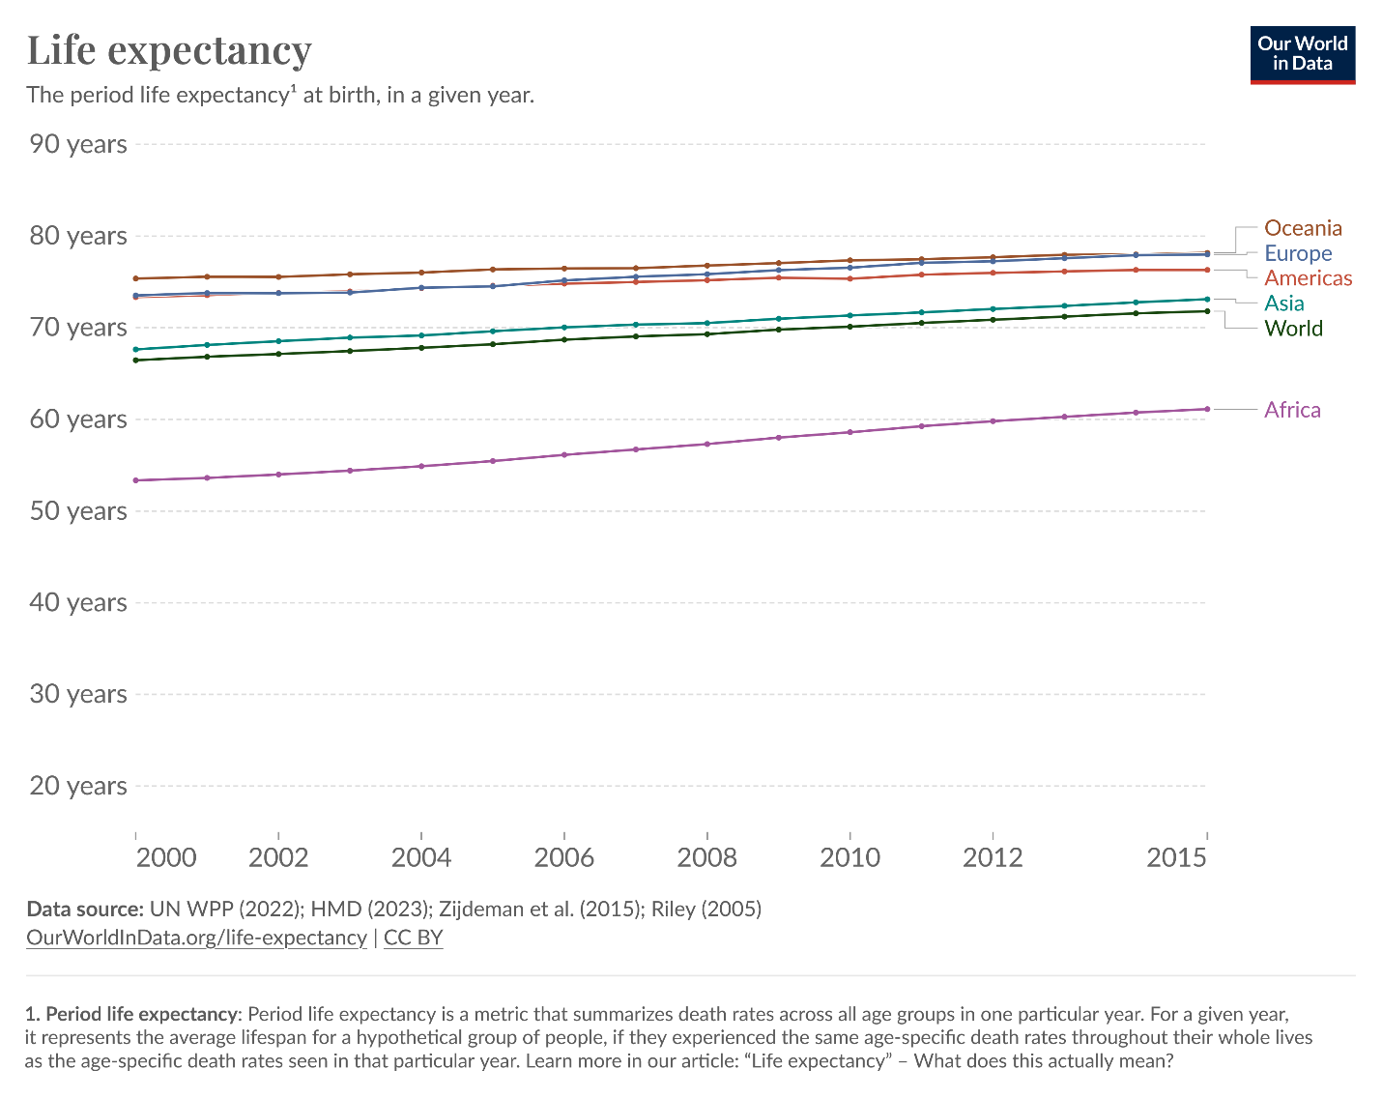

Figure1 Life Expectancy between 2000 and 2014

1. **Impact of Key Elements on Life Expectancy: Statistical Analysis**

Our objective is to conduct a comprehensive analysis of factors influencing LE across different countries. This study aims to investigate whether a significant difference in LE exists between developed and developing countries. Furthermore, we have identified 5 critical elements—Status of development, BMI, Total expenditure on health, HIV/AIDS prevalence, Income composition of resources, and Schooling—as potential determinants of LE. We examine the impact of these factors on LE using data provided by the WHO for the years 2000 to 2014. Finally, we provide a forecasting analysis to predict the trend in LE for next 3 years. To achieve this, we propose employing different statistical methods including “Descriptive statistics” as well as “Inferential Statistics” to assess the impact of these elements on LE.

1. **Descriptive Statistics:**

Descriptive statistics are short summaries that help understand a group of numbers. They include average values like mean, median, and mode, telling us where most numbers cluster, and measures of spread like standard deviation, showing how much the numbers vary. They're useful for getting a quick snapshot of data (Hayes, 2023).

* Status: Analyzing demographic characteristics and health indicators in both developing and developed countries.
* BMI: Examining the distribution of BMI across populations.
* Total Expenditure: Investigating healthcare spending patterns globally.
* HIV/AIDS: Assessing the prevalence and incidence rates of HIV/AIDS.
* Income Composition: Exploring economic factors influencing health outcomes.
* Schooling: Investigating educational levels and their correlation with LE.

1. **Inferential Statistics:**

Inferential statistics assess the significance of a test result, determining whether differences exist between samples. This significance is often quantified using p-values. The selection of the appropriate statistical test for a dataset depends on the nature of the analyzed data—whether it is binary, nominal, ordinal, interval, or ratio—the distribution of the dataset (normal or not), and whether the analysis investigates potential differences between samples or relationships between variables (Marshall and Jonker, 2011).

* ANOVA (Analysis of Variance): Examining variations in LE across different levels of categorical variables (Jones, 2023).
* Correlation Analysis: Assessing the strength and direction of relationships between LE and each identified element.
* Regression Analysis: Evaluating the combined impact of multiple factors on LE.

## **Test of Normality**

Evaluating the normality of data is crucial before undertaking any formal statistical analysis to avoid making incorrect conclusions (Steinskog, Tjøstheim and Kvamstø, 2007). Several tests are available to check whether a sample is derived from a population with a normal distribution. Kolmogorov-Smirnov test and Shapiro-wilk test are widely used to identify the normality of distribution within a dataset (Drezner, et al., 2010; A Anaeth, 2019). The Shapiro-Wilk test relies on correlations within given observations and their corresponding normal scores(Das and Imon, 2016).

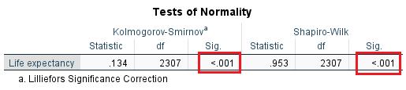

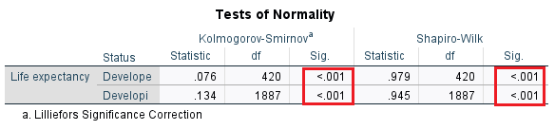

Table1 Tests of normality

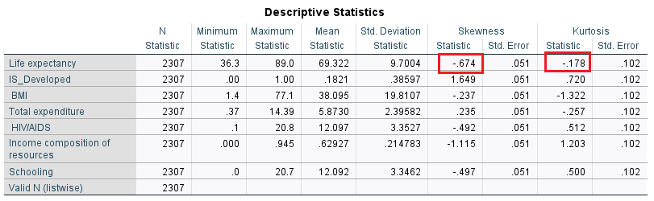

Table2 Descriptive statistics

In evaluating the normality of our sample distribution (Table1) both tests present p-value of <.001 which are less than 0.05. This provides statistical evidence that the data used deviates from normality. However, as noted by Field (2013), these tests, particularly with larger sample sizes like ours (2300), might yield statistically significant results even when deviations from normality are marginal. To gain a more comprehensive understanding, we turn to visual tools such as histogram and Q-Q plots, as recommended by Rafiqul (2018). The histograms for our data (Figure2) suggest the assumption of normality test has been met as the there is a symmetrical peak in the middle.

Understanding the implications of the Central Limit Theorem, we recognize that with an increasing sample size, the sampling distribution tends to approach normality, bringing the mean of the sampling distribution closer to the population mean. In our case, despite the statistical tests indicating non-normality, the visual examination and theoretical considerations suggest a potential convergence towards normality.

When considering skewness, the accepted range for normality, as suggested by some researchers (West et al., 1996), lies within [-2, 2]. Our statistical descriptive results (Table2) reveal a skewness of -.674, comfortably within the acceptable range, reinforcing the notion that, in practice, our data can be considered reasonably normal.

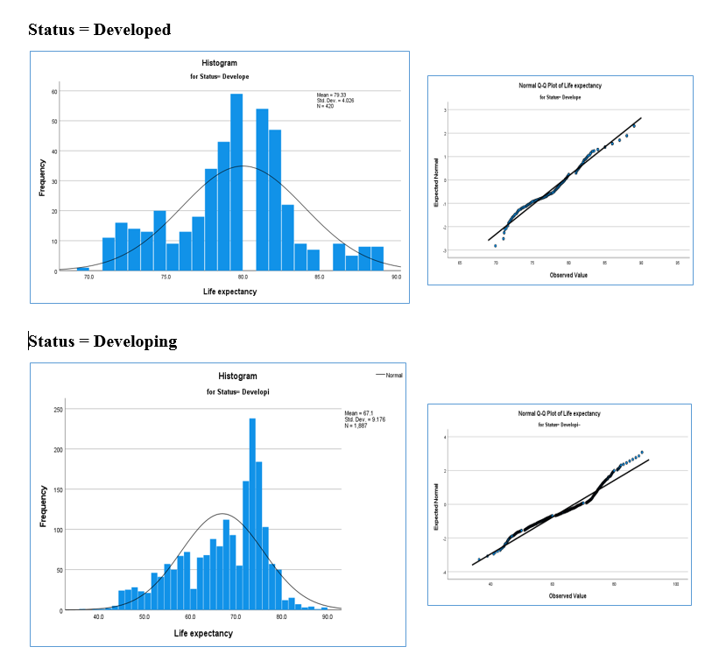

Figure2 Histogram and Q-Q plot

## **T-Test**

We employed a T-Test to rigorously examine whether a significant difference exists in LE between developed and developing countries.

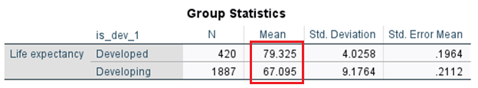

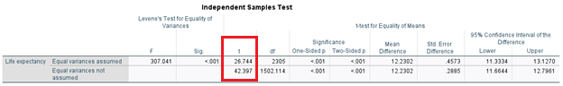

Table3 T-Tests

Our objective is to identify variables that impact LE. Initially, we compare LE between developed and developing countries. We conducted an independent T-Test to compare the means of LE between these two groups (developed and developing countries). The results, as shown in the Table3, indicate a significance level of <0.05, leading to the rejection of the null hypothesis. This implies insufficient evidence to support the assumption that the mean LE in developed and developing countries is the same. In other words, the LE in developed and developing countries is not equal. Moreover, positive t-statistic suggests that the mean of the first group (Developed Countries) is higher.

The hypotheses are represented as follows:

Null Hypothesis→

Alternative Hypothesis→

## **Regression**

This study aims to identify the effects of BMI, Total Expenditure, HIV/AIDS prevalence, Income Composition of Resources, Schooling, and the Status of countries on LE (LE).

There are multiple variables that affect LE, and multiple regression is a statistical method employed to analyze the variability of a dependent variable, in this case, LE. This analysis considers information provided by independent or predictor variables such as BMI, HIV, Schooling, and others (Kraha et al., 2012). The model for multiple regression is formulated as follows (Uyanık and Güler, 2013):

y = dependent variable

The hypothesis for identifying if the independent variables have any significant effect on LE is as below:

A scatterplot indicates the relationship between two quantitative variables measured against the same variable (Moore et al, 2013). Graph1shows the relationship between LE and BMI, total expenditure, HIV/AIDS prevalence, income composition of resources, schooling, and status of countries. One can quickly observe a strong relation between LE and income composition of resources. This can also be seen between schooling and LE. BMI can also be interpreted to have moderately good relationship with LE. As can be seen, the relationship between LE and HIV/AIDS is negative while there is a positive relationship with all other variables.

Graph 1 Scatter Plot Matrix between LE and independent variables

Table4 indicates that schooling has the most significant impact on LE, with Pearson correlation value of 0.75. This followed closely is the income composition of resources with correlation value of 0.725. A moderate positive correlation of LE and BMI with a correlation value of 0.581 is also identified. On the other hand, the correlation between LE and total expenditure is very weak with a value of 0.181. The only negative correlation is found between LE and HIV/AIDS, with a correlation value of t -0.576.

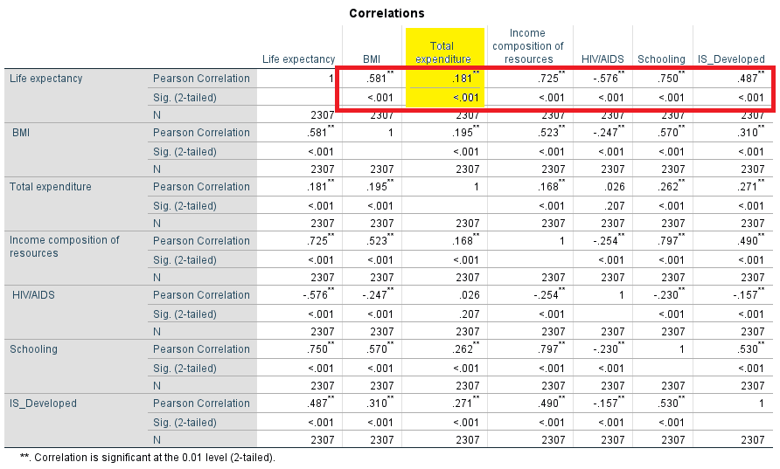

Table4 Correlations

As shown in Table5, some predictors in our regression model exhibit high correlation, which has the potential to affect the reliability of individual coefficients. The Variance Inflation Factor (VIF) is used to quantify how much the variance of an estimated regression coefficient increases when predictor variables are correlated. According to Katrutsa and Strijov (2017), a VIF less than 5 and condition scores below 30 suggest no significant multicollinearity. Upon examining the VIF scores and condition index in Table7, it is evident that the maximum VIF is 3.278, and all condition indexes are below 30. Therefore, the regression model does not exhibit problematic collinearity issues. In Table6, where higher absolute B values signify greater importance of the corresponding independent variable, the variable with the highest B is deemed the most important.

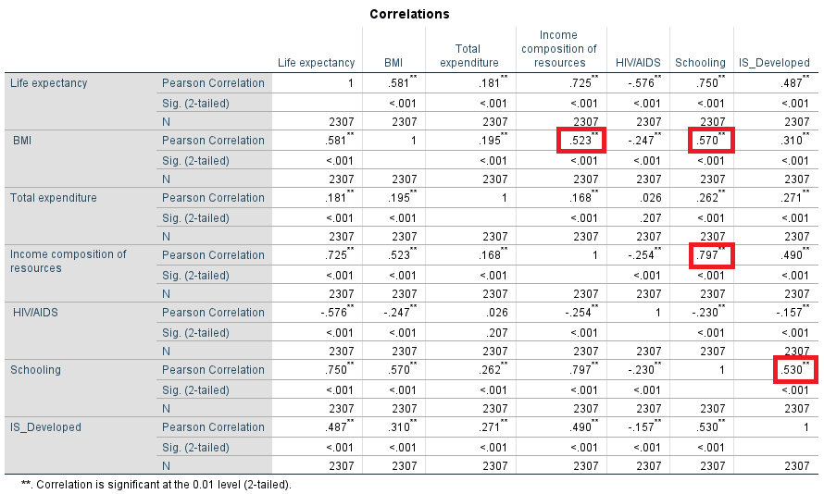

Table5 Correlations for collinearity diagnosis

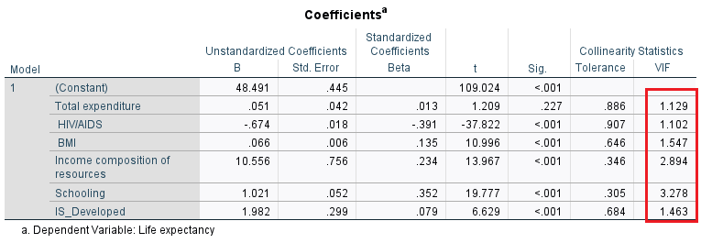

Table6 Coefficient for collinearity diagnosis

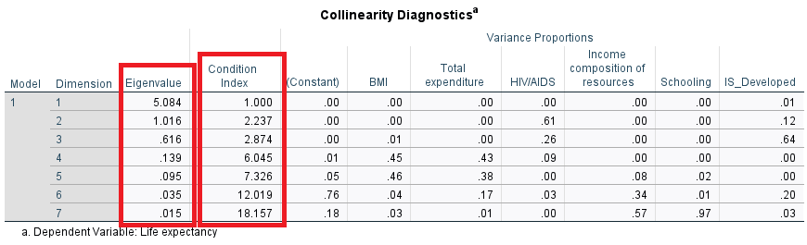

Table7 collinearity diagnostics

Following the linear regression analysis as depicted in Table8, it was determined that the model's capability to forecast the dependent variable is represented by R2=0.777, with an adjusted R2 value of 0.777. Considering the coefficients, it can be said that the independent variables predict nearly 78% of the LE. However, since the significance of ANOVA in Table9 is 0.000, we reject the null hypothesis which means that one or more that one of the parameters is not equal to zero. In summary, one can claim that the model adopted explains well the relationship between independent and dependent variables.

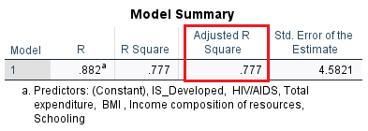

Table8 Model summary

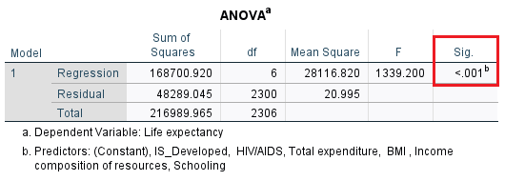

Table9 ANOVA

From the result of the regression analysis, the following is the presented regression equation:

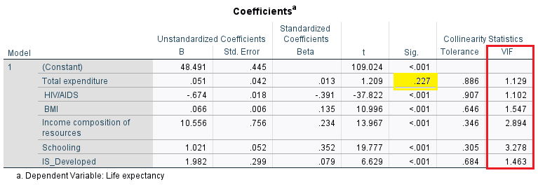

Table10 Multiple Regression Analysis Results

However, the significance level of total expenditure is more than 0.05 which means it is not significant. As a result, it should be deleted from the model and the do regression analysis again.

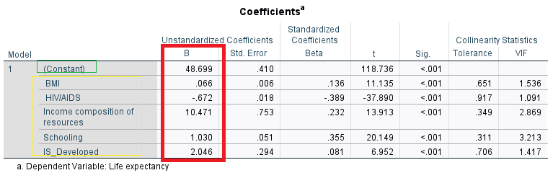  
Table11 Regression Analysis Results after changing the model variables

The new model is shown below:

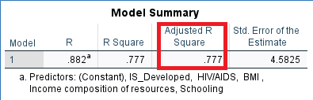

Table12 New Model summary-After removing Total Expenditure variable

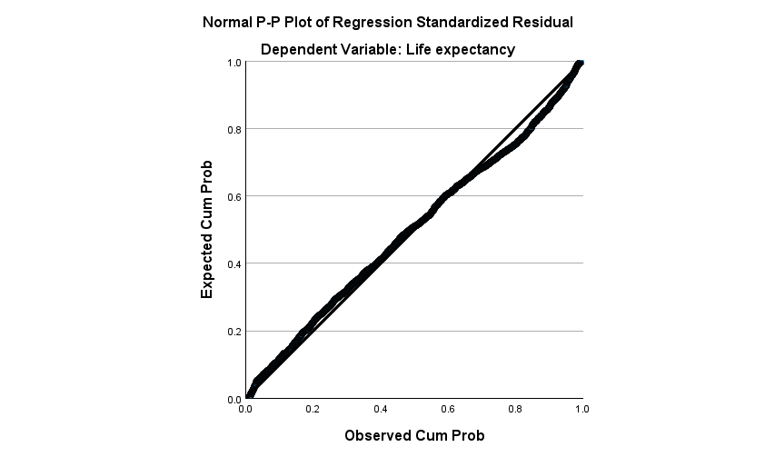As shown in Table4, the correlation between the variable 'Total Expenditure' was very weak, suggesting that this variable did not significantly contribute to explaining the variation in the dependent variable, as reflected by the unchanged adjusted R2 value (Table12). As expected, removing it from the model resulted in no change in the adjusted R2 value.

*Figure3 P-P Plot*

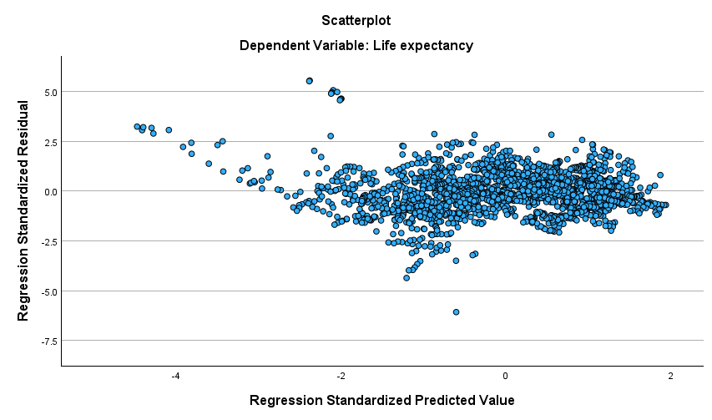

*Figure4 Scatter Plot*

# **Forecasting LE of countries according to their development status**

To forecast LE of developed and developing countries, this report utilizes data of 2000 to 2014 from WHO datasets.

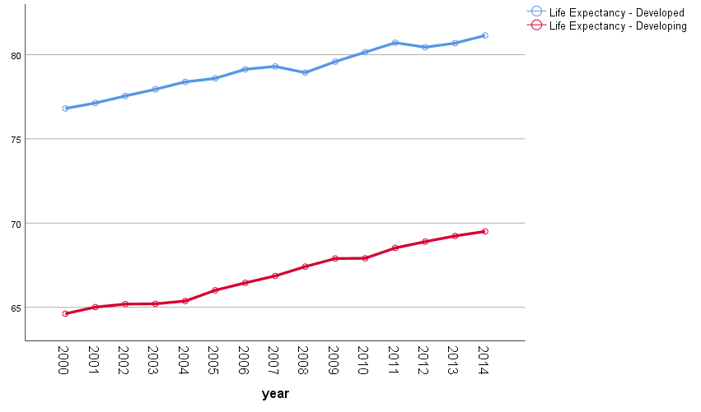

*Figure5 Life Expectancy between 2000 and 2014 in Developed and Developing countries*

As depicted in Figure 5 above, there is a slight yearly increase in the LE of developing countries from 64.6 in 2000 to 69.5 in 2014. In contrast, the LE of developed countries increases from 76.8 in 2000 to 79.3 in 2008, but then experiences a decrease in 2009 to 78.9, followed by a rise again to 81.13 in 2014. Utilizing 15 years of historical data, we aim to predict our dependent variable, i.e., the trend in LE, up to the year 2018.

To predict LE, we use the 'Expert Modeler' tool in SPSS, and the results are interpreted based on the model's findings and related literature. However, before delving deep into the prediction part, we inspect the status of our data in terms of non-stationarity of the mean. If our data is non-stationary, we initially need to apply differencing once or twice to remove the non-stationarity of our trend and then proceed with our analysis. The non-stationarity of data can be determined using autocorrelations and partial autocorrelations.

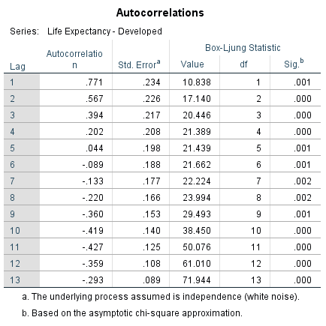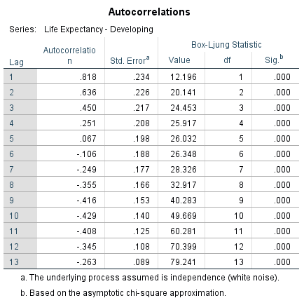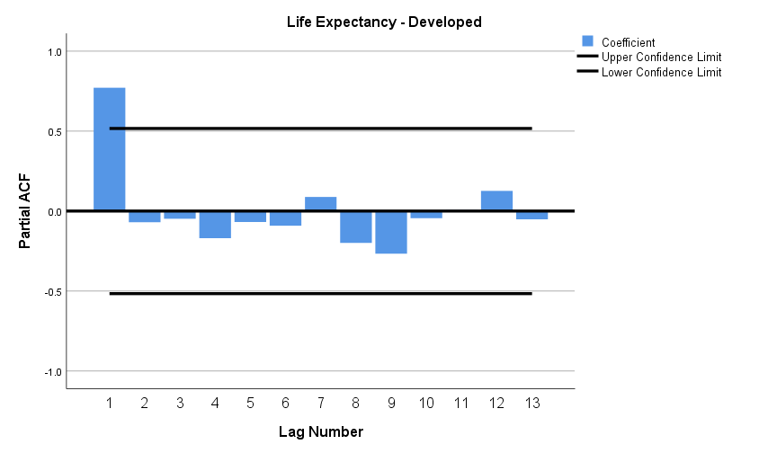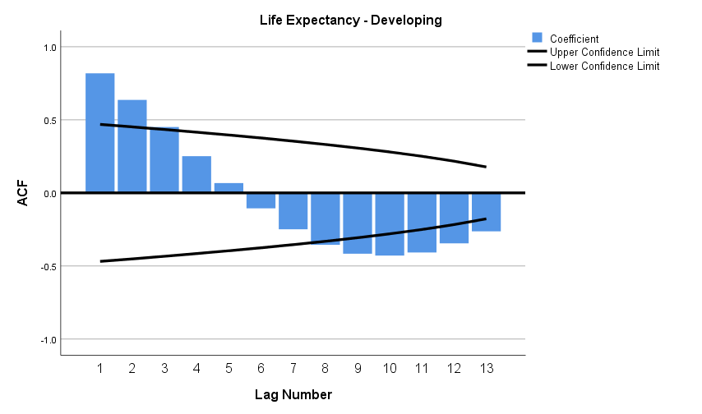

*Figure6 AutoCorrelation and coefficient*

As indicated in the autocorrelation tables above, the correlation between the LE of developed countries and a lagged version of itself at lag 1 is 0.771. This suggests a strong positive correlation between LE at time t and its t-1 value. Similarly, the autocorrelation at lag 2 is 0.567, which is also strong and positive. However, as we progress further down the lag line, the autocorrelation gradually decreases. This pattern is consistent with the autocorrelation of developing countries, which is 0.818 at lag 1 and 0.636 at lag 2, gradually decreasing for subsequent lags.

The null hypothesis in this context posits that the autocorrelation up to a certain lag is equal to 0. However, according to the Box-Ljung statistic, the p-value for all lags in both developed and developing countries is less than the significance level. This indicates evidence of non-zero autocorrelation, leading us to reject the null hypothesis (Zach, 2020).

Additionally, the autocorrelation function (ACF) diagrams for developing countries exhibit a gradual decay of autocorrelation between lags. However, in developed countries, the pattern is different. These results suggest that our assumption of having autocorrelations of zero for all lags is not met. Moreover, the results for developing countries suggest that we need to apply at least one differencing. By doing so, we might be able to use ARIMA for our prediction. Before proceeding, we also check the results of partial autocorrelation.

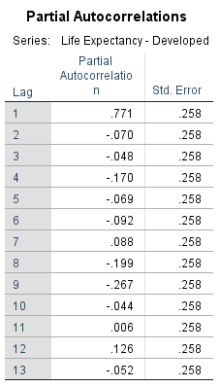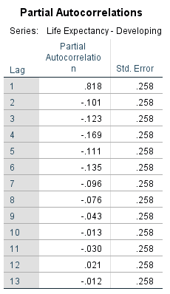

*Table13 Partial AutoCorrelations*

Partial autocorrelation of a LE’s time series data measures the correlation of it with its lagged version as a control for other lags effect. As the table above indicates, we have a strong positive correlation of 0.771 for developed countries and 0.818 for developing ones for the first lags. But at the values suddenly plummets down to the end. This pattern continues for all other lags and partial autocorrelation fluctuates between positive and negative values for both groups.

Our null hypothesis is that no partial autocorrelation exists between variable and the lagged variable. Considering the first lags with high values, we reject the null hypothesis in favor of alternative ones as there is a significant difference from zero and a strong positive correlation between the variable and its lag. Whereas, for lags 2 to 13 of both tables, the partial autocorrelations are not different from zero by significant amount and as so it can be assumed that no correlation exists between variables and their lags after controlling of all other variables’ effect in the model.

Finally using expert “Expert Modeler” in SPSS, a forecast of LE from 2015 to 2018 for both developing and developed countries is made.

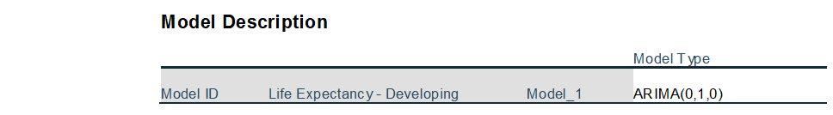

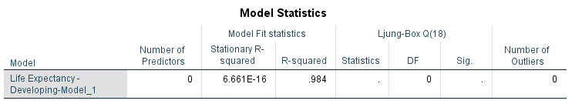

*Table14 ARIMA Model statistics*

The “Expert Modeler” applies ARIMA (autoregressive integrated moving average) which is a generalized model of ARMA (autoregressive moving average) to predict future LE of developing countries. ARIMA model with a difference of one i.e. ARIMA (0,1,0) which is known as “random walk”, is proposed by the modeler.

According to Model Statistics, stationary R-squared is **6.6613E-16**. The R-squared value is equal to **0.984**, which shows that the model explains **98.4%** of the variation of the response variable. The Ljung-Box Q statistic is **0** with **18 degrees of freedom** and the **p-value is 0**. Therefore, it signifies that there is strong evidence of autocorrelation in the model residuals and they exhibit serial correlation (Frost, 2023). Hence, time series can be applied to data for doing the prediction.

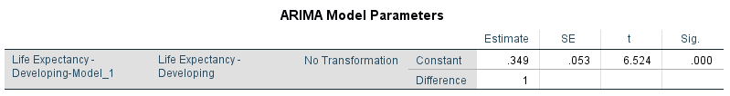

*Table15 ARIMA model parameters*

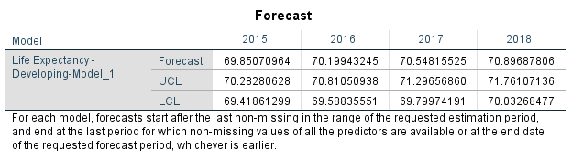

*Table16 Forecast*

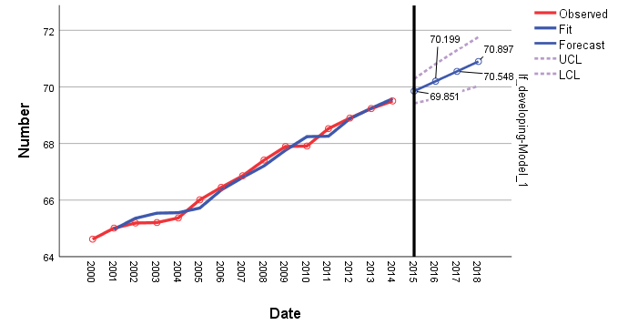

*Figure7 Forecasting result*

The prediction result indicates that there will be a steady increase in LE of developing countries from 69.8 in 2015 to 70.9 in 2018.

As for developed countries, “Expert Modeler” of SPSS fitted Holt model to do the Forecasting. This model which is also known as “double exponential smoothing method” is a simple technique for predicting time series values with a trend in them (Oyetunji, 2023). For developed countries relates a steady increase in LE over the next four years from 81.48 in 2015 to 82.39 in 2018. The result for both categories seems reasonable and unless unforeseen phenomena occur, LE should see a slight rise in the near future, regardless of development status.

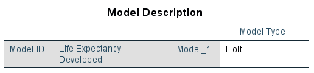

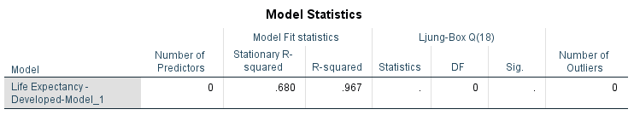

*Table17 Holt Model Statistics*

**References**

Das, K. R. and Imon, A. (2016) 'A brief review of tests for normality', *American Journal of Theoretical and Applied Statistics,* 5(1), pp. 5-12.

Dattani, S., Rodés-Guirao, L., Ritchie, H., Ortiz-Ospina, E. and Roser, M, (2023), 'Life Expectancy', *Our World in Data* [Online] [Accessed on 17th December 2023] <https://ourworldindata.org/life-expectancy>

Drezner, Z., Turel, O. and Zerom, D. (2010) 'A Modified Kolmogorov–Smirnov Test for Normality', *Communications in Statistics - Simulation and Computation,* 39(4), pp. 693-704.

Field, A. (2013) *Discovering Statistics Using IBM SPSS Statistics.* SAGE Publications, p. 188.

Frost, J. (2023) *Autocorrelation and Partial Autocorrelation in Time Series Data.* [Online] [Accessed on 19th December 2023] <https://statisticsbyjim.com/time-series/autocorrelation-partial-autocorrelation/>

Hayes, A. (2023). 'Descriptive Statistics: Definition, Overview', Types, Example, *Investopedia* [Online] [Accessed on 17th December 2023] <https://www.investopedia.com/terms/d/descriptive_statistics.asp>

Jones, G.P., Stambaugh,C. Stambaugh, N.and Kathryn E. Huber, K.E., 'Analysis of variance', (2023), *Translational Radiation Oncology*, PP. 171-177.

Katrutsa, A. and Strijov, V. (2017) 'Comprehensive study of feature selection methods to solve multicollinearity problem according to evaluation criteria', *Expert Systems with Applications,* 76, pp. 1-11.

Kim, J.H., (2005), Multicollinearity and misleading statistical results ', *Korean Journal of Anesthesiology*, [Online] [Accessed on 21th December 2023] <https://ekja.org/upload/pdf/kja-19087.pdf>

Kraha, A., Turner, H., Nimon, K., Zientek, L. and Henson, R. (2012) 'Tools to Support Interpreting Multiple Regression in the Face of Multicollinearity', *Frontiers in Psychology,* 3.

Manton, K.G. (2007) 'Life Expectancy', *Encyclopedia of Gerontology,Elsevier*, 2, pp. 61-67.

Marshall, G. and Jonker, L. (2011), 'An introduction to inferential statistics: A review and practical guide', Radiography, 17(1), PP. e1-e6.

Mindrila, D. (2018). 'Scatterplots and Correlation ', *From Chapter 4 of Basic practices of statistics. 6th edition. Westgate.edu*. [Online] [Accessed on 19th December 2023] <https://www.westga.edu/academics/research/vrc/assets/docs/scatterplots_and_correlation_notes.pdf>

Mishra, P., Pandey, C.M., Singh, U., Gupta, A., Sahu, C. and Keshri, A. (2019) 'Descriptive statistics and normality tests for statistical data ', *Annals of cardiac anaesthesia*, 22(1), PP. 67-72.

Naimark, D.M.J. (2017) 'Life Expectancy Measurements', *International Encyclopedia of Public Health,*

*Academic Press*, 2, pp. 419-431.

Oyetunji, I. (2023) *Exponential Smoothing: A Beginner's Guide to Getting Started*. [Online] [Accessed on 19th December 2023] <https://www.influxdata.com/blog/exponential-smoothing-beginners-guide/>

Rafiqul, M. (2018) 'Sample Size and Its Role in Central Limit Theorem (CLT)', *Computational and Applied Mathematics Journal,* 4.

Steinskog, D. J., Tjøstheim, D. B. and Kvamstø, N. G. (2007) 'A Cautionary Note on the Use of the Kolmogorov–Smirnov Test for Normality', *Monthly Weather Review,* 135(3), pp. 1151-1157.

Uyanık, G. K. and Güler, N. (2013) 'A Study on Multiple Linear Regression Analysis', *Procedia - Social and Behavioral Sciences,* 106, pp. 234-240.

World Health Organization, (2023a) *urgent-health-challenges-for-the-next-decade.* [Online] [Accessed on 17th December 2023] <https://www.who.int/news-room/photo-story/photo-story-detail/urgent-health-challenges-for-the-next-decade>

World Health Organization, (2023b) *who-we-are*. [Online] [Accessed on 17th December 2023] <https://www.who.int/about/who-we-are>

West, S. G., Curran, P. J. & Finch, J. F. (1996) The robustness of test statistics to nonnormality and specification error in confirmatory factor analysis. Psychological Methods, 1(1), PP. 16–29.

Zach (2020) *Ljung-Box Test: Definition + Example.* [Online] [Accessed on 19th December 2023] <https://www.statology.org/ljung-box-test/>