**1. Volumetric Reconstruction**

**Description**: Converts MRI slices into a 3D voxel grid, ideal for detailed and precise medical imaging. **Libraries**:

* **SimpleITK**: For reading and processing medical images.
* **scikit-image**: For surface extraction using the Marching Cubes algorithm.

**2. Photogrammetry**

**Description**: Uses multiple 2D images to reconstruct 3D models, suitable for external object scanning. **Libraries**:

* **COLMAP**: A general-purpose photogrammetry pipeline.
* **OpenMVG**: For structure from motion.
* **OpenMVS**: For dense reconstruction.

**3. Neural Radiance Fields (NeRF)**

**Description**: Uses neural networks to learn the volumetric scene function from images, producing realistic 3D reconstructions. **Libraries**:

* **nerf-pytorch**: A PyTorch implementation of NeRF.
* **instant-ngp**: NVIDIA's implementation for fast training and rendering of NeRF.

**4. Depth Sensors**

**Description**: Uses sensors like LiDAR or Kinect to directly measure depth and create 3D models. **Libraries**:

* **PCL (Point Cloud Library)**: For working with point clouds.
* **Intel RealSense SDK**: For handling data from RealSense depth cameras.

**5. Stereo Vision**

**Description**: Uses two or more cameras to capture different perspectives and generate depth information. **Libraries**:

* **OpenCV**: Contains stereo matching and depth map generation functions.
* **PCL (Point Cloud Library)**: For processing point clouds generated from stereo vision.
* These techniques can be used for 3D reconstruction depending on the solution we want. Several papers have use volumetric reconstruction technique. If we use this technique following results will be obtained.

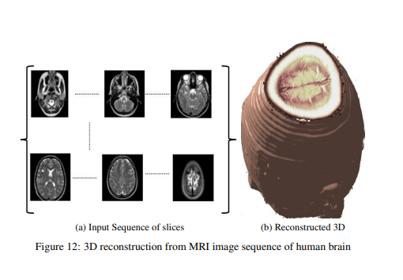

* But we want to have a solution like following, which shows lost depth due to 2D image.

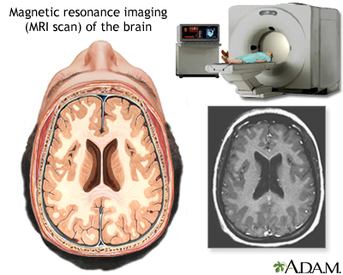

* Obviously, we have to research or think about this solution that it is possible or not. If possible then what steps should we take , what specific tools we can use? If not, then which other method to use? These are some important things to decide.