
Problem
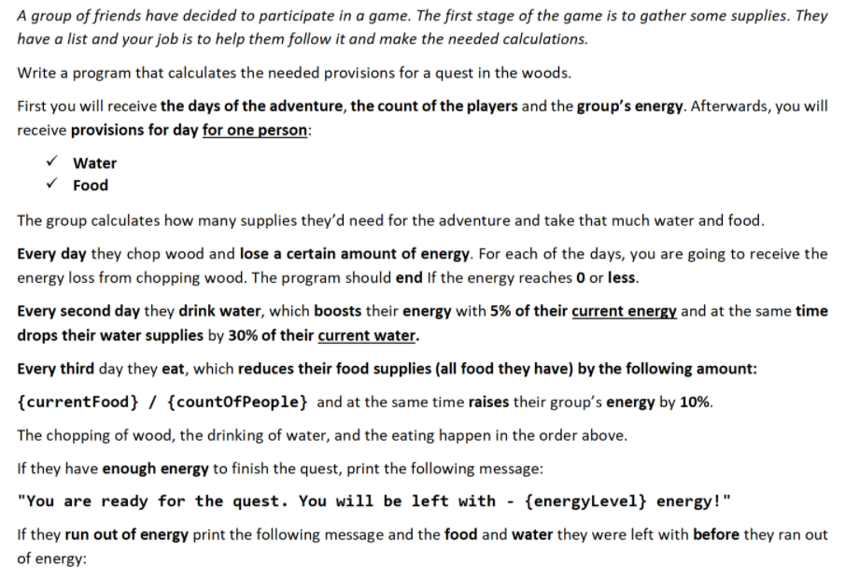
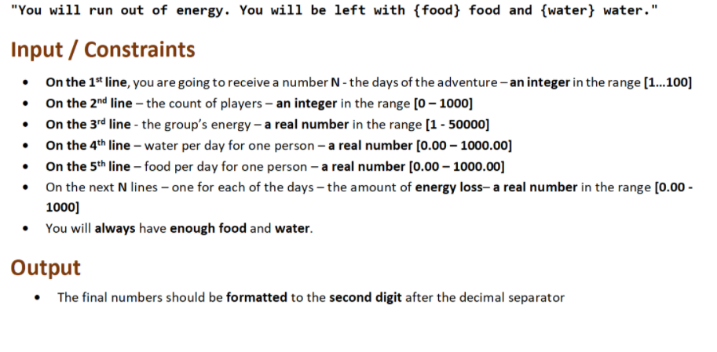

Examples
Input | Output
10  7  5035.5  11.3  7.2  942.3  500.57  520.68  540.87  505.99  630.3  784.20  321.21  456.8  330 | You are ready for the quest. You will be left with - 658.72 energy!

Input | Output
12  6  4430  9.8  5.5  620.3  840.2  960.1  220  340  674  365  345.5  212  412.12  258  496 | You will run out of energy. You will be left with 229.17 food and 118.59 water.

JS Input
The input will be provided as an array of strings
Input | Output
(["10",  "7",  "5035.5",  "11.3",  "7.2",  "942.3",  "500.57",  "520.68",  "540.87",  "505.99",  "630.3",  "784.20",  "321.21",  "456.8",  "330"]) | You are ready for the quest. You will be left with - 658.72 energy!

Input | Output
(["12",  "6",  "4430",  "9.8",  "5.5",  "620.3",  "840.2",  "960.1",  "220",  "340",  "674",  "365",  "345.5",  "212",  "412.12",  "258",  "496"]) | You will run out of energy. You will be left with 229.17 food and 118.59 water.

