**PyGame – Crash Course**

[PyGame](http://www.pygame.org/hifi.html) is a Python wrapper for the [SDL library](https://www.libsdl.org/). SDL is a cross-platform library for accessing computer multimedia hardware components (sound, video, input, etc.). SDL is an extremely powerful tool for building all kinds of things, but it’s written in C, and C is hard, so we use PyGame.



**In this tutorial we’ll go over the basic PyGame logic and collision detection as well as drawing to the screen and loading outside files into our game.**

**NOTE**: This tutorial assumes you have a basic understanding of computing principles (e.g., open notepad, navigate directories, ..).

1. You’ll be using the Python scripting language in combination with the `PyGame’ library to implement basic game mechanics
2. Open the command prompt from the `start’ menu in the bottom left (i.e., type `cmd’ at the start menu)
3. In the command prompt, type `python’ and you should see the ‘>>>’ arrows appear indicating you have Python on your machine.
4. Press `Cntrl Z’ then Enter to exit the Python command prompt.

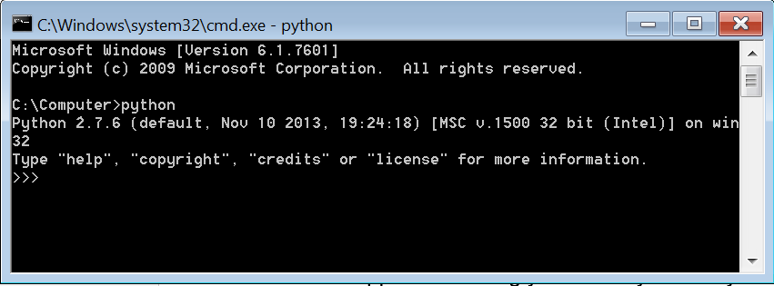

You’ll need to check that PyGame is installed on your machine. In the Command Prompt window navigate to the Python script directory:

Type: ‘cd C:\Python27\Scripts’

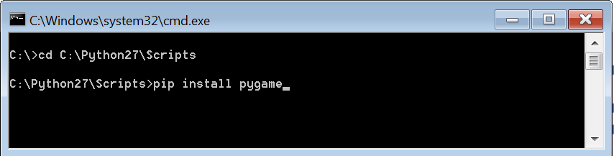

This should take you to the Python scripts folder. Then enter the following:

Type: ‘pip install pygame’

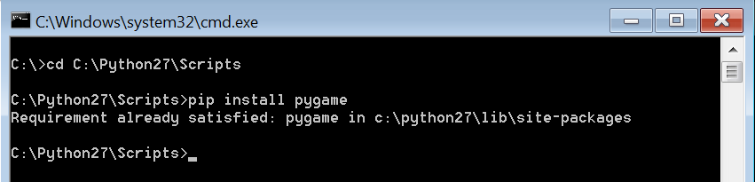

If you have pygame installed you should get the message informing you that pygame is already installed – otherwise, the pip installer will download and setup pygame for you.

You’ll create a folder on your machine (e.g., desktop) – from which you’ll create your `.py’ file (i.e., it’s a txt file for your Python script). You’ll be able to edit/type your .py file using one of the editors on the computer, e.g., notepad++.

**Setup**

Navigate to the PyGame [page](http://www.pygame.org/download.shtml) for further information about the PyGame package

Create a new *.py* file and input the following code:

|  |
| --- |
| import pygame  from pygame.locals import *  pygame.init() |

As with all Python programs, we begin by importing the modules we want to use. In this case we will be importing pygame itself and pygame.locals, which we will use later for some of the constants. The last line initializes all the PyGame modules, it must be called before you do anything else with PyGame.

**Building Blocks**

**Screen Objects**

First things first: We need something to draw on, so we will create a “[screen](https://www.pygame.org/docs/ref/display.html)” which will be our overall canvas. In order to create a screen to display on, we call the set_mode() method of pygame.display and then pass set_mode() a tuple with the width and height of the window we want (800x600 in this case):

|  |
| --- |
| import pygame  from pygame.locals import *  pygame.init()  screen = pygame.display.set_mode((800, 600)) |

If you run this now you’ll see our window pop up briefly and then immediately disappear as the program exits. Not very impressive, is it? In the next section we will introduce our main game loop to ensure that our program only exits when we give it the correct input.

**Game Loop**

The main [game/event loop](https://www.pygame.org/docs/ref/event.html) is where all the action happens. It runs continuously during gameplay, updating the game state, rendering the screen, and collecting input. When we create our loop we need to make sure that we have a way to get out of the loop and exit the application. To that end we will introduce some basic user input at the same time. All user input (and some other events we will get into later) go into the PyGame event queue, which you can access by calling pygame.event.get(). This will return a list of all the events in the queue, which we will loop through and respond to according to the type of event. For now all we care about are KEYDOWN and QUIT events:

|  |
| --- |
| # Variable to keep our main loop running  running = True  # Our main loop!  while running:  # for loop through the event queue  for event in pygame.event.get():  # Check for KEYDOWN event; KEYDOWN is a constant defined in pygame.locals, which we imported earlier  if event.type == KEYDOWN:  # If the Esc key has been pressed set running to false to exit the main loop  if event.key == K_ESCAPE:  running = False  # Check for QUIT event; if QUIT, set running to false  elif event.type == QUIT:  running = False |

Add these lines to the previous code and run it. You should see an empty window. It wont go away until you press the ESC key or trigger a QUIT event by closing the window.

**Surfaces and Rects**

[Surfaces](https://www.pygame.org/docs/ref/surface.html) and [Rects](https://www.pygame.org/docs/ref/rect.html) are basic building blocks in PyGame. Think of surfaces as a blank sheet of paper that you can draw whatever you want onto. Our screen object is also a Surface. They can hold images as well. Rects are a representation of a rectangular area that your Surface encompasses.

Let’s create a basic Surface that’s 50 pixels by 50 pixels, then let’s fill in the Surface with a color. We’ll use white because the default window background is black and we want it to be nice and visible. We’ll then call the get_rect() method on our Surface to get the rectangular area and the x, y coordinates of our surface:

|  |
| --- |
| # Create the surface and pass in a tuple with its length and width  surf = pygame.Surface((50, 50))  # Give the surface a color to differentiate it from the background  surf.fill((255, 255, 255))  rect = surf.get_rect() |

**Blit and Flip**

Just creating our Surface isn’t actually enough to see it on the screen. To do that we need to [Blit](https://www.pygame.org/docs/ref/surface.html" \l "pygame.Surface.blit) the Surface onto another Surface. Blit is just a technical way to say draw. You can only Blit from one Surface object to another – but remember, our screen is just another Surface object. Here’s how we’ll draw our surf to the screen:

|  |
| --- |
| # This line says "Draw surf onto screen at coordinates x:400, y:300"  screen.blit(surf, (400, 300))  pygame.display.flip() |

blit() takes two arguments: The Surface to draw and the location to draw it at on the source Surface. Here we use the exact center of the screen, but when you run the code you’ll notice our surf does not end up centered on the screen. This is because blit() will draw surf starting at the top left position.

Notice the call to pygame.display.flip() after our Blit. [Flip](https://www.pygame.org/docs/ref/display.html#pygame.display.flip) will update the entire screen with everything that has been drawn since the last flip. Without a call to flip(), nothing will show.

**Sprites**

What are Sprites? In programming terms a Sprite is a 2d representation of something on the screen. Essentially, a Sprite is a picture. Pygame provides a basic class called Sprite, which is meant to be extended and used to hold one or several graphical representations of an object that you want to display on the screen. We will extend the [Sprite](https://www.pygame.org/docs/ref/sprite.html) class so that we can use its built in methods. We’ll call this new object Player. Player will extend Sprite and have only two properties for now: surf and rect. We will also give surf a color (white in this case) just like the previous surface example except that now the Surface belongs to the Player:

|  |
| --- |
| class Player(pygame.sprite.Sprite):  def __init__(self):  super(Player, self).__init__()  self.surf = pygame.Surface((75, 25))  self.surf.fill((255, 255, 255))  self.rect = self.surf.get_rect() |

Let’s put it all together!

|  |
| --- |
| # import the pygame module  import pygame  # import pygame.locals for easier access to key coordinates  from pygame.locals import *  # Define our player object and call super to give it all the properties and methods of pygame.sprite.Sprite  # The surface we draw on the screen is now a property of 'player'  class Player(pygame.sprite.Sprite):  def __init__(self):  super(Player, self).__init__()  self.surf = pygame.Surface((75, 25))  self.surf.fill((255, 255, 255))  self.rect = self.surf.get_rect()  # initialize pygame  pygame.init()  # create the screen object  # here we pass it a size of 800x600  screen = pygame.display.set_mode((800, 600))  # instantiate our player; right now he's just a rectangle  player = Player()  # Variable to keep our main loop running  running = True  # Our main loop!  while running:  # for loop through the event queue  for event in pygame.event.get():  # Check for KEYDOWN event; KEYDOWN is a constant defined in pygame.locals, which we imported earlier  if event.type == KEYDOWN:  # If the Esc key has been pressed set running to false to exit the main loop  if event.key == K_ESCAPE:  running = False  # Check for QUIT event; if QUIT, set running to false  elif event.type == QUIT:  running = False  # Draw the player to the screen  screen.blit(player.surf, (400, 300))  # Update the display  pygame.display.flip() |

Run this code. You’ll see a white rectangle at roughly the middle of the screen:

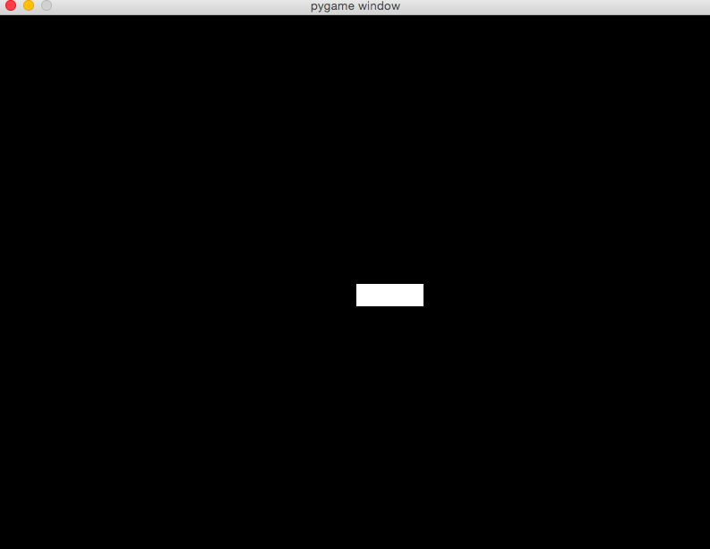

What do you think would happen if you changed screen.blit(player.surf,(400,300)) to screen.blit(player.surf, player.rect)? Once changed, try printing player.rect to the console. The first two attributes of the rect() are x, y coordinates of the top left corner of the rect(). When you pass Blit a Rect, it will use those coordinates to draw the surface. We will use this later to make our player move!

**User Input**

Here’s where the fun starts! Let’s make our player controllable. We discussed earlier that the keydown event pygame.event.get() pulls the latest event off the top of the event stack. Well, Pygame has another [event method](https://www.pygame.org/docs/ref/event.html) called pygame.event.get_pressed(). The get_pressed()method returns a dictionary with all the keydown events in the queue. We will put this in our main loop so we get the keys at every frame.

|  |
| --- |
| pressed_keys = pygame.event.get_pressed() |

Now we’ll write a method that will take that dictionary and define the behavior of the sprite based off the keys that are pressed. Here’s what it might look like:

|  |
| --- |
| def update(self, pressed_keys):  if pressed_keys[K_UP]:  self.rect.move_ip(0, -5)  if pressed_keys[K_DOWN]:  self.rect.move_ip(0, 5)  if pressed_keys[K_LEFT]:  self.rect.move_ip(-5, 0)  if pressed_keys[K_RIGHT]:  self.rect.move_ip(5, 0) |

K_UP, K_DOWN, K_LEFT, and K_RIGHT correspond to the arrow keys on the keyboard. So we check that key, and if it’s set to True, then we move our rect() in the relevant direction. Rects have two built-in methods for moving; here we use “[move in place](https://www.pygame.org/docs/ref/rect.html#pygame.Rect.move_ip)” – move_ip() – because we want to move the existing Rect without making a copy.

Add the above method to our Player class and put the get_pressed() call in the main loop. Our code should now look like this:

|  |
| --- |
| import pygame  from pygame.locals import *  class Player(pygame.sprite.Sprite):  def __init__(self):  super(Player, self).__init__()  self.surf = pygame.Surface((75, 25))  self.surf.fill((255, 255, 255))  self.rect = self.surf.get_rect()  def update(self, pressed_keys):  if pressed_keys[K_UP]:  self.rect.move_ip(0, -5)  if pressed_keys[K_DOWN]:  self.rect.move_ip(0, 5)  if pressed_keys[K_LEFT]:  self.rect.move_ip(-5, 0)  if pressed_keys[K_RIGHT]:  self.rect.move_ip(5, 0)  pygame.init()  screen = pygame.display.set_mode((800, 600))  player = Player()  running = True  while running:  for event in pygame.event.get():  if event.type == KEYDOWN:  if event.key == K_ESCAPE:  running = False  elif event.type == QUIT:  running = False  pressed_keys = pygame.key.get_pressed()  player.update(pressed_keys)  screen.blit(player.surf, (400, 300))  pygame.display.flip() |

Now you should be able to move your rectangle around the screen with the arrow keys. You may notice though that you can move off the screen, which is something we probably don’t want. So let’s add a bit of logic to the update method that tests if the rectangle’s coordinates have moved beyond our 800 by 600 boundary; and if so, move it back to the edge:

|  |
| --- |
| def update(self, pressed_keys):  if pressed_keys[K_UP]:  self.rect.move_ip(0, -5)  if pressed_keys[K_DOWN]:  self.rect.move_ip(0, 5)  if pressed_keys[K_LEFT]:  self.rect.move_ip(-5, 0)  if pressed_keys[K_RIGHT]:  self.rect.move_ip(5, 0)  #Keep player on the screen  if self.rect.left < 0:  self.rect.left = 0  elif self.rect.right > 800:  self.rect.right = 800  if self.rect.top <= 0:  self.rect.top = 0  elif self.rect.bottom >= 600:  self.rect.bottom = 600 |

Here instead of using a move method, we just alter the corresponding coordinates for top, bottom, left, or right.

Now let’s add some enemies!

First let’s create a new sprite class called ‘Enemy’. We will follow the same formula we used for the player class:

|  |
| --- |
| class Enemy(pygame.sprite.Sprite):  def __init__(self):  super(Enemy, self).__init__()  self.surf = pygame.Surface((20, 10))  self.surf.fill((255, 255, 255))  self.rect = self.surf.get_rect(center=(820, random.randint(0, 600)))  self.speed = random.randint(5, 20)  def update(self):  self.rect.move_ip(-self.speed, 0)  if self.rect.right < 0:  self.kill() |

There are a couple differences here that we should talk about. First off, when we call get_rect() on our surface, we are setting the center property x coordinate to 820, and our y coordinate to a random number generated by random.randint().

[Random](https://docs.python.org/3.5/library/random.html) is a python library that we will import at the beginning of our file in the complete code (import random). Why the random number? Simple: We want our incoming enemies to start past the right side of the screen (820), at a random place (0-600). We also use random to set a speed property for the enemies. This way we will have some enemies that are fast and some that are slow.

Our update() method for the enemies takes no arguments (we don’t care about input for enemies) and simply moves the enemy toward the left side of the screen at a rate of speed. And the last if statement in the update method tests to see if the enemy has gone past the left side of the screen with the right side of its rectangle (so that they don’t just disappear as soon as they touch the side of the screen). When they pass the side of the screen we call Sprites’ built-in kill() method to delete them from their sprite group thereby preventing them from being rendered. Kill does not release the memory taken by the enemy and relies on you no longer having a reference to it so the Python garbage collector will take care of it.

**Groups**

Another super useful object that PyGame provides are Sprite [groups](https://www.pygame.org/docs/ref/sprite.html#pygame.sprite.Group). They are exactly what they sound like – Groups of Sprites. So why do we use Sprite Groups instead of a list? Well, sprite groups have several methods built into them that will help us later with collisions and updating. Let’s make a Group right now that will hold all the Sprites in our game. After we create it, we will add the Player to the Group since that’s our only Sprite so far. We can create another group for enemies as well. When we call a Sprite’s kill() method, the sprite will be removed from all groups that it is a part of.

|  |
| --- |
| enemies = pygame.sprite.Group()  all_sprites = pygame.sprite.Group()  all_sprites.add(player) |

Now that we have this all_sprites group, let’s change how we are rendering our objects so that we render all objects in this group.

|  |
| --- |
| for entity in all_sprites:  screen.blit(entity.surf, entity.rect) |

Now anything we put into all_sprites will be rendered.

**Custom Events**

Now we have a Sprite Group for our enemies but no actual enemies. So how do we get some enemies on the screen? We could just create a bunch of them at the beginning, but then our game wouldn’t last more than a few seconds. So we will create a custom event that will fire off every few seconds and trigger the creation of a new enemy. We listen for this event in the same way that we listened for key presses or quit events. Creating a custom event is as easy as naming it:

|  |
| --- |
| ADDENEMY = pygame.USEREVENT + 1 |

That’s it! Now we have an event called ADDENEMY that we can listen for in our main loop. The only gotcha to keep in mind here is that we need our custom event to have a unique value that is greater than the value of USEREVENT. That’s why we set our new event to equal USEREVENT + 1. One small note for anyone curious about about these events: They are at their core just integer constants. USEREVENT has a numeric value and any custom event we create needs to be an integer value that is greater than USEREVENT (because all the values less than USEREVENTare already taken by built-ins).

Now that we’ve defined our event, we need to insert it into the event queue. Since we need to keep creating them over the course of the game, we will set a timer. To do this we use PyGame’s time() object.

|  |
| --- |
| pygame.time.set_timer(ADDENEMY, 250) |

This tells PyGame to fire our ADDENEMY event every 250 milliseconds (every quarter second). This goes outside of our game loop, but will still fire throughout the entire game. Now let’s add some code to listen for our event:

|  |
| --- |
| while running:  for event in pygame.event.get():  if event.type == KEYDOWN:  if event.key == K_ESCAPE:  running = False  elif event.type == QUIT:  running = False  elif(event.type == ADDENEMY):  new_enemy = Enemy()  enemies.add(new_enemy)  all_sprites.add(new_enemy) |

Keep in mind that set_timer() is exclusively used for inserting events into the PyGame event queue – it doesn’t do anything else.

Now we are listening for our ADDENEMY event, and when it fires, we create a new instance of the Enemy class. Then we add that instance to the enemies Sprite Group (which we will later use to test for collision) and to the all_sprites Group (so that it gets rendered along with everything else).

**Collision**

This is why you will love PyGame! Writing collision code is hard, but PyGame has a LOT of collision detection methods, some of which you can find [here](https://www.pygame.org/docs/ref/sprite.html#pygame.sprite.collide_rect). For this tutorial we will be using [spritecollideany](https://www.pygame.org/docs/ref/sprite.html" \l "pygame.sprite.spritecollideany). The spritecollideany() method takes a Sprite object and a Sprite Group and tests if the Sprite object intersects with any of the Sprites in the Sprite group. So we will take our player Sprite and our enemies Sprite Group and test if our player has been hit by an enemy. Here’s what it looks like in code:

|  |
| --- |
| if pygame.sprite.spritecollideany(player, enemies):  player.kill() |

We test if our player Sprite object collides with any Sprites in the enemies Sprite Group, and if it does, we call the kill() method on the player Sprite. Because we are only rendering sprites in the all_sprites Group, and the kill() method removes a Sprite from all its Groups, our player will no longer be rendered, thus ‘killing’ it. Let’s put it all together:

|  |
| --- |
| # import the pygame module  import pygame  # import random for random numbers!  import random  # import pygame.locals for easier access to key coordinates  from pygame.locals import *  class Player(pygame.sprite.Sprite):  def __init__(self):  super(Player, self).__init__()  self.surf = pygame.Surface((75, 25))  self.surf.fill((255, 255, 255))  self.rect = self.surf.get_rect()  def update(self, pressed_keys):  if pressed_keys[K_UP]:  self.rect.move_ip(0, -5)  if pressed_keys[K_DOWN]:  self.rect.move_ip(0, 5)  if pressed_keys[K_LEFT]:  self.rect.move_ip(-5, 0)  if pressed_keys[K_RIGHT]:  self.rect.move_ip(5, 0)  # Keep player on the screen  if self.rect.left < 0:  self.rect.left = 0  elif self.rect.right > 800:  self.rect.right = 800  if self.rect.top <= 0:  self.rect.top = 0  elif self.rect.bottom >= 600:  self.rect.bottom = 600  class Enemy(pygame.sprite.Sprite):  def __init__(self):  super(Enemy, self).__init__()  self.surf = pygame.Surface((20, 10))  self.surf.fill((255,255,255))  self.rect = self.surf.get_rect(  center=(random.randint(820, 900), random.randint(0, 600))  )  self.speed = random.randint(5, 20)  def update(self):  self.rect.move_ip(-self.speed, 0)  if self.rect.right < 0:  self.kill()  # initialize pygame  pygame.init()  # create the screen object  # here we pass it a size of 800x600  screen = pygame.display.set_mode((800, 600))  # Create a custom event for adding a new enemy.  ADDENEMY = pygame.USEREVENT + 1  pygame.time.set_timer(ADDENEMY, 250)  # create our 'player'; right now he's just a rectangle  player = Player()  background = pygame.Surface(screen.get_size())  background.fill((0, 0, 0))  enemies = pygame.sprite.Group()  all_sprites = pygame.sprite.Group()  all_sprites.add(player)  running = True  while running:  for event in pygame.event.get():  if event.type == KEYDOWN:  if event.key == K_ESCAPE:  running = False  elif event.type == QUIT:  running = False  elif(event.type == ADDENEMY):  new_enemy = Enemy()  enemies.add(new_enemy)  all_sprites.add(new_enemy)  screen.blit(background, (0, 0))  pressed_keys = pygame.key.get_pressed()  player.update(pressed_keys)  enemies.update()  for entity in all_sprites:  screen.blit(entity.surf, entity.rect)  if pygame.sprite.spritecollideany(player, enemies):  player.kill()  pygame.display.flip() |

Test this out!

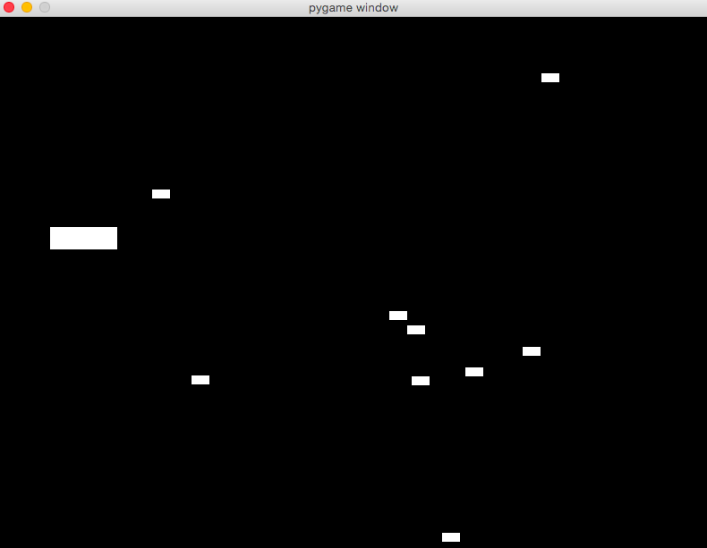

**Images**

Now we have a game, but kind of an ugly game. Next we will replace all the boring white rectangles with cool images that will make the game feel like an actual game.

In the previous code examples we used a Surface object filled with a color to represent everything in our game. While this is a good way to get a handle on what a surface is and how they work, it makes for an ugly game. We’re going to add some pictures for the enemies and the player. I like to draw my own images, so I made a little jet for the player and some missiles for the enemies, which you can download from the [repo](https://github.com/realpython/pygame-primer). You’re welcome to use my art, draw your own, or download some [free game art assets](http://www.gameart2d.com/) to use.

**Altering the Object Constructors**

Our current player constructor looks like this:

|  |
| --- |
| class Player(pygame.sprite.Sprite):  def __init__(self):  super(Player, self).__init__()  self.surf = pygame.Surface((75, 25))  self.surf.fill((255, 255, 255))  self.rect = self.surf.get_rect() |

Our new constructor will look like this:

|  |
| --- |
| class Player(pygame.sprite.Sprite):  def __init__(self):  super(Player, self).__init__()  self.image = pygame.image.load('jet.png').convert()  self.image.set_colorkey((255, 255, 255), RLEACCEL)  self.rect = self.image.get_rect() |

We want to replace our Surface object with an image. We will use pygame.image.load() by passing it a path to a file. The load() method will actually return a Surface object. We then call convert() on that Surface object to create a copy that will draw more quickly on the screen.

Next we call the set_colorkey() method on our image. The set_colorkey method sets the color in the image that PyGame will render as transparent. In this case I chose white, because that’s the background of my jet image. [RLEACCEL](https://www.pygame.org/docs/ref/surface.html#pygame.Surface.set_colorkey) is a optional parameter that will help PyGame render faster on non-accelerated displays.

Lastly, we get our rect object in the same way as before: By calling get_rect() on our image.

Remember the image is still a surface object; it now just has a picture painted on it.

Let’s do the same thing with the enemy constructor:

|  |
| --- |
| class Enemy(pygame.sprite.Sprite):  def __init__(self):  super(Enemy, self).__init__()  self.image = pygame.image.load('missile.png').convert()  self.image.set_colorkey((255, 255, 255), RLEACCEL)  self.rect = self.image.get_rect(  center=(random.randint(820, 900), random.randint(0, 600))  )  self.speed = random.randint(5,20) |

Now we have the same game we had before but nicely skinned with some cool images. I think it’s missing something, though. Let’s add a few clouds going past to give the impression of a jet flying through the sky. To do this we are going to use the exact same principles we used before. First, we will create the Cloud object with an image of a cloud and an update() method that continuously moves the cloud toward the left side of the screen. Then we will create a custom event to spawn our clouds at a set interval (we will also add the spawned clouds to the all_sprites group). Here’s what our cloud object will look like:

|  |
| --- |
| class Cloud(pygame.sprite.Sprite):  def __init__(self):  super(Cloud, self).__init__()  self.image = pygame.image.load('cloud.png').convert()  self.image.set_colorkey((0, 0, 0), RLEACCEL)  self.rect = self.image.get_rect(  center=(random.randint(820, 900), random.randint(0, 600))  )  def update(self):  self.rect.move_ip(-5, 0)  if self.rect.right < 0:  self.kill() |

That should all look familiar, as should this event creation code, which we will put right below our enemy creation event:

|  |
| --- |
| ADDCLOUD = pygame.USEREVENT + 2  pygame.time.set_timer(ADDCLOUD, 1000) |

And let’s create a new Sprite Group for them:

|  |
| --- |
| clouds = pygame.sprite.Group() |

Now in our main game loop, where we step through our event queue, we need to start listening for our ADDCLOUD event.

This:

|  |
| --- |
| for event in pygame.event.get():  if event.type == KEYDOWN:  if event.key == K_ESCAPE:  running = False  elif event.type == QUIT:  running = False  elif event.type == ADDENEMY:  new_enemy = Enemy()  enemies.add(new_enemy)  all_sprites.add(new_enemy) |

Will become this:

|  |
| --- |
| for event in pygame.event.get():  if event.type == KEYDOWN:  if event.key == K_ESCAPE:  running = False  elif event.type == QUIT:  running = False  elif event.type == ADDENEMY:  new_enemy = Enemy()  enemies.add(new_enemy)  all_sprites.add(new_enemy)  elif event.type == ADDCLOUD:  new_cloud = Cloud()  all_sprites.add(new_cloud)  clouds.add(new_cloud) |

We’re going to add the clouds to the all_sprites Group as well as the new clouds Group. We add them to both because we’re using all_sprites to render and clouds to call their update function. You might ask why we don’t add them to the existing enemies Group; after all, we’re calling nearly identical update functions on them. The reason is, we don’t want to test the player for collisions with the clouds. Our jet needs to pass cleanly through all the clouds. Now all that’s left is calling our clouds Group update() method.

**Conclusion**

That’s it! Test it again, and you should see something like:

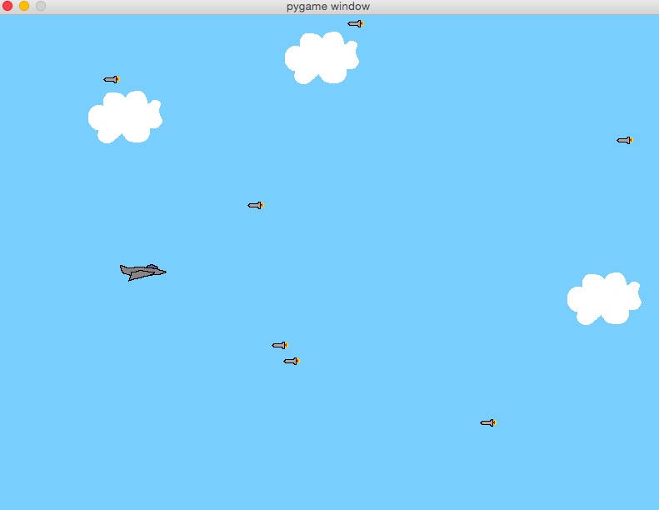

The complete code is available ‘http:// solentgames.github.io/pygame/pygame.zip’