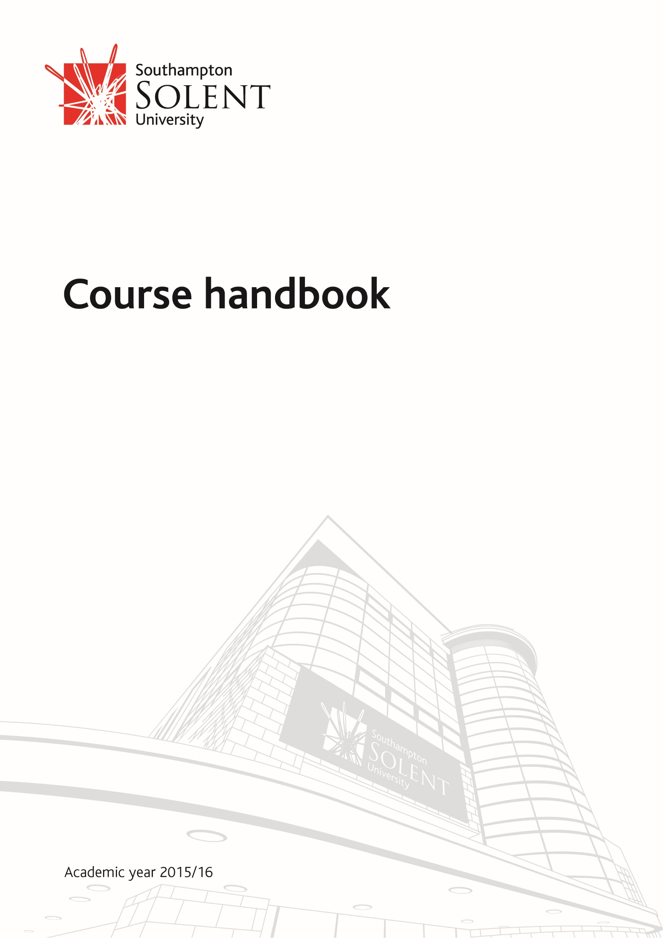

School of Media Arts and Technology

BSc (Hons) Computer Games (Indie)

# Contents

Contents 2

WELCOME 5

Welcome from the Director of School 5

Welcome from the Course Leader 8

We do not play games, we develop them. 8

How to become a programmer: 8

Your competition 8

Some Advice 9

What if this course isn’t for you? 10

This isn’t a course for everyone 10

What type of information is in the handbook 11

Comment 11

Who’s who on the Computer Games Indie Course 12

The Artists 13

Computing Staff 13

How will we communicate with you 14

KEY INFORMATION ABOUT THE ACADEMIC YEAR & TIMETABLES 15

Academic Year 15

Your timetable 15

Games Academy 15

Extra Curricula Activities 16

Game Jams and Groups 16

Professional Groups around Southampton 16

YOUR COURSE 17

Course Structure 17

Units on the Course 18

First Year 18

Second Year 19

Year Three 21

Course Learning and Teaching strategy 22

Professional Statutory Regulatory Body Accreditation detail 22

Learning Resources 22

Out of hours work 22

Library 22

Student Hub 23

Free Software 23

ASSESSMENT 24

Assessment & Feedback 24

Modes of assessment 24

Results and feedback 26

Modes of Feedback 26

Result outcomes 26

‘Your voice’ 26

STUDENT SUPPORT 27

Learning Skills Support (Succeed@Solent) 27

Students’ Information Centre 28

Employability and Enterprise Team 28

Access Solent 28

Mountbatten Library and Learning Resource Centre including the Study Skills Advisors 28

Learning Resource Centres (LRC) 28

International Advice Service 28

Sport Solent 28

OTHER USEFUL INFORMATION 30

Student Charter 30

Recognition of Prior Learning 30

Academic writing and referencing 30

Extenuating circumstances 30

Query and appeal against decision of an assessment or award board 30

Turnitin and Solent Online Learning submissions 30

Grade marking 31

Research ethics and integrity 31

Attendance and participation 31

THE LEGAL BIT 32

Student intellectual property rights (IPR) 32

APPENDICES 33

Appendix 1 – Programme Specification 34

Programme Specification 34

Map of Units to Intended Course Learning Outcomes 37

Course Structure and Assessment Summary 38

Admissions 39

Regulation of Assessment 40

Classification 41

Map to Computing Subject Benchmark 42

Learning Outcomes for exit awards 43

Learning outcomes for award of Dip HE 43

Foundation Years 45

Appendix 2 – Unit Descriptors 46

Unit Descriptors 46

# WELCOME

## Welcome from the Director of School

Welcome to the School of Media Arts and Technology (SoMAT). Whether you are a new or continuing student I hope that you thoroughly enjoy your time at Solent and take full advantage of the fantastic opportunities which we have created for you.

The School of Media Arts and Technology is the largest School at Solent and covers a wide range of courses - currently over 40 undergraduate and a developing portfolio of Masters degrees - and encompass the whole range of skills across film, television, broadcasting, music (performance, recording, live production, promotion and management), sound engineering and acoustics, live sound, radio, photography, screenwriting, performance, animation, CGI, computer games development, and a diverse range of courses in computing (software engineering, business information technology, web design and development, and computer networking and security).

Paul Marchbank  
Head of School

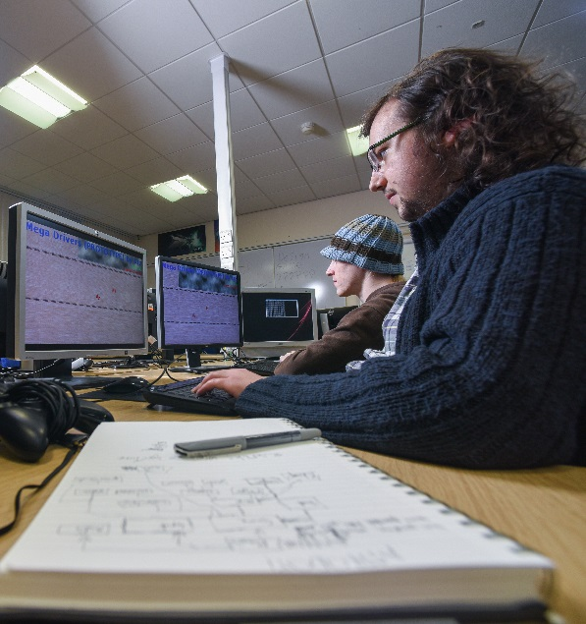The aim of the School is to create courses which have employability and 'real-world' learning at their heart and can boast enviable, and often unique, connections with industry. Accordingly we hope that whilst you are a student in SoMAT you will take full advantage of these connections - including unprecedented access to industry professionals through its Visiting Professors and Fellows programme, which currently boasts Oscar winning film editors, leading film directors from the British film industry, an Oscar and BAFTA winning Visual Effects Director, BAFTA winning Cinema and TV Sound Designers, an Oscar shortlisted screenwriter, TV and radio presenters, leading figures from music (from every field including producers, performers, songwriters, composers, managers, promotion and journalism); sound (film, TV, radio, location sound recordist, film sound mixers); cinematography, media law, screenwriting, film and TV producers, broadcast technology professionals, and music and media management; Games industry professionals include BAFTA winners and other leading AAA and indie games developers in all disciplines (production, art, code, sound, Q.A. etc.), and computing students benefit from visiting industry specialists across a wide range of disciplines.

Alongside the industry-focused curriculum I would thoroughly recommend that you become fully involved in the numerous in-house opportunities which provide our students with professional work experience with real clients. These additional experiences will give you a CV which will make you stand out when you graduate! These include Solent Productions, our professional film unit, Solent Music (who organise and run all things to do with music); SolentPost provides students with access to top class film and TV editors and editing opportunities; Solent Acoustics provides professional consultancy and training services on all aspects of noise and vibration control to a range of clients; the Games Academy and the Southern Independent Games Network provide support for student consultancy and, in conjunction with the University's entrepreneurship scheme, support for fledgling student enterprises; and Solent Creatives introduces students to clients requiring creative and technology solutions. Alongside this we also run the University's very own online student television platform SolentTV. We are a key partner in Southampton Film Week and we are home to Diegesis – a film and television review magazine. Additionally our students manage and operate Sonar Film and provide the technical facilities for Radio Sonar. They also run their own Live Events Society, providing PA facilities for local bands and venues.

As you would expect from a University dedicated to employability, the School boasts some of the best facilities in the UK - including three multi-camera HD green screen TV Studios, a 200 seat multicamera HD studio, an Outside Broadcast Vehicle, six music recording studios, eight radio studios, 4K cameras, a dubbing theatre, Foley studio and full 3-D 2k digital cinema, the latest computers, mobiles and tablets, games development kits, programmable drones and devices, VR equipment, MoCap suite, usability, and network, security and hacking labs.

Of course your best resource are our excellent staff! You will be taught by a mix of theoreticians, practitioners and technical instructors who are all very well qualified and experienced in their fields. Your lecturers hold a variety of higher degrees, teaching fellowships and professional industry accreditations. Many have attained, or are working towards doctoral qualifications, and are active in research at a national and international level. The School's staff are collectively well published and have had some of their research is officially classified as 'world leading!' Our practitioners bring with them some amazing real life experience and skills gained in their careers in industry and now bring to the curriculum this unique perspective in order to educate the next generation of specialists.

The School takes very seriously its vocational aims and aspirations. As such, graduate employment rates are excellent and recent graduates have gone on to work in all the fields taught within the School often with major employers such as BBC, ITV, Sky, IBM, Accenture, HP, Arqiva, Fujitsu, NEP Visions, and many many more.

The School of Media Arts and Technology is dynamic, exciting and at the forefront of media production and education, and our ambition is to provide the world with the next generation of practitioners, innovators and leaders in our fields. As you can see, we have put huge efforts in to making the School the best possible platform to nurture your talents. It’s up to you now to seize these opportunities and flourish!

Good luck with your studies. I hope you have a fantastic time with us!

Paul Marchbank

Director, School of Media Arts and Technology

[University Charter](http://www.solent.ac.uk/about/mission-and-values/charter.aspx)

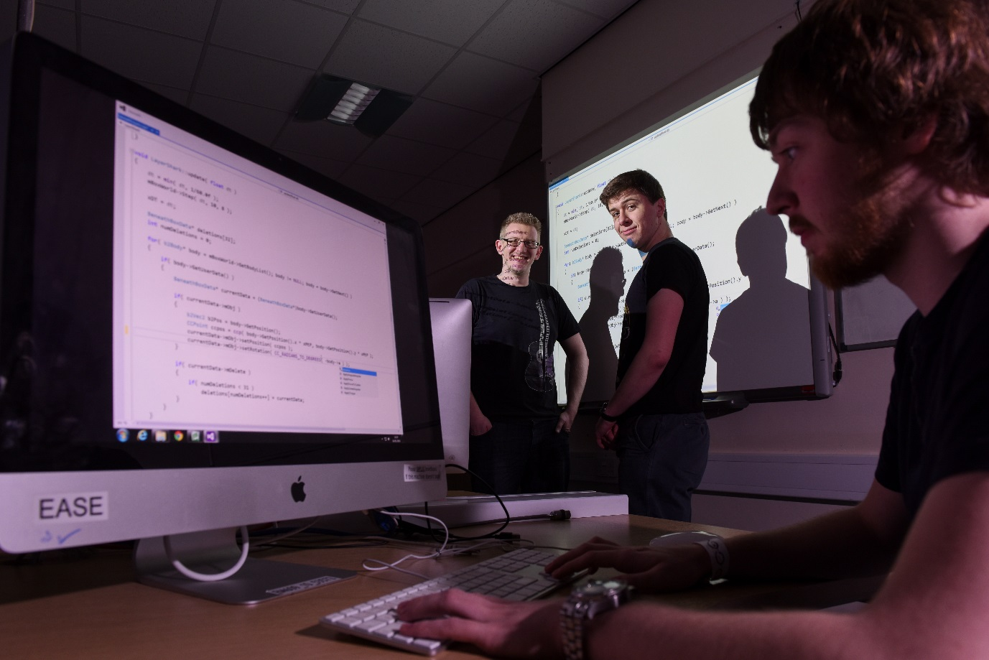

## Welcome from the Course Leader

### We do not play games, we develop them.

Get that straight, you’re here to become developers, this requires a lot of problem solving, maths and logical expertise. Once you graduate this you’ll be incredibly hireable, and not just in the games industry.

You are about embark on a long hard road to become a software developer.

Thank you for choosing the course. The technical units that you need have been written by industry veterans, Dave Horne (Codemasters, nVidia, ATI, Silicon Dreams), Mark Bennett (Creature Labs, Coventry University) and Nick Thomas (Therapist Games). They’ve been created to give you the skills required to make you employable. We know what knowledge and skills are needed to succeed in the games industry, and we’ve designed the course to give you them.

### How to become a programmer:

1. Participate in the tutorials
2. Think for yourself
3. Spend days failing
4. Finally succeed
5. Experiment with cool stuff in your spare time.

Developing software is actually about failure, and there’s often no right or wrong answer. It works or it doesn’t. This is what makes coding both a creative and logical art form.

If you start searching google before you’ve even tried to come up with a solution for yourself you’re not going to acquire the problem solving skills required to become a game developer.

You can’t be a game developer simply by watching tutorials. You need to do it for yourself. A lot.

### Your competition

When you graduate from Southampton Solent University, you will be showing off your skills against hundreds of other people graduating from both this course and others. To become the best you need self-motivation and curiosity. Compete against others in Game Jams, work with each other in teams. Make stuff in your spare time. You need a portfolio, a good degree and a website selling yourself.

You do not get employed simply by attending and listening. You need to prove yourself. Interviews for jobs in the games industry can take between 2 to 5 hours. You need to know your stuff.

### Some Advice

#### Questions

There’s no such thing as a silly or stupid question, remember this when we ask if you’re ok, or if you have any questions. We teach 100+ students in the first year, and we’ve heard all the questions before, because chances are someone in another group or another year has asked that question.

#### Eating and Drinking in the classroom

There is no eating or drinking in ANY of the classrooms, exceptions to this are bottles of water with a secure cap on them, and in RM603 we do have a breakout table, you are allowed to eat things there. Once you’ve finished, make sure all the packages are in the bin.

Lecturers and technicians can and will confiscate any unauthorised food or drink found on the tables, and will dispose of them.

#### Working with Others

You are going to be working in teams, this means that you need to be able to communicate, argue and critique each other. Remember Artists know more than you about art, Indies know more than you about production and business. Bow to their better judgement but never be scared of asking for more information.

## What if this course isn’t for you?

### This isn’t a course for everyone

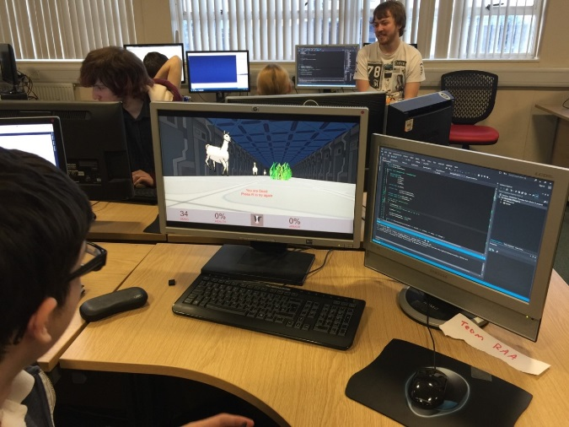You may find that after the first few weeks of this course, you’ll realise that you don’t want to put up with the very frustrating world of breaking through to the indie game scene. It’s really not uncommon, the good news is…

Southampton Solent offers a lot of courses and you’ll probably be able to find a course more suited to your needs easily. If that’s the case, make sure you make your decision in the **first 2 weeks** and you can transfer onto another course easily. Any later and you’ll have to wait until the next academic year.

Our students quite often move to the following courses:

#### BSc(Hons) Computer Games (Software Development) | [Link](http://www.solent.ac.uk/courses/2016/undergraduate/computer-games-software-development/course-details.aspx)

This is our sister course, It focusses on a lot lower level programming, if you’ve enjoyed the programming units and want more, I suggest this. You can actually easily move to this course any time in the first 14 weeks of this course as they share a very similar first year.

#### BA(Hons) Computer and Video Games | [Link](http://www.solent.ac.uk/courses/2015/undergraduate/computer-and-video-games-ba/course-details.aspx)

This is our art course, if you really enjoyed Christian’s units in art rather than the programming unit, this is possibly the course you need.

#### BSc(Hons) Computing | [link](http://www.solent.ac.uk/courses/2015/undergraduate/computing-bsc/course-details.aspx)

With a focus on technical computing and a strong emphasis on programming mobile applications, this comprehensive computing degree provides the diverse skills and knowledge you’ll need for a career in a wide range of computing roles.

With a strong focus on programming (using Java and Python), the course includes core units on software development, databases, web development and networking themes. You’ll also look at web APIs, JSON, HTML5 and big data analytics.

#### There’s loads more on the webpage | [link](http://www.solent.ac.uk/courses/2015/undergraduate/course-categories/computing-games-and-networking-courses.aspx)

There’s a wealth of other computing courses, check out the course pages, and the rest of the of the Solent website.

## What type of information is in the handbook

The course handbook provides you with information about how your course is taught and managed, and how you will be assessed. It also provides information around key course details, University facilities and services that will assist you whilst studying.

This handbook is accompanied by information on the Student portal and the Southampton Solent University “*Student Handbook Essential information 2015-16*”, which can be found on the portal:

[Student Handbook](http://portal.solent.ac.uk/documents/fci/student-handbook.pdf?t=1419244898051)

If any changes are necessary, the Course Handbook will be updated and the most recent version will be available on the portal.

### Comment

If you would like to comment on the handbook contents, or have any ideas on how to improve the information provided, please forward these by email to the course lead.

## Who’s who on the Computer Games Indie Course

#### person imageBenjamin Kenwright | Course Leader

[**BENJAMIN.KENWRIGHT@SOLENT.AC.UK**](mailto:BENJAMIN.KENWRIGHT@SOLENT.AC.UK) |

Dr Benjamin Kenwright is a highly skilled researcher/developer/leader in game technologies, management, and engineering operations.  Benjamin is the course leader/senior lecturer for all the undergraduate and postgraduate games degrees at Southampton Solent University.  Benjamin has over twenty years' experience in research, teaching, and industrial project management.

#### https://scontent.xx.fbcdn.net/v/t1.0-9/10003121_10152359295046000_1136796891_n.jpg?oh=befc97319b7ad53da71ffeaf87409f99&oe=57FC5FE3Christian Brindley | Lecturer

[**CHRISTIAN.BRINDLEY@SOLENT.AC.UK**](mailto:christian.brindley@solent.ac.uk) | RM236 | 023 8201 6041

Christian is a 3D artist with skills in many different areas within game production including character art, environment art, game design, animation & UI. He has worked on games such as Urban Trials for the PS3, and helped start up a Southampton based Indie company.

#### https://media.licdn.com/media/p/6/000/1fd/3d5/1a11a4d.jpgDave Cobb | Lecturer

[**DAVE.COBB@SOLENT.AC.UK**](mailto:dave.cobb@solent.ac.uk) | RM236 | 023 8201 6890

Dave is 25-year veteran of the computer game industry, with a background in C++ programming and production management, at major games publishers and indie developers. His experience and interests cover a broad range of topics including software engineering, game development tools and project management methodologies.

#### https://scontent.xx.fbcdn.net/v/t1.0-9/223411_1913354427552_6275102_n.jpg?oh=452f8f82d34d212077d486644f58c1da&oe=587266AEJames TerKeurst | Senior Lecturer

[**JAMES.TERKEURST@SOLENT.AC.UK**](mailto:JAMES.TERKEURST@SOLENT.AC.UK) | RM236 | 023 8201

Dr James TerKeurst has extensive international experience teaching game design and development.  James has also received numerous national and international grants to support a range of activities including novel game software development, digital entrepreneurship and global best practice in interactive software development.  James’ current research area is game design and software development pedagogy.

#### https://scontent.xx.fbcdn.net/v/t1.0-9/10434268_797688730285502_5251013026025861512_n.jpg?oh=422afa4641313b841befbd551986e7db&oe=57EEA52DNick Thomas | Lecturer

[**NICK.THOMAS@SOLENT.AC.UK**](mailto:Nick.Thomas@solent.ac.uk) | RM236 | 023 8201 3186

Nick Thomas has an MSc in robotics, he specializes in C#, Unity and Unreal engine. His career has been quite varied, ranging from working in his indie start-up company, to writing web pages and mobile applications.

#### https://scontent.xx.fbcdn.net/v/t1.0-9/7352_10152614362643899_9181599505259230388_n.jpg?oh=fa5d3f865c6238a45f633e95a422a3b1&oe=58342F6AMark Bennett | Lecturer

[**MARK.BENNETT@SOLENT.AC.UK**](mailto:mark.bennett@solent.ac.uk) | RM236 | 023 8201 6452

Mark is an experienced software engineer with experience in the games industry, working on the Creatures franchise. He has excellent knowledge of C++, Python and web development.

He has a Masters degree in machine learning and a strong interest in artificial intelligence and procedural generation.

#### https://scontent-lhr3-1.xx.fbcdn.net/v/t34.0-12/13694986_10157048098725063_1413081097_n.jpg?oh=a1ffd796d68ad5ccef8bff638d19f1c9&oe=5788F1F7Claire Oliver | Graduate Assistant

[**CLAIRE.OLIVER@SOLENT.AC.UK**](mailto:claire.oliver@solent.ac.uk) | RM236

Claire Oliver is a recent graduate from our BSc(hons) Computer Games Software Development, she finished the course with a 1st class honours and is proficient in C++, C# & the Unity engine. She has participated in games jams across the UK and will be assisting in a range of classes. The Artists

These staff do not teach directly on our course, they teach on the BA(Hons) Computer and Video Games course. These teach advanced 3d modelling techniques and rendering. They can often be found with the students in JM007

### The Artists

#### Adam BartonAdam Barton | Senior Lecturer

[**ADAM.BARTON@SOLENT.AC.UK**](mailto:adam.barton@solent.ac.uk) | Tel: 023 8201 6347 | JM226

Adam Barton is an experienced professional 3d artist and has managed commercial titles as animator, senior artist, technical artist and designer. Teaching began in 2003 when the video games course started and he has been the course leader since 2005. Adam is also co-developer at the games company Strangely Named.

#### https://scontent-lhr3-1.xx.fbcdn.net/v/t1.0-9/13442168_279519235732866_2868025604200661159_n.jpg?oh=43fca2439716648d2f8e3b92cb849a82&oe=58358611Arran Langmead | Lecturer

[**ARRAN.LANGMEAD@SOLENT.AC.UK**](mailto:Arran.langmead@solent.ac.uk) | Tel: 023 8201 6139 | JM226  
  
Arran Langmead is a 3D artist, independent games developer and founder of Strangely Named Studio.He has managed client projects with companies such as Kraft Foods, Beaulieu and Outpost VFX and continues to work on commercial products for both console and PC. Arran has over three years of teaching and industry experience.

#### Dr Nick Hampton | Researcher

[**NICK.HAMPTON@SOLENT.AC.UK**](mailto:Nick.hampton@solent.ac.uk) | Tel: 023 8201 6491 | JM225 |

Dr Nick Hampton is a lecturer, researcher and an indie games developer. He has a PhD in video game theory. He has over two years teaching experience and has two published Android and iOS titles. His research interests include virtual reality and augmented reality and human interactions with virtual constructs.

Research and enterprise outputs and activities include joint funded projects on gamification in higher education and video games as de-stressors.

### Computing Staff

Along the way you’ll come across these members of staff who teach a few of the units shared with the computing degrees

##### dupee-brianDr Brian Dupee: Senior Lecturer [Brian.Dupee@solent.ac.uk](mailto:Brian.Dupee@solent.ac.uk)| Tel: 023 8201 3451 | RM423

Brian is currently a Senior Lecturer in Computing specialising in units incorporating Artificial Intelligence, Software Engineering, Requirements Analysis, Mathematics for Computer Science, and Systems Analysis.  Brian studied Mathematics at both the University of Kent and Université de Picardie Jules Verne at Amiens, France, Computer Science Masters at Kent and his PhD in Computational Mathematics at University of Bath.  Creative outputs include ANNA, an Expert System for choosing and using numerical software for problem solving as well as a number of hybrid systems incorporating both symbolic and numerical computation.

Recent research interests vary between Artificial Intelligence, Formal Methods, Pragmatic Software Engineering and Quality Assurance. Brian has supervised 2 PhD students.

Units taught: System Software Development

##### https://www.cs.kent.ac.uk/people/staff/saf/dbdc/photos/sheila_baron.jpgSheila Baron: Senior Lecturer [sheila.baron@solent.ac.uk](mailto:sheila.baron@solent.ac.uk)| Tel: 023 8201 3074 | RM423

Sheila is a Senior Lecturer in the School of Media Arts & Technology. She has been teaching databases since 1996, and also teaches Requirements Engineering and Systems for Enterprise Effectiveness.

Units taught: Introduction to Databases

## How will we communicate with you

Outside of scheduled sessions the email system will be the main method of relaying important information to you, which will be sent to your student email address which you need to check regularly. Any hard copy correspondence will be sent to the address on your student record. It is important that you keep this up to date via your account details on the Student Portal.

Other methods of communication are via noticeboards, digital signage, the student portal and Solent Online Learning.

# KEY INFORMATION ABOUT THE ACADEMIC YEAR & TIMETABLES

## Academic Year

The Academic Year governs the University’s academic operations and service provision and within this, we have set term dates and examination periods.

The key term dates for BSc (Hons) Computer Games (Software Development) in 2016-17 are:

|  |  |
| --- | --- |
| Welcome week (1st years) | 19th September 2016 |
| Teaching year starts | 26th September 2016 |
| Winter break | 20th December 2016 – 4th January 2017 |
| Spring Break | 7th April 2017 – 24th April 2017 |
| Summer Break | 19th May - 18th September 2017 |
| Students’ results 1st Semester | Week Commencing 27th February 2017 |
| Students’ results 2nd Semester | Week Commencing 19th June 2017 |
| Referral Submission 1st Semester | Week Commencing 20th March 2017 |
| Referral Submission 2nd Semester | Week Commencing 26th June 2017 |
| Graduation ceremonies | 10th – 15th July 2017 |
| Assessment Boards 1st Semester | 13th February 2017 |

## Your timetable

CMISGo is the University's timetabling application which allows students to view their timetables via the timetabling application located on the homepage of the student portal.

For assistance on how to access and use this app follow the link below:

[Timetable app assistance](http://portal.solent.ac.uk/support/timetabling-and-rooming/timetabling/timetabling.aspx)

### Games Academy

On a Wednesday afternoon we’ll be running **Games Academy.** This is a prolonged game jam where you may be working with Artists, Animators, audio engineers and musicians.

Sometimes a Games Industry professional will come in and give a guest lecture. They may also take this time to look over some of your work to critique.

# Extra Curricula Activities

## Game Jams and Groups

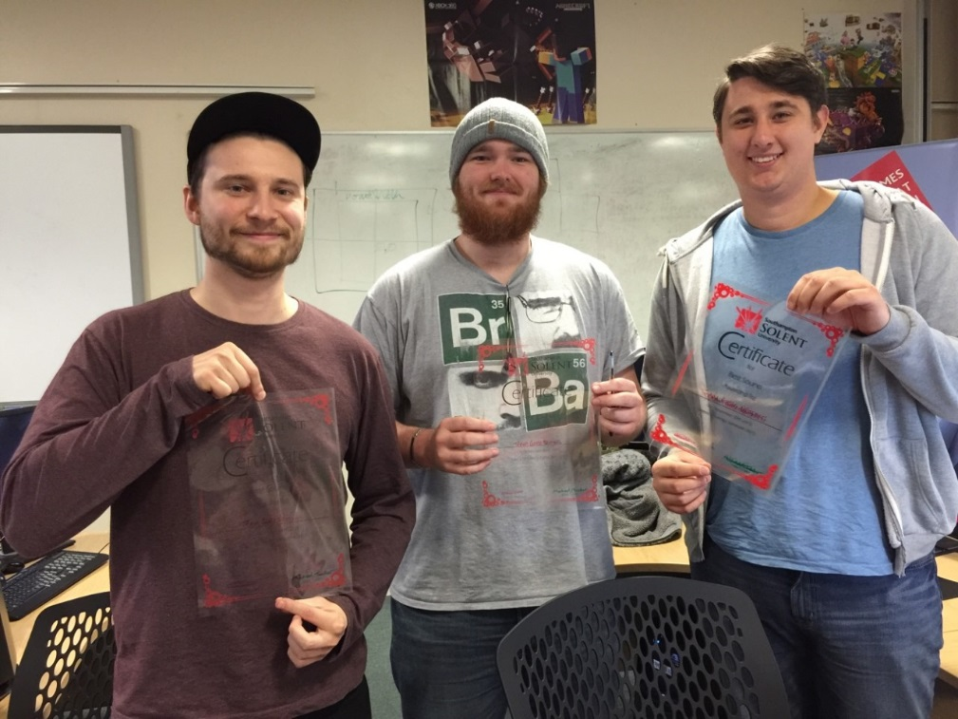

There are a number of other events through-out the year, keep an eye out for the following events

* [Southampton](https://www.facebook.com/SouthernIndependentGamesNetwork) Indie Game Network
* [Games Eden](http://www.gameseden.net/)
* [Ludum Dare (about 3 a year)](http://ludumdare.com/)
* [Dare 2B Digital](http://www.daretobedigital.com/)
* [Portsmouth Game Jam](http://gamejam.port.ac.uk/)
* [ProcJam](http://www.procjam.com/)
* [HackSoton](http://www.hacksoton.com/)
* Smaller Game Jams that are hosted by us

## Professional Groups around Southampton

Please remember, these are professional gathering so be respectful to those around

* [Developer South Coast](http://www.meetup.com/DeveloperSouthCoast/)
* Southampton Makers Space
* Southampton Game Devs

# YOUR COURSE

## Course Structure

You’ll find we have a lot of different units on the course, each unit is linked. Something you learn in one unit we expect to be applied in another without us needing to tell you.

However we do have a few columns of education. These columns are shown in the diagram below.

Failing to understand the concepts early on can create very unstable foundations for the rest of the course, I suggest you pay attention.

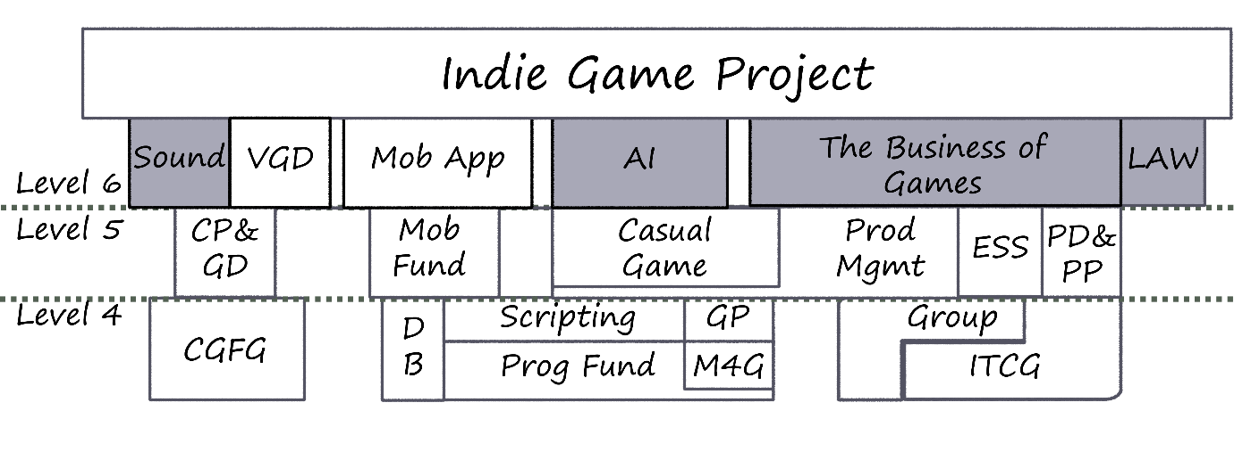

##### Level 4 (First Year)

This year is all about foundations, this is setting you up with all the skills you need to build upon. We push you hard here so that you have the foundations. Believe it or not, but you learn all the programming syntax you’ll ever need in this year.

##### Level 5 (Second Year)

So you’ve got the fundamentals, now you need to use them, explore, you’ll break many things, but you’ll learn a lot whilst doing it. We’ll teach you some new tools where you can use your skillsets, but your own self-motivation is required. You should really be thinking about your companies and plans for the future around here.

This year counts towards 30% of your final grade

##### Placement Year (Optional)

##### Level 6 (Third or Fourth Year)

Well now it gets hard, you’ve survived the previous two years. You’re choosing your speciality now.

You get two choose two options to choose and come up with a final year project of your own choosing.

This counts towards 70% of your final degree grade

## Units on the Course

Below you’ll find a short description of what you’ll learn on each of the units on the course.

### First Year

#### Programming Fundamentals | Updated 2013

**Keyskills:** C, Functional Programming, Basic Structures

Over a semester, our new cohort of students are introduced to the founding concepts of programming. They are taught logic, problem solving, basic programming techniques, debugging and good practice - all with a games twist and all in C.

This year, the assignments saw students use their newly minted C-skills to create a turn-based rpg-style battle game and a “match-three” puzzler.

#### Scripting for Game Engines (Indie Only) | Created 2013

**Keyskills:** Unity, Unreal, Decision Making, Object Oriented design

You’ll be introduced to different, industry standard, game engines (Unity, Unreal and sometimes CryEngine). After which you’ll be asked to create a number basic games in various game engines - showing that all the engines have similar feature sets, but different ways of applying it.

For assessment purposes you’ll be given a basic design document and will be asked to write a technical report detailing what game engine you would use to create it and why.

#### Maths For Games | Introduced 2013

**Keyskills:** Mathematics, 2d game systems, logical operators, mathematical functions, bits, basic linear algebra,

First years have a very broad range of maths skills which means this unit gets the new students to a level mathematical playfield. It covers 2d game math problems and ends with a basic introduction to 2d linear algebra. So all the students are at the right level for the following **Game Physics** Unit

There are two assessments for this unit, a two hour maths exam covering various basic concepts. The second assessment is a codebase with a number of empty maths functions that the students need to fill in, showing how the information learnt in other units applies across the board

#### Game Physics | Introduced 2013

**Keyskills:** Linear Algebra, Mathematics, Vertices, 3d Concepts, Rotation methods

After completing the 2D Maths For Games unit, we enter the world of 3D. This unit covers uses of matrices and vectors, Euler Angles, Quaternions, introduces Spatial Partitioning and how objects are displayed in 3d.

The single assessment is an Object Orientated OpenGL codebase with a number of basic mathematical methods missing (Matrix Math, Vertex creation, Rotations). With each method correctly filled in, the assessment shows obvious improvement.

#### Computer Graphics For Games | Updated 2014

This unit spans over the academic year introducing the students to industry standard tools used in current game development, this unit is the start of a design strand that will allow students to explore 3D graphics, going from design to implementation inside a game engine using such software as 3D Studio Max, Unreal Engine 4 & Unity while learning about the technology behind the art side of the games industry. The assessment is a presentation of various artistic skills acquired through the unit.

#### Group Projects

**Keyskills:** TeamWork, Timekeeping, Leadership, presentation skills, academic skills, Version Control

Here students are forced to work in teams creating various projects that will quite often fail. It introduces the students to failure, team building and the challenges that appear in development of anything.

The assessment gets the students to track their work through all the units, and create a game in an engine of their choice.

#### Intro To Computer Games

**Keyskills:** Business Skills, Unity (Javascript)

Students learn about feasibility, business skills, deployment strategies, mistakes from the past and initial development in Unity using Javascript

#### Introduction to Databases

**Keyskills:** Oracle, Database Design, SQL

This is a shared unit with our Computing degrees. It introduces students to Database Design and basic SQL interactions using an Oracle database.

### Second Year

#### Casual Game Development (Indie Only) | Created 2014

**Keyskills:** C++, SDL, Engine Development, FSM, Pathfinding

You’ll be given a brief to make a casual game using only the left mouse button in Unity. You must prepare a breakdown of user stories and sprints to create this game and meet the deadlines (you never know - they may well change!). Every week you’ll be taught a number of unity gameplay techniques, which will help you to develop your skills, enabling you complete your project.

This unit has two assessments; the first is to design the game with a breakdown of stories and timelines to meet certain deadlines. The second will be to present the product based upon the schedule.

#### Games Business and Production Management (indie Only) | Created 2014

**Keyskills:** Production Techniques, Production costs

In this unit you’ll learn about the true costs of running a studio, covering employment laws, insurance and many other key elements of business operations

#### Mobile Game Fundamentals | Introduced 2013

**Keyskills**: Javascript, Cocos2d-x, Android Development, Multi-platform, Problem solving

This unit is designed to show how concepts learnt in other units have been written in a professional codebase. This unit doesn’t focus too much on the technical aspects, but much more on getting the job done and exploring the codebase. Upon completing this unit, you’ll be prepared to take the option unit *Mobile Applications*.

#### Gameplay and Game Design | Updated 2014

**Keyskills:** Prototyping, Flash, Game Design

Here we teach the various game design techniques, involving prototyping, iterative design, board games and some game theory, whilst learning flash game development.

At the end of the unit, the students are required to submit a game design and a prototype build of a project in an engine of their choice.

#### Personal Development and Project Preparation | Updated 2014

**Keyskills:** Interviewing, Job Adverts, Employability, Preparation for Final Year Project

The goal of Personal Development and Project Preparation is to build up our student’s employability by analysis of various employment related documents (CVs, job listings...etc.) before they create their own, ready for when they enter industry.

The second half of the unit is to prepare the students for the beginning of their final major project in the third year culminating in the production of a feasibility study of their chosen project

#### Engineering Software Systems

**Keyskills:** Production Techniques, Testing Strategies, Agile

This unit is shared with our computing unit. It introduces the various techniques used for development of software products, such unit testing, extreme programming, agile and waterfall methodologies.

### Year Three

#### CORE: Video Game Design | Updated 2014

**Keyskills:** Game Design, 3d art skills, animation, Unreal, Unity

This expands the skills developed in **Computer Graphics for Games** and **Gameplay & Game design**. The students take the knowledge they have acquired prior to this unit and apply it to creating a demo section of a game along with learning more advanced techniques in visual arts & game flow theory, the students can work within teams to simulate studio development or individual depending on their preferences.

The assessment is a finished game project in either Unity or Unreal.

#### CORE: Indie Game Project

**Keyskills:** Self Motivation, whatever the student wants (with supervision)

Here the students have to choose a project and follow it through with one to one supervision from one of the staff to help fulfil the project's Aims and Objectives.

#### CORE: Mobile Applications | Introduced 2014

**Keyskills:** Javascript, Java, JNI, AdMob, In App Purchases, Amazon Web Services, Android Dev, Releasing to mobile marketplaces, SCRUM, Agile

This unit follows on from **Mobile Game Fundamentals**, students take the game created from the previous unit and start to add various APIs to it, learning about dependencies by implementing various third party APIs and making Java and C++ interact with each other.

#### OPTION: Business Of Computer Games | Introduced 2014

**Keyskills:** Finance, Funding, Invoicing, Legal

Here the students learn how they can make money from their businesses. Invoicing, Quoting and presentational skills are all important factors in this unit.

#### OPTION: Computer Law and Intellectual Property

**Keyskills:** Finance, Funding, Invoicing, Legal

This unit is designed to give non-law students a practical guide to the fast-changing area of law relating to computer/information technology. It will consider the protection it affords, and monitor the development of current issues in this area.

#### OPTION: Artificial Intelligence For Games | In development for 2016

**Keyskills:** AI, Behaviour Trees, Flocking and Pathfinding, Fuzzy Logic

## Course Learning and Teaching strategy

Most of the course is taught using material in Microsoft office, webpages, google docs and mercurial repositories. All of which can be found on the Solent Online Learning pages.

As I mentioned in the introduction, you cannot pass this course simply by turning up, or simply reading the content. Think of it like a board or card game. Simply understanding the rules is not going to make you a championship player. You must practice.

## Professional Statutory Regulatory Body Accreditation detail

We are hoping to apply for a Creative Skillset accreditation in the next few years… watch this space

## Learning Resources

We have many extra facilities that supply you with extra support throughout the university…

### Out of hours work

If you need to do work outside the usual university hours (evenings and weekends), you have access to the Andrews building.

### Library

And a library with our very own dedicated Librarian, so now I hand you over to Kathryn Ballard…

The Library gives you access to a wealth of quality information to support you in your courses.

There are printed books on computer games and all aspects of computing on Floor 1C, plus the printed magazines and journals such as PlayStation, Xbox, Edge and more.  This floor also has group study spaces you can use.  However, there is also a vast online library you can access via links on the Library Portal: this includes ebooks you can read off campus, electronic journals and magazine articles – you can access the databases to search across thousands of these in one hit.  If you want to watch or record relevant television and radio broadcasts then have a look at BoB National (it’s like a huge on demand TV service with coverage going back further and more channels to explore!)…

You will need to have your campus card on you to get into the Library – but once in, make use of the group or silent study spaces, borrow books using the self-service machines or access the computing and printing facilities in the Learning Resource Centre on Floor 2.  If you need help at any point, just ask at the help desk or find Kathryn Ballard, Information Librarian for the School of Media Arts & Technology in ML102 ([kathryn.ballard@solent.ac.uk](mailto:kathryn.ballard@solent.ac.uk)).

### Student Hub

As you enter any queries about the university. These include various things such as Hardship Fund, Counselling, Jobs and Housing. They do so much, if you have a query I suggest you pop in and chat to them.

<http://portal.solent.ac.uk/support/support.aspx>

### Free Software

We don’t want you pirating software during your time at Solent, to make sure you don’t, we make sure you have access to the following services

#### Microsoft Imagine

This gives you access to Windows operating systems and the Visual Studio version you need:

<https://www.dreamspark.com/Student/Default.aspx>

#### Office 365

Here you can access the latest version of Office:

https://products.office.com/en-us/student/office-in-education

# ASSESSMENT

## Assessment & Feedback

The University’s Assessment Regulations can be found at the link below and should be used in conjunction with other University policies, handbooks and portal information:

[SSU Assessment Regulations](http://portal.solent.ac.uk/documents/academic-services/academic-handbook/section-2/2o-assessment-policy-annex-1-assessment-regulations.pdf?t=1419250586616)

## Modes of assessment

**Where do you hand in?**

Once you’ve finished the assignment, you’re going to want to hand it in for us to mark. To do this head up to the assessments office, this is where you hand in hard copies. Make sure you include a digital version on CD or a USB stick

## Results and feedback

The University believes that you need clear feedback on assessments, at the right time, so that you can learn and improve. Upon submitting an assignment you should receive feedback after submission.

The results you receive are provisional until the relevant Assessment Boards have met to ratify the results for all students.

### Modes of Feedback

|  |  |
| --- | --- |
| **Mode** | **What it means** |
| Email | An email will be automatically sent out holding the individual feedback and sometimes generic feedback too |
| In Lesson/In Person | Some time in the lesson will be put aside to give you feedback either in person or as a group |

### Result outcomes

Once the results have been finalised these will be made available via the Student Portal.

You may see the following after each unit:

**PASS** – your marks have been confirmed and awarded

**REFER** – you have failed your coursework/examination, or did not submit/attend. However, you will, on this occasion, be allowed to retake the failed element(s) of assessment. The mark for any referred assessment is capped at the pass mark of 40%.

**DEFER –** you submitted and had accepted a claim for extenuating circumstances which means you do not lose one of your attempts to sit/resit an assessment. If you were taking an assessment as your first attempt, your marks for that assessment will not be capped at 40%.

## ‘Your voice’

The Student Voice is a key priority within the University. Your opinions have a valuable role in informing the development and enhancement of courses and shaping all aspects of the learning experience. There will be many opportunities to share your views and tell the University what you think, including:

* The National Student Survey (NSS) at Level 6 (a national survey of student satisfaction)
* Your Course survey at Level 4 and 5 (an internal survey of student satisfaction)
* Postgraduate Taught/Research Experience Survey (PTES/PRES) (Student satisfaction surveys for postgraduate students)
* Student Unit Evaluation (SUE) at all levels (a unit-level satisfaction survey)
* Informal feedback during scheduled sessions
* Feeding back to or as the Course Representative, or representing the course yourself
* Taking part in Course Development/Periodic review panels/teams
* University and student committees
* Course reviews
* Students’ Union

#### In-year Tutors

|  |  |  |
| --- | --- | --- |
| Name | Level | E-mail |
| James TurKeurst | 4 | James.turkeurst@solent.ac.uk |
| Christian Brindley | 5 | Christian.brindley@solent.ac.uk |
| Dave Cobb | 6 | Dave.cobb@solent.ac.uk |

## STUDENT SUPPORT

The University has strong support structures in place to assist you in times when you require a little extra support, some of these being listed below. More information can be found in the “Student Handbook” and the Student Portal.Student Handbook and the Student Portal

A wide range of information pertaining to your studies and the support structures in place to ensure that you are supported through your journey on the Student Portal and in the Student Handbook. For further information please follow the links:

[Key student documents](http://portal.solent.ac.uk/support/official-documents/student-documents/student-documents.aspx)

[Student Portal](http://portal.solent.ac.uk/home.aspx)

[Student Handbook](http://portal.solent.ac.uk/documents/fci/student-handbook.pdf?t=1419244898051)

### Learning Skills Support (Succeed@Solent)

The learning skills tutors provide academic skills support to all students and you also have access to an online support tool which covers a wide range of academic support. To make a 1:1 appointment email succeed@solent. To access this support follow the link: [S@S](http://mycourse.solent.ac.uk/course/view.php?id=90)Student Support Network Officers (SSNO)

Student Support Network Officers are there to support and advise you. The contact details of the course’s SSNO are listed in the ‘Who’s who’ section of this handbook.

### Students’ Information Centre

The Students’ Information Centre is based in the Andrews building and can support you on a wide range of areas including counselling and financial advice. For further information follow the link: [Students' Information Centre](http://portal.solent.ac.uk/support/students-1st/students-1st.aspx)

### Employability and Enterprise Team

The Employability and Enterprise team can help to enhance your employability and/or support your enterprise aspirations. For further details follow the link: [Employability and Enterprise](http://portal.solent.ac.uk/careers/careers.aspx)

### Access Solent

Access Solent can provide support to you to ensure that you are able to enjoy the full use of all facilities. The Access Solent team can work with you to ensure that you are fully supported. For further information follow the link: [Access Solent](http://portal.solent.ac.uk/support/one-to-one-student-support/access-solent/access-solent.aspx)

### Mountbatten Library and Learning Resource Centre including the Study Skills Advisors

This service is responsible for two libraries based on the EPT and Warsash campuses and a number of Learning Resource Centres (LRCs). The Mountbatten Library on the main campus offers a variety of opportunities to study on your own or in groups and the Warsash Library offers quiet study space. For further information follow the link: [SSU Library](http://portal.solent.ac.uk/library/library.aspx)

### Learning Resource Centres (LRC)

On the EPT site, the LRC is based within the Library, the Andrews Building, and the SJM Building; and within the Library building on the Warsash site. The LRC staff can assist you with any software/hardware difficulties you may be having as well as providing an equipment loan service. For further information follow the link: [IT support](http://portal.solent.ac.uk/it-and-media/it-and-media.aspx)

Students’ Union and student societiesThe Students’ Union provides support and information to students at Solent and gives you the opportunity to join a large number of student societies. For further information follow the link: [Solent Students' Union](http://www.solentsu.co.uk/)

### International Advice Service

The International Advice Service provides information and advice for international students on all aspects of student life. For further information follow the link: [International Advice Service](http://portal.solent.ac.uk/support/international-support/international-support.aspx)

### Sport Solent

Sport Solent offers opportunities to get involved in [competitive](http://www.solent.ac.uk/sport/team-solent/team-solent.aspx" \o "Team Solent clubs) and [recreational sport](http://www.solent.ac.uk/sport/fitness/fitness.aspx" \o "Fitness at Sport Solent), [coach education courses](http://www.solent.ac.uk/sport/coaching/coach-education-courses.aspx" \o "Coach education courses), [volunteering opportunities](http://www.solent.ac.uk/sport/sports-development/volunteering.aspx" \o "Volunteering opportunities at Sport Solent), [healthy lifestyle expertise](http://www.solent.ac.uk/sport/fitness/solent-health-spark.aspx" \o "Health and well being at Sport Solent) as well as [talented athlete support](http://www.solent.ac.uk/sport/scholarships/apply-for-a-scholarship.aspx" \o "Sport schloarships at Sport Solent).  For further information, follow the link: [Sport Solent](http://www.solent.ac.uk/sport/about-us/who-we-are.aspx)

# OTHER USEFUL INFORMATION

### Student Charter

The University’s Charter outlines the issues that are important to us all as a community and highlights the associated key information that you should be aware of. To access the full copy of the Charter please follow the link: [Charter link](http://portal.solent.ac.uk/documents/academic-services/policies-procedures-guidelines/solent-charter.pdf?t=1418308698512Purpose%20of%20the%20handbook)

### Recognition of Prior Learning

The University recognises that learning can be achieved in many ways and for those students who can demonstrate prior experience or certificated learning they may be able to gain recognition for academic credit against an award. For further information follow the link: [RPL Policy](http://portal.solent.ac.uk/documents/academic-services/academic-handbook/section-2/2h-accreditation-of-prior-learning-and-credit-transfer.pdf?t=1419250100873)

### Academic writing and referencing

You will develop your academic writing skills whilst studying at the University which will help you to achieve the higher grades and teaches you to think critically, objectively and reflectively. For academic pieces you will be required to use the Harvard referencing style. For further information follow the links below:

[Academic Writing - Succeed@solent](http://mycourse.solent.ac.uk/mod/book/view.php?id=2736)

[Referencing - Succeed@solent](http://mycourse.solent.ac.uk/mod/book/view.php?id=2937)

[Referencing guide](http://portal.solent.ac.uk/library/help/factsheets/resources/referencing-harvard.pdf?t=1419268301003)

[Academic misconduct guidance](http://portal.solent.ac.uk/support/official-documents/complaints-conduct/student-academic-misconduct.aspx)

### Extenuating circumstances

The University recognises that you may experience short term and unforeseen issues which will make it difficult for you to attend class or submit your assessments on time and the Extenuating circumstances procedure can support you with this. For further information follow the link: [Extenuating circumstances information](http://portal.solent.ac.uk/support/official-documents/extenuating-circumstances/extenuating-circumstances.aspx)

For longer term difficulties, there are other support options and you must discuss this with your Student Support Network officer.

### Query and appeal against decision of an assessment or award board

The University has a process which can be followed to query/appeal the results approved by an Assessment Board. For further information follow the link: [Query/Appeal details](http://portal.solent.ac.uk/documents/academic-services/academic-handbook/section-2/2m-policy-for-the-query-and-appeal-against-the-decision-of-a-unit-assessment-or-progression-and-award-board.pdf?t=1420729561416).

### Turnitin and Solent Online Learning submissions

The University uses Turnitin which is an originality checking and plagiarism prevention tool which encourages best practice for referencing and citing other people's ideas and written material. This online tool also allows you to manage the process of submitting and tracking assignments electronically. For further information follow the link: [Turnitin Submission information](http://mycourse.solent.ac.uk/mod/book/view.php?id=2734)

Anonymous marking unless otherwise approved, assessments are marked anonymously. For further information, please refer to the ‘[Student Handbook’](http://issuu.com/edc123/docs/student-handbook-2014-15?e=1356005/9319591).

### Grade marking

Unless otherwise approved your assessments will be marked using ‘Grade marking’ to ensure consistency of marking across the University. This means you’ll get a grade (e.g. B2) rather than a numeric mark. For further information please refer to the ‘[Student Handbook’](http://issuu.com/edc123/docs/student-handbook-2014-15?e=1356005/9319591).

### Research ethics and integrity

Ensuring that your research is undertaken with the right ethical methodology is important because it protects both the researcher and participant. When undertaking research you must ensure that you understand what is meant by research ethics and integrity and the University’s expectations around this. For further information follow the link: [Research ethics support](http://portal.solent.ac.uk/support/support-with-research/ethics/ethics.aspx)

### Attendance and participation

The University expects you to attend all your timetabled teaching sessions. We monitor your attendance, as we know that consistent attendance is closely linked to good academic performance, so it is in your best interest to attend each class if you want to be successful in your studies. For full information on attendance monitoring please follow the link: [Attendance monitoring](http://portal.solent.ac.uk/support/timetabling-and-rooming/attendance-monitoring/attendance-monitoring.aspx)

# THE LEGAL BIT

Disclaimer

The information in this course handbook is correct at the time of going to press, but should be read in conjunction with any course-related information on the student portal at [portal.solent.ac.uk](http://portal.solent.ac.uk/home.aspx)

The University reserves the right to change information, including:

The contents of the course handbook and in particular the timetable, location and delivery methods of the content, syllabus and assessment of the course, as set out in the programme specification and unit descriptors in this handbook and/or on the University's website; and

* its regulations, policies, procedures and fee structures, provided that such amendments:
* are as a result of student demand (or lack thereof)
* are as a result of unforeseen events or circumstances beyond the University's control, or
* are deemed reasonably necessary by the University.

In the event that amendments are made, the University will take steps to notify you as soon as is reasonably possible.

### Student intellectual property rights (IPR)

IPR are rights that are used to protect your ideas, intellectual creation, invention or design. A key aim of the University is to encourage and facilitate discovery, development and application of intellectual property (IP), maximising the benefit to the University, staff and students, as well as to wider society.

The creativity and involvement of staff and students are crucial in this endeavour, and are encouraged through provision of a framework to promote, recognise, evaluate, protect and make best use of IP.

The University’s intellectual property rights [policy](http://portal.solent.ac.uk/documents/academic-services/policies-procedures-guidelines/intellectual-property-rights-policy.pdf?t=1423839982441) sets out the framework to recognise and reward the contribution of staff and students — our [portal page on IPR](http://portal.solent.ac.uk/support/support-with-research/intellectual-property-rights/intellectual-property-rights.aspx) has more information.

# APPENDICES

## Appendix 1 – Programme Specification

### Programme Specification

|  |  |  |
| --- | --- | --- |
|  | **Course Data** | |
| **1** | **Awarding Institution** | Southampton Solent University |
| **2** | **Teaching Institution** | Southampton Solent University |
| **3** | **Accrediting Body** | N/A |
| **4** | **QAA Subject Benchmarking Group** | Computing |
| **5** | **QAA Framework for Higher Education Qualifications Level** | 6 |
| **6** | **Final Award** | BSc (Hons) Computer Games (Indie) (Including Placement award) |
| **7** | **UCAS Code** | I310 |
| **8** | **JACS Code** | I610 |
| **9** | **Course Code(s)** | BCGINF1, BCGINF2, BCGINF3  BCGINPL1, BCGINPL2, BCGINPL3, BCGINPL4 |
| **10** | **Language of Instruction** | English |
| **11** | **Language of Assessment** | English |
| **12** | **Mode of Study** | Full Time/Flexible |
| **13** | **Academic School** | Media Arts and Technology |
| **14** | **Programme** | Computer Games |
| **15** | **Foundation Years** | I132, I313 (See Annex 3) |
| **16** | **Placement Year** | I311 |

#### Aims of the Programme

The Computer Games Programme aims to:

* Deliver a stimulating programme of study that challenges students to achieve to the best of their ability and attain their career and personal aspirations.
* Give a thorough grounding, and opportunities for specialisation, in the areas of knowledge and the technical, practical, analytical, critical, creative and professional skills necessary for success in the fast-changing global computer games industry.
* Foster informed awareness of the demands and responsibilities involved in professional working and develop the personal, inter-personal and employability skills needed to learn, adapt and succeed.
* Promote a self-managed and enquiring approach to learning and work, and develop the ability to make independent, informed judgements and decisions and to work collaboratively with others.
* Produce graduates who are capable of making an immediate contribution in the workplace at an appropriate professional level and have the lifelong learning skills to help career progression in a rapidly changing technical environment.
* Provide opportunities for ‘real world’ and learning through use of live briefs, competitions and projects provided by employers or derived from industry practice.
* Develop communication skills in a broad range of spoken, written and computer-based media.
* Provide a range of opportunities, within and around the curriculum, including the Video
* Games Academy, for students to engage with industry professionals and employers and
* Undertake projects with peers.

In addition, the BSc (Hons) Computer Games (Indie) aims to:

* Equip students with a broad understanding of the business, technical and developmental issues associated with independent games development.
* Develop the creative, business and entrepreneurial skills to prepare students for careers in the independent games development sector.
* Foster the knowledge and skills required to organise and manage a small team specialising in independent and ‘casual’ games or other ‘apps’.

The BSc (Hons) Computer Games (Indie) with Placement also aims to:

* Support and enable students to acquire developed work-based and career-oriented experience and skills.
* Enable students to synthesise theory and practice in the workplace.

#### Intended Course Learning Outcomes

On successful completion of the course, students should be able to:

##### Knowledge and Understanding

* K1) Select appropriate technologies for the development of mobile and casual apps.
* K2) Explore and apply the design process.
* K3) Discuss the tools, techniques and business practices associated with the development of mobile and casual apps.

Teaching and Learning Methods: Lectures, tutorials, lab/practical workshops, group work, seminar, independent learning, online delivery, peer review, problem-based learning, personal learning record.

Assessment Methods: Design portfolios, time-constrained assessments, group reports, project reports, personal learning records, presentations, written reports, project outputs, lab workbook/logbooks, online assessments, examinations.

##### Cognitive Skills

* C1) Analyse, design and evaluate mobile and casual apps.
* C2) Create and apply appropriate problem-solving strategies in business and computing contexts.
* C3) Evaluate the processes and outcomes of an independent game project.

Teaching and Learning Methods: Tutorials, lab/practical workshops, group work, seminar, independent learning, peer review, problem-based learning.

Assessment Methods: Design portfolios, group reports, project reports, written reports, project outputs, online assessments.

#### Practical and Professional Skills

* P1) Adopt a systematic approach to the solution of problems associated with the business of creating independent games.
* P2) Undertake research-based activities using a range of appropriate resources and methods.
* P3) Apply computer-based tools and applications in various professional contexts.

In addition, students completing the BSc (Hons) Computer Games (Indie) with Placement should be able to:

* P4) Apply their learning and operate effectively in a workplace setting.

Teaching and Learning Methods: Tutorials, lab/practical workshops, group work, seminar, independent learning, peer review, problem-based learning, personal learning record, work placement.

Assessment Methods: Design portfolios, time-constrained assessments, group reports, project reports, personal learning records, presentations, written reports, project outputs, lab workbook / logbooks, online assessments.

#### Transferable and Key Skills

* T1) Work effectively in collaboration with others.
* T2) Present information convincingly using a range of different communication media.
* T3) Make appropriate evaluative judgements about their own learning, performance and achievement.

In addition, students completing the BSc (Hons) Computer Games (Indie) with Placement should be able to:

* T4) Reflect constructively on personal performance in a working context.

Teaching and Learning Methods: Tutorials, lab/practical workshops, group work, seminar, independent learning, peer review, problem-based learning, personal learning record.

Assessment Methods: Design portfolios, group reports, project reports, personal learning records, presentations, written reports, project outputs, lab workbook/logbooks, online assessments.

### Map of Units to Intended Course Learning Outcomes

|  |  |  |  |  |  |  |  |  |  |  |  |  |  |  |
| --- | --- | --- | --- | --- | --- | --- | --- | --- | --- | --- | --- | --- | --- | --- |
| **Unit Title** | **Knowledge & Understanding** | | | **Cognitive** | | | **Practical & Professional** | | | | **Transferable & Key** | | | |
| **K1** | **K2** | **K3** | **C1** | **C2** | **C3** | **P1** | **P2** | **P3** | **P4** | **T1** | **T2** | **T3** | **T4** |
| **FHEQ Level 4** | | | | | | | | | | | | | |  |
| Programming Fundamentals |  |  | • | • | • |  | • |  | • |  |  | • |  |  |
| Scripting for Game Engines | • |  | • | • |  |  |  | • |  |  |  |  |  |  |
| Computer Graphics for Games | • | • |  | • | • |  |  |  | • |  |  | • | • |  |
| Introduction to Databases |  |  | • | • |  |  |  |  | • |  |  | • |  |  |
| Group Projects |  |  | • |  | • |  |  |  |  |  | • | • | • |  |
| Introduction to Computer Games |  |  | • |  | • |  | • |  |  |  |  |  |  |  |
| Maths for Games |  |  | • |  | • |  | • |  |  |  |  |  |  |  |
| Games Physics |  |  | • |  | • |  | • |  | • |  |  |  |  |  |
| **FHEQ Level 5** | | | | | | | | | | | | | |  |
| Gameplay and Game Design | • | • |  | • |  | • |  |  | • |  |  | • |  |  |
| Mobile Game Fundamentals |  |  | • |  | • |  |  | • | • |  |  |  |  |  |
| Casual Game Development |  |  | • |  | • |  | • |  | • |  |  |  |  |  |
| Engineering Software Systems |  |  |  |  |  | • |  |  | • |  | • | • |  |  |
| Personal Development and Project Preparation |  |  | • |  | • |  | • |  |  |  |  |  |  |  |
| Game Business and Production Management |  |  | • |  |  | • | • |  |  |  |  | • |  |  |
| **Placement Year (where applicable)** | | | | | | | | | | | | | |  |
| **Work Placement** |  |  |  |  |  |  |  |  |  | • |  |  |  | • |
| **FHEQ Level 6** | | | | | | | | | | | | | |  |
| Indie Game Project | • | • |  |  | • |  | • | • |  |  |  | • |  |  |
| Video Game Design | • | • |  | • |  | • |  |  | • |  |  | • |  |  |
| Mobile Applications |  |  | • |  | • |  |  |  | • |  | • |  |  |  |
| Software Systems Development |  |  | • | • | • |  | • | • |  |  | • | • |  |  |
| Software Requirement Project Management |  |  | • |  | • |  | • |  |  |  | • |  | • |  |
| The Business of Games |  |  | • |  | • |  | • |  |  |  |  | • |  |  |
| Sound for Video and Computer Games | • |  |  | • |  |  |  |  | • |  | • |  |  |  |
| Artificial Intelligence for Games |  |  |  |  | • |  | • |  | • |  |  |  |  |  |
| Curriculum Plus |  |  |  |  |  |  |  |  |  |  |  |  |  |  |
| Computer Law and Intellectual Property |  |  | • |  | • |  | • | • |  |  |  | • | • |  |

### Course Structure and Assessment Summary

|  |  |  |  |  |  |  |  |  |
| --- | --- | --- | --- | --- | --- | --- | --- | --- |
| **Code** | **Unit Name** | **Credit** | **Type** | **Mode** | **Assessment Element Weighting %** | | | |
|  | | | | | **AE1** | **AE2** | **AE3** | **AE4** |
| **FHEQ Level 4** | | | | | | | | |
| CGP400 | Programming Fundamentals | 10 | C | CD | 40 | 60 |  |  |
| CGP404 | Scripting for Game Engines | 10 | C | CD | 100 |  |  |  |
| CGP405 | Computer Graphics for Games | 20 | C | CD | 100 |  |  |  |
| SWD401 | Introduction to Databases | 20 | C | CD | 100 |  |  |  |
| CGP406 | Group Projects | 20 | C | CD | 100 |  |  |  |
| CGP407 | Introduction to Computer Games | 20 | C | CD | 100 |  |  |  |
| CGP402 | Maths for Games | 10 | C | CD | 50 | 50 |  |  |
| CGP403 | Games Physics | 10 | C | CD | 100 |  |  |  |
| **FHEQ Level 5** | | | | | | | | |
| CGP502 | Gameplay and Game Design | 20 | C | CD | 100 |  |  |  |
| CGP503 | Mobile Game Fundamentals | 20 | C | CD | 30 | 70 |  |  |
| CGP505 | Casual Game Development | 20 | C | CD | 20 | 80 |  |  |
| SWD505 | Engineering Software Systems | 20 | C | CD | 100 |  |  |  |
| CGP504 | Personal Development and Project Preparation | 20 | C | CD | 30 | 70 |  |  |
| CGP506 | Game Business and Production Management | 20 | C | CD | 80 | 20 |  |  |
| **Placement Year (where applicable)** | | | | | | | | |
| PRJ167 | Work Placement | 120 | C | PL | 100 |  |  |  |
| **FHEQ Level 6** | | | | | | | | |
| CGP602 | Indie Game Project | 40 | C | CD | 30 | 70 |  |  |
| CGP603 | Video Game Design | 20 | C | CD | 100 |  |  |  |
| CGP605 | Mobile Applications | 20 | C | CD | 20 | 80 |  |  |
| SWD605 | Software Systems Development | 20 | O | CD | 50 | 50 |  |  |
| SAD601 | Software Requirements Project Management | 20 | O | CD | 50 | 50 |  |  |
| CGP604 | The Business of Games | 20 | O | CD | 80 | 20 |  |  |
| SMT137 | Sound for Video and Computer Games | 20 | O | CD | 50 | 50 |  |  |
| CGP606 | Artificial Intelligence for Games | 20 | O | CD | 50 | 50 |  |  |
|  | Curriculum Plus | 20 | O | See CP Programme | | | | |
| ISM600 | Computer Law and Intellectual Property | 20 | O | CD | 50 | 50 |  |  |

### 

**Unit type**: C = Core/Compulsory O = Option

**Unit mode (Delivery model)**: CD = Campus Delivery BK = Block Delivery BL = Blended Learning DL = Distance Learning and Self-Directed Learning EX = Experiential PL = Work Placement

SP = Study Placement WBL = Work Based Learning

Flexible Mode of Delivery: In addition to the full time mode of course delivery, students may, at the discretion of the University, study the above course on a flexible part time basis. In such cases, students must agree with the course leader which units they will study each academic year (min. 40 credits/ max. 100 credits) and all units must have been completed within the maximum registration period, calculated pro-rata based on the students attendance modes and will not exceed the part-time maximum registration period specified in Section 20 (Annex 1). It is expected that students will normally complete a level of study before progressing to the next level. Students will be expected to attend the sessions timetabled for delivery of the unit to the full time students.

### Admissions

For full details of the standard admission requirements for this course please see the University’s website:-

<http://www.solent.ac.uk/courses/course-search.aspx>

#### Advanced standing

Candidates with appropriate prior learning (or where they can demonstrate that they have achieved all the learning outcomes of an earlier stage/level) may be considered for advanced standing and admitted directly onto an appropriate stage or level of the course.

#### Non Standard Entry

Students without one of the qualifications indicated on the entry profile may be considered on the basis of previously achieved certificated learning, experiential learning and/or work-related experience.

### Regulation of Assessment

Assessment is carried out in accordance with Southampton Solent University’s Assessment Regulations and Assessment Policy, as set out in the current edition of the Academic Handbook (Section 2O).

#### Recognition of Prior Learning

Where a student wishes to apply for the recognition of prior learning they should follow the normal University RPL procedure.

#### Progression

Entry to Level 4 from Level 3: Minimum of 100 Level 3 credits

Entry to Level 5: 120 FHEQ Level 4 credits

Entry to Level 6: 120 FHEQ Level 4 credits + 120 FHEQ Level 5 credits

Entry to Level 6 (Placement award): 120 FHEQ Level 4 credits + 120 FHEQ Level 5 credits + 120 P credits

#### Awards

|  |  |
| --- | --- |
| 120 Level 3 credits: | Foundation Certificate |
| 120 credits, with a minimum of 120 at FHEQ Level 4 or higher: | Certificate of Higher Education |
| 240 credits, with a minimum of 120 at FHEQ Level 5 or higher: | Diploma of Higher Education |
| 300 credits, with a minimum of 60 at FHEQ  Level 6 or higher: | Ordinary Degree* |
| 360 credits, with a minimum of 120 at FHEQ Level 6:: | Honours Degree** |
| 480 credits, with a minimum of 120 at FHEQ Level 6: | Honours Degree*** |

*\* Students may be awarded an Ordinary degree having been assessed in 360 credits and successfully achieved at least 300 credits at Levels 4-6.*

*\*\*Students may be awarded an Honours degree having been assessed and awarded in 360 credits at Levels 4-6.*

*\*\*\*Students may be awarded an Honours degree having been assessed and awarded in 480 credits at Levels 4-6, with 120 P credits.*

### Classification

The degree classification for BSc (Hons) Computer Games (Indie) course is determined from the Level 5 and Level 6 results using the following method: credit weighted average from the best 100 credits at Level 6 (weighted at 70%) plus the credit weighted average from the best 100 credits at Level 5 and the remaining Level 6 credits (weighted at 30%).

#### Notes

##### Exemption(s) from Southampton Solent University Assessment Policy/Regulations:

None

##### Exemption(s) from the Southampton Solent University Academic Framework:

None

##### Special Provisions relating to requirements of Professional/Statutory Bodies:

None

Annex 1

### Map to Computing Subject Benchmark

|  |  |
| --- | --- |
| Threshold* | Learning Outcome |
| Demonstrate a requisite understanding of the main body of knowledge for their programme of study | K1 K3 |
| Understand and apply essential concepts, principles and practice of the subject in the context of well-defined scenarios, showing judgement in the selection and application of tools and techniques | K2 K3 C2 P2 |
| Produce work involving problem identification, the analysis, the design and the development of a system with appropriate documentation. The work will show some problem solving and evaluation skills drawing on some supporting evidence, and demonstrate a requisite understanding of the need for quality | K2 C1 C2 C3 |
| Demonstrate transferable skills and an ability to work under guidance and as a team member | T1 T2 T3 T4 |
| Identify appropriate practices within a professional and ethical framework and understand the need for continuing professional development | P1 P3 P4 K2 K3 T4 |
| Discuss applications based upon the body of knowledge | C1 K3 |

* This is intended to mean that all students (taken over all years) graduating with an honours degree in this discipline will have achieved this.

Annex 2

### Learning Outcomes for exit awards

#### Learning outcomes for award of Cert HE:

On successful completion of 120 credits, students should be able to:

#### Knowledge and Understanding

* K1) Recognise and describe, at a basic level, key aspects of the operation and generation of computer games and other software systems.
* K2) Accurately identify and deploy some of the tools and techniques associated with computer game development.

#### Cognitive Skills

* C1) Apply fundamental principles and techniques to design small-scale elements of computer games software.
* C2) Analyse and solve bounded problems within computer games development.

#### Practical and Professional Skills

* P1) Apply given methods and established techniques to solve computer games development problems.

#### Transferrable and Key Skills

* T1) Present information clearly and effectively.
* T2) Work independently with some support and guidance.

### Learning outcomes for award of Dip HE

On successful completion of 240 credits, students should be able to:

#### Knowledge and Understanding

* K1) Describe and explain a range of technical, creative and business processes, methods and applications and their relevance for indie games development.
* K2) Relate the activities of software development to aspects of industry and professional practice.
* K3) Discuss a range of tools and techniques associated with the development of computer games.

#### Cognitive Skills

* C1) Analyse and design computer games and other software systems.
* C2) Solve non-routine problems and generate solutions in a range of computer game contexts.

#### Professional Skills

* P1) Apply computer-based tools and environments in the development of applications for gaming.
* P2) Use judgement and knowledge of industry expectations and opportunities to plan and execute games-related work or projects.

#### Transferrable and Key Skills

* T1) Present information convincingly in a range of media.
* T2) Work independently with minimal guidance and act responsibly as a team member.
* T3) Reflect constructively on their own learning.

Annex 3

### Foundation Years

Where specified in the Programme Specification for a degree, students may progress from Foundation Years. The Course Approval Panel for each of the Foundation Years has confirmed that they are appropriate as a progression route to named degrees.

The following Foundation Year applies to this course. To see the programme specification please use the link and select the Foundation Year you wish to view:

The Technology Foundation Programme

http://www.solent.ac.uk/courses/2016/undergraduate/technology-foundation-year/course-details.aspx

## Appendix 2 – Unit Descriptors

### Unit Descriptors

You’ll find the unit descriptors of each unit on the Solent Online Learning Page of that unit. If however you want to see a unit that you don’t have access to on Solent Online Learning, you can find it here.

|  |  |  |
| --- | --- | --- |
| FHEQ Level 4 | | |
| CGP400 | Programming Fundamentals |
| CGP401 | Object-Oriented Development |
| CGP405 | Computer Graphics for Games |
| SWD401 | Introduction to Databases |
| CGP406 | Group Projects |
| CGP407 | Introduction to Computer Games |
| CGP402 | Maths for Games |
| CGP403 | Games Physics |
| FHEQ Level 5 | | |
| CGP500 | Console Development |
| CGP501 | Computer Games Programming |
| CGP502 | Gameplay and Game Design |
| CGP503 | Mobile Game Fundamentals |
| SWD505 | Engineering Software Systems |
| CGP504 | Personal Development and Project Preparation |
| FHEQ Level 6 | | |
| CGP600 | Advanced Games Programming |
| CGP601 | Game Development Project |
| SWD605 | Software Systems Development |
| CGP603 | Video Game Design |
| CGP605 | Mobile Applications |
| CGP606 | Artificial Intelligence for Games |
| SAD603 | Process Analysis and Requirements Engineering |
| SMT137 | Sound for Video and Computer Games |
| CGP604 | The Business of Games |

