



CIMS: Technical Document

# Table of Contents

Table of Contents 2

1. Company Details 5

2. Project & Client Details 6

3. Git Repository 7

4. Roles And Responsibility 8

5. Initial Requirement 9

1.1 Dialer Setup : 9

1.2 Email Module : 9

1.2.1 Agent Can send Email from Agent Panel (Bulk Email is Not Available) 9

1.2.2 We will use SMTP to send emails. 9

1.3 SMS Module : 9

1.3.1 Agent Can send SMS from Agent Panel. 9

1.3.2 Manager can select list & send SMS to entire list for bulk SMS. 9

1.3.3 We will use SMS Gateway API to send SMS. 9

1.4 Feedback IVR : 9

1.5 Voice Broadcasting solutions : 9

1.6 DNC Module : 9

1.7 Data Push API from 3rd Party Vendor to Specific Campaign (In build Feature) 9

1.8 API Integration : 9

1.8.1 Customer will click on CALL ME / HELP button on the website account. 9

1.8.2 Website will call our API and pass below details 9

1.8.3 Data will be stored in a campaign and call will be dialed immediately to the customer and all the above details will be shown on agent screen. 9

1.8.4 Once the data is inserted in a campaign server will send SUCCESSFUL OR UNSUCCESSFUL Response. 9

1.8.5 After the call has been dialed transaction id, customer name and customer phone will be available in daily status report 9

1.8.6 Report for API log insertion with Successful or Unsuccessful response will be available, which will show data for one day only. 9

1.9 CRM API Integration : 10

1.9.1 Receiving of data from Siebel to Dialshree dialer and vice versa will be done through API in SOAP format. To use SOAP format need API document with an example from Siebel team. 10

1.9.2 Dialshree will have all the list of fields on agent screen. Extra fields which are not available in dialshree will be available in Custom tab form. 10

1.9.3 Phone number on agent screen need to be masked. Need to show only last 4 digit number. 10

1.9.4 Fields which required drop down value like : Age, City, Marital status will have static data. 10

1.9.5 Data need to send back to Siebel for connected and non-connected calls. This data will be send on real time basis for both connected and non-connected calls. 10

1.9.6 Leads will be dialed on priority basis i.e New, Followup / Callback and then rest of the disposition. 10

1.9.7 For not-connected calls each leads need to be dialed 3 times a day with a gap of 2 hours of time and as per the call count business logic. 10

1.9.8 Call Hangup, Disposition, Call transfer, Manual dial all this features will be used from agent screen itself. 10

1.9.9 Dialer will inactivate all the not-connected numbers from dialer after 90 days. 10

1.9.10 Below are the explanation of fields which needs to be send to Siebel after call : a. Lead Status : Last status of call whether Connected or Not-Connected b. Call Status : Call status is disposition of call c. Lead Owner : If Call is connected then it will be agent name, if call is not connected then it will be list id d. Total no. of call attempts : Total number of attempts done to dial e. No. of call attempts : After changing disposition how many time call has been dialed for a lead. 10

1.9.11 There is no validation to be done on agent screen while call Hangup and disposition. 10

1.10 Customized Report : 10

1.10.1 NQ campaign wise. 10

1.10.2 Verification report 10

1.10.3 Graphical representation of the Report 10

1.10.4 Call centre verification with Rechurn 10

1.10.5 Call centre verification for this month alone 10

1.10.6 Automated call centre 10

1.10.7 Web lead over all call summary for the hour 10

1.10.8 Web lead over all TSR perf summary for the hour 10

1.11 Inbound Call Flow Report 11

1.12 Outbound Call Flow Report 13

1.13 Inbound Call Report 15

1.14 Out bound Call Report 17

1.15 IVR Department wise Report 19

1.16 Manual Inbound Outbound Recording Module 20

1.17 Inbound DID Report 21

1.18 Inbound IVR Report 22

1.19 PRI Fluctuation and PRI down Alert 23

1.19.1 PRI Fluctuation Alert 23

1.19.2 PRI Down Alert 23

1.20 SMS Module 25

1.21 Email Module 26

1.22 New File Structure 26

6. Additional Requirement 27

Document Revision History

This table holds record of signification changes made to the document.

|  |  |  |  |
| --- | --- | --- | --- |
| **Version** | **Date** | **Author** | **Description of change** |
| 1.0 | 16/11/2017 | Radhika Solgama | Technical Document |

1. Company Details

Company name:

City:

State:

Country:

Address:

1. Project & Client Details

**Clients Details**:

**Client Name:**

**Contact Person:**

**Project Details:**

1. Git Repository

**Server**: http://14.143.27.118:2001

**Link:** http://14.143.27.118:2001/elision-dialer/

**Git clone link:**

1. Roles And Responsibility

|  |  |  |
| --- | --- | --- |
| **Sr No.** | **Role** | **Responsibility** |
| 1 |  |  |
| 2 |  |  |
| 3 |  |  |

1. Initial Requirement

## Dialer Setup :

Elision provided solutions for 100 seat inbound and outbound Dialer.

## Email Module :

### Agent Can send Email from Agent Panel (Bulk Email is Not Available)

### We will use SMTP to send emails.

## SMS Module :

### Agent Can send SMS from Agent Panel.

### Manager can select list & send SMS to entire list for bulk SMS.

### We will use SMS Gateway API to send SMS.

## Feedback IVR :

We provided additional feedback IVR module to get the rating of our services.

## Voice Broadcasting solutions :

Elision provided solutions to send predefine voice message to customer number.

## DNC Module :

DNC (Check) (In build Feature‐Need to integrate External API of DNC).

## Data Push API from 3rd Party Vendor to Specific Campaign (In build Feature)

## API Integration :

### Customer will click on CALL ME / HELP button on the website account.

### Website will call our API and pass below details

* Customer Name
* Customer Phone
* Transaction ID

### Data will be stored in a campaign and call will be dialed immediately to the customer and all the above details will be shown on agent screen.

### Once the data is inserted in a campaign server will send SUCCESSFUL OR UNSUCCESSFUL Response.

### After the call has been dialed transaction id, customer name and customer phone will be available in daily status report

### Report for API log insertion with Successful or Unsuccessful response will be available, which will show data for one day only.

## CRM API Integration :

### Receiving of data from Siebel to Dialshree dialer and vice versa will be done through API in SOAP format. To use SOAP format need API document with an example from Siebel team.

### Dialshree will have all the list of fields on agent screen. Extra fields which are not available in dialshree will be available in Custom tab form.

### Phone number on agent screen need to be masked. Need to show only last 4 digit number.

### Fields which required drop down value like : Age, City, Marital status will have static data.

### Data need to send back to Siebel for connected and non-connected calls. This data will be send on real time basis for both connected and non-connected calls.

### Leads will be dialed on priority basis i.e New, Followup / Callback and then rest of the disposition.

### For not-connected calls each leads need to be dialed 3 times a day with a gap of 2 hours of time and as per the call count business logic.

### Call Hangup, Disposition, Call transfer, Manual dial all this features will be used from agent screen itself.

### Dialer will inactivate all the not-connected numbers from dialer after 90 days.

### Below are the explanation of fields which needs to be send to Siebel after call : a. Lead Status : Last status of call whether Connected or Not-Connected b. Call Status : Call status is disposition of call c. Lead Owner : If Call is connected then it will be agent name, if call is not connected then it will be list id d. Total no. of call attempts : Total number of attempts done to dial e. No. of call attempts : After changing disposition how many time call has been dialed for a lead.

### There is no validation to be done on agent screen while call Hangup and disposition.

## Customized Report :

### NQ campaign wise.

### Verification report

### Graphical representation of the Report

### Call centre verification with Rechurn

### Call centre verification for this month alone

### Automated call centre

### Web lead over all call summary for the hour

### Web lead over all TSR perf summary for the hour

## Inbound Call Flow Report

**Description :** Using this report user can see the Inbound call’s parameters like on which date inbound call was received , on which extension(Desk Number) this inbound call was answered, call’s duration in sec, call’s status(answered, busy, etc)

**FILTERS:** Inbound call flow report have three filters to filter out the data

1. Date range: If user wants to see the data of particular dates then user can select the date range. Date range selection is mandatory. If user can not select the date range then user can see the alert for date range selection.
2. Desk Number (Extension):  Second filter is desk number selection. If user want to see how many Inbound calls was received on particular extension then user select date range and type a Desk Number.
3. Caller Number : if user wants to see how many inbound call was received of particular number then user can select date range and type a Caller Number
4. If user want to see how many inbound call was received for particular caller Number  on particular extension(Desk Number) then user selects date range type Desk number and caller Number

* In this report we list out the total number of record and Total call Duration for particular page. If user select “10” in record drop down then user can see the first 10 record on “1” page and according to the record drop down page will be set.
* On first page user can see Total number of records :10 and according to the data user can see the Total call Duration of first 10 records.
* On second page user can see Total number of record is “first page total record + second page total record” but Total call duration is seen according to second page data.
* Download Functionality: user can download the csv file of data. If user can select date range and list out data on bases of filters and if data is not available then download button is disable if data is available then and then only download button is active and user can download the csv file.
* There are one condition in this report if logged in user is “**qcreport**”, this user can see data only for **"1490", "1491", "1200", "1008", "2235"** extension (Desk Number)

**Files:**

* inbound_did_report.php
* Generate_inbound_did_report.php
* download_inbound_did_report.php

**URL:** <http://192.168.0.36/clients/elision-cims/elisio-dialer/admin/inbound_did_report.php>

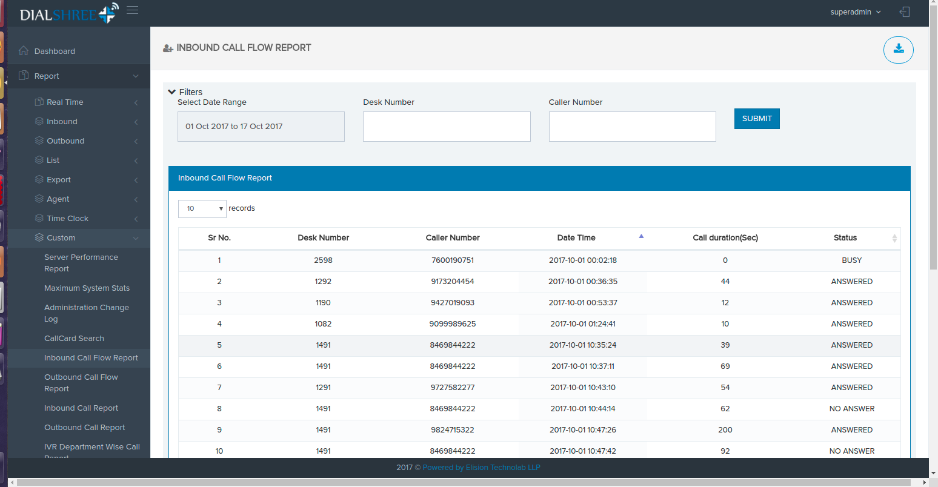

## Outbound Call Flow Report

**Description** : Using this report user can see the Outbound call’s parameters like on which date Outbound call was received , on which extension(Desk Number) this Outbound call was answered, call’s duration in sec, call’s status(answered, busy, etc)

**FILTERS:** Outbound call flow report have three filters to filter out the data

1. Date range: If user wants to see the data of particular dates then user can select the date range. Date range selection is mandatory. If user can not select the date range then user can see the alert for date range selection.
2. Desk Number (Extension):  Second filter is desk number selection. If user wants to see how many Outbound calls was received on particular extension then user can select date range and type a Desk Number.
3. Caller Number : if user wants to see how many Outbound call was received of particular number then user can select date range and type a Caller Number
4. If user want to see how many Outbound call was received for particular caller Number  on particular extension(Desk Number) then user selects date range type Desk number and caller Number

* In this report we list out the total number of record and total call Duration for particular page. If user select “10” in record drop down then user can see the first 10 record on “1” page and according to the record drop down page will be set.
* On first page user can see Total number of records: 10 and according to the data user can see the Total call Duration of first 10 records.
* On second page user can see Total number of record is “first page total record + second page total record” but Total call duration is seen according to second page data.
* Download Functionality: user can download the csv file of data. If user can select date range and list out data on bases of filters and if data is not available then download
* Button is disable if data is available then and then only download button is active and user can download the csv file.
* There are one condition in this report if logged in user is “**qcreport**”, this user can see data only for **"1490", "1491", "1200", "1008", "2235"** extension (Desk Number)

**Files**:

* outbound_did_report.php
* Generate_outbound_did_report.php
* download_outbound_did_report.php

**URL**: <http://192.168.0.36/clients/elision-cims/elision-dialer/admin/outbound_did_report.php>

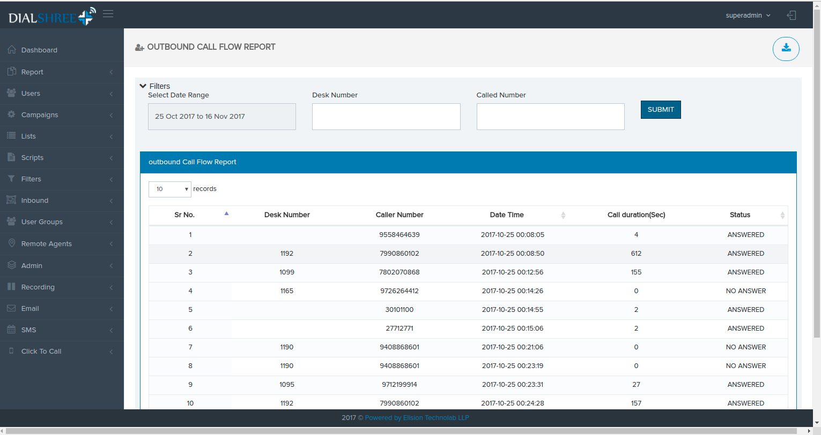

## Inbound Call Report

**Description :** Using this report user can see the Inbound call’s parameters like on which extension(Desk Number) this inbound call was answered and total Number of count of call for that extension (desk number)

**FILTERS:** Inbound call report have two filters to filter out the data

1. Date range: If user wants to see the data of particular dates then user select the date range. Date range selection is mandatory. If user can not select the date range then user see the alert for date range selection.
2. Desk Number (Extension):  Second filter is desk number selection. If user want to see the count Inbound calls for particular extension then user can select date range and type a Desk Number.

* In this report we list out the total number of record and total call count for particular page. If user select “10” in record drop down then user can see the first 10 record on “1” page and according to the record drop down page will be set.
* On first page user can see Total number of records: 10 and according to the data, user can see the Total call count of first 10 records.
* On second page user can see Total number of record is “first page total record + second page total record” but Total call count is seen according to second page data.
* Download Functionality: user can download the csv file of data. If user can select date range and list out data on bases of filters and if data is not available then download button is disable if data is available then and then only download button is active and user can download the csv file.

**Files:**

* inbound_call_report.php
* generate_inbound_call_report.php
* download_inbound_call.php

**URL:** <http://192.168.0.36/clients/elision-cims/elision-dialer/admin/inbound_call_report.php>

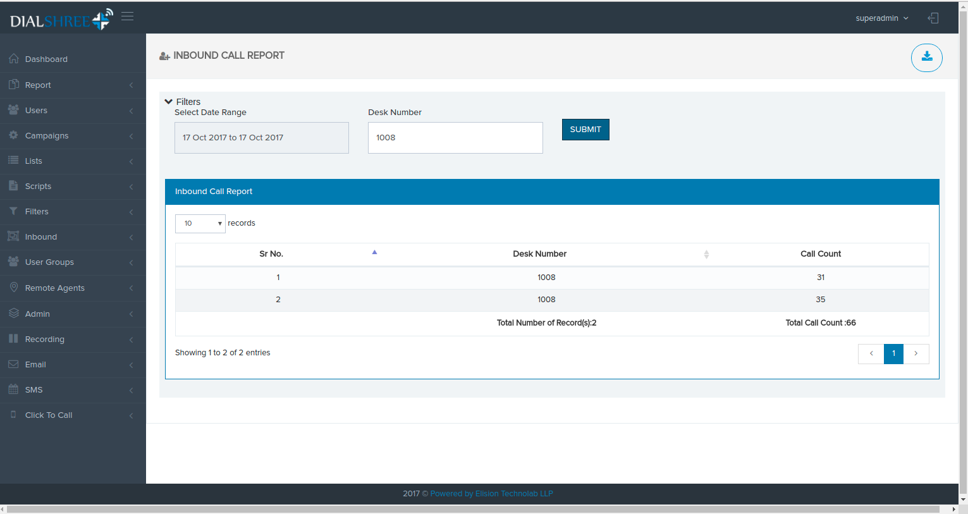

## Out bound Call Report

**Description :** Using this report user can see the Outbound call’s parameters like on which extension(Desk Number) this Outbound call was answered and total Number of count of call for that extension (desk number)

**FILTERS:** Outbound call report have two filters to filter out the data

1. Date range: If user wants to see the data of particular dates then user select the date range. Date range selection is mandatory. If user can not select the date range, then user see the alert for date range selection.
2. Desk Number (Extension):  Second filter is desk number selection. If user wants to see the count of inbound calls for particular extension then user select date range and type a Desk Number.

* In this report we list out the total number of record and total call count for particular page. If user select “10” in record drop down then user can see the first 10 record on “1” page and according to the record drop down page will be set.
* On first page user can see Total number of records: 10 and according to the data, user can see the Total call count of first 10 records.
* On second page user can see Total number of record is “first page total record + second page total record” but Total call count is seen according to second page data.
* Download Functionality: user can download the csv file of data. If user can select date range and list out data on bases of filters and if data is not available then download button is disabling if data is available then and then only download button is active and user can download the csv file.

**Files:**

* outbound_call_count_report.php
* generate_outbound_call_report.php
* download_outbound_call_report.php

**URL:**<http://192.168.0.36/clients/elision-cims/elision-dialer/admin/outbound_call_count_report.php>

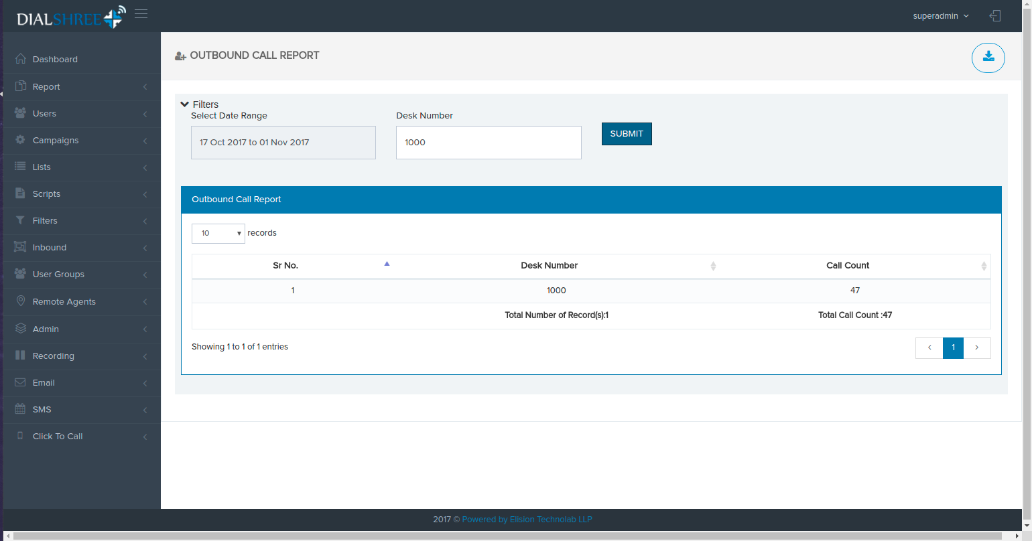

## IVR Department wise Report

**Description :**  Using this report user can see the Inbound call’s parameters like on which date inbound call was received ,in which department the call was transferred, on which extension(Desk Number) particular call was answered, call’s status(answered, busy, etc)

**FILTERS:** IVR department wise report have three filters to filter out the data

1. Date range: If user wants to see the data of particular dates then user can select the date range. Date range selection is mandatory. If user can not select the date range then user can see the alert for date range selection.
2. Caller Number : if user wants to see how many inbound call was received of particular number then user select date range and type a Caller Number
3. Department: if user wants to check call for particular department  then user selects the department. Here user can select one or more departments. if user can not select any department then user can see all departments record.
4. If user want to see how many inbound call was received for particular caller Number  on particular department then user selects date range and Department
5. Download Functionality: user can download the csv file of data. If user can select date range and list out data on bases of filters and if data is not available then download button is disable if data is available then and then only download button is active and user can download the csv file.

**Files:**

* dept_wise_report.php
* generate_dept_wise_report.php
* download_dept_wise_report.php

**URL:**<http://192.168.0.36/clients/elision-cims/elision-dialer/admin/dept_wise_report.php>

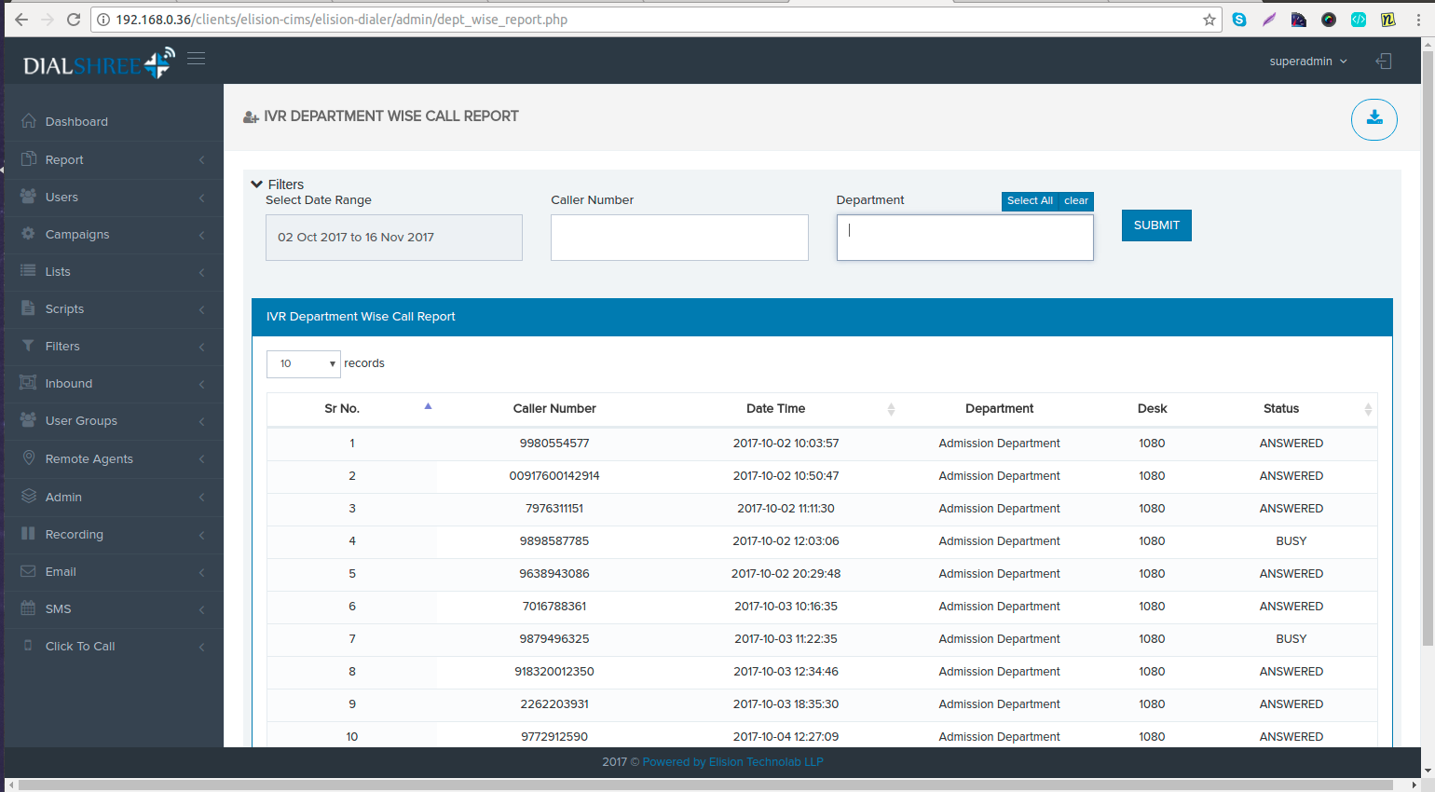

## Manual Inbound Outbound Recording Module

**Description :** Manual inbound Outbound Call Recording module is used to listing manual dial call’s date/time, it’s unique ID, phone number , extension, location, call type, and user can  play a file inline.

**FILTERS:** Manual Inbound Outbound Call Recording module have three filters to filter out the data

1. Date range: If user wants to see the data of particular dates then user can select the date range. Date range selection is mandatory. If user can not select the date range then user can see the alert for date range selection.
2. Select Call Type: if user wants to see the records of particular call type (Inbound, Outbound), then user select date range and call type.
3. Phone Number : if user wants to see the records of particular phone number, user can use this filter
4. Extension: if user wants to see the records of particular extension, user can use this filter.

* User can play recording file. By clicking on play icon
* To download recording files , just click on the check box button and click on the download button which is shown in panel’s heading
* User can download the csv file also, to download the csv file just click on another download button.
* There are one condition in this module if logged in user is “**qcrec**”, this user can see data only for **"1490", "1491", "1200", "1008", "2235"** extension (Desk Number)

**Files:** manual_inbound_outbound_recording.php

         generate_manual_inbound_outbound_recording.php

         Download_manual_inbound_outbound_recording.php

**URL:** <http://192.168.0.11/clients/elision-cims/elision-dialer/admin/manual_dial_call_recording.php>

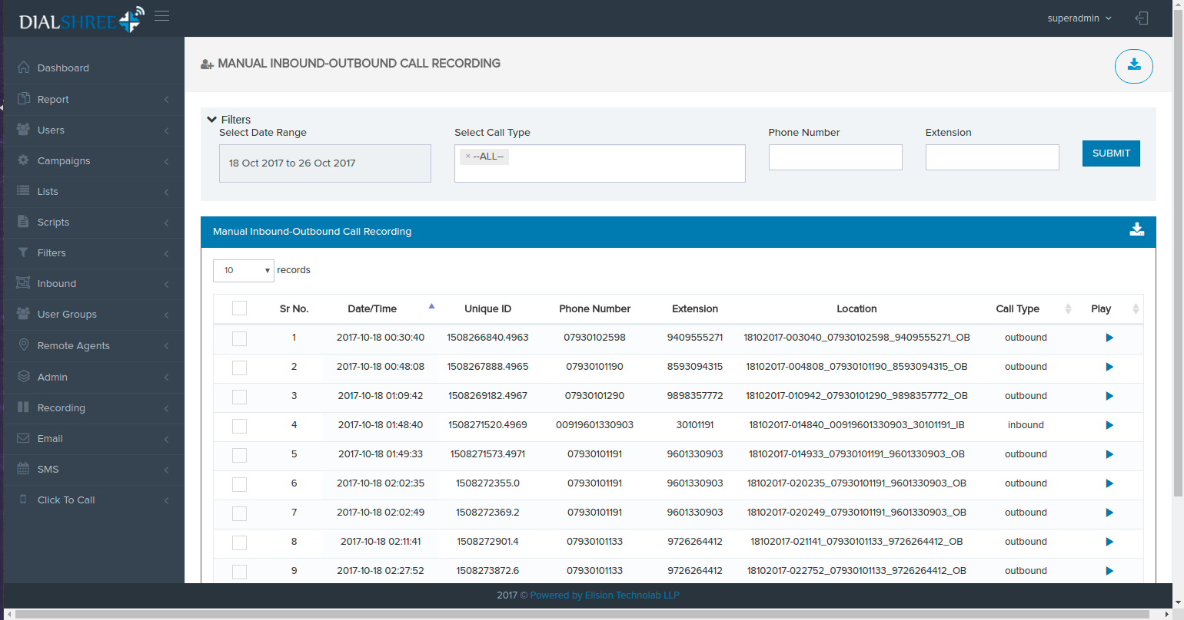

## Inbound DID Report

Description: Using this Report we can check the calls record in DID wise , server wise, date wais summary.

Filters: Inbound DID report have 2 filters

1. Date range: If user wants to see the data of particular dates then user can select the date range. Date range selection is mandatory. If user can not select the date range then user can see the alert for date range selection.
2. Select Inbound DID: If user wants to see the call summary of particular did then user can select a did and click on the submit button. Here user can select multiple dids to see the call records for multiple dids.this filter is also mandatory. If user can not select any did then user can see the alert for did selection.

* Did summary: in DID summary user can see the DID name , DiD description, call route , and how many call are done using  this DID.
* Server Summary : In server summary user can see how many calls are done for particular server
* Date summary: In Date summary user can see the date wise call count.

**FILE:** AST_DIDstats.php

**URL:** <http://192.168.0.36/clients/elision-cims/elision-dialer/admin/AST_DIDstats.php>

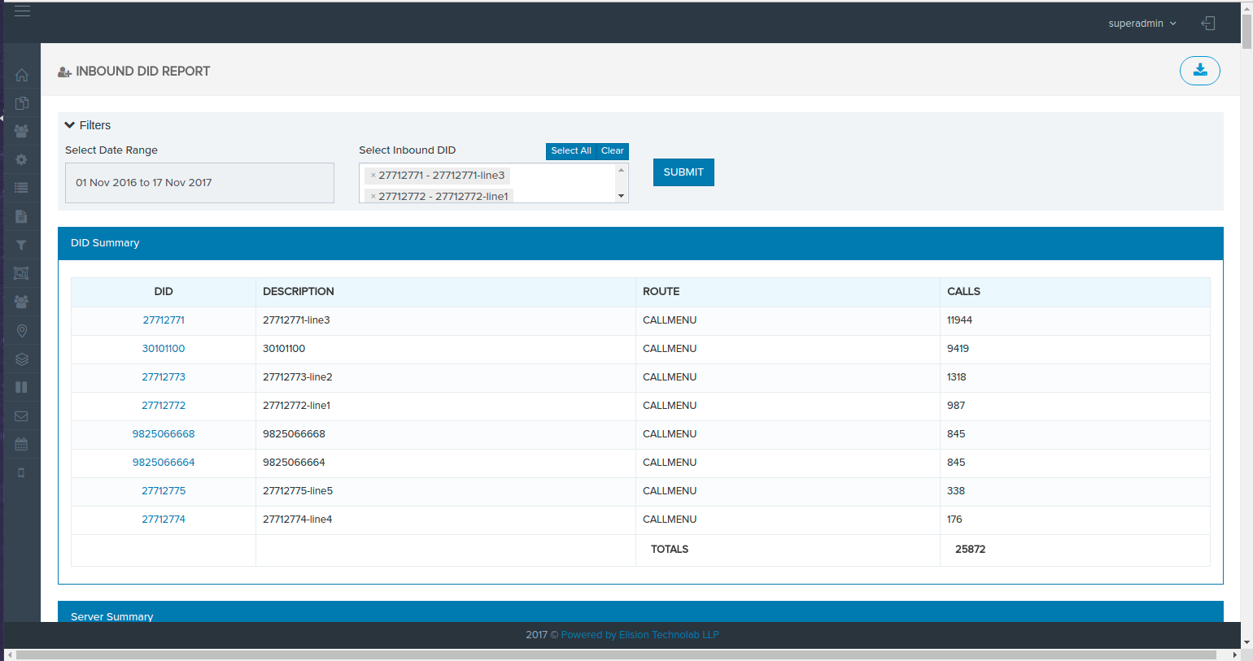

## Inbound IVR Report

**Description:** This report shows a breakdown of IVR paths followed by callers on selected IVRs based on the date range.

**Filters:**

1. Date range: If user wants to see the data of particular dates then user can select the date range. Date range selection is mandatory. If user can not select the date range then user can see the alert for date range selection.
2. Inbound Groups: this filter is a multi select user can select multiple inbound Groups.

* Using this report user can see the IVR calls , Queue calls, queue Drop calls, Queue drop percent, IVR AVG time, Total AVG time , Call path
* IVR CALLS = Total calls taken by or made through the selected IVRs that follow the 'CALL PATH'.
* QUEUE CALLS = Total inbound calls taken by the selected IVRs that follow the 'CALL PATH'.
* QUEUE DROP CALLS = Total inbound calls taken by the selected IVRs that follow the 'CALL PATH' that were dropped.
* QUEUE DROP PERCENT = Percentage of dropped inbound calls taken by the selected IVRs (QUEUE DROP CALLS / QUEUE CALLS).
* IVR AVG TIME = Average amount of time spent in-call, taken by dividing IVR CALLS by the total time spent in the selected IVRs.
* TOTAL AVG TIME = Total call time spent in the selected IVRs.
* CALL PATH = the specific call path followed on the IVR - report will display each distinct path followed by all the selected IVRs for the selected date range.

**FILES:** AST_DIDstats.php

**URL:** <http://192.168.0.11/clients/elision-cims/elision-dialer/admin/AST_DIDstats.php>

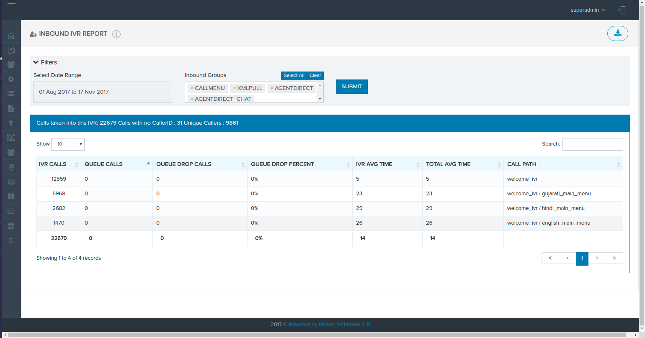

## PRI Fluctuation and PRI down Alert

### PRI Fluctuation Alert

* To alert about PRI Fluctuation on SMS & Email as per PRI Fluctuation Alerts Settings
* This script will fetch "**ANSWERED**" status data for given Cron Time.

1. If there is 0 count of this status from ovs_cdr_log then it will alert to people as per PRI Fluctuation Alerts Configurations & captures logs w.r.t. Modules' Log Table
2. Else it will capture log to vicidial_admin_log table about 'No Issue in PRI' like that.
3. If SMS/Email alerts are not sent though user has permission of it then check respected module Log Table.
4. Additional logs will be captured in vicidial_admin_log in case of user have no permission, no email alerts permission, no sms alert permission, no PRI Fluctuation alert permission etc.

* Below cron script will be used for this:
  + */5 * * * * /usr/bin/php /var/www/html/clients/elision-cims/elision-dialer/modules/Scripts/elision_pri_fluctuation_alerts.php 5Minutes

### PRI Down Alert

* To alert about PRI Down on SMS & Email as per PRI Down Alerts Settings
* This script will fetch execute below command to get PRI Down logs w.r.t. given Cron Time
  + grep -rin 'disable_span' /var/log/messages
* This command will number of log count of PRI Down for given cron time
* If PRI Down logs found then it will alert to people as per PRI Down Alerts Configurations & captures logs w.r.t. Modules' Log Table.
* It also insertes PRI Status log to 'elision_pri_status' table when there is PRI Down.
* Else it will capture log to vicidial_admin_log table about 'No PRI is down for given time-frame' like that.
* If SMS/Email alerts are not sent though user has permission of it then check respected module Log Table.
* Additional logs will be captured in vicidial_admin_log in case of user have no permission, no email alerts permission, no sms alert permission, no PRI Down alert permission etc.
* Below cron script will be used for this:
  + */5 * * * * /usr/bin/php /var/www/html/clients/elision-cims/elision-dialer/modules/Scripts/elision_pri_down_alerts.php 5Minutes
* Both crons have been tested @192.168.0.11 server successfully.

For these two alerts below table will have configurations:

Table: **elision_pri_notification_settings**

|  |  |
| --- | --- |
| Field Name | Description |
| setting_id | Auto Increment Value – PK |
| fname | First Name |
| lname | Last Name |
| target_email | Unique Email Address – Unique Key |
| target_mobile | Mobile Number |
| more_data | More data stored in JSON format if any. |
| pri_fluctuation | PRI Fluctuation Alert Permission – Default – 0 |
| pri_down | PRI Down Alert Permission – Default – 0 |
| sms_notification | Alerts on SMS Permission – Default – 0 |
| email_notification | Alerts on Email Permission – Default – 0 |

Below are the required modules for these alerts:

1. SMS – Client's SMS API, Templates will be configured.
2. Email – Client's Email SMTP Details, Email Templates will be configured

Below are the required tables with respect to SMS/Email Success/Failures Alerts:

1. elision_pri_status – logs of which PRI is Down
2. vicidial_admin_log - This will have cron messages except successfully goint to to send SMS & Email
3. elision_email_log - Success/Failure log of sent Email*
4. elision_sms_log - Success/Failure log of sent SMS*

* - These logs will not be captured in vicidial_admin_log table

## SMS Module

* SMS Template Name required as: [PRI Fluctuation](http://192.168.0.125/clients/elision-cims/elision-dialer/admin/sms_tpls.php?module=SMS&section=template&category=SMS_Module_Template)
* First you must create SMS API for all these alerts with Client Details. [Check here](http://192.168.0.125/clients/elision-cims/elision-dialer/admin/api.php?module=SMS&section=api&category=SMS_Module_API).
* SMS API Configuration:
  + API ID: **SMS Just Bank**
  + URL: <http://www.smsjust.com/blank/sms/user/urlsms.php>
  + Usename: cimshospital
  + Password: 123456
  + Provider: **SMS Just Bank**
  + Status: Active
  + API Type: PHP
  + Sender ID: CIMSHO
  + Format: Other

## Email Module

* Email Template Name required as: [PRI Fluctuation](http://192.168.0.125/clients/elision-cims/elision-dialer/admin/email_template.php?id=1&module=Email&section=email_templates&category=Email_Module_Templates)
* First you need to create Email SMTP for all these alerts with Client Details. [Check here](http://192.168.0.125/clients/elision-cims/elision-dialer/admin/smtp.php?module=Email&section=smtp&category=Email_Module_SMTP).
* SMTP Configuration:
  + Host: 172.16.30.111
  + Port: **25**
  + Username: alerts@cimshospital.org
  + Password: Cims@123456
  + Status: Active
  + Authentication: **none**
  + From Email: [alerts@cimshospital.org](mailto:alerts@cimshospital.org)

## New File Structure

1. /var/www/html/clients/elision-cims/elision-dialer/modules/Scripts/elision_pri_alerts_class.php
2. /var/www/html/clients/elision-cims/elision-dialer/modules/Scripts/elision_pri_fluctuation_alerts.php
3. /var/www/html/clients/elision-cims/elision-dialer/modules/Scripts/elision_pri_down_alerts.php
4. /var/www/html/clients/elision-cims/elision-dialer/modules/Scripts/pri_alerts.sql
5. /var/www/html/clients/elision-cims/elision-dialer/modules/Scripts/sample_log.txt – This is only for testing purpose for developer only.

Required Files/Directory Structure for Sending Email:

1. /var/www/html/clients/elision-cims/elision-dialer/modules/Scripts/mail_classfiles/

SQL Information: (Source: 192.168.0.11)

1. For 'elision_email_log', you need to apply below alter query which is also available to GIT:
   1. Path: /var/www/html/clients/elision-cims/elision-dialer/modules/elision_modules_tables.sql

*ALTER TABLE `elision_email_log` CHANGE `email_response` `email_response` LONGTEXT CHARACTER SET latin1 COLLATE latin1_swedish_ci NOT NULL;*

1. Additional Requirement

