



Ganesh Housing: Tech. Document

# Table of Contents

Table of Contents 2

1.0 Company Details 4

2.0 Project & Client Details 5

3.0 Git Repository 6

4.0 Roles and Responsibility 7

5.0 Initial Requirement 8

5.1 Customization 8

5.1.1 Incoming Call Routing 8

5.1.2 Priority Based Call Routing 9

5.1.3 Random Number Call Routing 12

5.2 Customized Admin Panel 13

5.3 Executive Panel 15

5.4 Customized Report 17

5.4.1 Miss Call PRI Report 17

5.4.2 After Office Hours Call Report 17

5.4.3 Campaign Wise Report 18

5.4.4 Agent Wise Report 18

5.4.5 User Login Report 20

6.0 Additional Requirement 21

6.1 Fixed summary alert report cron file Issue (20/12/2017) 21

Document Revision History

This table holds record of signification changes made to the document.

|  |  |  |  |
| --- | --- | --- | --- |
| **Version** | **Date** | **Author** | **Description of change** |
| 1.0 | 22/12/2017 | Radhika Solgama | Technical Document |

1.0 Company Details

Company name: Ganesh Housing

City: Ahmedabad

State :Gujarat

Country: India

Address: Ganesh Housing Corporation Limited  
  
 100 ft. Hebatpur-Thaltej Road, Opp. Zydus Hospital,  
  
 Thaltej, Ahmedabad - 380054, Gujarat.

2.0 Project & Client Details

**Clients Details**:

**Client Name:** Dhaval Rao

**Contact Person:**

**Mobile No:**

**Office No:** +91-79-6160 8888

**Project Details:**

3.0 Git Repository

**Server:**

**Link:**

**Git clone link:** git@gitlab.com: elision-ganeshhousing/elision-dialer.git

4.0 Roles and Responsibility

|  |  |  |
| --- | --- | --- |
| **Sr No.** | **Role** | **Responsibility** |
| 1 | Installation |  |
| 2 | Tested By |  |

1. Initial Requirement

## Customization

### Incoming Call Routing

* We deployed the elision solution for incoming call routing to executive’s mobile directly with call routine logic. When any incoming calls come to from SIP Based PRI Line to Elision Server, call will route on basis of Priority set from GUI. First the agi script will higher priority’s executive’s details like is he on leave? , today is his week off? , executive’s account is active or not. On the basis of this parameters system will route the call to executive’s Mobile directly. Below diagram shows the Graphical representation of call routing logic.

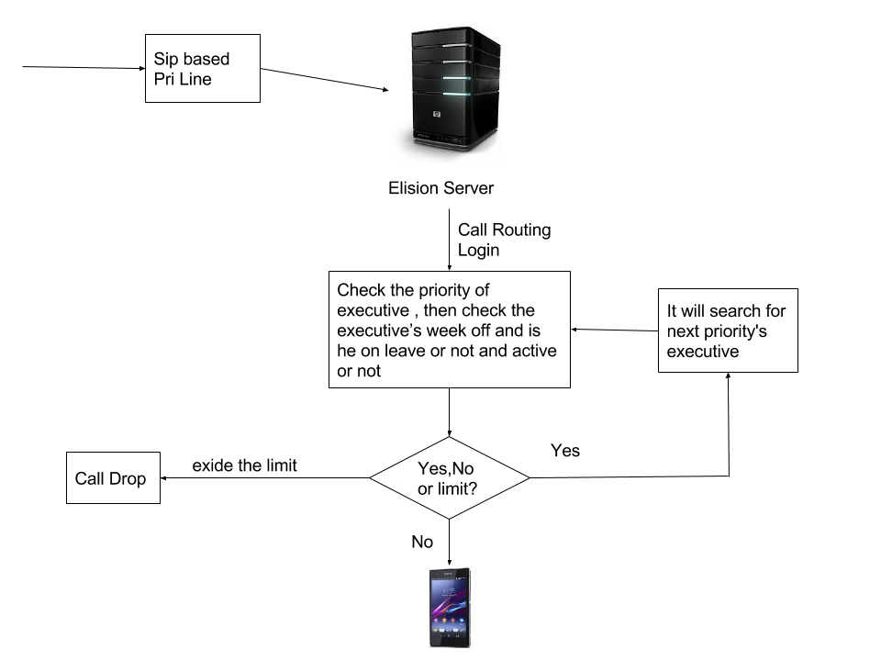

(Fig 1 – Call routine Logic)

* As shown in this figure call comes on SIP based PRI line that is configured in Elision server with peer (username and password).

Registration Peer & String:

*[tatasip]*

*type=friend*

*disallow=all*

*allow=alaw*

*allow=ulaw*

*allow=g729*

*host=10.0.70.2*

*dtmfmode=rfc2833*

*nat=no*

*canreinvite=no*

*context=trunkinbound*

*register => 67776208:7967776208:67776208@10.0.70.2/67776208*

### Priority Based Call Routing

* We have created AGI Script for the priority based call routing logic. In that script we are checking the executive’s details which can modify from GUI. The dial plan and agi script is as below:
* Dial Plan

;===============use this dialplan for inbound calling================pratik=========

exten => _7967776202,1,Set(UniqueID=${UNIQUEID})

exten => _7967776202,n,NoOp(============ ${UniqueID} ==============)

exten => _7967776202,n,Set(CALLTIME=${STRFTIME(${EPOCH},,%d%m%Y-%H%M%S)})

exten => _7967776202,n,Set(PHONE_NUMBER=${CALLERID(num)})

;exten => _7967776202,n,Set(CALLER=${EXTEN})

exten => _7967776202,n,Set(CALLFILE=${CALLTIME}_${PHONE_NUMBER}_${CALLER}_IB)

exten => _7967776202,n,Set(CALLTYPE=inbound)

exten => _7967776202,n,Monitor(wav,${CALLFILE})

exten => _7967776202,n,AGI(recording_log.php,${CALLFILE},${PHONE_NUMBER},${CALLTYPE},${UniqueID},${CALLER})

exten => _7967776202,n,AGI(agi-priority.agi,0)

;exten => _7967776202,n,AGI(agi-random.agi)

exten => _7967776202,n,NoOp(============ ${VALUE} ==============)

exten => _7967776202,n,Set(CALLERID(num)=${CALLER})

exten => _7967776202,n,playback(quality_purpose)

exten => _7967776202,n,Progress()

exten => _7967776202,n,Dial(SIP/0${VALUE}@tatasip,30,Ttor)

;exten => _7967776202,n,AGI(agi-random.agi)

exten => _7967776202,n,AGI(agi-priority.agi,1)

exten => _7967776202,n,NoOp(============ ${VALUE} ==============)

exten => _7967776202,n,Set(CALLERID(num)=${CALLER})

exten => _7967776202,n,Progress()

exten => _7967776202,n,Dial(SIP/0${VALUE}@tatasip,30,Ttor)

;exten => _7967776202,n,AGI(agi-random.agi)

exten => _7967776202,n,AGI(agi-priority.agi,2)

exten => _7967776202,n,NoOp(============ ${VALUE} ==============)

exten => _7967776202,n,Set(CALLERID(num)=${CALLER})

exten => _7967776202,n,Progress()

exten => _7967776202,n,Dial(SIP/0${VALUE}@tatasip,30,Ttor)

exten => _7967776202,n,AGI(agi-priority.agi,3)

exten => _7967776202,n,NoOp(============ ${VALUE} ==============)

exten => _7967776202,n,Set(CALLERID(num)=${CALLER})

exten => _7967776202,n,Progress()

exten => _7967776202,n,Dial(SIP/0${VALUE}@tatasip,30,Ttor)

exten => _7967776202,n,AGI(agi-priority.agi,4)

exten => _7967776202,n,NoOp(============ ${VALUE} ==============)

exten => _7967776202,n,Set(CALLERID(num)=${CALLER})

exten => _7967776202,n,Progress()

exten => _7967776202,n,Dial(SIP/0${VALUE}@tatasip,30,Ttor)

exten => _7967776202,n,AGI(agi-priority.agi,5)

exten => _7967776202,n,NoOp(============ ${VALUE} ==============)

exten => _7967776202,n,Set(CALLERID(num)=${CALLER})

exten => _7967776202,n,Progress()

exten => _7967776202,n,Dial(SIP/0${VALUE}@tatasip,30,Ttor)

exten => _7967776202,n,AGI(agi-priority.agi,6)

exten => _7967776202,n,NoOp(============ ${VALUE} ==============)

exten => _7967776202,n,Set(CALLERID(num)=${CALLER})

exten => _7967776202,n,Progress()

exten => _7967776202,n,Dial(SIP/0${VALUE}@tatasip,30,Ttor)

exten => _7967776202,n,AGI(agi-priority.agi,7)

exten => _7967776202,n,NoOp(============ ${VALUE} ==============)

exten => _7967776202,n,Set(CALLERID(num)=${CALLER})

exten => _7967776202,n,Progress()

exten => _7967776202,n,Dial(SIP/0${VALUE}@tatasip,30,Ttor)

exten => _7967776202,n,AGI(agi-priority.agi,8)

exten => _7967776202,n,NoOp(============ ${VALUE} ==============)

exten => _7967776202,n,Set(CALLERID(num)=${CALLER})

exten => _7967776202,n,Progress()

exten => _7967776202,n,Dial(SIP/0${VALUE}@tatasip,30,Ttor)

exten => _7967776202,n,AGI(agi-priority.agi,9)

exten => _7967776202,n,NoOp(============ ${VALUE} ==============)

exten => _7967776202,n,Set(CALLERID(num)=${CALLER})

exten => _7967776202,n,Progress()

exten => _7967776202,n,Dial(SIP/0${VALUE}@tatasip,30,Ttor)

exten => _7967776202,n,Hangup()

;===================================================================================

* AGI Script - agi-priority.agi:

#!/usr/bin/php -q

<?php

set_time_limit(30);

require('phpagi/phpagi.php');

require('/var/www/html/admin/dbconnect.php');

$try = $argv[1];

#$try = 4;

$try = $try+1;

$agi = new AGI();

$DAY= date('D');

#echo $DAY;

#exit;

#$query ="SELECT `phone_number` FROM `agent_details` where `weekoff` NOT LIKE '$DAY' and is_on_leave='n' ORDER BY RAND() limit 1";

$query ="SELECT `phone_number` FROM `agent_details` where `weekoff` NOT LIKE '$DAY' and is_on_leave='n' and active='Yes' and priority='$try' limit 1";

$result = mysql_query($query);

echo "$query\n";

$random_keys=mysql_fetch_array($result);

echo "$random_keys[0]\n";

$number=$random_keys[0];

$agi->verbose("parameter value ::" . $number);

$agi->set_variable('VALUE', $number);

?>

### Random Number Call Routing

* In this random number call routing, for any incoming call agi script will check active executives who are not on leave and also does not have week off and get any executive’s number randomly and call route to that executive’s number. The dial plan and agi script is as below:

#!/usr/bin/php -q

<?php

set_time_limit(30);

require('phpagi/phpagi.php');

require('/var/www/html/admin/dbconnect.php');

$agi = new AGI();

$DAY= date('D');

#echo $DAY;

#exit;

#$query ="SELECT `phone_number` FROM `agent_details` where `weekoff` NOT LIKE '$DAY' and is_on_leave='n' ORDER BY RAND() limit 1";

$query ="SELECT `phone_number` FROM `agent_details` where `weekoff` NOT LIKE '$DAY' and is_on_leave='n' and active='Yes' ORDER BY RAND() limit 1";

$result = mysql_query($query);

echo "$query\n";

$random_keys=mysql_fetch_array($result);

echo "$random_keys[0]\n";

$number=$random_keys[0];

$agi->verbose("parameter value ::" . $number);

$agi->set_variable('VALUE', $number);

?>

## Customized Admin Panel

* We have customized the admin panel to add, delete and edit any executive details from GUI itself. Admin user can set week of, Holiday dates like starting date of holiday and ending date of holiday, Active and inactive the executives. Also admin can set the username and password for executive panel login, also set the calls priority from this panel of all the executives.

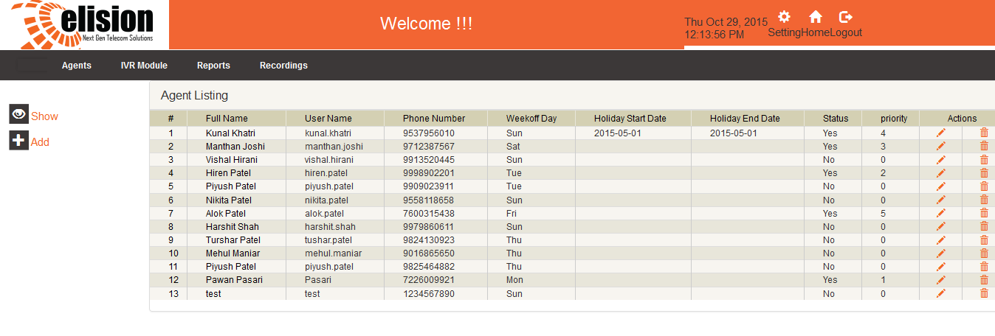

*(Fig 2- Executives Listing)*

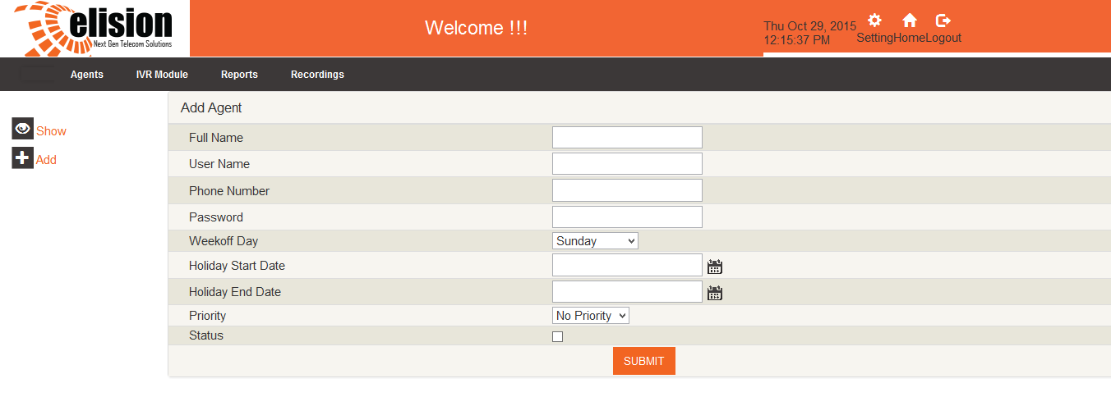

*(Fig 3 – Add Executive Panel)*

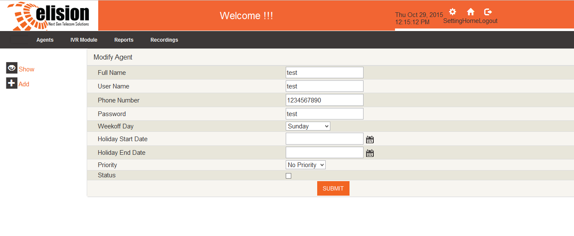

*(Fig 4 – Edit Executives Details)*

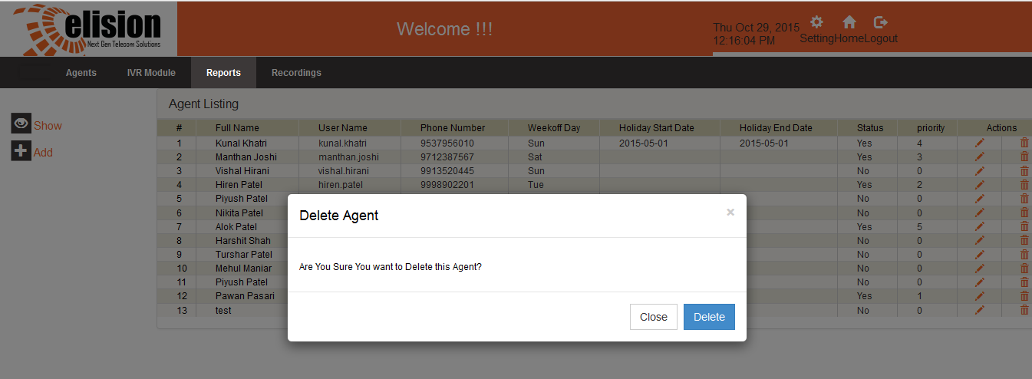

*(Fig 5 – Delete Executive)*

## Executive Panel

* We have developed new executive panel in which executive logged in by their username and password, and made calls for feedback or for follow up and for calling back of not connected numbers.
* In this panel all the statuses calls display:

1. Answer
2. No Answer
3. Miss call
4. After Office hour

* This Panel will search the latest records of caller. As an example if customer calls at first time nobody will answer that call so that call will marked as No answer. But after by using this panel executive call on that number and talked with him and its status will update to an answer call.
* From this panel executive can mark call as IMPORTANT, also add comments and that comment will display next time when executive does the call on same number.
* Executive will call via Click to call from this panel. When executive click on any number first he gets the ring on his registered mobile number and after picking up that call next call will dial to customer.

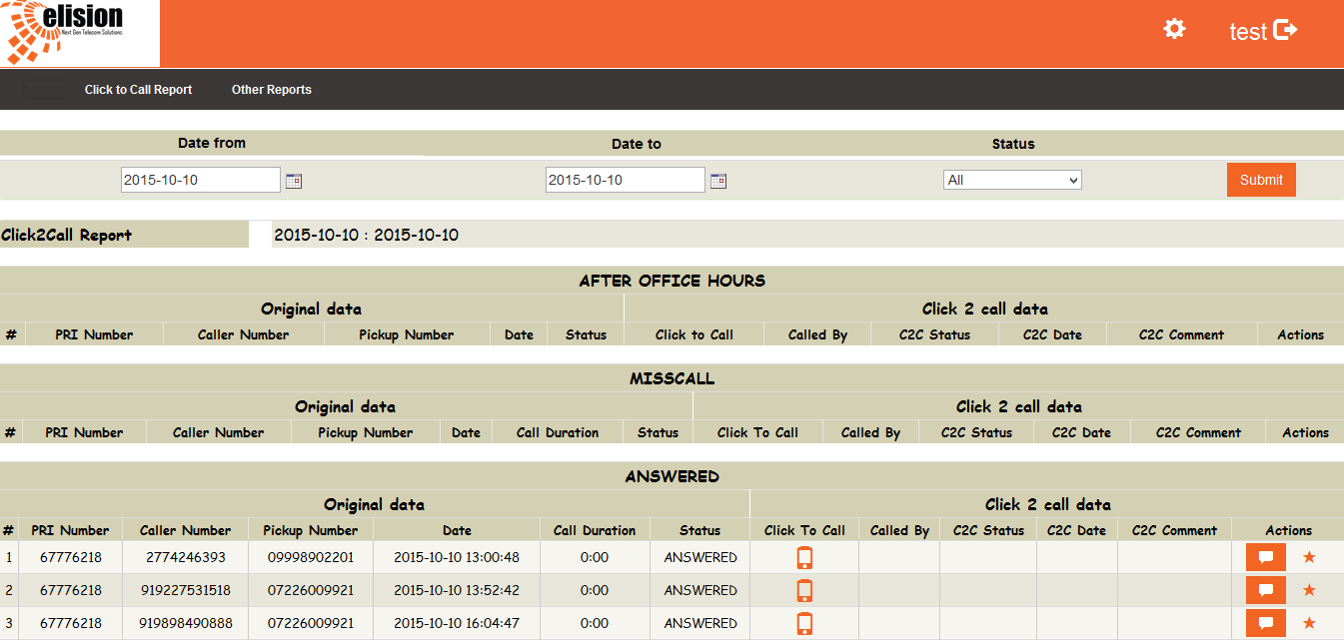

*(Fig 6 – executive panel)*

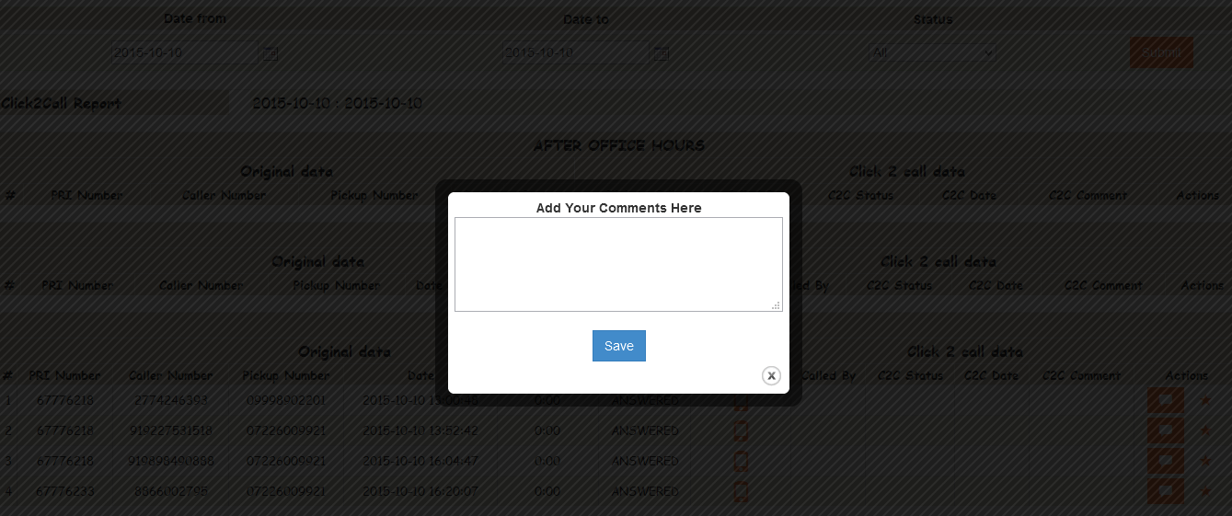

*(Fig 7 – Executive panel with comment box)*

## Customized Report

We have provided many customized reports and they are as below:

### Miss Call PRI Report

* This report will display the data or calls which are not routed on any executive’s number. When an incoming call comes it play welcome file and then after call route to executive’s number as per logic, but some caller hang up the call before call route to executive’s number that caller information will display in this report.
* This report is generates on basis of date time, PRI Number and Customer Number. We also given export this report data in csv format

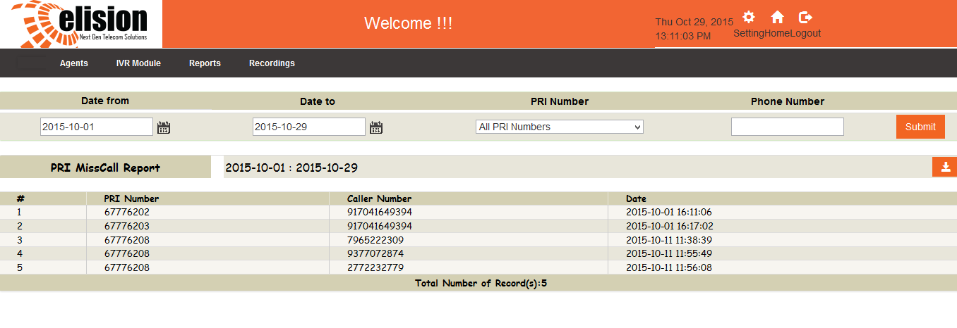

*(Fig 8 – Miss Call PRI Report)*

### After Office Hours Call Report

* They have 10 to 7 office hour timing if any calls come after 7 PM or before 10 AM then it plays office is closed audio file, and by this report we can get how many calls came before or after office hour so that executive will call back them manually from executive panel.
* This report is generates on basis of date time, PRI Number and Customer Number. We also given export this report data in csv format

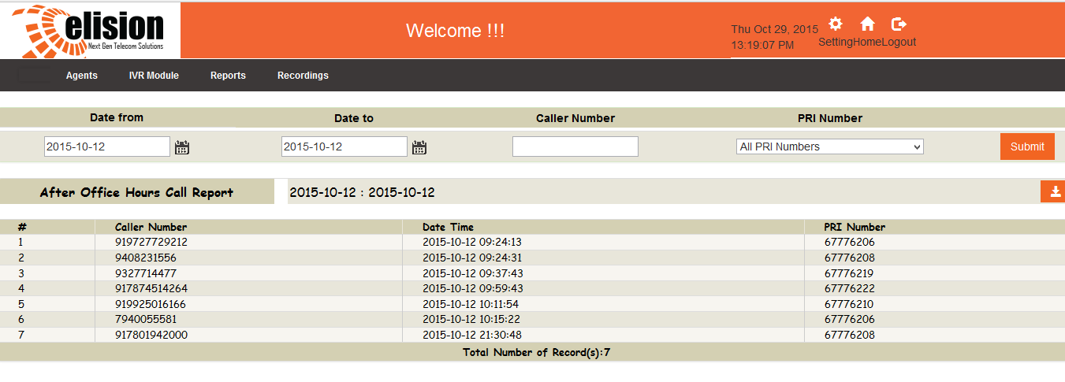

### Campaign Wise Report

* They have publish their PRI numbers in different different campaigns like News paper, Holdings, Film theatre, Mailer, Magazine, Social Media. By using this report they can get how many calls came in particular campaign or they also can search in between of this time period how many campaign’s calls came. We also given export this report data in csv format.
* And at the end of this report we provided summary of above calls campaign wise. So from this summary they can easily get the counts of each and every campaign.

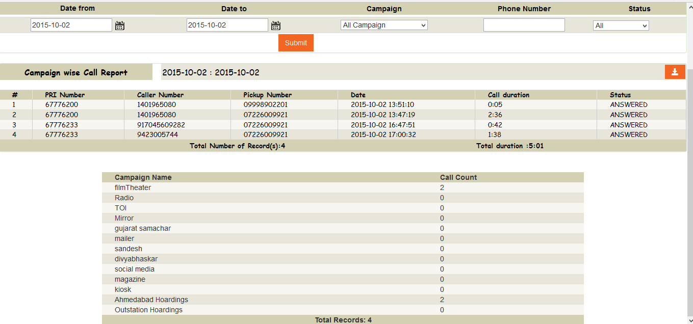

*(Fig 10 – campaign wise report)*

### Agent Wise Report

* This report is used to get the executive’s performance. How many calls attend by each executive and in which date time that call came, what was the duration of that call.
* Here calls are directly routed to executive’s mobile number so that admin person will not get exact idea how many calls they got and what he talked but from this report admin can see the details. And at the below we provided the summary of all the agent’s calls. We also given export this report data in csv format.

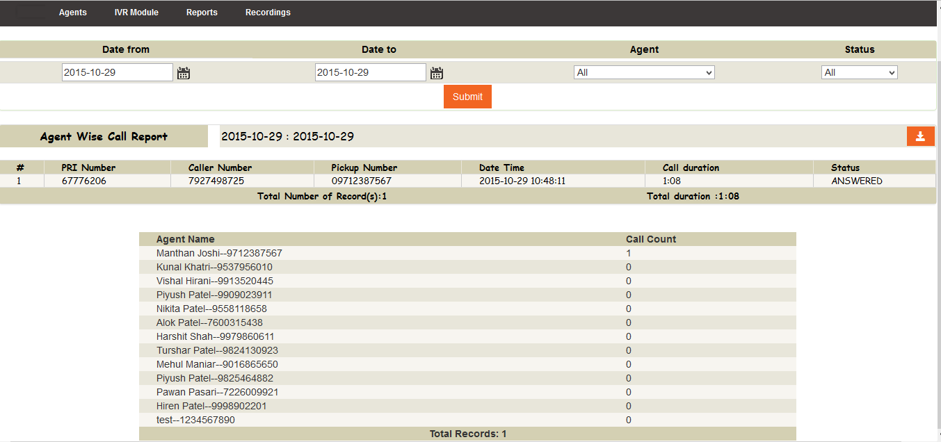

*(Fig 11 – Agent wise call Report)*

### User Login Report

* We had provided the executive panel from that executive call on previously came customer for feed back or follow up. So this report is based on that executive panel.
* This Report shows how many agents are using that executive panel, at which time they logged in to executive panel and at what time they logged out from there.
* We also provided the same summary report like above two reports from that admin get idea how many times executive logged in and how much executives using this system.

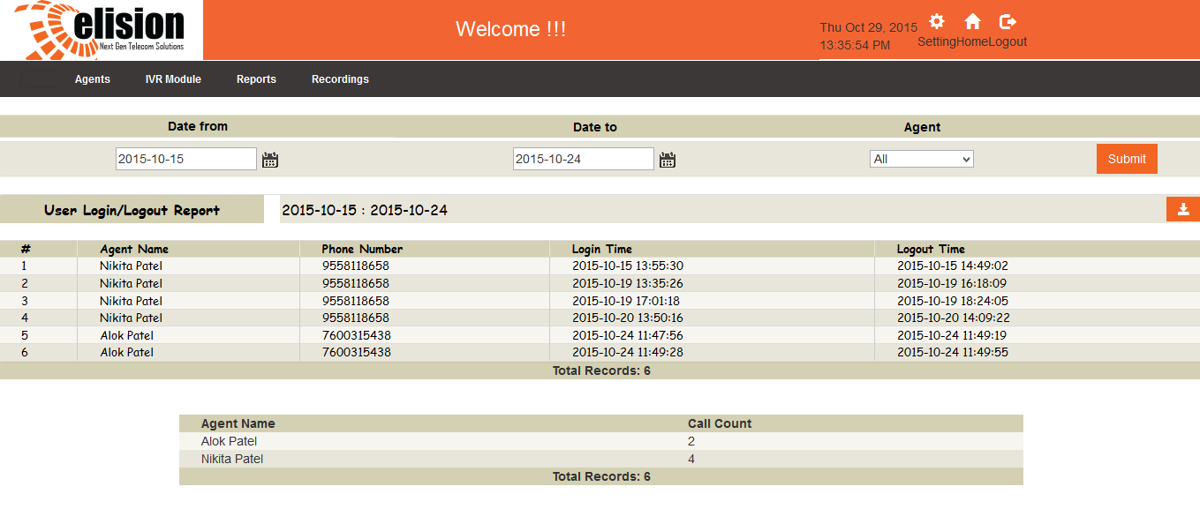

*(Fig 12- User Login Report)*

1. Additional Requirement

## Fixed summary alert report cron file Issue (20/12/2017)

* In summary alert report cron file the count of ANSWERED, NO ANSWERED, MISSED CALL counts WERE wrong.
* With the reference of inbound_did_report we change the query.and fixed it.

