



Prudent: Technical Document

# Table of Contents

Table of Contents 2

1. Company Details 4

2. Project & Client Details 5

3. Git Repository 6

4. Roles And Responsibility 7

5. Initial Requirement 8

5.1 GUI to Insert the registered customers 8

6. Additional Requirement 11

Document Revision History

|  |  |  |  |
| --- | --- | --- | --- |
| **Version** | **Date** | **Author** | **Description of change** |
| 1.0 | 31/01/2017 | Radhika Solgama | Technical Document |

1. Company Details

Company name: Prudent

City: Ahmedabad

State: Gujarat

Country: India

Address: Head-Customer Service | Prudent Corporate Advisory Services Ltd.703, Sears Tower, Gulbai Tekra, Off C.G. Road, Ahmedabad-380 006.

1. Project & Client Details

**Clients Details**:

**Client Name:** Herat Gandhi

**Contact Person:**

**Mobile No:** +91-9979858944

**Project Details:**

1. Git Repository

**Server:**

**Link:**

**Git clone link:** [git@gitlab.com:elision-prudent/elision-dialer.git](mailto:git@gitlab.com:elision-prudent/elision-dialer.git)

1. Roles And Responsibility

|  |  |  |
| --- | --- | --- |
| **Sr No.** | **Role** | **Responsibility** |
| 1 | Installation | Hardik Patel |
| 2 | Feasibility Check | Urmi Lakkad |
| 3 | Tested By |  |
| 4 | Insert Registered Users GUI | Radhika Solgama |

1. Initial Requirement

## GUI to Insert the registered customers

As per clients requirement we create the GUI to insert the registered customer. So when ever customers inbound call is lend it will check the number is present in register customers list. If number is not present in registered customer list then phone will be hang up.

We create form to insert the registered customer details. We create the table (elision_registered_customer) to insert the data in table. Below is the field description of table

**Table:** elision_registered_customer

**Field Description:**

1. Id = this field is auto increment field. Auto increment start with 1.
2. cust_name =  customer name
3. pri_number = primary number of customer. Unique key is set on this field. (limit = 10)
4. sec_number = another number of customer (limit = 10)
5. alt_number = alt number of customer (limit = 10)
6. land_line = landline number of customer (limit = 15)
7. branch_name = branch name
8. rm_category =  insert the category
9. designation = insert the designation
10. broker_code = broker code (limit =10)
11. arn_number = limit = 10 it will accept only numeric value
12. email_address = email address of customer
13. active = its value is either ‘Y’ or ‘N’

User can access this module by clicking on **Registered Customer link** from the side bar.

User can insert the registered users by using form. If user has bulk data of registered users then user can add the data by uploading the .csv file of data.

* Insert the Registered Customer using form

Look into below screenshots:

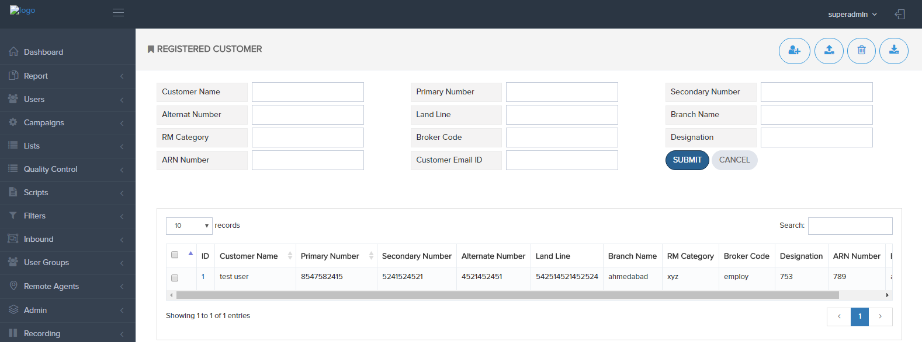

Here validation is set on customer name, numbers, and on ARN number (accept only numeric data).

To edit the records click on the ID and update your details and click on update button and user gets updated successfully alert when details is updated successfully.

To delete the records check mark the checkbox which you have to delete the record and click on the delete icon which is shown in top of the right side.

when user delete the records actually records not deleted but we update the active flag value to N. and we display only that records which active flag is set to ‘Y’.

To download the registered customer click on the download icon this is shown on the top of the right side.

* Insert Bulk Registered Customer

To insert the bulk data of registered customer. Click on the upload icon from the top of the right side. See the below screenshot:

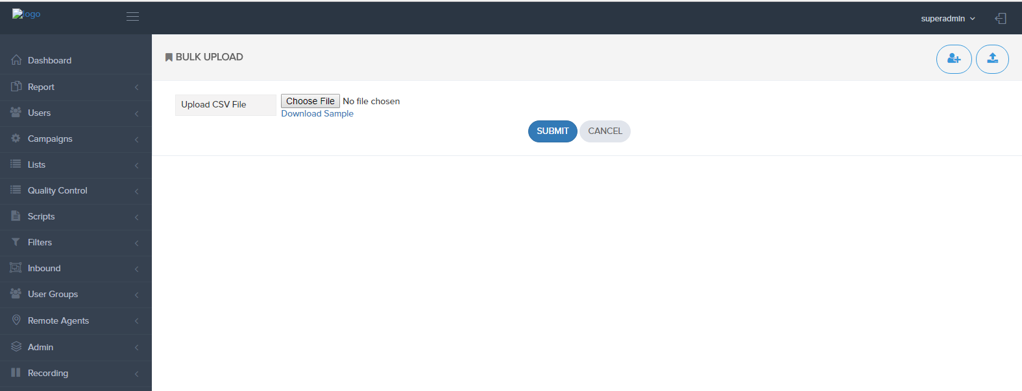

User can download the sample file by clicking on the Download sample.

And to insert the multiple data chose the .csv file of data and click on the submit button. User can see the alert of how many records are inserted successfully or how many records gets failed to insert.

Below are the files for Registered Customer GUI:

/var/www/html/clients/elision-prudent/elis-dialer/admin/ajax/registered_client_mapping_ajax.php  
 /var/www/html/clients/elision-prudent/elision-dialer/admin/registered_client_mapping.php  
 /var/www/html/clients/elision-prudent/elision-dialer/admin/upload_registered_users.php   
 /var/www/html/clients/elision-prudent/elision-dialer/admin/files/prudent_sample_file.csv

 /var/www/html/clients/elision-prudent/elision-dialer/admin/download_registered_client.php

1. Additional Requirement

