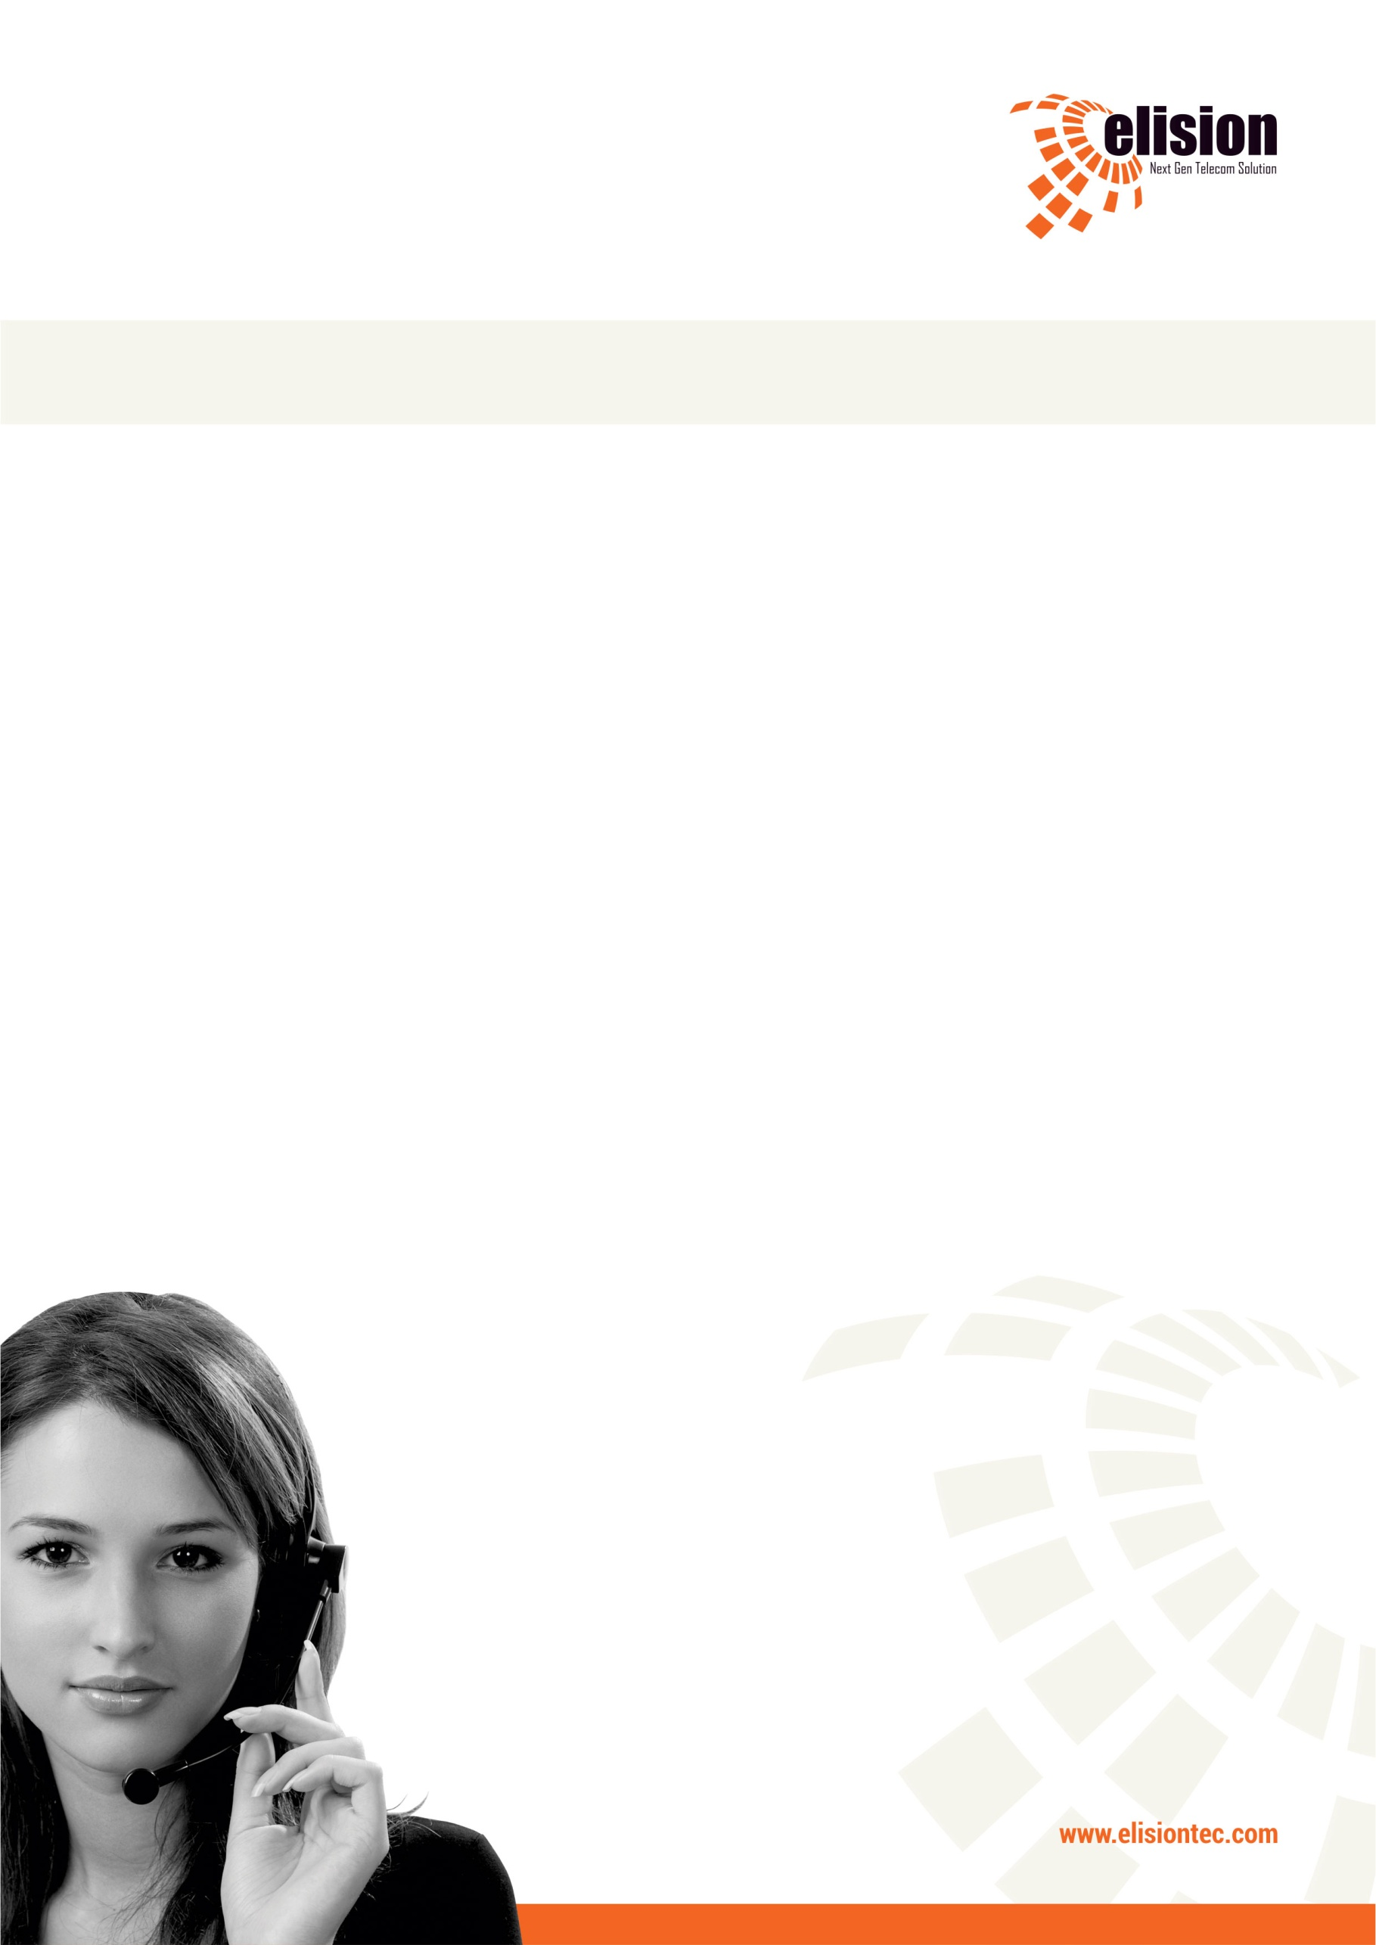



Torque: Technical Document

# Table of Contents

Table of Contents 2

1. Company Details 4

2. Project & Client Details 5

3. Git Repository 6

4. Roles And Responsibility 7

5. Initial Requirement 8

6. Additional Requirement 9

6.1 Send SMS using different provider using different template 9

6.2 Manual Inbound Recording Module. 10

Document Revision History

This table holds record of signification changes made to the document.

|  |  |  |  |
| --- | --- | --- | --- |
| **Version** | **Date** | **Author** | **Description of change** |
| 1.0 | 19/12/2017 | Radhika Solgama | Technical Document |

1. Company Details

Company name: Torque Automotive

City: Baroda

State: Gujarat

Country: India

Address:

1. Project & Client Details

**Clients Details**:

**Client Name:** Pratik Mehta

**Contact Person:**

**Mobile No:** 9099362000

**Project Details:**

1. Git Repository

**Server:** 117.247.83.240

**Link:** http://117.247.83.240:8888/admin/login.php

**Git clone link:** git clone git@gitlab.com:elision-Torque/elision-dialer.git

1. Roles And Responsibility

|  |  |  |
| --- | --- | --- |
| **Sr No.** | **Role** | **Responsibility** |
| 1 | Installation | Nikhil Nimje |
| 2 | Tested By |  |
| 3 | Manual Inbound Recording Module Develp By | Radhika Solgama |

1. Initial Requirement
2. Additional Requirement

## Send SMS using different provider using different template

* We rename the vicidial_sms_config to elision_sms_config table.
* Before understood this functionality we understood how SMS was sent before doing this functionality.
* We add the provider details in elision_sms_config table.
* To show the provider details click on the SMS->Show SMS Config Here only one provider details is activate. We can’t do multiple provider details activate.
* And SMS will be sent from different template using only this activates provider details.
* We can’t send SMS using different provider details.
* To Resolve this issue and send SMS from different template wise by using different provider we set below functionality
* When we add the provider details we can do multiple provider details activate
* When we create template click on the SMS - > add new SMS - >
* Here we set one field “Provider” to map the template with provider and in drop down user can see only activate provider name.
* To map the template with provider We create one table “elision_sms_mapping”
* So whenever we add or edit the template, template will be map with selected provider in elision_sms_mapping table
* And when user can send the SMS from agent panel, in backend process we check the selected template’s provider and it is activate or not. If it is activated then SMS will be sent using this provider details if this provider detail is not activated then SMS cannot send.
* Below is the modified file :
* /var/www/html/clients/elision-Torque/elision-dialer/admin/sms_email.php
* /var/www/html/clients/elision-Torque/elision-dialer/agent/sendsms_email.php
* /var/www/html/clients/elision-Torque/elision-dialer/admin/sms_config.php
* New Created file :

 /var/www/html/clients/elision-Torque/elision-dialer/agent/elision_sms_mapping.php

* New Table Details which we create:

              Database: elision_torque

              Table: elision_sms_mapping

Table SQL: CREATE TABLE IF NOT EXISTS `elision_sms_mapping` (

`mapping_id` int(11) NOT NULL AUTO_INCREMENT,

`template_id` varchar(255) NOT NULL,

`provider_id` varchar(255) NOT NULL,

PRIMARY KEY (`mapping_id`),

UNIQUE KEY `template_id` (`template_id`)

) ENGINE=InnoDB DEFAULT CHARSET=latin1 AUTO_INCREMENT=1 ;

## Manual Inbound Recording Module.

As per client request we provide the inbound transfer recording module to client.

To access this module click on Recording -> click on Inbound Transfer

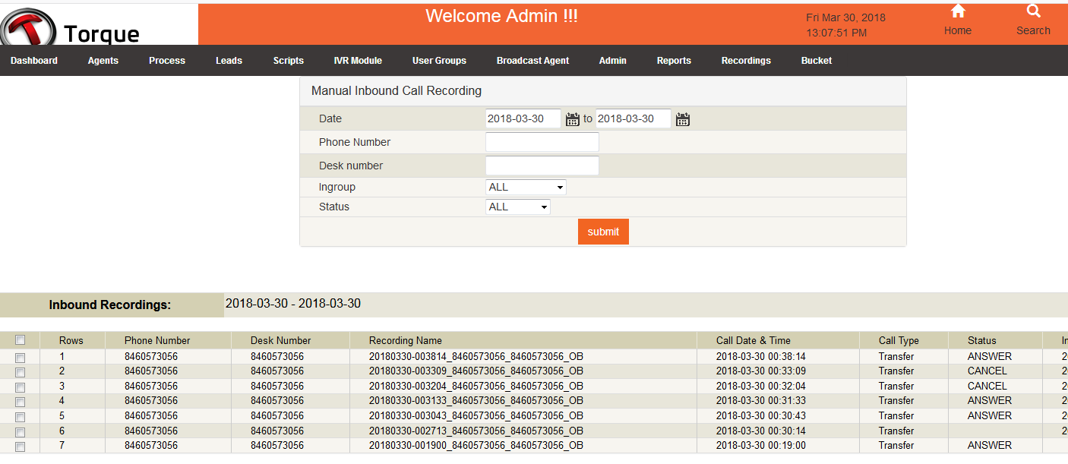

As shown In the above image there are five filters we can fetch the record date, phone Number , desk number ,in group and status wise.

We fetch the datat from elision_Recording table.

And below is the created files for this module:

admin/manual_download.php                  
admin/manual_inbound_recording_report.php  
admin/manual_play.php                       
admin/manual_recording_include.php

Modified Files: admin/top-menu.php

